|  |  |  |
| --- | --- | --- |
| **CONTENTS** | | |
| **sl.no** | **Program** | **Page.No** |
|  |  |  |
|  |  |  |
|  |  |  |
|  |  |  |
|  |  |  |
|  |  |  |
|  |  |  |
|  |  |  |
|  |  |  |
|  |  |  |
|  |  |  |
|  |  |  |
|  |  |  |

**PROGRAM 1**

Develop an HTML page using all basic tags.

<html>

<head>

<title>

GreenWoods

</title>

</head>

<body>

<center><h1><b>My COLLEGE</b></h1>

<p>

<b>GreenWoods Arts and science college palakkunnu </b>is the one of the famous college in <i>Kasargod</i><strike>palakkunnu</strike>district.<br>The college gives more importance in studies and other activities like <big>Arts and sports.</big><blink> GreenWoods</blink> provides better <u>education for students </u></p>

<p>

Atmosphere in the college is very good and <small>excellent</small>It helps to built up a brighter<big><i><b>future for student</b></li></big>

</p>

</body>

</html>

**OUTPUT**

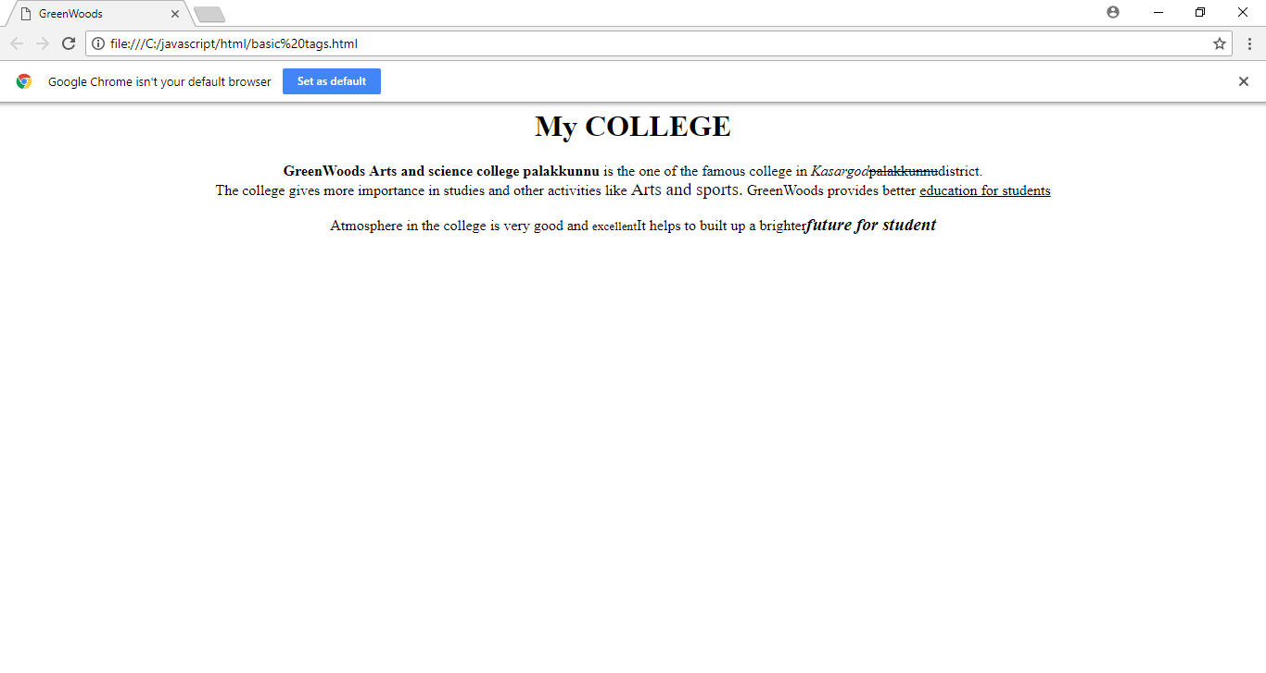

**PROGRAM 2**

Develop an HTML page containing all types of lists.

<html>

<head>

<title>List</title>

</head>

<body>

<ul>

<li>Mango</li>

<li>Apple</li>

<li>JackFruit</li>

</ul>

<ul>

<li>Carrot</li>

<li>Beetroot</li>

<li>Cabbage</li>

</ul>

<dl>

<dt>Apple</dt>

<dd>an Apple a day keep doctor away</dd>

<dt>Mango</dt>

<dd>Mango is a sweet fruit</dd>

</dl>

<dir>

<li>Fruit</li>

<li>Vegetables</li>

</dir>

<menu>

<li>Pepper</li>

<li>Ginger</li>

<li>Garlic</li>

</menu>

</body>

</html>

**OUTPUT**

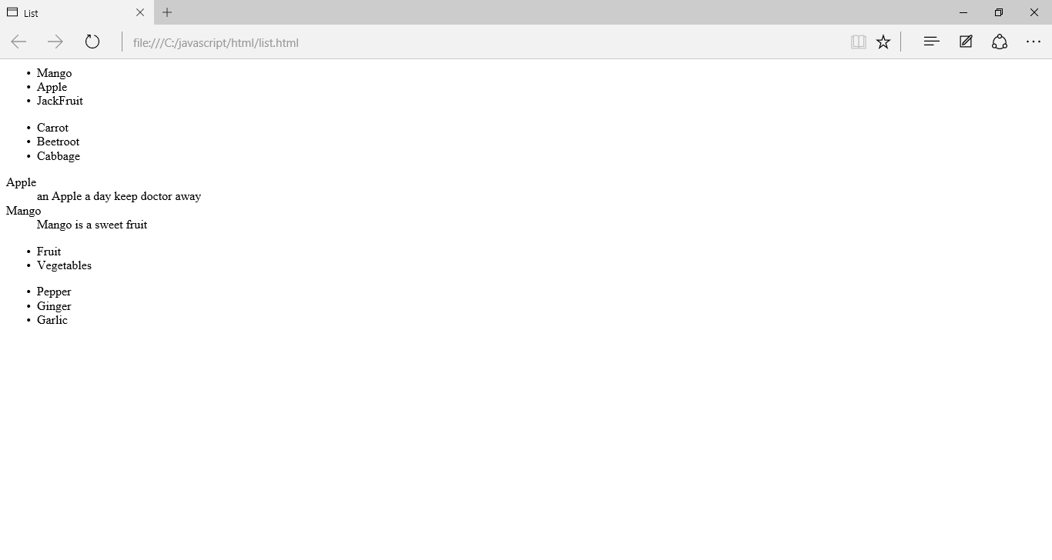

**PROGRAM 3**

Create a webpage giving the following train details in a tabular form with the heading Train Time Table,train name,starting place,destination,arrival and departure,time and fare.

<html>

<head>

<title>nn</title>

</head>

<body>

<table border="border" align="center">

<tr>

<td colspan=6 align="center"><b>Train Time Table</b></td>

</tr>

<tr>

<th>Train name</th>

<th>Starting place</th>

<th>Destination</th>

<th>Departure</th>

<th>Arrival time</th>

<th>Fare</th>

</tr>

<tr align="center">

<td>mngla lkspd exp</td>

<td>ksgd</td>

<td>ernklm</td>

<td>01:35</td>

<td>10:00</td>

<td>150</td>

</tr>

<tr align="center">

<td>kochuveli exp</td>

<td>ksgd</td>

<td>ernklm</td>

<td>01:35</td>

<td>10:00</td>

<td>168</td>

</tr>

<tr align="center">

<td>parasuram exp</td>

<td>ksgd</td>

<td>ernklm</td>

<td>05:36</td>

<td>13:55</td>

<td>160</td>

</tr>

<tr align="center">

<td>netravati</td>

<td>ksgd</td>

<td>ernklm</td>

<td>05:45</td>

<td>14:10</td>

<td>159</td>

</tr>

<tr align="center">

<td>ernad</td>

<td>ksgd</td>

<td>ernklm</td>

<td>08:12</td>

<td>16:15</td>

<td>190</td>

</tr>

</table>

</body>

</html>

**OUTPUT**

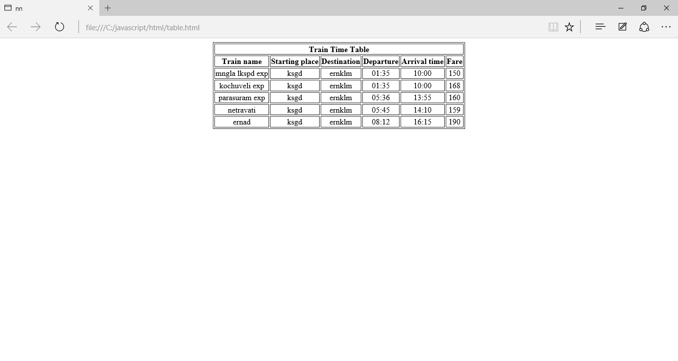

**PROGRAM 4**

Create a webpage that illustrate the onMouseOver and onMouseOut event handlers

<html>

<head>

<script>

function bigImg(x)

{

x.style.height="64px";

x.style.width="64px";

}

function normalImg(x)

{

x.style.height="32px";

x.style.width="32px";

}

</script>

</head>

<body>

<img onMouseOver="bigImg(this)" onMouseOut="normalImg(this)" border="0"

src="E:\picture\apple.jpeg"width="128" height="128">

</body>

</html>

**OUTPUT**

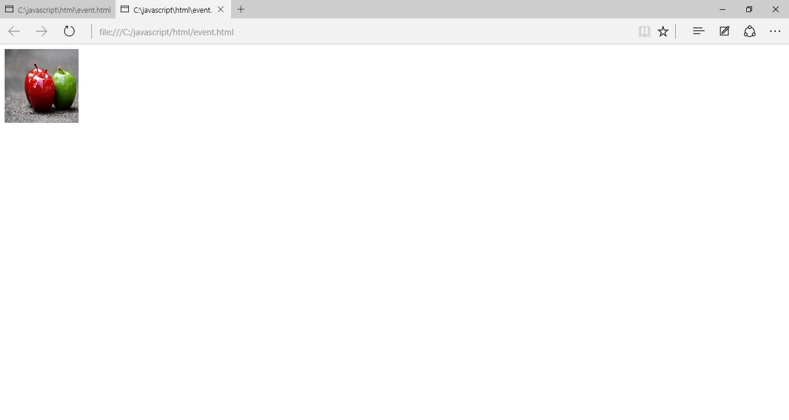

**PROGRAM 5**

Create an HTML page with image.Clicking on the image should load to external document.

**Image01.html**

<html>

<head>

</head>

<body>

<h2>ABOUT HTML </h2>

<p>HTML MEANS HYPER TEXT MARKUP LANGUAGE</p>

<p>

<a href="Details.html">

<img src="E:\picture\pexels-photo-672101.jpeg"height=200 width=200>

</a></p>

<p>

click on image to learn more

</p>

</body>

</html>

**Details.html**

<html>

<head>

</head>

<body>

<h2>DETAILS OF HTML</h2>

<p>The language used to develop webpage is called HTML.HTML is the language intepreted

by the browser webpage are also called HTML document</p><br />

<a href="image.html">

<img src="E:\picture\pexels-photo-1579065.jpeg"height=200 width=200></a>

<br><i>To get previous page click on image</i>

</body>

</

**OUTPUT**

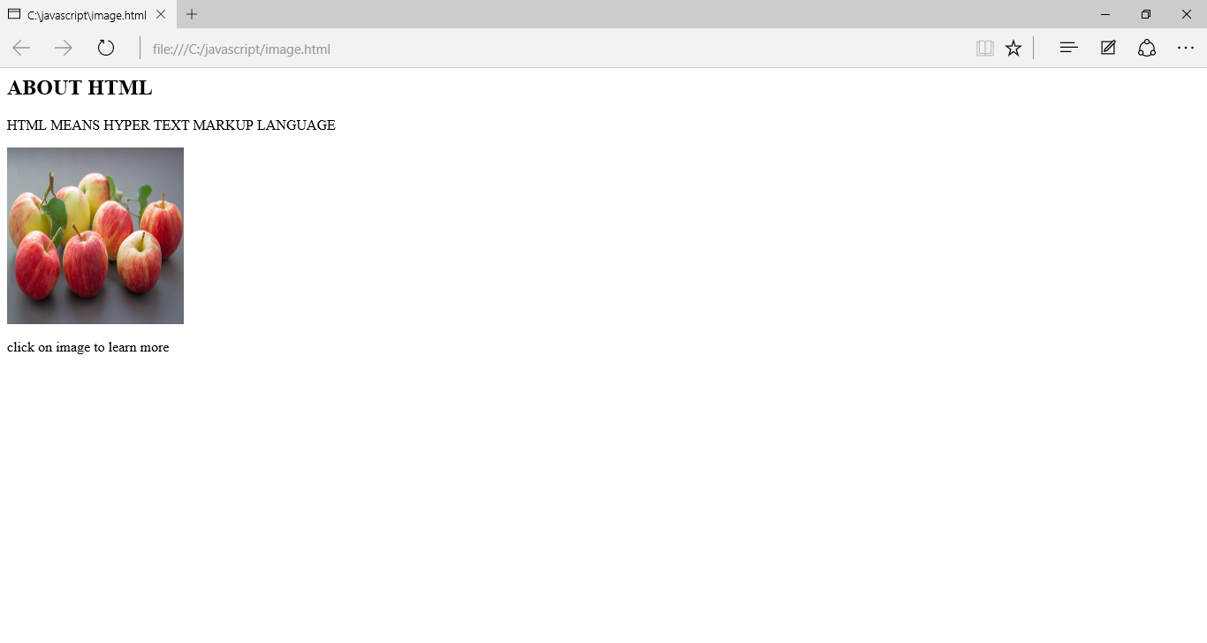

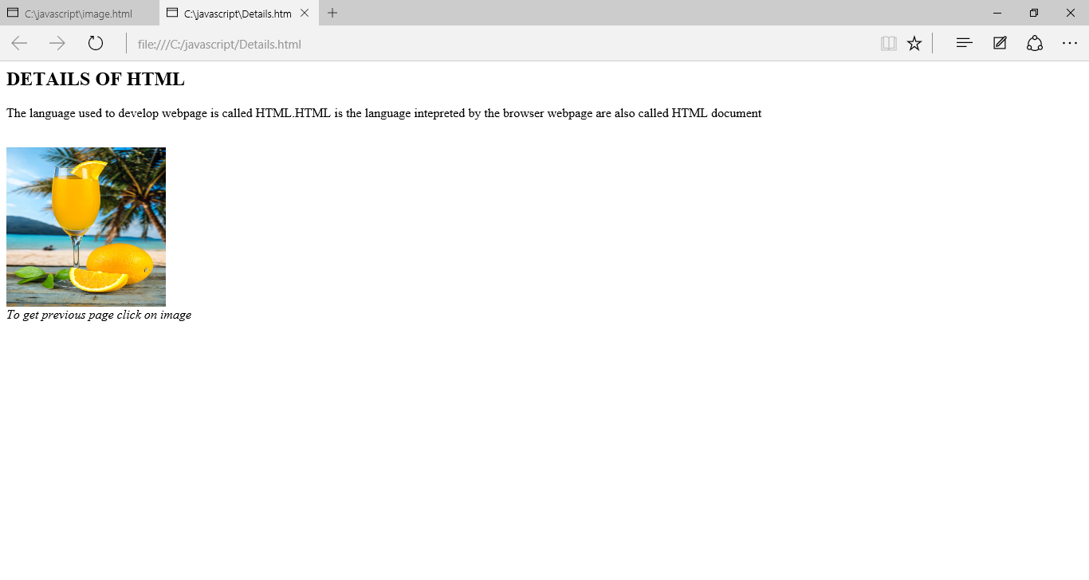

**PROGRAM 6**

Write a javascript program to find the factorial of a number.

<html>

<head>

<title>Factorial</title>

<script type="text/javascript" >

function fact()

{

var f=1;

var n=document.f.num.value;

if(n<=0)

{

alert("Enter a valid number");

}

else

{

for(var i=1;i<=n;i++)

{

f=f*i;

}

alert(n+"!="+f);

}

}

</script>

</head>

<body>

<h2>Factorial</h2>

<form name="f">

Enter a number<input type="text" name="num"><br>

<input type="submit" value="find" onClick="fact();">

<input type="reset" value="clear">

</form>

</body>

</html>

**OUTPUT**

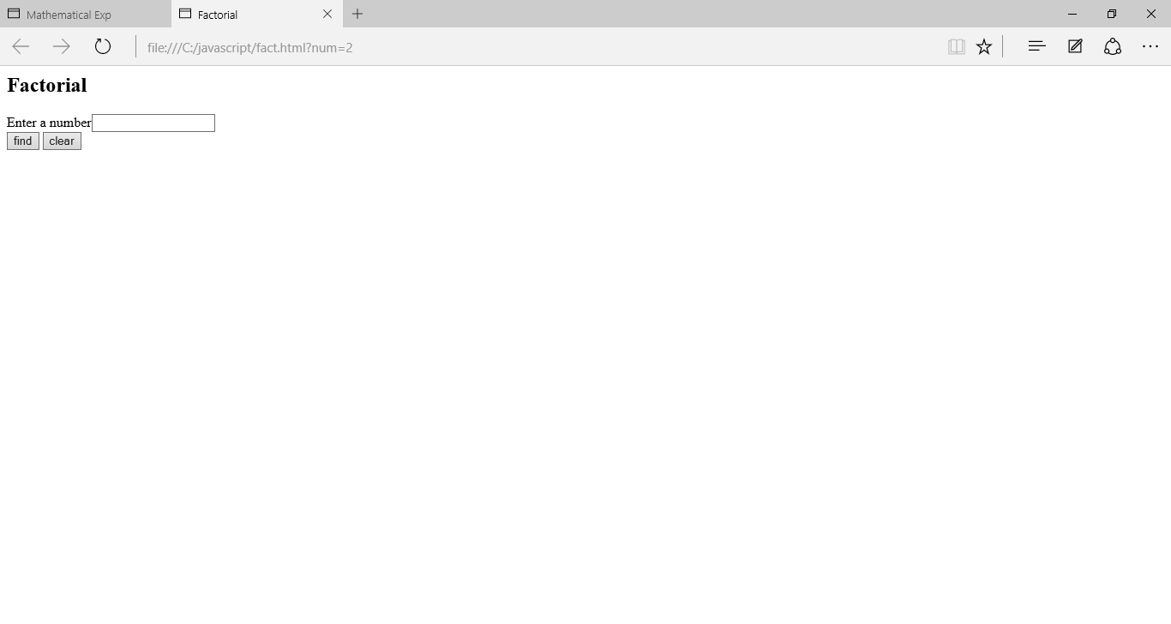

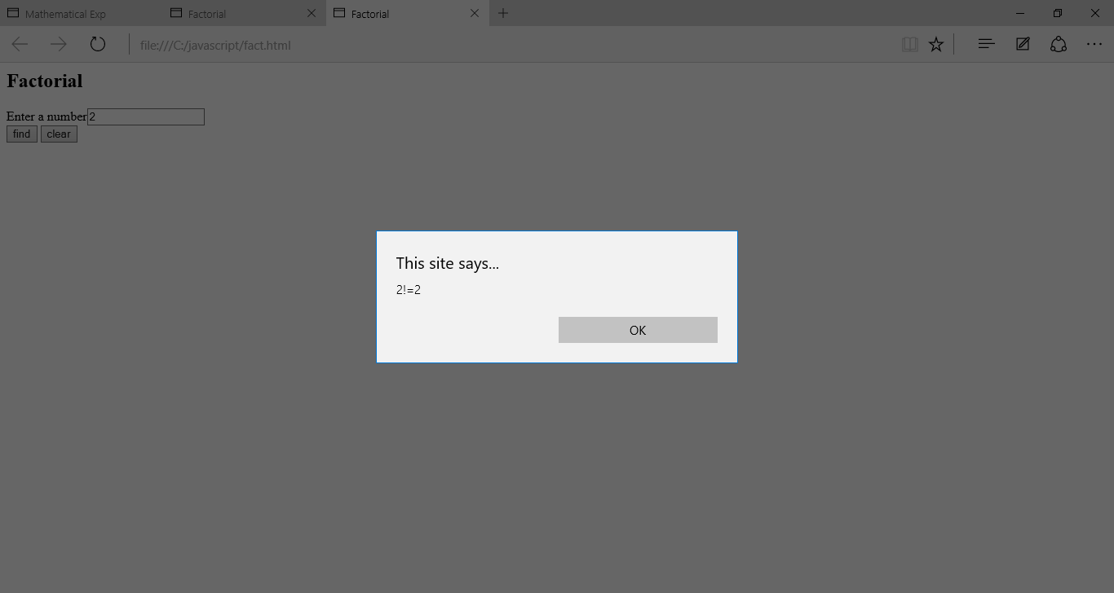

**PROGRAM 7**

Develop an HTML page that accepts any mathematical expression,evaluate that expression and display the result of the evaluation.

html>

<head>

<title>Mathematical Exp</title>

<script>

function test()

{

var n=document.f1.exp.value;

var result=eval(n);

alert("result="+result);

}

</script>

</head>

<body>

<h2>Mathematical Exp</h2>

<form name="f1">

Enter the expression<input type="text" id="exp" name="exp"><br>

<input type="button" value="evaluate" OnClick="test();">

<input type="reset" value="clear">

</form>

</body>

</html>

**OUTPUT**

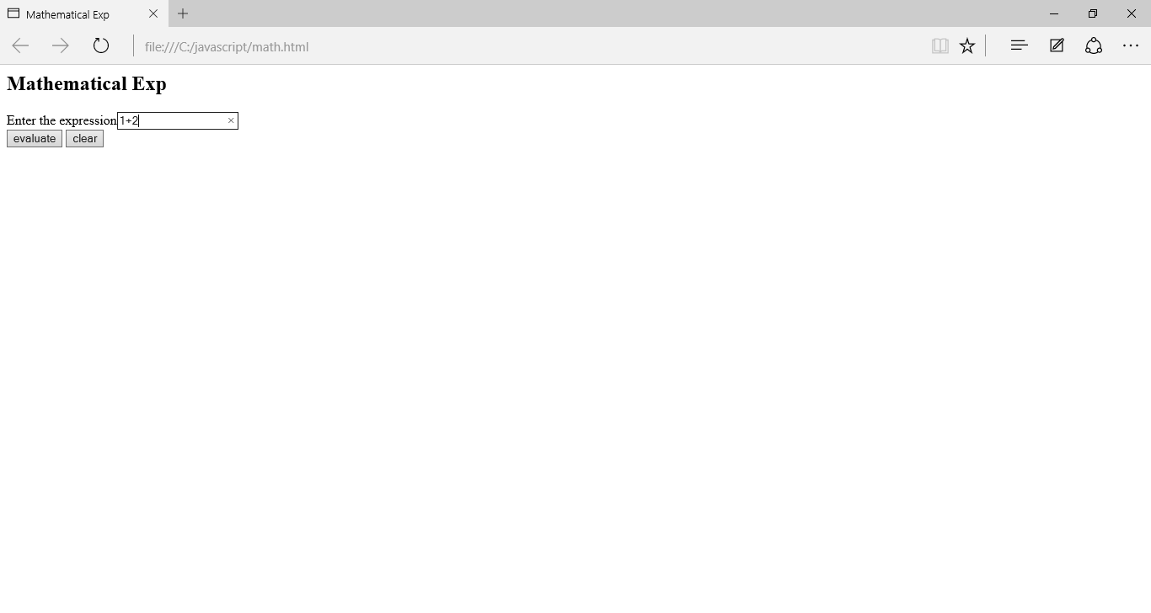

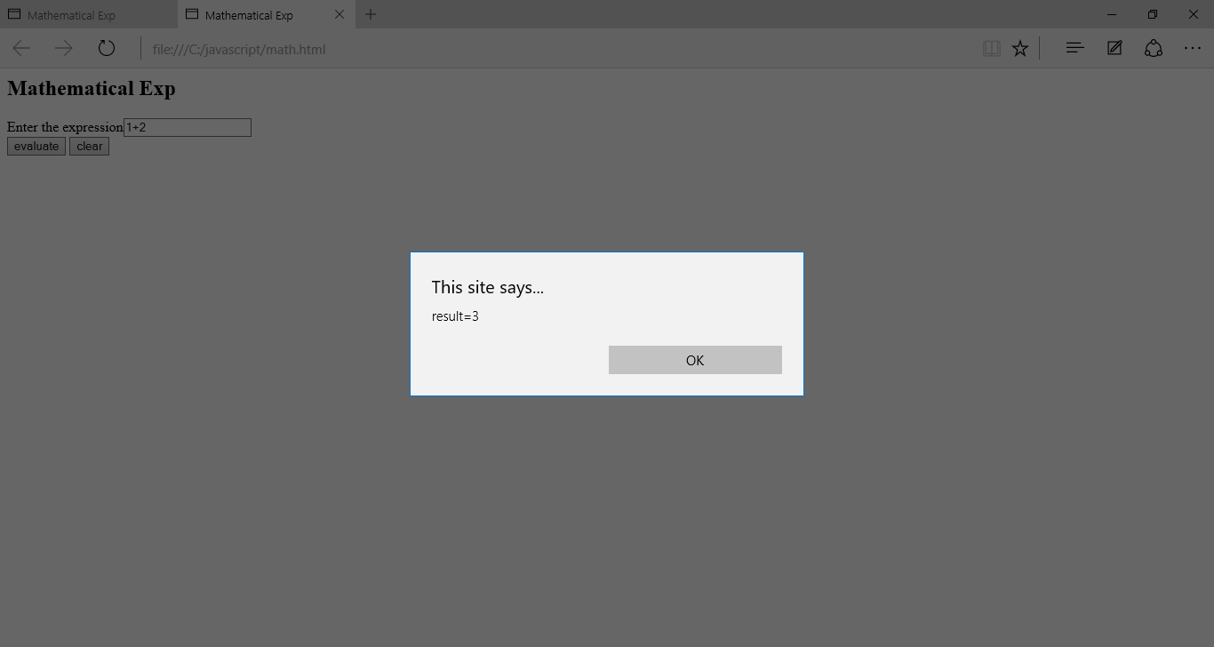

**PROGRAM 8**

Write a javascript program to print the prime numbers within a range.

<html>

<head>

<title>

</title>

</head>

<script type="text/javascript">

var count=1,n=3;

document.writeln("2");

while(count<10)

{

var flag=0;

for(var i=2;i<=(n/2);i++)

{

if((n%i)==0)

{

flag=1;

break;

}

}

if(flag==0)

{

count++;

document.writeln(n);

}

n++;

}

</script>

</body>

</html>

**OUTPUT**

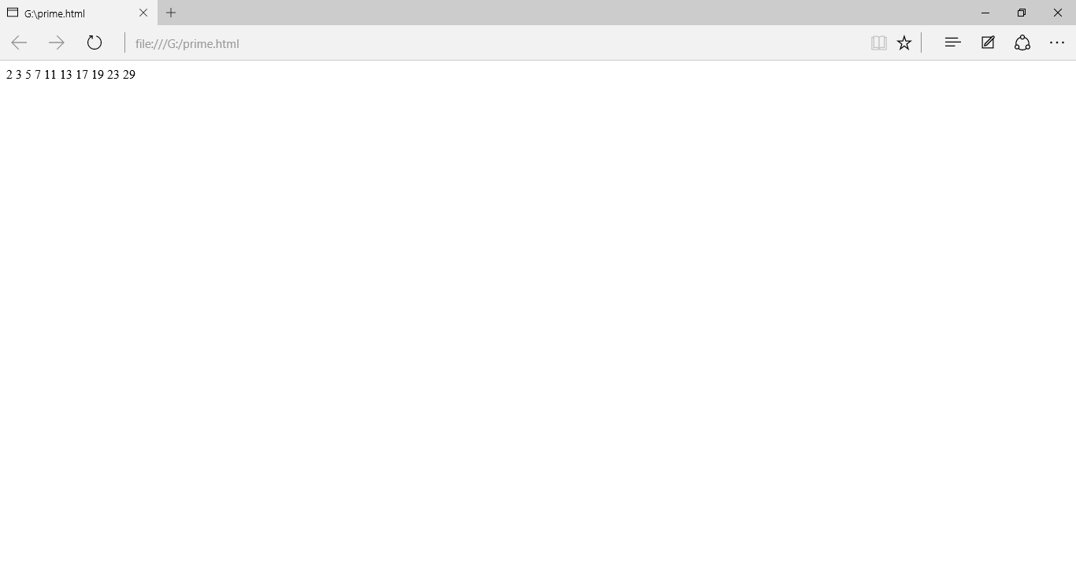

**PROGRAM 9**

Write a JavaScript code using arrays.

<html>

<head>

<title>Arrays!!!</title>

<script>

var students=new Array("John", "Ann", "Aaron", "Edwin", "Elizabeth");

Array.prototype.displayItems=function()

{

for(i=0;i<this.length;i++)

{

document.write(this[i] + "<br/ >");

}

}

document.write("students array<br/ >");

students.displayItems();

document.write("<br/ >The SORTED students array<br/ >");

students.sort();

students.displayItems();

document.write("<br/ >The REVERSED students array<br/ >");

students.reverse();

students.displayItems();

document.write("<br/ >THE students array after REMOVING the LAST item<br/>");

students.pop();

students.displayItems();

document.write("<br/ >THE students array after PUSH<br/ >");

students.push("New Stuff");

students.displayItems();

</script>

</head>

<body>

</body>

</html>

**OUTPUT**

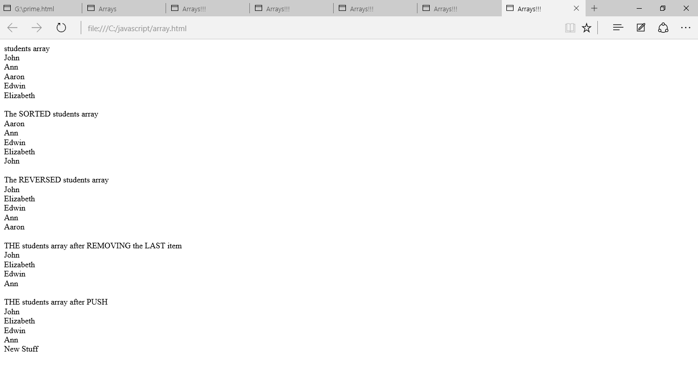

**PROGRAM 10**

Form validation using javascipt.

<html>

<head>

<title>Form validation</title>

</head>

<script>

function validationform()

{

var name=document.myform.name.value;

var mobno=document.myform.mobno.value;

if(name==null||name=="")

{

alert("name cannot be blank");

return false;

}

else if(mobno.length<10)

{

alert("mobno must be atleast 10 character long:");

return false;

}

}

</script>

<body bgcolor="green">

<form name="myform" method="post" action="abc.jsp" onsubmit="return validationform()">

Name:<input type="text" name="name"><br />

Mobileno:<input type="text" name="mobno"><br />

<input type="submit" value="register">

<input type="reset" value="reset">

</from>

</body>

</html>

**OUTPUT**

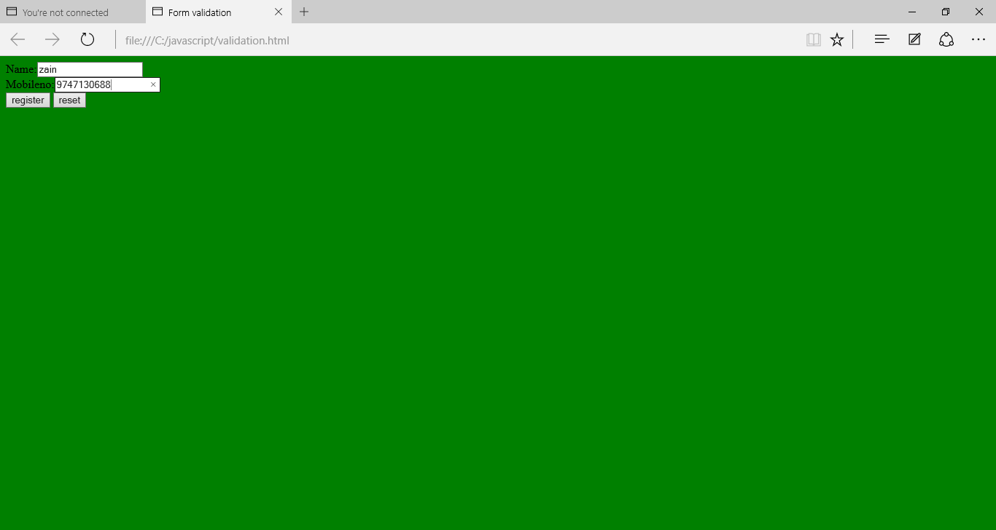

**PROGRAM 11**

Create an email registration form.Give necessary validations.

<html>

<head>

<script>

function check()

{

if(document.myform.user.value.length<1)

{

window.alert("missing your name");

return;

}

if(document.myform.pass.value.length<1)

{

window.alert("missing your password");

return;

}

if(document.myform.cpass.value.length<1)

{

window.alert("missing your confirm password");

return;

}

if(document.myform.first.value.length<1)

{

window.alert("missing your first name");

return;

}

if(document.myform.last.value.length<1)

{

window.alert("missing your last name");

return;

}

if(document.addtress.value.length<1)

{

window.alert("missing your address");

return;

}

s1=document.myform.pass.value;

s2=document.myform.cpass.value;

if(s1!=s2)

{

alert("wrong re_enter password");

}

else

{

alert("ok........");

}

}

</script>

</head>

<body bgcolor="pink">

<h1><b>Email id creation</b></h1>

<form name="myform">

<br>

<b>User name</b>

<input type="text" name="user" value="">@gmail.com<br>

<b>Password</b>

<input type="password" name="pass" value=""><br>

<b>Conform password</b>

<input type="password" name="cpass" value=""><br>

<b>First name</b>

<input type="text" name="first" value=""><br>

<b>Enter last name</b>

<input type="text" name="last" value=""><br>

<b>Address</b>

<textarea name="address"/></textarea><br>

<input type="submit" value="sumbit" onClick="check()"/><br>

</form>

</body>

</html>

**OUTPUT**

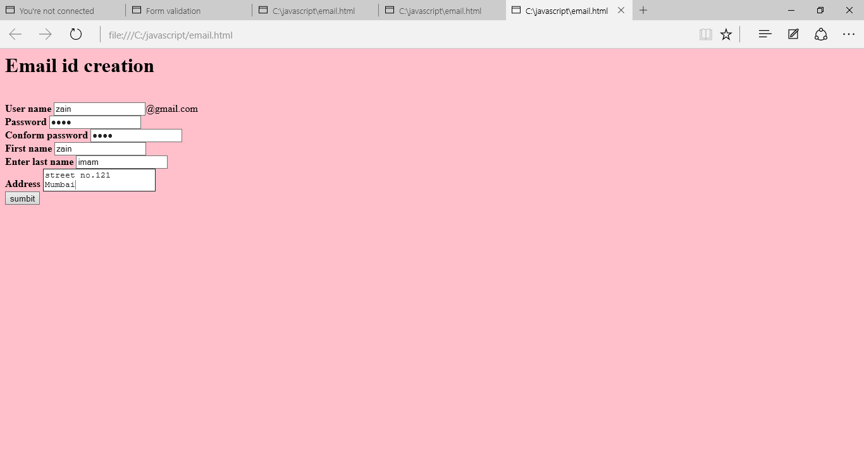

**PROGRAM 12**

Create a webpage for your college using frames, images and hyperlinks.

**frames.html**

<html>

<head>

<title>MY FRAME</title>

</head>

<frameset rows="50%,*">

<frame src="college.html" name=frame1>

<frameset cols="30%,*">

<frame src="link.html" name=frame2>

<frame src="aboutcollege.html" name=frame3>

</frameset>

</frameset>

</html>

**college.html**

<html>

<head>

<title>College</title>

</head>

<body bgcolor="blue">

<center><b>

<font color="red" size=6>GreenWoods Arts and Science<br>College<br>

</font>

<i><font color="pink"><br>(Affiliated to kannur university)</font>

</i>

<br>pallakunnu,po bekal,kasaragod,PIN:671318,phoneno:0467_2207648

</b></center>

</body>

</html>

**link.html**

<html>

<head>

<title>Links</title>

</head>

<body bgcolor="yellow">

<b><h3>

<ul>

<li><a href=aboutcollege.html target=frame3>ABOUT COLLEGE</a>

<li><a href=vision.html target=frame3>VISION AND MISSION</a>

<li><a href=department.html target=frame3>COURSES</a>

</ul>

</body>

</html>

**aboutcollege.html**

<html>

<head>

<title>About College</title>

</head>

<body bgcolor="red" size=8 <marquee>ABOUT COLLEGE </marquee>

<br>

<p><u>Welcome to GreenWoods</u>

<br>

<font size=4><br>

GWSC started functioning with BCA,BCom computer application in the year 2008.

Now it provides BA English,BBM,BSc Maths courses.

</body>

</html>

**department.html**

<html>

<head>

<title>Department</title>

</head>

<body bgcolor="cyan" size=8><u><b><center>

Available Courses</center></b></u>

<ol type=1>

<font size=5>

<li>Degree courses</li>

<ul type="disc">

<li>BSc Computer Science</li>

<li>BCA</li>

<li>BCom</li>

</ul>

<li>PG Course</li>

<ul type="circle">

<li>MCA</li>

</ul>

</body>

</html>

**vision.html**

<html>

<head>

<title>Vision</title>

</head>

<body bgcolor="purple">

<font color="blue" size=4><u>1.VISION</ul></b></font>

<br>

<ul type="square">

<li> to strive for excellence in education for the realization of a vibrant and inclusive society

<br>

<font color="blue" size=4><b><u>2.MISSION</u></b></font>

<br>

<li>Import quality education to meet national and global changes.

<li>Blend theoratical knowledge with practical skills.

</ul>

</body>

</html>

**OUTPUT**

