**ECE 7349-ADVANCE TOPICS IN MICROELECTRONCIS**

**SPRING - 2014**

DESIGN LAYOUT AND SIMULATION OF FOUR BIT LINEAR FEEDBACK SHIFT REGISTER

***Primary Examiner: Professor Earl Charlson***

**Project Report Submitted By**

Sharath Chandra (PS ID: 1257931)

Srivatsan Badri Narayanan (PS ID: 1090241)

***Date: 2nd MAY 2014.***

**INTRODUCTION**

An LFSR is a shift register that when clocked, advances the signal through the register from one bit to the next most-significant bit. A linear feedback shift register can be formed by performing exclusive-OR on the outputs of two or more of the flip-flops together and feeding those outputs back into the input of one of the flip-flops. The feedback causes the value in the shift register to cycle through a set of unique values. The choice of LFSR length, gate type, LFSR type, and maximum length logic and tap positions allows the user to control the implementation and feedback of the LFSR which in turn controls the sequence of repeating values the LFSR will iterate through.

*Inspiration: Linear Feedback Shift Register is used in our project “Keypad Scanner” to implement a module for password protection system using DE2 board demonstration. In this project LFSR circuit is used as a module to introduce a delay of 8ms to avoid debouncing effect of a mechanical switch. Thus LFSR circuit has a wide range of application in implementing various digital circuits and we personally had implemented, tested and verified its functionality in our above mentioned project. This experience has inspired us to design and verify the layout for LFSR circuit.*

The layouts of circuits have been drawn using MAGIC VLSI software of Ubuntu (a Linux flavor) with CMOS technology.

Block Diagram of LFSR with XOR feedback

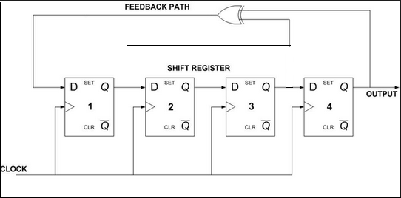

**SPICE EXTRACTION STEPS:-**

* The layout is designed in Magic VLSI software and saved.
* "Extract all" command is used to generate all netlists of the designed layout.
* As a result, .ext file is generated.
* This .ext file is converted into spice file through command "ext2spice filename"
* A new terminal is opened & a command "vi filename.spice" is entered to view generated spice file.
* The contents of this file are copied and saved as .cir file with all voltage sources & ground typed.
* This .cir file is simulated in LtSpice software of windows version.

**Note**: Oracle VM Virtual box is used to run Ubuntu in parallel with Windows and file sharing is enabled between both of these operating systems.

CMOS TECHNOLOGY

**Complementary metal–oxide–semiconductor** (**CMOS**) is a major class of integrated circuits. CMOS technology is widely used in Digital circuits’ viz., microprocessors, microcontrollers, static RAM, and other digital logic circuits. CMOS technology is also used for a wide variety of analog circuits such as image sensors, data converters, and highly integrated transceivers in many types of communication systems.

CMOS was also sometimes referred to as **complementary-symmetry metal–oxide–semiconductor** (or COS-MOS). The words "complementary-symmetry" refer to the fact that the typical digital design style with CMOS uses complementary and symmetrical pairs of p-type and n-type metal oxide semiconductor field effect transistors (MOSFETs) for logic functions.

Two important characteristics of CMOS devices are high noise immunity and low static power consumption. Significant power is only drawn when the transistors in the CMOS device are switching between on and off states i.e., CMOS draws power only during transition. Consequently, CMOS devices do not produce as much waste heat as other forms of logic.

To design the layout of circuits in our project we have made use of Invertor, NAND, Ex-OR gates as a basic elements Thus it is appropriate to mention here their functionalities in brief.

Inverter Gate:

CMOS Inverter circuit is composed of two MOSFETs.  The top FET (MP) is a PMOS type device while the bottom FET (MN) is an NMOS type.  The body effect is not present in either device since the body of each device is directly connected to the device’s source.  Both gates are connected to the input line.  The output line connects to the drains of both FETs.

Truth table:-

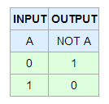

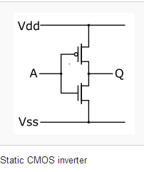

**EX-OR GATE**

The output of Ex-OR gate is high if one and only one of the inputs A or B is high. If either both the inputs are high or both are low the output is low. XOR can also be viewed as addition modulo 2. As a result, XOR gates are used to implement binary addition in computers. A [half adder](http://en.wikipedia.org/wiki/Half_adder) consists of an XOR gate and an [AND gate](http://en.wikipedia.org/wiki/AND_gate).

Truth Table:-

|  |  |  |
| --- | --- | --- |
| **INPUT** | | **OUTPUT** |
| A | B | A Ex-OR B |
| 0 | 0 | 0 |
| 0 | 1 | 1 |
| 1 | 0 | 1 |
| 1 | 1 | 0 |

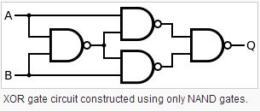

NAND GATE

The NAND gate is significant because any Boolean function can be implemented by using a combination of NAND gates. This property is called [functional completeness](http://en.wikipedia.org/wiki/Functional_completeness). NAND GATE is a [logic gate](http://en.wikipedia.org/wiki/Logic_gate) which produces an output that is false only if all its inputs are true; thus its output is [complement](http://en.wikipedia.org/wiki/Complement_(set_theory)) to that of the [AND gate](http://en.wikipedia.org/wiki/AND_gate). A LOW (0) output results only if both the inputs to the gate are HIGH (1); if one or both inputs are LOW (0), a HIGH (1) output results. It is made using transistors.

Truth Table:-

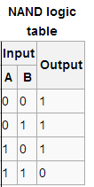

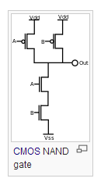

**D Flip Flop:**

A flip-flop or latch is a [circuit](http://en.wikipedia.org/wiki/Electronic_circuit) that has two stable states and can be used to store state information. The circuit can be made to change state by signals applied to one or more control inputs and will have one or two outputs. It is the basic storage element in [sequential logic](http://en.wikipedia.org/wiki/Sequential_logic).

The D flip-flop takes one data input and updates its state Q, on a clock tick, according to the table shown below. D flip flop can be implemented using the universal gates NAND and NOR.

Below is the D flip flop implementation using NAND gate.

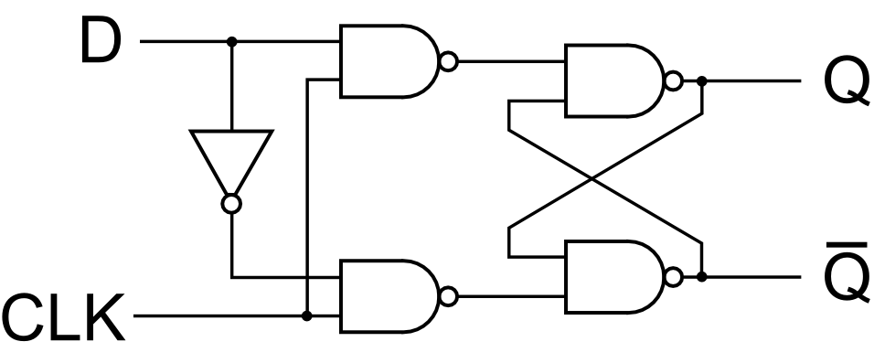

Truth Table:-

|  |  |  |
| --- | --- | --- |
| **INPUT** | **OUTPUT** | |
| D | Q | Qbar |
| 0 | 0 | 1 |
| 1 | 1 | 0 |

Series of D flip-flops connected together form Serial In & Parallel out Shift register when feedback mechanism is not used.

**SPECIFICATION FOR LFSR**

**Linear Feedback Shift Register**

**Linear Feedback Shift Register for a sequence of four bits can** be implemented by connecting four D flip flops sequentially and feedback from any of the D flip flops can be tapped and connected to the EXOR gate. LFSR can be implemented either using many to one or one to many feedback mechanisms.

Many to one approach of implementing a LFSR is as shown below.

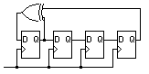

As explained above we have implemented a LFSR circuit wherein we have used a LFSR test bench. This LFSR test bench provides a provision for the user to select number of bits, type of feedback, the feedback logic gate to be used a LFSR circuit.

In the above screen shot we have selected shift register length as 4 and feedback structure as many to one and feedback logic gate as EXOR gate. The following is the pattern obtained starting with rising edge of clock cycle.

|  |  |
| --- | --- |
| Clock | Pattern Obtained |
| 1 | 1000 |
| 2 | 0001 |
| 3 | 0011 |
| 4 | 0111 |
| 5 | 1111 |
| 6 | 1110 |
| 7 | 1101 |
| 8 | 1010 |
| 9 | 0101 |
| 10 | 1011 |
| 11 | 0010 |
| 12 | 1110 |
| 13 | 1001 |
| 14 | 0010 |
| 15 | 0100 |

LAYOUTS

Magic VLSI layout for Inverter

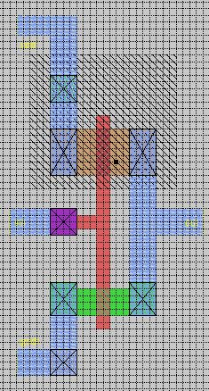

Magic VLSI Layout for Ex-OR Gate

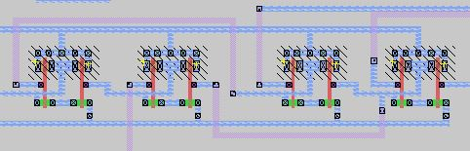

Magic VLSI Layout of Rising Edge D- Flip Flop

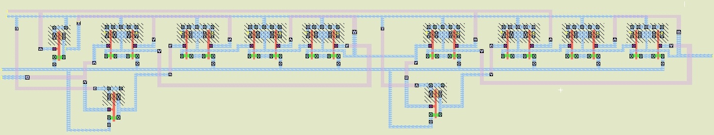

D-Flip Flop Layout

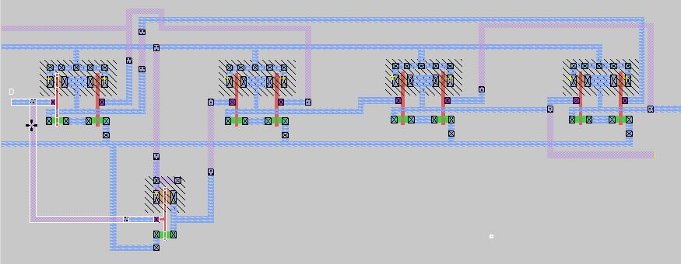

Layout for Final Design:-

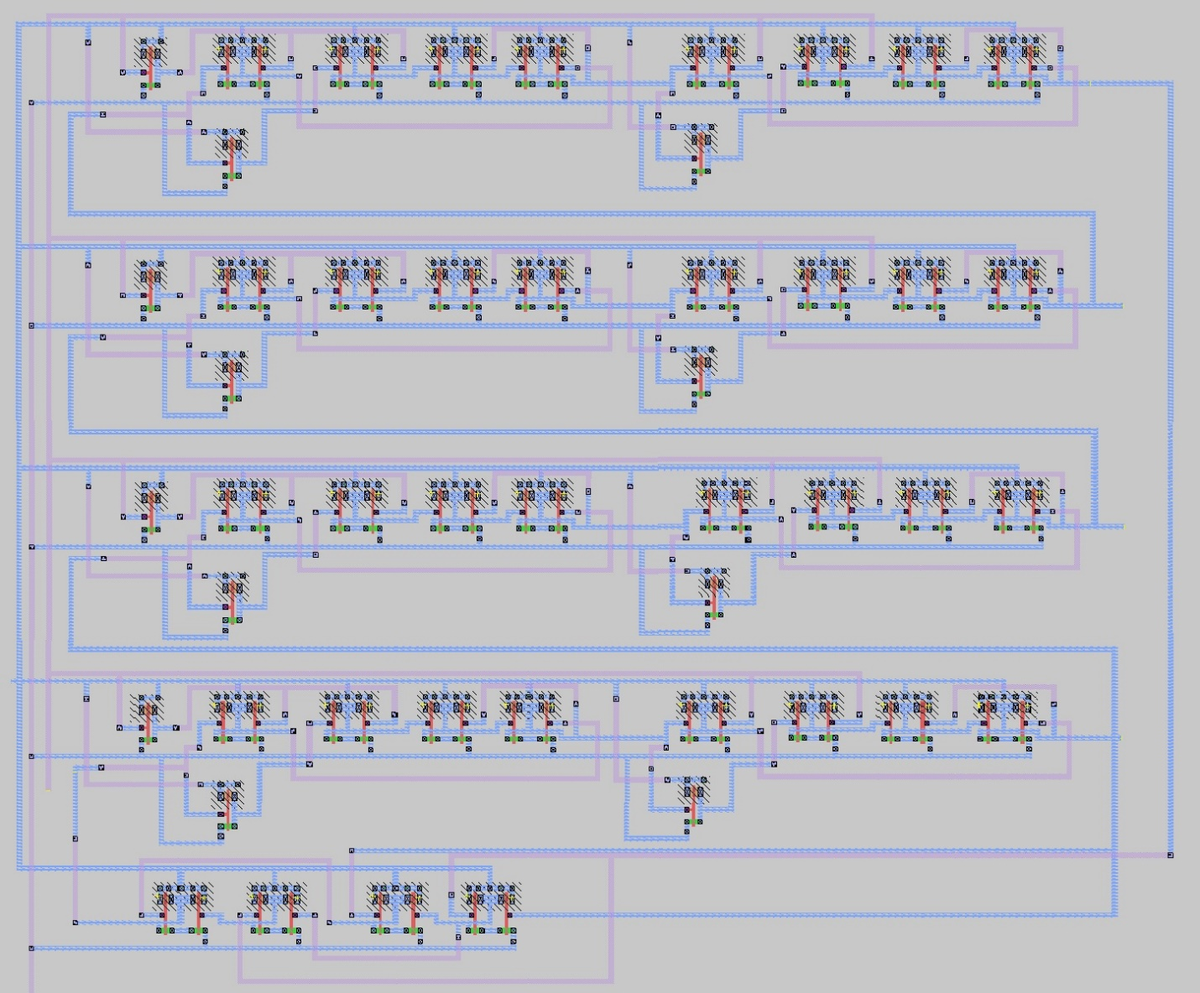

Labelled Layout of Final Design:-

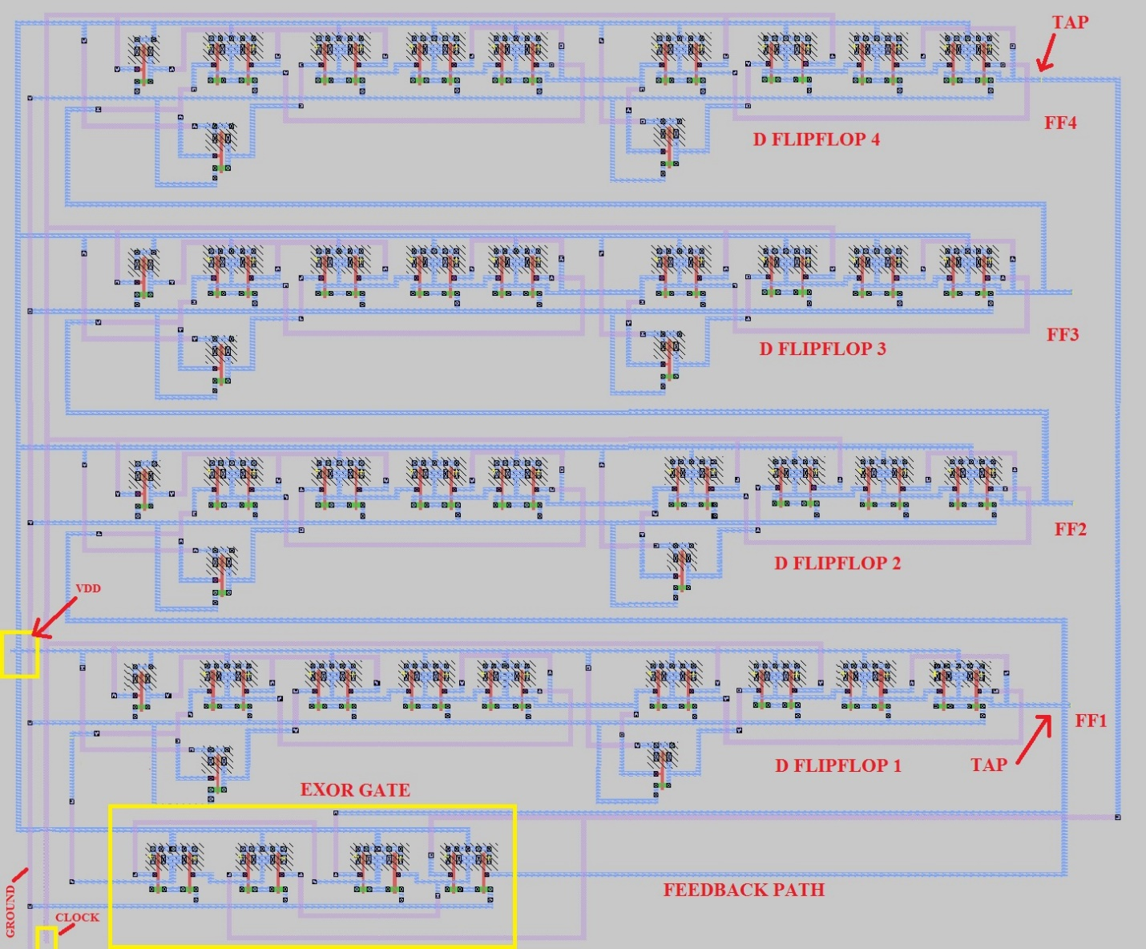

**SPICE CODE:**

Spice code extract for Linear Feedback Shift Register.

* SPICE3 file created from test.ext - technology: scmos .option scale=1u

M1000 a_n1229_208# clock vdd vdd pfet w=8 l=2

+ ad=56 pd=30 as=4128 ps=2376

M1001 a_n1172_209# FF3 vdd vdd pfet w=8 l=2

+ ad=96 pd=56 as=0 ps=0

M1002 vdd a_n1229_208# a_n1172_209# vdd pfet w=8 l=2

+ ad=0 pd=0 as=0 ps=0

M1003 a_n1075_209# a_n1159_130# vdd vdd pfet w=8 l=2

+ ad=96 pd=56 as=0 ps=0

M1004 vdd a_n1229_208# a_n1075_209# vdd pfet w=8 l=2

+ ad=0 pd=0 as=0 ps=0

M1005 a_n989_209# a_n1075_209# vdd vdd pfet w=8 l=2

+ ad=96 pd=56 as=0 ps=0

M1006 vdd a_n954_207# a_n989_209# vdd pfet w=8 l=2

+ ad=0 pd=0 as=0 ps=0

M1007 a_n954_207# a_n989_209# vdd vdd pfet w=8 l=2

+ ad=96 pd=56 as=0 ps=0

M1008 vdd a_n1172_209# a_n954_207# vdd pfet w=8 l=2

+ ad=0 pd=0 as=0 ps=0

M1009 a_n761_209# a_n954_207# vdd vdd pfet w=8 l=2

+ ad=96 pd=56 as=0 ps=0

M1010 vdd clock a_n761_209# vdd pfet w=8 l=2

+ ad=0 pd=0 as=0 ps=0

M1011 a_n665_210# a_n748_134# vdd vdd pfet w=8 l=2

+ ad=96 pd=56 as=0 ps=0

M1012 vdd clock a_n665_210# vdd pfet w=8 l=2

+ ad=0 pd=0 as=0 ps=0

M1013 a_n583_209# a_n665_210# vdd vdd pfet w=8 l=2

+ ad=96 pd=56 as=0 ps=0

M1014 vdd FF4 a_n583_209# vdd pfet w=8 l=2

+ ad=0 pd=0 as=0 ps=0

M1015 FF4 a_n583_209# vdd vdd pfet w=8 l=2

+ ad=96 pd=56 as=0 ps=0

M1016 vdd a_n761_209# FF4 vdd pfet w=8 l=2

+ ad=0 pd=0 as=0 ps=0

M1017 a_n1229_208# clock gnd Gnd nfet w=4 l=2

+ ad=28 pd=22 as=1344 ps=1056

M1018 a_n1163_209# FF3 a_n1172_209# Gnd nfet w=4 l=2

+ ad=56 pd=44 as=28 ps=22

M1019 gnd a_n1229_208# a_n1163_209# Gnd nfet w=4 l=2

+ ad=0 pd=0 as=0 ps=0

M1020 a_n1066_209# a_n1159_130# a_n1075_209# Gnd nfet w=4 l=2

+ ad=56 pd=44 as=28 ps=22

M1021 gnd a_n1229_208# a_n1066_209# Gnd nfet w=4 l=2

+ ad=0 pd=0 as=0 ps=0

M1022 a_n980_209# a_n1075_209# a_n989_209# Gnd nfet w=4 l=2

+ ad=56 pd=44 as=28 ps=22

M1023 gnd a_n954_207# a_n980_209# Gnd nfet w=4 l=2

+ ad=0 pd=0 as=0 ps=0

M1024 a_n906_209# a_n989_209# a_n954_207# Gnd nfet w=4 l=2

+ ad=56 pd=44 as=28 ps=22

M1025 gnd a_n1172_209# a_n906_209# Gnd nfet w=4 l=2

+ ad=0 pd=0 as=0 ps=0

M1026 a_n752_209# a_n954_207# a_n761_209# Gnd nfet w=4 l=2

+ ad=56 pd=44 as=28 ps=22

M1027 gnd clock a_n752_209# Gnd nfet w=4 l=2

+ ad=0 pd=0 as=0 ps=0

M1028 a_n656_210# a_n748_134# a_n665_210# Gnd nfet w=4 l=2

+ ad=56 pd=44 as=28 ps=22

M1029 gnd clock a_n656_210# Gnd nfet w=4 l=2

+ ad=0 pd=0 as=0 ps=0

M1030 a_n574_209# a_n665_210# a_n583_209# Gnd nfet w=4 l=2

+ ad=56 pd=44 as=28 ps=22

M1031 gnd FF4 a_n574_209# Gnd nfet w=4 l=2

+ ad=0 pd=0 as=0 ps=0

M1032 a_n492_209# a_n583_209# FF4 Gnd nfet w=4 l=2

+ ad=56 pd=44 as=28 ps=22

M1033 gnd a_n761_209# a_n492_209# Gnd nfet w=4 l=2

+ ad=0 pd=0 as=0 ps=0

M1034 a_n1159_130# FF3 vdd vdd pfet w=8 l=2

+ ad=56 pd=30 as=0 ps=0

M1035 a_n748_134# a_n954_207# vdd vdd pfet w=8 l=2

+ ad=56 pd=30 as=0 ps=0

M1036 a_n748_134# a_n954_207# gnd Gnd nfet w=4 l=2

+ ad=28 pd=22 as=0 ps=0

M1037 a_n1159_130# FF3 gnd Gnd nfet w=4 l=2

+ ad=28 pd=22 as=0 ps=0

M1038 a_n1229_n64# clock vdd vdd pfet w=8 l=2

+ ad=56 pd=30 as=0 ps=0

M1039 a_n1172_n63# FF2 vdd vdd pfet w=8 l=2

+ ad=96 pd=56 as=0 ps=0

M1040 vdd a_n1229_n64# a_n1172_n63# vdd pfet w=8 l=2

+ ad=0 pd=0 as=0 ps=0

M1041 a_n1075_n63# a_n1159_n142# vdd vdd pfet w=8 l=2

+ ad=96 pd=56 as=0 ps=0

M1042 vdd a_n1229_n64# a_n1075_n63# vdd pfet w=8 l=2

+ ad=0 pd=0 as=0 ps=0

M1043 a_n989_n63# a_n1075_n63# vdd vdd pfet w=8 l=2

+ ad=96 pd=56 as=0 ps=0

M1044 vdd a_n954_n65# a_n989_n63# vdd pfet w=8 l=2

+ ad=0 pd=0 as=0 ps=0

M1045 a_n954_n65# a_n989_n63# vdd vdd pfet w=8 l=2

+ ad=96 pd=56 as=0 ps=0

M1046 vdd a_n1172_n63# a_n954_n65# vdd pfet w=8 l=2

+ ad=0 pd=0 as=0 ps=0

M1047 a_n761_n63# a_n954_n65# vdd vdd pfet w=8 l=2

+ ad=96 pd=56 as=0 ps=0

M1048 vdd clock a_n761_n63# vdd pfet w=8 l=2

+ ad=0 pd=0 as=0 ps=0

M1049 a_n665_n62# a_n748_n138# vdd vdd pfet w=8 l=2

+ ad=96 pd=56 as=0 ps=0

M1050 vdd clock a_n665_n62# vdd pfet w=8 l=2

+ ad=0 pd=0 as=0 ps=0

M1051 a_n583_n63# a_n665_n62# vdd vdd pfet w=8 l=2

+ ad=96 pd=56 as=0 ps=0

M1052 vdd FF3 a_n583_n63# vdd pfet w=8 l=2

+ ad=0 pd=0 as=0 ps=0

M1053 FF3 a_n583_n63# vdd vdd pfet w=8 l=2

+ ad=96 pd=56 as=0 ps=0

M1054 vdd a_n761_n63# FF3 vdd pfet w=8 l=2

+ ad=0 pd=0 as=0 ps=0

M1055 a_n1229_n64# clock gnd Gnd nfet w=4 l=2

+ ad=28 pd=22 as=0 ps=0

M1056 a_n1163_n63# FF2 a_n1172_n63# Gnd nfet w=4 l=2

+ ad=56 pd=44 as=28 ps=22

M1057 gnd a_n1229_n64# a_n1163_n63# Gnd nfet w=4 l=2

+ ad=0 pd=0 as=0 ps=0

M1058 a_n1066_n63# a_n1159_n142# a_n1075_n63# Gnd nfet w=4 l=2

+ ad=56 pd=44 as=28 ps=22

M1059 gnd a_n1229_n64# a_n1066_n63# Gnd nfet w=4 l=2

+ ad=0 pd=0 as=0 ps=0

M1060 a_n980_n63# a_n1075_n63# a_n989_n63# Gnd nfet w=4 l=2

+ ad=56 pd=44 as=28 ps=22

M1061 gnd a_n954_n65# a_n980_n63# Gnd nfet w=4 l=2

+ ad=0 pd=0 as=0 ps=0

M1062 a_n906_n63# a_n989_n63# a_n954_n65# Gnd nfet w=4 l=2

+ ad=56 pd=44 as=28 ps=22

M1063 gnd a_n1172_n63# a_n906_n63# Gnd nfet w=4 l=2

+ ad=0 pd=0 as=0 ps=0

M1064 a_n752_n63# a_n954_n65# a_n761_n63# Gnd nfet w=4 l=2

+ ad=56 pd=44 as=28 ps=22

M1065 gnd clock a_n752_n63# Gnd nfet w=4 l=2

+ ad=0 pd=0 as=0 ps=0

M1066 a_n656_n62# a_n748_n138# a_n665_n62# Gnd nfet w=4 l=2

+ ad=56 pd=44 as=28 ps=22

M1067 gnd clock a_n656_n62# Gnd nfet w=4 l=2

+ ad=0 pd=0 as=0 ps=0

M1068 a_n574_n63# a_n665_n62# a_n583_n63# Gnd nfet w=4 l=2

+ ad=56 pd=44 as=28 ps=22

M1069 gnd FF3 a_n574_n63# Gnd nfet w=4 l=2

+ ad=0 pd=0 as=0 ps=0

M1070 a_n492_n63# a_n583_n63# FF3 Gnd nfet w=4 l=2

+ ad=56 pd=44 as=28 ps=22

M1071 gnd a_n761_n63# a_n492_n63# Gnd nfet w=4 l=2

+ ad=0 pd=0 as=0 ps=0

M1072 a_n1159_n142# FF2 vdd vdd pfet w=8 l=2

+ ad=56 pd=30 as=0 ps=0

M1073 a_n748_n138# a_n954_n65# vdd vdd pfet w=8 l=2

+ ad=56 pd=30 as=0 ps=0

M1074 a_n748_n138# a_n954_n65# gnd Gnd nfet w=4 l=2

+ ad=28 pd=22 as=0 ps=0

M1075 a_n1159_n142# FF2 gnd Gnd nfet w=4 l=2

+ ad=28 pd=22 as=0 ps=0

M1076 a_n1229_n315# clock vdd vdd pfet w=8 l=2

+ ad=56 pd=30 as=0 ps=0

M1077 a_n1172_n314# FF1 vdd vdd pfet w=8 l=2

+ ad=96 pd=56 as=0 ps=0

M1078 vdd a_n1229_n315# a_n1172_n314# vdd pfet w=8 l=2

+ ad=0 pd=0 as=0 ps=0

M1079 a_n1075_n314# a_n1159_n393# vdd vdd pfet w=8 l=2

+ ad=96 pd=56 as=0 ps=0

M1080 vdd a_n1229_n315# a_n1075_n314# vdd pfet w=8 l=2

+ ad=0 pd=0 as=0 ps=0

M1081 a_n989_n314# a_n1075_n314# vdd vdd pfet w=8 l=2

+ ad=96 pd=56 as=0 ps=0

M1082 vdd a_n954_n316# a_n989_n314# vdd pfet w=8 l=2

+ ad=0 pd=0 as=0 ps=0

M1083 a_n954_n316# a_n989_n314# vdd vdd pfet w=8 l=2

+ ad=96 pd=56 as=0 ps=0

M1084 vdd a_n1172_n314# a_n954_n316# vdd pfet w=8 l=2

+ ad=0 pd=0 as=0 ps=0

M1085 a_n761_n314# a_n954_n316# vdd vdd pfet w=8 l=2

+ ad=96 pd=56 as=0 ps=0

M1086 vdd clock a_n761_n314# vdd pfet w=8 l=2

+ ad=0 pd=0 as=0 ps=0

M1087 a_n665_n313# a_n748_n389# vdd vdd pfet w=8 l=2

+ ad=96 pd=56 as=0 ps=0

M1088 vdd clock a_n665_n313# vdd pfet w=8 l=2

+ ad=0 pd=0 as=0 ps=0

M1089 a_n583_n314# a_n665_n313# vdd vdd pfet w=8 l=2

+ ad=96 pd=56 as=0 ps=0

M1090 vdd FF2 a_n583_n314# vdd pfet w=8 l=2

+ ad=0 pd=0 as=0 ps=0

M1091 FF2 a_n583_n314# vdd vdd pfet w=8 l=2

+ ad=96 pd=56 as=0 ps=0

M1092 vdd a_n761_n314# FF2 vdd pfet w=8 l=2

+ ad=0 pd=0 as=0 ps=0

M1093 a_n1229_n315# clock gnd Gnd nfet w=4 l=2

+ ad=28 pd=22 as=0 ps=0

M1094 a_n1163_n314# FF1 a_n1172_n314# Gnd nfet w=4 l=2

+ ad=56 pd=44 as=28 ps=22

M1095 gnd a_n1229_n315# a_n1163_n314# Gnd nfet w=4 l=2

+ ad=0 pd=0 as=0 ps=0

M1096 a_n1066_n314# a_n1159_n393# a_n1075_n314# Gnd nfet w=4 l=2

+ ad=56 pd=44 as=28 ps=22

M1097 gnd a_n1229_n315# a_n1066_n314# Gnd nfet w=4 l=2

+ ad=0 pd=0 as=0 ps=0

M1098 a_n980_n314# a_n1075_n314# a_n989_n314# Gnd nfet w=4 l=2

+ ad=56 pd=44 as=28 ps=22

M1099 gnd a_n954_n316# a_n980_n314# Gnd nfet w=4 l=2

+ ad=0 pd=0 as=0 ps=0

M1100 a_n906_n314# a_n989_n314# a_n954_n316# Gnd nfet w=4 l=2

+ ad=56 pd=44 as=28 ps=22

M1101 gnd a_n1172_n314# a_n906_n314# Gnd nfet w=4 l=2

+ ad=0 pd=0 as=0 ps=0

M1102 a_n752_n314# a_n954_n316# a_n761_n314# Gnd nfet w=4 l=2

+ ad=56 pd=44 as=28 ps=22

M1103 gnd clock a_n752_n314# Gnd nfet w=4 l=2

+ ad=0 pd=0 as=0 ps=0

M1104 a_n656_n313# a_n748_n389# a_n665_n313# Gnd nfet w=4 l=2

+ ad=56 pd=44 as=28 ps=22

M1105 gnd clock a_n656_n313# Gnd nfet w=4 l=2

+ ad=0 pd=0 as=0 ps=0

M1106 a_n574_n314# a_n665_n313# a_n583_n314# Gnd nfet w=4 l=2

+ ad=56 pd=44 as=28 ps=22

M1107 gnd FF2 a_n574_n314# Gnd nfet w=4 l=2

+ ad=0 pd=0 as=0 ps=0

M1108 a_n492_n314# a_n583_n314# FF2 Gnd nfet w=4 l=2

+ ad=56 pd=44 as=28 ps=22

M1109 gnd a_n761_n314# a_n492_n314# Gnd nfet w=4 l=2

+ ad=0 pd=0 as=0 ps=0

M1110 a_n1159_n393# FF1 vdd vdd pfet w=8 l=2

+ ad=56 pd=30 as=0 ps=0

M1111 a_n748_n389# a_n954_n316# vdd vdd pfet w=8 l=2

+ ad=56 pd=30 as=0 ps=0

M1112 a_n748_n389# a_n954_n316# gnd Gnd nfet w=4 l=2

+ ad=28 pd=22 as=0 ps=0

M1113 a_n1159_n393# FF1 gnd Gnd nfet w=4 l=2

+ ad=28 pd=22 as=0 ps=0

M1114 a_n1230_n563# clock vdd vdd pfet w=8 l=2

+ ad=56 pd=30 as=0 ps=0

M1115 a_n1173_n562# D vdd vdd pfet w=8 l=2

+ ad=96 pd=56 as=0 ps=0

M1116 vdd a_n1230_n563# a_n1173_n562# vdd pfet w=8 l=2

+ ad=0 pd=0 as=0 ps=0

M1117 a_n1076_n562# a_n1160_n641# vdd vdd pfet w=8 l=2

+ ad=96 pd=56 as=0 ps=0

M1118 vdd a_n1230_n563# a_n1076_n562# vdd pfet w=8 l=2

+ ad=0 pd=0 as=0 ps=0

M1119 a_n990_n562# a_n1076_n562# vdd vdd pfet w=8 l=2

+ ad=96 pd=56 as=0 ps=0

M1120 vdd a_n955_n564# a_n990_n562# vdd pfet w=8 l=2

+ ad=0 pd=0 as=0 ps=0

M1121 a_n955_n564# a_n990_n562# vdd vdd pfet w=8 l=2

+ ad=96 pd=56 as=0 ps=0

M1122 vdd a_n1173_n562# a_n955_n564# vdd pfet w=8 l=2

+ ad=0 pd=0 as=0 ps=0

M1123 a_n762_n562# a_n955_n564# vdd vdd pfet w=8 l=2

+ ad=96 pd=56 as=0 ps=0

M1124 vdd clock a_n762_n562# vdd pfet w=8 l=2

+ ad=0 pd=0 as=0 ps=0

M1125 a_n666_n561# a_n749_n637# vdd vdd pfet w=8 l=2

+ ad=96 pd=56 as=0 ps=0

M1126 vdd clock a_n666_n561# vdd pfet w=8 l=2

+ ad=0 pd=0 as=0 ps=0

M1127 a_n584_n562# a_n666_n561# vdd vdd pfet w=8 l=2

+ ad=96 pd=56 as=0 ps=0

M1128 vdd FF1 a_n584_n562# vdd pfet w=8 l=2

+ ad=0 pd=0 as=0 ps=0

M1129 FF1 a_n584_n562# vdd vdd pfet w=8 l=2

+ ad=96 pd=56 as=0 ps=0

M1130 vdd a_n762_n562# FF1 vdd pfet w=8 l=2

+ ad=0 pd=0 as=0 ps=0

M1131 a_n1230_n563# clock gnd Gnd nfet w=4 l=2

+ ad=28 pd=22 as=0 ps=0

M1132 a_n1164_n562# D a_n1173_n562# Gnd nfet w=4 l=2

+ ad=56 pd=44 as=28 ps=22

M1133 gnd a_n1230_n563# a_n1164_n562# Gnd nfet w=4 l=2

+ ad=0 pd=0 as=0 ps=0

M1134 a_n1067_n562# a_n1160_n641# a_n1076_n562# Gnd nfet w=4 l=2

+ ad=56 pd=44 as=28 ps=22

M1135 gnd a_n1230_n563# a_n1067_n562# Gnd nfet w=4 l=2

+ ad=0 pd=0 as=0 ps=0

M1136 a_n981_n562# a_n1076_n562# a_n990_n562# Gnd nfet w=4 l=2

+ ad=56 pd=44 as=28 ps=22

M1137 gnd a_n955_n564# a_n981_n562# Gnd nfet w=4 l=2

+ ad=0 pd=0 as=0 ps=0

M1138 a_n907_n562# a_n990_n562# a_n955_n564# Gnd nfet w=4 l=2

+ ad=56 pd=44 as=28 ps=22

M1139 gnd a_n1173_n562# a_n907_n562# Gnd nfet w=4 l=2

+ ad=0 pd=0 as=0 ps=0

M1140 a_n753_n562# a_n955_n564# a_n762_n562# Gnd nfet w=4 l=2

+ ad=56 pd=44 as=28 ps=22

M1141 gnd clock a_n753_n562# Gnd nfet w=4 l=2

+ ad=0 pd=0 as=0 ps=0

M1142 a_n657_n561# a_n749_n637# a_n666_n561# Gnd nfet w=4 l=2

+ ad=56 pd=44 as=28 ps=22

M1143 gnd clock a_n657_n561# Gnd nfet w=4 l=2

+ ad=0 pd=0 as=0 ps=0

M1144 a_n575_n562# a_n666_n561# a_n584_n562# Gnd nfet w=4 l=2

+ ad=56 pd=44 as=28 ps=22

M1145 gnd FF1 a_n575_n562# Gnd nfet w=4 l=2

+ ad=0 pd=0 as=0 ps=0

M1146 a_n493_n562# a_n584_n562# FF1 Gnd nfet w=4 l=2

+ ad=56 pd=44 as=28 ps=22

M1147 gnd a_n762_n562# a_n493_n562# Gnd nfet w=4 l=2

+ ad=0 pd=0 as=0 ps=0

M1148 a_n1160_n641# D vdd vdd pfet w=8 l=2

+ ad=56 pd=30 as=0 ps=0

M1149 a_n749_n637# a_n955_n564# vdd vdd pfet w=8 l=2

+ ad=56 pd=30 as=0 ps=0

M1150 a_n749_n637# a_n955_n564# gnd Gnd nfet w=4 l=2

+ ad=28 pd=22 as=0 ps=0

M1151 a_n1160_n641# D gnd Gnd nfet w=4 l=2

+ ad=28 pd=22 as=0 ps=0

M1152 D a_n1220_n721# vdd vdd pfet w=8 l=2

+ ad=96 pd=56 as=0 ps=0

M1153 vdd a_n1188_n737# D vdd pfet w=8 l=2

+ ad=0 pd=0 as=0 ps=0

M1154 a_n1188_n737# FF4 vdd vdd pfet w=8 l=2

+ ad=96 pd=56 as=0 ps=0

M1155 vdd a_n1105_n737# a_n1188_n737# vdd pfet w=8 l=2

+ ad=0 pd=0 as=0 ps=0

M1156 a_n1220_n721# FF1 vdd vdd pfet w=8 l=2

+ ad=96 pd=56 as=0 ps=0

M1157 vdd a_n1105_n737# a_n1220_n721# vdd pfet w=8 l=2

+ ad=0 pd=0 as=0 ps=0

M1158 a_n1105_n737# FF4 vdd vdd pfet w=8 l=2

+ ad=96 pd=56 as=0 ps=0

M1159 vdd FF1 a_n1105_n737# vdd pfet w=8 l=2

+ ad=0 pd=0 as=0 ps=0

M1160 a_n1214_n735# a_n1220_n721# D Gnd nfet w=4 l=2

+ ad=56 pd=44 as=28 ps=22

M1161 gnd a_n1188_n737# a_n1214_n735# Gnd nfet w=4 l=2

+ ad=0 pd=0 as=0 ps=0

M1162 a_n1131_n735# FF4 a_n1188_n737# Gnd nfet w=4 l=2

+ ad=56 pd=44 as=28 ps=22

M1163 gnd a_n1105_n737# a_n1131_n735# Gnd nfet w=4 l=2

+ ad=0 pd=0 as=0 ps=0

M1164 a_n1024_n735# FF1 a_n1220_n721# Gnd nfet w=4 l=2

+ ad=56 pd=44 as=28 ps=22

M1165 gnd a_n1105_n737# a_n1024_n735# Gnd nfet w=4 l=2

+ ad=0 pd=0 as=0 ps=0

M1166 a_n941_n735# FF4 a_n1105_n737# Gnd nfet w=4 l=2

+ ad=56 pd=44 as=28 ps=22

M1167 gnd FF1 a_n941_n735# Gnd nfet w=4 l=2

+ ad=0 pd=0 as=0 ps=0

C0 vdd gnd! 1.4fF

C1 clock gnd! 0.5fF

rgnd gnd 0 1e-6

v1 vdd gnd 5

v2 clock gnd pulse(0 5 30ns 0.5ps 0.5ps 20ns 30ns)

.trans 1ns 1000ns

.MODEL nfet NMOS ( kp=4.32e-4 vt0=0.4)

.MODEL pfet pMOS ( kp=1.12e-4 vt0=-0.4)

.print dc v(D)

.print dc v(FF1)

.print dc v(FF2)

.print dc v(FF3)

.print dc v(FF4)

.print dc v(clock)

.end

**WAVEFORMS**

Output Waveform of Inverter

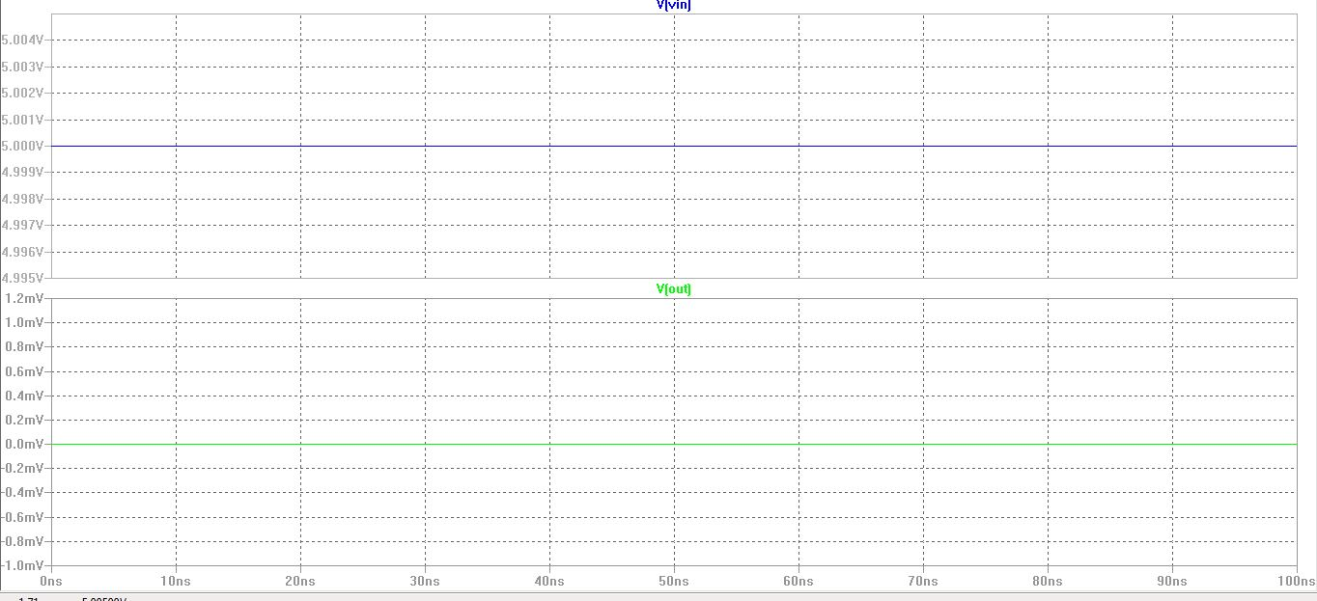

Output waveform of EX-OR Gate

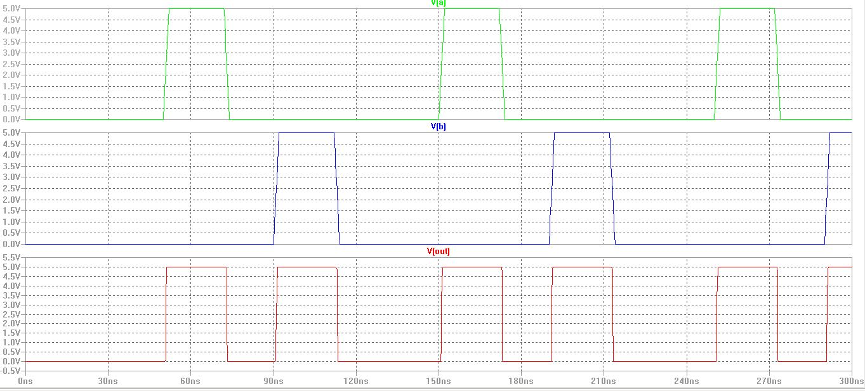

Output of D-Flip Flop Rising Edge

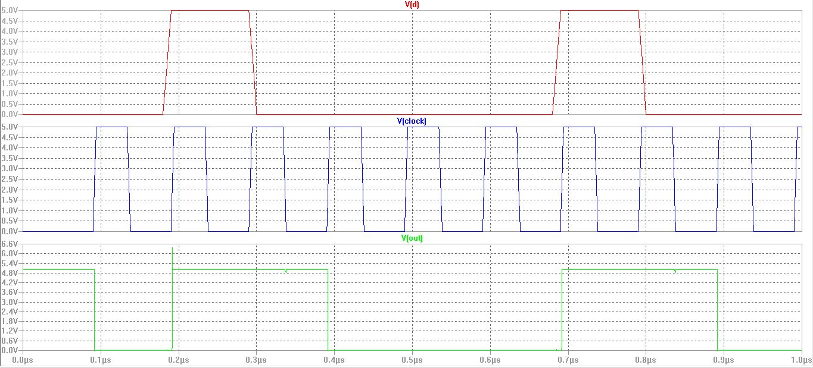

Output of D-latch with clock

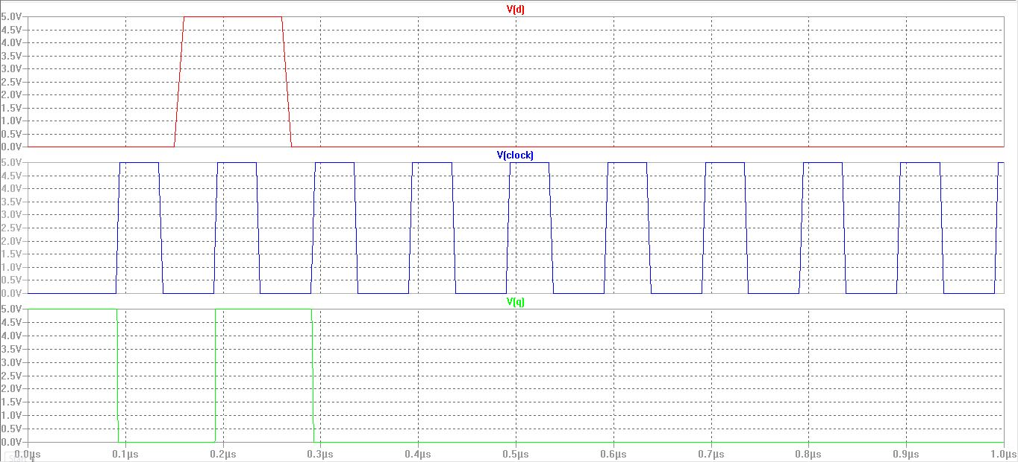

Output of D-latch with inverted clock

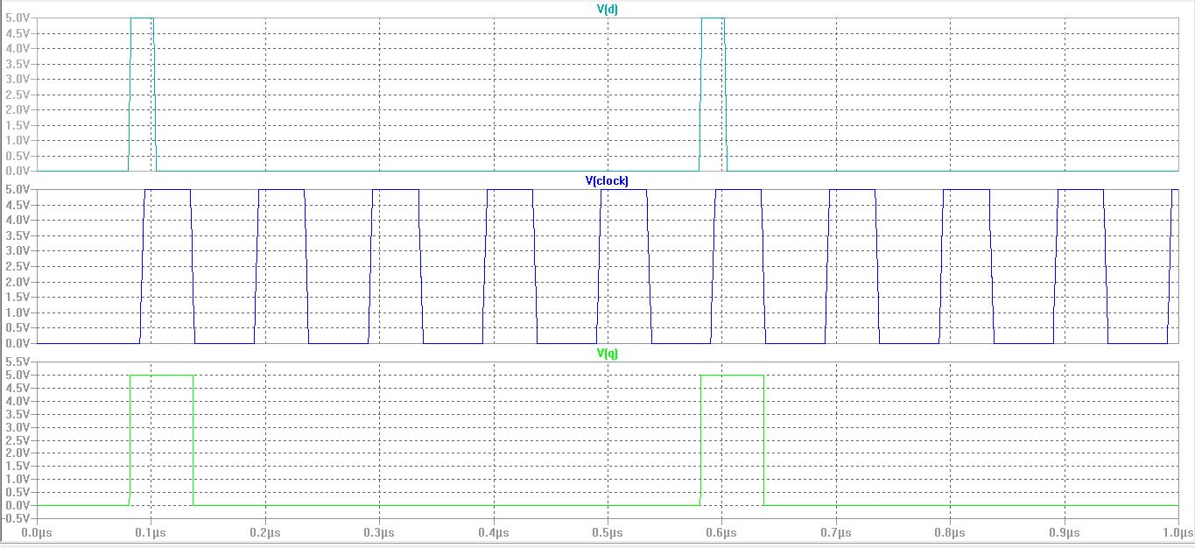

Output of series of D-Flip flops without feedback

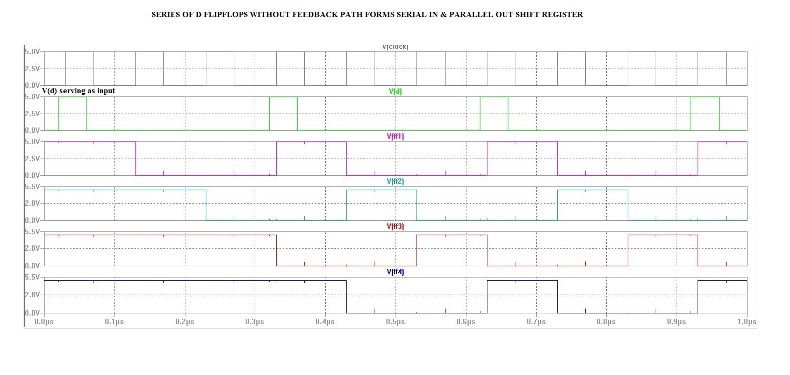

Output waveform of LFSR

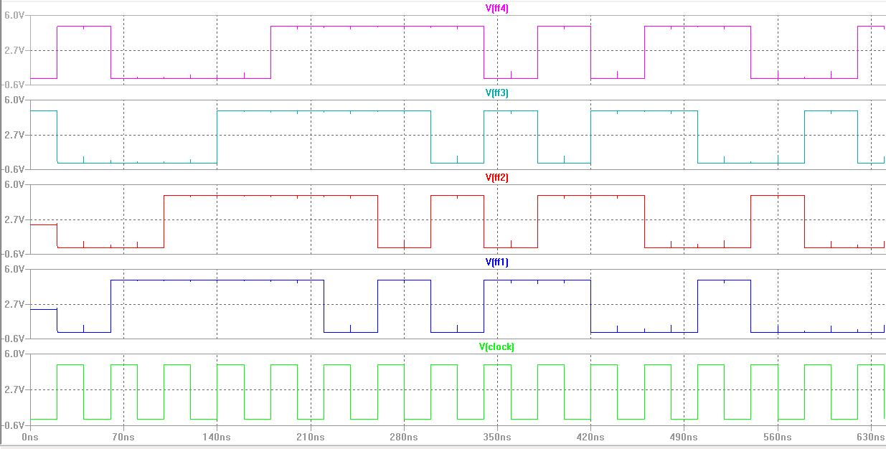

Labelled Output waveform of LFSR

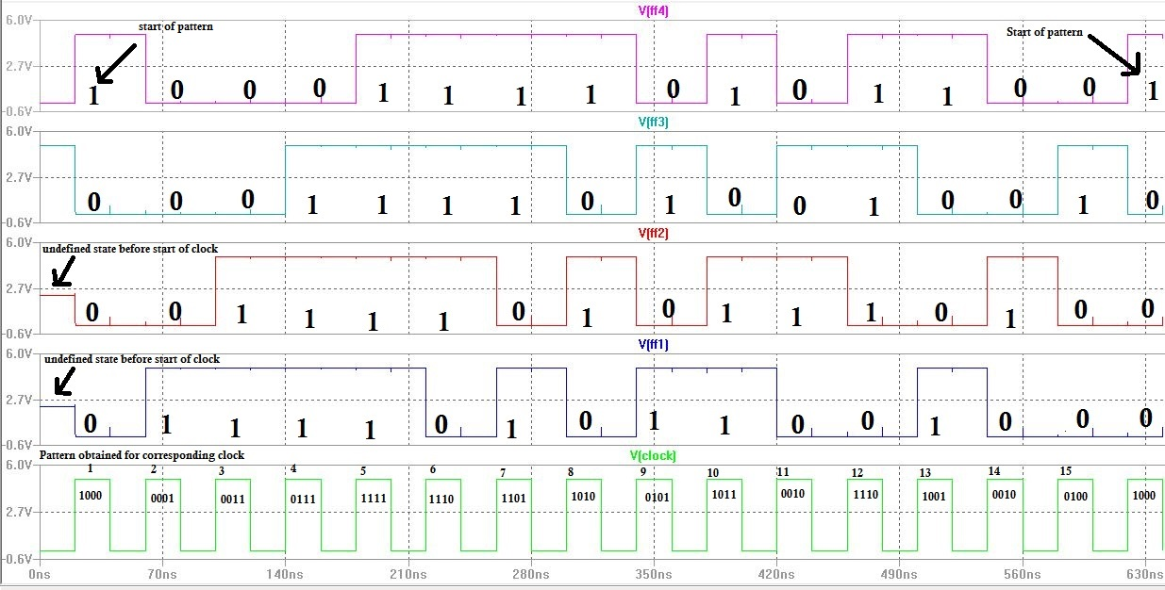

**CONCLUSION:**

The Magic VLSI layout for 4 bit Linear Feedback Shift Register is successfully drawn using Magic VLSI software and the circuit’s spice extract is simulated using LtSpice. The simulation results obtained successfully verifies the operation of 4 bit Linear Feedback Shift Register.

This project includes implementation of logics such as Ex-OR, Inverter and D flip flop using universal gates NAND and NOR. So these concepts can be extended to a wide area of digital logic circuits implementation such as multipliers, MAC (Multiplier and Accumulator) unit, and memory units viz., RAM, ROM, SRAM, DRAM and several other digital processors’ units.

REFERENCES:

1) N. A. Doshi, S. B. Dhobale, and S. R. Kakade," LFSR Counter Implementation in CMOS VLSI", World Academy of Science, Engineering and Technology 48 2008173

2) <http://waset.org/publications/4463/lfsr-counter-implementation-in-cmos-vlsi>

**ACKNOWLEDGEMENTS:**

1. ECC lab and facilities.
2. LtSpice online tutorials.
3. Prof. E. Joe Charlson.