Design Document

Version: 1.1.2
Date: 12/09/2014

This document is a design document designed for Ewash that describes the system, the various GUI pages and hardware design specifications.

1. Introduction

This is a design document that gives a detail overview of the working and components of system. It was realized to a descibe the various flowcharts, GUI pages, MySQL pages. The flow consists of the design, the schematic, tables, SQL queries and evrything that was implemented in the design of the system.

2. Architecture Design

The main architecture consists of an RFID tag, that is read by the RFID card reader. The values of which are pulled onto the PI and then pushed onto the server. The GUI, accesses the same server along with the databse that is interconnected with the GUI and server implemented using MySQL.
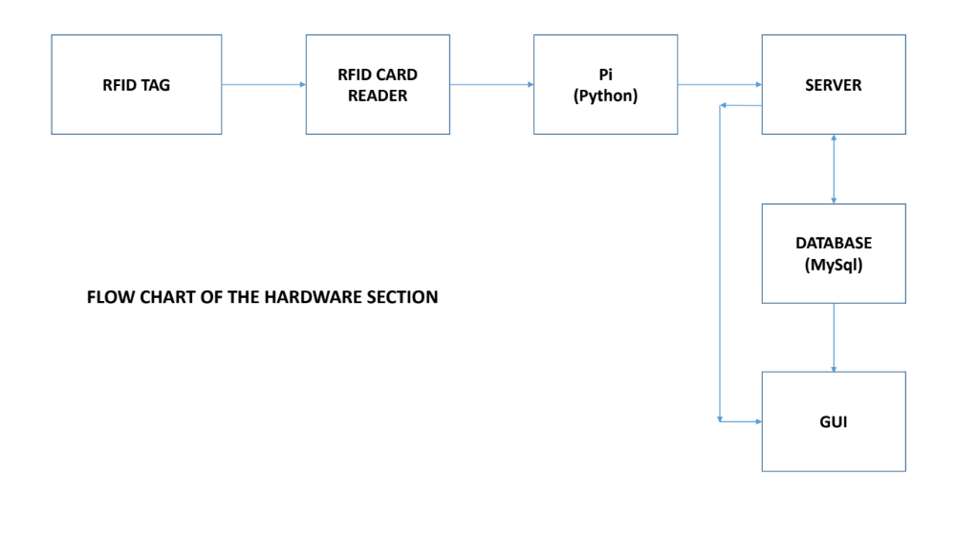

ARCHITECTURE

3. Database Design

The following are the database designed for the company.

- TABLE 1

Description: The database describes the client/customer information.

- TABLE 2

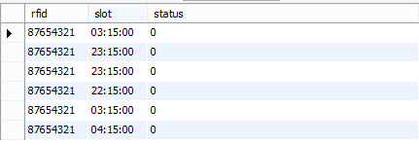
Description: The table describles the slot and the rfid tag number.

- TABLE 3

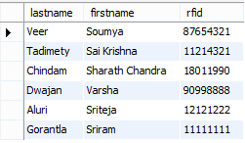

Description: The tag numbers of different users.

SQL queries:

This is one of the SQL queries that we have implemented.

Insert into user_table
values(4,2345,'sriram','gorantla','sgorantla@uh.edu','sreee','898656678789','sriram123','abc','available');
SELECT * FROM test1.user_table where Profile_Name='sgorantla@uh.edu' and Password='sriram123'
and Status='available';
DELIMITER //
CREATE PROCEDURE `insertusers`
(
IN id1 int(11),
IN rfid1 int(11),
IN firstname varchar(45),
IN lastname varchar(45),
IN profilename varchar(45),
IN email varchar(100),
IN phone varchar(15),
IN password1 varchar(45),
IN role1 varchar(45),
IN status1 varchar(45)
)

LANGUAGE SQL
DETERMINISTIC
SQL SECURITY DEFINER
COMMENT 'A procedure'
BEGIN
Declare usercount int;
SET usercount=(select count(Profile_Name) from user_table where Profile_Name=profilename and
Status=status1);
IF(usercount=0) then
Insert into user_table values
(id1,rfid1,firstname,lastname,profilename,email,phone,password1,role1,status1);
END IF;
END //
DELIMITER ;
DELIMITER //

4. Graphical User Interface
The various GUI pages that have been used are listed along with a description of it.
The flowchart gives a simple idea of how the GUI pages work.

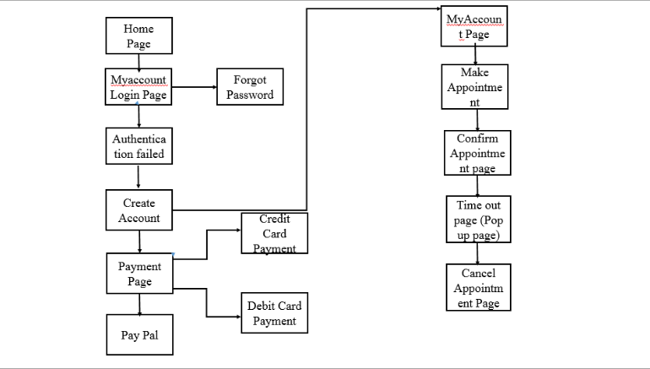

The developed GUI pages and the desriptions are as follows

- HOME PAGE

Description: The home page of the company that shows various options that are available to the user. A client can navigate through various pages from the home page.

- REGISTRATION PAGE
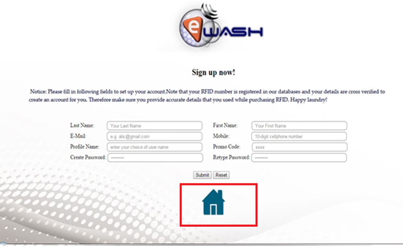

Description: For new users/clients who want to access the avail the E-wash facility must first register themselves

- LOGIN PAGE
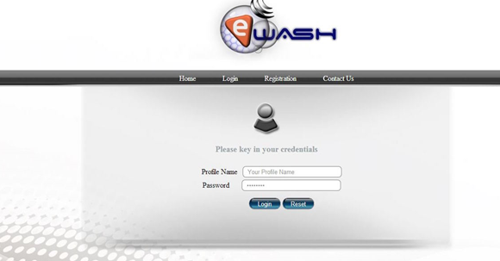

Description:

The login page allows the customer to login by entering the Profile Name and Password. Here the user enters the assigned name along with the password and press Login button. It will redirect them to My Accounts Page.

5. MY ACCOUNT PAGE

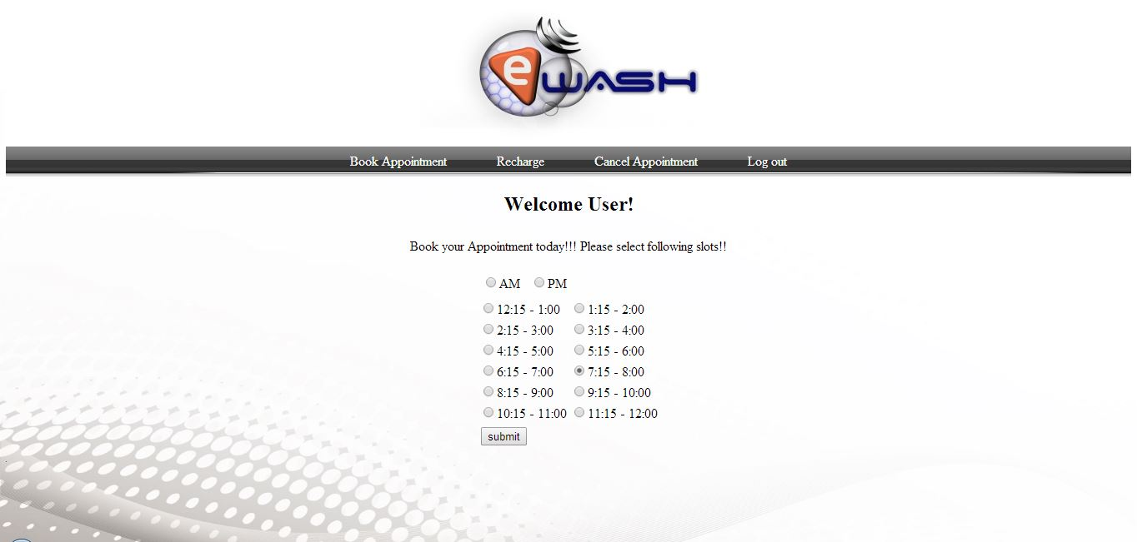

Description:
My account page used to book slot, recharge the card, cancel appointments and to logout.

6. Raspberry Pi

When a user access the washing area, and taps his RFID. The following happens:The raspberryPi accesses the database. The database consists of a booking table whose fields are RFID, SLOT and STATUS.When a user selects the time slot. The RFID of the user gets stored along with the status as 1.Status 1 predominantly means that the status is pending.The apache tomcat, this a server is basically automated to perform the following function.The are two integral components the servlet context listener and the scheduled context executer. They get triggered as soon as the web pages are accessed. When the user taps the card, the request is serviced. The database table gets updated and the status is now set to 0.When the status is 0 the database accesses the accounts page, the calculated amount is deducted.The scheduled context executer subsequently deletes that entry from the database.
The servlet context listener and the schedule context executer shuts down once the web pages is closed.

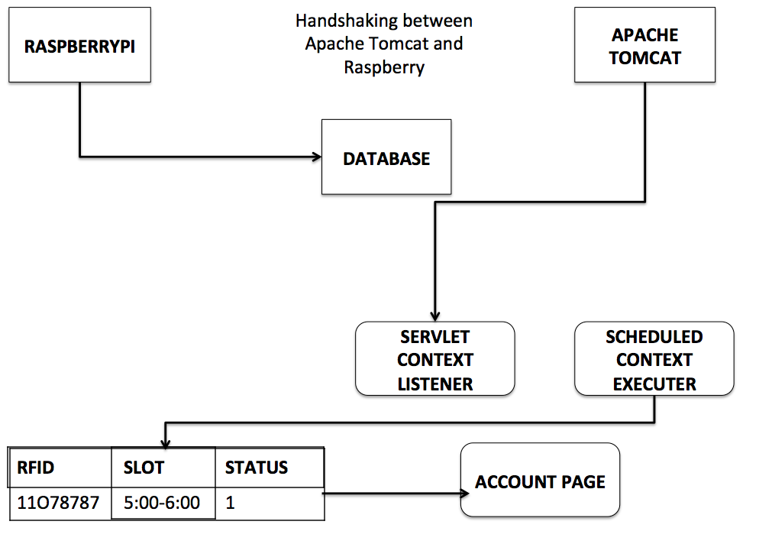

7. References

PHP : http://www.w3schools.com/PHP/
JavaScript: http://www.w3schools.com/js/default.asp
Testing details: http://docs.pylonsproject.org/docs/pyramid/en/latest/narr/testing.html
Junit links:.
http://www.tutorialspoint.com/junit/
https://code.google.com/p/t2framework/wiki/JUnitQuickTutorial
https://courses.cs.washington.edu/courses/cse143/11wi/eclipse-tutorial/junit.shtml
MySQL: http://dev.mysql.com/doc/refman/5.0/en/tutorial.html
http://www.mysqltutorial.org/
http://www.tutorialspoint.com/mysql/

