1. In the below elements which of them are values or an expression? eg:- values can be integer or string and expressions will be mathematical operators.

* :- Operator is used for mathematical operation’s , this will use for multplying

'hello':- it is a string

-87.8 :- value is a float with – symbol

- :- mathematical operation’s , this will use for substracting

/ :- mathematical operation’s , this will use for Division

* mathematical operation’s , this will use for Addition

6 :- value is a integer

2. What is the difference between string and variable?

String:- string will be assign In between ‘ ’ or “ “ , when we type any character r number Integer, when the it is in between quotes , the character r integer will be in string

Example:- printing numeric number in string

A = ‘12’

B = ‘24’

C = A+B

Print(c)

Output :- 1224

Integer : - we will use for data which numerical value to do anykind of operations , in integer , character is not allowed only we can use float and integers

Example :- add using two number

A = 12

B = 24

C = A+B

Print(c)

Output :- 36

3. Describe three different data types.

Data type Used for Example

Integer whole numbers 2,3,4,5

Float Number with a decimal point 2.3,4.5,6.6

Character text data “xyz”

|  |  |  |
| --- | --- | --- |
| Boolean Logical Values True or False |  |  |

4. What is an expression made up of? What do all expressions do?

Answer :- An expression is a construct made up of variables, operators, and method invocations, which are constructed according to the syntax of the language, that evaluates to a single value.

5. This assignment statements, like spam = 10. What is the difference between an expression and a statement?

Answer :- Expression is made up of different numbers, varibles, and opertors and its use PEDMAS Rule.(Parenthesis Exponents Division Multiplication Addition Subtraction)

6. After running the following code, what does the variable bacon contain?

bacon = 22

bacon + 1

Ans = 23

7. What should the values of the following two terms be?

'spam' + 'spamspam'

'spam' * 3

Answer : - print(‘spam’*3)

Output:- spamspamspam

8. Why is eggs a valid variable name while 100 is invalid?

Answer :- egg is a valid name because, it start from character

100 is invalid beacouse it starts from integer

Example :-

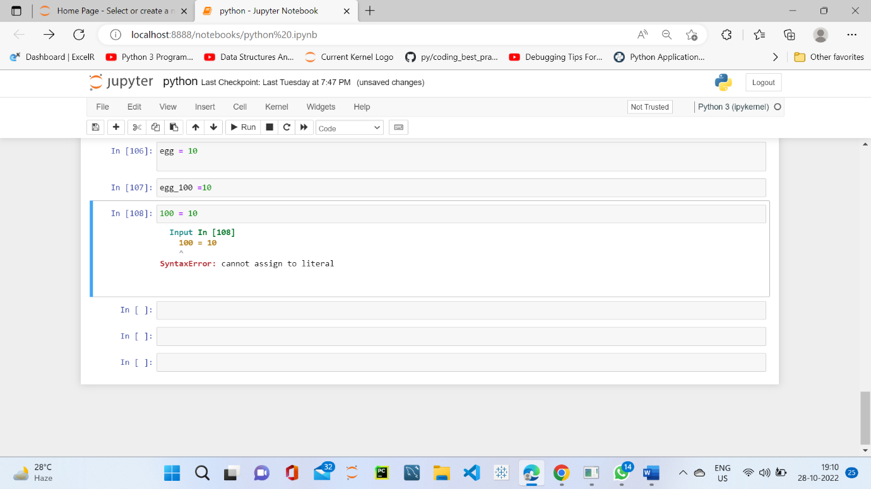

9. What three functions can be used to get the integer, floating-point number, or string version of a value?

Answer :- int() integer

float() floating-point

str() string value

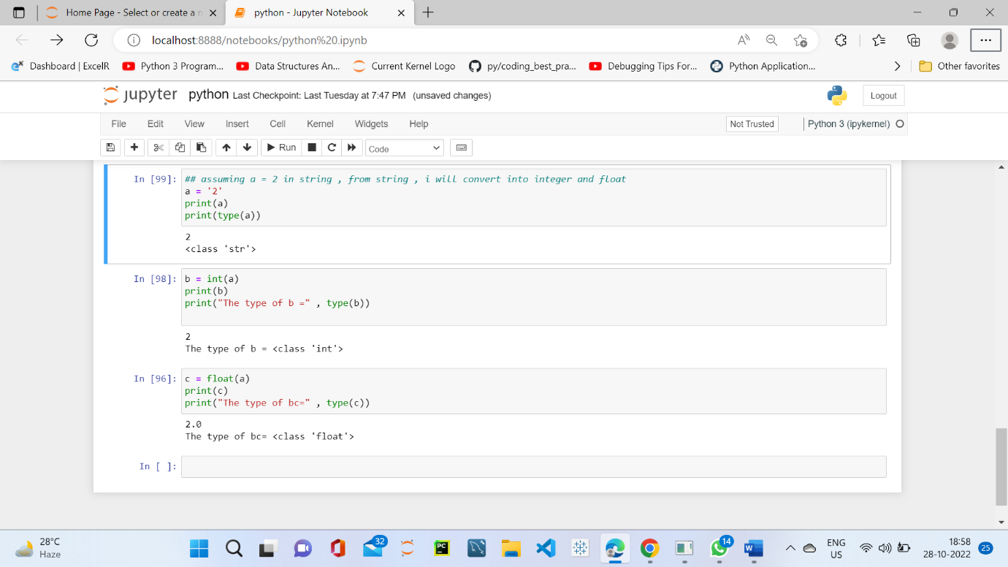

10. Why does this expression cause an error? How can you fix it?

'I have eaten ' + 99 + ' burritos.'

