Task 1
Create one Jenkins job using the below code and create three stages:
- stage1: Git clone to download the source code.
- stage2: Sonarqube Integration to check the quality of code.
- stage3: Slack Integration to send the alerts to slack.
URL: https://github.com/betawins/VProfile-1.git
Stage 1: To clone the source code:

Create Jenkins job - freestyle, add repository URL in source code management,
Also pass credentials if repository is private, if public not necessary. and branch specifier
(/main or /master).

Save.
Build job manually
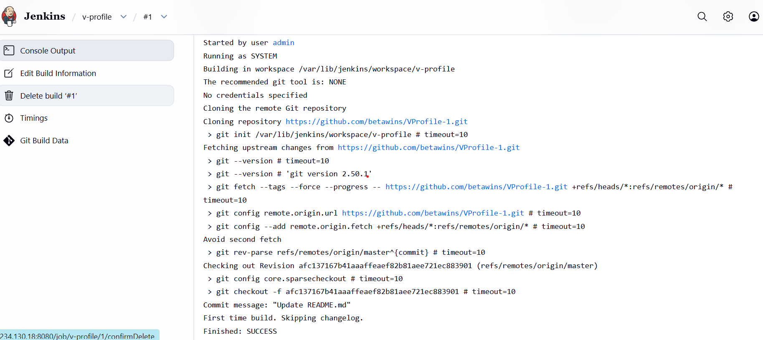

Task 2
Create one Jenkins job using the below code and create three stages:
- stage1: Git clone to download the source code.
- stage2: Sonarqube Integration to check the quality of code.
- stage3: Slack Integration to send the alerts to slack.
URL: https://github.com/betawins/hiring-app.git

