Assignment- 2

1. Connect to the Store Sales Data and do the following

Remove all the blank rows.

Update the column header if they are not updated

Create a text table and show the sales in terms of

1. Customers
2. Product Category
3. Regions

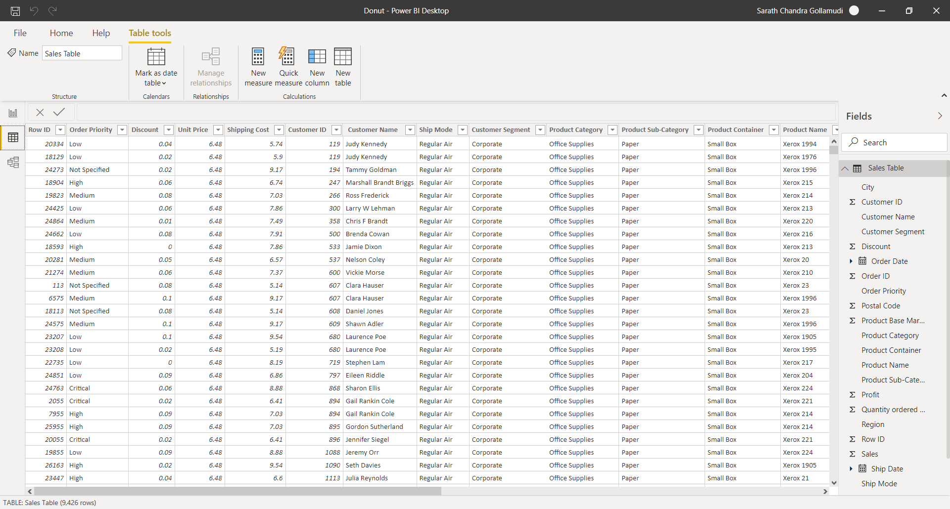

2. Create a line and Clustered Column Chart showing the Sales and Discount as per the State or Province

* Format the bars and line with different colors
* Which state has the highest sales in terms Technology

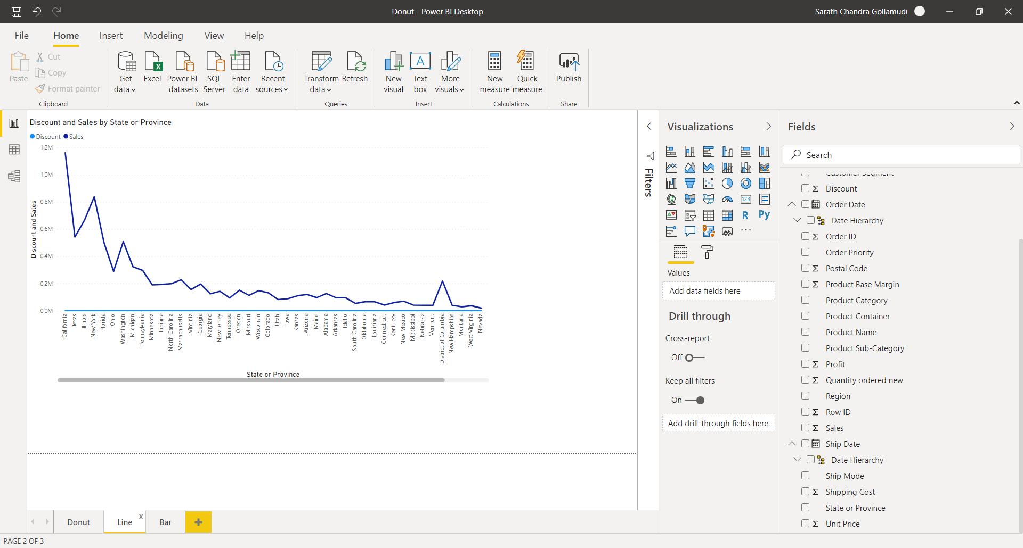

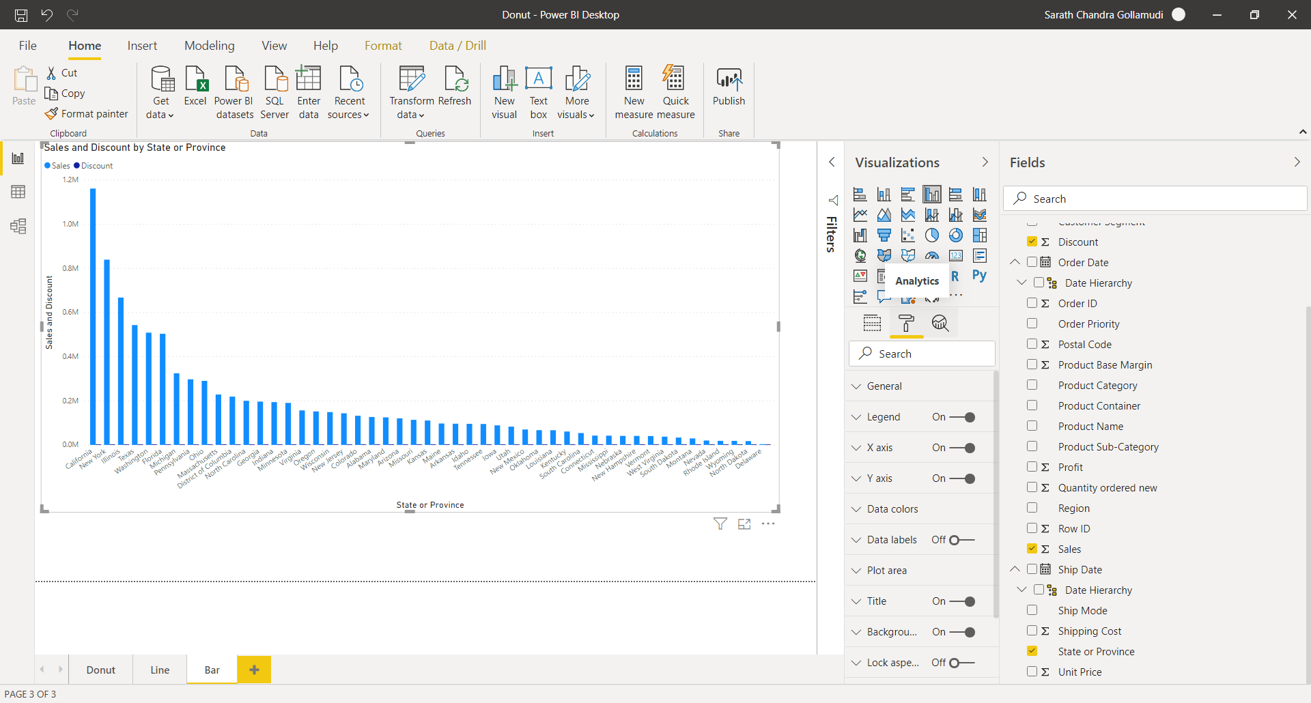

3. Create a Donut Chart showing sales in terms of Product category

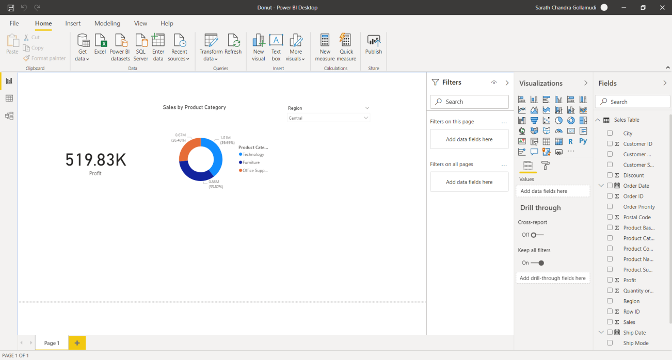

4. Create a *Slicer* and show the regions in dropdown. See how all the visuals mentioned above behaving when a particular region is selected.

