Assignment – 1

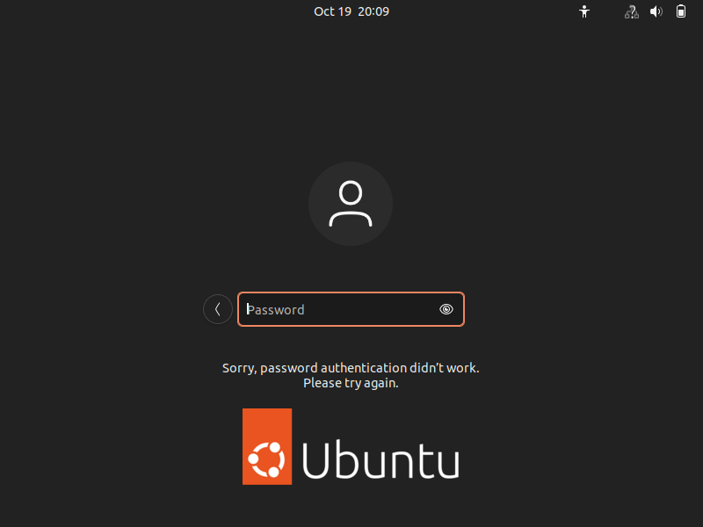

After trying to login with non-existent username it will terminate to password option after entering the password again it will terminate to the page where we cant access while it is showing like sorry your password authentication didn’t work please try again.