1. Introduction

Our HCL HQ offices are facing a challenge with available parking spaces. HCL Currently has 4 parking areas:

* 2 outside parking areas who are available for everybody
* 2 inside parking areas, spots here are assigned to people who (see appendix):
* Are with the company more than 15 years
* Are ranked vice president or higher in the company hierarchy.

There are currently not enough spaces outside, resulting in ‘creative’ parking by some people:

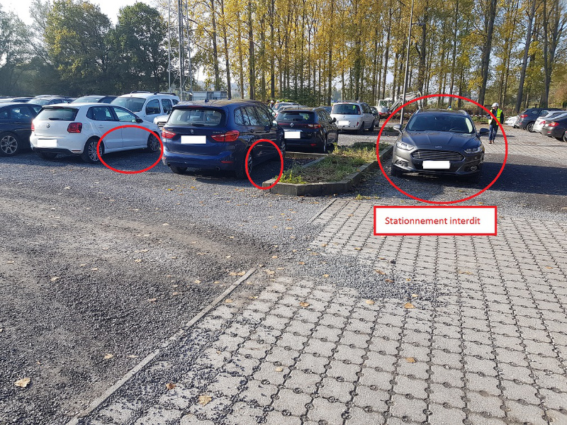s

Figure 1: Parking Problem (1/2)

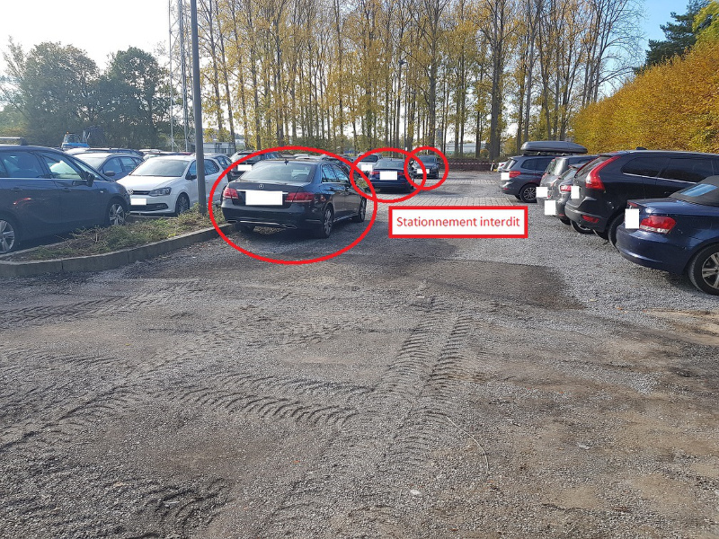

Figure 2: Parking Problem (2/2)

Because of the creativity put forward in finding a parking spot – we are facing a potential hazard situation:

* Fire trucks will have a hard time reaching certain parts of the building if necessary.
* People are facing difficulties maneuvering around the parking causing involuntary damage to certain vehicles.
* People get blocked by other cars
* Etc.

The parking spots inside are not all in use. We see today that on average 30% of all parking spots in the inside garages are not used. This because people are working from home, are on holiday, are on business travel, …

We want to solve this problem by creating a mobile application. Main idea is that parking spots can be marked available by a spot owner and that a lottery runs every day assigning free spots to people who have signed up for one.

# 2. Application overview

2.1. General tool description

Description

The parking app should maximize parking usage at HCL HQ. The goal of the application is minimizing the number of empty spots in the garage whereby more spots are available to people without reserved spots. The application manages the availability of parking spots with the aid of a raffle, where people without a parking spot can subscribe to.

High level process:

2.2. Roles & Responsibilities

In total the Parking Application has 3 roles:

1. **Spot owner:** A spot owner can indicate whether his spot will be available or not. The spot owners can do this in the web application and the mobile application
2. **HQ- Based employees**: Users, who are based in HQ will be able to use the mobile application. They can state on which days they will be in HQ and on which days they will not. The application (and in the extension thereof the raffle) should keep this into account
3. **Admin**: Access to all services of the application

2.3. Application overview

*Back-end application (web)*

* Spot owners should be able to free up their parking spots
* The parking spots that were freed up are being put into the raffle
* All the logic of the raffle should be in the back-end

*Front-end application (mobile)*

* Spot owner should be able to free up their parking spot
* The user should be able to see the spot they won for today
* The user should be able to see the spot they won for tomorrow
* The user should be able to accept/decline a spot they won
* The user should be able to indicate the days he wishes to receive a parking spot
* The application should send push notifications to the user
* The application should not play an active role in the life of the user, it would be unwise to enable the user to actively look at their phone while driving.

*Architecture*

* Composed of 1 front-end (Xamarin app or Progressive Webapp)
* 1 Restful API
* The application should be hosted in the Cloud and be publicly accessible

# 3. Assumptions

1. For this hackathon Authentication and Reporting on usage statistics is out of scope
2. Either a mobile app using Xamarin or a progressive webapp has to be build
3. All the code should be kept in source control (git)
4. Commit code for every feature written
5. Client Roles:

|  |  |
| --- | --- |
| Name | Role |
| Filip Wilms | Product Owner |
| Thomas Browet | Architect |
| Wesley Cabus | Code Reviewer |

# 4. Appendix: Wireframes

A screenshot of a cell phone

Description generated with high confidence

Figure 3: East Wing



Figure 4: West Wing