**Project-LAB4**

**The Digital clock**

**Name: Sharath Venkatesh**

**Questions**

**Based on the above project design requirements, how will you design this digital clock system?** **Please draw below a block diagram for the subcomponents needed for this system; and explain briefly the functionality of each block/subsystem.**

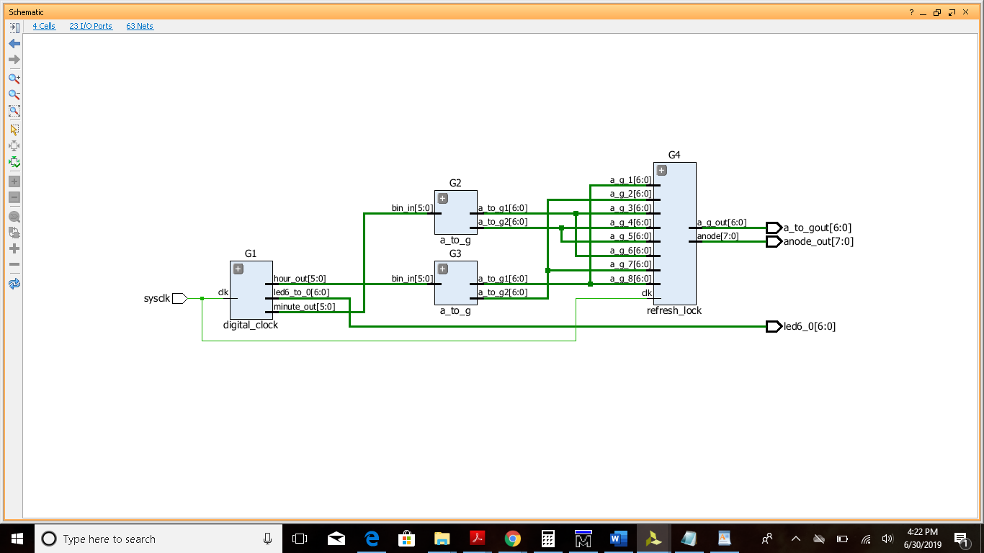

**Additionally, what will be the state diagram describing the transition of states among the above-mentioned three states and their corresponding input/outputs?**

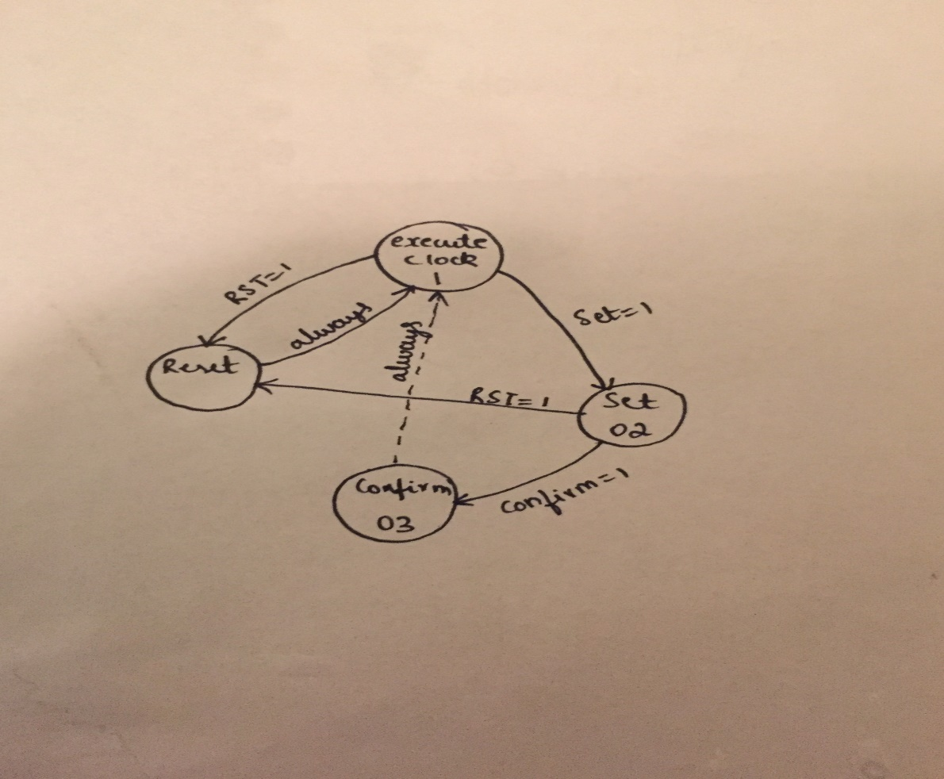

**Per your design, what is your VHDL entity code for this digital clock system? Please insert below the source code for the VHDL entity file(s) and describe the functionality of each VHDL entity file included in your project.**

library IEEE;

use IEEE.STD_LOGIC_1164.ALL;

use IEEE.STD_LOGIC_UNSIGNED.ALL;

entity full_system is

port( sysclk :in std_logic;

a_to_gout : out std_logic_vector(6 downto 0);

anode_out : out std_logic_vector(7 downto 0);

led6_0: out std_logic_vector(6 downto 0));

end full_system;

architecture structural of full_system is

-----------mux---------------------

component refresh_lock is

Port (a_g_1,a_g_2,a_g_3,a_g_4,a_g_5,a_g_6,a_g_7,a_g_8:in std_logic_vector(6 downto 0);

clk:in std_logic;

a_g_out:out std_logic_vector(6 downto 0);

anode:out std_logic_vector(7 downto 0));

end component refresh_lock;

----------digital clock------------

component digital_clock is

Port (clk : in std_logic;

minute_out : out std_logic_vector(5 downto 0):="000000";

hour_out: out std_logic_vector(5 downto 0):="000000";

led6_to_0 : out std_logic_vector(6 downto 0):="0000000");

end component digital_clock;

----------a to g-----------------

component a_to_g is

Port (bin_in : in std_logic_vector(5 downto 0):="000000";

a_to_g1,a_to_g2: out std_logic_vector(6 downto 0));

end component a_to_g;

Signal S3,S4,S5,S6 : std_logic_vector(6 downto 0);

Signal S1,S2 : std_logic_vector(5 downto 0);

begin

G1: digital_clock port map( clk=>sysclk,minute_out => S1,hour_out => S2,led6_to_0 =>led6_0);

G2: a_to_g port map(bin_in => S1,a_to_g1 => S5,a_to_g2 => S6);---minute

G3: a_to_g port map(bin_in => S2,a_to_g1 => S3,a_to_g2 => S4);---hr

G4: refresh_lock port map(a_g_1 => S3,a_g_2 => S4 ,a_g_3 => S5,a_g_4 => S6 ,a_g_5 =>S6 ,a_g_6 => S5 ,a_g_7=> S4,a_g_8 => S3,clk => sysclk,a_g_out => a_to_gout,anode => anode_out);

end structural;

---------------mux------------------------

library IEEE;

use IEEE.STD_LOGIC_1164.ALL;

use IEEE.std_logic_unsigned.all;

entity refresh_lock is

Port (a_g_1,a_g_2,a_g_3,a_g_4,a_g_5,a_g_6,a_g_7,a_g_8:in std_logic_vector(6 downto 0);

clk:in std_logic;

a_g_out:out std_logic_vector(6 downto 0);

anode:out std_logic_vector(7 downto 0));

end refresh_lock;

architecture Behavioral of refresh_lock is

signal count :std_logic_vector(2 downto 0):="000";

signal count1:std_logic_vector(2 downto 0):="000";

signal count2 :std_logic_vector(27 downto 0):=x"0000000";

signal int_clk: std_logic :='0';

begin

counter:process(int_clk) is

begin

if(rising_edge(int_clk)) then

if(count = "111")then

count<="000";

a_g_out<=a_g_8;

elsif(count ="000") then

count<=count+1;

a_g_out<=a_g_1;

elsif(count ="001") then

count<=count+1;

a_g_out<=a_g_2;

elsif(count ="010") then

count<=count+1;

a_g_out<=a_g_3;

elsif(count ="011") then

count<=count+1;

a_g_out<=a_g_4;

elsif(count ="100") then

count<=count+1;

a_g_out<=a_g_5;

elsif(count ="101") then

count<=count+1;

a_g_out<=a_g_6;

elsif(count ="110") then

count<=count+1;

a_g_out<=a_g_7;

end if;

end if;

end process counter;

anode_counter:process(int_clk) is

begin

if(rising_edge(int_clk)) then

if(count1 = "111")then

count1<="000";

anode<="01111111";

elsif(count1 ="000") then

count1<=count1+1;

anode<="11111110";

elsif(count ="001") then

count1<=count1+1;

anode<="11111101";

elsif(count1 ="010") then

count1<=count1+1;

anode<="11111011";

elsif(count1 ="011") then

count1<=count1+1;

anode<="11110111";

elsif(count1 ="100") then

count1<=count1+1;

anode<="11101111";

elsif(count1 ="101") then

count1<=count1+1;

anode<="11011111";

elsif(count1 ="110") then

count1<=count1+1;

anode<="10111111";

end if;

end if;

end process anode_counter;

slow_clock_process: process(clk) is

begin

if(rising_edge(clk)) then

if count2 < x"0000000" then

count2<=count2+1;

else

int_clk<= not int_clk;

count2<=(others => '0');

end if;

end if;

end process slow_clock_process;

end Behavioral;

---------------a_to_g----------------------

library IEEE;

use IEEE.STD_LOGIC_1164.ALL;

use IEEE.STD_LOGIC_UNSIGNED.ALL;

entity a_to_g is

Port (bin_in : in std_logic_vector(5 downto 0):="000000";

a_to_g1,a_to_g2: out std_logic_vector(6 downto 0));

end a_to_g;

architecture structural of a_to_g is

begin

process(bin_in) is

begin

case bin_in is

when "000000" =>

a_to_g1<="1000000";

a_to_g2<="1000000";--00

when "000001" =>

a_to_g1<="1000000";

a_to_g2<="1111001";--01

when "000010" =>

a_to_g1<="1000000";

a_to_g2<="0100100";--02

when "000011" =>

a_to_g1<="1000000";

a_to_g2<="0110000";--03

when "000100" =>

a_to_g1<="1000000";

a_to_g2<="0011011";--04

when "000101" =>

a_to_g1<="1000000";

a_to_g2<="0010010";--05

when "000110" =>

a_to_g1<="1000000";

a_to_g2<="0000010";--06

when "000111" =>

a_to_g1<="1000000";

a_to_g2<="1111000";--07

when "001000" =>

a_to_g1<="1000000";

a_to_g2<="0000000";--08

when "001001" =>

a_to_g1<="1000000";

a_to_g2<="0011000";--09

when "001010" =>

a_to_g1<="1111001";

a_to_g2<="1000000";--10

when "001011" =>

a_to_g1<="1111001";

a_to_g2<="1111001";--11

when "001100" =>

a_to_g1<="1111001";

a_to_g2<="0100100";--12

when "001101" =>

a_to_g1<="1111001";

a_to_g2<="0110000";--13

when "001110" =>

a_to_g1<="1111001";

a_to_g2<="0011011";--14

when "001111" =>

a_to_g1<="1111001";

a_to_g2<="0010010";--15

when "010000" =>

a_to_g1<="1111001";

a_to_g2<="1000000";--16

when "010001" =>

a_to_g1<="1111001";

a_to_g2<="1111000";--17

when "010010" =>

a_to_g1<="1111001";

a_to_g2<="0000000";--18

when "010011" =>

a_to_g1<="1111001";

a_to_g2<="0011000";--19

when "010100" =>

a_to_g1<="0100100";

a_to_g2<="1000000";--20

when "010101" =>

a_to_g1<="0100100";

a_to_g2<="1111001";--21

when "010110" =>

a_to_g1<="0100100";

a_to_g2<="0100100";--22

when "010111" =>

a_to_g1<="0100100";

a_to_g2<="0110000";--23

when "011000" =>

a_to_g1<="0100100";

a_to_g2<="0011011";--24

when "011001" =>

a_to_g1<="0100100";

a_to_g2<="0010010";--25

when "011010" =>

a_to_g1<="0100100";

a_to_g2<="0000010";--26

when "011011" =>

a_to_g1<="0100100";

a_to_g2<="1111000";--27

when "011100" =>

a_to_g1<="0100100";

a_to_g2<="0000000";--28

when "011101" =>

a_to_g1<="0100100";

a_to_g2<="0011000";--29

when "011110" =>

a_to_g1<="0110000";

a_to_g2<="1000000";--30

when "011111" =>

a_to_g1<="0110000";

a_to_g2<="1111001";--31

when "100000" =>

a_to_g1<="0110000";

a_to_g2<="0100100";--32

when "100001" =>

a_to_g1<="0110000";

a_to_g2<="0110000";--33

when "100010" =>

a_to_g1<="0110000";

a_to_g2<="0011011";--34

when "100011" =>

a_to_g1<="0110000";

a_to_g2<="0010010";--35

when "100100" =>

a_to_g1<="0110000";

a_to_g2<="0000010";--36

when "100101" =>

a_to_g1<="0110000";

a_to_g2<="1111000";--37

when "100110" =>

a_to_g1<="0110000";

a_to_g2<="0000000";--38

when "100111" =>

a_to_g1<="0110000";

a_to_g2<="0011000";--39

when "101000" =>

a_to_g1<="0011011";

a_to_g2<="1000000";--40

when "101001" =>

a_to_g1<="0011011";

a_to_g2<="1111001";--41

when "101010" =>

a_to_g1<="0011011";

a_to_g2<="0100100";--42

when "101011" =>

a_to_g1<="0011011";

a_to_g2<="0110000";--43

when "101100" =>

a_to_g1<="0011011";

a_to_g2<="0011011";--44

when "101101" =>

a_to_g1<="0011011";

a_to_g2<="0010010";--45

when "101110" =>

a_to_g1<="0011011";

a_to_g2<="0000010";--46

when "101111" =>

a_to_g1<="0011011";

a_to_g2<="1111000";--47

when "110000" =>

a_to_g1<="0011011";

a_to_g2<="0000000";--48

when "110001" =>

a_to_g1<="0011011";

a_to_g2<="0011000";--49

when "110010" =>

a_to_g1<="0010010";

a_to_g2<="1000000";--50

when "110011" =>

a_to_g1<="0010010";

a_to_g2<="1111001";--51

when "110100" =>

a_to_g1<="0010010";

a_to_g2<="0100100";--52

when "110101" =>

a_to_g1<="0010010";

a_to_g2<="0110000";--53

when "110110" =>

a_to_g1<="0010010";

a_to_g2<="0011011";--54

when "110111" =>

a_to_g1<="0010010";

a_to_g2<="0010010";--55

when "111000" =>

a_to_g1<="0010010";

a_to_g2<="0000010";--56

when "111001" =>

a_to_g1<="0010010";

a_to_g2<="1111000";--57

when "111010" =>

a_to_g1<="0010010";

a_to_g2<="0000000";--58

when "111011" =>

a_to_g1<="0010010";

a_to_g2<="0011000";--59

when others =>

a_to_g1<="1000000";

a_to_g2<="1000000";

end case;

end process;

end structural;

---------------clock----------------------

library IEEE;

use IEEE.STD_LOGIC_1164.ALL;

use IEEE.STD_LOGIC_UNSIGNED.ALL;

entity digital_clock is

Port (clk : in std_logic;

minute_out : out std_logic_vector(5 downto 0):="000000";

hour_out: out std_logic_vector(5 downto 0):="000000";

led6_to_0 : out std_logic_vector(6 downto 0):="0000000");

end digital_clock;

architecture structural of digital_clock is

signal m1: std_logic_vector(5 downto 0):="000000";

signal h1 : std_logic_vector(5 downto 0):="000000";

signal count1 :std_logic_vector(27 downto 0):=x"000012B";

signal count2 :std_logic_vector(27 downto 0):=x"0004650";

signal count3 :std_logic_vector(27 downto 0):=x"0000004";

signal m_a_1: std_logic_vector(5 downto 0):="000000";----alarm minute

signal h_a_1 : std_logic_vector(5 downto 0):="000000";-----alarm hour

signal seconds :std_logic_vector(6 downto 0):="0000000";

signal int_clk1: std_logic :='0';

signal int_clk2: std_logic :='0';

signal int_clk3: std_logic :='0';

signal flag: std_logic:='1';

begin

-----state transition------------

--------seconds-----------------

sec_process:process(int_clk3) is

begin

if(flag ='1') then

if (rising_edge(int_clk3)) then

if( seconds < "0111011")then

seconds<=seconds+1;

else

seconds<="0000000";

end if;

led6_to_0<= seconds;

end if;

end if;

end process sec_process;

--------minute------------------

M1_process:process(int_clk1,m1) is

begin

if(flag ='1') then

if (rising_edge(int_clk1)) then

if(m1 < "111011") then

m1<=m1+1;

else

m1<="000000";

end if;

minute_out<=m1;

end if;

else

minute_out<=m1;

end if;

end process M1_process;

--------hour------------------

M2_process:process(int_clk2) is

begin

if(flag='1')then

if( rising_edge(int_clk2))then

if(h1 < "010111") then

h1<=h1+1;

else

h1<="000000";

end if;

hour_out<=h1;

end if;

else

hour_out<=h1;

end if;

end process M2_process;

----------- clocks-----------------

------------seconds clock---------

slow_clock_1sec: process(clk) is

begin

if(rising_edge(clk)) then

if count3 < x"0000004" then

count3<=count3+1;

else

int_clk3<= not int_clk3;

count3<=(others => '0');

end if;

end if;

end process slow_clock_1sec;

------------60sec clock-----------

slow_clock_60sec: process(clk) is

begin

if(rising_edge(clk)) then

if count1 < x"000012B" then

count1<=count1+1;

else

int_clk1<= not int_clk1;

count1<=(others => '0');

end if;

end if;

end process slow_clock_60sec;

------------1hr clock-----------

slow_clock_1hr: process(clk) is

begin

if(rising_edge(clk)) then

if count2 < x"0004650" then

count2<=count2+1;

else

int_clk2<= not int_clk2;

count2<=(others => '0');

end if;

end if;

end process slow_clock_1hr;

end structural;

**Based on your design, what will be a good test bench for simulating the operation of your system? Please describe it and insert below the source code from your VHDL testbench file.**

library IEEE;

use IEEE.Std_logic_1164.all;

use IEEE.Numeric_Std.all;

entity full_system_tb is

end;

architecture bench of full_system_tb is

component full_system

port( sysclk :in std_logic;

a_to_gout : out std_logic_vector(6 downto 0);

anode_out : out std_logic_vector(7 downto 0);

led6_0: out std_logic_vector(6 downto 0));

end component;

signal sysclk: std_logic;

signal a_to_gout: std_logic_vector(6 downto 0);

signal anode_out: std_logic_vector(7 downto 0);

signal led6_0: std_logic_vector(6 downto 0);

constant clock_period: time := 100 ms;

signal stop_the_clock: boolean;

begin

uut: full_system port map ( sysclk => sysclk,

a_to_gout => a_to_gout,

anode_out => anode_out,

led6_0 => led6_0 );

stimulus: process

begin

-- Put initialisation code here

-- Put test bench stimulus code here

stop_the_clock <= false;

wait;

end process;

clocking: process

begin

while not stop_the_clock loop

sysclk <= '0', '1' after clock_period / 2;

wait for clock_period;

end loop;

wait;

end process;

end;

**CALCULATIONS:**

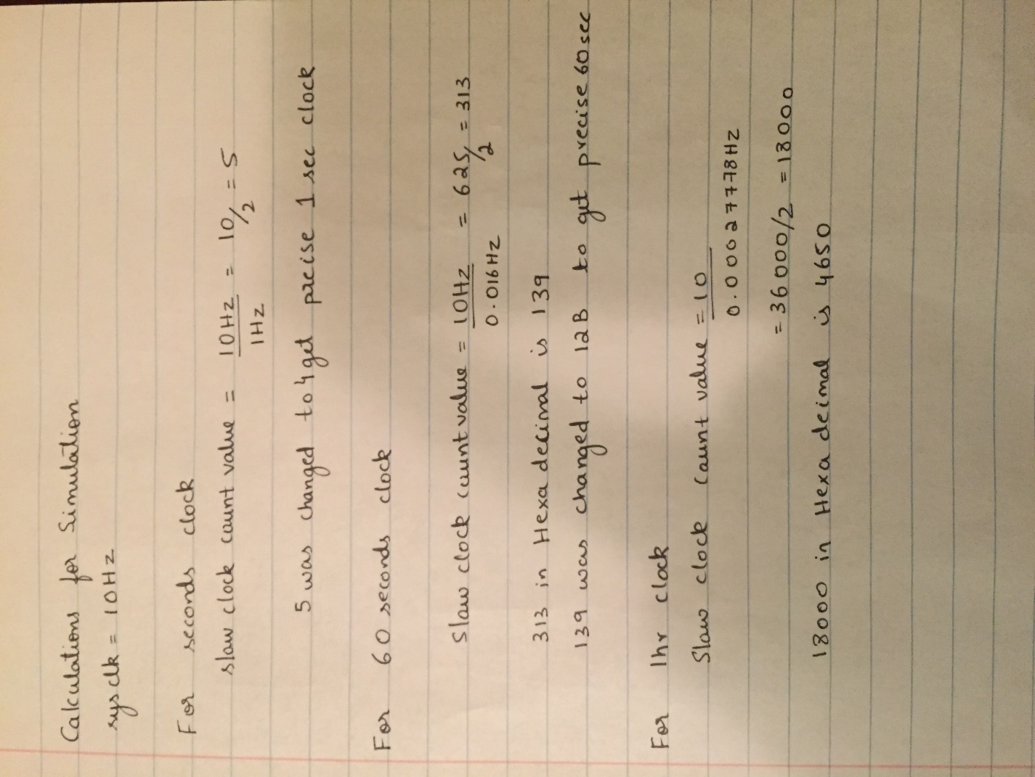

**What is the result waveform from your simulation? Based on this simulation, is your system implementation functioning as designed?**

**Output for 1:35 = 5700 sec.**

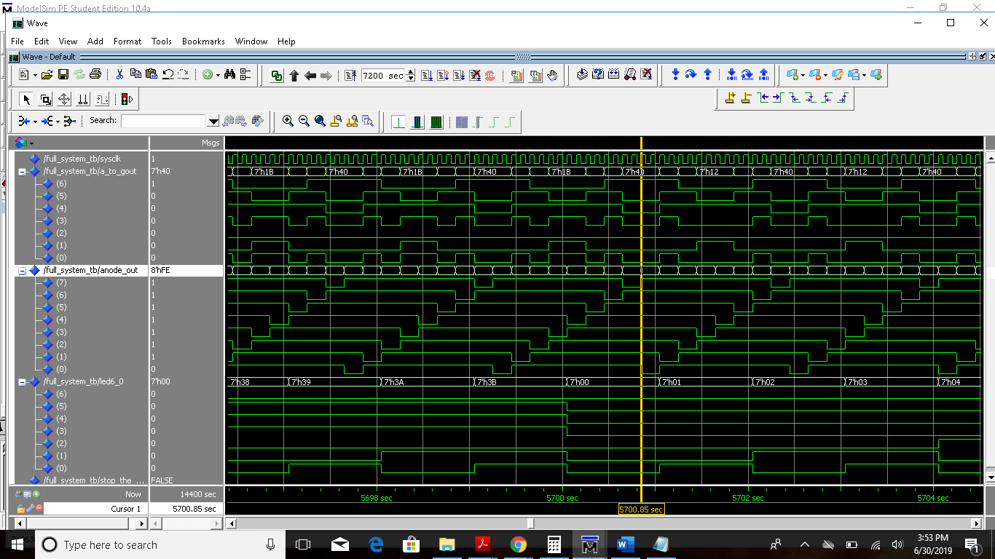

**Output at 12:15 = 44100 sec**

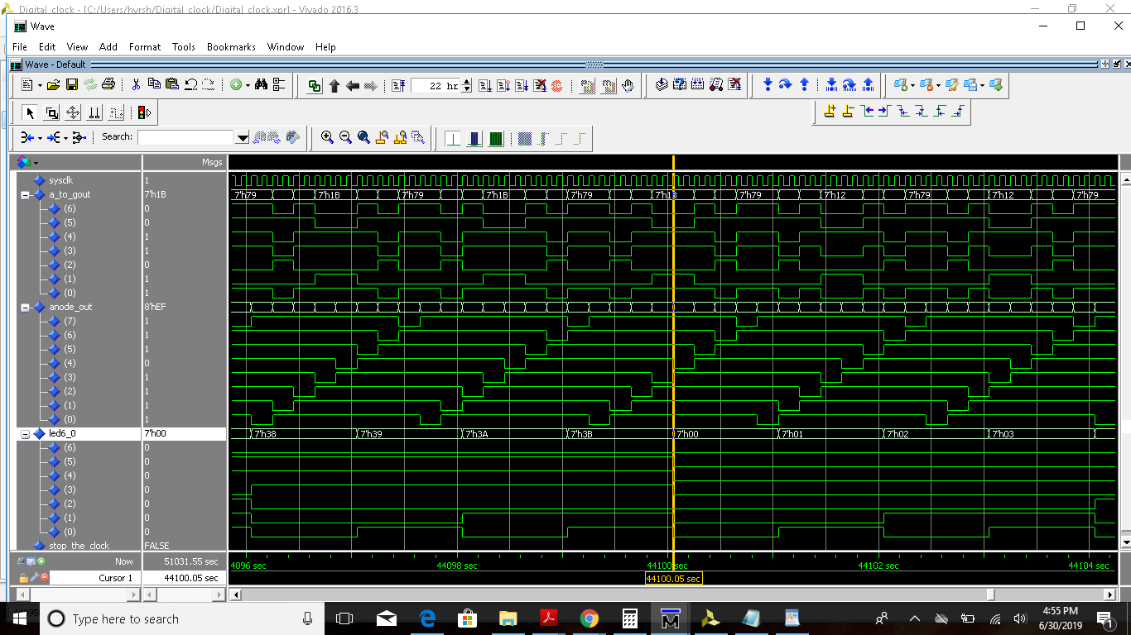

After the QuestaSim simulation, please implement your digital clock on the Nexys 4 DDR board, and use the setup as given earlier. After implementing your digital design on the Nexys 4 board, please demonstrate it to the instructor; and create a short video demonstrating your test results. Please upload the short video as an attachment to this report in Titanium.