EGEE 448: Digital Systems Design with FPGA Summer 2019
Homework/Lab Project 3: Design a Keyless Entry System using FPGA Board
Instructor: Dr. Jidong Huang
Student Team Member 1: Sharath Venkatesh
Contribution of Student Team Member 1:
System Design
VHDL programming
Testing
Homework/Lab Objectives: The main purpose of this lab project is to design a simplified keyless entry system using a FPGA Board.
Evaluation: Grade for lab will be based on 1) In-class activities, and 2) Homework/Lab report.
Homework/Lab Report: Homework/Lab report based on this instruction document will be collected on Wed., June 19th at the beginning of the class. The completed lab report shall be uploaded to Titanium using homework assignment tool. Name your lab report as HW3_EE448_YourName.doc, e.g., HW3_EE448_DoeJohn.doc.
Please ask the instructor to verify the FPGA board implementation results for this project after you finish it. Please notice that you are allowed to form a group of no more than two students to work on this project. If you plan to work in a group, please identify clearly in your HW/Lab report the names of the group members, and the corresponding contributions from each group member. For each group, only one HW/Lab report submission is needed.
PART A) Digital Design Problem

Question 1) Design a Keyless Entry System using VHDL
Design Project:
Based on the above project design requirements, how will you design this keyless entry system? Please draw below a block diagram for the subcomponents needed for this system; and explain briefly the functionality of each block/subsystem.
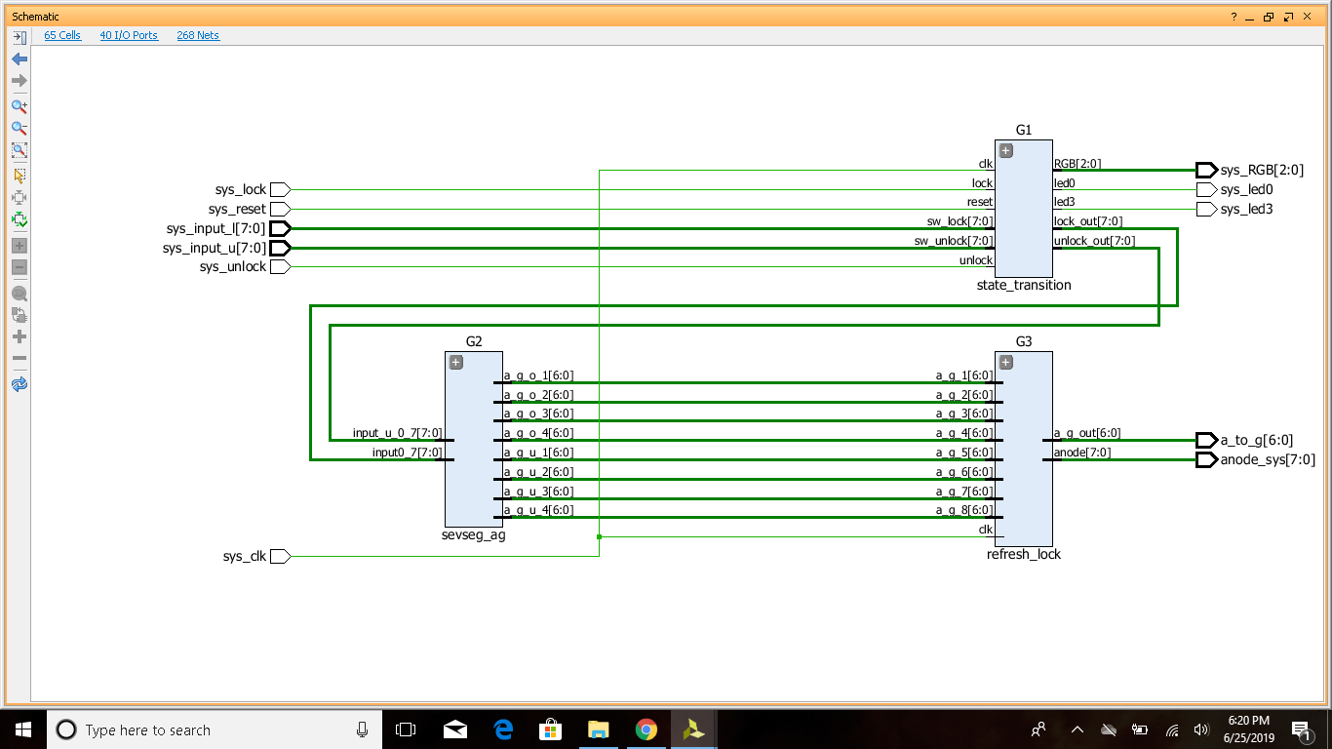

State transition: This block is used to change the states of the system from state0(reset) to state5(invalid unllck). This block performs operations on system inputs and activates LED),LED3,RGB based on the current state of the system. It also ouputs what shoould be displayed on to seven segment(lock_out,unlock_out).Lock,Unlock,Reset inputs are taken at 1Hz frequency to eliminate debounce.

sevseg_ag: This block takes the outputs(lock_out,unlock_out) from the state transition block and converts every two bit into its corresponding a_to_g value. It outputs a_to_g values for each of the 8, seven segment led’s.

refresh_lock: This block takes all the eight a_to_g values and multiplexes one value at a time to the “a_to_g” of the system. The anode is activated 1-bit at a time simultaneoulsy with the “a_to_g” values. Refreshing is done at 100Khz.

Additionally, what will be the state diagram describing the transition of states among the above-mentioned six states and their corresponding input/outputs?

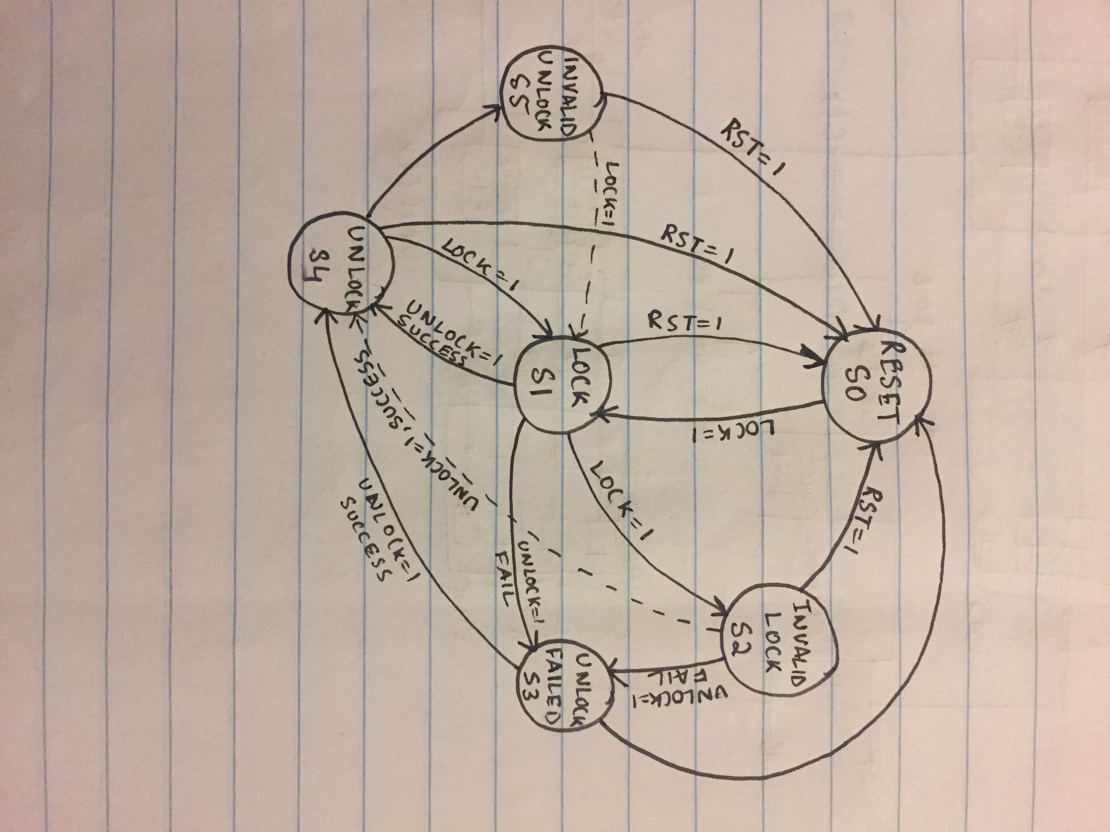

Per your design, what is your VHDL entity code for this digital keyless system? Please insert below the source code for the VHDL entity file(s) and describe the functionality of each VHDL entity file included in your project.

**Slow clock=system clock for simulation.

library IEEE;
use IEEE.STD_LOGIC_1164.ALL;
use IEEE.std_logic_unsigned.all;

entity keyless_door is
Port (sys_input_l:in std_logic_vector(7 downto 0);
sys_input_u:in std_logic_vector(7 downto 0);
sys_clk,sys_reset,sys_lock,sys_unlock:in std_logic;
sys_led0,sys_led3:out std_logic;
a_to_g:out std_logic_vector(6 downto 0);
anode_sys:out std_logic_vector(7 downto 0);
sys_RGB:out std_logic_vector(2 downto 0));
end keyless_door;

architecture Structural of keyless_door is
---------state transition-----------
component state_transition is
Port (sw_lock,sw_unlock:in std_logic_vector(7 downto 0);
reset,lock,unlock,clk: in std_logic;
led0,led3:out std_logic;
RGB:out std_logic_vector(2 downto 0);
unlock_out:out std_logic_vector(7 downto 0);
lock_out:out std_logic_vector(7 downto 0));
end component state_transition;
---------sevseg_ag------------------
component sevseg_ag is
Port (input0_7:in std_logic_vector(7 downto 0);
input_u_0_7:in std_logic_vector(7 downto 0);
a_g_o_1,a_g_o_2,a_g_o_3,a_g_o_4:out std_logic_vector(6 downto 0);--lock
a_g_u_1,a_g_u_2,a_g_u_3,a_g_u_4:out std_logic_vector(6 downto 0));--unlock
end component sevseg_ag;
------------------demux_refresh-----------------
component refresh_lock is
Port (a_g_1,a_g_2,a_g_3,a_g_4,a_g_5,a_g_6,a_g_7,a_g_8:in std_logic_vector(6 downto 0);
clk:in std_logic;
a_g_out:out std_logic_vector(6 downto 0);
anode:out std_logic_vector(7 downto 0));
end component refresh_lock;
Signal S9,S10 : std_logic_vector(7 downto 0);
Signal S1,S2,S3,S4,S5,S6,S7,S8: std_logic_vector(6 downto 0);
begin
G1: state_transition port map(sw_lock => sys_input_l,sw_unlock => sys_input_u,reset => sys_reset ,lock => sys_lock ,unlock => sys_unlock,clk => sys_clk,led0 => sys_led0,led3 => sys_led3,RGB => sys_RGB,unlock_out => S9,lock_out => S10 );
G2: sevseg_ag port map(input0_7 => S10,input_u_0_7 => S9,a_g_o_1 => S1,a_g_o_2=> S2,a_g_o_3=> S3,a_g_o_4=> S4,a_g_u_1 => S5,a_g_u_2=> S6,a_g_u_3=> S7,a_g_u_4=> S8);
G3: refresh_lock port map(a_g_1 => S1 ,a_g_2=> S2,a_g_3=> S3,a_g_4=> S4,a_g_5=> S5,a_g_6=> S6,a_g_7=> S7,a_g_8=> S8,clk => sys_clk,a_g_out =>a_to_g,anode =>anode_sys);
end Structural;

--------------------sevseg_ag-------------------
library IEEE;
use IEEE.STD_LOGIC_1164.ALL;
use IEEE.std_logic_unsigned.all;

entity sevseg_ag is
Port (input0_7:in std_logic_vector(7 downto 0);
input_u_0_7:in std_logic_vector(7 downto 0);
a_g_o_1,a_g_o_2,a_g_o_3,a_g_o_4:out std_logic_vector(6 downto 0);--lock
a_g_u_1,a_g_u_2,a_g_u_3,a_g_u_4:out std_logic_vector(6 downto 0));--unlock
end sevseg_ag;

architecture Behavioral of sevseg_ag is
begin
processSW1_0:process(input0_7(1 downto 0)) is
begin
case input0_7(1 downto 0) is
when "00" =>
a_g_o_1<="1000000";
when "01" =>
a_g_o_1<="1111001";
when "10" =>
a_g_o_1<="0100100";
when "11" =>
a_g_o_1<="0110000";
when others =>
a_g_o_1<="1111111";
end case;
end process processSW1_0;

processSW3_2:process(input0_7(3 downto 2)) is
begin
case input0_7(3 downto 2) is
when "00" =>
a_g_o_2<="1000000";
when "01" =>
a_g_o_2<="1111001";
when "10" =>
a_g_o_2<="0100100";
when "11" =>
a_g_o_2<="0110000";
when others =>
a_g_o_2<="1111111";
end case;
end process processSW3_2;

processSW5_4:process(input0_7(5 downto 4)) is
begin
case input0_7(5 downto 4) is
when "00" =>
a_g_o_3<="1000000";
when "01" =>
a_g_o_3<="1111001";
when "10" =>
a_g_o_3<="0100100";
when "11" =>
a_g_o_3<="0110000";
when others =>
a_g_o_3<="1111111";
end case;
end process processSW5_4;

processSW7_6:process(input0_7(7 downto 6)) is
begin
case input0_7(7 downto 6) is
when "00" =>
a_g_o_4<="1000000";
when "01" =>
a_g_o_4<="1111001";
when "10" =>
a_g_o_4<="0100100";
when "11" =>
a_g_o_4<="0110000";
when others =>
a_g_o_4<="1111111";
end case;
end process processSW7_6;
------------------------------------unlock-----
processSW_u_1_0:process(input_u_0_7(1 downto 0)) is
begin
case input_u_0_7(1 downto 0) is
when "00" =>
a_g_u_1<="1000000";
when "01" =>
a_g_u_1<="1111001";
when "10" =>
a_g_u_1<="0100100";
when "11" =>
a_g_u_1<="0110000";
when others =>
a_g_u_1<="1111111";
end case;
end process processSW_u_1_0;

processSW_u_3_2:process(input_u_0_7(3 downto 2)) is
begin
case input_u_0_7(3 downto 2) is
when "00" =>
a_g_u_2<="1000000";
when "01" =>
a_g_u_2<="1111001";
when "10" =>
a_g_u_2<="0100100";
when "11" =>
a_g_u_2<="0110000";
when others =>
a_g_u_1<="1111111";
end case;
end process processSW_u_3_2;

processSW_u_5_4:process(input_u_0_7(5 downto 4)) is
begin
case input_u_0_7(5 downto 4) is
when "00" =>
a_g_u_3<="1000000";
when "01" =>
a_g_u_3<="1111001";
when "10" =>
a_g_u_3<="0100100";
when "11" =>
a_g_u_3<="0110000";
when others =>
a_g_u_3<="1111111";
end case;
end process processSW_u_5_4;

processSW_u_7_6:process(input_u_0_7(7 downto 6)) is
begin
case input_u_0_7(7 downto 6) is
when "00" =>
a_g_u_4<="1000000";
when "01" =>
a_g_u_4<="1111001";
when "10" =>
a_g_u_4<="0100100";
when "11" =>
a_g_u_4<="0110000";
when others =>
a_g_u_4<="1111111";
end case;
end process processSW_u_7_6;
end Behavioral;
-----------------demux and refresh----------------------------
library IEEE;
use IEEE.STD_LOGIC_1164.ALL;
use IEEE.std_logic_unsigned.all;

entity refresh_lock is
Port (a_g_1,a_g_2,a_g_3,a_g_4,a_g_5,a_g_6,a_g_7,a_g_8:in std_logic_vector(6 downto 0);
clk:in std_logic;
a_g_out:out std_logic_vector(6 downto 0);
anode:out std_logic_vector(7 downto 0));
end refresh_lock;

architecture Behavioral of refresh_lock is
signal count :std_logic_vector(2 downto 0):="000";
signal count1:std_logic_vector(2 downto 0):="000";
signal count2 :std_logic_vector(27 downto 0):=x"0000000";
signal int_clk: std_logic :='0';
begin
counter:process(int_clk) is
begin
if(rising_edge(int_clk)) then
if(count = "111")then
count<="000";
a_g_out<=a_g_8;
elsif(count ="000") then
count<=count+1;
a_g_out<=a_g_1;
elsif(count ="001") then
count<=count+1;
a_g_out<=a_g_2;
elsif(count ="010") then
count<=count+1;
a_g_out<=a_g_3;
elsif(count ="011") then
count<=count+1;
a_g_out<=a_g_4;
elsif(count ="100") then
count<=count+1;
a_g_out<=a_g_5;
elsif(count ="101") then
count<=count+1;
a_g_out<=a_g_6;
elsif(count ="110") then
count<=count+1;
a_g_out<=a_g_7;
end if;
end if;
end process counter;

anode_counter:process(int_clk) is
begin
if(rising_edge(int_clk)) then
if(count1 = "111")then
count1<="000";
anode<="01111111";
elsif(count1 ="000") then
count1<=count1+1;
anode<="11111110";
elsif(count ="001") then
count1<=count1+1;
anode<="11111101";
elsif(count1 ="010") then
count1<=count1+1;
anode<="11111011";
elsif(count1 ="011") then
count1<=count1+1;
anode<="11110111";
elsif(count1 ="100") then
count1<=count1+1;
anode<="11101111";
elsif(count1 ="101") then
count1<=count1+1;
anode<="11011111";
elsif(count1 ="110") then
count1<=count1+1;
anode<="10111111";
end if;
end if;
end process anode_counter;
slow_clock_process: process(clk) is
begin
if(rising_edge(clk)) then
if count2 < x"00186A0" then
count2<=count2+1;
else
int_clk<= not int_clk;
count2<=(others => '0');
end if;
end if;
end process slow_clock_process;
end Behavioral;
----------------------------------state transition----------------
library IEEE;
use IEEE.STD_LOGIC_1164.ALL;
use IEEE.std_logic_unsigned.all;

entity state_transition is
Port (sw_lock,sw_unlock:in std_logic_vector(7 downto 0);
reset,lock,unlock,clk: in std_logic;
led0,led3:out std_logic;
RGB:out std_logic_vector(2 downto 0);
unlock_out:out std_logic_vector(7 downto 0);
lock_out:out std_logic_vector(7 downto 0));
end state_transition;

architecture Behavioral of state_transition is
type statetype is(state0,state1,state2,state3,state4,state5);
signal state,next_state :statetype:=state0;
signal count :std_logic_vector(27 downto 0):=x"0000000";
signal int_clk: std_logic :='0';
signal success: std_logic;
signal temp : std_logic_vector(7 downto 0);
begin
process(state,lock,unlock) is
begin
led3 <='0';
led0 <='0';
next_state<=state;
case state is
when state0 =>
unlock_out<="00000000";
lock_out<="00000000";
led3 <='1';
RGB<="010";
if(lock= '1')then
temp<=sw_lock;
next_state<=state1;
else next_state<=state0;
end if;
when state1 =>
unlock_out<="00000000";
lock_out<=temp;
if(temp = sw_unlock)then
success<='1';
else
success<='0';
end if;
if(lock= '1')then
next_state<=state2;
elsif(unlock= '1') and (success = '0')then
next_state<=state3;
elsif(unlock ='1') and (success ='1') then
next_state<=state4;
-- next_state<=state3;
end if;
RGB<="000";
led0<='1';
led3<='0';
when state2 =>
led0<='1';
lock_out<=temp;
RGB<="001";
if(temp = sw_unlock)then
success<='1';
else
success<='0';
end if;
if(unlock = '1') and (success='0') then
next_state<=state3;
elsif(unlock = '1') and (success='1') then
next_state<=state4;
end if;
when state3 =>
led0<='1';
RGB<="100";
if(temp = sw_unlock)then
success<='1';
else
success<='0';
end if;
if(unlock ='1') and (success='1') then
next_state<=state4;
end if;
when state4 =>
lock_out<="00000000";
unlock_out<=sw_unlock;
RGB<="000";
led0<='0';
led3<='1';
if(lock='1') then
temp<=sw_lock;
next_state<=state1;
elsif(unlock ='1')then
next_state<=state5;
end if;
when state5 =>
led3<='1';
RGB<="110";
if(lock='1') then
temp<=sw_lock;
next_state<=state1;
end if;
end case;
end process;

clk_process: process is
begin
wait until(int_clk'event and int_clk ='1');
if reset ='1' then
state <= state0;
else
state<=next_state;
end if;
end process clk_process;

slow_clock_process: process(clk) is
begin
if(rising_edge(clk)) then
if count < x"0989680" then
count<=count+1;
else
int_clk<= not int_clk;
count<=(others => '0');
end if;
end if;
end process slow_clock_process;

end Behavioral;
Based on your design, what will be a good test bench for simulating the operation of your system? Please describe it and insert below the source code from your VHDL testbench file.

library IEEE;
use IEEE.Std_logic_1164.all;
use IEEE.Numeric_Std.all;

entity keyless_door_tb is
end;

architecture bench of keyless_door_tb is

component keyless_door
Port (sys_input_l:in std_logic_vector(7 downto 0);
sys_input_u:in std_logic_vector(7 downto 0);
sys_clk,sys_reset,sys_lock,sys_unlock:in std_logic;
sys_led0,sys_led3:out std_logic;
a_to_g:out std_logic_vector(6 downto 0);
anode_sys:out std_logic_vector(7 downto 0);
sys_RGB:out std_logic_vector(2 downto 0));
end component;

signal sys_input_l: std_logic_vector(7 downto 0);
signal sys_input_u: std_logic_vector(7 downto 0);
signal sys_clk,sys_reset,sys_lock,sys_unlock: std_logic;
signal sys_led0,sys_led3: std_logic;
signal a_to_g: std_logic_vector(6 downto 0);
signal anode_sys: std_logic_vector(7 downto 0);
signal sys_RGB: std_logic_vector(2 downto 0);

constant clock_period: time := 10 ns;
signal stop_the_clock: boolean;

begin

uut: keyless_door port map ( sys_input_l => sys_input_l,
sys_input_u => sys_input_u,
sys_clk => sys_clk,
sys_reset => sys_reset,
sys_lock => sys_lock,
sys_unlock => sys_unlock,
sys_led0 => sys_led0,
sys_led3 => sys_led3,
a_to_g => a_to_g,
anode_sys => anode_sys,
sys_RGB => sys_RGB );

stimulus: process
begin

-- Put initialisation code here
sys_input_l<= "11100100";
sys_input_u<="11100100";
sys_reset<= '1';
sys_lock<='0';
sys_unlock<='0';
wait for 100 ns;
sys_input_l<= "11100100";
sys_input_u<="00000000";
sys_reset<= '0';
sys_lock<='1';
sys_unlock<='0';
wait for 100 ns;
sys_input_l<= "11100100";
sys_input_u<="11100100";
sys_reset<= '0';
sys_lock<='0';
sys_unlock<='1';
wait for 100 ns;
sys_input_l<= "00001100";
sys_input_u<="00000000";
sys_reset<= '0';
sys_lock<='1';
sys_unlock<='0';
wait for 100 ns;
sys_input_l<= "00001100";
sys_input_u<="00000000";
sys_reset<= '0';
sys_lock<='1';
sys_unlock<='0';
wait for 100 ns;
sys_input_l<= "00001100";
sys_input_u<="00000000";
sys_reset<= '1';
sys_lock<='0';
sys_unlock<='0';
wait for 100 ns;
-- Put test bench stimulus code here

stop_the_clock <= false;
wait;
end process;

clocking: process
begin
while not stop_the_clock loop
sys_clk <= '0', '1' after clock_period / 2;
wait for clock_period;
end loop;
wait;
end process;

end;

What is the result waveform from your simulation? Based on this simulation, is your system implementation functioning as designed?
WITHOUT RGB
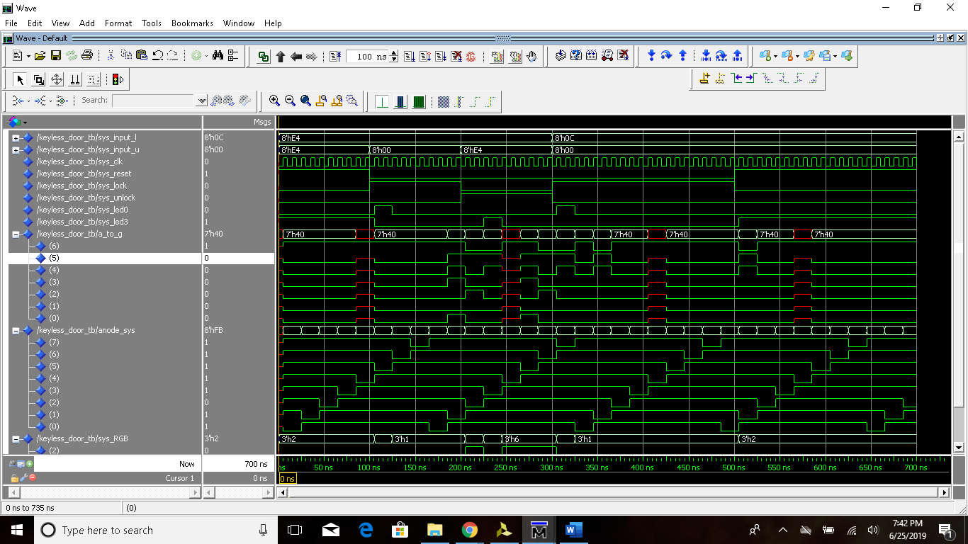

WITH RGB
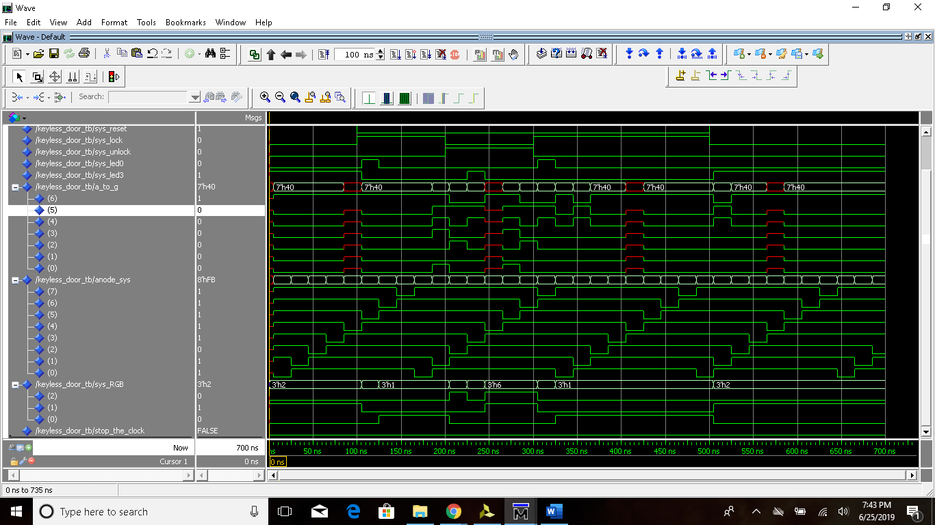

After the QuestaSim simulation, please implement your keyless entry system on the Nexys 4 DDR board, and use the setup as given earlier.

After implementing your keyless entry system design on the Nexys 4 board, please demonstrate it to the instructor; and create a short video demonstrating your test results. Please upload the short video as an attachment to this report in Titanium.

Grading of the Project:
Your design project will be graded based on both the report and the in-class demonstrations before the due-date. The following factors will be considered when grading this project.

• Does your design fully comply with and meet all the design specifications as described?
• Points will be deducted for each deviation from the specifications
• Partial credits will be given depending on how much progress was made
• Your VHDL entity code and Testbench design with simulation analysis.
• The extent to which your design is implemented on the Nexys 4 DDR board.
• Points will be deducted for each deviation from the specifications
• Partial credits will be given depending on how much progress was made
• The extent to which your written report and oral presentation in the short video explains how your system is designed, and how the simulation and board implementation verifies your system design.

