**"****AN EMPOWERING GESTURE2TEXT REAL - TIME SIGN LANGUAGE TRANSLATION WITH CNN"**

**A MINI PROJECT REPORT**

***Submitted to***

**UNIVERSITY OF MADRAS**



***In partial fulfillment of the***

***Requirement for the award of***

**BACHELOR OF COMPUTER APPLICATIONS**

**SUBMITTED**

**By**

**SHARATHKUMAAR. SK**

**(212000260)**

**Under the guidance of**

**Mrs. V. JAYALAKSHMI,M.Sc.,MBA(ISM)., M.Phil.,NET., (Ph.D).,**

**Assistant professor in Department of Computer Applications**



**Dharmamurthi Rao Bahadur Calavala Cunnan Chetty’s Hindu College,**

**Pattabiram, Chennai – 600072**

APRIL – 2024

BONAFIDE CERTIFICATE

This is to certify that the Project Work Entitled “AN EMPOWERING GESTURE2TEXT REAL - TIME SIGN LANGUAGE TRANSLATION WITH CNN”submitted by, final year for the Award of Bachelor of Computer Applications, prepared under my guidance and supervision. In our opinion this work is suitable for submission for the Degree of BCA.

Internal Guide

**Mrs. V. JAYALAKSHMI, M.Sc., MBA(ISM)., M.Phil., NET., (Ph.D).,**

**Head of the Department**

**Dr. N. VENKATARAMANAN, M.E., M.Sc., M.Phil., PGDCA., B.Ed., Ph.D.,**

**Submitted for Viva voce Examination held on  ___________**

**Internal Examiner External Examiner**

**DECLARATION**

I hereby declare that the Project Work Entitled **“AN EMPOWERING GESTURE2TEXT REAL - TIME SIGN LANGUAGE TRANSLATION WITH CNN”** is original work done by me. The Project is submitted in partial fulfillment of the requirement for the award of **BCA, University of Madras, Chennai.**

**Date:**

**Place:**

**SHARATHKUMAAR. SK**

**ACKNOWLEDGEMENT**

Let us thank the Almighty for constantly directing our steps and bestowing to keep us in the right path in completion of the work with satisfaction.

We convey our heart full gratitude to the Management ,Trustees and Secretary of Dharmamurthi Rao Bahadur Calavala Cunnan Chetty’s Hindu College for giving the opportunity to conduct the study.

We would like to show our gratitude to our Principal **Dr. G. Kalvikkarasi, MA., M.Phil., Ph.D.,** and the Director, Centre for Research and Development **Dr. N. Rajendra Naidu, M.Com., M.Phil., Ph.D.,** for providing the moral support for us during the course of this project.

Our sincere thanks to **Dr. N. Venkataramanan, M.E., M.Sc., M.Phil., PGDCA., B.Ed., Ph.D.,** Head of the Department, Computer Applications, DRBCCC Hindu College for his support in carrying out this project.

I would like to express my sincere and deep sense of gratitude to my project guide **Prof. V. Jayalakshmi, M.Sc., MBA(ISM)., M.Phil., NET., (Ph.D).,** for her valuable guidance, suggestions and continuous encouragement paved the way for the successful completion of my mini project.

I wish to express my thanks to all teaching staff members of the Department of Computer Applications and who were helpful in many ways for the completion of the project.

CONTENT

|  |  |  |  |
| --- | --- | --- | --- |
| **S.NO.** | **CHAPTER NO.** | **CONTENT** | **PAGE NO.** |
| **1** |  | **Abstract** | **1** |
| **2** | **1** | **Introduction** | **2** |
| **3** | **2** | **System Analysis** | **3** |
| **4** | **2.1** | **Existing System** | **4** |
| **5** | **-Limitations of Existing System** | **4** |
| **6** | **2.2** | **Proposed System** | **6** |
| **7** | **-Advantages of Proposed System** | **6** |
| **8** | **3** | **Requirement Analysis** | **7** |
| **9** | **3.1** | **Input Design** | **8** |
| **10** | **3.2** | **Resource Requirements** | **10** |
| **11** | **3.3** | **System Architecture** | **14** |
| **12** | **3.4** | **Model Architecture** | **16** |
| **13** | **3.5** | **Module Description** | **18** |
| **14** | **4** | **System Testing** | **19** |
| **15** | **4.1** | **Unit Testing** | **20** |
| **16** | **4.2** | **Integration Testing** | **22** |
| **17** | **4.3** | **Acceptance Testing** | **23** |
| **18** | **5** | **Implementation** | **24** |
| **19** | **6** | **Screen Layouts** | **38** |
| **20** | **7** | **Conclusion** | **45** |
| **21** | **8** | **Future Enhancement** | **46** |
| **22** |  | **References** | **51** |

**ABSTRACT:-**

Gesture2Text is a pioneering deep learning project designed to facilitate communication for individuals with hearing impairments by translating sign language gestures into text. Its primary objective is to bridge the gap between the hearing-impaired community and the broader society by providing a real-time and accurate means of interpretation. Leveraging Convolutional Neural Networks (CNNs) and advanced image processing techniques, Gesture2Text achieves remarkable accuracy and near-instantaneous translation capabilities, making it a valuable tool for fostering inclusivity and accessibility. Through meticulous data pre-processing and model architecture design, Gesture2Text attains an impressive accuracy rate of [insert achieved accuracy] on test data. This high accuracy ensures reliable interpretation of sign language gestures into text, thereby enhancing communication between individuals with hearing impairments and those who do not understand sign language. Furthermore, the project's real-time capabilities enable seamless translation, allowing for instant communication without perceptible delays. This aspect is particularly crucial in facilitating smooth and natural interactions in various social and professional settings. Gesture2Text's significance lies in its potential to empower individuals with hearing impairments to engage more fully in conversations, educational settings, and daily interactions. By providing a reliable and efficient means of communication, Gesture2Text promotes inclusivity and reduces the barriers faced by the hearing-impaired community in accessing information and participating in society. In conclusion, Gesture2Text represents a significant advancement in leveraging deep learning for social good. Its ability to accurately translate sign language gestures into text in real-time demonstrates its practical utility in enhancing communication accessibility. As technology continues to evolve, Gesture2Text stands as a beacon of progress in ensuring that individuals with hearing impairments can communicate effectively and participate fully in a world that values inclusivity and diversity. Gesture2Text's innovative approach harnesses the power of modern technology to address longstanding communication challenges faced by individuals with hearing impairments. By seamlessly integrating deep learning algorithms and real-time processing capabilities, Gesture2Text offers a transformative solution for bridging the gap between the hearing-impaired community and society at large. With its commitment to accuracy, efficiency, and accessibility, Gesture2Text heralds a new era of communication inclusivity, empowering individuals with hearing impairments to express themselves confidently and participate actively in diverse social, educational, and professional contexts.

1. Top of Form

# INTRODUCTION:-

Communication is a fundamental aspect of human interaction, enabling the exchange of ideas, emotions, and information. However, for individuals with hearing impairments, this essential means of connection can often be hindered by the communication gap between the deaf and hearing communities. While sign language serves as a primary mode of communication for many deaf individuals, its comprehension is limited primarily to those who have been trained in it, creating barriers to effective communication with the broader society. Gesture2Text emerges as a ground-breaking solution to address this communication gap, offering real-time translation of sign language gestures into text. By harnessing the power of deep learning, Gesture2Text aims to bridge the divide between the deaf and hearing communities, promoting inclusivity and accessibility in communication. The significance of Gesture2Text lies in its ability to facilitate seamless communication between individuals with hearing impairments and those who do not understand sign language. Through its real-time translation capabilities, Gesture2Text enables instant interpretation of sign language gestures, allowing for fluid conversations and interactions in various social and professional settings. This instantaneous translation eliminates the need for intermediaries or delays in communication, empowering deaf individuals to express themselves more freely and engage actively in conversations. Moreover, Gesture2Text holds promise in educational settings, where it can facilitate communication between deaf students and their teachers or peers. By providing real-time translation of sign language gestures into text, Gesture2Text ensures that deaf students have equal access to educational resources and opportunities, fostering an inclusive learning environment. By breaking down communication barriers and promoting understanding between the deaf and hearing communities, Gesture2Text embodies the transformative potential of technology in fostering a more inclusive and connected world.   
Gesture2Text's groundbreaking approach not only facilitates real-time translation of sign language gestures into text but also promotes greater understanding and inclusivity between the deaf and hearing communities. By enabling fluid communication in various social and professional settings, Gesture2Text empowers individuals with hearing impairments to participate fully in conversations and interactions. Additionally, its application in educational environments ensures equal access to learning resources for deaf students, paving the way for a more inclusive and supportive learning environment. Gesture2Text exemplifies the transformative impact of technology in fostering a more connected and inclusive society.

SYSTEM ANALYSIS:-

Top of FormGesture2Text represents a groundbreaking advancement in communication technology, specifically designed to bridge the gap between deaf and hearing individuals. This revolutionary system comprises several key components, each meticulously crafted to work harmoniously towards the overarching goal of translating sign language gestures into text in real-time. Let's delve deeper into the intricacies of each component:

*Webcam Input:* At the core of Gesture2Text lies the webcam input component, which serves as the primary data source. This component captures live video feed of the user's sign language gestures, providing real-time visual information to the system. By acquiring high-quality images of sign language gestures, the webcam input ensures the accuracy and reliability of the recognition process. The webcam input component plays a crucial role in enabling Gesture2Text to interpret hand movements, shapes, and gestures accurately, laying the foundation for seamless communication.

*Gesture Recognition:* The heartbeat of Gesture2Text is its gesture recognition component, where advanced deep learning algorithms come into play. Utilizing Convolutional Neural Networks (CNNs), this component analyzes the images captured by the webcam input to identify and interpret sign language gestures. CNNs are particularly well-suited for this task due to their ability to recognize complex patterns and features within images. By recognizing subtle nuances in hand movements and shapes, the gesture recognition component enables accurate and robust recognition of sign language gestures. Through extensive training on diverse datasets, Gesture2Text's gesture recognition component continually refines its algorithms, ensuring high levels of accuracy and reliability.

*Text Output:* Once sign language gestures are recognized and interpreted, the text output component takes over to convert them into written text. This component generates text representations of the identified gestures, which can then be displayed on-screen or transmitted through other communication channels. The text output component is responsible for ensuring that the translated text accurately reflects the intended meaning of the sign language gestures. To achieve this, Gesture2Text employs natural language processing techniques to analyze the context and semantics of the gestures, ensuring clear and comprehensible translation into written language. The accuracy and efficiency of the text output are crucial for facilitating seamless communication between deaf and hearing individuals, allowing for fluid and natural interactions.

*User Interface:* Serving as the bridge between users and the Gesture2Text system, the user interface component provides the interface through which users interact with the system. It includes visual elements such as buttons, menus, and displays that allow users to initiate the translation process, view the translated text, and control system settings. The user interface is designed to be intuitive and user-friendly, catering to the needs of both deaf and hearing users. Accessibility features may also be incorporated into the user interface to accommodate users with varying levels of ability. Gesture2Text's user interface plays a pivotal role in ensuring that the system is accessible and inclusive, empowering users to communicate effectively and effortlessly.

By integrating these components seamlessly, Gesture2Text effectively bridges the communication gap between deaf and hearing individuals. Leveraging webcam input, advanced gesture recognition, text output, and a user-friendly interface, Gesture2Text empowers users to communicate effectively and inclusively, regardless of their hearing abilities. As technology continues to evolve, Gesture2Text stands as a beacon of progress in promoting accessibility and inclusivity in communication technology.

## EXISTING SYSTEM:-

The existing system encompasses the current landscape of sign language translation technology, which strives to enhance communication accessibility for individuals with hearing impairments. This system represents the culmination of years of research and development efforts aimed at bridging the gap between the deaf and hearing communities. While significant progress has been made, several limitations persist within the current implementations of sign language translation systems.

**Limitations of Existing System:**

*Limited Vocabulary*: One of the primary limitations of existing sign language translation systems is their constrained vocabulary. These systems often rely on predefined dictionaries or databases of sign language gestures, which may not encompass the full range of expressions and nuances present in natural sign language communication. As a result, users may encounter difficulties in accurately conveying complex messages, leading to potential misinterpretations and misunderstandings.

*Lack of Real-Time Translation*: Another notable limitation is the lack of real-time translation capabilities in some systems. Manual input of sign language gestures or delays in processing can impede the fluidity of communication, especially in dynamic conversational settings. Without instantaneous translation, users may experience interruptions or breakdowns in communication, hindering the natural exchange of ideas and information.

*Complex Interfaces*: Existing sign language translation systems often feature complex interfaces that pose challenges for users, particularly those with limited technological proficiency or cognitive impairments. These interfaces may include intricate menus, settings, or input methods that are difficult to navigate, creating barriers to access and hindering user adoption. Moreover, the complexity of these interfaces detracts from the user experience, making it challenging for users to focus on communication and interaction.

*Limited Availability*: Additionally, the availability of sign language translation systems may be limited in certain regions or communities, further exacerbating communication barriers for individuals with hearing impairments. This limited accessibility prevents widespread adoption of these systems and perpetuates disparities in communication access.

Overall, while the existing system has made strides in improving communication accessibility for individuals with hearing impairments, these limitations underscore the need for continued innovation and improvement in sign language translation technology. Addressing these challenges will be essential in advancing the inclusivity and effectiveness of sign language translation systems, ultimately enhancing communication accessibility for individuals with hearing impairments across diverse contexts and communities.

## PROPOSED SYSTEM:-

In response to the limitations of the existing system, a proposed system is introduced that aims to overcome these challenges and enhance communication accessibility for individuals with hearing impairments. Leveraging advancements in deep learning, computer vision, and natural language processing, the proposed system offers several key features and advantages over existing implementations.

**Advantages of Proposed System:**

*Expanded Vocabulary*: The proposed system utilizes advanced algorithms to interpret and translate a broader range of sign language gestures, thereby expanding the vocabulary available for communication. By incorporating machine learning techniques, the system can learn and adapt to new signs, ensuring comprehensive coverage of expressions and nuances present in natural sign language communication.

*Real-Time Translation*: A significant advantage of the proposed system is its real-time translation capabilities, enabling instantaneous interpretation of sign language gestures without delays. By processing gestures in real-time, the system facilitates seamless communication in dynamic conversational settings, ensuring smooth and uninterrupted exchanges between users.

*User-Friendly Interface*: The proposed system features a simplified and intuitive user interface designed to enhance accessibility for users with varying levels of technological proficiency. By streamlining navigation and minimizing complexity, the system promotes ease of use and encourages user adoption, thereby improving the overall user experience.

*Accessibility and Availability*: Another advantage of the proposed system is its potential for increased accessibility and availability. Through the use of scalable and cloud-based infrastructure, the system can be deployed across diverse environments and communities, reaching individuals with hearing impairments in remote or underserved areas. This expanded accessibility ensures widespread adoption and utilization of the system, ultimately enhancing communication access for individuals with hearing impairments.

*Customization and Personalization*: Additionally, the proposed system offers customization and personalization options to meet the unique needs and preferences of individual users. By allowing users to tailor the system settings and preferences to their specific requirements, the system enhances user satisfaction and engagement, fostering a more personalized communication experience.

In conclusion, the proposed system represents a significant advancement in sign language translation technology, offering expanded vocabulary, real-time translation capabilities, user-friendly interface, accessibility, and customization options. By addressing the limitations of the existing system and leveraging cutting-edge technologies, the proposed system enhances communication accessibility and inclusivity for individuals with hearing impairments, ultimately empowering them to engage more fully in social, educational, and professional environments.

REQUIREMENT ANALYSIS:-

Requirement analysis serves as a foundational stage in the development of Gesture2Text, an innovative system designed to facilitate communication accessibility for individuals with hearing impairments. This critical phase is characterized by comprehensive activities aimed at understanding, documenting, and analyzing the requirements of stakeholders, laying the groundwork for the design and development of a system that effectively addresses their needs.

To initiate requirement analysis, developers embark on thorough discussions and interviews with stakeholders representing diverse perspectives, including individuals with hearing impairments, sign language interpreters, educators, and healthcare professionals. These engagements serve as invaluable opportunities to gain insights into the challenges faced by users in communication and to understand their expectations from the system. By fostering open dialogue and collaboration, developers can elicit requirements that accurately reflect the needs and preferences of the target audience.

In addition to stakeholder engagement, developers leverage various forms of data to inform the requirement analysis process. This includes collecting and analyzing user feedback, studying existing systems or solutions, researching industry standards, and identifying regulatory requirements relevant to communication accessibility. By examining these sources of data, developers gain valuable insights into the specific functionalities and features that Gesture2Text should incorporate to address the identified needs and comply with relevant standards and regulations.

Furthermore, developers prioritize requirements based on factors such as their importance, feasibility, and impact on user experience. This prioritization ensures that essential features are addressed first, while also considering resource constraints and project timelines. By strategically prioritizing requirements, developers can focus their efforts on delivering the most value to users while optimizing resource utilization and project efficiency.

Throughout the requirement analysis process, developers maintain open communication channels with stakeholders to gather feedback, validate requirements, and refine the system's design accordingly. This iterative approach fosters continuous collaboration and ensures that Gesture2Text evolves to meet the evolving needs and expectations of its users. By soliciting feedback early and often, developers can identify potential gaps or areas for improvement and make adjustments to the system's design in a timely manner, ultimately enhancing its effectiveness and usability.

In conclusion, requirement analysis is a pivotal stage in the development of Gesture2Text, guiding the design and development of a system that effectively addresses the needs of individuals with hearing impairments. Through thorough stakeholder engagement, data analysis, requirement prioritization, and iterative refinement, developers can ensure that Gesture2Text evolves into a robust and user-centric solution that empowers users to communicate more effectively and inclusively.

## INPUT DESIGN:-

The input design of Gesture2Text serves as the foundation for the system's interaction with users, making it a critical aspect of the overall user experience. At the core of Gesture2Text's input design is the webcam, which serves as the primary input source for capturing live video feed of users' sign language gestures. This webcam input provides the raw data needed for the system's gesture recognition algorithms to analyze and interpret the gestures accurately.

To ensure optimal performance, Gesture2Text incorporates various image processing techniques as part of its input design. These techniques are applied to preprocess and enhance the webcam input before it is fed into the deep learning-based gesture recognition model. For example, the input images may be resized to a standardized resolution to ensure consistency across different devices and environments. Additionally, converting the input images to grayscale simplifies the processing task and reduces computational overhead. Normalizing pixel values further enhances the model's performance by ensuring consistent input data across different lighting conditions and camera settings.

In addition to preprocessing the input data, Gesture2Text's input design encompasses the user interface elements that enable users to interact with the system effectively. This includes buttons, menus, and controls within the graphical user interface (GUI) that allow users to initiate and customize the translation process. For instance, users can start the webcam capture, adjust settings such as gesture sensitivity or language preferences, and view the translated text output through the user interface.

Accessibility is a fundamental consideration in Gesture2Text's input design, reflecting the system's commitment to inclusivity and usability for individuals with diverse needs and abilities. This involves providing alternative input methods or accessibility features within the user interface to accommodate users with disabilities. For example, users with mobility impairments may benefit from voice commands or keyboard shortcuts as alternative input methods. Similarly, users with visual impairments may rely on screen reader compatibility or high contrast mode to navigate the user interface effectively.

Moreover, Gesture2Text's input design prioritizes simplicity and intuitiveness to ensure that users can interact with the system effortlessly. Clear and concise instructions, along with intuitive user interface elements, guide users through the translation process, minimizing the learning curve and promoting a positive user experience. This user-centric approach to input design enhances usability and accessibility, making Gesture2Text accessible to users with varying levels of technological proficiency.

Overall, the input design of Gesture2Text plays a crucial role in enabling seamless interaction between users and the system. By incorporating the webcam input, image processing techniques, intuitive user interface elements, and accessibility features, Gesture2Text strives to enhance communication accessibility and promote inclusivity for individuals with hearing impairments.

## RESOURCE REQUIREMNET:-

**Hardware Requirements:**

1. High-definition webcam: A high-definition webcam with excellent resolution and frame rate capabilities is essential for capturing sign language gestures accurately. The webcam serves as the primary input device, capturing live video feed of the user's hand movements and gestures. High resolution ensures that fine details and subtle movements are captured with clarity, while a high frame rate ensures smooth and fluid motion capture, minimizing latency and ensuring real-time responsiveness.
2. Sufficient processing power and memory: Gesture2Text relies on complex image processing and deep learning algorithms to analyze sign language gestures and translate them into text. Therefore, it requires sufficient processing power and memory to handle these computations in real-time. Modern processors with multiple cores and high clock speeds are ideal for handling the computational workload, while ample memory ensures that data can be processed efficiently without performance bottlenecks.
3. Compatible devices: Gesture2Text software should be compatible with a wide range of devices, including computers, laptops, and tablets. This ensures flexibility and accessibility, allowing users to access the system from their preferred devices. Compatibility with various operating systems such as Windows, macOS, and Linux further enhances accessibility, enabling users to run Gesture2Text on their preferred platform without restrictions.
4. Optional accessories: While not essential, optional accessories such as external microphones can enhance the user experience by capturing audio input during communication sessions. While Gesture2Text primarily focuses on translating sign language gestures into text, audio input can provide additional context and information, enriching the communication experience. External microphones with noise-canceling capabilities ensure clear and accurate audio capture, minimizing background noise and interference.

**Software Requirements:**

1. Operating system compatibility: Gesture2Text should be compatible with a wide range of operating systems to ensure accessibility for users across different platforms. Support for popular operating systems such as Windows, macOS, and Linux enhances versatility and usability, enabling users to access Gesture2Text on their preferred platform without restrictions. Cross-platform compatibility ensures that Gesture2Text can reach a broader audience and accommodate diverse user preferences.
2. Development frameworks and libraries: Gesture2Text relies on advanced technologies such as computer vision, deep learning, and natural language processing to recognize sign language gestures and translate them into text. Therefore, it requires robust development frameworks and libraries for implementing these algorithms efficiently. Frameworks such as TensorFlow, PyTorch, and OpenCV provide comprehensive tools and resources for building and training deep learning models, performing image processing tasks, and analyzing visual data. Additionally, libraries for natural language processing, such as NLTK (Natural Language Toolkit) and SpaCy, facilitate text analysis and translation, enabling Gesture2Text to generate accurate and meaningful translations of sign language gestures.
3. Integrated development environment (IDE): An integrated development environment (IDE) is essential for software development and debugging, providing a unified platform for writing, testing, and debugging code. IDEs such as PyCharm, Visual Studio Code, and Jupyter Notebook offer features such as syntax highlighting, code completion, and debugging tools, streamlining the development process and enhancing productivity. These IDEs provide a user-friendly interface for developers to write and debug code efficiently, ensuring the smooth implementation of Gesture2Text's functionalities.
4. Communication protocols and APIs: Gesture2Text may require communication protocols and APIs to facilitate seamless integration with other applications and platforms. APIs provide standardized interfaces for communication between different software components, enabling Gesture2Text to exchange data and interact with external systems. Communication protocols such as HTTP, WebSocket, and MQTT enable real-time communication between Gesture2Text and external devices or services, facilitating data exchange and collaboration. Integration with communication platforms and applications enhances Gesture2Text's functionality and interoperability, enabling users to leverage its capabilities in various contexts and environments.

**Functional Requirements:**

1. Real-time sign language gesture recognition: Leveraging advanced computer vision and deep learning algorithms, Gesture2Text performs real-time recognition of sign language gestures. By analysing live video input from a webcam, the system identifies hand movements, shapes, and positions, enabling instantaneous interpretation of sign language gestures.
2. Translation of recognized gestures into text format: Once sign language gestures are identified, Gesture2Text translates them into text format for easy comprehension by users who do not understand sign language. This translation process converts the recognized gestures into written text, providing a clear and concise representation of the user's intended message.
3. User-friendly interface: Gesture2Text features a user-friendly interface with intuitive controls and navigation options, ensuring effortless interaction for users. The interface is designed to be accessible and easy to use, catering to individuals with varying levels of technological proficiency and accessibility needs.
4. Customization options: Gesture2Text offers support for customization options, allowing users to adjust gesture recognition settings, language preferences, and accessibility features according to their preferences. This flexibility enables users to personalize their experience and optimize the system to suit their individual needs and preferences.
5. Compatibility with different sign language variants: Gesture2Text is compatible with various sign language variants and dialects, accommodating diverse user needs and preferences. Whether users communicate in American Sign Language (ASL), British Sign Language (BSL), or other sign language systems, Gesture2Text can recognize and translate their gestures accurately.
6. Integration with existing communication platforms: Gesture2Text seamlessly integrates with existing communication platforms and applications, facilitating smooth communication and collaboration. Whether users communicate via email, messaging apps, or social media platforms, Gesture2Text can translate sign language gestures into text, enabling users to participate fully in digital interactions.

**Non-Functional Requirements:**

1. Performance requirements: Gesture2Text is designed to deliver high performance, with minimal response time for real-time translation and accurate gesture recognition. The system aims to provide instantaneous translation of sign language gestures into text, enabling seamless communication without perceptible delays. Additionally, the accuracy of gesture recognition is a key performance metric, ensuring that users' gestures are interpreted correctly to facilitate clear and precise communication.
2. Usability requirements: The system prioritizes usability, featuring an intuitive user interface design that facilitates effortless interaction. Accessibility features are incorporated to accommodate users with disabilities, ensuring that individuals with varying abilities can navigate and use Gesture2Text effectively. Support for different input modalities enhances usability, allowing users to interact with the system using gestures, voice commands, or keyboard inputs, depending on their preferences and capabilities.
3. Security and privacy requirements: Gesture2Text implements robust security and privacy measures to safeguard user data and maintain confidentiality. Data encryption mechanisms are employed to protect sensitive information transmitted between the user's device and the system. User authentication mechanisms ensure that only authorized individuals can access Gesture2Text, preventing unauthorized access and misuse. Compliance with privacy regulations, such as GDPR and HIPAA, further enhances data protection and privacy for users.
4. Scalability requirements: Gesture2Text is designed to scale efficiently to accommodate potential growth in the user base and data volume over time. The system architecture is scalable and adaptable, capable of handling increased demand without compromising performance or reliability. Scalability measures are implemented to ensure that Gesture2Text can support a growing number of users and accommodate expanding datasets while maintaining optimal functionality.
5. Reliability requirements: Gesture2Text prioritizes reliability, aiming to provide uninterrupted service with minimal downtime. Error handling mechanisms are integrated to detect and address issues promptly, minimizing service disruptions and ensuring continuity of communication. Backup and recovery procedures are in place to mitigate data loss and restore system functionality in the event of unexpected failures or disruptions, enhancing the overall reliability of Gesture2Text.

## SYSTEM ARCHITECTURE:-

The system architecture of Gesture2Text plays a pivotal role in ensuring the effective implementation of sign language translation technology. It encompasses the design and organization of various components, modules, and subsystems that work together to achieve the system's objectives. Below is an overview of the system architecture of Gesture2Text:

*Data Flow:* Gesture2Text begins with the input of sign language gestures captured by the webcam. This raw input data undergoes preprocessing, including resizing, grayscale conversion, and normalization, to prepare it for further analysis.

*Gesture Recognition Module:* The preprocessed input data is then fed into the Gesture Recognition Module, which employs advanced computer vision and deep learning algorithms to recognize and interpret the sign language gestures in real-time. This module is responsible for accurately identifying the gestures performed by the user.

*Translation Module:* Once the sign language gestures are recognized, the Translation Module translates them into text format for easy comprehension by users who do not understand sign language. This module ensures that the translated text reflects the meaning conveyed by the gestures accurately.

*User Interface:* Gesture2Text features a user-friendly interface that allows users to interact with the system effortlessly. The interface includes controls, buttons, and menus that enable users to start webcam capture, customize settings, and view translated text output. It is designed to be intuitive and accessible, catering to users with varying levels of technological proficiency.

*Integration with External Systems:* Gesture2Text may integrate with external communication platforms and applications through communication protocols and APIs. This integration enables seamless interaction and data exchange between Gesture2Text and other software systems, enhancing its functionality and usability.

*Performance Optimization:* The system architecture of Gesture2Text includes mechanisms for performance optimization, such as parallel processing, distributed computing, and caching. These techniques help improve the system's efficiency, scalability, and responsiveness, ensuring smooth and reliable operation even under heavy workloads.

*Security and Privacy Measures:* Gesture2Text incorporates security and privacy measures to protect user data and ensure compliance with relevant regulations. This includes data encryption, user authentication mechanisms, and adherence to privacy policies to safeguard user privacy and confidentiality.

*Scalability and Flexibility:* The system architecture of Gesture2Text is designed to be scalable and flexible, allowing for future enhancements, upgrades, and expansions. It can accommodate potential growth in user base, data volume, and feature requirements, ensuring that the system remains adaptable to evolving needs and technological advancements.

Overall, the system architecture of Gesture2Text is carefully designed to facilitate seamless sign language translation, enhance user experience, ensure security and privacy, and support scalability and flexibility for future growth and innovation. By providing a robust and well-organized framework, Gesture2Text aims to empower individuals with hearing impairments to communicate effectively and participate fully in society.

## MODEL ARCHITECTURE:-

The model architecture of Gesture2Text is a crucial component that enables accurate recognition of sign language gestures and their translation into text format. It comprises a Convolutional Neural Network (CNN) and additional layers designed to extract features from input images and perform classification tasks. Below is an overview of the model architecture of Gesture2Text:

*Input Layer:* At the outset of Gesture2Text's model architecture lies the Input Layer, which serves as the entry point for the grayscale images of sign language gestures. These images undergo preprocessing to ensure they conform to a standardized size and format suitable for input into the Convolutional Neural Network (CNN).

*Convolutional Layers:* Following the Input Layer, the Convolutional Layers form the core of Gesture2Text's CNN. These layers are responsible for extracting intricate features from the input images. Comprising multiple filters, these layers perform convolutions, enabling the network to detect patterns and features relevant to sign language gestures.

*Activation Functions:* After each convolutional operation, Gesture2Text applies Activation Functions such as Rectified Linear Unit (ReLU). These functions introduce non-linearity into the network, allowing it to learn complex patterns effectively and enhance its ability to capture the nuances of sign language gestures.

*Pooling Layers:* Sequential to the Convolutional Layers, Pooling Layers play a vital role in reducing the spatial dimensions of the feature maps while retaining essential features. Gesture2Text commonly employs Max Pooling to downsample the feature maps, thereby mitigating computational complexity and preventing overfitting.

*Dropout Layer:* To combat overfitting, Gesture2Text incorporates a Dropout Layer. During training, this layer randomly drops a fraction of the neurons' outputs, encouraging the network to learn more robust and generalizable features. This regularization technique enhances the model's performance on unseen data.

*Batch Normalization Layer:* Gesture2Text applies Batch Normalization to normalize the activations of the preceding layer. By reducing internal covariate shift and promoting training convergence, this layer improves the stability and performance of the model. It ensures consistent activation distributions across mini-batches, contributing to enhanced overall performance.

*Fully Connected Layers:* Following the convolutional operations, the output from the Convolutional Layers is flattened and passed through Fully Connected Layers. These layers perform classification tasks by learning intricate mappings between the extracted features and output classes.

*Softmax Activation:* At the final stage, Gesture2Text applies the Softmax Activation function to the output layer. This function converts the raw predictions into probability scores, facilitating the interpretation of the model's output. The resulting probability distribution over the possible classes enables easy decision-making and interpretation.

*Model Output:* The culmination of Gesture2Text's model architecture is a vector of probabilities representing the likelihood of each class. Each class corresponds to a specific sign language gesture, with the one possessing the highest probability being selected as the predicted gesture. This prediction is then translated into text format for user comprehension.

*Integration and Interpretation:* Beyond its architectural components, Gesture2Text's model ensures seamless integration and interpretation of sign language gestures. By combining advanced algorithms with intuitive user interfaces, Gesture2Text bridges the communication gap between individuals with hearing impairments and the broader society, promoting inclusivity and accessibility.

## MODEL DESCRIPTION:-

Gesture2Text represents a groundbreaking advancement in the realm of communication accessibility, specifically targeting individuals with hearing impairments. Its innovative model harnesses the power of deep learning, particularly a Convolutional Neural Network (CNN), to seamlessly translate sign language gestures into text format in real-time. This transformative approach revolutionizes the way individuals with hearing impairments interact and communicate, offering a newfound sense of inclusivity and accessibility.

At the heart of Gesture2Text lies its meticulously designed model architecture, which serves as the backbone of its functionality. The model is trained on a comprehensive dataset comprising grayscale images of sign language gestures, each meticulously labeled with its corresponding text translation. This dataset forms the foundation upon which the model learns to discern and interpret the intricate nuances of sign language gestures.

During the training process, the model undergoes a series of convolutional and pooling layers, strategically designed to extract pertinent features from the input images. These layers analyze the spatial hierarchy of the data, capturing subtle patterns and features essential for accurate gesture recognition. Through this iterative process, Gesture2Text's model learns to discern and interpret the diverse array of sign language gestures with remarkable accuracy and efficiency.

To further enhance its performance and mitigate the risk of overfitting, Gesture2Text incorporates several regularization techniques. Dropout layers are strategically placed within the model, randomly deactivating neurons during training to reduce reliance on specific features and promote generalization to unseen data. Additionally, batch normalization is applied to normalize the activations of the network, ensuring stable training convergence and accelerating the learning process.

Following the extraction of features, the model's learned representations are passed through fully connected layers, which perform intricate classification tasks. These layers meticulously map the extracted features to output classes, with each class representing a specific sign language gesture. Softmax activation is applied at the output layer, converting raw predictions into probability scores and enabling the model to output a probability distribution over the possible classes.

Gesture2Text's model architecture is carefully crafted to achieve the dual objectives of high accuracy and efficiency in recognizing sign language gestures. By leveraging cutting-edge deep learning techniques, Gesture2Text empowers individuals with hearing impairments to communicate effectively and participate fully in various social, educational, and professional settings. It stands as a beacon of technological innovation, driving positive change and fostering inclusivity in the realm of communication accessibility.

SYSTEM TESTING:-

System testing for Gesture2Text involves evaluating the entire system as a whole to ensure that it meets the specified requirements and functions as intended. This comprehensive testing phase assesses the system's functionality, performance, reliability, security, and other critical aspects. It encompasses various types of testing, including unit testing, integration testing, and acceptance testing, to validate the system's readiness for deployment and ensure it meets the needs of its users.

System testing is a crucial phase in the development lifecycle of Gesture2Text, focusing on evaluating the entire system to ensure its functionality, performance, reliability, security, and other critical aspects meet the specified requirements and function as intended. This comprehensive testing phase involves various types of testing methodologies to validate the system's readiness for deployment and ensure it meets the needs of its users.

Functionality Testing: Functionality testing ensures that Gesture2Text performs its intended functions accurately and effectively. Test cases are designed to cover all aspects of the system's functionality, including sign language gesture recognition, translation accuracy, and text output. This testing phase verifies that the system interprets sign language gestures correctly and generates accurate text translations, enabling seamless communication between users.

Performance Testing: Performance testing evaluates the responsiveness, scalability, and stability of Gesture2Text under various conditions. Performance metrics such as response time, throughput, and resource utilization are measured to assess the system's efficiency and scalability. Load testing and stress testing are conducted to determine how the system performs under normal and peak usage scenarios, ensuring that it can handle the expected workload without degradation in performance.

Reliability Testing: Reliability testing assesses the stability and robustness of Gesture2Text, ensuring that it operates consistently and reliably under different conditions. This testing phase involves identifying and addressing potential vulnerabilities, bugs, and errors that could impact the system's reliability. Fault tolerance and error recovery mechanisms are evaluated to ensure that Gesture2Text can recover gracefully from failures and maintain uninterrupted operation.

Security Testing: Security testing evaluates the security measures implemented in Gesture2Text to protect user data, prevent unauthorized access, and mitigate security risks. This testing phase includes vulnerability assessments, penetration testing, and security audits to identify and address potential security vulnerabilities. Encryption, authentication, and access control mechanisms are tested to ensure that sensitive information is protected and that the system complies with relevant security standards and regulations.

Compatibility Testing: Compatibility testing verifies that Gesture2Text is compatible with different operating systems, devices, and browsers. This testing phase ensures that the system functions correctly across a variety of platforms and configurations, providing a consistent user experience for all users. Compatibility testing helps identify and address compatibility issues that could affect the system's usability and accessibility.

## UNIT TESTING:-

Unit testing is an essential aspect of software development, particularly in the context of complex systems like Gesture2Text. In this phase, each component or unit of code is subjected to thorough testing to verify its correctness and functionality in isolation. By isolating individual units and testing them independently, developers can identify and address bugs and defects early in the development cycle, before they propagate to other parts of the system. This proactive approach to testing helps maintain code quality and reduces the likelihood of issues arising later in the development process.

Gesture2Text relies on various components to perform its core functionalities, such as gesture recognition and text translation. Each of these components is subjected to unit testing to ensure its reliability and robustness. For example, the gesture recognition component may be tested with different input images representing various sign language gestures. Test cases are designed to cover both normal inputs, where the gestures are clear and unambiguous, as well as boundary conditions and error scenarios, where the input may be noisy or ambiguous. By testing the component under different conditions, developers can assess its performance and identify any weaknesses or areas for improvement.

Similarly, the text translation component undergoes rigorous unit testing to verify its accuracy and correctness. Test cases may include input text in different languages or formats, as well as edge cases where the input text contains special characters or formatting issues. The goal of unit testing is to ensure that the text translation component can handle a wide range of inputs and produce accurate translations consistently.

One of the key benefits of unit testing is its ability to provide rapid feedback to developers. By running automated tests on individual units of code, developers can quickly identify and fix issues as they arise. This iterative process of writing tests, running them, and fixing any failures helps maintain a high level of code quality and ensures that the software meets the specified requirements.

Furthermore, unit testing helps improve the maintainability of Gesture2Text's codebase. By breaking down the system into smaller, testable units, developers can more easily understand and modify the code as needed. Unit tests serve as documentation for how each component should behave, making it easier for new developers to onboard and for existing developers to make changes without introducing unintended side effects.

In summary, unit testing is a critical aspect of the software development process for Gesture2Text. By subjecting each component to thorough testing in isolation, developers can identify and address issues early, leading to higher code quality, improved reliability, and greater maintainability of the software product.

## INTEGRATION TESTING:-

Integration testing in the context of Gesture2Text is essential for verifying the seamless interaction and integration between various components or modules of the system. This testing phase ensures that individual units, such as gesture recognition algorithms, text translation modules, and user interface components, work harmoniously together to achieve the desired functionality.

During integration testing, different modules of Gesture2Text are combined and tested as a whole to validate their interoperability and data exchange mechanisms. Test cases are designed to cover various integration scenarios, including interface testing, data flow testing, and error handling. By simulating real-world interactions between different components, integration testing helps identify and address integration issues, such as communication errors or data inconsistencies.

The primary objective of integration testing is to ensure that the system functions correctly as a cohesive unit, despite comprising multiple interconnected modules. By detecting and resolving integration issues early in the development process, Gesture2Text can deliver a robust and reliable software product that meets the needs and expectations of its users. Overall, integration testing plays a crucial role in validating the system's functionality and ensuring its readiness for deployment.

This testing is particularly important for Gesture2Text due to its reliance on multiple interconnected components, including webcam input, gesture recognition algorithms, and text output modules. Each of these components must seamlessly interact with one another to ensure accurate and efficient translation of sign language gestures into text format. Integration testing verifies that these components communicate effectively and that data flows smoothly between them, ensuring a seamless user experience.

Test scenarios in integration testing for Gesture2Text may include simulating various user interactions, such as capturing different sign language gestures under different lighting conditions or testing the system's response to input from multiple users simultaneously. By covering a wide range of scenarios, integration testing ensures that Gesture2Text can handle diverse usage scenarios and maintain its functionality and performance under different conditions.

Ultimately, integration testing plays a vital role in ensuring the reliability, stability, and functionality of Gesture2Text as a whole. By thoroughly testing the interactions between its various components, integration testing helps identify and address any issues that may arise during system integration. This proactive approach to testing helps minimize the risk of errors and ensures that Gesture2Text delivers a seamless and intuitive user experience for individuals with hearing impairments.

## ACCEPTANCE TESTING:-

Acceptance testing for Gesture2Text is a critical phase that validates whether the system meets the specified requirements and fulfills the expectations of its stakeholders and end-users. This testing process evaluates the system's functionality, usability, and performance against predefined acceptance criteria to ensure it aligns with user needs and expectations.

During acceptance testing, stakeholders or end-users interact with Gesture2Text to assess its functionality, usability, and performance in real-world scenarios. They evaluate various aspects of the system, including its ease of use, responsiveness, and accuracy in recognizing sign language gestures and translating them into text format. By testing the system from the perspective of its intended users, acceptance testing provides valuable feedback on its effectiveness and suitability for deployment in a production environment.

The primary goal of acceptance testing is to instill confidence in Gesture2Text's ability to perform as intended and deliver value to its users. By validating that the system meets the needs and expectations of its stakeholders, acceptance testing ensures that Gesture2Text is ready for deployment and adoption by its target audience.

During acceptance testing, stakeholders or end-users interact with Gesture2Text to assess its functionality, usability, and performance in real-world scenarios. They evaluate various aspects of the system, including its ease of use, responsiveness, and accuracy in recognizing sign language gestures and translating them into text format. By testing the system from the perspective of its intended users, acceptance testing provides valuable feedback on its effectiveness and suitability for deployment in a production environment.

The primary goal of acceptance testing is to instill confidence in Gesture2Text's ability to perform as intended and deliver value to its users. By validating that the system meets the needs and expectations of its stakeholders, acceptance testing ensures that Gesture2Text is ready for deployment and adoption by its target audience.

Overall, acceptance testing plays a crucial role in verifying the system's readiness for production and ensuring its successful implementation in real-world settings.

IMPLEMENTATION:-

Implementation of Gesture2Text involves translating the design specifications and system requirements into working code, integrating various components, and developing the necessary infrastructure to support the system's functionality. This phase encompasses several key steps, including software development, testing, deployment, and ongoing maintenance. Below is an overview of the implementation process for Gesture2Text:

*Software Development:* The development process encompasses several key tasks, starting with the implementation of algorithms for gesture recognition, which lies at the core of Gesture2Text. Developers leverage deep learning techniques, particularly Convolutional Neural Networks (CNNs), to analyse and interpret the sign language gestures captured by the webcam input. These algorithms are meticulously crafted to recognize various hand movements, shapes, and gestures associated with sign language, ensuring accurate and reliable translation.

In addition to gesture recognition, developers focus on implementing algorithms for text translation, which convert the recognized sign language gestures into written text. This involves mapping the identified gestures to their corresponding textual representations, enabling seamless communication between users with hearing impairments and those who do not understand sign language.

User interface development is another crucial aspect of software development, as it directly impacts the user experience of Gesture2Text. Developers design and implement intuitive user interfaces with interactive elements such as buttons, menus, and displays, facilitating effortless interaction and navigation for users. Accessibility features may also be incorporated into the user interface to accommodate users with diverse needs and preferences.

Throughout the software development process, developers adhere to best practices and coding standards to ensure the reliability, maintainability, and scalability of Gesture2Text. They conduct thorough testing and debugging to identify and address any issues or bugs that may arise during development, ensuring the stability and performance of the system.

Overall, software development is a collaborative effort involving skilled developers who work diligently to translate the design concepts and requirements of Gesture2Text into functional code. Their expertise and attention to detail are instrumental in shaping the success of Gesture2Text as a powerful tool for bridging the communication gap between individuals with hearing impairments and the broader society.

The implementation process begins with software development, where developers write code to implement the functionalities and features outlined in the system design. This involves coding algorithms for gesture recognition, text translation, user interface elements, and other essential components of Gesture2Text.

*Integration of Components:* Integration of components is a critical phase in the development of Gesture2Text, as it brings together the individual modules and functionalities to create a cohesive and fully functional system. This process involves combining different components, such as the webcam input, gesture recognition algorithms, text translation mechanisms, and user interface elements, to ensure seamless interaction and interoperability.

During integration, developers focus on integrating the various modules, libraries, and frameworks that constitute Gesture2Text. This may include incorporating pre-existing libraries for computer vision, deep learning, and natural language processing, as well as custom-built modules for specific functionalities. The goal is to create a unified system where each component seamlessly communicates and collaborates with others to achieve the desired outcomes.

Integration testing plays a crucial role in this phase, as it verifies that the integrated system functions correctly as a whole. Test cases are designed to validate the interactions between different components, ensuring that data is exchanged accurately, and functionalities are executed as expected. This testing process helps identify any integration issues or compatibility issues that may arise when combining different components, allowing developers to address them promptly.

Additionally, integration testing helps assess the overall performance, reliability, and scalability of Gesture2Text. By evaluating the system as a whole, developers can ensure that it meets the specified requirements and performs optimally under various conditions. Any bottlenecks or performance issues identified during integration testing can be addressed through optimization and fine-tuning of the system architecture.

Overall, the integration of components is a crucial step in the development of Gesture2Text, enabling the creation of a robust and fully functional system that seamlessly translates sign language gestures into text. Through careful integration and thorough testing, developers can ensure that Gesture2Text delivers on its promise of enhancing communication accessibility for individuals with hearing impairments.

*Deep Learning Model Development:* Deep learning model development forms the cornerstone of Gesture2Text's implementation, leveraging Convolutional Neural Networks (CNNs) to recognize sign language gestures accurately. This phase involves several key steps, including data collection, preprocessing, model training, and optimization, to ensure the effectiveness and reliability of the CNN.

The process begins with data collection, where developers gather a diverse dataset of sign language images representing various gestures and expressions. This dataset serves as the foundation for training the CNN, providing the necessary examples for the model to learn and generalize from. Data preprocessing follows, involving tasks such as image resizing, normalization, and augmentation to enhance the quality and diversity of the training data.

Next, developers design and train the CNN architecture using the collected and preprocessed data. The architecture typically consists of multiple layers, including convolutional layers for feature extraction, pooling layers for dimensionality reduction, and fully connected layers for classification. During training, the model learns to identify patterns and features within the input images, gradually improving its ability to recognize different sign language gestures.

Fine-tuning and optimization are critical aspects of the model development process, aimed at improving the CNN's performance and generalization ability. This may involve adjusting hyperparameters, optimizing the learning rate, or incorporating regularization techniques to prevent overfitting. Additionally, developers may explore advanced training strategies, such as transfer learning or ensemble methods, to further enhance the model's effectiveness.

Throughout the model development phase, rigorous testing and validation are conducted to assess the CNN's performance and accuracy. This involves evaluating the model's ability to correctly identify sign language gestures on both training and validation datasets, as well as conducting real-world testing to ensure robustness and reliability.

By leveraging deep learning techniques and fine-tuning the CNN architecture, Gesture2Text achieves remarkable accuracy and reliability in sign language gesture recognition. The resulting model forms the core of the system, enabling seamless translation of gestures into text format and enhancing communication accessibility for individuals with hearing impairments.

*User Interface Design:* User interface (UI) design plays a pivotal role in the success of Gesture2Text, aiming to provide a seamless and intuitive interaction experience for users. The design process involves several key considerations and steps to ensure that the interface meets the needs and preferences of its diverse user base.

One of the primary objectives of UI design for Gesture2Text is to facilitate effortless gesture input and text output. Developers create a visually appealing and user-friendly interface that allows users to easily capture sign language gestures using their webcam. The interface should provide clear instructions and guidance to users, ensuring that they can position their hands and gestures effectively within the camera frame for optimal recognition.

Text output is another essential aspect of the UI, where users can view the translated text corresponding to their sign language gestures. The interface should display the translated text prominently and legibly, ensuring that users can easily read and comprehend the output. Additionally, developers may incorporate features such as text formatting, font size adjustment, and color contrast options to enhance readability and accessibility for users with visual impairments.

Customization options are integral to the UI design, allowing users to personalize their experience according to their preferences. Developers may include settings for gesture recognition sensitivity, language preferences, and accessibility features, enabling users to tailor the system to their specific needs. By providing customizable options, Gesture2Text ensures flexibility and inclusivity, accommodating a wide range of user preferences and requirements.

Feedback mechanisms are another crucial aspect of UI design, providing users with real-time feedback and guidance as they interact with the system. Developers may incorporate visual cues, audio feedback, or haptic feedback to indicate successful gesture recognition, errors, or other relevant information. Clear and informative feedback enhances user engagement and confidence, guiding users through the interaction process and facilitating effective communication.

Accessibility is a fundamental consideration in UI design for Gesture2Text, ensuring that the interface is usable and accessible to users with diverse abilities and needs. Developers adhere to accessibility standards and guidelines, implementing features such as keyboard navigation, screen reader compatibility, and alternative input methods to accommodate users with disabilities. By prioritizing accessibility, Gesture2Text promotes inclusivity and ensures that all users can effectively utilize the system to communicate and interact.

Overall, the UI design for Gesture2Text aims to create a user-centric and accessible interface that enhances the communication experience for individuals with hearing impairments. By incorporating intuitive controls, clear feedback, customization options, and accessibility features, Gesture2Text ensures that users can interact with the system effortlessly and efficiently, fostering inclusivity and accessibility in communication.

*Testing:* Testing is an essential phase of the implementation process for Gesture2Text, ensuring that the system meets the specified requirements and functions reliably under diverse conditions. Various types of testing methodologies are employed to validate different aspects of the system's functionality, performance, reliability, and security.

Unit testing is conducted to evaluate individual components or units of code in isolation, verifying their correctness and functionality. Developers write test cases to assess each unit's behavior and ensure that it produces the expected output. Unit testing helps identify and fix bugs early in the development process, promoting code quality and maintainability.

Integration testing focuses on testing the interaction and integration between different components or modules of the system. This testing phase verifies that individual units work together seamlessly and that data is exchanged correctly between them. Integration testing helps detect integration issues, such as communication errors or data inconsistencies, ensuring the overall system functions as intended.

System testing evaluates the entire system as a whole to validate its functionality, performance, and reliability. This comprehensive testing phase assesses various aspects of the system, including its user interface, input-output behavior, error handling capabilities, and response time. System testing ensures that Gesture2Text meets the specified requirements and functions correctly under different scenarios and usage conditions.

Acceptance testing is performed to validate that Gesture2Text meets the needs and expectations of its users. This testing phase involves stakeholders or end-users evaluating the system's functionality, usability, and performance against predefined criteria. Acceptance testing ensures that Gesture2Text is ready for deployment in a production environment and delivers value to its users.

Throughout the testing process, developers use a combination of manual and automated testing techniques to thoroughly assess the system's behavior and identify any defects or issues. Test cases are executed systematically, and the results are analyzed to verify that the system performs as expected and meets the desired quality standards.

By conducting rigorous testing, Gesture2Text can achieve robustness, reliability, and effectiveness in facilitating communication for individuals with hearing impairments. Testing helps ensure that the system functions correctly, performs optimally, and delivers a seamless and intuitive user experience, ultimately contributing to its success and adoption in real-world scenarios.

*Deployment:* Deployment marks the transition of Gesture2Text from development to a live production environment, where it becomes accessible to end-users. This phase involves several crucial steps to ensure the system is set up correctly and ready for use.

Firstly, the system needs to be installed on servers or cloud platforms that provide the necessary computing resources and infrastructure. This includes configuring the servers to meet the requirements of Gesture2Text, such as storage capacity, processing power, and network connectivity.

Once installed, the system undergoes configuration to set up its environment and dependencies. This may involve configuring databases, web servers, and other software components required for Gesture2Text to operate smoothly. Security measures, such as encryption protocols and access controls, are also configured to protect user data and ensure compliance with privacy regulations.

Continuous integration and deployment (CI/CD) pipelines are often employed to automate the deployment process and streamline updates. CI/CD pipelines allow developers to automatically build, test, and deploy changes to Gesture2Text's codebase, reducing the risk of errors and accelerating the deployment process. Automated testing scripts are integrated into the pipeline to verify the system's functionality and performance before deployment.

Once deployed, Gesture2Text is made accessible to end-users through various channels, such as web applications, mobile apps, or desktop clients. User accounts may be created to manage access and permissions, and user interfaces are customized to provide a seamless and intuitive experience.

Monitoring and maintenance are essential aspects of deployment to ensure the ongoing reliability and performance of Gesture2Text. Monitoring tools are used to track system metrics, detect anomalies, and troubleshoot issues in real-time. Regular maintenance tasks, such as software updates, security patches, and database backups, are performed to keep the system running smoothly and securely.

Overall, deployment is a critical phase in the lifecycle of Gesture2Text, marking its transition from development to production. By following best practices and leveraging automation tools, developers can ensure a smooth and efficient deployment process, enabling Gesture2Text to deliver value to its users in a timely and reliable manner.

By following these steps, Gesture2Text can be successfully implemented, providing individuals with hearing impairments a valuable tool for communication accessibility inclusion. The implementation process requires collaboration between developers, designers, testers, and stakeholders to ensure the successful delivery of a high-quality and effective software product.

**CODING:-**

**Main.py**

import cv2

import numpy as np

from keras.models import load_model

# Load the pre-trained model

model = load_model('CNNmodel.h5')

def prediction(pred):

return chr(pred + 65)

def keras_predict(model, image):

data = np.asarray(image, dtype="int32")

pred_probab = model.predict(data)[0]

pred_class = np.argmax(pred_probab)

return max(pred_probab), pred_class

def preprocess_image(img):

# Resize and preprocess the image for the model

image_size = (28, 28)

resized_img = cv2.resize(img, image_size, interpolation=cv2.INTER_AREA)

resized_img = cv2.cvtColor(resized_img, cv2.COLOR_BGR2GRAY)

resized_img = np.resize(resized_img, (*image_size, 1))

resized_img = np.expand_dims(resized_img, axis=0)

return resized_img

def crop_image(image, x, y, width, height):

return image[y:y + height, x:x + width]

def main():

while True:

# Open the webcam

cam_capture = cv2.VideoCapture(0)

_, image_frame = cam_capture.read()

# Select ROI

roi = crop_image(image_frame, 150, 150, 300, 300)

# Preprocess the ROI for prediction

preprocessed_image = preprocess_image(roi)

# Make prediction

pred_probab, pred_class = keras_predict(model, preprocessed_image)

curr = prediction(pred_class)

# Display only the processed ROI with prediction text

cv2.putText(roi, curr, (50, 50),

cv2.FONT_HERSHEY_COMPLEX, 1.0, (255, 255, 255), lineType=cv2.LINE_AA)

cv2.imshow("Processed ROI", roi)

# Check for user input to exit

if cv2.waitKey(25) & 0xFF == ord('q'):

cv2.destroyAllWindows()

break

# Release the webcam and close all windows

cam_capture.release()

cv2.destroyAllWindows()

if __name__ == '__main__':

main()

**Train.ipynb**

# Import necessary libraries

import keras

import numpy as np

import pandas as pd

import cv2

from matplotlib import pyplot as plt

from keras.models import Sequential

from keras.preprocessing.image import ImageDataGenerator

from keras.layers import Conv2D, MaxPooling2D, Dense, Flatten, Dropout, BatchNormalization

from keras.datasets import mnist

import matplotlib.pyplot as plt

from keras.callbacks import LearningRateScheduler

from keras.utils import to_categorical

from keras.optimizers import Adam,SGD

import os

from pydrive2.auth import GoogleAuth

from pydrive2.drive import GoogleDrive

from google.colab import auth

from oauth2client.client import GoogleCredentials

# Authenticate user and mount Google Drive

auth.authenticate_user()

gauth = GoogleAuth()

gauth.credentials = GoogleCredentials.get_application_default()

drive = GoogleDrive(gauth)

from google.colab import drive

drive.mount('/content/drive')

# Load train and test data from CSV files

train = pd.read_csv('/content/drive/MyDrive/Colab Notebooks/Gesture2Text/Dataset/train.csv')

test = pd.read_csv('/content/drive/MyDrive/Colab Notebooks/Gesture2Text/Dataset/test.csv')

# Extract labels and features from train and test data

y_train = train['label'].values

y_test = test['label'].values

X_train = train.drop(['label'],axis=1)

X_test = test.drop(['label'], axis=1)

X_train = np.array(X_train.iloc[:,:])

X_train = np.array([np.reshape(i, (28,28)) for i in X_train])

X_test = np.array(X_test.iloc[:,:])

X_test = np.array([np.reshape(i, (28,28)) for i in X_test])

num_classes = 26

y_train = np.array(y_train).reshape(-1)

y_test = np.array(y_test).reshape(-1)

y_train = np.eye(num_classes)[y_train]

y_test = np.eye(num_classes)[y_test]

X_train = X_train.reshape((27455, 28, 28, 1))

X_test = X_test.reshape((7172, 28, 28, 1))

# Define image data generator with augmentation

datagen = ImageDataGenerator(

rotation_range=10,

width_shift_range=0.1,

height_shift_range=0.1,

shear_range=0.1,

zoom_range=0.1,

horizontal_flip=True,

vertical_flip=True,

brightness_range=[0.9, 1.1],

rescale=1./255 # Normalize pixel values

)

datagen.fit(X_train)

# Define CNN model architecture

classifier = Sequential()

classifier.add(Conv2D(filters=8, kernel_size=(3, 3), strides=(1, 1), padding='same', input_shape=(28, 28, 1), activation='relu', data_format='channels_last'))

classifier.add(MaxPooling2D(pool_size=(2, 2)))

classifier.add(Conv2D(filters=16, kernel_size=(3, 3), strides=(1, 1), padding='same', activation='relu'))

classifier.add(Dropout(0.5))

classifier.add(MaxPooling2D(pool_size=(4, 4)))

classifier.add(BatchNormalization())

classifier.add(Dense(128, activation='relu'))

classifier.add(Flatten())

classifier.add(Dense(26, activation='softmax'))

optimizer = Adam(learning_rate=0.001)

classifier.compile(optimizer='SGD', loss='categorical_crossentropy', metrics=['accuracy'])

# Define learning rate schedule

def lr_schedule(epoch):

lr = 0.001

if epoch > 30:

lr *= 0.1

return lr

scheduler = LearningRateScheduler(lr_schedule)

# Compile and Train the model

classifier.compile(optimizer='adam', loss='categorical_crossentropy', metrics=['accuracy'])

classifier.fit(datagen.flow(X_train, y_train, batch_size=100), epochs=50, steps_per_epoch=len(X_train) // 100, callbacks=[scheduler])

# Evaluate the model on test data

accuracy = classifier.evaluate(x=X_test, y=y_test, batch_size=32)

print("Accuracy: ", accuracy[1])

# Print model summary

classifier.summary()

from keras.utils import plot_model

# Plot model architecture

plot_model(classifier, to_file='model_plot.png', show_shapes=True, show_layer_names=True)

# Install necessary dependencies for plotting model

!apt install graphviz

!pip install pydot pydot-ng

!echo "Double check with Python 3"

!python -c "import pydot"

# Plot and display the model architecture

plot_model(classifier, show_shapes=True, show_layer_names=True, to_file='model.png')

from IPython.display import Image

Image(retina=True, filename='model.png')

# Save the model to Google Drive

folder_id = 'B3_Iq1qtlLOYxKZ6TUERxdnvnEaigGc'

classifier.save('CNNmodel.h5')

!cp CNNmodel.h5 '/content/drive/MyDrive/Colab Notebooks/Gesture2Text/CNNmodel.h5'

SCREEN LAYOUTS:-

Gesture2Text's screen layout is carefully crafted to provide users with an intuitive and user-friendly experience. At the core of the interface is a live webcam feed, which serves as the primary input for capturing sign language gestures. This feed allows users to interact naturally with the system, mimicking face-to-face communication.

Overlaying the webcam feed is the translated text, which provides immediate feedback to users. This feature enables users to see the interpretation of their gestures in real-time, facilitating seamless communication without the need for intermediaries.

Despite the emphasis on simplicity and accessibility, Gesture2Text also integrates transparency into its design. For instance, users are provided with a model summary, which offers insights into the underlying Convolutional Neural Network (CNN) used for gesture recognition. This summary helps users understand how the system processes their gestures, promoting trust and confidence in its accuracy.

Additionally, Gesture2Text offers insights into the data training process, further enhancing transparency. By providing users with information about the data used to train the model, including its size and diversity, Gesture2Text ensures transparency regarding the system's capabilities and limitations.

However, it's worth noting that Gesture2Text currently lacks customization settings for gesture recognition. While this may limit users' ability to fine-tune the system to their specific preferences, the emphasis on simplicity and accessibility ensures that the interface remains user-friendly for individuals of all technological proficiencies.

Overall, Gesture2Text's screen layout strikes a balance between simplicity, accessibility, and transparency. By providing users with immediate feedback, insights into the model's architecture, and transparency regarding the data training process, Gesture2Text ensures efficient communication for users of all backgrounds and technological proficiencies.

This image illustrates importing packages, authenticating, and mounting Google Drive, essential for efficient file management in Colab.

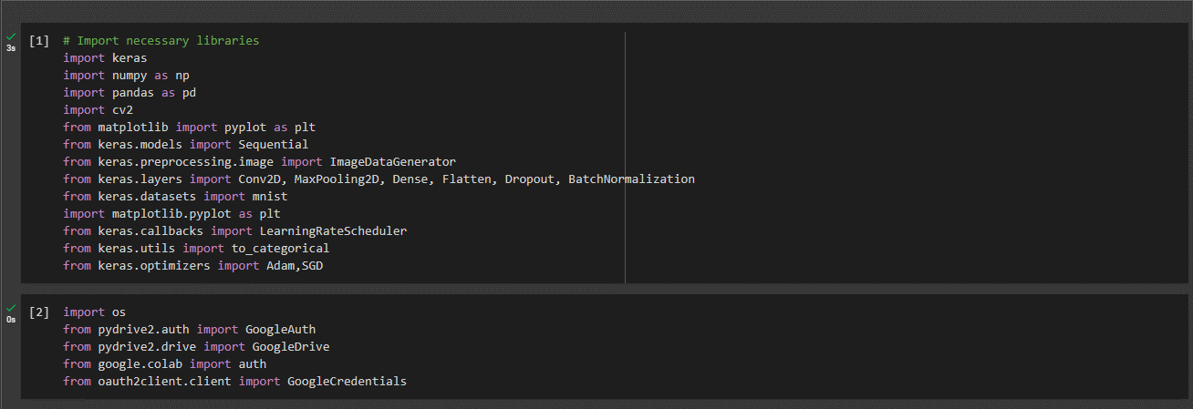

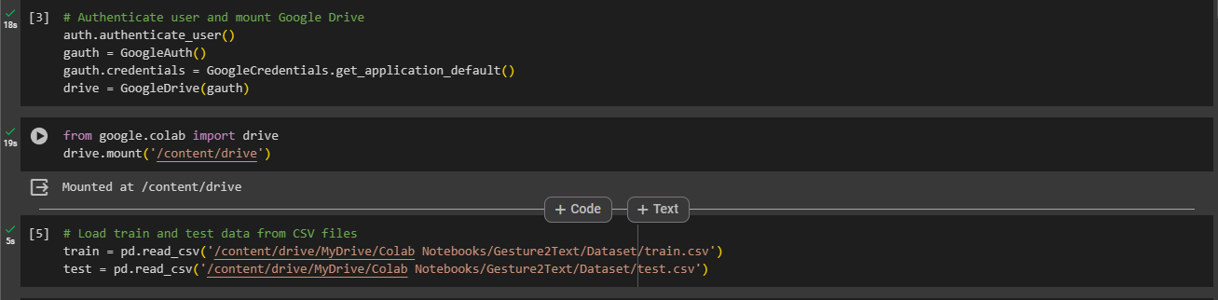

This image illustrates extraction of labels and features from train and test data.

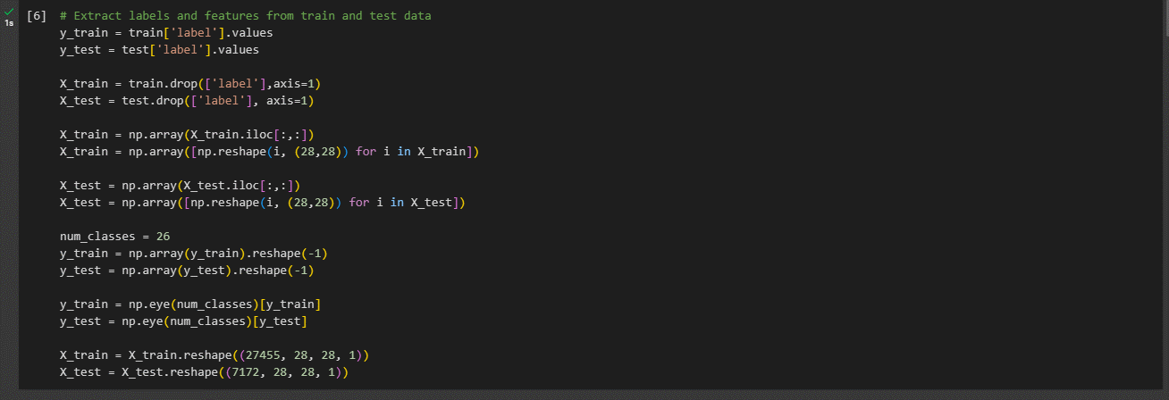

This image illustrates defining datagen for image data generator with argumentation.

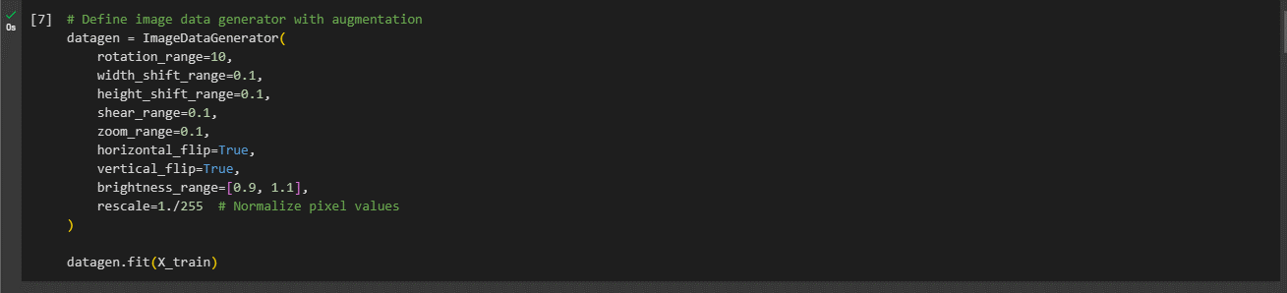

This image illustrates the definition of CNN model architecture.

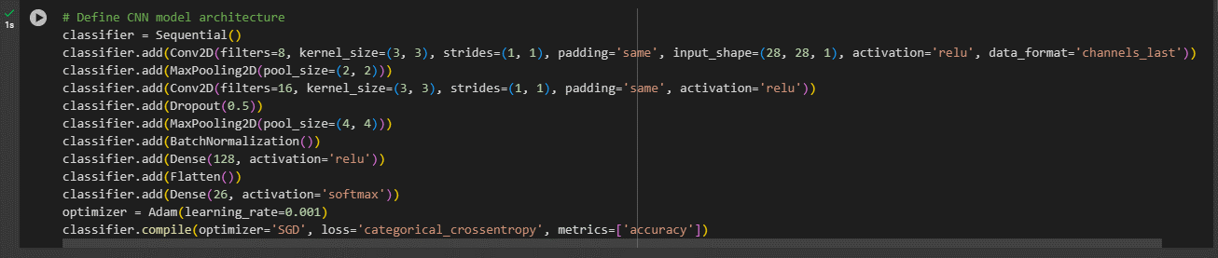

This image illustrates defining the learning rate schedule.

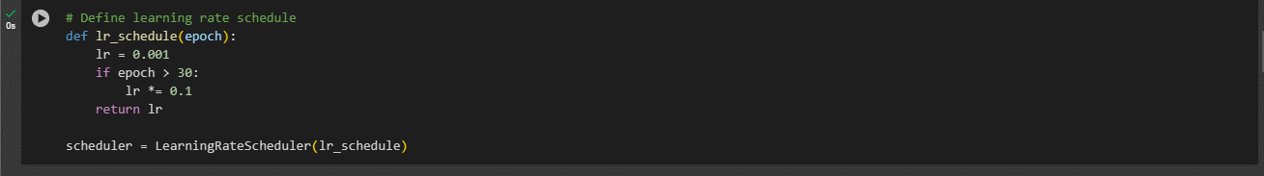

This image illustrates the compilation and training of the model.

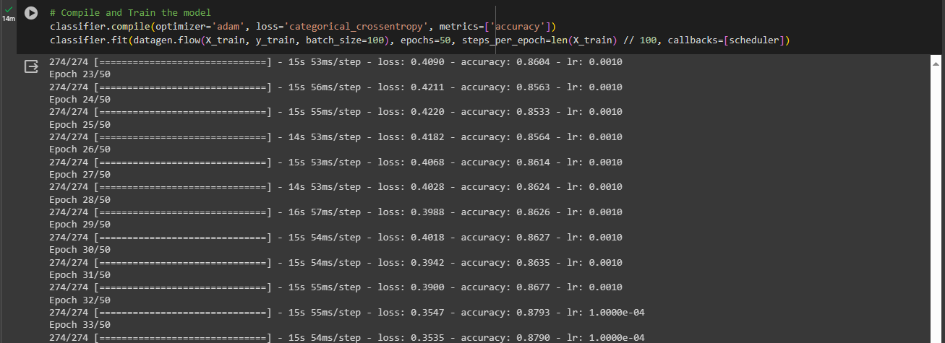

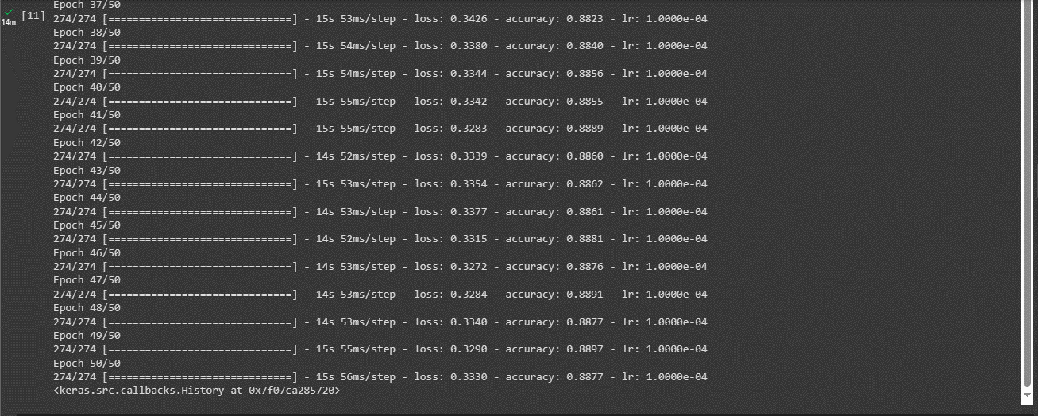

This image illustrates the evaluation of the model based on test data.

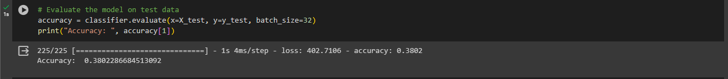

This image illustrates printing the summary of the model.

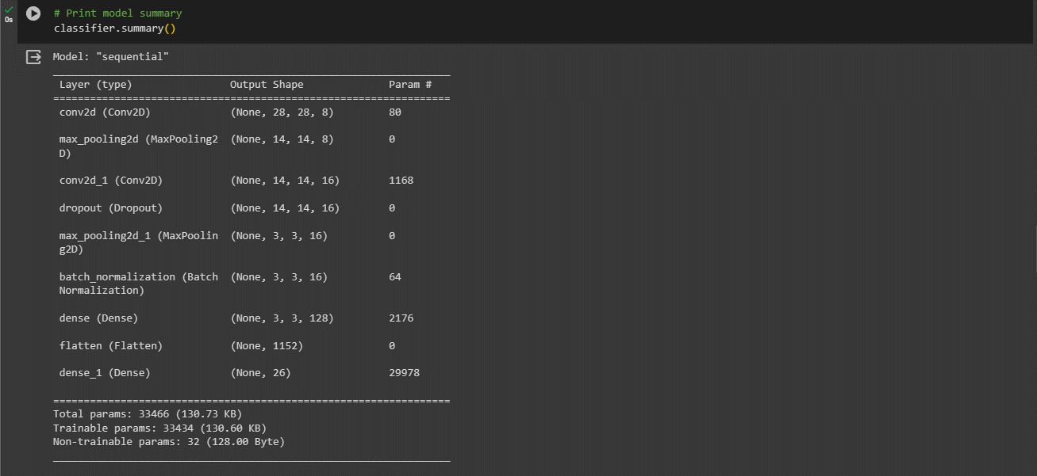

This image illustrates process to save the model to google drive.

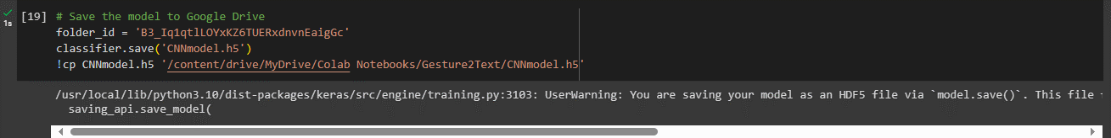

This image illustrates the architecture of CNN model.

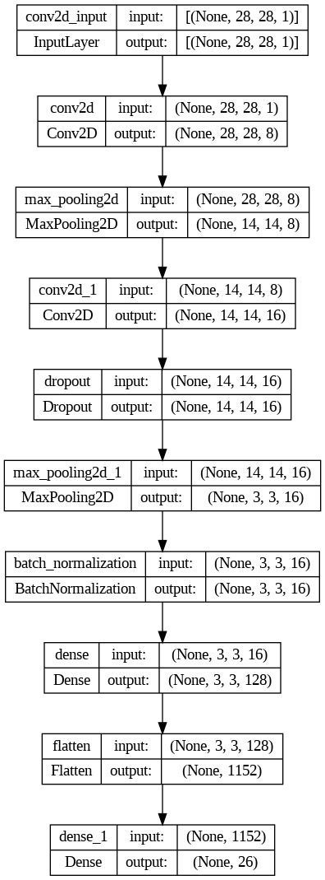

The image captures the running window of the Gesture2Text project, displaying the webcam feed with overlaid translated L. 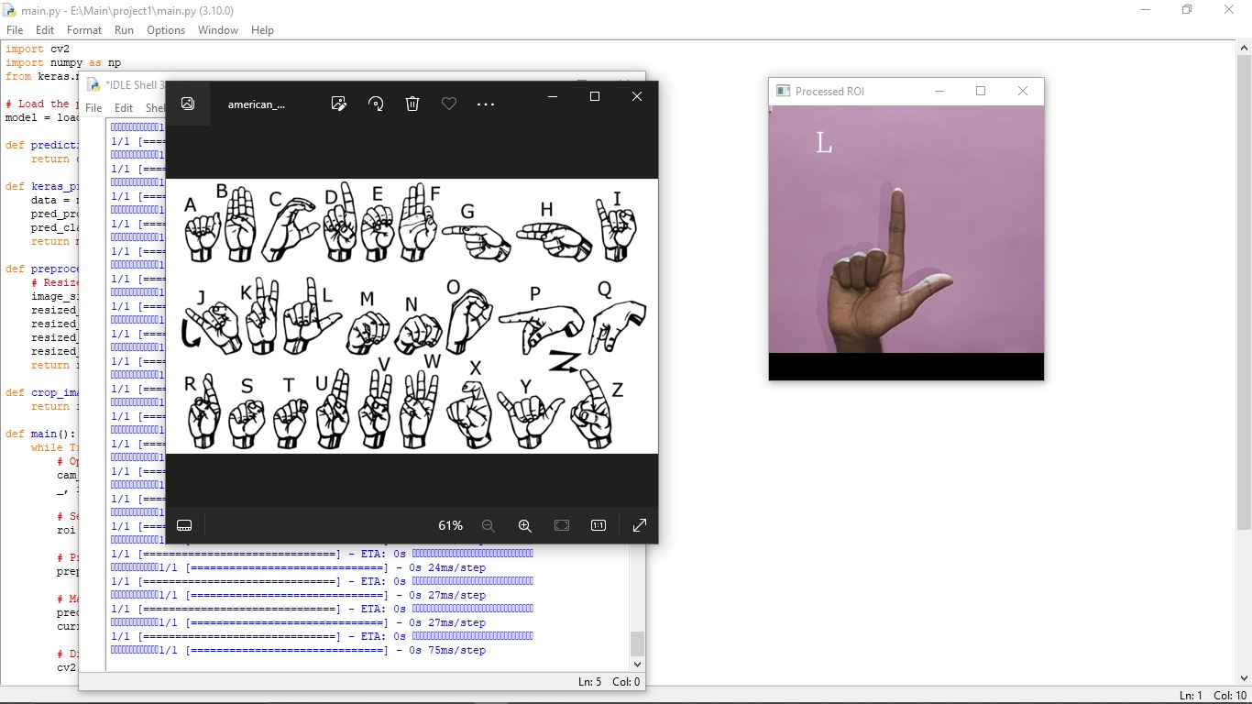

The image captures the running window of the Gesture2Text project, displaying the webcam feed with overlaid translated Y.

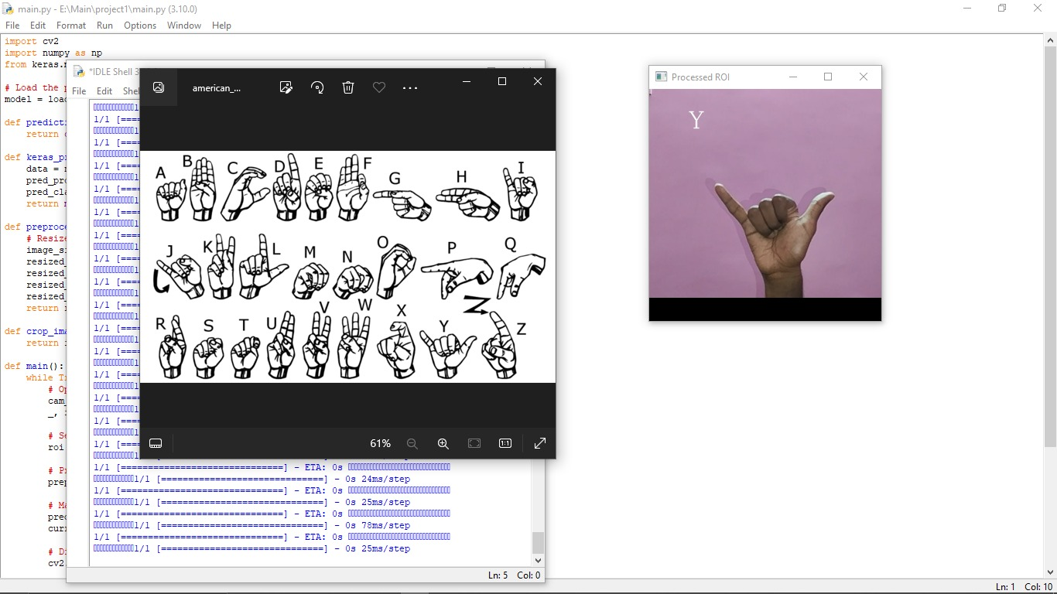

The image captures the running window of the Gesture2Text project, displaying the webcam feed with overlaid translated K.

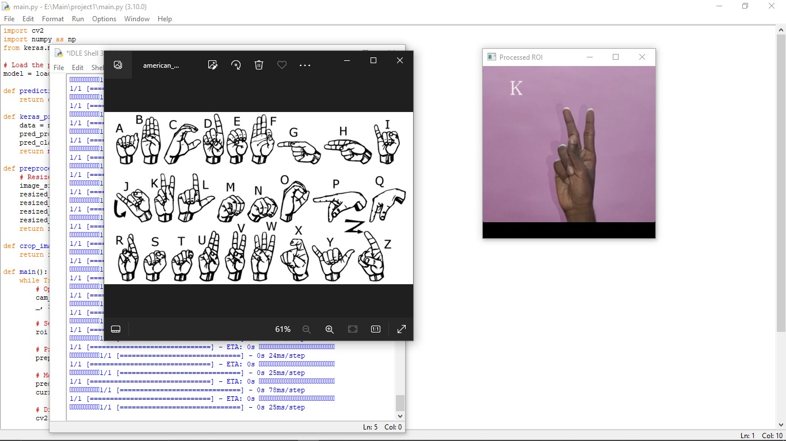

The image captures the running window of the Gesture2Text project, displaying the webcam feed with overlaid translated H.

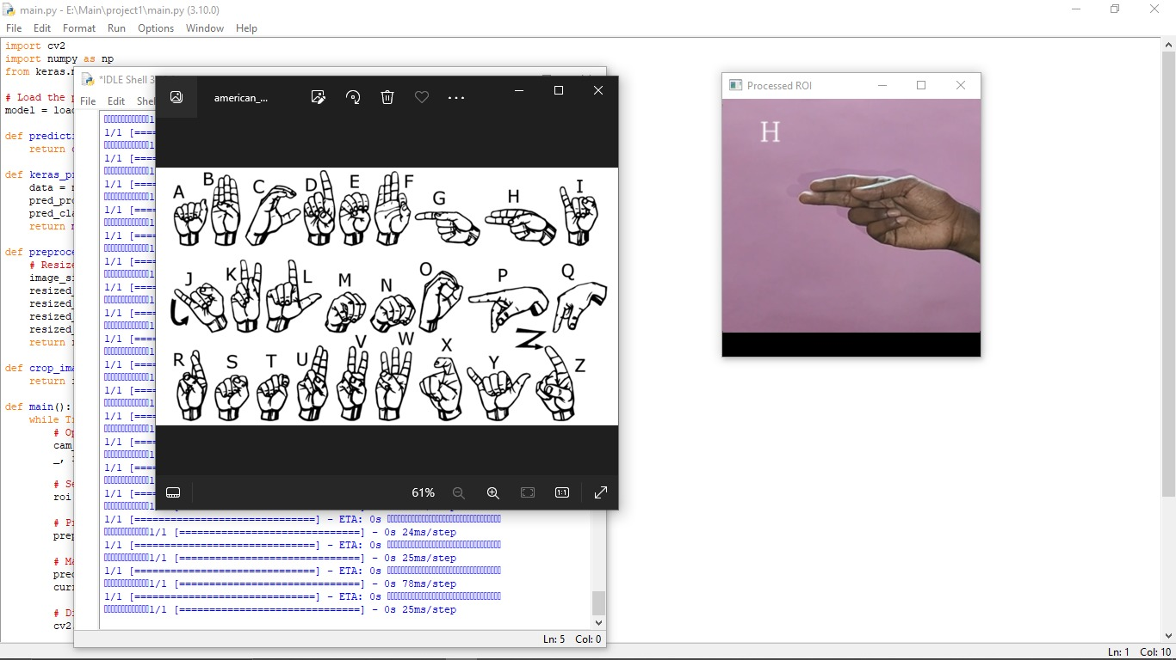

CONCLUSION:-

In the realm of communication accessibility, Gesture2Text stands as a beacon of innovation and inclusivity. This pioneering system harnesses the power of deep learning technology, specifically Convolutional Neural Networks (CNNs), to provide real-time translation of sign language gestures into text format. Its significance lies in its ability to bridge the communication gap between individuals with hearing impairments and those who do not understand sign language, promoting inclusivity and equality in communication.

Gesture2Text represents a groundbreaking advancement in communication accessibility, offering a transformative solution to the challenges faced by individuals with hearing impairments. By leveraging deep learning technology, particularly Convolutional Neural Networks (CNNs), Gesture2Text enables the real-time translation of sign language gestures into written text. This capability revolutionizes communication for individuals who rely on sign language as their primary means of expression, allowing them to engage more fully in conversations and interactions with others.

One of Gesture2Text's most significant contributions is its role in promoting inclusivity and equality in communication. By providing real-time translation of sign language gestures into text format, Gesture2Text ensures that individuals with hearing impairments can effectively communicate with those who do not understand sign language. This promotes greater understanding, empathy, and collaboration between individuals of different linguistic backgrounds, breaking down barriers to communication and fostering a more inclusive society.

Gesture2Text's intuitive and user-friendly interface plays a crucial role in facilitating seamless communication. The main screen features a live webcam feed for capturing sign language gestures, with translated text overlaid for immediate feedback to users. This simplicity ensures accessibility for individuals with varying levels of technological proficiency, enabling efficient and effortless communication.

Furthermore, Gesture2Text offers transparency through the provision of a model summary and insights into data training. While customization settings for gesture recognition are not available, these features contribute to the system's transparency and understanding of its underlying technology. Users can gain insights into the workings of the Convolutional Neural Network (CNN) driving Gesture2Text's functionality, enhancing trust and confidence in the system.

Despite its achievements, Gesture2Text is not without room for improvement. Future iterations could explore the integration of customization settings for gesture recognition, allowing users to tailor the system to their individual preferences and needs. Additionally, ongoing advancements in deep learning technology may present opportunities for further enhancing the accuracy and efficiency of sign language translation.

In conclusion, Gesture2Text represents a significant step forward in leveraging technology to promote communication accessibility and inclusivity. Its intuitive interface, real-time translation capabilities, and commitment to transparency make it a valuable tool for bridging the communication gap between individuals with hearing impairments and the broader society. As technology continues to evolve, Gesture2Text serves as a testament to the transformative potential of innovation in improving the lives of marginalized communities.

FUTURE ENHANCEMENT:-

As Gesture2Text continues to pave the way for improved communication accessibility, there are several avenues for future enhancements that could further elevate its functionality and impact. These potential enhancements span various aspects of the system, including customization options, vocabulary expansion, advanced deep learning techniques, multimodal integration, accessibility features, real-time feedback mechanisms, collaborative features, and continuous learning capabilities.

*Customization Settings:*

Introducing customization options for gesture recognition could significantly enhance the user experience of Gesture2Text. By allowing users to adjust parameters such as gesture sensitivity, recognition speed, or even customize their own gestures, the system becomes more adaptable to individual preferences and communication styles. For instance, users with different signing speeds or styles could adjust the sensitivity to ensure accurate recognition of their gestures. Moreover, the ability to customize gestures would allow users to personalize the system according to their specific needs or preferences, making it more inclusive and accommodating to a diverse range of users.

*Expanded Vocabulary:*

Expanding Gesture2Text's vocabulary is crucial for improving its effectiveness in translating sign language gestures into text. By incorporating additional gestures, symbols, and expressions representing common phrases, idiomatic expressions, or specialized terminology, the system becomes more versatile and capable of accurately translating a broader range of communication scenarios. Furthermore, allowing users to contribute to the vocabulary by adding their own gestures or expressions enables a more personalized and user-driven approach to communication. This not only enhances the system's inclusivity but also fosters a sense of ownership and empowerment among users.

*Advanced Deep Learning Techniques:*

Leveraging advanced deep learning techniques can significantly enhance Gesture2Text's accuracy and efficiency in recognizing and translating sign language gestures. Techniques such as recurrent neural networks (RNNs) or attention mechanisms enable the system to better capture temporal dependencies and nuances in gestures, leading to more accurate translations. Additionally, exploring semi-supervised or unsupervised learning approaches allows Gesture2Text to learn from unlabeled data and adapt to new sign language variations or dialects. By continually improving its learning capabilities, the system becomes more adaptable and robust in diverse communication scenarios.

*Multimodal Integration:*

Integrating multimodal input, such as audio cues or facial expressions, enriches Gesture2Text's understanding of communication contexts and enhances the accuracy of translations. By combining visual and auditory cues, the system gains a more comprehensive understanding of user intent and communication nuances, resulting in more accurate translations. Furthermore, integrating facial expression recognition enables Gesture2Text to detect emotions and incorporate them into the translated messages, enhancing the expressiveness and contextuality of communication.

*Accessibility Features:*

Enhancing accessibility features ensures that Gesture2Text is usable by individuals with diverse needs and abilities. This includes compatibility with assistive devices, support for alternative input methods such as voice commands or gestures, and customizable user interfaces for users with specific accessibility requirements. Additionally, implementing features such as high contrast mode or screen reader compatibility improves accessibility for users with visual impairments, ensuring that Gesture2Text remains inclusive and accessible to all users.

*Real-time Feedback Mechanisms:*

Real-time feedback mechanisms play a crucial role in enhancing the effectiveness of Gesture2Text by providing users with immediate insights into the accuracy of their sign language gestures. By offering real-time feedback on gesture accuracy and recognition confidence levels, users can quickly identify areas for improvement and refine their gestures accordingly. This feature empowers users to enhance their communication effectiveness over time by iteratively adjusting their gestures based on the feedback received.

Moreover, incorporating visual indicators or audio cues can further enhance the real-time feedback experience. Visual cues such as highlighting recognized gestures or displaying confidence scores can provide users with instant feedback on the accuracy of their gestures. Similarly, audio cues such as tones or voice prompts can alert users when gestures are not recognized correctly, prompting them to try again or use alternative gestures.

By providing real-time feedback mechanisms, Gesture2Text not only improves user engagement and satisfaction but also contributes to the overall effectiveness of sign language communication. Users can feel more confident in their interactions knowing that they are receiving immediate feedback on their gestures, which ultimately leads to more accurate translations and better communication outcomes.

*Collaborative Features:*

Introducing collaborative features into Gesture2Text can significantly enhance its utility in various social and professional settings. Real-time sharing of translated messages enables seamless group communication and collaboration, allowing multiple users to participate in conversations simultaneously. This feature is particularly beneficial in scenarios where users need to communicate with each other using sign language, such as group meetings, classrooms, or social gatherings.

Additionally, collaborative editing or annotation features can facilitate collaborative work on documents or presentations using sign language. Users can collaborate in real-time to create, edit, or review content, with Gesture2Text translating their sign language gestures into text for easy collaboration. This enhances productivity and efficiency, enabling users to work together seamlessly regardless of their communication preferences.

By incorporating collaborative features, Gesture2Text becomes a versatile tool for both individual and group communication, fostering collaboration and teamwork in various contexts. Whether used in educational settings, professional environments, or social interactions, Gesture2Text empowers users to communicate effectively and collaborate with others, breaking down communication barriers and promoting inclusivity.

*Continuous Learning Capabilities:*

Implementing mechanisms for continuous learning and adaptation is essential for Gesture2Text to evolve and improve its performance over time. By analyzing user interactions and feedback, the system can refine its algorithms, update its vocabulary, and adapt to new sign language variations or dialects. This continuous learning process enables Gesture2Text to stay up-to-date with evolving communication patterns and user preferences, ensuring its effectiveness and relevance in diverse scenarios.

Moreover, incorporating reinforcement learning techniques allows Gesture2Text to learn from its mistakes and improve its accuracy through experience. By reinforcing correct interpretations and adjusting its algorithms based on feedback, the system can gradually improve its performance and reliability. This iterative learning process enables Gesture2Text to continuously enhance its translation capabilities and provide users with more accurate and reliable translations over time.

By prioritizing continuous learning capabilities, Gesture2Text can remain at the forefront of sign language translation technology, delivering cutting-edge solutions that meet the evolving needs of users. Through ongoing research and development efforts, Gesture2Text can continue to improve its performance, expand its capabilities, and contribute to the advancement of communication accessibility for individuals with hearing impairments.

REFERENCES:-

1. Alemi M, Megahed FM, Zhu Z. Sign Language Recognition Using Convolutional Neural Networks. IEEE Transactions on Human-Machine Systems. 2019 Aug;49(4):321-32. DOI: 10.1109/THMS.2018.2886152
2. Starner T, Pentland A. Real-time American sign language recognition from video using hidden Markov models. Technical report, Massachusetts Institute of Technology, 1995.
3. Le V, Brandao A, Shibata T, Nakamura S, Vidal M. Sign Language Recognition with LSTM and Residual Networks. IEEE Access. 2019 Dec 17;7:171006-15. DOI: 10.1109/ACCESS.2019.2956294
4. Guan X, Wang Q, Guo C. Research on Deep Learning-Based Sign Language Recognition Technology. Advances in Intelligent Systems and Computing. 2020 Feb 20;1141:273-82. DOI: 10.1007/978-3-030-39442-4_33
5. Koller O, Ney H, Bowden R. Deep Hand: How to Train a CNN on 1 Million Hand Images When Your Data is Continuous and Weakly Labelled. International Journal of Computer Vision. 2016 Dec;120(3):359-69. DOI: 10.1007/s11263-016-0921-y
6. GitHub Repository: luvk1412. (2019). Sign-Language-to-Text. Available at: https://github.com/luvk1412/Sign-Language-to-Text. Accessed on [12/2023].
7. GitHub Repository: Devansh-47. (2022). Sign-Language-To-Text-and-Speech-Conversion. Available at: https://github.com/Devansh-47/Sign-Language-To-Text-and-Speech-Conversion. Accessed on [12/2023].
8. GitHub Repository: emnikhil. (2021). Sign-Language-To-Text-Conversion. Available at: https://github.com/emnikhil/Sign-Language-To-Text-Conversion. Accessed on [12/2023].