## Problem Statement: <https://leetcode.com/problems/fizz-buzz/>

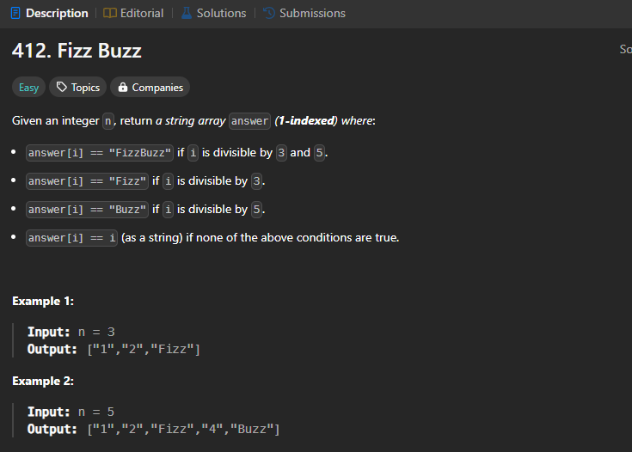

## Simple Iterative Approach:

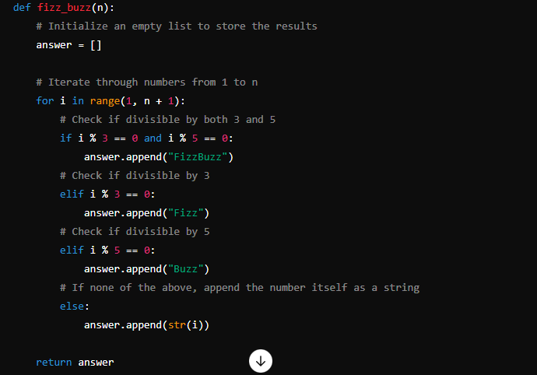

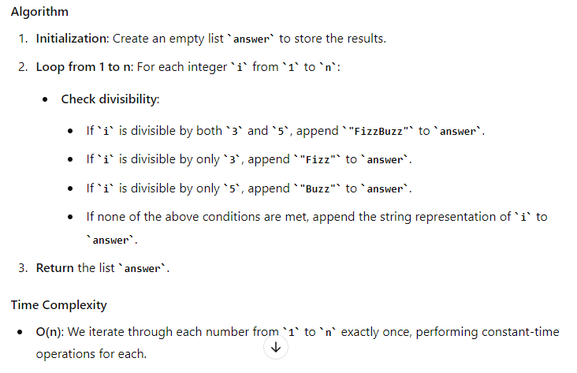

**Method 2: Dictionary based approach**

def fizz_buzz_dict(n):

# Initialize an empty list to store the results

answer = []

# Dictionary to store the divisibility rules

fizz_buzz_dict = {3: "Fizz", 5: "Buzz"}

# Iterate through numbers from 1 to n

for i in range(1, n + 1):

output = ""

# Check divisibility for each key in the dictionary

for key in fizz_buzz_dict:

if i % key == 0:

output += fizz_buzz_dict[key]

# If no divisibility rules match, use the number itself

if output == "":

output = str(i)

# Append the result to the answer list

answer.append(output)

return answer

# Example usage

n = 15

print(fizz_buzz_dict(n)) # Output: ['1', '2', 'Fizz', '4', 'Buzz', 'Fizz', '7', '8', 'Fizz', 'Buzz', '11', 'Fizz', '13', '14', 'FizzBuzz']

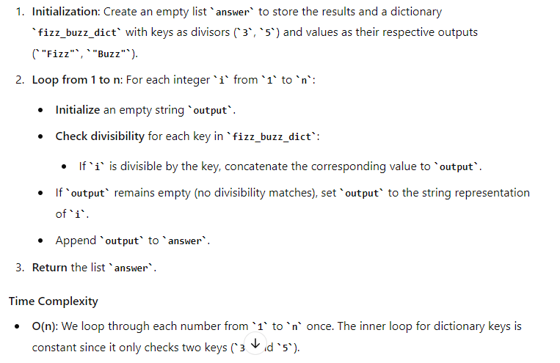

**String Concatenation:**

**def fizz_buzz_concat(n):**

**# Initialize an empty list to store the results**

**answer = []**

**# Iterate through numbers from 1 to n**

**for i in range(1, n + 1):**

**output = ""**

**# Concatenate 'Fizz' if divisible by 3**

**if i % 3 == 0:**

**output += "Fizz"**

**# Concatenate 'Buzz' if divisible by 5**

**if i % 5 == 0:**

**output += "Buzz"**

**# If output is still empty, set it to the current number**

**if output == "":**

**output = str(i)**

**# Append the result to the answer list**

**answer.append(output)**

**return answer**

**# Example usage**

**n = 15**

**print(fizz_buzz_concat(n)) # Output: ['1', '2', 'Fizz', '4', 'Buzz', 'Fizz', '7', '8', 'Fizz', 'Buzz', '11', 'Fizz', '13', '14', 'FizzBuzz']**

