## Problem Statement: <https://leetcode.com/problems/palindrome-number/description/>

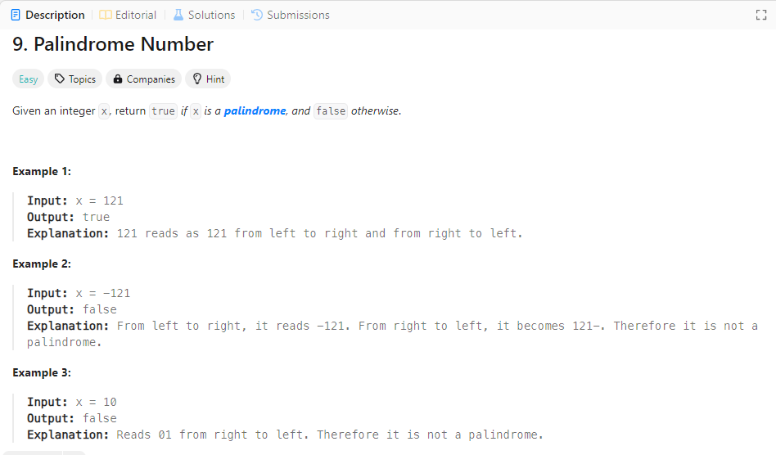

Reverse Number Method:

## def is_palindrome(x: int) -> bool:

## if x < 0:

## return False

## original = x

## reversed_num = 0

## while x > 0:

## reversed_num = reversed_num * 10 + x % 10

## x = x // 10

## return original == reversed_num

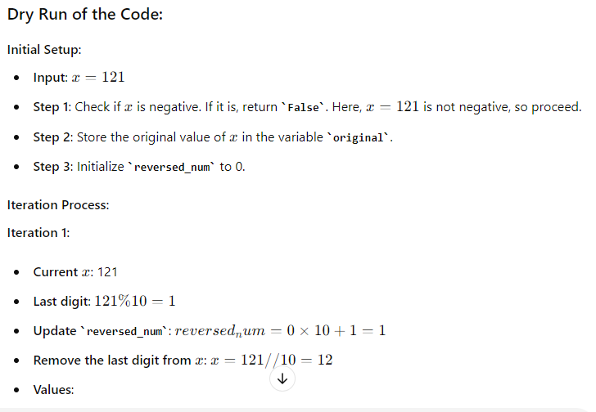

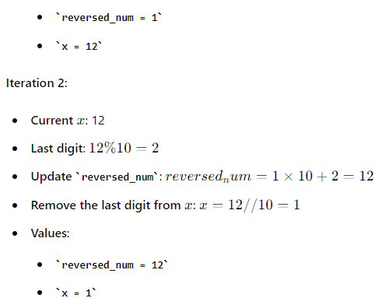

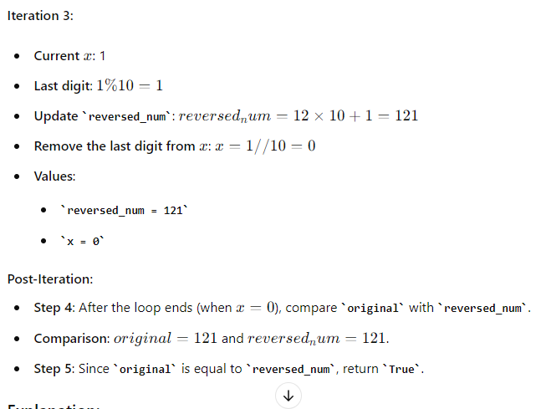

### Time complexity: O(n)

## String conversion Method:

def is_palindrome(x: int) -> bool:

s = str(x)

return s == s[::-1]

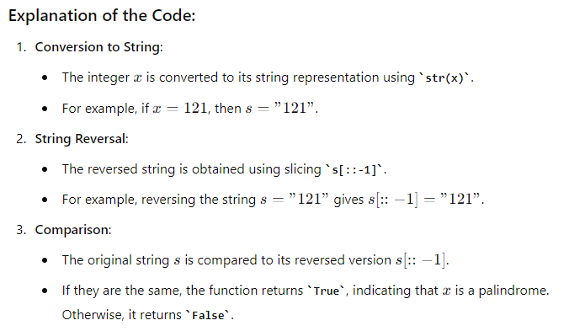

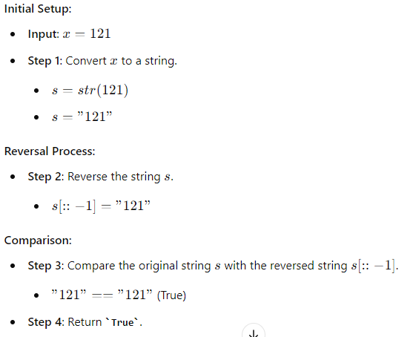

### Two Pointer method:

