1. Design an application that contains Phone Contacts in vertical linear manner. Selected contact appears at the top of the list with a large italicized font and a blue background

Steps:
- You will use Android studio IDE to create an Android application and name it as My Application under a package com.example.saira_000.myapplication.
- Modify src/MainActivity.java file and add required code to take care of making a call.
- Modify layout XML file res/layout/activity_main.xml add any GUI component if required. I'm adding a simple button to Call 91-000-000-0000 number
- No need to define default string constants.Android studio takes care of default constants.
- Modify AndroidManifest.xml as shown below
- Run the application to launch Android emulator and verify the result of the changes done in the application.

Following is the content of the modified main activity file src/MainActivity.java.
package com.example.saira_000.myapplication;

import android.Manifest;
import android.content.Intent;
import android.content.pm.PackageManager;
import android.net.Uri;
import android.os.Bundle;
import android.support.v4.app.ActivityCompat;
import android.support.v7.app.AppCompatActivity;
import android.view.View;
import android.widget.Button;

public class MainActivity extends AppCompatActivity {
private Button button;

@Override
protected void onCreate(Bundle savedInstanceState) {
super.onCreate(savedInstanceState);
setContentView(R.layout.activity_main);
button = (Button) findViewById(R.id.buttonCall);

button.setOnClickListener(new View.OnClickListener() {
public void onClick(View arg0) {
Intent callIntent = new Intent(Intent.ACTION_CALL);
callIntent.setData(Uri.parse("tel:0377778888"));

if (ActivityCompat.checkSelfPermission(MainActivity.this,
Manifest.permission.CALL_PHONE) != PackageManager.PERMISSION_GRANTED) {
return;
}
startActivity(callIntent);
}
});

}
}
Following will be the content of res/layout/activity_main.xml file −
<?xml version="1.0" encoding="utf-8"?>
<LinearLayout xmlns:android="http://schemas.android.com/apk/res/android"
android:layout_width="fill_parent"
android:layout_height="fill_parent"
android:orientation="vertical" >

<Button
android:id="@+id/buttonCall"
android:layout_width="wrap_content"
android:layout_height="wrap_content"
android:text="call 0377778888" />

</LinearLayout>
Following will be the content of res/values/strings.xml to define two new constants −
<?xml version="1.0" encoding="utf-8"?>
<resources>
<string name="app_name">My Application</string>
</resources>
Following is the default content of AndroidManifest.xml −
<?xml version="1.0" encoding="utf-8"?>
<manifest xmlns:android="http://schemas.android.com/apk/res/android"
package="com.example.saira_000.myapplication" >

<uses-permission android:name="android.permission.CALL_PHONE" />

<application
android:allowBackup="true"
android:icon="@drawable/ic_launcher"
android:label="@string/app_name"
android:theme="@style/AppTheme" >

<activity
android:name="com.example.saira_000.myapplication.MainActivity"
android:label="@string/app_name" >

<intent-filter>
<action android:name="android.intent.action.MAIN" />
<category android:name="android.intent.category.LAUNCHER" />
</intent-filter>

</activity>

</application>
</manifest>
Let's try to run your My Application application. I assume you have connected your actual Android Mobile device with your computer. To run the app from Android studio, open one of your project's activity files and click Run icon from the toolbar.Select your mobile device as an option and then check your mobile device which will display following screen −
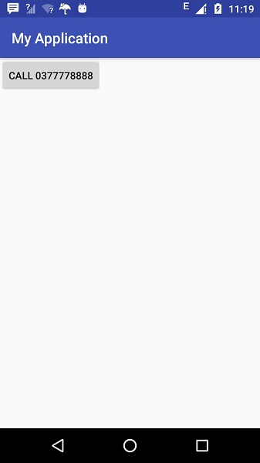
Now use Call button to make phone call as shown below –
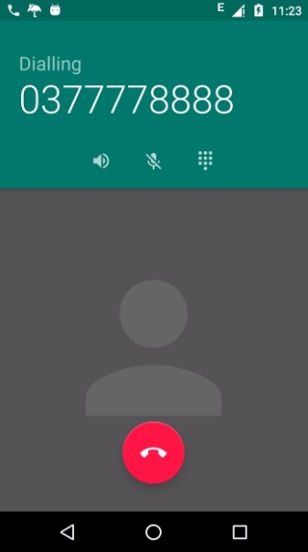

2. Create an application that uses Layout Managers and Event Listeners

Procedure:

Creating a New project:
- Open Android Stdio and then click on File -> New -> New project.
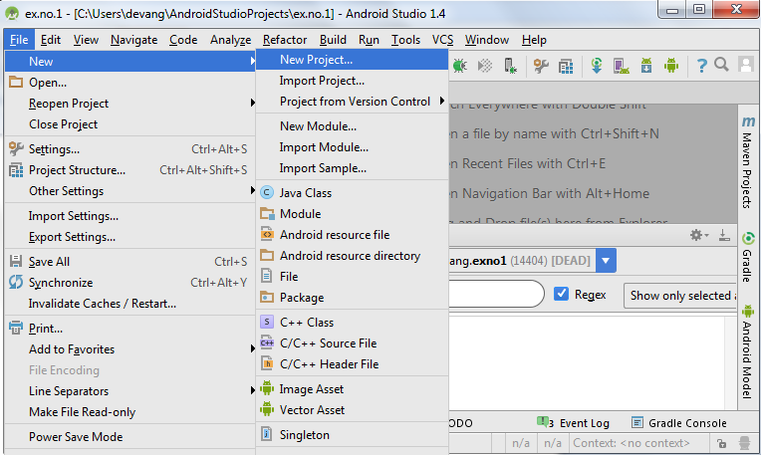
- Then type the Application name as “ex.no.2″ and click Next.
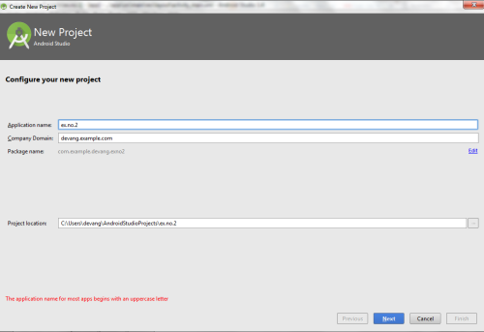
- Then select the Minimum SDK as shown below and click Next.
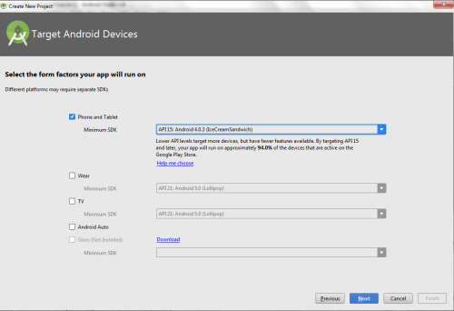
- Then select the Empty Activity and click Next.
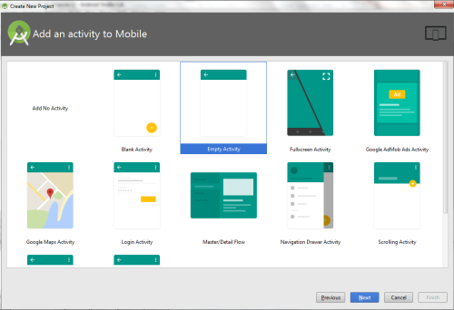
- Finally click Finish.
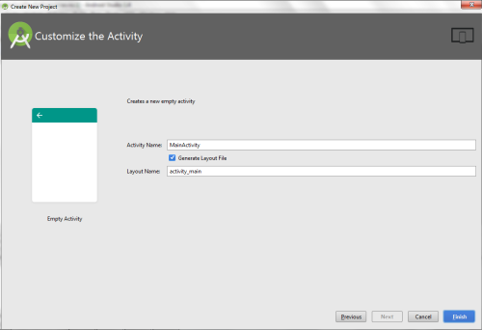
- It will take some time to build and load the project.
- After completion it will look as given below.
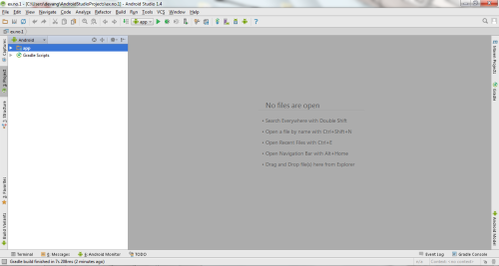

Creating Second Activity for the Android Application:
- Click on File -> New -> Activity -> Empty Activity.
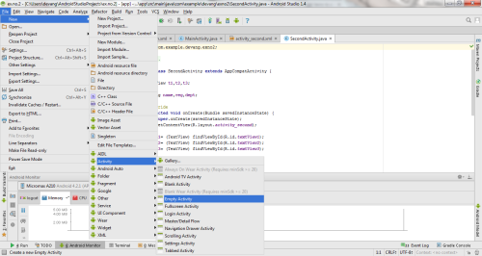
- Type the Activity Name as SecondActivity and click Finish button.
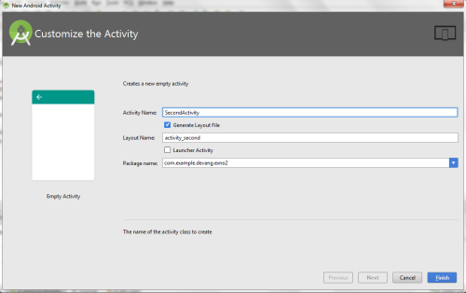
- Thus Second Activity For the application is created.

Designing layout for the Android Application:

Designing Layout for Main Activity:
- Click on app -> res -> layout -> activity_main.xml.
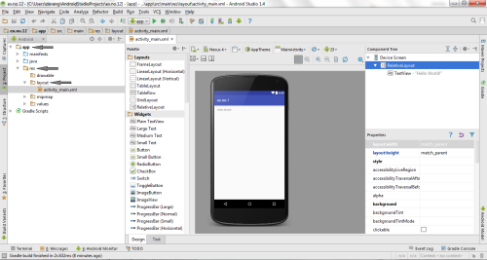
- Now click on Text as shown below.
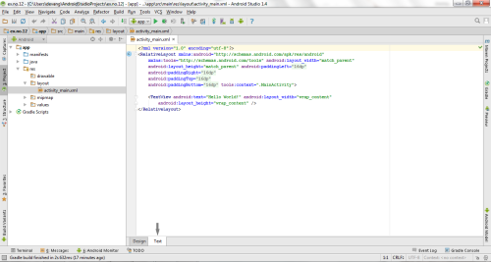
- Then delete the code which is there and type the code as given below.
Code for Activity_main.xml:

<?xml version="1.0" encoding="utf-8"?>
<RelativeLayout xmlns:android="http://schemas.android.com/apk/res/android"
xmlns:tools="http://schemas.android.com/tools"
android:layout_width="match_parent"
android:layout_height="match_parent"
tools:context=".MainActivity">
<LinearLayout
android:layout_width="match_parent"
android:layout_height="100dp">
<TextView
android:id="@+id/textView"
android:layout_width="match_parent"
android:layout_height="wrap_content"
android:layout_margin="30dp"
android:text="Details Form"
android:textSize="25sp"
android:gravity="center"/>
</LinearLayout>

<GridLayout
android:id="@+id/gridLayout"
android:layout_width="match_parent"
android:layout_height="match_parent"
android:layout_marginTop="100dp"
android:layout_marginBottom="200dp"
android:columnCount="2"
android:rowCount="3">
<TextView
android:id="@+id/textView1"
android:layout_width="wrap_content"
android:layout_height="wrap_content"
android:layout_margin="10dp"
android:layout_row="0"
android:layout_column="0"
android:text="Name"
android:textSize="20sp"
android:gravity="center"/>

<EditText
android:id="@+id/editText"
android:layout_width="wrap_content"
android:layout_height="wrap_content"
android:layout_margin="10dp"
android:layout_row="0"
android:layout_column="1"
android:ems="10"/>

<TextView
android:id="@+id/textView2"
android:layout_width="wrap_content"
android:layout_height="wrap_content"
android:layout_margin="10dp"
android:layout_row="1"
android:layout_column="0"
android:text="Reg.No"
android:textSize="20sp"
android:gravity="center"/>

<EditText
android:id="@+id/editText2"
android:layout_width="wrap_content"
android:layout_height="wrap_content"
android:layout_margin="10dp"
android:layout_row="1"
android:layout_column="1"
android:inputType="number"
android:ems="10"/>

<TextView
android:id="@+id/textView3"
android:layout_width="wrap_content"
android:layout_height="wrap_content"
android:layout_margin="10dp"
android:layout_row="2"
android:layout_column="0"
android:text="Dept"
android:textSize="20sp"
android:gravity="center"/>

<Spinner
android:id="@+id/spinner"
android:layout_width="wrap_content"
android:layout_height="wrap_content"
android:layout_margin="10dp"
android:layout_row="2"
android:layout_column="1"
android:spinnerMode="dropdown"/>

</GridLayout>

<Button
android:id="@+id/button"
android:layout_width="wrap_content"
android:layout_height="wrap_content"
android:layout_alignParentBottom="true"
android:layout_centerInParent="true"
android:layout_marginBottom="150dp"
android:text="Submit"/>

</RelativeLayout>
- Now click on Design and your activity will look as given below.
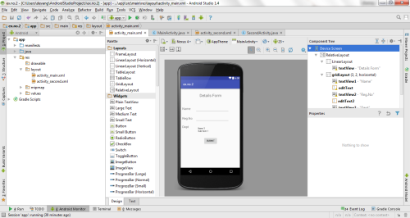
- So now the designing part of Main Activity is completed.

Designing Layout for Second Activity:
- Click on app -> res -> layout -> activity_second.xml.
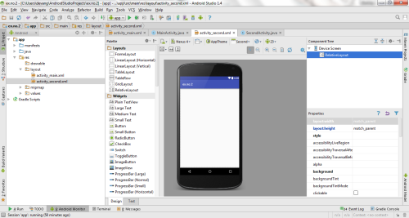
- Now click on Text as shown below.
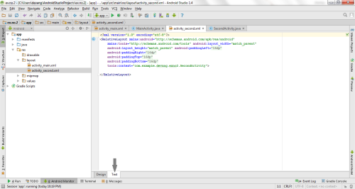
- Then delete the code which is there and type the code as given below.
Code for Activity_second.xml:

<?xml version="1.0" encoding="utf-8"?>
<LinearLayout xmlns:android="http://schemas.android.com/apk/res/android"
xmlns:tools="http://schemas.android.com/tools"
android:layout_width="match_parent"
android:layout_height="match_parent"
tools:context="com.example.devang.exno2.SecondActivity"
android:orientation="vertical"
android:gravity="center">

<TextView
android:id="@+id/textView1"
android:layout_width="wrap_content"
android:layout_height="wrap_content"
android:layout_margin="20dp"
android:text="New Text"
android:textSize="30sp"/>

<TextView
android:id="@+id/textView2"
android:layout_width="wrap_content"
android:layout_height="wrap_content"
android:layout_margin="20dp"
android:text="New Text"
android:textSize="30sp"/>

<TextView
android:id="@+id/textView3"
android:layout_width="wrap_content"
android:layout_height="wrap_content"
android:layout_margin="20dp"
android:text="New Text"
android:textSize="30sp"/>

</LinearLayout>
- Now click on Design and your activity will look as given below.
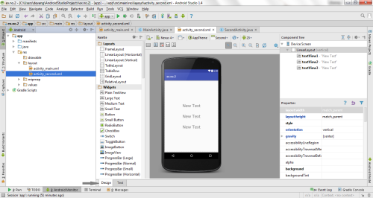
- So now the designing part of Second Activity is also completed.

Java Coding for the Android Application:

Java Coidng for Main Activity:
- Click on app -> java -> com.example.exno2 -> MainActivity.
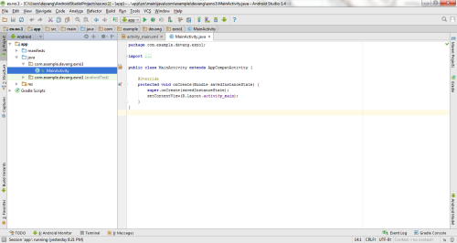
- Then delete the code which is there and type the code as given below.
Code for MainActivity.java:

package com.example.exno2;
import android.content.Intent;
import android.support.v7.app.AppCompatActivity;
import android.os.Bundle;
import android.view.View;
import android.widget.ArrayAdapter;
import android.widget.Button;
import android.widget.EditText;
import android.widget.Spinner;

public class MainActivity extends AppCompatActivity {

//Defining the Views
EditText e1,e2;
Button bt;
Spinner s;
//Data for populating in Spinner
String [] dept_array={"CSE","ECE","IT","Mech","Civil"};
String name,reg,dept;
@Override
protected void onCreate(Bundle savedInstanceState) {
super.onCreate(savedInstanceState);
setContentView(R.layout.activity_main);
//Referring the Views
e1= (EditText) findViewById(R.id.editText);
e2= (EditText) findViewById(R.id.editText2);

bt= (Button) findViewById(R.id.button);
s= (Spinner) findViewById(R.id.spinner);
//Creating Adapter for Spinner for adapting the data from array to Spinner
ArrayAdapter adapter= new ArrayAdapter(MainActivity.this,android.R.layout.simple_spinner_item,dept_array);
s.setAdapter(adapter);
//Creating Listener for Button
bt.setOnClickListener(new View.OnClickListener() {
@Override
public void onClick(View v) {
//Getting the Values from Views(Edittext & Spinner)
name=e1.getText().toString();
reg=e2.getText().toString();
dept=s.getSelectedItem().toString();
//Intent For Navigating to Second Activity
Intent i = new Intent(MainActivity.this,SecondActivity.class);
//For Passing the Values to Second Activity
i.putExtra("name_key", name);
i.putExtra("reg_key",reg);
i.putExtra("dept_key", dept);
startActivity(i);
}
});
}
}
So now the Coding part of Main Activity is completed. Java Coding for Second Activity:
Click on app -> java -> com.example.exno2 -> SecondActivity.
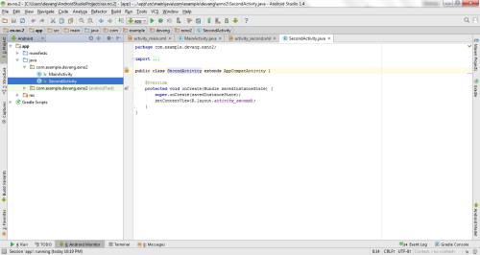
Then delete the code which is there and type the code as given below.
Code for SecondActivity.java:

package com.example.exno2;
import android.content.Intent;
import android.support.v7.app.AppCompatActivity;
import android.os.Bundle;
import android.widget.TextView;
public class SecondActivity extends AppCompatActivity {
TextView t1,t2,t3;
String name,reg,dept;
@Override
protected void onCreate(Bundle savedInstanceState) {
super.onCreate(savedInstanceState);
setContentView(R.layout.activity_second);
t1= (TextView) findViewById(R.id.textView1);
t2= (TextView) findViewById(R.id.textView2);
t3= (TextView) findViewById(R.id.textView3);
//Getting the Intent
Intent i = getIntent();
//Getting the Values from First Activity using the Intent received
name=i.getStringExtra("name_key");
reg=i.getStringExtra("reg_key");
dept=i.getStringExtra("dept_key");
//Setting the Values to Intent
t1.setText(name);
t2.setText(reg);
t3.setText(dept);
}
}
- So now the Coding part of Second Activity is also completed.
- Now run the application to see the output.

Output:
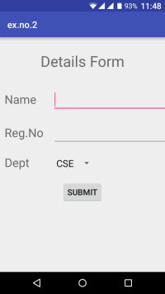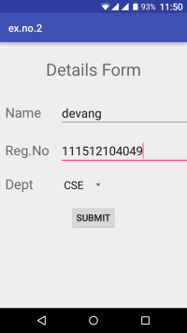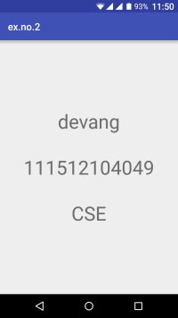

3. Develop a standard calculator application to perform basic calculations like addition, subtraction, multiplication and division.

Creating a New project:
- Open Android Stdio and then click on File -> New -> New project.
- Then type the Application name as “ex.no.3″ and click Next.
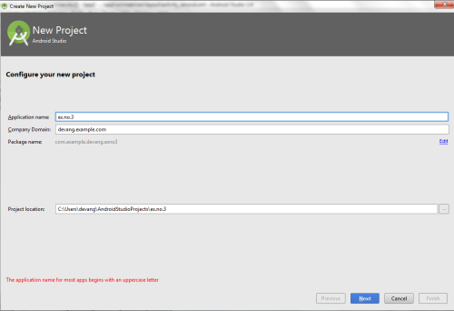
- Then select the Minimum SDK as shown below and click Next.
- Then select the Empty Activity and click Next.
- Finally click Finish.
- It will take some time to build and load the project.
- After completion it will look as given below.

Designing layout for the Android Application:
- Click on app -> res -> layout -> activity_main.xml.
- Now click on Text as shown below.
- Then delete the code which is there and type the code as given below.
Code for Activity_main.xml:

<?xml version="1.0" encoding="utf-8"?>
<LinearLayout
xmlns:android="http://schemas.android.com/apk/res/android"
android:orientation="vertical"
android:layout_width="match_parent"
android:layout_height="match_parent"
android:layout_margin="20dp">
<LinearLayout
android:id="@+id/linearLayout1"
android:layout_width="match_parent"
android:layout_height="wrap_content"
android:layout_margin="20dp">
<EditText
android:id="@+id/editText1"
android:layout_width="match_parent"
android:layout_height="wrap_content"
android:layout_weight="1"
android:inputType="numberDecimal"
android:textSize="20sp" />
<EditText
android:id="@+id/editText2"
android:layout_width="match_parent"
android:layout_height="wrap_content"
android:layout_weight="1"
android:inputType="numberDecimal"
android:textSize="20sp" />
</LinearLayout>

<LinearLayout
android:id="@+id/linearLayout2"
android:layout_width="match_parent"
android:layout_height="wrap_content"
android:layout_margin="20dp">
<Button
android:id="@+id/Add"
android:layout_width="match_parent"
android:layout_height="wrap_content"
android:layout_weight="1"
android:text="+"
android:textSize="30sp"/>
<Button
android:id="@+id/Sub"
android:layout_width="match_parent"
android:layout_height="wrap_content"
android:layout_weight="1"
android:text="-"
android:textSize="30sp"/>
<Button
android:id="@+id/Mul"
android:layout_width="match_parent"
android:layout_height="wrap_content"
android:layout_weight="1"
android:text="*"
android:textSize="30sp"/>
<Button
android:id="@+id/Div"
android:layout_width="match_parent"
android:layout_height="wrap_content"
android:layout_weight="1"
android:text="/"
android:textSize="30sp"/>
</LinearLayout>
<TextView
android:id="@+id/textView"
android:layout_width="match_parent"
android:layout_height="wrap_content"
android:layout_marginTop="50dp"
android:text="Answer is"
android:textSize="30sp"
android:gravity="center"/>
</LinearLayout>
- Now click on Design and your application will look as given below.
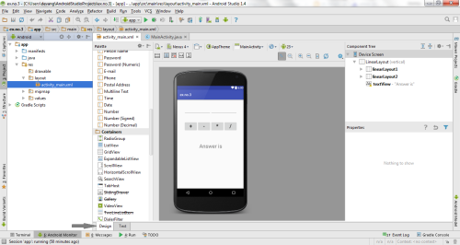
- So now the designing part is completed.

Java Coding for the Android Application:
- Click on app -> java -> com.example.exno3 -> MainActivity.
- Then delete the code which is there and type the code as given below.
Code for MainActivity.java:

package com.example.devang.exno3;
import android.os.Bundle;
import android.support.v7.app.AppCompatActivity;
import android.text.TextUtils;
import android.view.View;
import android.view.View.OnClickListener;
import android.widget.Button;
import android.widget.EditText;
import android.widget.TextView;
public class MainActivity extends AppCompatActivity implements OnClickListener
{
//Defining the Views
EditText Num1;
EditText Num2;
Button Add;
Button Sub;
Button Mul;
Button Div;
TextView Result;

@Override
public void onCreate(Bundle savedInstanceState)
{
super.onCreate(savedInstanceState);
setContentView(R.layout.activity_main);
//Referring the Views
Num1 = (EditText) findViewById(R.id.editText1);
Num2 = (EditText) findViewById(R.id.editText2);
Add = (Button) findViewById(R.id.Add);
Sub = (Button) findViewById(R.id.Sub);
Mul = (Button) findViewById(R.id.Mul);
Div = (Button) findViewById(R.id.Div);
Result = (TextView) findViewById(R.id.textView);
// set a listener
Add.setOnClickListener(this);
Sub.setOnClickListener(this);
Mul.setOnClickListener(this);
Div.setOnClickListener(this);
}

@Override
public void onClick (View v)
{

float num1 = 0;
float num2 = 0;
float result = 0;
String oper = "";

// check if the fields are empty
if (TextUtils.isEmpty(Num1.getText().toString()) || TextUtils.isEmpty(Num2.getText().toString()))
return;
// read EditText and fill variables with numbers
num1 = Float.parseFloat(Num1.getText().toString());
num2 = Float.parseFloat(Num2.getText().toString());
// defines the button that has been clicked and performs the corresponding operation
// write operation into oper, we will use it later for output
switch (v.getId())
{
case R.id.Add:
oper = "+";
result = num1 + num2;
break;
case R.id.Sub:
oper = "-";
result = num1 - num2;
break;
case R.id.Mul:
oper = "*";
result = num1 * num2;
break;
case R.id.Div:
oper = "/";
result = num1 / num2;
break;
default:
break;
}
// form the output line
Result.setText(num1 + " " + oper + " " + num2 + " = " + result);
}
}
- So now the Coding part is also completed.
- Now run the application to see the output.

Output:
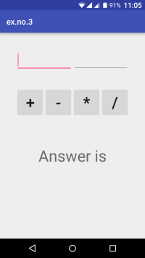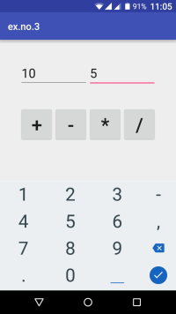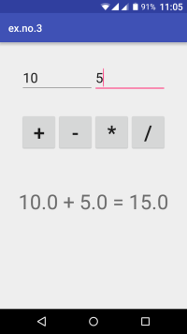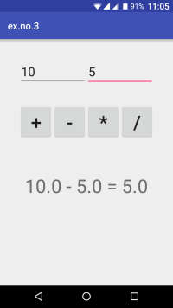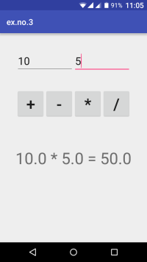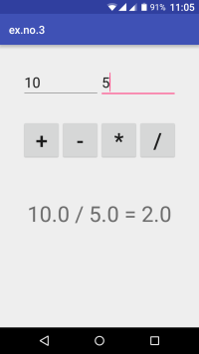

4. Devise an application that draws basic graphical primitives (rectangle, circle) on the screen Android Application to draw Basic Graphical Primitives

Creating a New project:
- Open Android Studio and then click on File -> New -> New project.
- Then type the Application name as “ex.no.4″ and click Next.
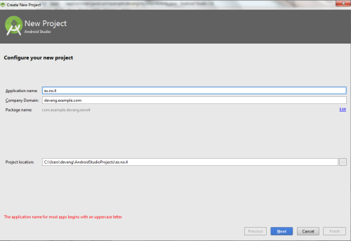
- Then select the Minimum SDK as shown below and click Next.
- Then select the Empty Activity and click Next.
- Finally click Finish.
- It will take some time to build and load the project.
- After completion it will look as given below.

Designing layout for the Android Application:
- Click on app -> res -> layout -> activity_main.xml.
- Now click on Text as shown below.
- Then delete the code which is there and type the code as given below.
Code for Activity_main.xml:

<?xml version="1.0" encoding="utf-8"?>
<RelativeLayout xmlns:android="http://schemas.android.com/apk/res/android"
android:layout_width="match_parent"
android:layout_height="match_parent">
<ImageView
android:layout_width="match_parent"
android:layout_height="match_parent"
android:id="@+id/imageView" />
</RelativeLayout>
- Now click on Design and your application will look as given below.
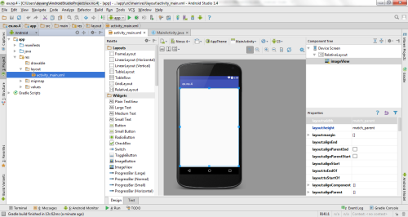
- So now the designing part is completed.

Java Coding for the Android Application:
- Click on app -> java -> com.example.exno4 -> MainActivity.
- Then delete the code which is there and type the code as given below.
Code for MainActivity.java:

package com.example.exno4;
import android.app.Activity;
import android.graphics.Bitmap;
import android.graphics.Canvas;
import android.graphics.Color;
import android.graphics.Paint;
import android.graphics.drawable.BitmapDrawable;
import android.os.Bundle;
import android.widget.ImageView;
public class MainActivity extends Activity
{
@Override
public void onCreate(Bundle savedInstanceState)
{
super.onCreate(savedInstanceState);
setContentView(R.layout.activity_main);
//Creating a Bitmap
Bitmap bg = Bitmap.createBitmap(720, 1280, Bitmap.Config.ARGB_8888);
//Setting the Bitmap as background for the ImageView
ImageView i = (ImageView) findViewById(R.id.imageView);
i.setBackgroundDrawable(new BitmapDrawable(bg));
//Creating the Canvas Object
Canvas canvas = new Canvas(bg);
//Creating the Paint Object and set its color & TextSize
Paint paint = new Paint();
paint.setColor(Color.BLUE);
paint.setTextSize(50);
//To draw a Rectangle
canvas.drawText("Rectangle", 420, 150, paint);
canvas.drawRect(400, 200, 650, 700, paint);
//To draw a Circle
canvas.drawText("Circle", 120, 150, paint);
canvas.drawCircle(200, 350, 150, paint);
//To draw a Square
canvas.drawText("Square", 120, 800, paint);
canvas.drawRect(50, 850, 350, 1150, paint);
//To draw a Line
canvas.drawText("Line", 480, 800, paint);
canvas.drawLine(520, 850, 520, 1150, paint);
}
}
- So now the Coding part is also completed.
- Now run the application to see the output.

Output:
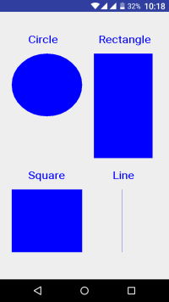

5. Build an mobile application that create, save, update and delete data in a database

Procedure:s

Creating a New project:
- Open Android Studio and then click on File -> New -> New project.
- Then type the Application name as “ex.no.5″ and click Next.
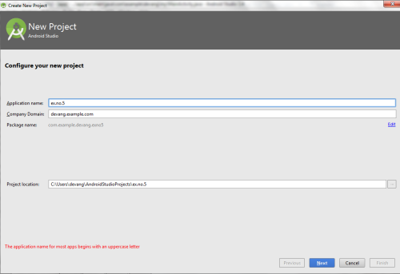
- Then select the Minimum SDK as shown below and click Next.
- Then select the Empty Activity and click Next.
- Finally click Finish.
- It will take some time to build and load the project.
- After completion it will look as given below.

Designing layout for the Android Application:
- Click on app -> res -> layout -> activity_main.xml.
- Now click on Text as shown below.
- Then delete the code which is there and type the code as given below.
Code for Activity_main.xml:
?
<?xml version="1.0" encoding="utf-8"?>
<AbsoluteLayout xmlns:android="http://schemas.android.com/apk/res/android"
android:layout_width="match_parent"
android:layout_height="match_parent">
<TextView
android:layout_width="wrap_content"
android:layout_height="wrap_content"
android:layout_x="50dp"
android:layout_y="20dp"
android:text="Student Details"
android:textSize="30sp" />
<TextView
android:layout_width="wrap_content"
android:layout_height="wrap_content"
android:layout_x="20dp"
android:layout_y="110dp"
android:text="Enter Rollno:"
android:textSize="20sp" />
<EditText
android:id="@+id/Rollno"
android:layout_width="150dp"
android:layout_height="wrap_content"
android:layout_x="175dp"
android:layout_y="100dp"
android:inputType="number"
android:textSize="20sp" />
<TextView
android:layout_width="wrap_content"
android:layout_height="wrap_content"
android:layout_x="20dp"
android:layout_y="160dp"
android:text="Enter Name:"
android:textSize="20sp" />
<EditText
android:id="@+id/Name"
android:layout_width="150dp"
android:layout_height="wrap_content"
android:layout_x="175dp"
android:layout_y="150dp"
android:inputType="text"
android:textSize="20sp" />
<TextView
android:layout_width="wrap_content"
android:layout_height="wrap_content"
android:layout_x="20dp"
android:layout_y="210dp"
android:text="Enter Marks:"
android:textSize="20sp" />
<EditText
android:id="@+id/Marks"
android:layout_width="150dp"
android:layout_height="wrap_content"
android:layout_x="175dp"
android:layout_y="200dp"
android:inputType="number"
android:textSize="20sp" />
<Button
android:id="@+id/Insert"
android:layout_width="150dp"
android:layout_height="wrap_content"
android:layout_x="25dp"
android:layout_y="300dp"
android:text="Insert"
android:textSize="30dp" />
<Button
android:id="@+id/Delete"
android:layout_width="150dp"
android:layout_height="wrap_content"
android:layout_x="200dp"
android:layout_y="300dp"
android:text="Delete"
android:textSize="30dp" /
<Button
android:id="@+id/Update"
android:layout_width="150dp"
android:layout_height="wrap_content"
android:layout_x="25dp"
android:layout_y="400dp"
android:text="Update"
android:textSize="30dp" />
<Button
android:id="@+id/View"
android:layout_width="150dp"
android:layout_height="wrap_content"
android:layout_x="200dp"
android:layout_y="400dp"
android:text="View"
android:textSize="30dp" />
<Button
android:id="@+id/ViewAll"
android:layout_width="200dp"
android:layout_height="wrap_content"
android:layout_x="100dp"
android:layout_y="500dp"
android:text="View All"
android:textSize="30dp" />
</AbsoluteLayout>
Now click on Design and your application will look as given below.
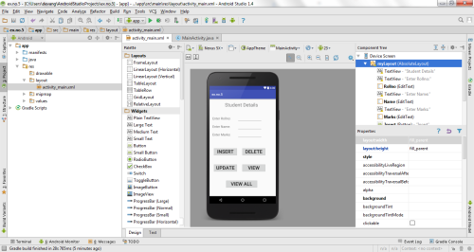
- So now the designing part is completed.

Java Coding for the Android Application:
- Click on app -> java -> com.example.exno5 -> MainActivity.
- Then delete the code which is there and type the code as given below.

Code for MainActivity.java:

package com.example.exno5;
import android.app.Activity;
import android.app.AlertDialog.Builder;
import android.content.Context;
import android.database.Cursor;
import android.database.sqlite.SQLiteDatabase;
import android.os.Bundle;
import android.view.View;
import android.view.View.OnClickListener;
import android.widget.Button;
import android.widget.EditText;
public class MainActivity extends Activity implements OnClickListener
{
EditText Rollno,Name,Marks;
Button Insert,Delete,Update,View,ViewAll;
SQLiteDatabase db;
/** Called when the activity is first created. */
@Override
public void onCreate(Bundle savedInstanceState)
{
super.onCreate(savedInstanceState);
setContentView(R.layout.activity_main);
Rollno=(EditText)findViewById(R.id.Rollno);
Name=(EditText)findViewById(R.id.Name);
Marks=(EditText)findViewById(R.id.Marks);
Insert=(Button)findViewById(R.id.Insert);
Delete=(Button)findViewById(R.id.Delete);
Update=(Button)findViewById(R.id.Update);
View=(Button)findViewById(R.id.View);
ViewAll=(Button)findViewById(R.id.ViewAll);
Insert.setOnClickListener(this);
Delete.setOnClickListener(this);
Update.setOnClickListener(this);
View.setOnClickListener(this);
ViewAll.setOnClickListener(this);
// Creating database and table
db=openOrCreateDatabase("StudentDB", Context.MODE_PRIVATE, null);
db.execSQL("CREATE TABLE IF NOT EXISTS student(rollno VARCHAR,name VARCHAR,marks
VARCHAR);");
}
public void onClick(View view)
{
// Inserting a record to the Student table
if(view==Insert)
{
// Checking for empty fields
if(Rollno.getText().toString().trim().length()==0||
Name.getText().toString().trim().length()==0||
Marks.getText().toString().trim().length()==0)
{
showMessage("Error", "Please enter all values");
return;
}
db.execSQL("INSERT INTO student VALUES('"+Rollno.getText()+"','"+Name.getText()+
"','"+Marks.getText()+"');");
showMessage("Success", "Record added");
clearText();
}
// Deleting a record from the Student table
if(view==Delete)
{
// Checking for empty roll number
if(Rollno.getText().toString().trim().length()==0)
{
showMessage("Error", "Please enter Rollno");
return;
}
Cursor c=db.rawQuery("SELECT * FROM student WHERE rollno='"+Rollno.getText()+"'", null);
if(c.moveToFirst())
{
db.execSQL("DELETE FROM student WHERE rollno='"+Rollno.getText()+"'");
showMessage("Success", "Record Deleted");
}
else
{
showMessage("Error", "Invalid Rollno");
}
clearText();
}
// Updating a record in the Student table
if(view==Update)
{
// Checking for empty roll number
if(Rollno.getText().toString().trim().length()==0)
{
showMessage("Error", "Please enter Rollno");
return;
}
Cursor c=db.rawQuery("SELECT * FROM student WHERE rollno='"+Rollno.getText()+"'", null);
if(c.moveToFirst()) {
db.execSQL("UPDATE student SET name='" + Name.getText() + "',marks='" + Marks.getText() +
"' WHERE rollno='"+Rollno.getText()+"'");
showMessage("Success", "Record Modified");
}
else {
showMessage("Error", "Invalid Rollno");
}
clearText();
}
// Display a record from the Student table
if(view==View)
{
// Checking for empty roll number
if(Rollno.getText().toString().trim().length()==0)
{
showMessage("Error", "Please enter Rollno");
return;
}
Cursor c=db.rawQuery("SELECT * FROM student WHERE rollno='"+Rollno.getText()+"'", null);
if(c.moveToFirst())
{
Name.setText(c.getString(1));
Marks.setText(c.getString(2));
}
else
{
showMessage("Error", "Invalid Rollno");
clearText();
}
}
// Displaying all the records
if(view==ViewAll)
{
Cursor c=db.rawQuery("SELECT * FROM student", null);
if(c.getCount()==0)
{
showMessage("Error", "No records found");
return;
}
StringBuffer buffer=new StringBuffer();
while(c.moveToNext())
{
buffer.append("Rollno: "+c.getString(0)+"\n");
buffer.append("Name: "+c.getString(1)+"\n");
buffer.append("Marks: "+c.getString(2)+"\n\n");
}
showMessage("Student Details", buffer.toString());
}
}
public void showMessage(String title,String message)
{
Builder builder=new Builder(this);
builder.setCancelable(true);
builder.setTitle(title);
builder.setMessage(message);
builder.show();
}
public void clearText()
{
Rollno.setText("");
Name.setText("");
Marks.setText("");
Rollno.requestFocus();
}
}
- So now the Coding part is also completed.
- Now run the application to see the output.

Output:
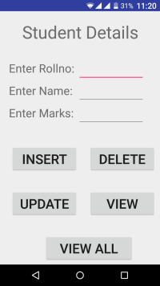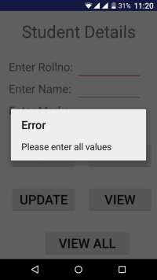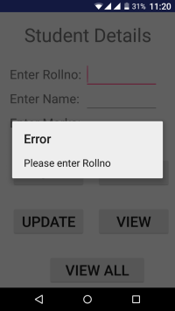
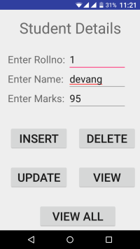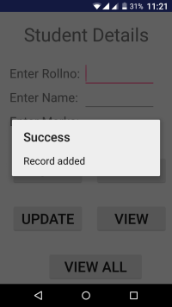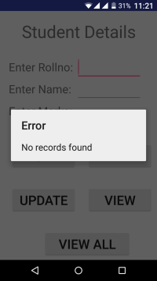
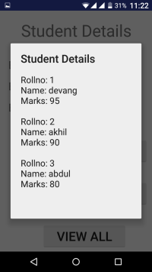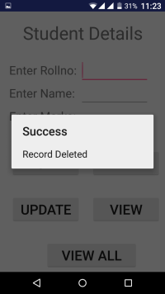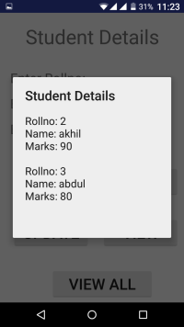
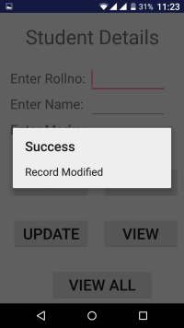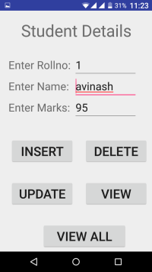

6. Devise an application that implements Multi threading

Procedure:

Creating a New project:
- Open Android Studio and then click on File -> New -> New project.
- Then type the Application name as “ex.no.7″ and click Next.
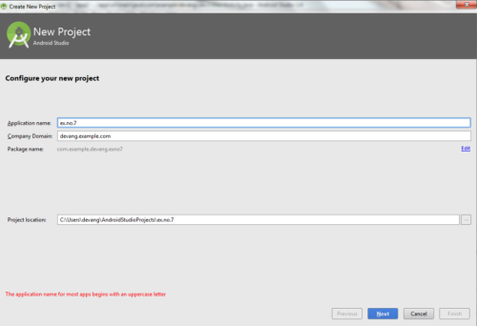
- Then select the Minimum SDK as shown below and click Next.
- Then select the Empty Activity and click Next.
- Finally click Finish.
- It will take some time to build and load the project.
- After completion it will look as given below.

Designing layout for the Android Application:
- Click on app -> res -> layout -> activity_main.xml
- Now click on Text as shown below.
- Then delete the code which is there and type the code as given below.
Code for Activity_main.xml:
?
<?xml version="1.0" encoding="utf-8"?>
<LinearLayout xmlns:android="http://schemas.android.com/apk/res/android"
android:layout_width="match_parent"
android:layout_height="match_parent"
android:orientation="vertical" >

<ImageView
android:id="@+id/imageView"
android:layout_width="250dp"
android:layout_height="250dp"
android:layout_margin="50dp"
android:layout_gravity="center" />
<Button
android:id="@+id/button"
android:layout_width="wrap_content"
android:layout_height="wrap_content"
android:layout_margin="10dp"
android:layout_gravity="center"
android:text="Load Image 1" />
<Button
android:id="@+id/button2"
android:layout_width="wrap_content"
android:layout_height="wrap_content"
android:layout_margin="10dp"
android:layout_gravity="center"
android:text="Load image 2" />
</LinearLayout>

- Now click on Design and your application will look as given below.
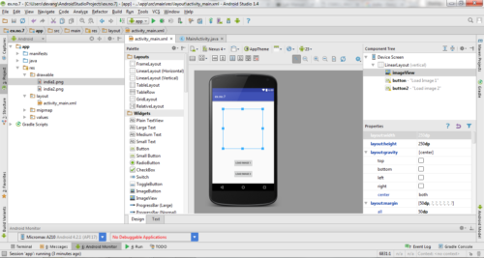
- So now the designing part is completed. Java Coding for the Android Application:
- Click on app -> java -> com.example.exno7 -> MainActivity.
- Then delete the code which is there and type the code as given below.
Code for MainActivity.java:

package com.example.exno7;
import android.os.Bundle;
import android.support.v7.app.AppCompatActivity;
import android.view.View;
import android.widget.Button;
import android.widget.ImageView;
public class MainActivity extends AppCompatActivity
{
ImageView img;
Button bt1,bt2;
@Override
protected void onCreate(Bundle savedInstanceState)
{
super.onCreate(savedInstanceState);
setContentView(R.layout.activity_main);
bt1 = (Button)findViewById(R.id.button);
bt2= (Button) findViewById(R.id.button2);
img = (ImageView)findViewById(R.id.imageView);
bt1.setOnClickListener(new View.OnClickListener()
{
@Override
public void onClick(View v)
{
new Thread(new Runnable()
{
@Override
public void run()
{
img.post(new Runnable()
{
@Override
public void run()
{
img.setImageResource(R.drawable.india1);
}
});
}
}).start();
}
});

bt2.setOnClickListener(new View.OnClickListener()
{
@Override
public void onClick(View v)
{
new Thread(new Runnable()
{
@Override
public void run()
{
img.post(new Runnable()
{
@Override
public void run()
{
img.setImageResource(R.drawable.india2);
}
});
}
}).start();
}
});
}
}
- So now the Coding part is also completed.
- Now run the application to see the output.
Note: Before Running the Application, Copy the Images given below and Paste it in
“app -> res -> drawable” by pressing “right click mouse button on drawable” and selecting the “Paste” option.

Output:
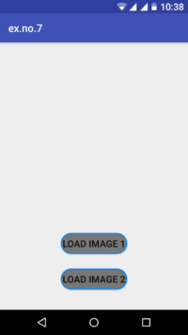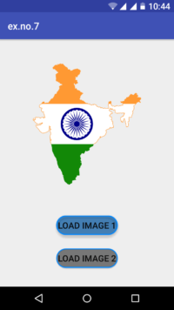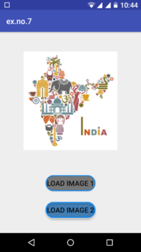

7. Develop a mobile application that uses GPS location information

1)Open eclipse or android studio and select new android project

2)Give project name and select next

3) Choose the android version.Choose the lowest android version(Android 2.2) and select next

4) Enter the package name.package name must be two word seprated by comma and click finish 5)Go to package explorer in the left hand side.select our project.

6)Go to res folder and select layout.Double click the main.xml file.

Add the code below
<?xml version="1.0" encoding="utf-8"?>
<RelativeLayout xmlns:android="http://schemas.android.com/apk/res/android"
android:id="@+id/relativeLayout1"
android:layout_width="match_parent"
android:layout_height="match_parent" >
<Button
android:id="@+id/show_Location"
android:layout_width="wrap_content"
android:layout_height="wrap_content
android:text="Show_Location"
android:layout_centerVertical="true"
android:layout_centerHorizontal="true"
/>
</RelativeLayout>

7) Now select mainactivity.java file and type the following code.In my coding maniactivity name
is GPSlocationActivity.

package gps.location;
//import android.R;
import android.app.Activity;
import android.os.Bundle;
import android.view.View;
import android.widget.Button;
import android.widget.Toast;
public class GPSlocationActivity extends Activity {
/** Called when the activity is first created. */
Button btnShowLocation;
GPStrace gps;
@Override
public void onCreate(Bundle savedInstanceState) {
super.onCreate(savedInstanceState);
setContentView(R.layout.main);

btnShowLocation=(Button)findViewById(R.id.show_Location);
btnShowLocation.setOnClickListener(new View.OnClickListener() {
@Override
public void onClick(View v) {
// TODO Auto-generated method stub
gps=new GPStrace(GPSlocationActivity.this);
if(gps.canGetLocation()){
double latitude=gps.getLatitude(); double
longitude=gps.getLongtiude();
Toast.makeText(getApplicationContext(),"Your Location is
\nLat:"+latitude+"\nLong:"+longitude, Toast.LENGTH_LONG).show();
}
else
{
gps.showSettingAlert();
}
}
});
}
}
8)Go to src folder and Right Click on your package folder and choose new class and give the
class nams as GPStrace

9)Select the GPStrace.java file and paste the following code.
package gps.location;
import android.app.AlertDialog;

import android.app.Service;
import android.content.Context;
import android.content.DialogInterface;
import android.content.Intent;
import android.location.Location;
import android.location.LocationListener;
import android.location.LocationManager;
import android.os.Bundle;
import android.os.IBinder;
import android.provider.Settings;
public class GPStrace extends Service implements LocationListener{
private final Context context;
boolean isGPSEnabled=false;
boolean canGetLocation=false;
boolean isNetworkEnabled=false;
Location location;
double latitude;
double longtitude;
private static final long MIN_DISTANCE_CHANGE_FOR_UPDATES=10;
private static final long MIN_TIME_BW_UPDATES=1000*60*1;
protected LocationManager locationManager;
public GPStrace(Context context)
{
this.context=context;
getLocation();
}
public Location getLocation()
{
try{
locationManager=(LocationManager) context.getSystemService(LOCATION_SERVICE);
isGPSEnabled=locationManager.isProviderEnabled(LocationManager.GPS_PROVIDER);
isNetworkEnabled=locationManager.isProviderEnabled(LocationManager.NETWORK_PROVI
DER);
if(!isGPSEnabled && !isNetworkEnabled){
}else{
this.canGetLocation=true;
if(isNetworkEnabled){
locationManager.requestLocationUpdates(
LocationManager.NETWORK_PROVIDER,
MIN_TIME_BW_UPDATES,
MIN_DISTANCE_CHANGE_FOR_UPDATES,this);
}
33
www.Vidyarthiplus.com
www.vidyarthiplus.com
if(locationManager!=null){
location=locationManager.getLastKnownLocation(LocationManager.NETWORK_PROVIDER)
;
if(location !=null){
latitude=location.getLatitude();
longtitude=location.getLongitude();
}
}
}
if(isGPSEnabled){
if(location==null){
locationManager.requestLocationUpdates(LocationManager.GPS_PROVIDER,MIN_TIME_B
W_UPDATES, MIN_DISTANCE_CHANGE_FOR_UPDATES, this);
if(locationManager!=null){
location=locationManager.getLastKnownLocation(LocationManager.GPS_PROVIDER);
if(location!=null){
latitude=location.getLatitude();
longtitude=location.getLongitude();
}
}
}
}
}
catch(Exception e)
{
e.printStackTrace();
}
return location;
}
public void stopUsingGPS(){
if(locationManager!=null){
locationManager.removeUpdates(GPStrace.this);
}
}
public double getLatitude(){
if(location!=null){
latitude=location.getLatitude();
}
return latitude;
}
public double getLongtiude(){
if(location!=null){
longtitude=location.getLatitude();
}
return longtitude;
}
public boolean canGetLocation(){
return this.canGetLocation;
}
public void showSettingAlert(){
AlertDialog.Builder alertDialog=new AlertDialog.Builder(context);
alertDialog.setTitle("GPS is settings");
alertDialog.setMessage("GPS is not enabled.Do you want to go to setting menu?");
alertDialog.setPositiveButton("settings", new DialogInterface.OnClickListener() {
@Override
public void onClick(DialogInterface dialog,int which){
Intent intent=new Intent(Settings.ACTION_LOCATION_SOURCE_SETTINGS);
context.startActivity(intent);
}
});
alertDialog.setNegativeButton("cancel", new DialogInterface.OnClickListener() {
@Override
public void onClick(DialogInterface dialog, int which) {
// TODO Auto-generated method stub
dialog.cancel();
}
});
alertDialog.show();
}
@Override
public void onLocationChanged(Location location) {
// TODO Auto-generated method stub
}
@Override
public void onProviderDisabled(String provider) {
// TODO Auto-generated method stub
}
@Override
public void onProviderEnabled(String provider) {
// TODO Auto-generated method stub
}
@Override
public void onStatusChanged(String provider, int status, Bundle extras) {
// TODO Auto-generated method stub
}
@Override
public IBinder onBind(Intent intent) {
// TODO Auto-generated method stub
return null;
}}
10)Go to manifest.xml file and add the code below
<uses-permission
android:name="android.permission.ACCESS_FINE_LOCATION"/>
<uses-permission
android:name="android.permission.INTERNET"/>

11)Now go to main.xml and right click .select run as option and select run configuration

8. Create an application that writes data to the SD card.

Procedure:

Creating a New project:
- Open Android Studio and then click on File -> New -> New project.
- Then type the Application name as “ex.no.9″ and click Next.
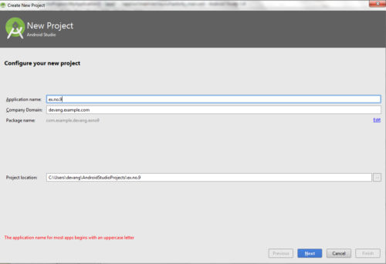
- Then select the Minimum SDK as shown below and click Next.
- Then select the Empty Activity and click Next.
- Finally click Finish.
- It will take some time to build and load the project.
- After completion it will look as given below.

Designing layout for the Android Application:
- Click on app -> res -> layout -> activity_main.xml.
- Now click on Text as shown below.
- Then delete the code which is there and type the code as given below.
Code for Activity_main.xml:

<?xml version="1.0" encoding="utf-8"?>
<LinearLayout xmlns:android="http://schemas.android.com/apk/res/android"
android:layout_width="match_parent"
android:layout_height="match_parent"
android:layout_margin="20dp"
android:orientation="vertical">
<EditText
android:id="@+id/editText"
android:layout_width="match_parent"
android:layout_height="wrap_content"
android:singleLine="true"
android:textSize="30dp" />

<Button
android:id="@+id/button"
android:layout_width="match_parent"
android:layout_height="wrap_content"
android:layout_margin="10dp"
android:text="Write Data"
android:textSize="30dp" />
<Button
android:id="@+id/button2"
android:layout_width="match_parent"
android:layout_height="wrap_content"
android:layout_margin="10dp"
android:text="Read data"
android:textSize="30dp" />
<Button
android:id="@+id/button3"
android:layout_width="match_parent"
android:layout_height="wrap_content"
android:layout_margin="10dp"
android:text="Clear"
android:textSize="30dp" />
</LinearLayout>
- Now click on Design and your application will look as given below.
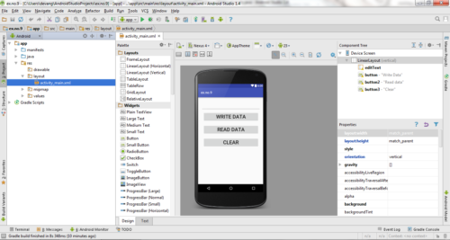
- So now the designing part is completed.

Adding permissions in Manifest for the Android Application:
- Click on app -> manifests -> AndroidManifest.xml
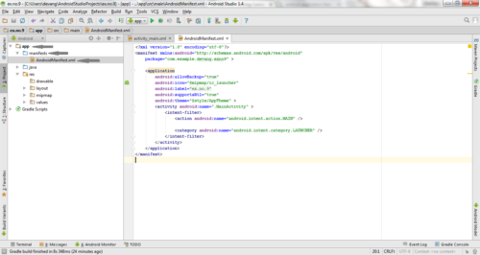
- Now include the WRITE_EXTERNAL_STORAGE permissions in the AndroidManifest.xml file as shown below
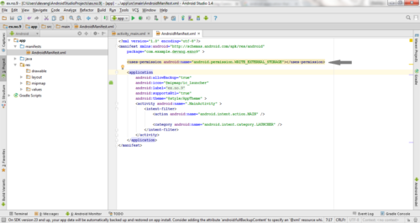

Code for AndroidManifest.xml:

<?xml version="1.0" encoding="utf-8"?>
<manifest xmlns:android="http://schemas.android.com/apk/res/android"
package="com.example.exno9" >
<uses-permission android:name="android.permission.WRITE_EXTERNAL_STORAGE"></uses-permission>
<application
android:allowBackup="true"
android:icon="@mipmap/ic_launcher"
android:label="@string/app_name"
android:supportsRtl="true"
android:theme="@style/AppTheme" >
<activity android:name=".MainActivity" >
<intent-filter>
<action android:name="android.intent.action.MAIN" />
<category android:name="android.intent.category.LAUNCHER" />
</intent-filter>
</activity>
</application>
</manifest>
- So now the Permissions are added in the Manifest.

Java Coding for the Android Application:
- Click on app -> java -> com.example.exno9 -> MainActivity.
- Then delete the code which is there and type the code as given below.

Code for MainActivity.java:
package com.example.exno9;
import android.os.Bundle;
import android.support.v7.app.AppCompatActivity;
import android.view.View;
import android.widget.Button;
import android.widget.EditText;
import android.widget.Toast;
import java.io.BufferedReader;
import java.io.File;
import java.io.FileInputStream;
import java.io.FileOutputStream;
import java.io.InputStreamReader;
public class MainActivity extends AppCompatActivity
{
EditText e1;
Button write,read,clear;
@Override
protected void onCreate(Bundle savedInstanceState)
{
super.onCreate(savedInstanceState);
setContentView(R.layout.activity_main);
e1= (EditText) findViewById(R.id.editText);
write= (Button) findViewById(R.id.button);
read= (Button) findViewById(R.id.button2);
clear= (Button) findViewById(R.id.button3);
write.setOnClickListener(new View.OnClickListener()
{
@Override
public void onClick(View v)
{
String message=e1.getText().toString();
try
{
File f=new File("/sdcard/myfile.txt");
f.createNewFile();
FileOutputStream fout=new FileOutputStream(f);
fout.write(message.getBytes());
fout.close();
Toast.makeText(getBaseContext(),"Data Written in SDCARD",Toast.LENGTH_LONG).show();
}
catch (Exception e)
{
Toast.makeText(getBaseContext(),e.getMessage(),Toast.LENGTH_LONG).show();
}
}
});
read.setOnClickListener(new View.OnClickListener()
{
@Override
public void onClick(View v)
{
String message;
String buf = "";
try
{
File f = new File("/sdcard/myfile.txt");
FileInputStream fin = new FileInputStream(f);
BufferedReader br = new BufferedReader(new InputStreamReader(fin));
while ((message = br.readLine()) != null)
{
buf += message;
}
e1.setText(buf);
br.close();
fin.close();
Toast.makeText(getBaseContext(),"Data Recived from SDCARD",Toast.LENGTH_LONG).show();
}
catch (Exception e)
{
Toast.makeText(getBaseContext(), e.getMessage(), Toast.LENGTH_LONG).show();
}
}
});
clear.setOnClickListener(new View.OnClickListener()
{
@Override
public void onClick(View v)
{
e1.setText("");
}
});
}
}
- So now the Coding part is also completed.
- Now run the application to see the output.

Output:
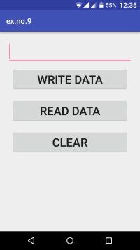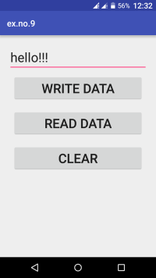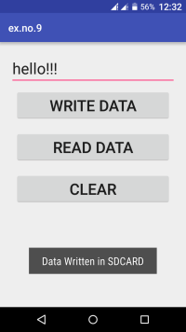
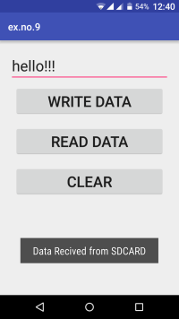

9. Implement an application that creates an alert upon receiving a message.

Procedure:

Creating a New project:
- Open Android Studio and then click on File -> New -> New project.
- Then type the Application name as “ex.no.10″ and click Next.
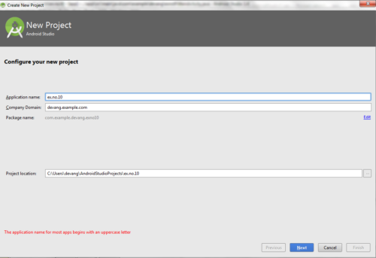
- Then select the Minimum SDK as shown below and click Next.
- Then select the Empty Activity and click Next.
- Finally click Finish.
- It will take some time to build and load the project.
- After completion it will look as given below.

Creating Second Activity for the Android Application:
- Click on File -> New -> Activity -> Empty Activity.
- Type the Activity Name as SecondActivity and click Finish button.
- Thus Second Activity For the application is created.

Designing layout for the Android Application:
- Click on app -> res -> layout -> activity_main.xml.
- Now click on Text as shown below.
- Then delete the code which is there and type the code as given below.
Code for Activity_main.xml:

<?xml version="1.0" encoding="utf-8"?>
<LinearLayout xmlns:android="http://schemas.android.com/apk/res/android"
android:layout_width="match_parent"
android:layout_height="match_parent"
android:layout_margin="10dp"
android:orientation="vertical">
<TextView
android:layout_width="wrap_content"
android:layout_height="wrap_content"
android:text="Message"
android:textSize="30sp" />
<EditText
android:id="@+id/editText"
android:layout_width="match_parent"
android:layout_height="wrap_content"
android:singleLine="true"
android:textSize="30sp" />
<Button
android:id="@+id/button"
android:layout_width="wrap_content"
android:layout_height="wrap_content"
android:layout_margin="30dp"
android:layout_gravity="center"
android:text="Notify"
android:textSize="30sp"/>
</LinearLayout>
- Now click on Design and your application will look as given below.
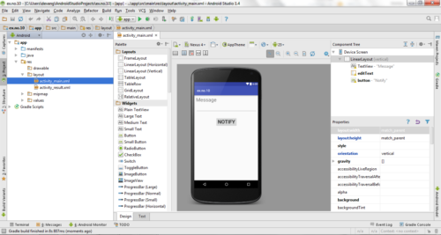
- So now the designing part is completed.

Java Coding for the Android Application:
- Click on app -> java -> com.example.exno10 -> MainActivity.
- Then delete the code which is there and type the code as given below.
Code for MainActivity.java:
?
package com.example.exno10;
import android.app.Notification;
import android.app.NotificationManager;
import android.app.PendingIntent;
import android.content.Intent;
import android.os.Bundle;
import android.support.v7.app.AppCompatActivity;
import android.view.View;
import android.widget.Button;
import android.widget.EditText;
public class MainActivity extends AppCompatActivity
{
Button notify;
EditText e;
@Override
protected void onCreate(Bundle savedInstanceState)
{
super.onCreate(savedInstanceState);
setContentView(R.layout.activity_main);
notify= (Button) findViewById(R.id.button);
e= (EditText) findViewById(R.id.editText);
notify.setOnClickListener(new View.OnClickListener()
{
@Override
public void onClick(View v)
{
Intent intent = new Intent(MainActivity.this, SecondActivity.class);
PendingIntent pending = PendingIntent.getActivity(MainActivity.this, 0, intent, 0);
Notification noti = new Notification.Builder(MainActivity.this).setContentTitle("New Message").setContentText
(e.getText().toString()).setSmallIcon(R.mipmap.ic_launcher).setContentIntent(pending).build();
NotificationManager manager = (NotificationManager) getSystemService(NOTIFICATION_SERVICE);
noti.flags |= Notification.FLAG_AUTO_CANCEL;
manager.notify(0, noti);
}
});
}
}
- So now the Coding part is also completed.
- Now run the application to see the output.

Output:
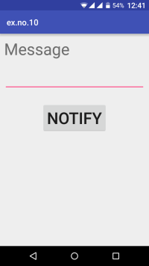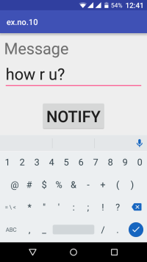
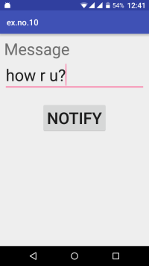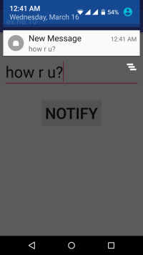

10. Devise a mobile application that creates alarm clock

Creating a New project:
- Open Android Studio and then click on File -> New -> New project.
- Then type the Application name as “ex.no.11″ and click Next.
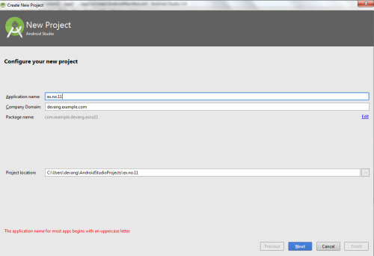
- Then select the Minimum SDK as shown below and click Next.
- Then select the Empty Activity and click Next.
- Finally click Finish.
- It will take some time to build and load the project.
- After completion it will look as given below.

Creating Second Activity for the Android Application:
- Click on File -> New -> Activity -> Empty Activity.
- Type the Activity Name as AlarmReceiver and click Finish button.
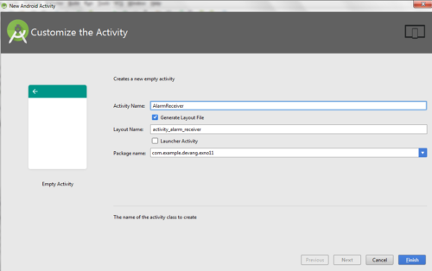
- Thus Second Activity For the application is created.

Designing layout for the Android Application:
- Click on app -> res -> layout -> activity_main.xml.
- Now click on Text as shown below.
- Then delete the code which is there and type the code as given below.
Code for Activity_main.xml:
?
<?xml version="1.0" encoding="utf-8"?>
<LinearLayout xmlns:android="http://schemas.android.com/apk/res/android"
android:layout_width="match_parent"
android:layout_height="match_parent"
android:orientation="vertical">
<TimePicker
android:id="@+id/timePicker"
android:layout_width="wrap_content"
android:layout_height="wrap_content"
android:layout_gravity="center" />
<ToggleButton
android:id="@+id/toggleButton"
android:layout_width="wrap_content"
android:layout_height="wrap_content"
android:layout_gravity="center"
android:layout_margin="20dp"
android:checked="false"
android:onClick="OnToggleClicked" />
</LinearLayout>
- Now click on Design and your application will look as given below.
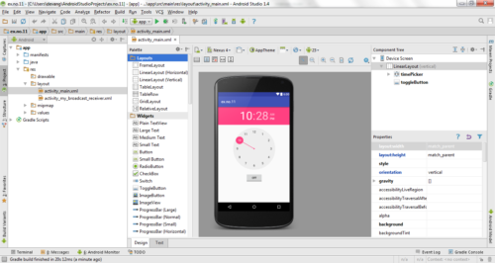
- So now the designing part is completed. Changes in Manifest for the Android Application:
- Click on app -> manifests -> AndroidManifest.xml
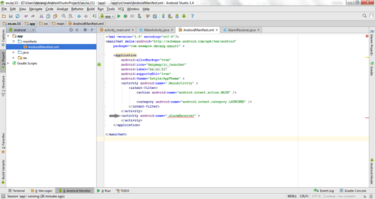
- Now change the activity tag to receiver tag in the AndroidManifest.xml file as shown below
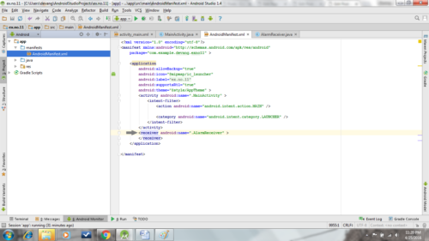

Code for AndroidManifest.xml:
?
<?xml version="1.0" encoding="utf-8"?>
<manifest xmlns:android="http://schemas.android.com/apk/res/android"
package="com.example.exno11" >
<application
android:allowBackup="true"
android:icon="@mipmap/ic_launcher"
android:label="@string/app_name"
android:supportsRtl="true"
android:theme="@style/AppTheme" >
<activity android:name=".MainActivity" >
<intent-filter>
<action android:name="android.intent.action.MAIN" />
<category android:name="android.intent.category.LAUNCHER" />
</intent-filter>
</activity>
<receiver android:name=".AlarmReceiver" >
</receiver>
</application>
</manifest>
- So now the changes are done in the Manifest. Java Coding for the Android Application:

Java Coding for Main Activity:
- Click on app -> java -> com.example.exno11 -> MainActivity.
- Then delete the code which is there and type the code as given below.
Code for MainActivity.java:
?
package com.example.exno11;
import android.app.AlarmManager;
import android.app.PendingIntent;
import android.content.Intent;
import android.os.Bundle;
import android.support.v7.app.AppCompatActivity;
import android.view.View;
import android.widget.TimePicker;
import android.widget.Toast;
import android.widget.ToggleButton;
import java.util.Calendar;
public class MainActivity extends AppCompatActivity
{
TimePicker alarmTimePicker;
PendingIntent pendingIntent;
AlarmManager alarmManager;
@Override
protected void onCreate(Bundle savedInstanceState)
{
super.onCreate(savedInstanceState);
setContentView(R.layout.activity_main);
alarmTimePicker = (TimePicker) findViewById(R.id.timePicker);
alarmManager = (AlarmManager) getSystemService(ALARM_SERVICE);
}
public void OnToggleClicked(View view)
{
long time;
if (((ToggleButton) view).isChecked())
{
Toast.makeText(MainActivity.this, "ALARM ON", Toast.LENGTH_SHORT).show();
Calendar calendar = Calendar.getInstance();
calendar.set(Calendar.HOUR_OF_DAY, alarmTimePicker.getCurrentHour());
calendar.set(Calendar.MINUTE, alarmTimePicker.getCurrentMinute());
Intent intent = new Intent(this, AlarmReceiver.class);
pendingIntent = PendingIntent.getBroadcast(this, 0, intent, 0);
time=(calendar.getTimeInMillis()-(calendar.getTimeInMillis()%60000));
if(System.currentTimeMillis()>time)
{
if (calendar.AM_PM == 0)
time = time + (1000*60*60*12);
else
time = time + (1000*60*60*24);
}
alarmManager.setRepeating(AlarmManager.RTC_WAKEUP, time, 10000, pendingIntent);
}
else
{
alarmManager.cancel(pendingIntent);
Toast.makeText(MainActivity.this, "ALARM OFF", Toast.LENGTH_SHORT).show();
}
}
}
- So now the Coding part of Main Activity is completed. Java Coding for Alarm Receiver:
- Click on app -> java -> com.example.exno11 -> AlarmReceiver.
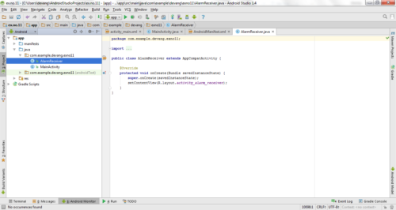
- Then delete the code which is there and type the code as given below.
Code for AlarmReceiver.java:
?
package com.example.exno11;
import android.content.BroadcastReceiver;
import android.content.Context;
import android.content.Intent;
import android.media.Ringtone;
import android.media.RingtoneManager;
import android.net.Uri;
import android.widget.Toast;
public class AlarmReceiver extends BroadcastReceiver
{
@Override
public void onReceive(Context context, Intent intent)
{
Toast.makeText(context, "Alarm! Wake up! Wake up!", Toast.LENGTH_LONG).show();
Uri alarmUri = RingtoneManager.getDefaultUri(RingtoneManager.TYPE_ALARM);
if (alarmUri == null)
{
alarmUri = RingtoneManager.getDefaultUri(RingtoneManager.TYPE_NOTIFICATION);
}
Ringtone ringtone = RingtoneManager.getRingtone(context, alarmUri);
ringtone.play();
}
}
- So now the Coding part of Alarm Receiver is also completed.
- Now run the application to see the output.

Output:
