**1. Introduction:**

A web application called DriveEasyRentals was created to make renting a car easier for administrators and users. In addition to enabling administrators to control vehicle inventory, it offers user-friendly features like account registration, vehicle reservations, and dynamic car listings. The application guarantees smooth interactions and effective data handling because it was developed with PHP for backend processing and MySQL database for data management.

**2. Features:**

1. **Features for Users:**   
   Registration and Login: In order to safely access the system's features, users must register and log in.





Car Listings: Shows a dynamic grid of rental cars along with information about availability, model, type, and daily cost.

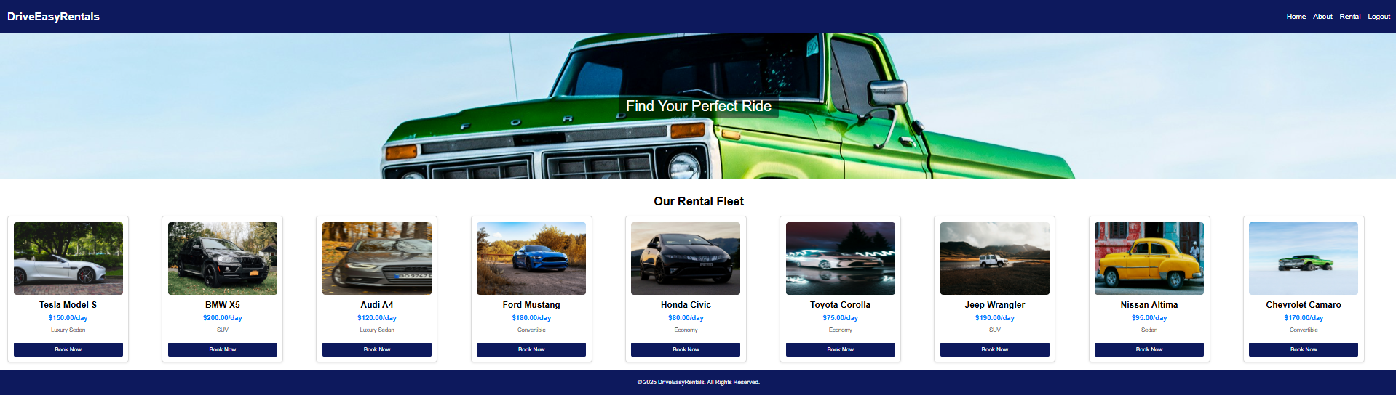

Car Booking: By choosing pick-up and drop-off dates, users can reserve a car, and the total cost is dynamically determined.

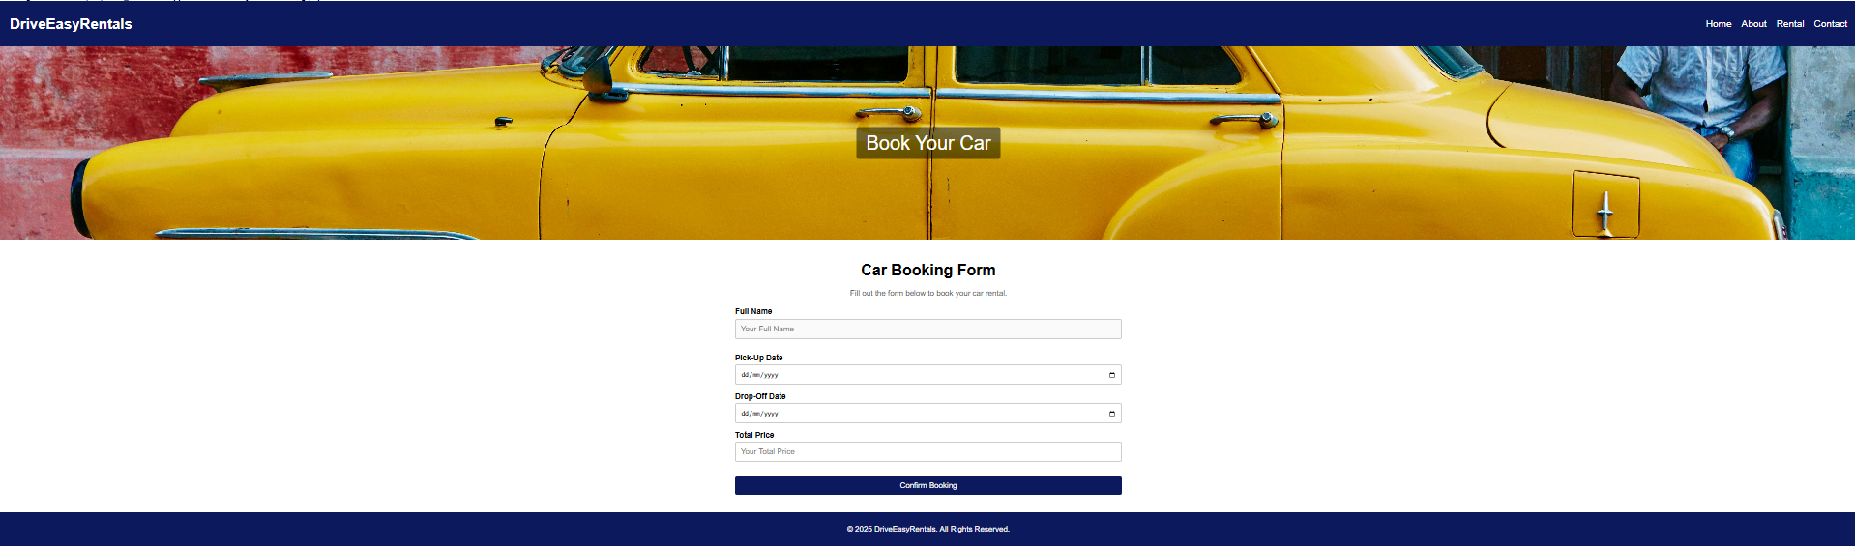

1. **Features for the administrator:**   
   View Cars: Admins have tabular access to the complete car inventory.

Update Cars: Using an easy-to-use interface, administrators can change information like availability and price.

Delete Cars: Using the delete feature, administrators can eliminate cars from the database.

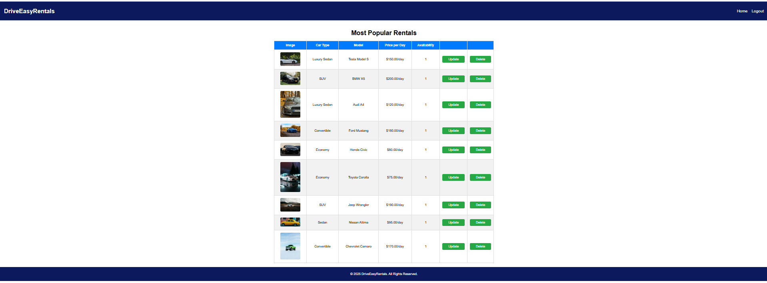

1. **Content That Changes:**   
   PHP and SQL queries are used to update booking information and vehicle details in real-time.

**3. Structure of the code:**

The program is set up for scalability and maintainability:   
Frontend: Created with HTML and CSS to create user-friendly and responsive interfaces.

Backend: PHP manages database interactions, data processing, and business logic.

Database Interaction: CRUD (Create, Read, Update, and Delete) operations are effectively managed by SQL queries.

User authentication: To limit access to areas that are authorized, secure user sessions are used.

**4. Schema for Databases**:

There are three main tables in the rentaldb database:   
  
**a. Cars Table:** Holds information about the rental car.

**CREATE TABLE `cars` (**

**`id` INT(11) NOT NULL AUTO_INCREMENT,**

**`model` VARCHAR(100) NOT NULL,**

**`type` VARCHAR(50) NOT NULL,**

**`price_per_day` DECIMAL(10,2) NOT NULL,**

**`availability` TINYINT(1) DEFAULT 1,**

**`carImage` VARCHAR(150) NOT NULL,**

**PRIMARY KEY (`id`)**

**);**

**Sample Data**:

* Tesla Model S, Luxury Sedan, $150/day, Available.
* BMW X5, SUV, $200/day, Available.

**b. Rentals Table**: Manages user bookings.

**CREATE TABLE `rentals` (**

**`id` INT(11) NOT NULL AUTO_INCREMENT,**

**`user_id` INT(11),**

**`car_id` INT(11),**

**`pickup_date` DATE,**

**`dropoff_date` DATE,**

**`total_price` DECIMAL(10,2),**

**`rentalStatus` VARCHAR(50) DEFAULT 'Pending',**

**PRIMARY KEY (`id`),**

**FOREIGN KEY (`user_id`) REFERENCES `users` (`id`),**

**FOREIGN KEY (`car_id`) REFERENCES `cars` (`id`)**

**);**

**Sample Data**:

* Booking for Tesla Model S, $750 for 5 days, Status: Confirmed.

**c. Users Table**: Stores user information, including roles (Admin/Member).

**CREATE TABLE `users` (**

**`id` INT(11) NOT NULL AUTO_INCREMENT,**

**`name` VARCHAR(100) NOT NULL,**

**`email` VARCHAR(120) NOT NULL UNIQUE,**

**`password` VARCHAR(30) NOT NULL,**

**`role` VARCHAR(20) NOT NULL,**

**PRIMARY KEY (`id`)**

**);**

**Sample Data**:

* Ram, Admin, ram.krishna@example.com.

**5. Hosting and Presentation:**

GitHub Repository:   
GitHub hosts the application code and associated materials.  
DriveEasyRentals can be found at <https://github.com/sharaths15/Drive-Easy-Rentals>

Presentation: A thorough project presentation can be found in the docs folder of the GitHub repository.

**6. Individual Reflections:**   
  
As the front-end developer, it was essential to making sure the website worked on all devices and looked well. Using PHP, HTML5, CSS3, and JavaScript to develop and implement the website's general layout was the first significant contribution. I made sure the interface was easy to use and visually appealing by concentrating on designing with the user in mind. The user experience was improved by the thoughtful design of the navigation bar, which featured dropdown menus for easy access to various sites. One notable achievement is the creation of a responsive Hero Image Slider. In addition to showing, you the cutest rental options. This slider also dynamically adapts to multiple screen sizes, ensuring a flawless experience for users of PCs, tablets, and mobile devices. Using a lightweight JavaScript framework, I have improved the functionality of the slider without sacrificing its visual appeal.

I have created a branding plan that includes a consistent colour scheme, fonts, and graphic elements to create a unified website. These elements convey the reliability and professionalism of the Drive Easy Rentals brand. To make the website look more polished and interactive, I have also added subtle animations such as button hover effects and Change face. An additional area of ​​concern was accessibility. I have added alt text to each image to ensure the website complied with WCAG guidelines. Users using assistive technology such as screen readers Web browsers can now be used with these improvements. I have also included features like adjustable font size and high contrast themes. To help people with visual impairments by finding and fixing compatibility issues, I have ensured that websites work properly on Chrome, Firefox, and Safari, although troubleshooting interactive design challenges is especially difficult. But my knowledge ensured that the website was responsive.