Sharat_Sripada_HW6.R

ssharat

2020-02-23

#  
# Course: IST-687  
# Name: Sharat Sripada  
# Homework #4  
# Due Date: 2/23/2020  
# Date Submitted: 2/23/2020  
# Topic: Using ggplot to visualize data (Air Quality Analysis)  
  
# install.packages("ggplot2")  
# install.packages("reshape2")  
  
library("ggplot2")  
library("reshape2")  
  
air <- airquality  
  
# Function to plot a histogram given a data-frame, column-name  
my_ggplot_hist <- function(my_df, my_col){  
 g <- ggplot(my_df, aes(x=my_col))  
 g <- g + geom_histogram(binwidth = 5, color = 'white', fill = 'black')  
 g  
   
}  
  
# Function to plot a box-plot given a data-frame, column-name  
my_ggplot_box <- function(my_df, my_col){  
 g <- ggplot(my_df, aes(x = ' ', y = my_col))  
 g <- g + geom_boxplot()  
 g  
}  
  
# Function to plot a line plot given a data-frame, x & y axes  
my_ggplot_line <- function(my_df, my_x, my_y){  
 g <- ggplot(my_df, aes(x = my_x, y = my_y, group = 1))  
 g <- g + geom_line()  
 g  
}  
  
  
# Step-2: Clean the Data  
# Calculate mean for the Ozone column  
ozone_mean <- mean(air$Ozone, na.rm = TRUE)  
cat("Replacing NAs in Ozone column with mean =", ozone_mean)

## Replacing NAs in Ozone column with mean = 42.12931

air$Ozone[is.na(air$Ozone)] <- ozone_mean  
  
# Calculate mean for the Solar.R column   
solar_mean <- mean(air$Solar.R, na.rm = TRUE)  
cat("Replacing NAs in Solar column with mean =", solar_mean)

## Replacing NAs in Solar column with mean = 185.9315

air$Solar.R[is.na(air$Solar.R)] <- solar_mean  
  
# Print the columns & examine for NAs  
print(air$Ozone)

## [1] 41.00000 36.00000 12.00000 18.00000 42.12931 28.00000 23.00000  
## [8] 19.00000 8.00000 42.12931 7.00000 16.00000 11.00000 14.00000  
## [15] 18.00000 14.00000 34.00000 6.00000 30.00000 11.00000 1.00000  
## [22] 11.00000 4.00000 32.00000 42.12931 42.12931 42.12931 23.00000  
## [29] 45.00000 115.00000 37.00000 42.12931 42.12931 42.12931 42.12931  
## [36] 42.12931 42.12931 29.00000 42.12931 71.00000 39.00000 42.12931  
## [43] 42.12931 23.00000 42.12931 42.12931 21.00000 37.00000 20.00000  
## [50] 12.00000 13.00000 42.12931 42.12931 42.12931 42.12931 42.12931  
## [57] 42.12931 42.12931 42.12931 42.12931 42.12931 135.00000 49.00000  
## [64] 32.00000 42.12931 64.00000 40.00000 77.00000 97.00000 97.00000  
## [71] 85.00000 42.12931 10.00000 27.00000 42.12931 7.00000 48.00000  
## [78] 35.00000 61.00000 79.00000 63.00000 16.00000 42.12931 42.12931  
## [85] 80.00000 108.00000 20.00000 52.00000 82.00000 50.00000 64.00000  
## [92] 59.00000 39.00000 9.00000 16.00000 78.00000 35.00000 66.00000  
## [99] 122.00000 89.00000 110.00000 42.12931 42.12931 44.00000 28.00000  
## [106] 65.00000 42.12931 22.00000 59.00000 23.00000 31.00000 44.00000  
## [113] 21.00000 9.00000 42.12931 45.00000 168.00000 73.00000 42.12931  
## [120] 76.00000 118.00000 84.00000 85.00000 96.00000 78.00000 73.00000  
## [127] 91.00000 47.00000 32.00000 20.00000 23.00000 21.00000 24.00000  
## [134] 44.00000 21.00000 28.00000 9.00000 13.00000 46.00000 18.00000  
## [141] 13.00000 24.00000 16.00000 13.00000 23.00000 36.00000 7.00000  
## [148] 14.00000 30.00000 42.12931 14.00000 18.00000 20.00000

print(air$Solar.R)

## [1] 190.0000 118.0000 149.0000 313.0000 185.9315 185.9315 299.0000 99.0000  
## [9] 19.0000 194.0000 185.9315 256.0000 290.0000 274.0000 65.0000 334.0000  
## [17] 307.0000 78.0000 322.0000 44.0000 8.0000 320.0000 25.0000 92.0000  
## [25] 66.0000 266.0000 185.9315 13.0000 252.0000 223.0000 279.0000 286.0000  
## [33] 287.0000 242.0000 186.0000 220.0000 264.0000 127.0000 273.0000 291.0000  
## [41] 323.0000 259.0000 250.0000 148.0000 332.0000 322.0000 191.0000 284.0000  
## [49] 37.0000 120.0000 137.0000 150.0000 59.0000 91.0000 250.0000 135.0000  
## [57] 127.0000 47.0000 98.0000 31.0000 138.0000 269.0000 248.0000 236.0000  
## [65] 101.0000 175.0000 314.0000 276.0000 267.0000 272.0000 175.0000 139.0000  
## [73] 264.0000 175.0000 291.0000 48.0000 260.0000 274.0000 285.0000 187.0000  
## [81] 220.0000 7.0000 258.0000 295.0000 294.0000 223.0000 81.0000 82.0000  
## [89] 213.0000 275.0000 253.0000 254.0000 83.0000 24.0000 77.0000 185.9315  
## [97] 185.9315 185.9315 255.0000 229.0000 207.0000 222.0000 137.0000 192.0000  
## [105] 273.0000 157.0000 64.0000 71.0000 51.0000 115.0000 244.0000 190.0000  
## [113] 259.0000 36.0000 255.0000 212.0000 238.0000 215.0000 153.0000 203.0000  
## [121] 225.0000 237.0000 188.0000 167.0000 197.0000 183.0000 189.0000 95.0000  
## [129] 92.0000 252.0000 220.0000 230.0000 259.0000 236.0000 259.0000 238.0000  
## [137] 24.0000 112.0000 237.0000 224.0000 27.0000 238.0000 201.0000 238.0000  
## [145] 14.0000 139.0000 49.0000 20.0000 193.0000 145.0000 191.0000 131.0000  
## [153] 223.0000

# Step-3:   
# Create a histogram for the Ozone column as X var.  
my_ggplot_hist(air, air$Ozone)

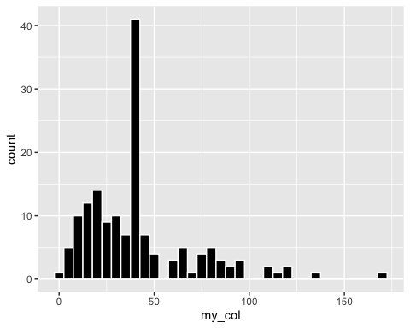

# Create a histogram for the Solar column as X var.  
my_ggplot_hist(air, air$Solar.R)

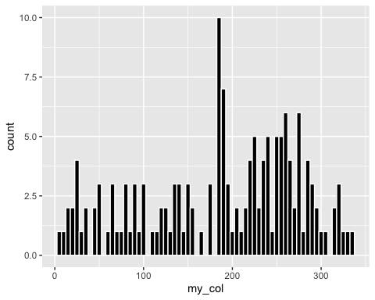

# Create a histogram for the Wind column as X var.  
my_ggplot_hist(air, air$Wind)

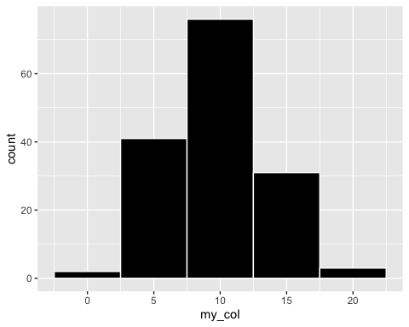

# Create a histogram for the Temp column as X var.  
my_ggplot_hist(air, air$Temp)

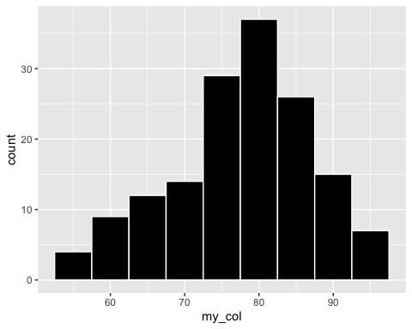

# Create a histogram for the Month column as X var.  
my_ggplot_hist(air, air$Month)

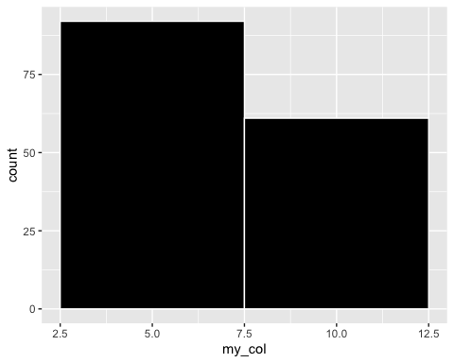

# Create a histogram for the Day column as X var.  
my_ggplot_hist(air, air$Day)

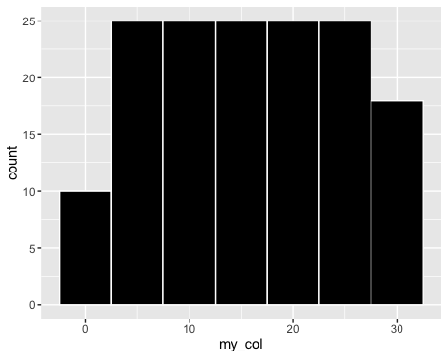

# Create a box-plot for Ozone  
my_ggplot_box(air, air$Ozone)

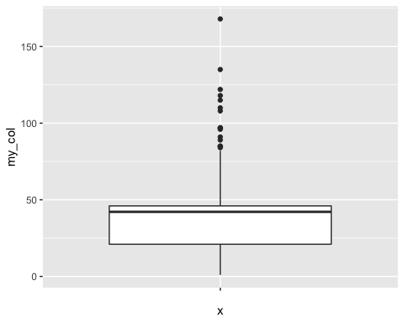

# Create a box-plot for Wind  
my_ggplot_box(air, air$Wind)

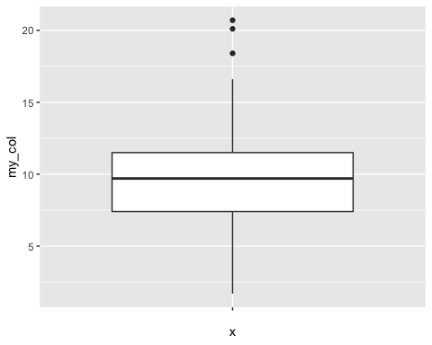

# Reading the box-plot visually:  
# min = 1.25  
# max = 20.625  
# Q1 = 7.5  
# Q3 = 11.25  
# Median = 9.375  
summary(air$Wind)

## Min. 1st Qu. Median Mean 3rd Qu. Max.   
## 1.700 7.400 9.700 9.958 11.500 20.700

# TO-DO: Work on reading box-plots more accurately - Can you change Axis to granular values?  
  
# Step-3:  
# Create a new column in df air called Date  
air$Date <- gsub(" ", "", paste("1973", "-", air$Month, "-", air$Day))  
print(air$Date)

## [1] "1973-5-1" "1973-5-2" "1973-5-3" "1973-5-4" "1973-5-5" "1973-5-6"   
## [7] "1973-5-7" "1973-5-8" "1973-5-9" "1973-5-10" "1973-5-11" "1973-5-12"  
## [13] "1973-5-13" "1973-5-14" "1973-5-15" "1973-5-16" "1973-5-17" "1973-5-18"  
## [19] "1973-5-19" "1973-5-20" "1973-5-21" "1973-5-22" "1973-5-23" "1973-5-24"  
## [25] "1973-5-25" "1973-5-26" "1973-5-27" "1973-5-28" "1973-5-29" "1973-5-30"  
## [31] "1973-5-31" "1973-6-1" "1973-6-2" "1973-6-3" "1973-6-4" "1973-6-5"   
## [37] "1973-6-6" "1973-6-7" "1973-6-8" "1973-6-9" "1973-6-10" "1973-6-11"  
## [43] "1973-6-12" "1973-6-13" "1973-6-14" "1973-6-15" "1973-6-16" "1973-6-17"  
## [49] "1973-6-18" "1973-6-19" "1973-6-20" "1973-6-21" "1973-6-22" "1973-6-23"  
## [55] "1973-6-24" "1973-6-25" "1973-6-26" "1973-6-27" "1973-6-28" "1973-6-29"  
## [61] "1973-6-30" "1973-7-1" "1973-7-2" "1973-7-3" "1973-7-4" "1973-7-5"   
## [67] "1973-7-6" "1973-7-7" "1973-7-8" "1973-7-9" "1973-7-10" "1973-7-11"  
## [73] "1973-7-12" "1973-7-13" "1973-7-14" "1973-7-15" "1973-7-16" "1973-7-17"  
## [79] "1973-7-18" "1973-7-19" "1973-7-20" "1973-7-21" "1973-7-22" "1973-7-23"  
## [85] "1973-7-24" "1973-7-25" "1973-7-26" "1973-7-27" "1973-7-28" "1973-7-29"  
## [91] "1973-7-30" "1973-7-31" "1973-8-1" "1973-8-2" "1973-8-3" "1973-8-4"   
## [97] "1973-8-5" "1973-8-6" "1973-8-7" "1973-8-8" "1973-8-9" "1973-8-10"  
## [103] "1973-8-11" "1973-8-12" "1973-8-13" "1973-8-14" "1973-8-15" "1973-8-16"  
## [109] "1973-8-17" "1973-8-18" "1973-8-19" "1973-8-20" "1973-8-21" "1973-8-22"  
## [115] "1973-8-23" "1973-8-24" "1973-8-25" "1973-8-26" "1973-8-27" "1973-8-28"  
## [121] "1973-8-29" "1973-8-30" "1973-8-31" "1973-9-1" "1973-9-2" "1973-9-3"   
## [127] "1973-9-4" "1973-9-5" "1973-9-6" "1973-9-7" "1973-9-8" "1973-9-9"   
## [133] "1973-9-10" "1973-9-11" "1973-9-12" "1973-9-13" "1973-9-14" "1973-9-15"  
## [139] "1973-9-16" "1973-9-17" "1973-9-18" "1973-9-19" "1973-9-20" "1973-9-21"  
## [145] "1973-9-22" "1973-9-23" "1973-9-24" "1973-9-25" "1973-9-26" "1973-9-27"  
## [151] "1973-9-28" "1973-9-29" "1973-9-30"

# Create a line plot for Ozone  
my_ggplot_line(air, air$Date, air$Ozone)

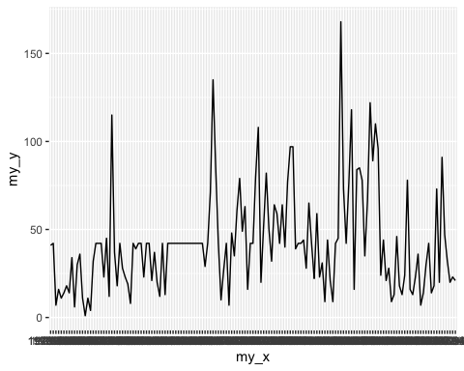

# Create a line plot for Temp  
my_ggplot_line(air, air$Date, air$Temp)

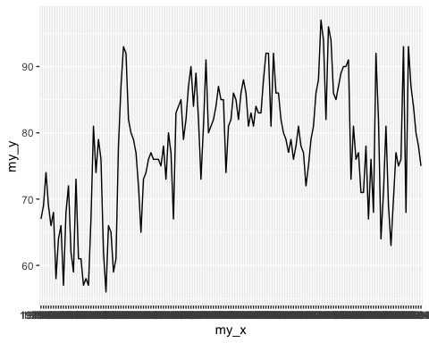

# Create a line plot for Wind  
my_ggplot_line(air, air$Date, air$Wind)

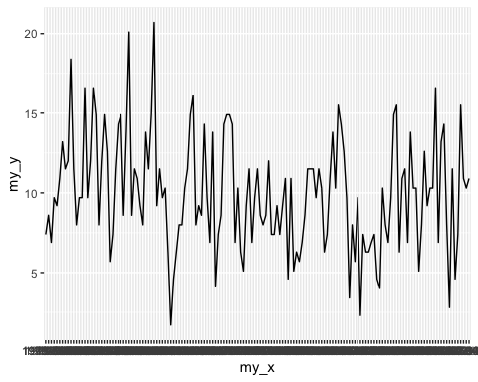

# Create a line plot for Solar.R  
my_ggplot_line(air, air$Date, air$Solar.R)

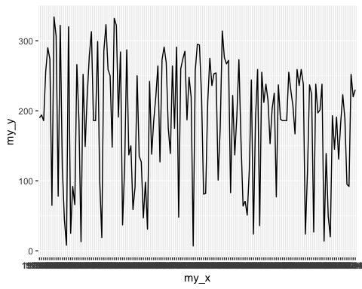

# Create one chart comprising all 4x lines in different colors  
g <- ggplot(air, aes(x = Date, group=1))  
g <- g + geom_line(aes(y = Ozone, group=1), color = "red")  
g <- g + geom_line(aes(y = Temp, group=1), color = "orange")  
g <- g + geom_line(aes(y = Wind, group=1), color = "black")  
g <- g + geom_line(aes(y = Solar.R, group=1), color = "blue")  
g

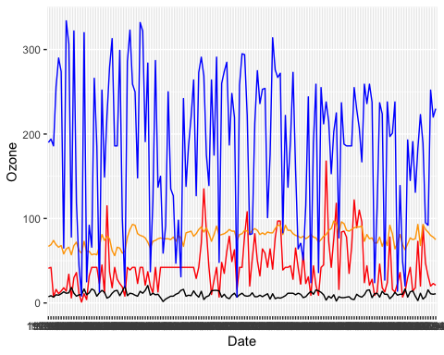

# Scale the Wind data/column - Create a new column WindScaled in air df  
air$WindScaled <- air$Wind * 10  
g <- ggplot(air, aes(x = Date, group=1))  
g <- g + geom_line(aes(y = Ozone, group=1), color = "red")  
g <- g + geom_line(aes(y = Temp, group=1), color = "orange")  
g <- g + geom_line(aes(y = WindScaled, group=1), color = "black")  
g <- g + geom_line(aes(y = Solar.R, group=1), color = "blue")  
g

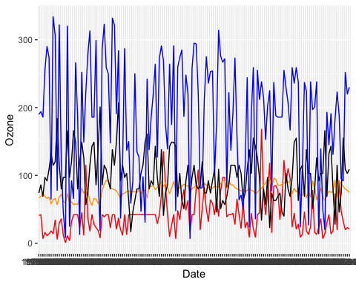

# Create a new data-frame picking Date, Ozone, Temp, WindScaled, Solar.R from air  
new_air <- data.frame(air$Date, air$Ozone, air$Solar.R, air$Temp, air$WindScaled)  
  
# Using the melt function from reshape2 shrink/collapse table  
melt_new_air <- melt(new_air, id.vars=1)  
g <- ggplot(melt_new_air, aes(x = air.Date, y = value, col = variable, group = 1))  
g <- g + geom_line()  
g

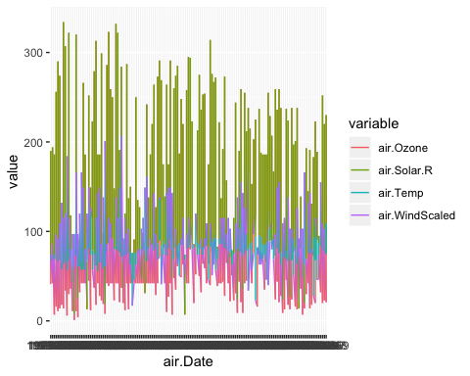

# Step-4: Create a heap-map using the geom_tile function  
g <- ggplot(melt_new_air, aes(air.Date, variable))  
g <- g + geom_tile(aes(fill = value) , color = "white" ) + scale_fill_gradient(low = "white", high = "steelblue")  
g

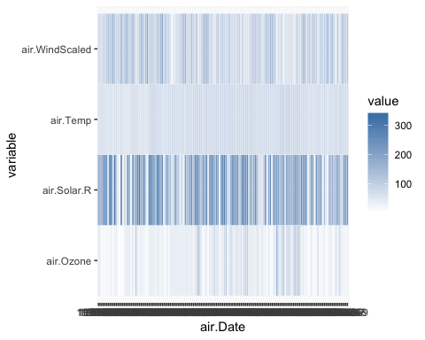

# Step-5: Create a scatter plot  
g <- ggplot(air, aes(x=Wind, y=Temp))  
g <- g + geom_point(aes(size=Ozone, color=Solar.R))  
g

