Sharat_Sripada_HW9.R

ssharat

2020-03-15

#  
# Course: IST-687  
# Name: Sharat Sripada  
# Homework #9  
# Due Date: 3/15/2020  
# Date Submitted: 3/15/2020  
# Topic: SVMs, Comparing different models - Classification, Regression.  
#  
# install.packages("kernlab")  
# install.packages("gridExtra")  
# For KSVM  
library(kernlab)  
# For SVM  
library(e1071)  
# For plottting multiple graphs in one  
library(gridExtra)  
  
aq <- data.frame(airquality)  
  
# Replace NAs with mean  
ozone_mean <- mean(na.omit(aq$Ozone))  
solar_mean <- mean(na.omit(aq$Solar.R))  
aq$Ozone[is.na(aq$Ozone)] <- ozone_mean  
aq$Solar.R[is.na(aq$Solar.R)] <- solar_mean  
  
dim(aq)

## [1] 153 6

randindex <- sample(1:dim(aq)[1])  
  
# By theory, we use 2/3rd data for trainData & 1/3rd   
# data for testData.  
cutpoint2_3 <- floor(2 * length(randindex) /3)  
trainData <- aq[randindex[1:cutpoint2_3],]  
testData <- aq[randindex[(cutpoint2_3 + 1):length(randindex)],]  
  
# Build a model using kernel SVM   
ksvmoutput <- ksvm(Ozone~., data=trainData,   
 kernel="rbfdot", #kernel function that projects the low dimensional problem into higher dimensional space   
 kpar="automatic", #params used to control radial function kernel(rbfdot)  
 C=10, #C -> cost of constraints  
 cross=10, #use 10 fold cross-validation in this model  
 prob.model=TRUE)  
ksvmoutput

## Support Vector Machine object of class "ksvm"   
##   
## SV type: eps-svr (regression)   
## parameter : epsilon = 0.1 cost C = 10   
##   
## Gaussian Radial Basis kernel function.   
## Hyperparameter : sigma = 0.139794036766887   
##   
## Number of Support Vectors : 91   
##   
## Objective Function Value : -224.6402   
## Training error : 0.176371   
## Cross validation error : 484.9765   
## Laplace distr. width : 36.97081

# Predict data based on data from the model/svmoutput  
# & testData  
ksvmpredict <- predict(ksvmoutput, testData, type="votes")  
str(ksvmpredict)

## num [1:51, 1] 43.4 47.6 69.8 46.3 54.7 ...

str(testData)

## 'data.frame': 51 obs. of 6 variables:  
## $ Ozone : num 42.1 49 135 42.1 85 ...  
## $ Solar.R: num 286 248 269 250 175 ...  
## $ Wind : num 8.6 9.2 4.1 9.2 7.4 6.9 14.9 13.8 12 4.6 ...  
## $ Temp : int 78 85 84 92 89 91 91 80 86 87 ...  
## $ Month : int 6 7 7 6 7 9 7 6 7 8 ...  
## $ Day : int 1 2 1 12 10 1 14 14 27 6 ...

# Create a comparison data-frame that contains the testData for Ozone  
# & predicted values using the ksvm() function  
compTable <- data.frame(testData[,1], ksvmpredict[,1])  
colnames(compTable) <- c('Test', 'Pred')  
compTable

## Test Pred  
## 1 42.12931 43.375591  
## 2 49.00000 47.559827  
## 3 135.00000 69.830658  
## 4 42.12931 46.269756  
## 5 85.00000 54.687693  
## 6 96.00000 67.108526  
## 7 42.12931 47.767821  
## 8 42.12931 31.631938  
## 9 52.00000 43.528537  
## 10 66.00000 70.700334  
## 11 59.00000 71.414737  
## 12 6.00000 18.438487  
## 13 42.12931 29.785210  
## 14 71.00000 48.820658  
## 15 28.00000 32.066891  
## 16 39.00000 43.933669  
## 17 16.00000 34.841513  
## 18 14.00000 -7.590209  
## 19 29.00000 20.416271  
## 20 42.12931 66.847192  
## 21 37.00000 -3.647420  
## 22 12.00000 15.768222  
## 23 42.12931 35.251958  
## 24 27.00000 24.959515  
## 25 89.00000 51.526846  
## 26 50.00000 93.475228  
## 27 108.00000 69.613389  
## 28 35.00000 49.211113  
## 29 61.00000 74.102091  
## 30 21.00000 29.366063  
## 31 47.00000 47.371721  
## 32 110.00000 59.994114  
## 33 18.00000 5.387649  
## 34 97.00000 79.554614  
## 35 65.00000 28.962253  
## 36 39.00000 36.840058  
## 37 24.00000 13.334442  
## 38 19.00000 18.239346  
## 39 36.00000 38.201021  
## 40 14.00000 36.701197  
## 41 42.12931 17.591625  
## 42 16.00000 19.364467  
## 43 21.00000 17.136250  
## 44 7.00000 30.532234  
## 45 21.00000 14.168876  
## 46 118.00000 109.197284  
## 47 122.00000 84.688440  
## 48 13.00000 24.956581  
## 49 64.00000 86.728997  
## 50 32.00000 18.566006  
## 51 31.00000 35.003357

# Calculate the root mean square error(RMSE)  
sqrt(mean((compTable$Test - compTable$Pred) ^ 2))

## [1] 21.75754

# RMSE=17.72  
  
# Compute absolute error  
compTable$error <- abs(compTable$Test - compTable$Pred)  
  
# Create a new data-frame with error, temp, wind data  
ksvmPlot <- data.frame(compTable$error, testData$Temp, testData$Wind)  
  
# Assign column names  
colnames(ksvmPlot) <- c('Abs.Error', 'Temp', 'Wind')  
  
# Plot the data-frame using ggplot  
library(ggplot2)

##   
## Attaching package: 'ggplot2'

## The following object is masked from 'package:kernlab':  
##   
## alpha

ksvm_ggplot <- ggplot(ksvmPlot, aes(x=Temp, y=Wind)) + geom_point(aes(size=Abs.Error, color=Abs.Error)) +  
 ggtitle("ksvm")  
  
ksvm_ggplot

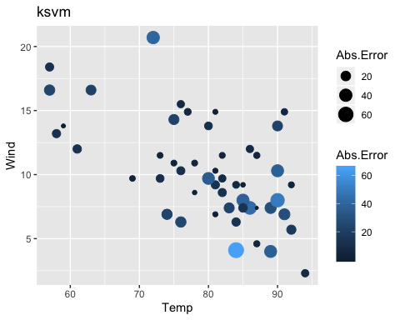

# Build a model using SVM  
svmoutput <- svm(Ozone~., data=trainData, kernel="linear", cost=10, scale=FALSE)  
  
svmoutput

##   
## Call:  
## svm(formula = Ozone ~ ., data = trainData, kernel = "linear", cost = 10,   
## scale = FALSE)  
##   
##   
## Parameters:  
## SVM-Type: eps-regression   
## SVM-Kernel: linear   
## cost: 10   
## gamma: 0.2   
## epsilon: 0.1   
##   
##   
## Number of Support Vectors: 102

# Predict data based on data from the model/svmoutput  
# & testData  
svmpredict <- predict(svmoutput, testData, type="votes")  
str(svmpredict)

## Named num [1:51] 45.1 52.6 59.7 67.3 60 ...  
## - attr(*, "names")= chr [1:51] "32" "63" "62" "43" ...

str(testData)

## 'data.frame': 51 obs. of 6 variables:  
## $ Ozone : num 42.1 49 135 42.1 85 ...  
## $ Solar.R: num 286 248 269 250 175 ...  
## $ Wind : num 8.6 9.2 4.1 9.2 7.4 6.9 14.9 13.8 12 4.6 ...  
## $ Temp : int 78 85 84 92 89 91 91 80 86 87 ...  
## $ Month : int 6 7 7 6 7 9 7 6 7 8 ...  
## $ Day : int 1 2 1 12 10 1 14 14 27 6 ...

# Create a comparison data-frame that contains the testData for Ozone  
# & predicted values using the ksvm() function  
svm_compTable <- data.frame(testData[,1], svmpredict)  
colnames(svm_compTable) <- c('Test', 'Pred')  
svm_compTable

## Test Pred  
## 32 42.12931 45.1162995  
## 63 49.00000 52.6085679  
## 62 135.00000 59.6650352  
## 43 42.12931 67.3179123  
## 71 85.00000 59.9760637  
## 124 96.00000 59.1940795  
## 75 42.12931 57.5915310  
## 45 42.12931 44.6387775  
## 88 52.00000 46.5951329  
## 98 66.00000 59.3965363  
## 92 59.00000 51.2791765  
## 18 6.00000 -9.5435746  
## 72 42.12931 45.1957182  
## 40 71.00000 58.2745410  
## 105 28.00000 45.6846003  
## 41 39.00000 58.5617586  
## 82 16.00000 30.4315028  
## 148 14.00000 -4.2525130  
## 38 29.00000 43.7276148  
## 55 42.12931 47.6866285  
## 48 37.00000 19.1812656  
## 50 12.00000 27.9416380  
## 35 42.12931 49.9525243  
## 74 27.00000 35.7766872  
## 100 89.00000 57.7723400  
## 90 50.00000 62.8641110  
## 86 108.00000 57.2466152  
## 97 35.00000 51.6148339  
## 79 61.00000 59.8800366  
## 135 21.00000 27.3967663  
## 128 47.00000 49.2755839  
## 101 110.00000 60.5048312  
## 15 18.00000 -0.9514171  
## 70 97.00000 71.7696062  
## 106 65.00000 40.0856537  
## 93 39.00000 40.4736352  
## 133 24.00000 31.1393062  
## 8 19.00000 0.1118186  
## 146 36.00000 40.0384354  
## 151 14.00000 27.2466104  
## 25 42.12931 -6.1082287  
## 12 16.00000 30.6618164  
## 132 21.00000 31.0582289  
## 11 7.00000 39.8156187  
## 47 21.00000 31.9397794  
## 121 118.00000 80.1098041  
## 99 122.00000 66.9167709  
## 141 13.00000 25.9028414  
## 91 64.00000 57.1245987  
## 24 32.00000 8.5793971  
## 111 31.00000 39.7720197

# Calculate the root mean square error(RMSE)  
sqrt(mean((svm_compTable$Test - svm_compTable$Pred) ^ 2))

## [1] 23.90929

# RMSE=19.47  
  
# Compute absolute error  
svm_compTable$error <- abs(svm_compTable$Test - svm_compTable$Pred)  
  
# Create a new data-frame with error, temp, wind data  
svmPlot <- data.frame(svm_compTable$error, testData$Temp, testData$Wind)  
  
# Assign column names  
colnames(svmPlot) <- c('Abs.Error', 'Temp', 'Wind')  
  
# Plot the data-frame using ggplot  
svm_ggplot <- ggplot(svmPlot, aes(x=Temp, y=Wind)) + geom_point(aes(size=Abs.Error, color=Abs.Error)) +  
 ggtitle("svm")  
  
svm_ggplot

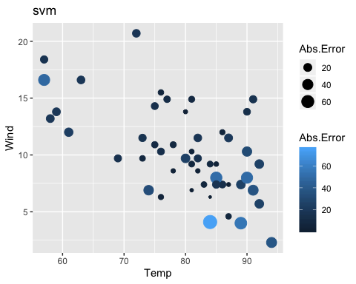

# Build a model using liner regression (lm function)  
lmoutput <- lm(formula=Ozone~., data=testData)  
lm_test <- data.frame(Solar.R=aq$Solar.R, Wind=aq$Wind,   
 Temp=aq$Temp, Month=aq$Month, Day=aq$Day)  
  
lmpredict <- predict(lmoutput, lm_test, type="response")  
  
# Create a comparison data-frame that contains the testData for Ozone  
# & predicted values using the lm() function  
lm_compTable <- data.frame(testData[,1], lmpredict)  
colnames(lm_compTable) <- c('Test', 'Pred')  
  
# Calculate the root mean square error(RMSE)  
sqrt(mean((lm_compTable$Test - lm_compTable$Pred) ^ 2))

## [1] 39.9913

# RMSE=29.68  
  
# Compute absolute error  
lm_compTable$error <- abs(lm_compTable$Test - lm_compTable$Pred)  
  
# Create a new data-frame with error, temp, wind data  
lmPlot <- data.frame(lm_compTable$error, testData$Temp, testData$Wind)  
  
# Assign column names  
colnames(lmPlot) <- c('Abs.Error', 'Temp', 'Wind')  
  
# Plot the data-frame using ggplot  
lm_ggplot <- ggplot(lmPlot, aes(x=Temp, y=Wind)) + geom_point(aes(size=Abs.Error, color=Abs.Error)) +  
 ggtitle("lm")  
  
lm_ggplot

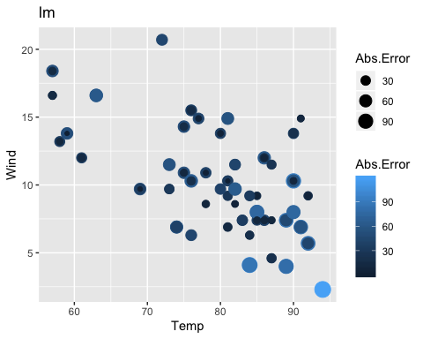

# Conclusion:  
# - RMSE for ksvm(17.72) is lower than RMSE for svm(19.47) & lm(29.68)  
# - Plotting the abs. error also showed a higher range & number for lm model (kvm and svm are comparable)  
# For the given data-set, KSVM is a marginally better algorithm than svm & way better than lm  
  
# Using gridExtra to represent graphs in one plane  
grid.arrange(ksvm_ggplot, svm_ggplot, lm_ggplot, nrow=2)

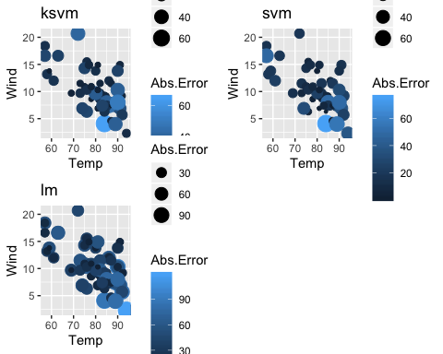

# Moving now to classification based algorithms.  
# - classification based algorithms predict with 0/1  
# - regression/linear based algorithms (previous section) predict a value  
  
# Creating a new var goodOzone: if Ozone >= meanOzone then 1 else 0  
trainData$goodOzone <- ifelse(trainData$Ozone < ozone_mean, 0, 1)  
testData$goodOzone <- ifelse(testData$Ozone < ozone_mean, 0, 1)  
  
# Remove Ozone from trainData & testData  
trainData <- trainData[,-1]  
testData <- testData[,-1]  
trainData$goodOzone <- as.factor(trainData$goodOzone)  
testData$goodOzone <- as.factor(testData$goodOzone)  
  
# Build a model based on ksvm  
ksvmgood <- ksvm(goodOzone~., data=trainData,   
 kernel="rbfdot", #kernel function that projects the low dimensional problem into higher dimensional space   
 kpar="automatic", #params used to control radial function kernel(rbfdot)  
 C=10, #C -> cost of constraints  
 cross=10, #use 10 fold cross-validation in this model  
 prob.model=TRUE)  
ksvmgood

## Support Vector Machine object of class "ksvm"   
##   
## SV type: C-svc (classification)   
## parameter : cost C = 10   
##   
## Gaussian Radial Basis kernel function.   
## Hyperparameter : sigma = 0.176126877372317   
##   
## Number of Support Vectors : 58   
##   
## Objective Function Value : -321.4427   
## Training error : 0.107843   
## Cross validation error : 0.344545   
## Probability model included.

# Predict data based on data from the model/svmoutput  
# & testData  
ksvm_goodPred <- predict(ksvmgood, testData)  
ksvm_goodPred # This should yield a 0/1

## [1] 1 1 1 1 1 1 1 1 1 1 1 0 0 1 1 1 0 0 0 1 0 0 1 1 1 1 1 1 1 0 0 1 0 1 0 0 0 0  
## [39] 1 1 0 0 0 0 0 1 1 0 1 0 1  
## Levels: 0 1

# Create a comparison data-frame that contains the testData for Ozone  
# & predicted values using the ksvm() function  
ksvm_goodcompTable <- data.frame(testData[,6], ksvm_goodPred)  
colnames(ksvm_goodcompTable) <- c('Test', 'Pred')  
ksvm_goodcompTable

## Test Pred  
## 1 1 1  
## 2 1 1  
## 3 1 1  
## 4 1 1  
## 5 1 1  
## 6 1 1  
## 7 1 1  
## 8 1 1  
## 9 1 1  
## 10 1 1  
## 11 1 1  
## 12 0 0  
## 13 1 0  
## 14 1 1  
## 15 0 1  
## 16 0 1  
## 17 0 0  
## 18 0 0  
## 19 0 0  
## 20 1 1  
## 21 0 0  
## 22 0 0  
## 23 1 1  
## 24 0 1  
## 25 1 1  
## 26 1 1  
## 27 1 1  
## 28 0 1  
## 29 1 1  
## 30 0 0  
## 31 1 0  
## 32 1 1  
## 33 0 0  
## 34 1 1  
## 35 1 0  
## 36 0 0  
## 37 0 0  
## 38 0 0  
## 39 0 1  
## 40 0 1  
## 41 1 0  
## 42 0 0  
## 43 0 0  
## 44 0 0  
## 45 0 0  
## 46 1 1  
## 47 1 1  
## 48 0 0  
## 49 1 1  
## 50 0 0  
## 51 0 1

# Calculate the percentage of correct values (this is different from the   
# linear/regression models where we calculate RMSE)  
percentage_ksvm <- length(which(ksvm_goodcompTable$Test == ksvm_goodcompTable$Pred))/dim(ksvm_goodcompTable)[1]  
percentage_ksvm

## [1] 0.7843137

# Pecentage = 0.6862  
  
# Confusion matrix  
results <- table(Test=ksvm_goodcompTable$Test, Pred=ksvm_goodcompTable$Pred)  
print(results)

## Pred  
## Test 0 1  
## 0 17 7  
## 1 4 23

# Plot the results  
ksvm_goodcompTable$correct <- ifelse(ksvm_goodcompTable$Test==ksvm_goodcompTable$Pred,"correct","wrong")  
plot_ksvm <- data.frame(ksvm_goodcompTable$correct,   
 testData$Temp,  
 testData$Wind,  
 testData$goodOzone,  
 ksvm_goodcompTable$Pred)  
  
colnames(plot_ksvm) <- c("correct","Temp","Wind","goodOzone","Predict")  
ksvm_ggplot <- ggplot(plot_ksvm, aes(x=Temp,y=Wind)) +   
 geom_point(aes(size=correct,color=goodOzone,shape = Predict))+  
 ggtitle("ksvm - good/bad ozone")  
ksvm_ggplot

## Warning: Using size for a discrete variable is not advised.

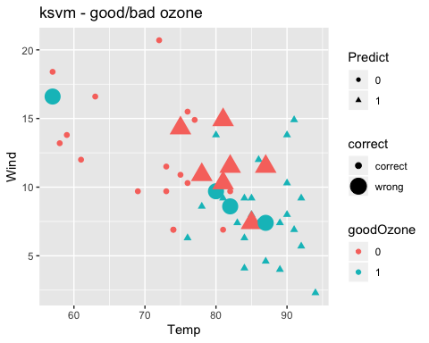

# Build a model based on svm  
svmgood <- svm(goodOzone~., data=trainData, kernel="linear", cost=10, scale=FALSE)  
svmgood

##   
## Call:  
## svm(formula = goodOzone ~ ., data = trainData, kernel = "linear",   
## cost = 10, scale = FALSE)  
##   
##   
## Parameters:  
## SVM-Type: C-classification   
## SVM-Kernel: linear   
## cost: 10   
##   
## Number of Support Vectors: 52

# Predict data based on data from the model/svmoutput  
# & testData  
svm_goodPred <- predict(svmgood, testData)  
svm_goodPred # This should yield a 0/1

## 32 63 62 43 71 124 75 45 88 98 92 18 72 40 105 41 82 148 38 55   
## 0 0 0 0 0 0 0 0 0 0 0 0 0 0 0 0 0 0 0 0   
## 48 50 35 74 100 90 86 97 79 135 128 101 15 70 106 93 133 8 146 151   
## 0 0 0 0 0 0 0 0 0 0 0 0 0 0 0 0 0 0 0 0   
## 25 12 132 11 47 121 99 141 91 24 111   
## 0 0 0 0 0 0 0 0 0 0 0   
## Levels: 0 1

# Create a comparison data-frame that contains the testData for Ozone  
# & predicted values using the ksvm() function  
svm_goodcompTable <- data.frame(testData[,6], svm_goodPred)  
colnames(svm_goodcompTable) <- c('Test', 'Pred')  
svm_goodcompTable

## Test Pred  
## 32 1 0  
## 63 1 0  
## 62 1 0  
## 43 1 0  
## 71 1 0  
## 124 1 0  
## 75 1 0  
## 45 1 0  
## 88 1 0  
## 98 1 0  
## 92 1 0  
## 18 0 0  
## 72 1 0  
## 40 1 0  
## 105 0 0  
## 41 0 0  
## 82 0 0  
## 148 0 0  
## 38 0 0  
## 55 1 0  
## 48 0 0  
## 50 0 0  
## 35 1 0  
## 74 0 0  
## 100 1 0  
## 90 1 0  
## 86 1 0  
## 97 0 0  
## 79 1 0  
## 135 0 0  
## 128 1 0  
## 101 1 0  
## 15 0 0  
## 70 1 0  
## 106 1 0  
## 93 0 0  
## 133 0 0  
## 8 0 0  
## 146 0 0  
## 151 0 0  
## 25 1 0  
## 12 0 0  
## 132 0 0  
## 11 0 0  
## 47 0 0  
## 121 1 0  
## 99 1 0  
## 141 0 0  
## 91 1 0  
## 24 0 0  
## 111 0 0

# Calculate the percentage of correct values (this is different from the   
# linear/regression models where we calculate RMSE)  
percentage_svm <- length(which(svm_goodcompTable$Test == svm_goodcompTable$Pred))/dim(svm_goodcompTable)[1]  
percentage_svm

## [1] 0.4705882

# Percentage = 0.80392  
  
# Confusion matrix  
results <- table(Test=svm_goodcompTable$Test, Pred=svm_goodcompTable$Pred)  
print(results)

## Pred  
## Test 0 1  
## 0 24 0  
## 1 27 0

# Plot the results  
svm_goodcompTable$correct <- ifelse(svm_goodcompTable$Test==svm_goodcompTable$Pred,"correct","wrong")  
plot_svm <- data.frame(svm_goodcompTable$correct,   
 testData$Temp,  
 testData$Wind,  
 testData$goodOzone,  
 svm_goodcompTable$Pred)  
  
colnames(plot_svm) <- c("correct","Temp","Wind","goodOzone","Predict")  
svm_ggplot <- ggplot(plot_svm, aes(x=Temp,y=Wind)) +   
 geom_point(aes(size=correct,color=goodOzone,shape = Predict))+  
 ggtitle("svm - good/bad ozone")  
svm_ggplot

## Warning: Using size for a discrete variable is not advised.

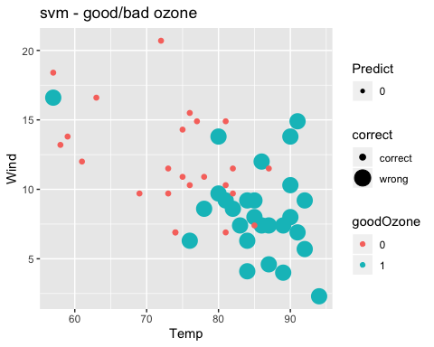

# Build a model based on Naive Bayes algorithm  
nbgood <- svm(goodOzone~., data=trainData)  
nbgood

##   
## Call:  
## svm(formula = goodOzone ~ ., data = trainData)  
##   
##   
## Parameters:  
## SVM-Type: C-classification   
## SVM-Kernel: radial   
## cost: 1   
##   
## Number of Support Vectors: 73

# Predict data based on data from the model/svmoutput  
# & testData  
nb_goodPred <- predict(nbgood, testData)  
nb_goodPred # This should yield a 0/1

## 32 63 62 43 71 124 75 45 88 98 92 18 72 40 105 41 82 148 38 55   
## 0 1 1 1 1 1 1 0 1 1 1 0 1 1 1 1 0 0 1 1   
## 48 50 35 74 100 90 86 97 79 135 128 101 15 70 106 93 133 8 146 151   
## 0 0 1 1 1 1 1 1 1 0 1 1 0 1 1 0 0 0 0 0   
## 25 12 132 11 47 121 99 141 91 24 111   
## 0 0 0 0 0 1 1 0 1 0 1   
## Levels: 0 1

# Create a comparison data-frame that contains the testData for Ozone  
# & predicted values using the ksvm() function  
nb_goodcompTable <- data.frame(testData[,6], nb_goodPred)  
colnames(nb_goodcompTable) <- c('Test', 'Pred')  
nb_goodcompTable

## Test Pred  
## 32 1 0  
## 63 1 1  
## 62 1 1  
## 43 1 1  
## 71 1 1  
## 124 1 1  
## 75 1 1  
## 45 1 0  
## 88 1 1  
## 98 1 1  
## 92 1 1  
## 18 0 0  
## 72 1 1  
## 40 1 1  
## 105 0 1  
## 41 0 1  
## 82 0 0  
## 148 0 0  
## 38 0 1  
## 55 1 1  
## 48 0 0  
## 50 0 0  
## 35 1 1  
## 74 0 1  
## 100 1 1  
## 90 1 1  
## 86 1 1  
## 97 0 1  
## 79 1 1  
## 135 0 0  
## 128 1 1  
## 101 1 1  
## 15 0 0  
## 70 1 1  
## 106 1 1  
## 93 0 0  
## 133 0 0  
## 8 0 0  
## 146 0 0  
## 151 0 0  
## 25 1 0  
## 12 0 0  
## 132 0 0  
## 11 0 0  
## 47 0 0  
## 121 1 1  
## 99 1 1  
## 141 0 0  
## 91 1 1  
## 24 0 0  
## 111 0 1

# Calculate the percentage of correct values (this is different from the   
# linear/regression models where we calculate RMSE)  
percentage_nb <- length(which(nb_goodcompTable$Test == nb_goodcompTable$Pred))/dim(nb_goodcompTable)[1]  
percentage_nb

## [1] 0.8235294

# Percentage = 0.7843  
  
# Confusion matrix  
results <- table(Test=nb_goodcompTable$Test, Pred=nb_goodcompTable$Pred)  
print(results)

## Pred  
## Test 0 1  
## 0 18 6  
## 1 3 24

# Plot the results  
nb_goodcompTable$correct <- ifelse(nb_goodcompTable$Test==nb_goodcompTable$Pred,"correct","wrong")  
plot_nb <- data.frame(nb_goodcompTable$correct,   
 testData$Temp,  
 testData$Wind,  
 testData$goodOzone,  
 nb_goodcompTable$Pred)  
  
colnames(plot_nb) <- c("correct","Temp","Wind","goodOzone","Predict")  
nb_ggplot <- ggplot(plot_nb, aes(x=Temp,y=Wind)) +   
 geom_point(aes(size=correct,color=goodOzone,shape = Predict))+  
 ggtitle("nb - good/bad ozone")  
nb_ggplot

## Warning: Using size for a discrete variable is not advised.

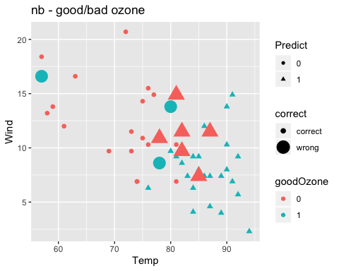

# Conclusion:  
 # - Percentage of accuracy for svm(80%) is higher than ksvm(68%) & nb(78%)  
 # For the given data-set, SVM is a better algorithm than KSVM & Naive Bayes   
  
# Using gridExtra to represent graphs in one plane  
grid.arrange(ksvm_ggplot, svm_ggplot, nb_ggplot, nrow=2)

## Warning: Using size for a discrete variable is not advised.  
  
## Warning: Using size for a discrete variable is not advised.  
  
## Warning: Using size for a discrete variable is not advised.

