Sharat_Sripada_HW5

# install.packages('tm')  
# install.packages('tmap')  
# install.packages('quanteda')  
# install.packages('philentropy')  
# install.packages('factoextra')  
# install.packages('rpart')  
# install.packages('tibble')  
# install.packages('rattle')  
# install.packages('randomForest')  
  
  
library(tm)

## Loading required package: NLP

library(tmap)  
library(quanteda)

## Package version: 2.1.1

## Parallel computing: 2 of 4 threads used.

## See https://quanteda.io for tutorials and examples.

##   
## Attaching package: 'quanteda'

## The following objects are masked from 'package:tm':  
##   
## as.DocumentTermMatrix, stopwords

## The following objects are masked from 'package:NLP':  
##   
## meta, meta<-

## The following object is masked from 'package:utils':  
##   
## View

library(RColorBrewer)  
library(wordcloud)  
library(philentropy)  
library(factoextra)

## Loading required package: ggplot2

##   
## Attaching package: 'ggplot2'

## The following object is masked from 'package:NLP':  
##   
## annotate

## Welcome! Want to learn more? See two factoextra-related books at https://goo.gl/ve3WBa

library(rpart)  
library(tibble)  
library(rattle)

## Loading required package: bitops

## Rattle: A free graphical interface for data science with R.  
## Version 5.4.0 Copyright (c) 2006-2020 Togaware Pty Ltd.  
## Type 'rattle()' to shake, rattle, and roll your data.

library(rpart.plot)  
library(randomForest)

## randomForest 4.6-14

## Type rfNews() to see new features/changes/bug fixes.

##   
## Attaching package: 'randomForest'

## The following object is masked from 'package:rattle':  
##   
## importance

## The following object is masked from 'package:ggplot2':  
##   
## margin

## Introduction

See section related ‘Classification using Decision Trees’ for work related to HW5. The remainder of the homework uses the same data-structures, visualizations etc as HW-4

We begin our analysis by ingesting a corpus of documents and running through the following pipelines:

* loading the documents using the R Corpus function
* build a document term matrix (DTM)
* visualize wordclouds
* dive into the core concepts of clustering
* classify disputed documents from results of clustering

#load the data/corpus  
FedPapersCorpus <- Corpus(DirSource("/Users/venkatasharatsripada/Downloads/IST707repo-master/FedPapersCorpus"))  
numFedPapers <- length(FedPapersCorpus)

summary(FedPapersCorpus)

## Length Class Mode  
## dispt_fed_49.txt 2 PlainTextDocument list  
## dispt_fed_50.txt 2 PlainTextDocument list  
## dispt_fed_51.txt 2 PlainTextDocument list  
## dispt_fed_52.txt 2 PlainTextDocument list  
## dispt_fed_53.txt 2 PlainTextDocument list  
## dispt_fed_54.txt 2 PlainTextDocument list  
## dispt_fed_55.txt 2 PlainTextDocument list  
## dispt_fed_56.txt 2 PlainTextDocument list  
## dispt_fed_57.txt 2 PlainTextDocument list  
## dispt_fed_62.txt 2 PlainTextDocument list  
## dispt_fed_63.txt 2 PlainTextDocument list  
## Hamilton_fed_1.txt 2 PlainTextDocument list  
## Hamilton_fed_11.txt 2 PlainTextDocument list  
## Hamilton_fed_12.txt 2 PlainTextDocument list  
## Hamilton_fed_13.txt 2 PlainTextDocument list  
## Hamilton_fed_15.txt 2 PlainTextDocument list  
## Hamilton_fed_16.txt 2 PlainTextDocument list  
## Hamilton_fed_17.txt 2 PlainTextDocument list  
## Hamilton_fed_21.txt 2 PlainTextDocument list  
## Hamilton_fed_22.txt 2 PlainTextDocument list  
## Hamilton_fed_23.txt 2 PlainTextDocument list  
## Hamilton_fed_24.txt 2 PlainTextDocument list  
## Hamilton_fed_25.txt 2 PlainTextDocument list  
## Hamilton_fed_26.txt 2 PlainTextDocument list  
## Hamilton_fed_27.txt 2 PlainTextDocument list  
## Hamilton_fed_28.txt 2 PlainTextDocument list  
## Hamilton_fed_29.txt 2 PlainTextDocument list  
## Hamilton_fed_30.txt 2 PlainTextDocument list  
## Hamilton_fed_31.txt 2 PlainTextDocument list  
## Hamilton_fed_32.txt 2 PlainTextDocument list  
## Hamilton_fed_33.txt 2 PlainTextDocument list  
## Hamilton_fed_34.txt 2 PlainTextDocument list  
## Hamilton_fed_35.txt 2 PlainTextDocument list  
## Hamilton_fed_36.txt 2 PlainTextDocument list  
## Hamilton_fed_59.txt 2 PlainTextDocument list  
## Hamilton_fed_6.txt 2 PlainTextDocument list  
## Hamilton_fed_60.txt 2 PlainTextDocument list  
## Hamilton_fed_61.txt 2 PlainTextDocument list  
## Hamilton_fed_65.txt 2 PlainTextDocument list  
## Hamilton_fed_66.txt 2 PlainTextDocument list  
## Hamilton_fed_67.txt 2 PlainTextDocument list  
## Hamilton_fed_68.txt 2 PlainTextDocument list  
## Hamilton_fed_69.txt 2 PlainTextDocument list  
## Hamilton_fed_7.txt 2 PlainTextDocument list  
## Hamilton_fed_70.txt 2 PlainTextDocument list  
## Hamilton_fed_71.txt 2 PlainTextDocument list  
## Hamilton_fed_72.txt 2 PlainTextDocument list  
## Hamilton_fed_73.txt 2 PlainTextDocument list  
## Hamilton_fed_74.txt 2 PlainTextDocument list  
## Hamilton_fed_75.txt 2 PlainTextDocument list  
## Hamilton_fed_76.txt 2 PlainTextDocument list  
## Hamilton_fed_77.txt 2 PlainTextDocument list  
## Hamilton_fed_78.txt 2 PlainTextDocument list  
## Hamilton_fed_79.txt 2 PlainTextDocument list  
## Hamilton_fed_8.txt 2 PlainTextDocument list  
## Hamilton_fed_80.txt 2 PlainTextDocument list  
## Hamilton_fed_81.txt 2 PlainTextDocument list  
## Hamilton_fed_82.txt 2 PlainTextDocument list  
## Hamilton_fed_83.txt 2 PlainTextDocument list  
## Hamilton_fed_84.txt 2 PlainTextDocument list  
## Hamilton_fed_85.txt 2 PlainTextDocument list  
## Hamilton_fed_9.txt 2 PlainTextDocument list  
## HM_fed_18.txt 2 PlainTextDocument list  
## HM_fed_19.txt 2 PlainTextDocument list  
## HM_fed_20.txt 2 PlainTextDocument list  
## Jay_fed_2.txt 2 PlainTextDocument list  
## Jay_fed_3.txt 2 PlainTextDocument list  
## Jay_fed_4.txt 2 PlainTextDocument list  
## Jay_fed_5.txt 2 PlainTextDocument list  
## Jay_fed_64.txt 2 PlainTextDocument list  
## Madison_fed_10.txt 2 PlainTextDocument list  
## Madison_fed_14.txt 2 PlainTextDocument list  
## Madison_fed_37.txt 2 PlainTextDocument list  
## Madison_fed_38.txt 2 PlainTextDocument list  
## Madison_fed_39.txt 2 PlainTextDocument list  
## Madison_fed_40.txt 2 PlainTextDocument list  
## Madison_fed_41.txt 2 PlainTextDocument list  
## Madison_fed_42.txt 2 PlainTextDocument list  
## Madison_fed_43.txt 2 PlainTextDocument list  
## Madison_fed_44.txt 2 PlainTextDocument list  
## Madison_fed_45.txt 2 PlainTextDocument list  
## Madison_fed_46.txt 2 PlainTextDocument list  
## Madison_fed_47.txt 2 PlainTextDocument list  
## Madison_fed_48.txt 2 PlainTextDocument list  
## Madison_fed_58.txt 2 PlainTextDocument list

# meta(FedPapersCorpus[[1]])

#Ignore extremely rare words - <2% of documents  
(minTermFreq <- 0.02 * numFedPapers)

## [1] 1.7

#Also, ignore common words - >75%-95% of documents  
(maxTermFreq <- 0.95 * numFedPapers)

## [1] 80.75

#   
Papers_DTM <- DocumentTermMatrix(FedPapersCorpus,  
 control=list(  
 stopwords=TRUE,  
 wordLengths=c(3,15),  
 removePunctuation=T,  
 removeNumbers=T,  
 tolower=T,  
 stemming=T,  
 remove_separators=T,  
 bounds=list(global=c(minTermFreq, maxTermFreq))  
 ))  
DTM <- as.matrix(Papers_DTM)  
(DTM[1:11,1:10])

## Terms  
## Docs abandon abat abb abet abil abl ablest abolish abolit abort  
## dispt_fed_49.txt 0 0 0 0 0 2 0 0 0 0  
## dispt_fed_50.txt 0 0 0 0 0 0 0 0 0 0  
## dispt_fed_51.txt 0 0 0 0 0 1 0 0 0 0  
## dispt_fed_52.txt 0 0 0 0 1 1 0 0 0 0  
## dispt_fed_53.txt 0 1 0 0 0 0 0 0 0 0  
## dispt_fed_54.txt 0 0 0 0 0 0 0 0 0 0  
## dispt_fed_55.txt 0 0 0 0 0 0 0 0 0 0  
## dispt_fed_56.txt 0 0 0 0 0 0 0 0 0 0  
## dispt_fed_57.txt 0 0 0 0 0 0 0 0 0 0  
## dispt_fed_62.txt 0 0 0 0 0 1 0 0 0 0  
## dispt_fed_63.txt 0 0 0 0 0 4 0 0 0 0

col_WordFreq <- colSums(as.matrix(Papers_DTM))  
(head(col_WordFreq))

## abandon abat abb abet abil abl   
## 9 2 5 2 15 74

#Length of all words  
(length(col_WordFreq))

## [1] 3370

(row_WordFreq <- rowSums(as.matrix(Papers_DTM)))

## dispt_fed_49.txt dispt_fed_50.txt dispt_fed_51.txt dispt_fed_52.txt   
## 677 480 783 743   
## dispt_fed_53.txt dispt_fed_54.txt dispt_fed_55.txt dispt_fed_56.txt   
## 903 766 865 649   
## dispt_fed_57.txt dispt_fed_62.txt dispt_fed_63.txt Hamilton_fed_1.txt   
## 889 983 1244 659   
## Hamilton_fed_11.txt Hamilton_fed_12.txt Hamilton_fed_13.txt Hamilton_fed_15.txt   
## 1020 901 400 1256   
## Hamilton_fed_16.txt Hamilton_fed_17.txt Hamilton_fed_21.txt Hamilton_fed_22.txt   
## 814 663 823 1494   
## Hamilton_fed_23.txt Hamilton_fed_24.txt Hamilton_fed_25.txt Hamilton_fed_26.txt   
## 717 826 825 983   
## Hamilton_fed_27.txt Hamilton_fed_28.txt Hamilton_fed_29.txt Hamilton_fed_30.txt   
## 573 639 876 819   
## Hamilton_fed_31.txt Hamilton_fed_32.txt Hamilton_fed_33.txt Hamilton_fed_34.txt   
## 673 589 640 883   
## Hamilton_fed_35.txt Hamilton_fed_36.txt Hamilton_fed_59.txt Hamilton_fed_6.txt   
## 942 1095 720 868   
## Hamilton_fed_60.txt Hamilton_fed_61.txt Hamilton_fed_65.txt Hamilton_fed_66.txt   
## 892 591 816 899   
## Hamilton_fed_67.txt Hamilton_fed_68.txt Hamilton_fed_69.txt Hamilton_fed_7.txt   
## 688 604 1174 952   
## Hamilton_fed_70.txt Hamilton_fed_71.txt Hamilton_fed_72.txt Hamilton_fed_73.txt   
## 1295 677 842 941   
## Hamilton_fed_74.txt Hamilton_fed_75.txt Hamilton_fed_76.txt Hamilton_fed_77.txt   
## 422 822 796 798   
## Hamilton_fed_78.txt Hamilton_fed_79.txt Hamilton_fed_8.txt Hamilton_fed_80.txt   
## 1245 421 892 974   
## Hamilton_fed_81.txt Hamilton_fed_82.txt Hamilton_fed_83.txt Hamilton_fed_84.txt   
## 1581 642 2374 1656   
## Hamilton_fed_85.txt Hamilton_fed_9.txt HM_fed_18.txt HM_fed_19.txt   
## 1114 808 926 907   
## HM_fed_20.txt Jay_fed_2.txt Jay_fed_3.txt Jay_fed_4.txt   
## 692 709 622 663   
## Jay_fed_5.txt Jay_fed_64.txt Madison_fed_10.txt Madison_fed_14.txt   
## 605 966 1316 882   
## Madison_fed_37.txt Madison_fed_38.txt Madison_fed_39.txt Madison_fed_40.txt   
## 1122 1348 981 1132   
## Madison_fed_41.txt Madison_fed_42.txt Madison_fed_43.txt Madison_fed_44.txt   
## 1479 1140 1344 1178   
## Madison_fed_45.txt Madison_fed_46.txt Madison_fed_47.txt Madison_fed_48.txt   
## 810 980 1167 738   
## Madison_fed_58.txt   
## 847

### Normalization

#create a normalized version of Papers_DTM  
Papers_M <- as.matrix(Papers_DTM)  
Papers_M_N1 <- apply(Papers_M, 1, function(i) round(i/sum(i),3))  
Papers_Matrix_Norm <- t(Papers_M_N1)  
  
#compare the original and normalized version  
(Papers_M[c(1:11),c(1000:1010)])

## Terms  
## Docs edit effect effectu efficaci effici effort eight eighth  
## dispt_fed_49.txt 0 1 1 0 0 0 0 0  
## dispt_fed_50.txt 0 3 0 0 0 0 0 0  
## dispt_fed_51.txt 0 0 0 0 0 0 0 0  
## dispt_fed_52.txt 0 1 1 0 0 0 0 0  
## dispt_fed_53.txt 0 2 1 0 0 0 0 0  
## dispt_fed_54.txt 0 3 0 2 0 0 0 0  
## dispt_fed_55.txt 0 0 0 0 0 0 1 0  
## dispt_fed_56.txt 0 2 0 0 0 0 3 0  
## dispt_fed_57.txt 0 0 2 0 0 0 0 0  
## dispt_fed_62.txt 0 4 0 0 0 0 0 0  
## dispt_fed_63.txt 0 2 2 0 0 0 0 0  
## Terms  
## Docs either elaps elect  
## dispt_fed_49.txt 1 0 1  
## dispt_fed_50.txt 3 0 2  
## dispt_fed_51.txt 0 0 1  
## dispt_fed_52.txt 0 0 21  
## dispt_fed_53.txt 2 1 20  
## dispt_fed_54.txt 0 0 1  
## dispt_fed_55.txt 2 0 3  
## dispt_fed_56.txt 2 0 3  
## dispt_fed_57.txt 0 0 10  
## dispt_fed_62.txt 0 0 2  
## dispt_fed_63.txt 0 0 14

(Papers_Matrix_Norm[c(1:11),c(1000:1010)])

## Terms  
## Docs edit effect effectu efficaci effici effort eight eighth  
## dispt_fed_49.txt 0 0.001 0.001 0.000 0 0 0.000 0  
## dispt_fed_50.txt 0 0.006 0.000 0.000 0 0 0.000 0  
## dispt_fed_51.txt 0 0.000 0.000 0.000 0 0 0.000 0  
## dispt_fed_52.txt 0 0.001 0.001 0.000 0 0 0.000 0  
## dispt_fed_53.txt 0 0.002 0.001 0.000 0 0 0.000 0  
## dispt_fed_54.txt 0 0.004 0.000 0.003 0 0 0.000 0  
## dispt_fed_55.txt 0 0.000 0.000 0.000 0 0 0.001 0  
## dispt_fed_56.txt 0 0.003 0.000 0.000 0 0 0.005 0  
## dispt_fed_57.txt 0 0.000 0.002 0.000 0 0 0.000 0  
## dispt_fed_62.txt 0 0.004 0.000 0.000 0 0 0.000 0  
## dispt_fed_63.txt 0 0.002 0.002 0.000 0 0 0.000 0  
## Terms  
## Docs either elaps elect  
## dispt_fed_49.txt 0.001 0.000 0.001  
## dispt_fed_50.txt 0.006 0.000 0.004  
## dispt_fed_51.txt 0.000 0.000 0.001  
## dispt_fed_52.txt 0.000 0.000 0.028  
## dispt_fed_53.txt 0.002 0.001 0.022  
## dispt_fed_54.txt 0.000 0.000 0.001  
## dispt_fed_55.txt 0.002 0.000 0.003  
## dispt_fed_56.txt 0.003 0.000 0.005  
## dispt_fed_57.txt 0.000 0.000 0.011  
## dispt_fed_62.txt 0.000 0.000 0.002  
## dispt_fed_63.txt 0.000 0.000 0.011

#verify for word 'embarrass' in document 'dispt_fed_62.txt' if the   
#normalization math is correct  
  
(row_WordFreq)

## dispt_fed_49.txt dispt_fed_50.txt dispt_fed_51.txt dispt_fed_52.txt   
## 677 480 783 743   
## dispt_fed_53.txt dispt_fed_54.txt dispt_fed_55.txt dispt_fed_56.txt   
## 903 766 865 649   
## dispt_fed_57.txt dispt_fed_62.txt dispt_fed_63.txt Hamilton_fed_1.txt   
## 889 983 1244 659   
## Hamilton_fed_11.txt Hamilton_fed_12.txt Hamilton_fed_13.txt Hamilton_fed_15.txt   
## 1020 901 400 1256   
## Hamilton_fed_16.txt Hamilton_fed_17.txt Hamilton_fed_21.txt Hamilton_fed_22.txt   
## 814 663 823 1494   
## Hamilton_fed_23.txt Hamilton_fed_24.txt Hamilton_fed_25.txt Hamilton_fed_26.txt   
## 717 826 825 983   
## Hamilton_fed_27.txt Hamilton_fed_28.txt Hamilton_fed_29.txt Hamilton_fed_30.txt   
## 573 639 876 819   
## Hamilton_fed_31.txt Hamilton_fed_32.txt Hamilton_fed_33.txt Hamilton_fed_34.txt   
## 673 589 640 883   
## Hamilton_fed_35.txt Hamilton_fed_36.txt Hamilton_fed_59.txt Hamilton_fed_6.txt   
## 942 1095 720 868   
## Hamilton_fed_60.txt Hamilton_fed_61.txt Hamilton_fed_65.txt Hamilton_fed_66.txt   
## 892 591 816 899   
## Hamilton_fed_67.txt Hamilton_fed_68.txt Hamilton_fed_69.txt Hamilton_fed_7.txt   
## 688 604 1174 952   
## Hamilton_fed_70.txt Hamilton_fed_71.txt Hamilton_fed_72.txt Hamilton_fed_73.txt   
## 1295 677 842 941   
## Hamilton_fed_74.txt Hamilton_fed_75.txt Hamilton_fed_76.txt Hamilton_fed_77.txt   
## 422 822 796 798   
## Hamilton_fed_78.txt Hamilton_fed_79.txt Hamilton_fed_8.txt Hamilton_fed_80.txt   
## 1245 421 892 974   
## Hamilton_fed_81.txt Hamilton_fed_82.txt Hamilton_fed_83.txt Hamilton_fed_84.txt   
## 1581 642 2374 1656   
## Hamilton_fed_85.txt Hamilton_fed_9.txt HM_fed_18.txt HM_fed_19.txt   
## 1114 808 926 907   
## HM_fed_20.txt Jay_fed_2.txt Jay_fed_3.txt Jay_fed_4.txt   
## 692 709 622 663   
## Jay_fed_5.txt Jay_fed_64.txt Madison_fed_10.txt Madison_fed_14.txt   
## 605 966 1316 882   
## Madison_fed_37.txt Madison_fed_38.txt Madison_fed_39.txt Madison_fed_40.txt   
## 1122 1348 981 1132   
## Madison_fed_41.txt Madison_fed_42.txt Madison_fed_43.txt Madison_fed_44.txt   
## 1479 1140 1344 1178   
## Madison_fed_45.txt Madison_fed_46.txt Madison_fed_47.txt Madison_fed_48.txt   
## 810 980 1167 738   
## Madison_fed_58.txt   
## 847

#dispt_fed_62 has 798 words in total  
#there are 2x words of 'embarrass' so, 2/798 = 0.0025 ~0.003 (3 places after decimal)

### Data-structures

Papers_dtm_matrix <- as.matrix(Papers_DTM)  
str(Papers_dtm_matrix)

## num [1:85, 1:3370] 0 0 0 0 0 0 0 0 0 0 ...  
## - attr(*, "dimnames")=List of 2  
## ..$ Docs : chr [1:85] "dispt_fed_49.txt" "dispt_fed_50.txt" "dispt_fed_51.txt" "dispt_fed_52.txt" ...  
## ..$ Terms: chr [1:3370] "abandon" "abat" "abb" "abet" ...

Papers_dtm_matrix[c(1:11),c(2:10)]

## Terms  
## Docs abat abb abet abil abl ablest abolish abolit abort  
## dispt_fed_49.txt 0 0 0 0 2 0 0 0 0  
## dispt_fed_50.txt 0 0 0 0 0 0 0 0 0  
## dispt_fed_51.txt 0 0 0 0 1 0 0 0 0  
## dispt_fed_52.txt 0 0 0 1 1 0 0 0 0  
## dispt_fed_53.txt 1 0 0 0 0 0 0 0 0  
## dispt_fed_54.txt 0 0 0 0 0 0 0 0 0  
## dispt_fed_55.txt 0 0 0 0 0 0 0 0 0  
## dispt_fed_56.txt 0 0 0 0 0 0 0 0 0  
## dispt_fed_57.txt 0 0 0 0 0 0 0 0 0  
## dispt_fed_62.txt 0 0 0 0 1 0 0 0 0  
## dispt_fed_63.txt 0 0 0 0 4 0 0 0 0

### Convert to a data-frame

Papers_DF <- as.data.frame(as.matrix(Papers_DTM))  
str(Papers_DF)

## 'data.frame': 85 obs. of 3370 variables:  
## $ abandon : num 0 0 0 0 0 0 0 0 0 0 ...  
## $ abat : num 0 0 0 0 1 0 0 0 0 0 ...  
## $ abb : num 0 0 0 0 0 0 0 0 0 0 ...  
## $ abet : num 0 0 0 0 0 0 0 0 0 0 ...  
## $ abil : num 0 0 0 1 0 0 0 0 0 0 ...  
## $ abl : num 2 0 1 1 0 0 0 0 0 1 ...  
## $ ablest : num 0 0 0 0 0 0 0 0 0 0 ...  
## $ abolish : num 0 0 0 0 0 0 0 0 0 0 ...  
## $ abolit : num 0 0 0 0 0 0 0 0 0 0 ...  
## $ abort : num 0 0 0 0 0 0 0 0 0 0 ...  
## $ abound : num 0 0 0 0 0 0 0 0 0 0 ...  
## $ abridg : num 0 0 0 1 0 0 0 0 0 0 ...  
## $ abroad : num 0 0 0 0 0 0 0 0 0 0 ...  
## $ absolut : num 0 2 2 1 0 0 0 0 0 0 ...  
## $ absorb : num 0 0 0 0 0 0 0 0 0 0 ...  
## $ abstain : num 0 0 0 0 0 0 0 0 0 0 ...  
## $ abstract : num 0 0 0 0 0 0 0 0 0 0 ...  
## $ absurd : num 0 0 0 0 0 0 0 0 0 0 ...  
## $ abund : num 0 0 0 0 0 0 0 0 0 0 ...  
## $ abus : num 1 1 2 1 1 0 0 0 0 0 ...  
## $ abyss : num 0 0 0 0 0 0 0 0 0 0 ...  
## $ acced : num 0 0 0 0 0 0 0 0 0 0 ...  
## $ accept : num 0 0 0 0 0 0 0 0 0 1 ...  
## $ access : num 0 0 0 2 0 0 0 0 0 0 ...  
## $ accid : num 0 0 0 0 0 0 0 0 0 0 ...  
## $ accident : num 0 0 0 1 0 0 0 0 0 0 ...  
## $ accommod : num 0 0 0 0 1 0 0 0 0 0 ...  
## $ accompani : num 0 0 0 0 0 0 0 1 0 0 ...  
## $ accomplic : num 0 0 0 0 0 0 0 0 0 0 ...  
## $ accomplish : num 0 0 0 0 0 0 0 0 0 0 ...  
## $ accord : num 0 0 0 0 1 2 2 1 1 0 ...  
## $ account : num 0 0 0 0 0 0 1 0 0 0 ...  
## $ accumul : num 0 0 0 0 0 0 0 0 0 0 ...  
## $ accur : num 1 0 0 0 1 0 0 0 0 1 ...  
## $ accuraci : num 0 0 0 0 0 1 0 0 0 0 ...  
## $ accus : num 0 0 0 0 0 0 0 0 0 0 ...  
## $ accustom : num 0 0 0 0 0 0 0 0 0 0 ...  
## $ achaean : num 0 0 0 0 0 0 0 0 0 0 ...  
## $ acknowledg : num 0 1 0 0 0 0 0 0 0 1 ...  
## $ acquaint : num 1 0 0 0 2 0 0 2 0 1 ...  
## $ acquiesc : num 0 0 0 0 0 0 0 0 0 0 ...  
## $ acquir : num 1 0 0 0 5 0 0 2 0 0 ...  
## $ acquisit : num 0 0 0 0 0 0 0 0 0 0 ...  
## $ act : num 0 0 0 1 2 1 0 1 0 1 ...  
## $ action : num 0 0 1 0 0 0 0 0 0 1 ...  
## $ activ : num 0 4 0 0 0 0 0 0 0 0 ...  
## $ actor : num 0 0 0 0 0 0 0 0 0 0 ...  
## $ actual : num 1 2 0 0 4 0 0 0 1 0 ...  
## $ actuat : num 0 0 0 0 0 0 1 0 1 0 ...  
## $ adapt : num 0 0 0 0 0 0 0 0 0 0 ...  
## $ add : num 0 0 0 0 1 0 0 1 1 0 ...  
## $ addict : num 0 0 0 0 0 0 0 0 0 0 ...  
## $ addit : num 0 0 1 1 0 0 0 0 1 1 ...  
## $ address : num 0 0 0 0 0 0 0 0 0 0 ...  
## $ adduc : num 0 0 0 0 0 0 0 0 0 0 ...  
## $ adept : num 0 0 0 0 0 0 0 0 0 0 ...  
## $ adequ : num 1 1 0 0 0 0 0 0 0 0 ...  
## $ adher : num 0 0 1 0 0 1 0 0 0 0 ...  
## $ adjourn : num 0 0 0 0 0 0 0 0 0 0 ...  
## $ adjud : num 0 0 0 0 0 0 0 0 0 0 ...  
## $ adjust : num 0 0 0 0 0 1 0 0 0 0 ...  
## $ administ : num 0 0 2 0 0 0 0 0 0 1 ...  
## $ administr : num 1 2 1 0 0 0 0 0 1 0 ...  
## $ admir : num 0 0 0 0 0 0 0 0 0 0 ...  
## $ admiralti : num 0 0 0 0 0 0 0 0 0 0 ...  
## $ admiss : num 0 0 0 0 0 1 0 0 1 1 ...  
## $ admit : num 1 0 3 0 1 5 2 0 1 0 ...  
## $ admitt : num 0 0 0 0 0 0 0 0 0 0 ...  
## $ admonish : num 0 0 0 0 0 0 0 0 0 0 ...  
## $ admonit : num 0 0 0 0 0 0 0 0 0 1 ...  
## $ adopt : num 0 0 0 1 0 1 0 0 0 1 ...  
## $ advanc : num 0 0 0 0 1 0 0 1 1 2 ...  
## $ advantag : num 4 1 0 2 2 4 0 1 0 7 ...  
## $ adventiti : num 0 0 0 0 0 0 0 0 0 0 ...  
## $ adventur : num 0 0 0 0 0 0 0 0 0 0 ...  
## $ advers : num 2 0 0 0 0 0 0 0 0 0 ...  
## $ adversari : num 0 0 0 0 0 0 0 0 0 0 ...  
## $ advert : num 0 0 0 0 0 0 0 0 0 0 ...  
## $ advertis : num 0 0 0 0 0 0 0 0 0 0 ...  
## $ advic : num 0 0 0 0 0 0 0 0 0 1 ...  
## $ advis : num 0 0 0 0 0 0 0 0 0 0 ...  
## $ advoc : num 0 0 0 0 0 1 0 1 0 0 ...  
## $ affair : num 0 0 1 0 9 0 1 5 0 4 ...  
## $ affect : num 0 0 0 1 0 0 0 0 1 1 ...  
## $ affin : num 0 0 0 0 0 0 0 0 0 0 ...  
## $ affirm : num 0 0 0 0 2 0 0 0 0 1 ...  
## $ afford : num 0 0 0 0 1 0 0 0 0 0 ...  
## $ affront : num 0 0 0 0 0 0 0 0 0 0 ...  
## $ afraid : num 0 0 0 0 0 0 1 0 0 0 ...  
## $ afterward : num 0 0 0 0 0 0 0 0 0 0 ...  
## $ age : num 0 0 0 1 0 0 0 0 0 2 ...  
## $ agenc : num 0 0 1 0 0 0 0 0 0 1 ...  
## $ agent : num 1 1 0 0 0 0 0 0 0 0 ...  
## $ aggrand : num 0 0 0 0 0 0 0 0 0 0 ...  
## $ aggrandiz : num 1 0 0 0 0 0 0 0 1 0 ...  
## $ aggreg : num 0 0 0 0 0 2 0 0 0 0 ...  
## $ aggress : num 0 0 0 0 0 0 0 0 0 0 ...  
## $ aggressor : num 0 0 0 0 0 0 0 0 0 0 ...  
## $ agit : num 0 0 0 0 0 0 0 0 0 0 ...  
## [list output truncated]

### Example word cloud

Breaking the word clouds based on the document list: - 1:11 -> disputed papers - 12:62 -> Hamilton papers - 63:70 -> Ignoring HM_fed*, Jay_fed* papers - 71:85 -> Madison papers

disputedpaperswc <- wordcloud(colnames(Papers_dtm_matrix), Papers_dtm_matrix[11,], scale=c(3.5,0.25))

## Warning in wordcloud(colnames(Papers_dtm_matrix), Papers_dtm_matrix[11, : senat  
## could not be fit on page. It will not be plotted.

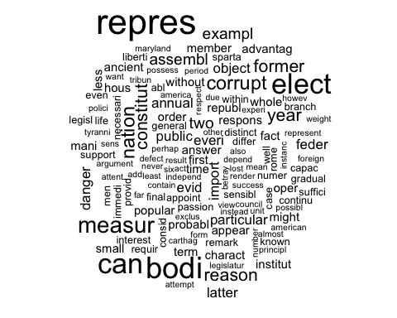

(head(sort(as.matrix(Papers_DTM)[11,], decreasing = TRUE), n=50))

## senat repres bodi can elect measur corrupt   
## 24 18 15 14 14 11 9   
## nation constitut former reason year assembl exampl   
## 9 8 8 8 8 7 7   
## two annual danger everi evid feder import   
## 7 6 6 6 6 6 6   
## latter object particular public advantag ancient answer   
## 6 6 6 6 5 5 5   
## appear charact fact first hous institut less   
## 5 5 5 5 5 5 5   
## mani member might oper order popular probabl   
## 5 5 5 5 5 5 5   
## republ respons small term time whole without   
## 5 5 5 5 5 5 5   
## abl   
## 4

HamiltonPapersWC <- wordcloud(colnames(Papers_dtm_matrix), Papers_dtm_matrix[12:62, ], scale=c(3.5,1.25))

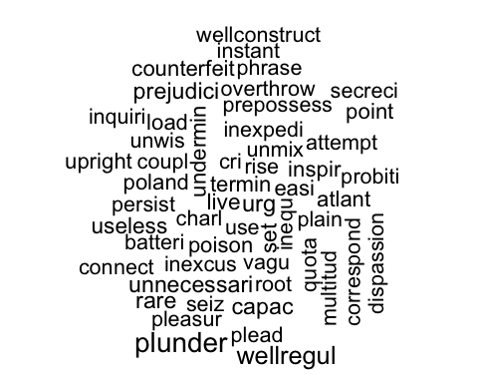

MadisonPapersWC <- wordcloud(colnames(Papers_dtm_matrix), Papers_dtm_matrix[71:85, ], scale=c(2.5,1.25))

## Warning in wordcloud(colnames(Papers_dtm_matrix), Papers_dtm_matrix[71:85, :  
## mankind could not be fit on page. It will not be plotted.

## Warning in wordcloud(colnames(Papers_dtm_matrix), Papers_dtm_matrix[71:85, :  
## imposs could not be fit on page. It will not be plotted.

## Warning in wordcloud(colnames(Papers_dtm_matrix), Papers_dtm_matrix[71:85, :  
## escap could not be fit on page. It will not be plotted.

## Warning in wordcloud(colnames(Papers_dtm_matrix), Papers_dtm_matrix[71:85, :  
## impos could not be fit on page. It will not be plotted.

## Warning in wordcloud(colnames(Papers_dtm_matrix), Papers_dtm_matrix[71:85, :  
## particip could not be fit on page. It will not be plotted.

## Warning in wordcloud(colnames(Papers_dtm_matrix), Papers_dtm_matrix[71:85, :  
## afford could not be fit on page. It will not be plotted.

## Warning in wordcloud(colnames(Papers_dtm_matrix), Papers_dtm_matrix[71:85, :  
## chargeabl could not be fit on page. It will not be plotted.

## Warning in wordcloud(colnames(Papers_dtm_matrix), Papers_dtm_matrix[71:85, :  
## moral could not be fit on page. It will not be plotted.

## Warning in wordcloud(colnames(Papers_dtm_matrix), Papers_dtm_matrix[71:85, :  
## pardon could not be fit on page. It will not be plotted.

## Warning in wordcloud(colnames(Papers_dtm_matrix), Papers_dtm_matrix[71:85, :  
## continu could not be fit on page. It will not be plotted.

## Warning in wordcloud(colnames(Papers_dtm_matrix), Papers_dtm_matrix[71:85, :  
## suffic could not be fit on page. It will not be plotted.

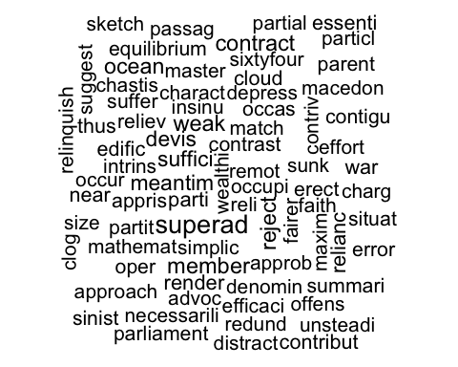

## Analysis

### Distance metrics

m <- Papers_dtm_matrix  
m_norm <- Papers_Matrix_Norm  
  
distMatrix_E <- distance(m, method='euclidean', use.row.names = TRUE)

## Metric: 'euclidean'; comparing: 85 vectors.

# print(distMatrix_E)  
heatmap(distMatrix_E)

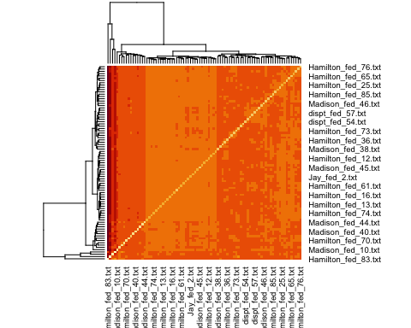

distMatrix_M <- distance(m, method='manhattan', use.row.names = TRUE)

## Metric: 'manhattan'; comparing: 85 vectors.

# print(distMatrix_M)  
heatmap(distMatrix_M)

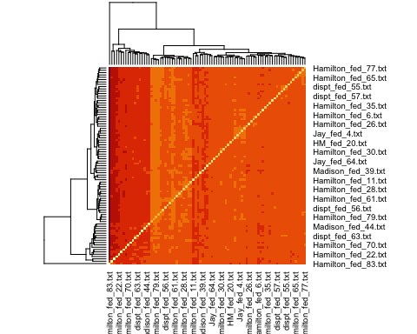

distMatrix_C <- distance(m, method = 'cosine', use.row.names = TRUE)

## Metric: 'cosine'; comparing: 85 vectors.

# print(distMatrix_C)  
heatmap(distMatrix_C)

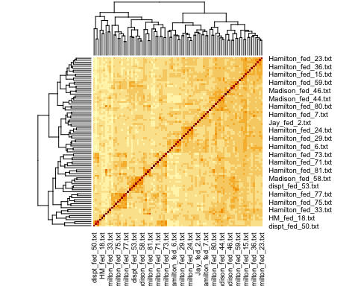

distMatrix_C_norm <- distance(m_norm, method='cosine', use.row.names = TRUE)

## Metric: 'cosine'; comparing: 85 vectors.

# print(distMatrix_C_norm)  
heatmap(distMatrix_C_norm)

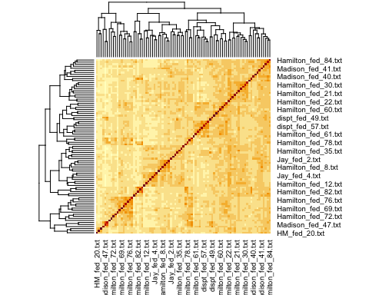

The dist() function has issues with ‘cosine’ methods. Instead, used distance() function and obtain cosine similarity visualization. Heat-maps prove cosine similarity measurements are likely more suitable for document analysis.

### Data

We will explore the following two methods to cluster the data and determine an author to the disputed papers:

* K-means algorithm
* HAC algorithm

Given that the number of authors here are namely Hamilton and Madison, we will start with choosing number of clusters = 2.

First, is the k-means algorithm:

k <- 2  
set.seed(5)  
km.res <- kmeans(Papers_dtm_matrix, k, nstart=100, iter.max=50)  
str(km.res)

## List of 9  
## $ cluster : Named int [1:85] 1 1 1 1 1 1 1 1 1 1 ...  
## ..- attr(*, "names")= chr [1:85] "dispt_fed_49.txt" "dispt_fed_50.txt" "dispt_fed_51.txt" "dispt_fed_52.txt" ...  
## $ centers : num [1:2, 1:3370] 0.1084 0 0.0241 0 0.0602 ...  
## ..- attr(*, "dimnames")=List of 2  
## .. ..$ : chr [1:2] "1" "2"  
## .. ..$ : chr [1:3370] "abandon" "abat" "abb" "abet" ...  
## $ totss : num 202176  
## $ withinss : num [1:2] 174195 6448  
## $ tot.withinss: num 180642  
## $ betweenss : num 21533  
## $ size : int [1:2] 83 2  
## $ iter : int 1  
## $ ifault : int 0  
## - attr(*, "class")= chr "kmeans"

#plot a visualization  
fviz_cluster(km.res, Papers_dtm_matrix)

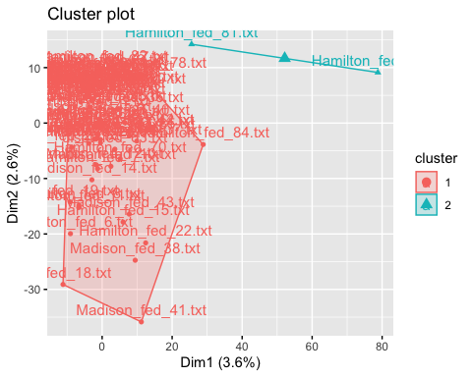

k <- 7  
km.res <- kmeans(Papers_Matrix_Norm, k, nstart=50, iter.max=50)  
str(km.res)

## List of 9  
## $ cluster : Named int [1:85] 1 1 1 5 5 5 5 5 5 7 ...  
## ..- attr(*, "names")= chr [1:85] "dispt_fed_49.txt" "dispt_fed_50.txt" "dispt_fed_51.txt" "dispt_fed_52.txt" ...  
## $ centers : num [1:7, 1:3370] 7.69e-05 0.00 7.14e-05 0.00 0.00 ...  
## ..- attr(*, "dimnames")=List of 2  
## .. ..$ : chr [1:7] "1" "2" "3" "4" ...  
## .. ..$ : chr [1:3370] "abandon" "abat" "abb" "abet" ...  
## $ totss : num 0.226  
## $ withinss : num [1:7] 0.03396 0.00231 0.02952 0.00754 0.02239 ...  
## $ tot.withinss: num 0.174  
## $ betweenss : num 0.0514  
## $ size : int [1:7] 13 2 14 4 10 5 37  
## $ iter : int 4  
## $ ifault : int 0  
## - attr(*, "class")= chr "kmeans"

#plot a visualization  
fviz_cluster(km.res, Papers_Matrix_Norm)

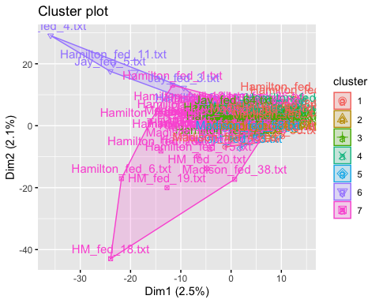

Now, we explore the HAC algorithms

#Euclidean distance measure  
dist.eul <- as.dist(distMatrix_E)  
groups_E <- hclust(dist.eul, method='ward.D')  
  
#Visualizations  
plot(groups_E, cex=0.5, font=22, hang=-1, main="HAC cluster dendogram with Euclidean Similarity")  
rect.hclust(groups_E, k=2)

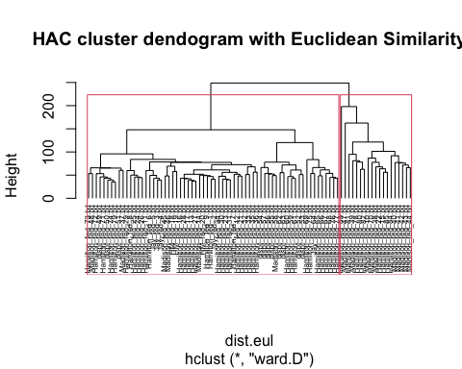

#Cosine distance measure  
dist.cos <- as.dist(distMatrix_C)  
groups_C <- hclust(dist.cos, method='ward.D')  
  
#Visualizations  
plot(groups_C, cex=0.5, font=22, hang=-1, main="HAC cluster dendogram with Cosine Similarity")  
rect.hclust(groups_C, k=2)

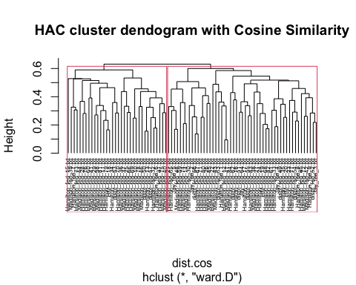

#Cosine distance measure (Normalized)  
dist.cosnorm <- as.dist(distMatrix_C_norm)  
groups_C_norm <- hclust(dist.cosnorm, method='ward.D')  
  
#Visualizations  
plot(groups_C_norm, cex=0.5, font=22, hang=-1, main="HAC cluster dendogram with Cosine Similarity (Normalized")  
rect.hclust(groups_C_norm, k=2)

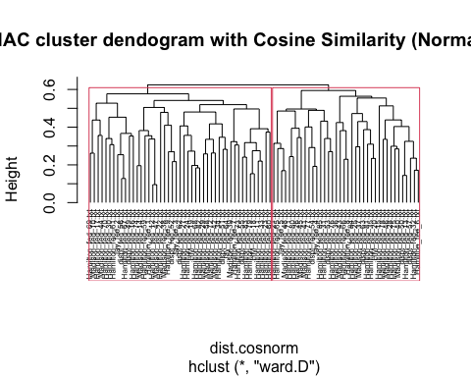

### Analysis and Results

### K-Means

Here are some results/observations with experiments around different cluster sizes:

* cluster-size=2

**SSEs**

Within cluster sum of squares by cluster is high:

[1] 174194.7 6447.5

This is an indication of high deviation between data-points and the centroid which we would ideally like to be lower. To explore k-means further, we could consider using the k-medoids/expectation-max or PAM algorithms.

**Data**

Most of the data-points were grouped into cluster-1 and this did not help to clearly determine the author for the disputed papers.

* cluster-size=7

**SSE**

SSEs look a lot better with increased cluster-size

Within cluster sum of squares by cluster:

[1] 0.00754175 0.03396400 0.06862076 0.00231200 0.02952307 0.00990520 0.02239410

**Data**

Disputed papers were placed in clusters - 2, 7, 3:

* Number of disputed papers in cluster-2 = 3
* Number of disputed papers in cluster-7 = 7
* Number of disputed papers in cluster-3 = 1

Cluster-7 that has the highest papers does not have sufficient majority of Hamilton/Madison papers to make a decision.

Overall, k-means does not seem like a good algorithm for document analysis use-cases.

### HAC algorithm

In comparison, seems like plotting and analyzing dendograms, seems a plausible means to realize the exercise. To a very large extent we can classify the disputed documents to the corresponding authors.

## Conclusions

With Hierarchical Agglomerative Clustering (HAC) techniques (and dendograms to analyze the results) we conclude by analyzing one disputed document dispt_fed_49.txt across:

* Eucledian

In plot ‘HAC cluster dendogram with Euclidean Similarity’, see document ‘dispt_fed_49.txt’ present in the first-cluster on the left and is associated by nodes/leafs that belong to Hamilton so, we can conclude it was written by author Hamilton with moderate confidence.

* Cosine

In plot ‘HAC cluster dendogram with Cosine Similarity’, see document ‘dispt_fed_49.txt’ belonging to a cluster towards the end. Again, the nodes/leafs around it are documents by author Hamilton.

* Cosine-Normalized

Likewise, in plot ‘HAC cluster dendogram with Cosine Similarity (Normalized)’ the surrounding nodes/leafs are related to author Hamilton.

In similar lines, we could extend the study to all disputed documents and hence classify them between the two authors.

## Classification using Decision Trees

This week we will explore classification using Decision Trees and use it as a means to classify the disputed papers.

First we will prepare a train, test data-sets and use 60% data for training.

# Make a copy of Papers_DF  
Papers_DF1 <- Papers_DF%>%tibble::rownames_to_column()  
names(Papers_DF1)[1] <- "Author"  
Papers_DF1[1:11,1] <- "dispt"  
Papers_DF1[12:62,1] <- "hamil"  
Papers_DF1[63:85,1] <- "madis"  
# head(Papers_DF1)  
  
numDisputed <- 11  
numTotalPapers <- nrow(Papers_DF1)  
  
# Decide the train ratio  
trainRatio <- .60  
  
set.seed(11)  
sample <- sample.int(n = numTotalPapers-numDisputed, size=floor(trainRatio*numTotalPapers), replace=FALSE)  
newsample <- sample + numDisputed  
  
# Construct the train/test data-sets such that:  
# train - Hamilton/Madison papers  
# test - will have disptuted and few Hamilton/Madison papers   
train <- Papers_DF1[newsample,]  
test <- Papers_DF1[-newsample,]  
  
length(newsample)/nrow(Papers_DF1)

## [1] 0.6

## Classification

rpart, a recursive partitioning and regression test package in R will be used to make predictions through classification. Further, rpart uses the CART algorithm, a non-greedy algorithm and is known to efficient.

### DT-Model1

train_tree1 <- rpart(Author ~ ., data = train, method='class', control=rpart.control(cp=0))  
summary(train_tree1)

## Call:  
## rpart(formula = Author ~ ., data = train, method = "class", control = rpart.control(cp = 0))  
## n= 51   
##   
## CP nsplit rel error xerror xstd  
## 1 0.875 0 1.000 1.000 0.2071042  
## 2 0.000 1 0.125 0.375 0.1438059  
##   
## Variable importance  
## alexand hamilton jame madison upon although   
## 22 22 15 15 15 11   
##   
## Node number 1: 51 observations, complexity param=0.875  
## predicted class=hamil expected loss=0.3137255 P(node) =1  
## class counts: 35 16  
## probabilities: 0.686 0.314   
## left son=2 (37 obs) right son=3 (14 obs)  
## Primary splits:  
## alexand < 0.5 to the right, improve=18.177, (0 missing)  
## hamilton < 0.5 to the right, improve=18.177, (0 missing)  
## jame < 0.5 to the left, improve=18.177, (0 missing)  
## madison < 0.5 to the left, improve=18.177, (0 missing)  
## upon < 1.5 to the right, improve=18.177, (0 missing)  
## Surrogate splits:  
## hamilton < 0.5 to the right, agree=1.000, adj=1.000, (0 split)  
## jame < 0.5 to the left, agree=0.922, adj=0.714, (0 split)  
## madison < 0.5 to the left, agree=0.922, adj=0.714, (0 split)  
## upon < 0.5 to the right, agree=0.922, adj=0.714, (0 split)  
## although < 0.5 to the left, agree=0.863, adj=0.500, (0 split)  
##   
## Node number 2: 37 observations  
## predicted class=hamil expected loss=0.05405405 P(node) =0.7254902  
## class counts: 35 2  
## probabilities: 0.946 0.054   
##   
## Node number 3: 14 observations  
## predicted class=madis expected loss=0 P(node) =0.2745098  
## class counts: 0 14  
## probabilities: 0.000 1.000

# Plot rpart using fancyRpartPlot  
fancyRpartPlot(train_tree1)

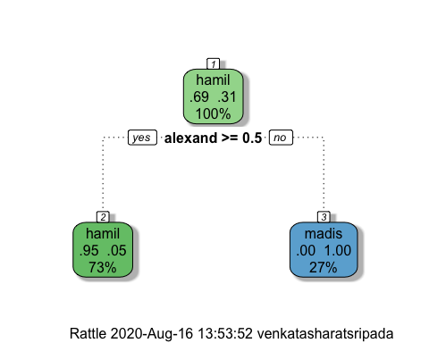

# Get confusion matrix  
predicted1 <- predict(train_tree1, test, type='class')  
table(Authorship=predicted1, true=test$Author)

## true  
## Authorship dispt hamil madis  
## hamil 11 16 1  
## madis 0 0 6

The confusion matrix shows the disputed papers may have belonged to Hamilton with sufficient confidence since a high percentage of predictions are accurate. Following couple of observations: - It wrongly predicted, 2 papers as Madison where the Author was Hamilton - It accurately predicted all Madison papers

### DT-Model2

Notice with Model-1 that the tree was not allowed to grow and limited to a root and two immediate leaf nodes. In the second model, we will attempt to attempt to override the defaults and grow the tree namely using the following: - minsplit - minimum number of observations that must exist in a node - maxdepth - maximum depth the tree can grow

Hopefully, this will also lead to better accuracy.

train_tree2 <- rpart(Author ~ ., data = train, method='class', control=rpart.control(cp=0, minsplit = 2, maxdepth=5))  
summary(train_tree2)

## Call:  
## rpart(formula = Author ~ ., data = train, method = "class", control = rpart.control(cp = 0,   
## minsplit = 2, maxdepth = 5))  
## n= 51   
##   
## CP nsplit rel error xerror xstd  
## 1 0.875 0 1.000 1.0000 0.2071042  
## 2 0.125 1 0.125 0.2500 0.1199980  
## 3 0.000 2 0.000 0.3125 0.1327269  
##   
## Variable importance  
## alexand hamilton jame madison upon although catastroph   
## 17 17 16 16 16 9 4   
## templ abb   
## 4 2   
##   
## Node number 1: 51 observations, complexity param=0.875  
## predicted class=hamil expected loss=0.3137255 P(node) =1  
## class counts: 35 16  
## probabilities: 0.686 0.314   
## left son=2 (37 obs) right son=3 (14 obs)  
## Primary splits:  
## alexand < 0.5 to the right, improve=18.177, (0 missing)  
## hamilton < 0.5 to the right, improve=18.177, (0 missing)  
## jame < 0.5 to the left, improve=18.177, (0 missing)  
## madison < 0.5 to the left, improve=18.177, (0 missing)  
## upon < 1.5 to the right, improve=18.177, (0 missing)  
## Surrogate splits:  
## hamilton < 0.5 to the right, agree=1.000, adj=1.000, (0 split)  
## jame < 0.5 to the left, agree=0.922, adj=0.714, (0 split)  
## madison < 0.5 to the left, agree=0.922, adj=0.714, (0 split)  
## upon < 0.5 to the right, agree=0.922, adj=0.714, (0 split)  
## although < 0.5 to the left, agree=0.863, adj=0.500, (0 split)  
##   
## Node number 2: 37 observations, complexity param=0.125  
## predicted class=hamil expected loss=0.05405405 P(node) =0.7254902  
## class counts: 35 2  
## probabilities: 0.946 0.054   
## left son=4 (35 obs) right son=5 (2 obs)  
## Primary splits:  
## catastroph < 0.5 to the left, improve=3.783784, (0 missing)  
## jame < 0.5 to the left, improve=3.783784, (0 missing)  
## madison < 0.5 to the left, improve=3.783784, (0 missing)  
## templ < 1 to the left, improve=3.783784, (0 missing)  
## upon < 1.5 to the right, improve=3.783784, (0 missing)  
## Surrogate splits:  
## jame < 0.5 to the left, agree=1.000, adj=1.0, (0 split)  
## madison < 0.5 to the left, agree=1.000, adj=1.0, (0 split)  
## templ < 1 to the left, agree=1.000, adj=1.0, (0 split)  
## upon < 1.5 to the right, agree=1.000, adj=1.0, (0 split)  
## abb < 0.5 to the left, agree=0.973, adj=0.5, (0 split)  
##   
## Node number 3: 14 observations  
## predicted class=madis expected loss=0 P(node) =0.2745098  
## class counts: 0 14  
## probabilities: 0.000 1.000   
##   
## Node number 4: 35 observations  
## predicted class=hamil expected loss=0 P(node) =0.6862745  
## class counts: 35 0  
## probabilities: 1.000 0.000   
##   
## Node number 5: 2 observations  
## predicted class=madis expected loss=0 P(node) =0.03921569  
## class counts: 0 2  
## probabilities: 0.000 1.000

# Plot rpart using fancyRpartPlot  
fancyRpartPlot(train_tree2)

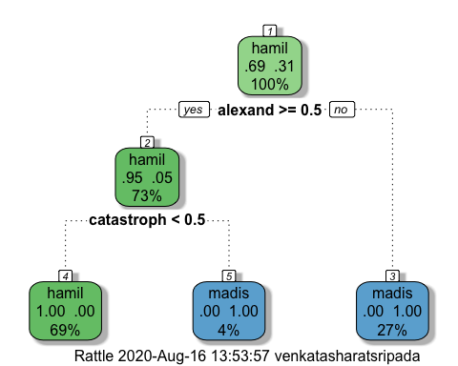

# Get confusion matrix  
predicted2 <- predict(train_tree2, test, type='class')  
table(Authorship=predicted2, true=test$Author)

## true  
## Authorship dispt hamil madis  
## hamil 11 16 1  
## madis 0 0 6

The accuracy improved a tad bit with this model which further gives us confidence about the disputed papers belonging to Hamilton.

### DT-Model3

Finally, let’s explore this via Random Forests. Random Forests improve predictive accuracy by generating a large number of bootstrapped trees (based on random sample of variables), classifying a case using each tree in this new ‘forest’, and deciding a final predicted outcome by combining the results across all of the trees. This is also commonly termed an Ensemble Method.

train$Author <- as.factor(train$Author)  
train_tree3 <- randomForest(x=train[2:ncol(train)], y=train$Author, data = train, ntree=100, mtry=2, importance=TRUE)  
predicted3 <- predict(train_tree3, test)  
table(Authorship=predicted3, true=test$Author)

## true  
## Authorship dispt hamil madis  
## hamil 11 16 7  
## madis 0 0 0

### Conclusion

The prediction using Decision Trees points to the disputed papers belonging to Hamilton. As pointed out in each of the sections above, we have sufficient confidence, given the accuracy of prediction in the confusion-matrix. Also, the ensemble method via Random Forests provides similar results.

An important characteristic of Decision Trees on such data-sets/problems is that, while building the trees and the underlying computations can be complex, the algorithm is fairly quick when making subsequent decisions.