Sharat_Sripada_HW6_7

library(FactoMineR)  
library(dplyr)

##   
## Attaching package: 'dplyr'

## The following objects are masked from 'package:stats':  
##   
## filter, lag

## The following objects are masked from 'package:base':  
##   
## intersect, setdiff, setequal, union

library(rattle)

## Loading required package: tibble

## Loading required package: bitops

## Rattle: A free graphical interface for data science with R.  
## Version 5.4.0 Copyright (c) 2006-2020 Togaware Pty Ltd.  
## Type 'rattle()' to shake, rattle, and roll your data.

library(e1071)  
library(caret)

## Loading required package: lattice

## Loading required package: ggplot2

library(rpart)  
library(randomForest)

## randomForest 4.6-14

## Type rfNews() to see new features/changes/bug fixes.

##   
## Attaching package: 'randomForest'

## The following object is masked from 'package:ggplot2':  
##   
## margin

## The following object is masked from 'package:rattle':  
##   
## importance

## The following object is masked from 'package:dplyr':  
##   
## combine

library(class)

## Introduction

This submission will dive into comparing the performance of various models covered through Week5-8. These include Naive Bayes, Decision Trees, SVM, KSVMs, KNN and Random Forest on a data-set comprising images of digits. The data and the problem statement is defined in the following Kaggle competition: <https://www.kaggle.com/c/digit-recognizer/overview>

To state the purpose briefly, we will attempt to accurately predict number images by training the models specified above.

## EDA

### Dimensionality and data reduction

As a first step let us load up the data from Kaggle and run some EDA

filename <- '/Users/venkatasharatsripada/Downloads/train.csv'  
digits_all <- read.csv(filename, header=TRUE, stringsAsFactors = TRUE)  
  
# Examine the data  
str(digits_all)

## 'data.frame': 42000 obs. of 785 variables:  
## $ label : int 1 0 1 4 0 0 7 3 5 3 ...  
## $ pixel0 : int 0 0 0 0 0 0 0 0 0 0 ...  
## $ pixel1 : int 0 0 0 0 0 0 0 0 0 0 ...  
## $ pixel2 : int 0 0 0 0 0 0 0 0 0 0 ...  
## $ pixel3 : int 0 0 0 0 0 0 0 0 0 0 ...  
## $ pixel4 : int 0 0 0 0 0 0 0 0 0 0 ...  
## $ pixel5 : int 0 0 0 0 0 0 0 0 0 0 ...  
## $ pixel6 : int 0 0 0 0 0 0 0 0 0 0 ...  
## $ pixel7 : int 0 0 0 0 0 0 0 0 0 0 ...  
## $ pixel8 : int 0 0 0 0 0 0 0 0 0 0 ...  
## $ pixel9 : int 0 0 0 0 0 0 0 0 0 0 ...  
## $ pixel10 : int 0 0 0 0 0 0 0 0 0 0 ...  
## $ pixel11 : int 0 0 0 0 0 0 0 0 0 0 ...  
## $ pixel12 : int 0 0 0 0 0 0 0 0 0 0 ...  
## $ pixel13 : int 0 0 0 0 0 0 0 0 0 0 ...  
## $ pixel14 : int 0 0 0 0 0 0 0 0 0 0 ...  
## $ pixel15 : int 0 0 0 0 0 0 0 0 0 0 ...  
## $ pixel16 : int 0 0 0 0 0 0 0 0 0 0 ...  
## $ pixel17 : int 0 0 0 0 0 0 0 0 0 0 ...  
## $ pixel18 : int 0 0 0 0 0 0 0 0 0 0 ...  
## $ pixel19 : int 0 0 0 0 0 0 0 0 0 0 ...  
## $ pixel20 : int 0 0 0 0 0 0 0 0 0 0 ...  
## $ pixel21 : int 0 0 0 0 0 0 0 0 0 0 ...  
## $ pixel22 : int 0 0 0 0 0 0 0 0 0 0 ...  
## $ pixel23 : int 0 0 0 0 0 0 0 0 0 0 ...  
## $ pixel24 : int 0 0 0 0 0 0 0 0 0 0 ...  
## $ pixel25 : int 0 0 0 0 0 0 0 0 0 0 ...  
## $ pixel26 : int 0 0 0 0 0 0 0 0 0 0 ...  
## $ pixel27 : int 0 0 0 0 0 0 0 0 0 0 ...  
## $ pixel28 : int 0 0 0 0 0 0 0 0 0 0 ...  
## $ pixel29 : int 0 0 0 0 0 0 0 0 0 0 ...  
## $ pixel30 : int 0 0 0 0 0 0 0 0 0 0 ...  
## $ pixel31 : int 0 0 0 0 0 0 0 0 0 0 ...  
## $ pixel32 : int 0 0 0 0 0 0 0 0 0 0 ...  
## $ pixel33 : int 0 0 0 0 0 0 0 0 0 0 ...  
## $ pixel34 : int 0 0 0 0 0 0 0 0 0 0 ...  
## $ pixel35 : int 0 0 0 0 0 0 0 0 0 0 ...  
## $ pixel36 : int 0 0 0 0 0 0 0 0 0 0 ...  
## $ pixel37 : int 0 0 0 0 0 0 0 0 0 0 ...  
## $ pixel38 : int 0 0 0 0 0 0 0 0 0 0 ...  
## $ pixel39 : int 0 0 0 0 0 0 0 0 0 0 ...  
## $ pixel40 : int 0 0 0 0 0 0 0 0 0 0 ...  
## $ pixel41 : int 0 0 0 0 0 0 0 0 0 0 ...  
## $ pixel42 : int 0 0 0 0 0 0 0 0 0 0 ...  
## $ pixel43 : int 0 0 0 0 0 0 0 0 0 0 ...  
## $ pixel44 : int 0 0 0 0 0 0 0 0 0 0 ...  
## $ pixel45 : int 0 0 0 0 0 0 0 0 0 0 ...  
## $ pixel46 : int 0 0 0 0 0 0 0 0 0 0 ...  
## $ pixel47 : int 0 0 0 0 0 0 0 0 0 0 ...  
## $ pixel48 : int 0 0 0 0 0 0 0 0 0 0 ...  
## $ pixel49 : int 0 0 0 0 0 0 0 0 0 0 ...  
## $ pixel50 : int 0 0 0 0 0 0 0 0 0 0 ...  
## $ pixel51 : int 0 0 0 0 0 0 0 0 0 0 ...  
## $ pixel52 : int 0 0 0 0 0 0 0 0 0 0 ...  
## $ pixel53 : int 0 0 0 0 0 0 0 0 0 0 ...  
## $ pixel54 : int 0 0 0 0 0 0 0 0 0 0 ...  
## $ pixel55 : int 0 0 0 0 0 0 0 0 0 0 ...  
## $ pixel56 : int 0 0 0 0 0 0 0 0 0 0 ...  
## $ pixel57 : int 0 0 0 0 0 0 0 0 0 0 ...  
## $ pixel58 : int 0 0 0 0 0 0 0 0 0 0 ...  
## $ pixel59 : int 0 0 0 0 0 0 0 0 0 0 ...  
## $ pixel60 : int 0 0 0 0 0 0 0 0 0 0 ...  
## $ pixel61 : int 0 0 0 0 0 0 0 0 0 0 ...  
## $ pixel62 : int 0 0 0 0 0 0 0 0 0 0 ...  
## $ pixel63 : int 0 0 0 0 0 0 0 0 0 0 ...  
## $ pixel64 : int 0 0 0 0 0 0 0 0 0 0 ...  
## $ pixel65 : int 0 0 0 0 0 0 0 0 0 0 ...  
## $ pixel66 : int 0 0 0 0 0 0 0 0 0 0 ...  
## $ pixel67 : int 0 0 0 0 0 0 0 0 0 0 ...  
## $ pixel68 : int 0 0 0 0 0 0 0 0 0 0 ...  
## $ pixel69 : int 0 0 0 0 0 0 0 0 0 0 ...  
## $ pixel70 : int 0 0 0 0 0 0 0 0 0 0 ...  
## $ pixel71 : int 0 0 0 0 0 0 0 0 0 0 ...  
## $ pixel72 : int 0 0 0 0 0 0 0 0 0 0 ...  
## $ pixel73 : int 0 0 0 0 0 0 0 0 0 0 ...  
## $ pixel74 : int 0 0 0 0 0 0 0 0 0 0 ...  
## $ pixel75 : int 0 0 0 0 0 0 0 0 0 0 ...  
## $ pixel76 : int 0 0 0 0 0 0 0 0 0 0 ...  
## $ pixel77 : int 0 0 0 0 0 0 0 0 0 0 ...  
## $ pixel78 : int 0 0 0 0 0 0 0 0 0 0 ...  
## $ pixel79 : int 0 0 0 0 0 0 0 0 0 0 ...  
## $ pixel80 : int 0 0 0 0 0 0 0 0 0 0 ...  
## $ pixel81 : int 0 0 0 0 0 0 0 0 0 0 ...  
## $ pixel82 : int 0 0 0 0 0 0 0 0 0 0 ...  
## $ pixel83 : int 0 0 0 0 0 0 0 0 0 0 ...  
## $ pixel84 : int 0 0 0 0 0 0 0 0 0 0 ...  
## $ pixel85 : int 0 0 0 0 0 0 0 0 0 0 ...  
## $ pixel86 : int 0 0 0 0 0 0 0 0 0 0 ...  
## $ pixel87 : int 0 0 0 0 0 0 0 0 0 0 ...  
## $ pixel88 : int 0 0 0 0 0 0 0 0 0 0 ...  
## $ pixel89 : int 0 0 0 0 0 0 0 0 0 0 ...  
## $ pixel90 : int 0 0 0 0 0 0 0 0 0 0 ...  
## $ pixel91 : int 0 0 0 0 0 0 0 0 0 0 ...  
## $ pixel92 : int 0 0 0 0 0 0 0 0 0 0 ...  
## $ pixel93 : int 0 0 0 0 0 0 0 0 0 0 ...  
## $ pixel94 : int 0 0 0 0 0 0 0 0 0 0 ...  
## $ pixel95 : int 0 0 0 0 0 0 0 0 0 0 ...  
## $ pixel96 : int 0 0 0 0 0 0 0 0 0 0 ...  
## $ pixel97 : int 0 0 0 0 0 0 0 0 0 0 ...  
## [list output truncated]

# Label has data-type as int, changing to factor  
digits_all$label <- as.factor(digits_all$label)  
  
# Examine the dimensionality of the data-set  
dim(digits_all)

## [1] 42000 785

# Reduce dimensionality of data  
# Default ncp=5, play around with ncp values  
# to find a suitable number of reduced dimensionality  
pca_digits <- PCA(t(select(digits_all, -label)), ncp=30)

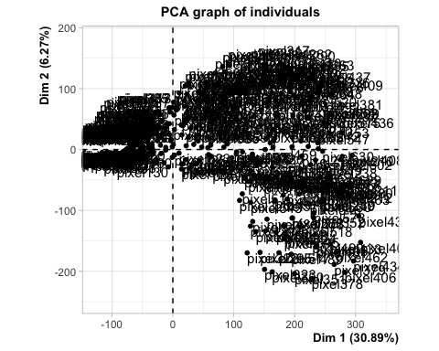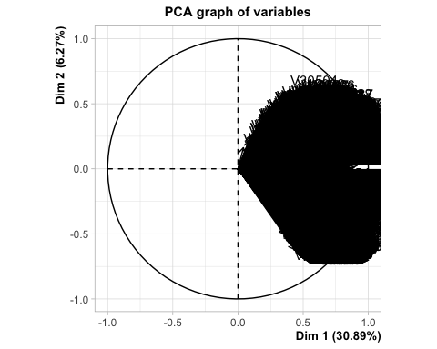

Let’s apply PCA and reduce the data-set dimensionality and the number of data samples.

digits_reduced <- data.frame(digits_all$label, pca_digits$var$coord)  
  
# Examine digits_reduced  
dim(digits_reduced)

## [1] 42000 31

# Reduce number of samples  
percent <- 0.25  
set.seed(275)  
digitsplit <- sample(nrow(digits_reduced), nrow(digits_reduced)*percent)  
digits_final <- digits_reduced[digitsplit,]  
  
# Examine the final data-frame we will use for all modelling  
dim(digits_final)

## [1] 10500 31

### Data splitting for Cross-validation

First, we will split the train-set based on a k-value (here k=10, means a 10-fold cross-validation model) and carve out test-set based on a holdout value. The remaining data will serve as the training set.

NOTE:

This is a far more exhaustive validation of machine learning models than the simple ‘Hold-Out Test’ which would split the data into train/test based on simple ratios.

N <- nrow(digits_final)  
  
# Number of splits  
kfolds <- 10  
  
# Split the data into train/test  
holdout <- split(sample(1:N), 1:kfolds)

## Cross-validation results across various models

### Naive Bayes

Create the test and train data-sets and run the Naive Bayes machine learning model

all_results <- list()  
all_labels <- list()  
  
for (k in 1:kfolds) {  
 digits_final_test <- digits_final[holdout[[k]],]  
 digits_final_train <- digits_final[-holdout[[k]], ]  
   
 # View the train/test data-sets   
 head(digits_final_test)  
 head(digits_final_train)  
  
 # Remove the label from the test-data  
 digits_final_test_noLabel <- digits_final_test[-c(1)]  
  
 # Just the label  
 digits_final_test_Label <- digits_final_test[c(1)]  
  
 # Train the model  
 train_nb <- naiveBayes(digits_all.label~., data=digits_final_train, na.action=na.pass)  
  
 # Make predictions  
 predict_nb <- predict(train_nb, digits_final_test_noLabel)  
  
 # Evaluate accuracy of the model  
 comp_table <- data.frame(Actual=digits_final_test_Label$digits_all.label, Predicted=predict_nb)  
 matrix_nb <- confusionMatrix(as.factor(comp_table$Predicted), as.factor(comp_table$Actual))  
  
 print(matrix_nb$overall)  
   
 # Visualize Naive-Bayes plots  
 plot(predict_nb, ylab='Density', main='NB plot')  
}

## Accuracy Kappa AccuracyLower AccuracyUpper AccuracyNull   
## 0.8600000 0.8441539 0.8375272 0.8804320 0.1276190   
## AccuracyPValue McnemarPValue   
## 0.0000000 NaN

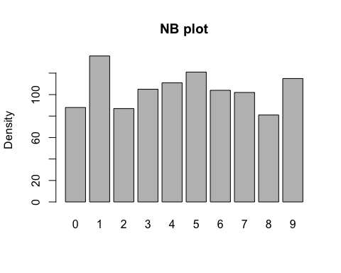

## Accuracy Kappa AccuracyLower AccuracyUpper AccuracyNull   
## 0.8476190 0.8304662 0.8244343 0.8688351 0.1238095   
## AccuracyPValue McnemarPValue   
## 0.0000000 NaN

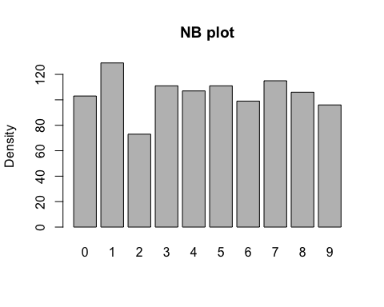

## Accuracy Kappa AccuracyLower AccuracyUpper AccuracyNull   
## 0.8514286 0.8346155 0.8284574 0.8724089 0.1257143   
## AccuracyPValue McnemarPValue   
## 0.0000000 NaN

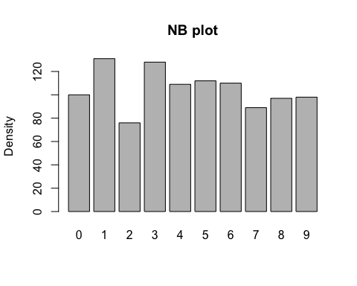

## Accuracy Kappa AccuracyLower AccuracyUpper AccuracyNull   
## 0.8476190 0.8306496 0.8244343 0.8688351 0.1114286   
## AccuracyPValue McnemarPValue   
## 0.0000000 NaN

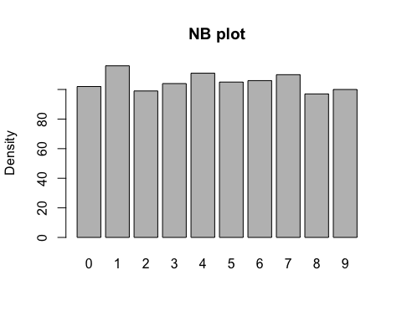

## Accuracy Kappa AccuracyLower AccuracyUpper AccuracyNull   
## 0.8638095 0.8485454 0.8415665 0.8839894 0.1209524   
## AccuracyPValue McnemarPValue   
## 0.0000000 NaN

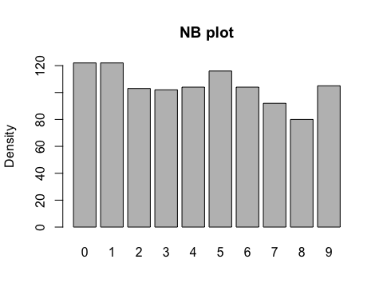

## Accuracy Kappa AccuracyLower AccuracyUpper AccuracyNull   
## 0.8580952 0.8423039 0.8355095 0.8786513 0.1171429   
## AccuracyPValue McnemarPValue   
## 0.0000000 NaN

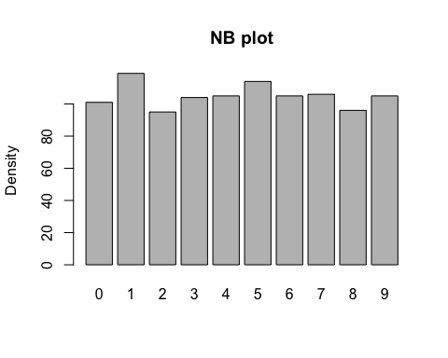

## Accuracy Kappa AccuracyLower AccuracyUpper AccuracyNull   
## 0.8542857 0.8378216 0.8314778 0.8750861 0.1247619   
## AccuracyPValue McnemarPValue   
## 0.0000000 NaN

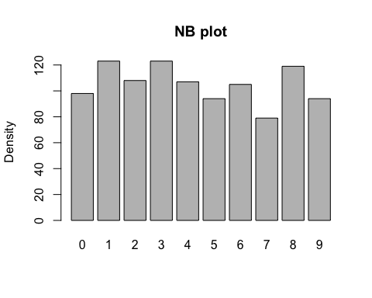

## Accuracy Kappa AccuracyLower AccuracyUpper AccuracyNull   
## 0.8647619 0.8496054 0.8425772 0.8848779 0.1142857   
## AccuracyPValue McnemarPValue   
## 0.0000000 NaN

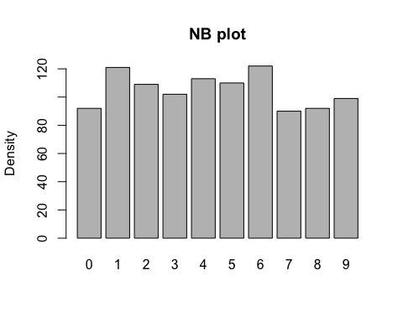

## Accuracy Kappa AccuracyLower AccuracyUpper AccuracyNull   
## 0.8790476 0.8654962 0.8577800 0.8981626 0.1161905   
## AccuracyPValue McnemarPValue   
## 0.0000000 NaN

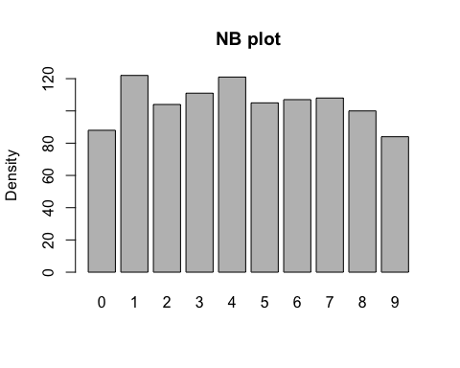

## Accuracy Kappa AccuracyLower AccuracyUpper AccuracyNull   
## 0.8447619 0.8274205 0.8214201 0.8661516 0.1142857   
## AccuracyPValue McnemarPValue   
## 0.0000000 NaN

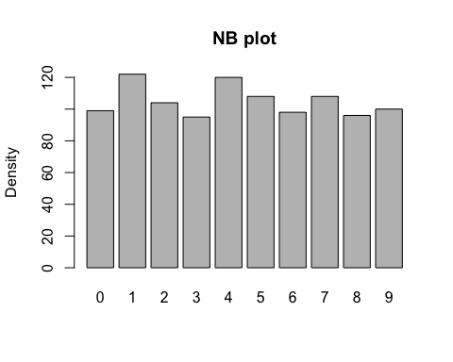

The overall accuracy for this model ranges between 83-88%.

### Decision-Trees

For this exercise, we will split the data (sampled data, rather than the original data) with 80:20 rule and then verify the performance of this model.

Model DT-1

# 80% of first N rows is train-data  
train_rows <- as.integer(0.8 * dim(digits_final)[1])  
digits_train <- digits_final[1:train_rows,]  
dim(digits_train)

## [1] 8400 31

# 20% of remaining is test-data  
digits_test <- digits_final[(train_rows+1):dim(digits_final)[1],]  
dim(digits_test)

## [1] 2100 31

train_dt1 <- rpart(digits_all.label~ ., data=digits_train, method='class')  
printcp(train_dt1)

##   
## Classification tree:  
## rpart(formula = digits_all.label ~ ., data = digits_train, method = "class")  
##   
## Variables actually used in tree construction:  
## [1] Dim.12 Dim.16 Dim.2 Dim.3 Dim.4 Dim.5 Dim.6 Dim.7 Dim.9   
##   
## Root node error: 7395/8400 = 0.88036  
##   
## n= 8400   
##   
## CP nsplit rel error xerror xstd  
## 1 0.102028 0 1.00000 1.00000 0.0040223  
## 2 0.081880 2 0.79594 0.79621 0.0056743  
## 3 0.070047 4 0.63218 0.63029 0.0061594  
## 4 0.055037 5 0.56214 0.56498 0.0061968  
## 5 0.045030 6 0.50710 0.51156 0.0061662  
## 6 0.034483 7 0.46207 0.46680 0.0060978  
## 7 0.012711 8 0.42759 0.43638 0.0060283  
## 8 0.010683 9 0.41487 0.42461 0.0059963  
## 9 0.010000 11 0.39351 0.41298 0.0059617

# Plot rpart using fancyRpartPlot  
fancyRpartPlot(train_dt1)

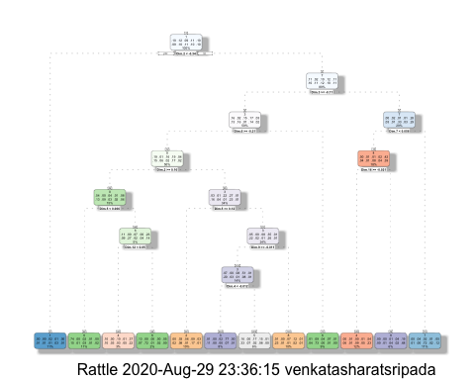

# Predict labels using Decision Tree   
predict_dt1 <- predict(train_dt1, digits_test, type='class')  
  
# Plot confusion matrix   
comp_table <- data.frame(Actual=digits_test$digits_all.label, Predicted=predict_dt1)  
matrix_dt1 <- confusionMatrix(as.factor(comp_table$Predicted), as.factor(comp_table$Actual))  
  
print(matrix_dt1$overall)

## Accuracy Kappa AccuracyLower AccuracyUpper AccuracyNull   
## 0.6519048 0.6129176 0.6310915 0.6722931 0.1104762   
## AccuracyPValue McnemarPValue   
## 0.0000000 NaN

With an accuracy of ~62%, this seems clearly a less accurate model. Next, let us attempt to prune the tree to reduce the node complexity and overall run-time.

dt1_prune <- prune(train_dt1, cp=train_dt1$cptable[which.min(train_dt1$cptable[,"xerror"]),"CP"])  
  
# Visualize pruned tree  
fancyRpartPlot(dt1_prune)

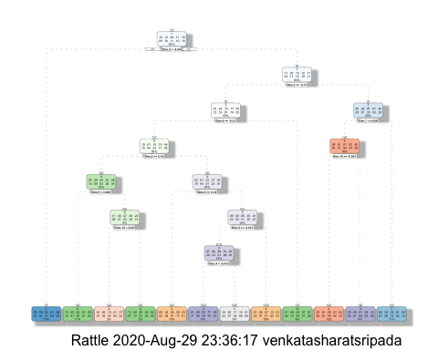

# Predict labels based on the pruned tree   
predict_dt1_prune <- predict(dt1_prune, digits_test, type='class')  
  
# Plot confusion matrix   
comp_table <- data.frame(Actual=digits_test$digits_all.label, Predicted=predict_dt1_prune)  
matrix_dt1_prune <- confusionMatrix(as.factor(comp_table$Predicted), as.factor(comp_table$Actual))  
  
print(matrix_dt1_prune$overall)

## Accuracy Kappa AccuracyLower AccuracyUpper AccuracyNull   
## 0.6519048 0.6129176 0.6310915 0.6722931 0.1104762   
## AccuracyPValue McnemarPValue   
## 0.0000000 NaN

Pruned tree and actual decision tree turned out to be similar and thus yielded no benefits

### Random Forests

Random Forests generates a bunch of bootstrapped sub-trees and combining the results in an Ensemble method.

train_dt2 <- randomForest(x=digits_train[2:ncol(digits_train)], y=digits_train$digits_all.label, data = digits_train,   
 ntree=100, mtry=2, importance=TRUE)  
  
# Predict labels based Random Forest algorithm  
predict_dt2 <- predict(train_dt2, digits_test)  
  
# Plot confusion matrix   
comp_table <- data.frame(Actual=digits_test$digits_all.label, Predicted=predict_dt2)  
matrix_dt2 <- confusionMatrix(as.factor(comp_table$Predicted), as.factor(comp_table$Actual))  
  
print(matrix_dt2$overall)

## Accuracy Kappa AccuracyLower AccuracyUpper AccuracyNull   
## 0.9376190 0.9306534 0.9264122 0.9475842 0.1104762   
## AccuracyPValue McnemarPValue   
## 0.0000000 NaN

By far, the best accuracy so far with prediction accuracy at ~92%

### KNN

# To prevent model over-fitting, re-model training-set  
# Reduce number of samples  
percent <- 0.15  
set.seed(275)  
digitsplit_knn <- sample(nrow(digits_all), nrow(digits_all)*percent)  
digits_final_knn <- digits_all[digitsplit_knn,]  
  
# Examine the final data-frame we will use for knn modeling  
dim(digits_final_knn)

## [1] 6300 785

# Slice the data-set  
N <- nrow(digits_final_knn)  
kfolds_knn <- 2  
set.seed(30)  
holdout_knn <- split(sample(1:N), 1:kfolds_knn)   
  
# Start with some finite k_guess  
k_guess <- round(sqrt(N)/10)  
  
all_results <- data.frame(Actual=c(), Predicted=c())  
for (k in 1:kfolds_knn) {  
 digits_final_test <- digits_final_knn[holdout_knn[[k]],]  
 digits_final_train <- digits_final_knn[-holdout_knn[[k]], ]  
   
 digits_final_no_label <- digits_final_test[-c(1)]  
 digits_final_label <- digits_final_test[c(1)]  
   
 predict_knn <- knn(train=digits_final_train, test=digits_final_test, cl=digits_final_train$label,   
 k=k_guess)  
   
 # Put results in each iteration in all_results  
 all_results <- rbind(all_results, data.frame(Actual=digits_final_label$label, Predicted=predict_knn))  
   
}  
  
# Get the overall accuracy for k=7  
matrix_knn <- confusionMatrix(as.factor(all_results$Predicted), as.factor(all_results$Actual))  
print(matrix_knn$overall)

## Accuracy Kappa AccuracyLower AccuracyUpper AccuracyNull   
## 0.9114286 0.9014342 0.9041413 0.9183322 0.1201587   
## AccuracyPValue McnemarPValue   
## 0.0000000 NaN

The accuracy for knn is at ~91%. Repeating the test for k=3, 5, 8 yielded the following results:

* k=3, accuracy - ~92%
* k=5, accuracy - ~92%

### SVMs

all_results <- data.frame(Actual=c(), Predicted=c())  
for (k in 1:kfolds) {  
 digits_final_test <- digits_final[holdout[[k]],]  
 digits_final_train <- digits_final[-holdout[[k]], ]  
   
 digits_final_no_label <- digits_final_test[-c(1)]  
 digits_final_label <- digits_final_test[c(1)]  
   
 train_svm <- svm(digits_final_train$digits_all.label ~ ., digits_final_train, na.action = na.pass)  
   
 # Predict using svm modeling  
 predict_svm <- predict(train_svm, digits_final_no_label, type=c('class'))  
   
 # Put results in each iteration in all_results  
 all_results <- rbind(all_results, data.frame(Actual=digits_final_label$digits_all.label, Predicted=predict_svm))  
   
}  
  
# Get the overall accuracy for SVM  
matrix_svm <- confusionMatrix(as.factor(all_results$Predicted), as.factor(all_results$Actual))  
print(matrix_svm$overall)

## Accuracy Kappa AccuracyLower AccuracyUpper AccuracyNull   
## 0.9686667 0.9651633 0.9651541 0.9719161 0.1164762   
## AccuracyPValue McnemarPValue   
## 0.0000000 NaN

The accuracy here is pretty good at 96.53% and is proving to be the best of the machine-learning models.

### KSVMs

Finally, let’s run the data-set through the various KSVMs types, namely:

* linear
* polynomial
* sigmoid

# Let's start with experimenting with kernel SVM Linear modeling  
all_results <- data.frame(Actual=c(), Predicted=c())  
for (k in 1:kfolds) {  
 digits_final_test <- digits_final[holdout[[k]],]  
 digits_final_train <- digits_final[-holdout[[k]], ]  
   
 digits_final_no_label <- digits_final_test[-c(1)]  
 digits_final_label <- digits_final_test[c(1)]  
   
 train_ksvm <- svm(digits_final_train$digits_all.label ~ ., digits_final_train, kernel='linear',   
 na.action = na.pass)  
   
 # Predict using KSVM modeling  
 predict_ksvm <- predict(train_ksvm, digits_final_no_label, type=c('class'))  
   
 # Put results in each iteration in all_results  
 all_results <- rbind(all_results, data.frame(Actual=digits_final_label$digits_all.label, Predicted=predict_ksvm))  
   
}  
  
# Get the overall accuracy for KSVM (Linear)  
matrix_ksvm <- confusionMatrix(as.factor(all_results$Predicted), as.factor(all_results$Actual))  
print(matrix_ksvm$overall)

## Accuracy Kappa AccuracyLower AccuracyUpper AccuracyNull   
## 0.9124762 0.9026751 0.9069081 0.9178143 0.1164762   
## AccuracyPValue McnemarPValue   
## 0.0000000 NaN

# Repeat the experiment with kernel SVM as Polynomial  
all_results <- data.frame(Actual=c(), Predicted=c())  
for (k in 1:kfolds) {  
 digits_final_test <- digits_final[holdout[[k]],]  
 digits_final_train <- digits_final[-holdout[[k]], ]  
   
 digits_final_no_label <- digits_final_test[-c(1)]  
 digits_final_label <- digits_final_test[c(1)]  
   
 train_ksvm <- svm(digits_final_train$digits_all.label ~ ., digits_final_train, kernel='polynomial',   
 na.action = na.pass)  
   
 # Predict using KSVM modeling  
 predict_ksvm <- predict(train_ksvm, digits_final_no_label, type=c('class'))  
   
 # Put results in each iteration in all_results  
 all_results <- rbind(all_results, data.frame(Actual=digits_final_label$digits_all.label, Predicted=predict_ksvm))  
   
}  
  
# Get the overall accuracy for KSVM (Linear)  
matrix_ksvm <- confusionMatrix(as.factor(all_results$Predicted), as.factor(all_results$Actual))  
print(matrix_ksvm$overall)

## Accuracy Kappa AccuracyLower AccuracyUpper AccuracyNull   
## 0.9686667 0.9651632 0.9651541 0.9719161 0.1164762   
## AccuracyPValue McnemarPValue   
## 0.0000000 NaN

The accuracy with kernel=‘polynomial’ yielded marginally better results at 96.78% vs linear at 91.39%.

# Repeat the experiment with kernel SVM as Sigmoid  
all_results <- data.frame(Actual=c(), Predicted=c())  
for (k in 1:kfolds) {  
 digits_final_test <- digits_final[holdout[[k]],]  
 digits_final_train <- digits_final[-holdout[[k]], ]  
   
 digits_final_no_label <- digits_final_test[-c(1)]  
 digits_final_label <- digits_final_test[c(1)]  
   
 train_ksvm <- svm(digits_final_train$digits_all.label ~ ., digits_final_train, kernel='sigmoid',   
 na.action = na.pass)  
   
 # Predict using KSVM modeling  
 predict_ksvm <- predict(train_ksvm, digits_final_no_label, type=c('class'))  
   
 # Put results in each iteration in all_results  
 all_results <- rbind(all_results, data.frame(Actual=digits_final_label$digits_all.label, Predicted=predict_ksvm))  
   
}  
  
# Get the overall accuracy for KSVM (Linear)  
matrix_ksvm <- confusionMatrix(as.factor(all_results$Predicted), as.factor(all_results$Actual))  
print(matrix_ksvm$overall)

## Accuracy Kappa AccuracyLower AccuracyUpper AccuracyNull   
## 7.932381e-01 7.700444e-01 7.853634e-01 8.009498e-01 1.164762e-01   
## AccuracyPValue McnemarPValue   
## 0.000000e+00 6.118680e-17

By far, KSVM - Sigmoid model yielded the worst results at 79.62%

## Conclusion

The data-set related to images of written digits, was run through all the machine learning algorithms covered within the course-work for IST-707 - Decision Tree, Naive Bayes, KNN, SVMs, KSVMs and Random Forest. While each of them have have their strengths/weaknesses, I’ve ordered them in their ability to accurately predict data (limited to the nature of this data-set), based on the experiments presented thus far:

* KSVMs - Polynomial
* SVMs
* KSVMs - Linear
* Random Forest
* KNN
* Naive Bayes
* KSVMs - Sigmoid
* Decision Trees