SLE-3: Architectural Design Using Full C4 Model

Course: 02AML204 – Introduction to Artificial Intelligence
PRN: 25UAM120 | Name: Sharayu Rakesh Savale | Division: B

1. System Title & Description
Graph Search System using BFS and DFS
A graph search system that takes a graph, start node and goal node as input. It uses BFS and DFS to search the graph and produces the search result/path. The system continues the Graph Search work performed in SLE-2.

2. Context Diagram – Level 1

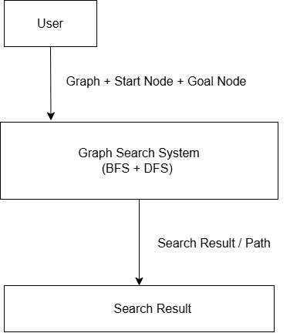

The user provides the graph, start node and goal node. The system performs BFS or DFS and returns the search result/path.

3. Container Diagram – Level 2
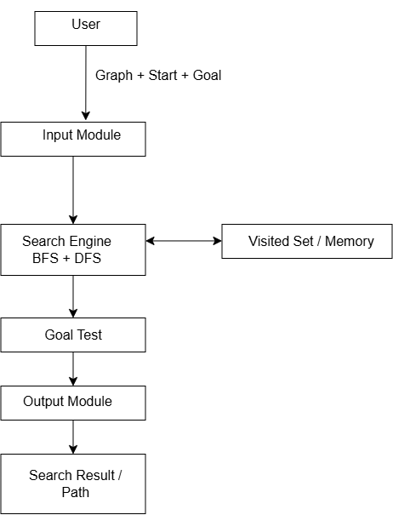

• Input Module: Takes graph, start node and goal node.
• Search Engine: Performs BFS and DFS.
• Visited Set / Memory: Stores visited nodes.
• Goal Test: Checks whether the goal is reached.
• Output Module: Displays the search result/path.

4. Component Diagram – Level 3
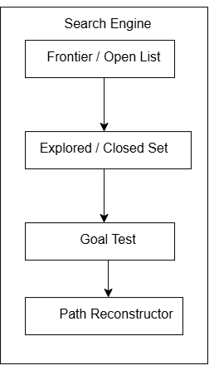

The Search Engine is divided into Frontier/Open List, Explored/Closed Set, Goal Test and Path Reconstructor. These components work together to perform the search and produce the final path.

5. Code Level Overview – Level 4
• graph = {...} – Stores graph structure.
• bfs_search() – Performs BFS.
• dfs_search() – Performs DFS.
• goal_test() – Checks the goal node.
• reconstruct_path() – Reconstructs the path.
• main() – Handles input and output.

6. Design Decisions
The system is divided into separate containers for clear organization. BFS and DFS are placed in the Search Engine because they perform the main search operation. The architecture continues the Graph Search System from SLE-2.

7. AI Contribution
AI used: ChatGPT. AI helped in understanding C4 requirements and planning the architecture. I created the diagrams, selected the system structure, and prepared the final report.

8. Conclusion
The C4 model helped me understand the Graph Search System from overall system context to code-level functions. It also connected the architecture with my previous SLE-2 work.

