AWS-Config-Setup-Lab

AWS Config is a service that enables you to assess, audit, and evaluate the configurations of yourAWS resources, providing a detailed inventory and configuration history for compliance and security analysis.

This section will guide you to:
- Set up AWS Config using console

This lab has one subsection, namely:
2.9.1 Setting up AWS Config using console

Step 2.9.1: Setting up AWS Config using console
- Sign in to the AWS Management Console, and open the AWS Config Console at https://console.aws.amazon.com/config/
If this is your first time, note that the AWS Config page looks like this:
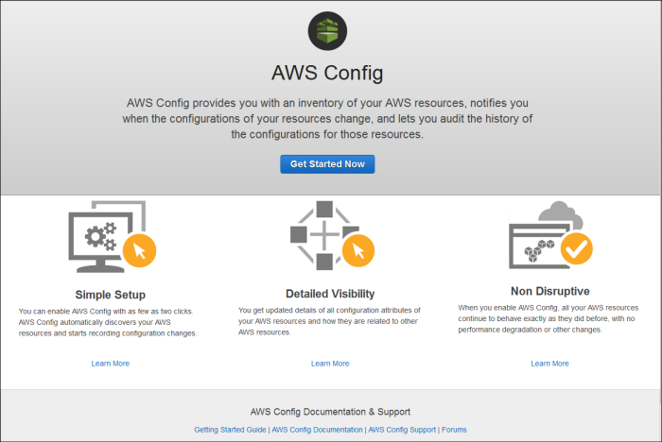

- Choose Get Started Now
- On the Settings page, for Resource types to record, specify all the resource types you want AWS Config to record.
- For Amazon S3 Bucket, choose the Amazon S3 bucket to which AWS Config will send configuration history and configuration snapshot files

  - Create a new bucket: For Bucket Name, type a name for your Amazon S3 bucket
  - Choose a bucket from your account: For Bucket Name, choose your preferred bucket
  - Choose a bucket from another account: For Bucket Name, type the name of the bucket you have chosen
- For Amazon SNS Topic, choose whether AWS Config streams information by selecting the Stream configuration changes and notifications to an Amazon SNS topic. AWS Config sends notifications such as configuration history delivery, configuration snapshot delivery, and compliance.
- If you chose to have AWS Config stream to an Amazon SNS topic, choose the target topic
  - Create a new topic: For Topic Name, type a name for your SNS topic
  - Choose a topic from your account: For Topic Name, select your preferred topic
  - Choose a topic from another account: For Topic ARN, type the Amazon Resource Name (ARN) of the topic

- For the AWS Config role, choose the IAM role that permits AWS Config record configuration information and send this information to Amazon S3 and Amazon SNS
  - Create a role: AWS Config creates a role that has the required permissions. For Role name, you can customize the name that AWS Config creates
  - Choose a role from your account: For Role name, choose an IAM role in your account
- If you are setting up AWS Config in a region that supports rules, choose Next. Otherwise, choose Save. AWS Config displays the Resource inventory page.

