AWS-Custom-VPC-Configuration

This section will guide you to:
- Create a custom VPC

This lab has two subsections, namely:
8.1.1 Creating a custom VPC
8.1.2 Editing and increasing the range of hosts
Step 8.1.1: Creating a custom VPC
- AWS VPC service is enabled in your practice lab.

- Refer MEAN: Lab Guide - Phase 4 to learn how to use this lab.

- Go to the Amazon dashboard

- Select VPC

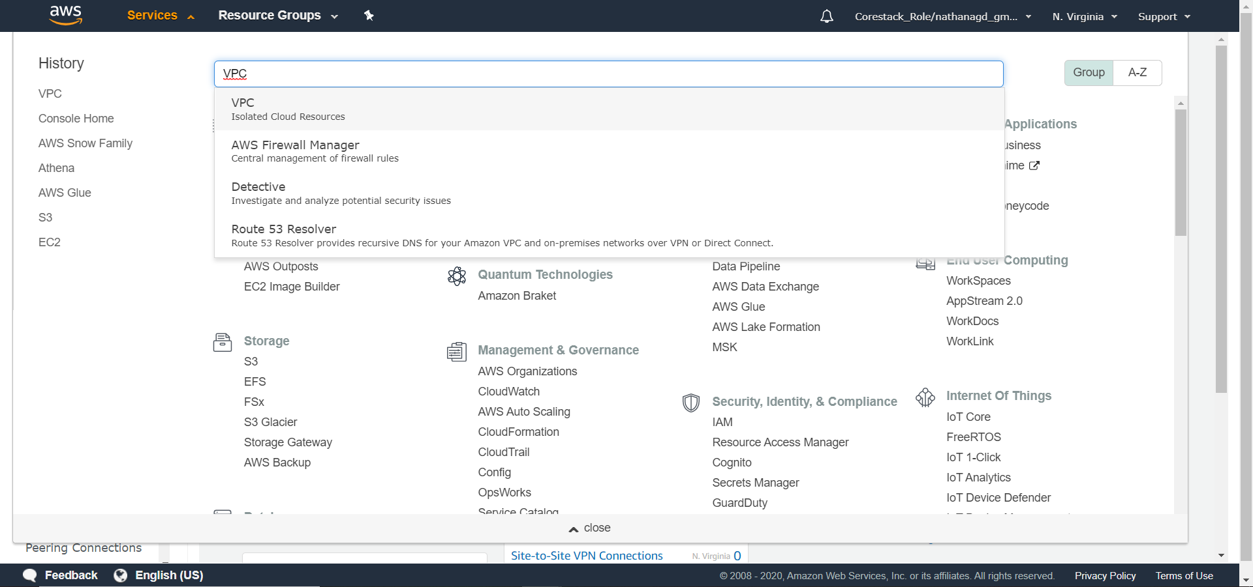

- Go to Your VPCs in the VPC Management Console

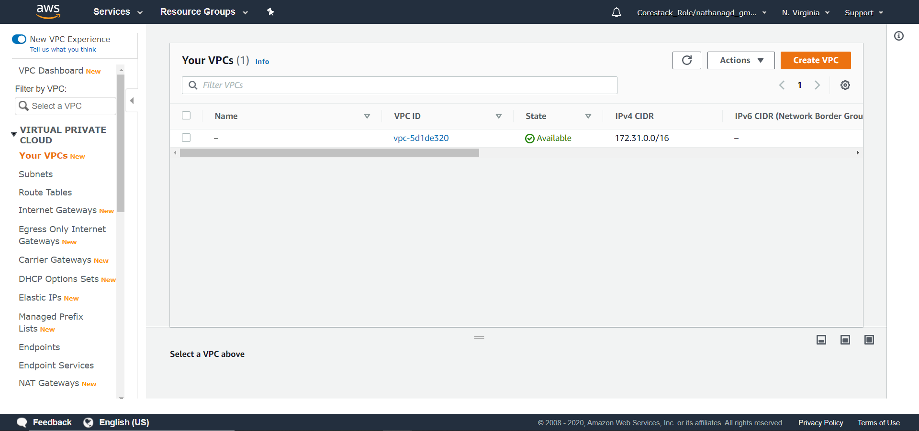

- Click on the Create VPC button

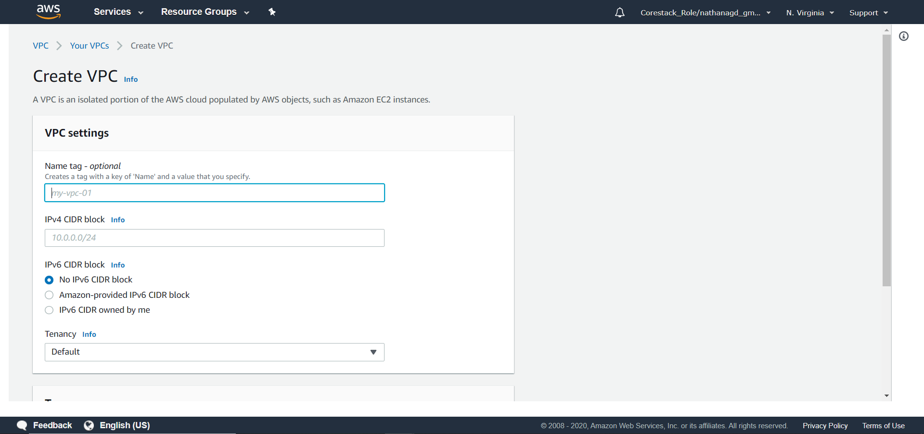

- Provide a name for the VPC, and choose from a range of IP addresses (10.0.0.0/16 to 10.0.0.0/24) where /16 will have 65,536 IP addresses and /24 will have 256 IP addresses. Leave all other fields as they are, and provide name tags if you want.
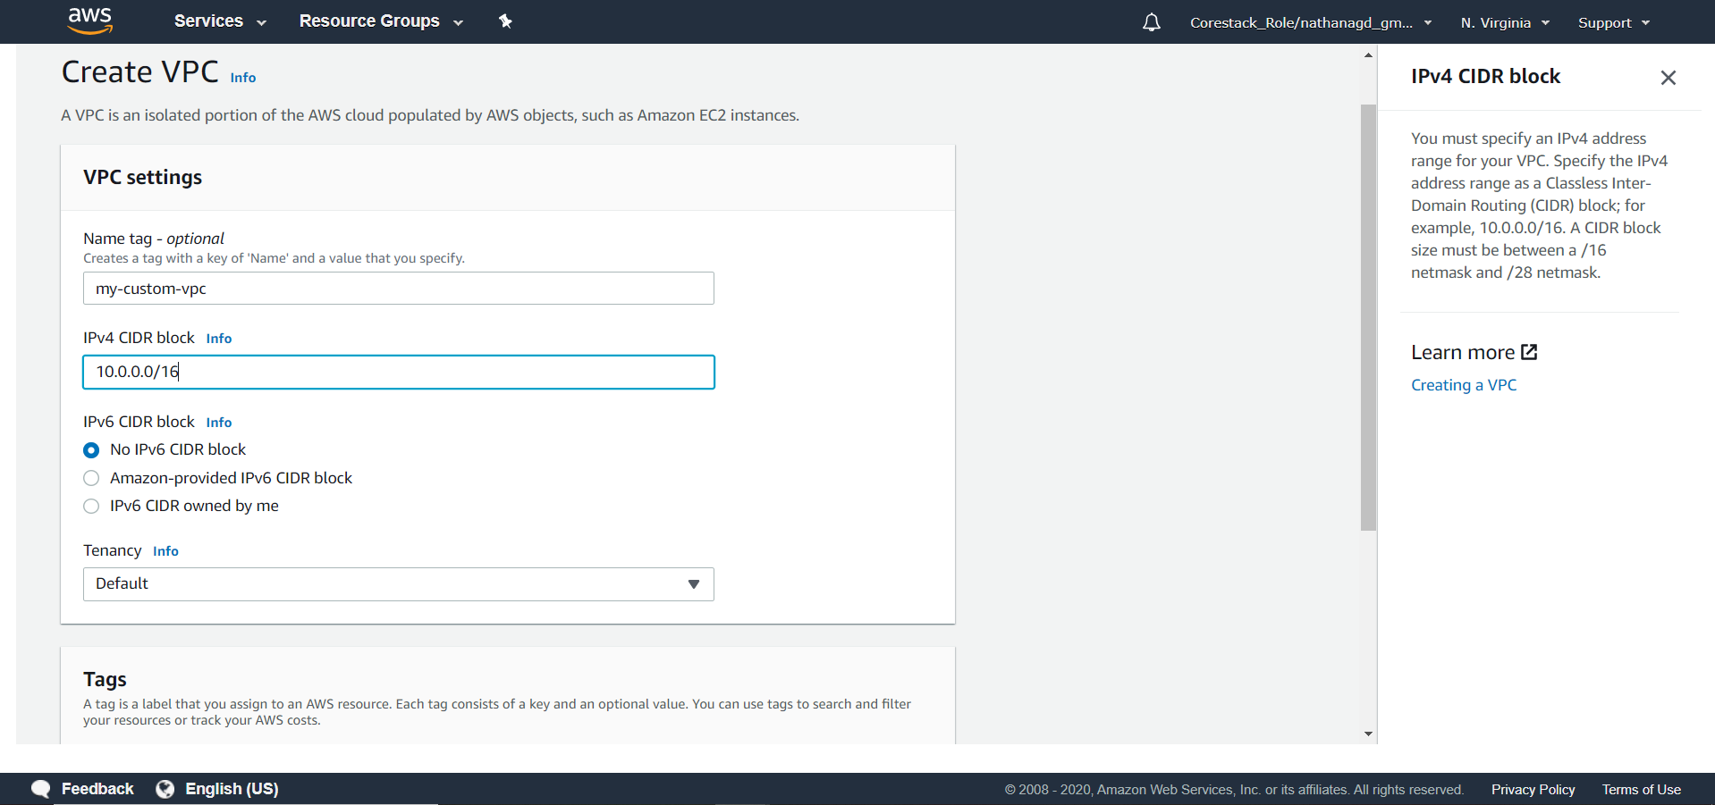

- Click on Create. Your VPC will be created, and all the relevant information will be shown to you.

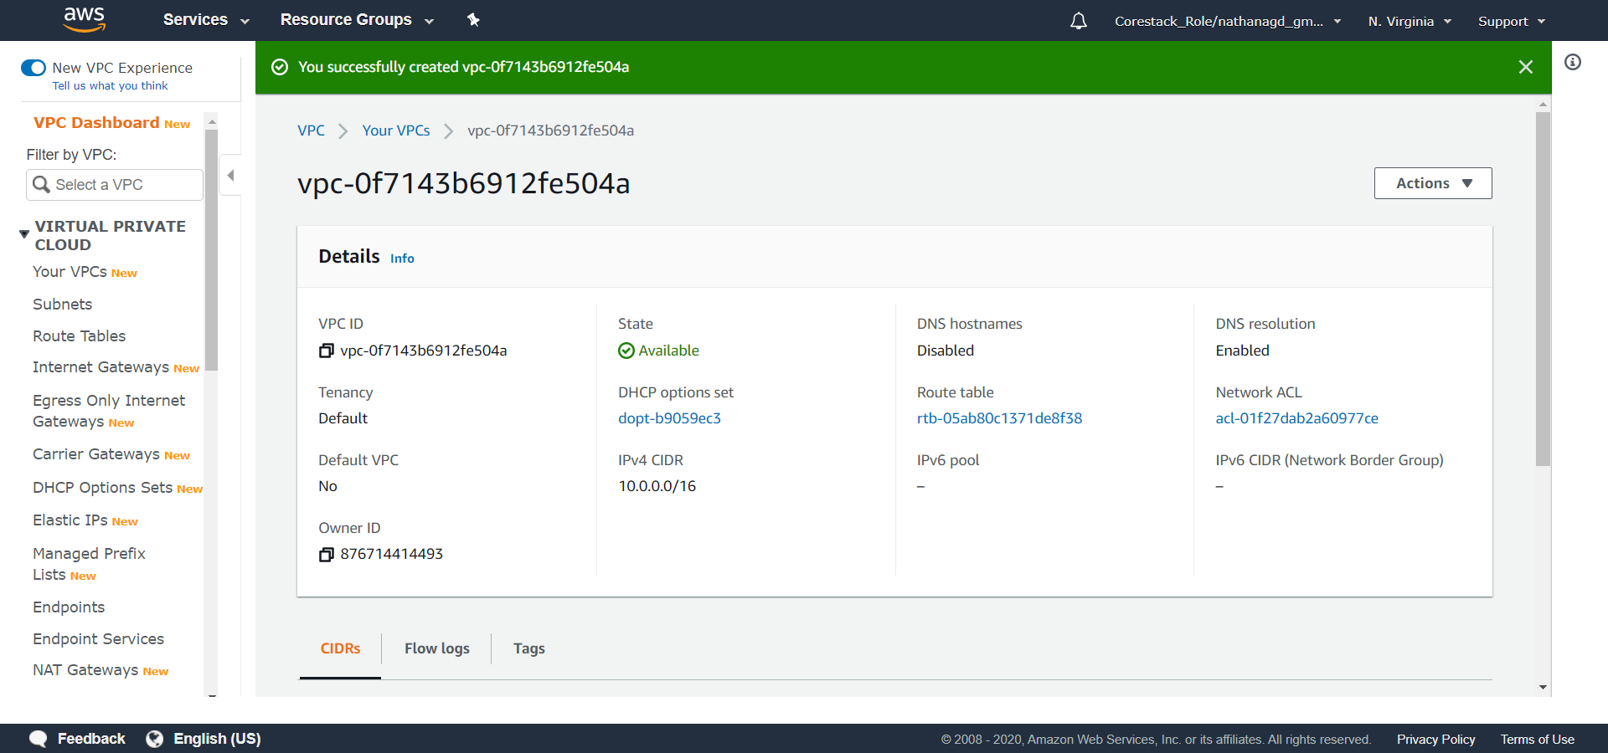

Step 8.1.2: Editing and increasing the range of hosts (CIDRs)
- You want to increase your IPV4 connection limits and want more IP addresses. In order to do this, go to Actions, and then select Edit CIDRs.

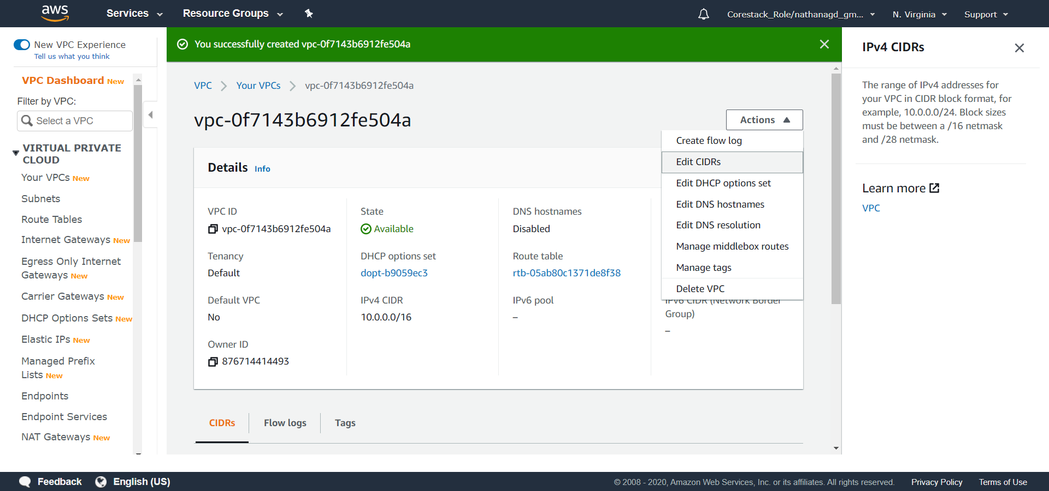

- Here, you can add up to five CIDRs as shown below:

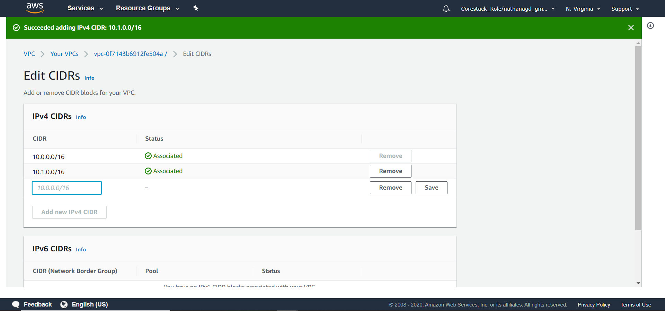

- So, the maximum number of CIDRs you can increase is up to 3,27,680.

