Automating App Installation on EC2 Instance

Step 1: Install apps when launching an instance

  - Navigate to the AWS console home dashboard, search for and click on EC2

  - Click on Instances on the left pane:
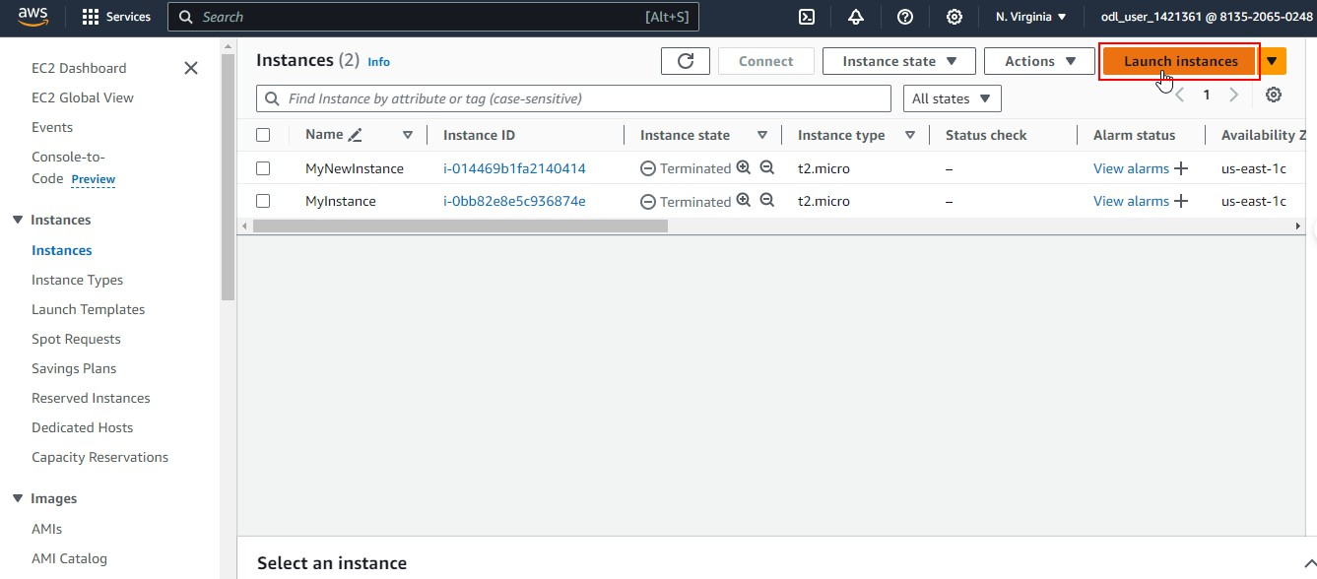
  - Click on the Launch instances button as shown:

  - Add a desired name as shown:

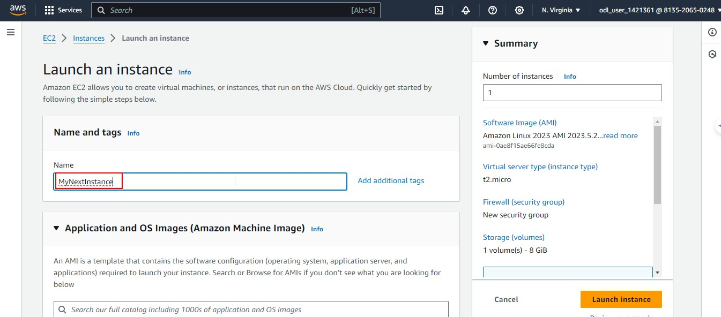

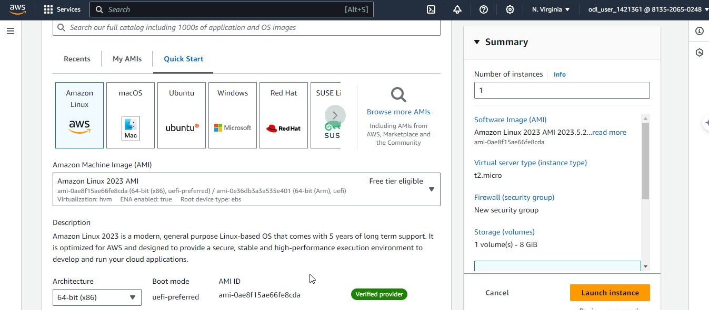
  - Select the desired AMI as shown:

  - Select t2.micro as the Instance type as shown:

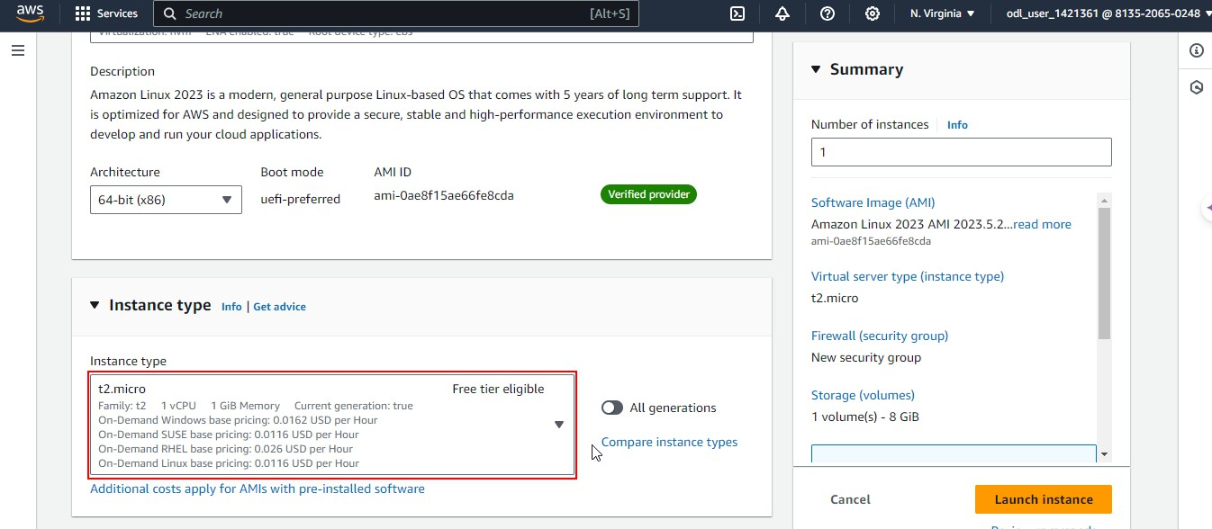

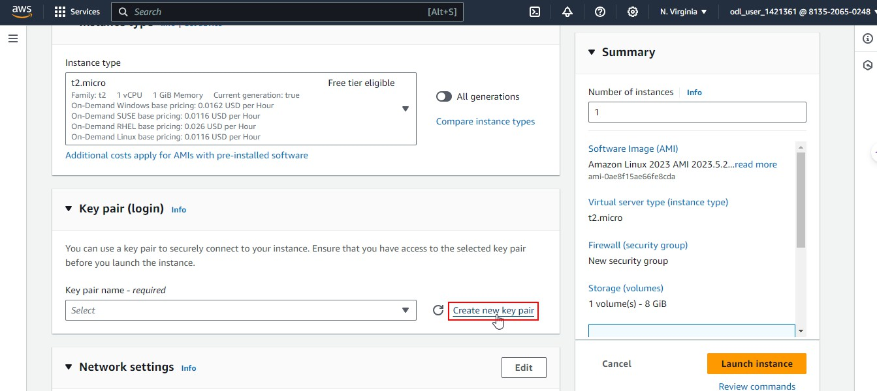
  - Click on Create new key pair

  - Add a desired name, select the required format for the private key file, and click on the
Create key pair button

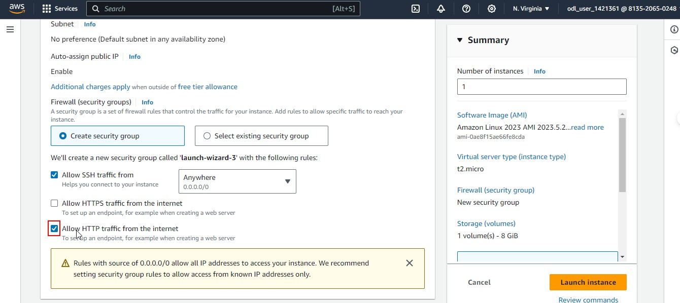
  - Click on the Allow HTTP traffic from the internet checkbox as shown:

  - Navigate to the Advance details section and scroll down to the User data box. Add the following code and click on Launch instance:
#!/bin/bash
echo "updating system">>/tmp/user-data-run.log apt update -y
echo "Installing package">>/tmp/user-data-run.log apt install -y apache2 php
echo "Downloading code">>/tmp/user-data-run.log cd/tmp

git clone https//github.com/nindate/web-pages.git echo "Deploying code">>/tmp/user-data-run.log mv web-pages/simple-site/* /var/www/html/ rm/var/www/html/index.html
echo "system ready to use">>/tmp/user-data-run.log

By following these steps, you have successfully automated the installation of applications while launching an EC2 instance in AWS using User Data.

