AWS-Network-Load-Balancer-Setup

Step 1: Set up the Network Load Balancer

  - Navigate to the AWS console home dashboard, search for and click on EC2

  - Navigate to Load Balancers under the Load Balancing section and click Create load balancer

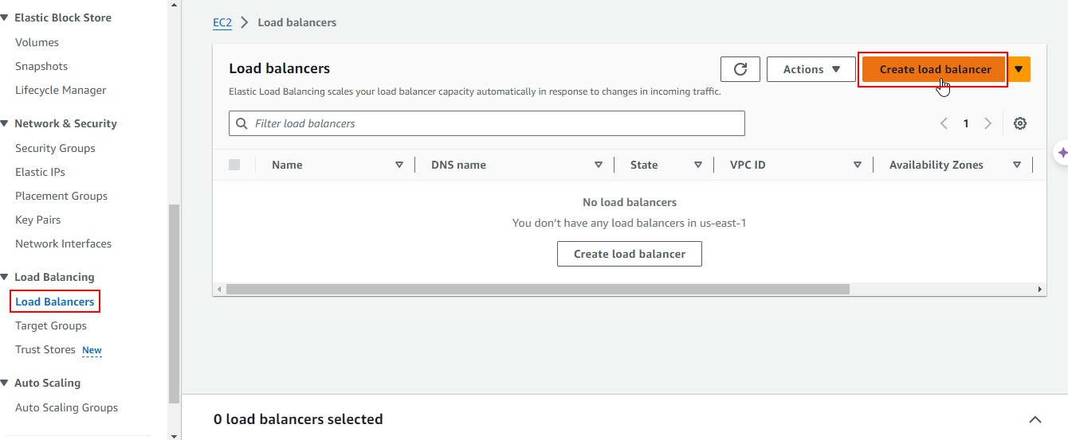

  - Choose Network Load Balancer and click on Create
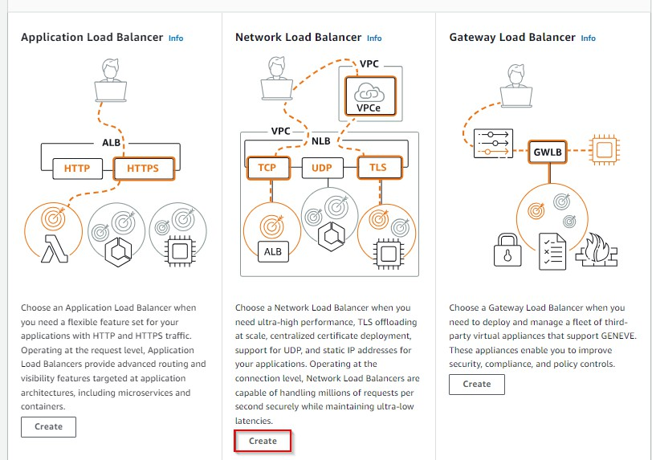

  - 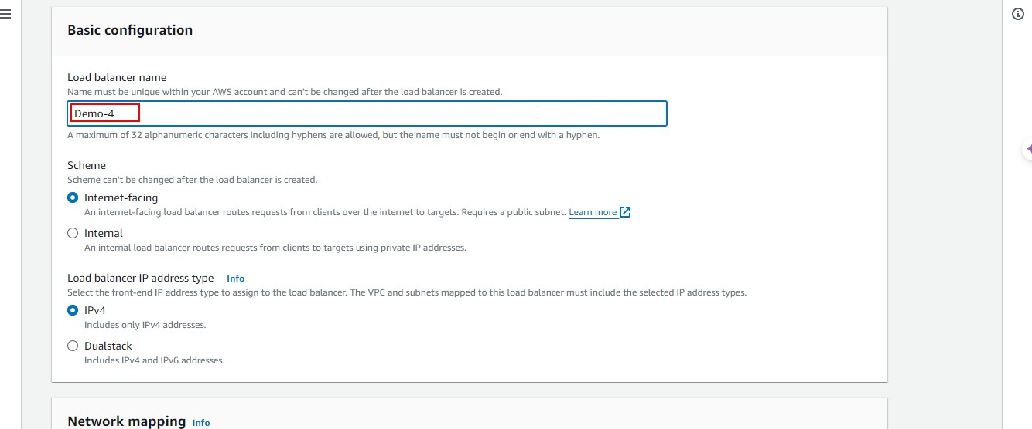Enter the Load balancer name as Demo-4

  - 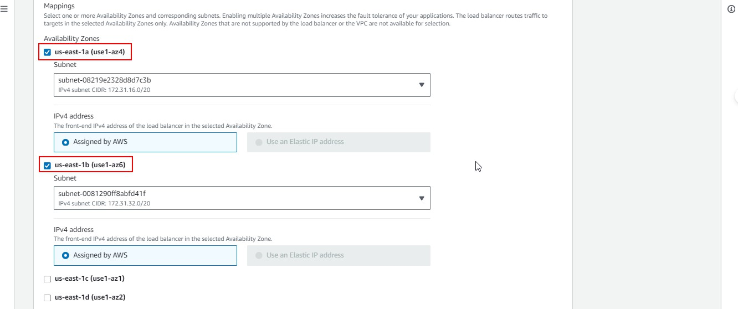Select the Mappings, us-east-1a and us-east-1b

  - 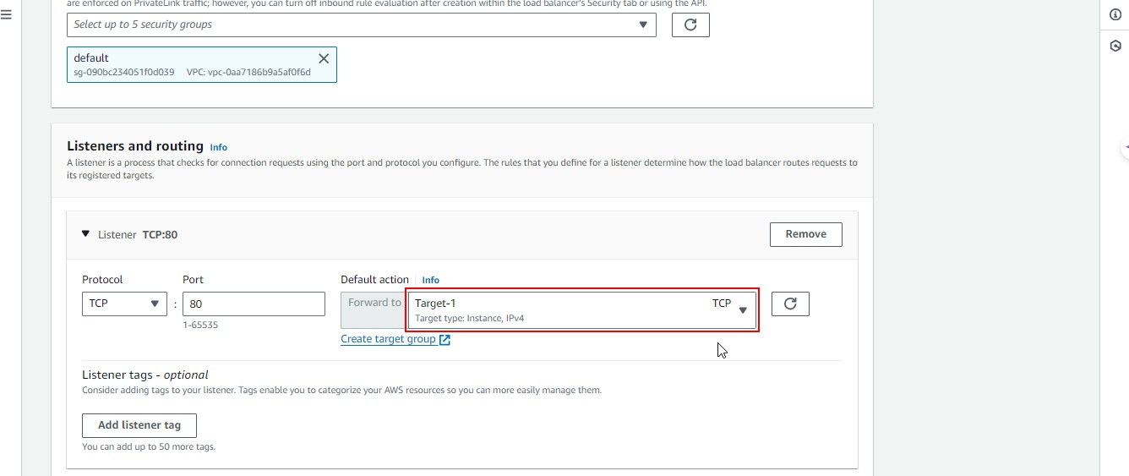Click on Create target group

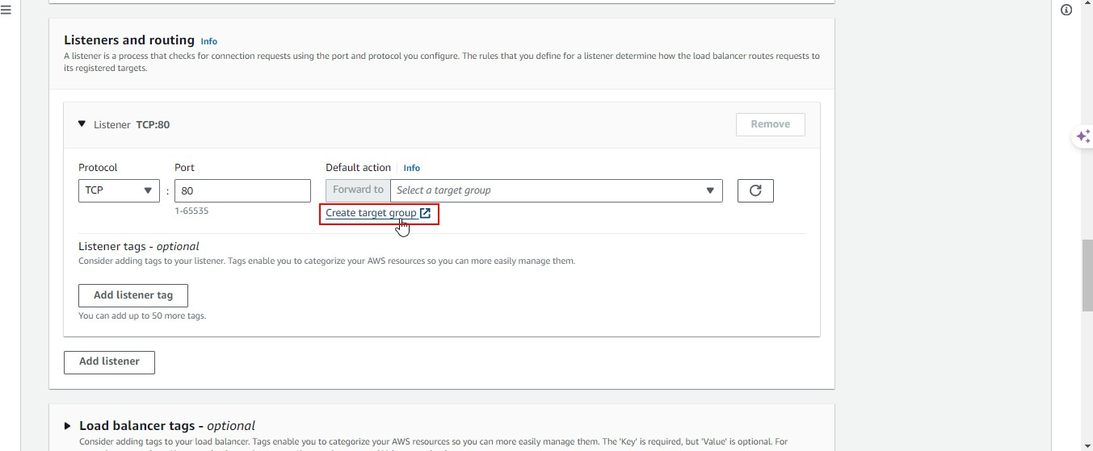

On the Listeners and routing tab, add more than one listener and select the target group name. Refer to the previous demos to learn how to create target groups.

  - Select Target-1 as the Default action

  - Add Target-2 as another Default action

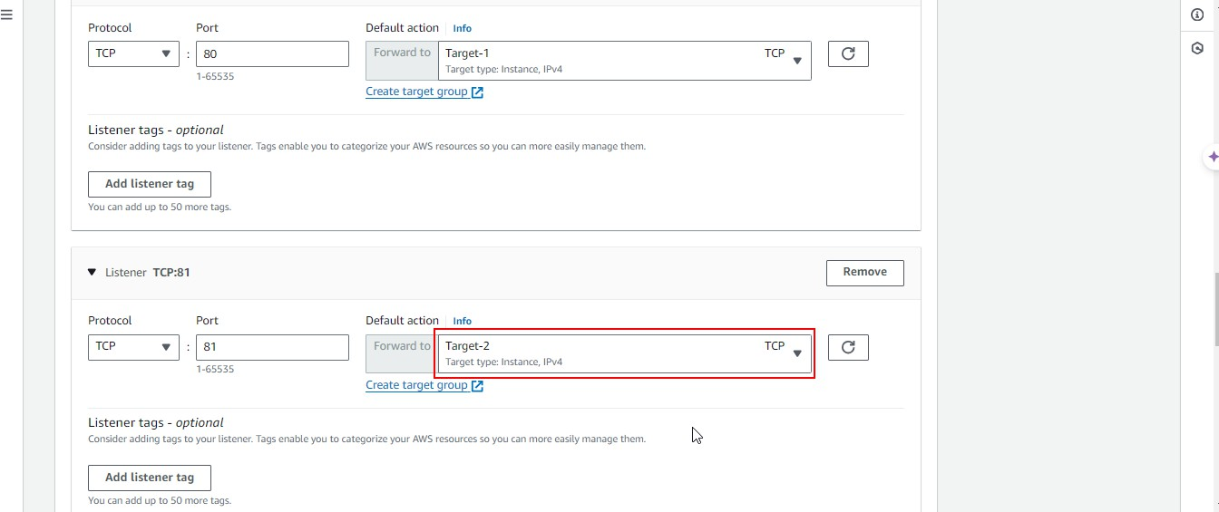

  - 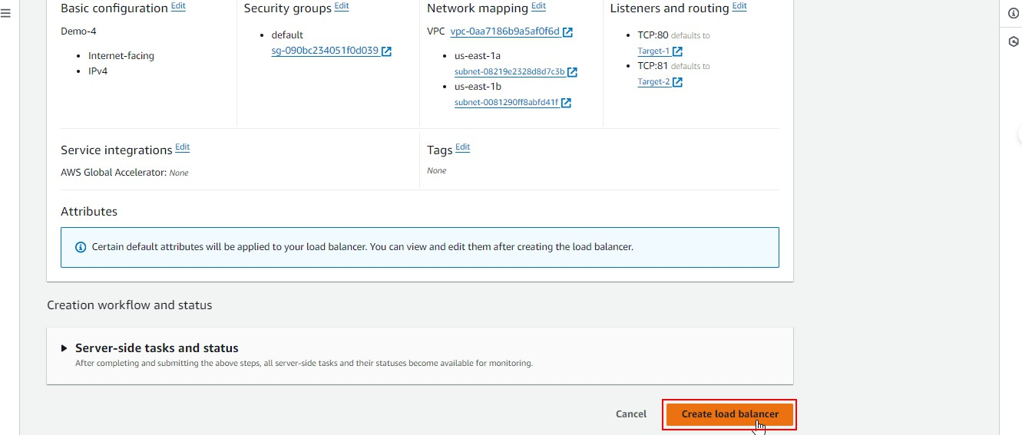Click on Create load balancer

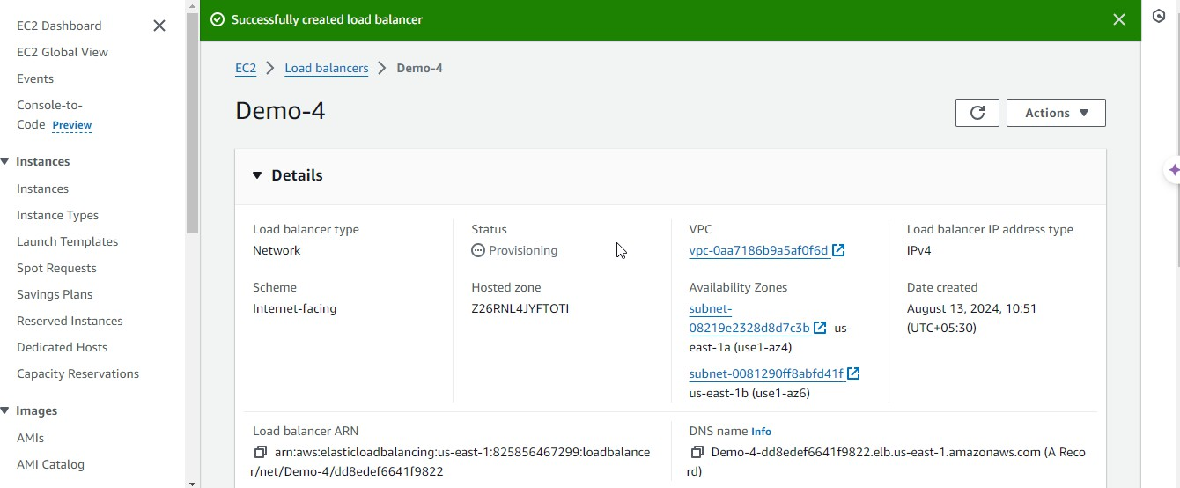

The load balancer Demo-4 has been successfully created.

  - Select the load balancer and click on Details to access the VPC and DNS name

By following these steps, you have successfully created a Network Load Balancer to distribute traffic across the specified availability zones using multiple listeners and target groups.

