AWS-Route53-Latency-Routing

This section will guide you to:
- Create a record set for latency routing policy

Creating a record set for latency routing policy

Step 1: Creating a record set for latency routing policy
- Open Route 53 console
- In the dashboard, click on Hosted zones and create a hosted zone as shown below
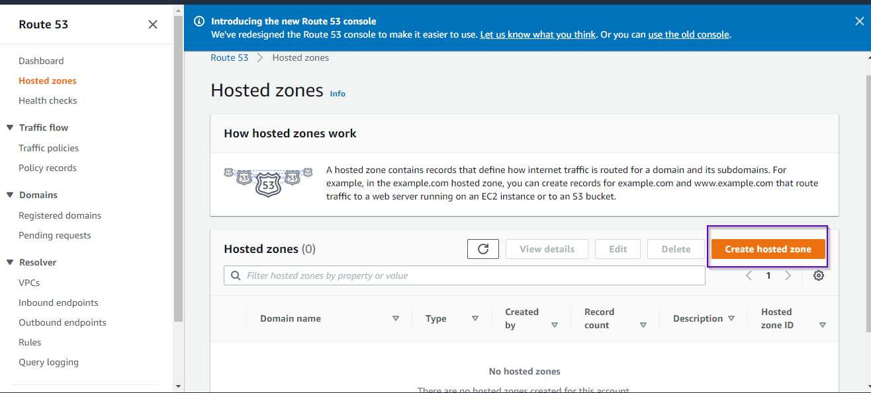

3.Enter the domain name for the hosted zone and create it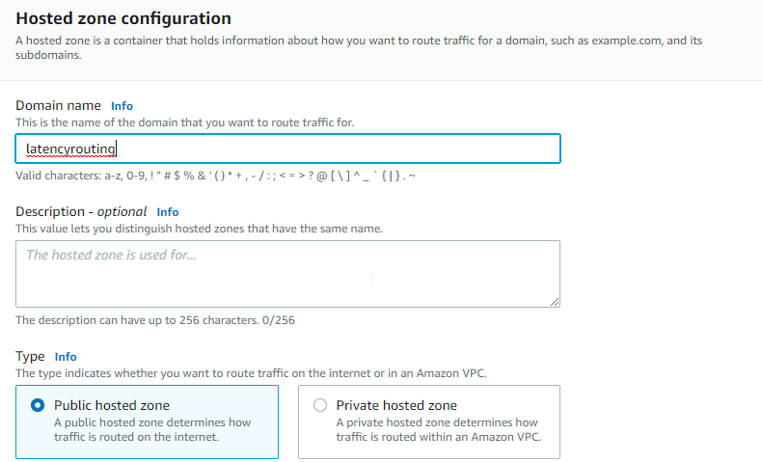
4.Once you create it, navigate to the page with hosted zones where you can create a record
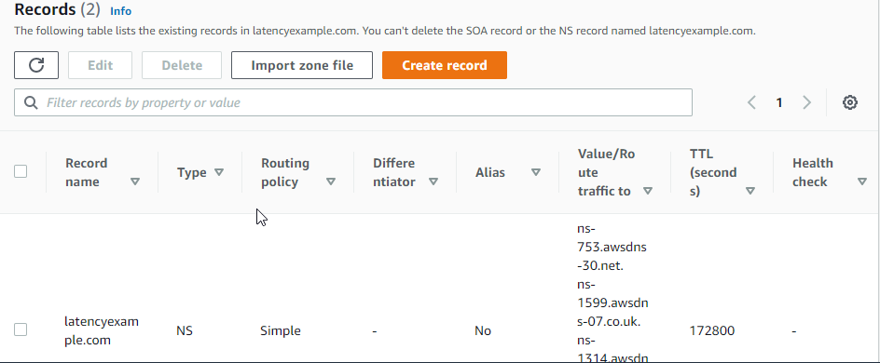

5. The previous step will take you to the page of routing policies as shown below. Select Latency routing and then select Next.

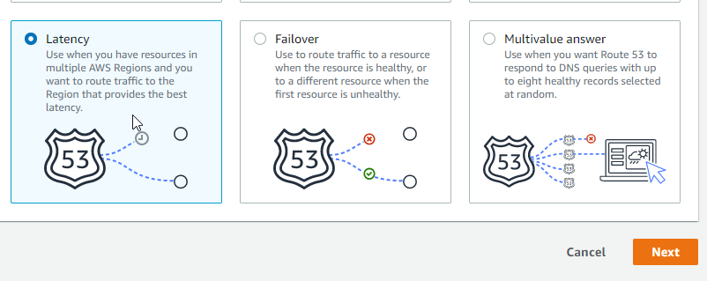
6. Provide the necessary information as shown below and define it.
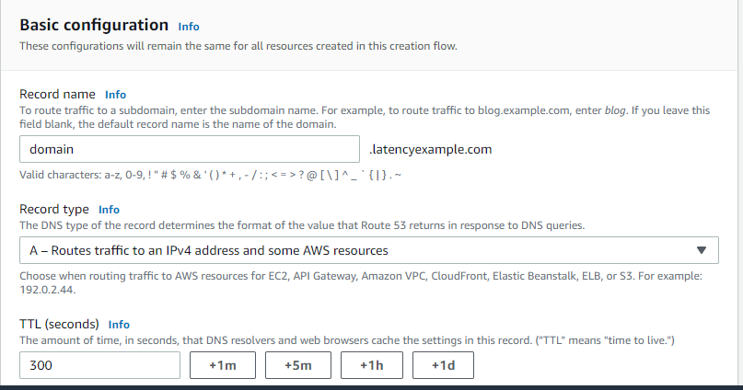

7. After this, define the latency record providing the necessary information as shown below.
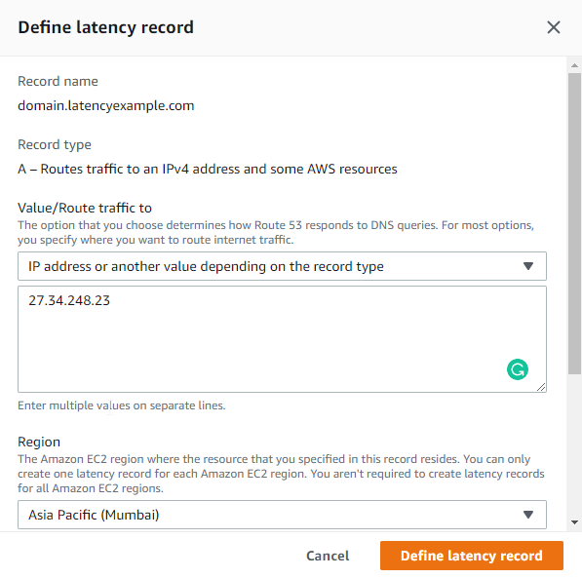

8. Now, create the records
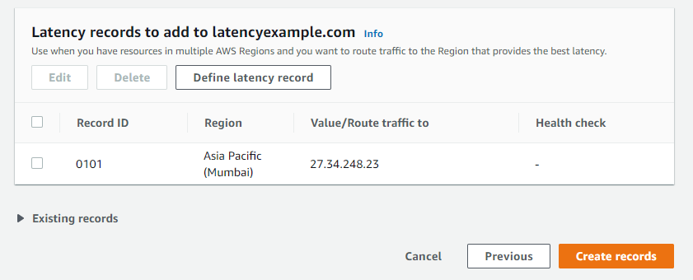

9. Finally, you can view the hosted zone details as shown below.

