Amazon S3 Cross-Region Replication (CRR)
Amazon S3 Cross-Region Replication (CRR) is a feature that allows you to replicate objects from a source S3 bucket in one AWS region to a destination S3 bucket in another AWS region.
So, you have to create two buckets.
- One should be source bucket in Mumbai region.
- Then another should be in Singapore region.
- Now click on create bucket.
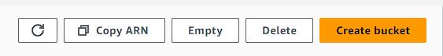
4.This is your source bucket in Mumbai region. Give it a name.
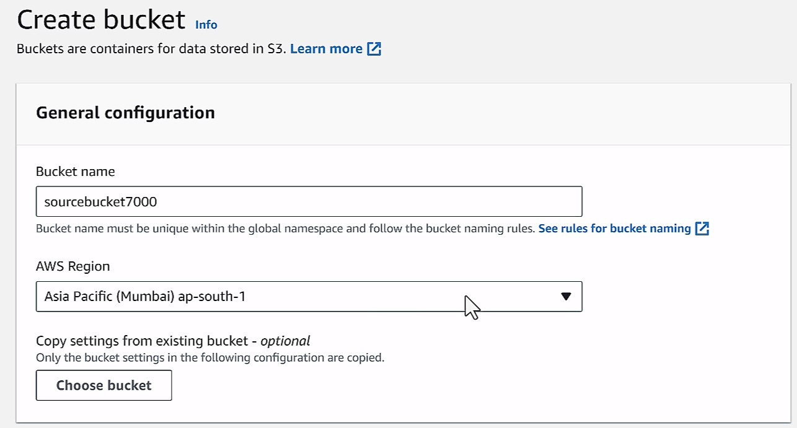
5.Now enable bucket versioning because it is needed for you to create replication.
6.You can keep block public access option enabled because you are not going to access the buckets.After that just create your bucket
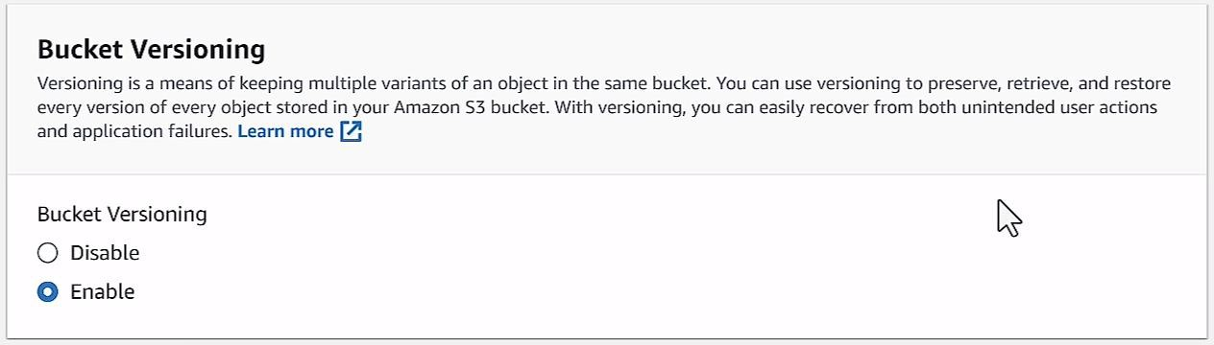

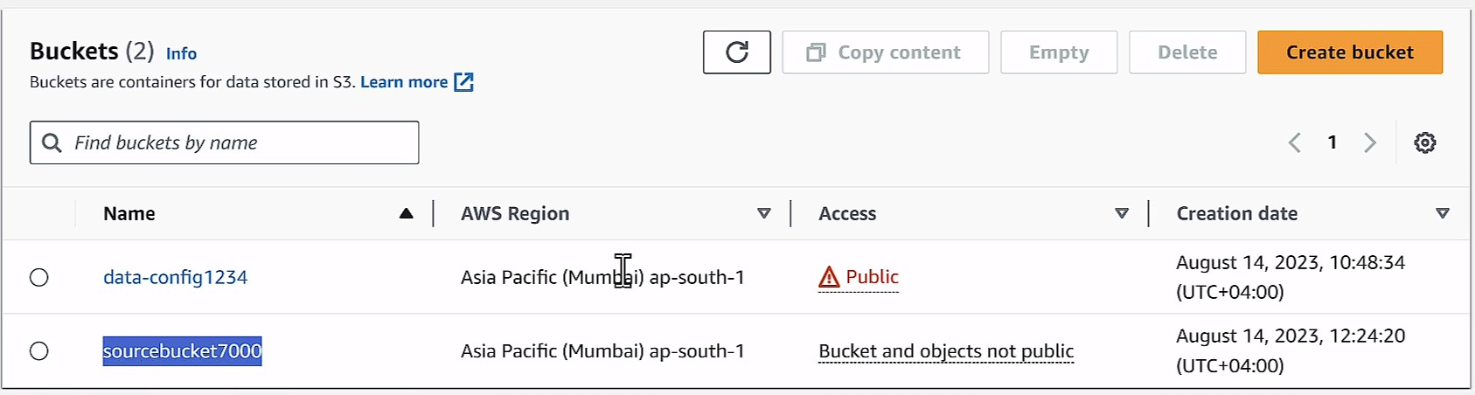
7.Now go and create a bucket in Singapore with same specification. Enable bucket versioning.Then just create your bucket
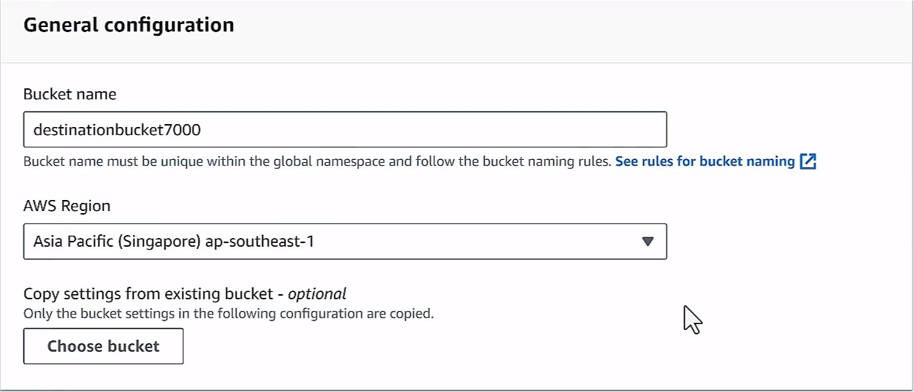
8.Here you can see both of your buckets for source and destination.
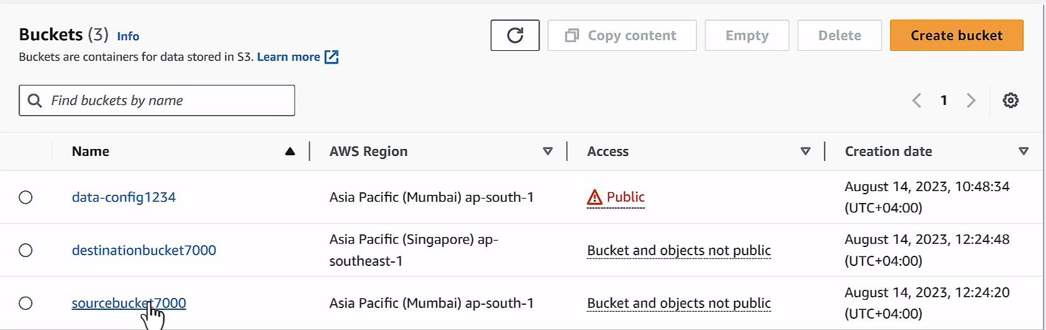
9.Now open your source bucket and upload some file to it.
10.After uploading your files. Go to management.

11.Then in management, you have to scroll down to something known as create replication rule.
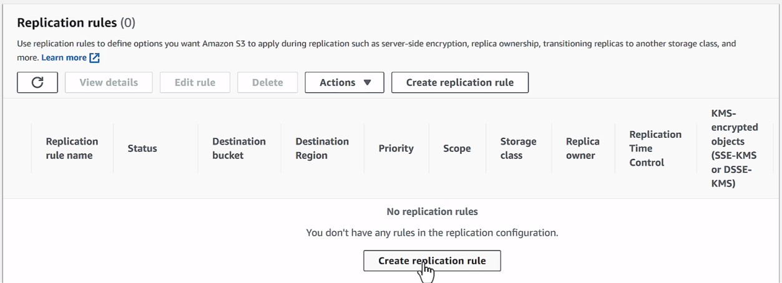
12.Here you have to give a replication rule name.
13.The status should be enabled.
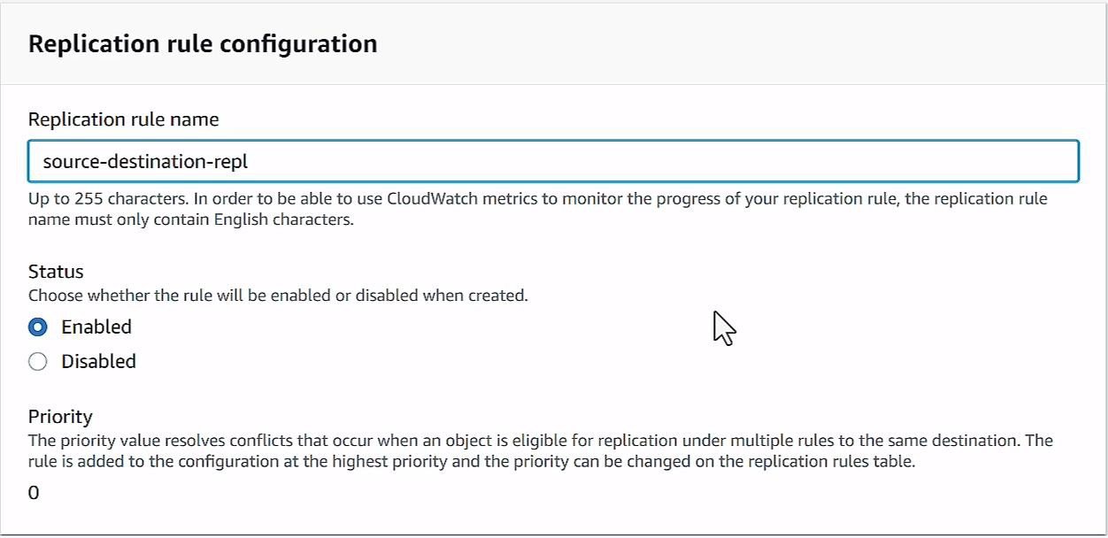
14.Then for the source bucket option, click on apply to all objects in the bucket.
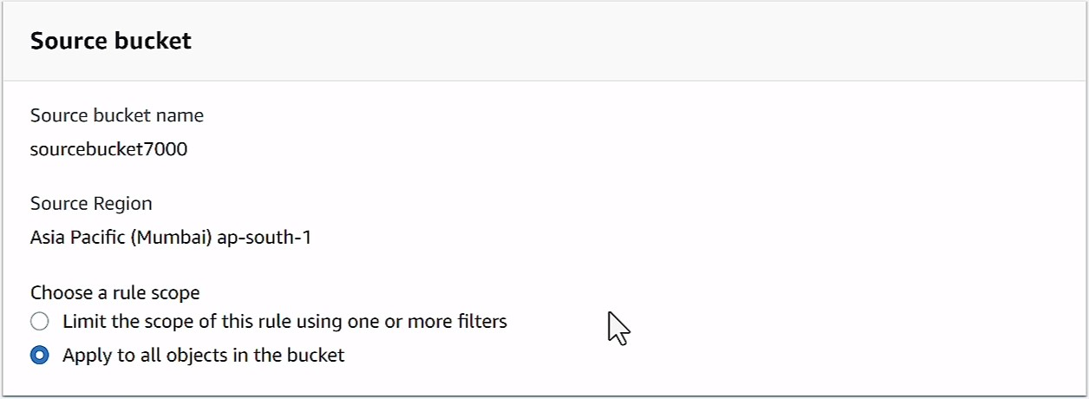
15.Now you to choose the destination.
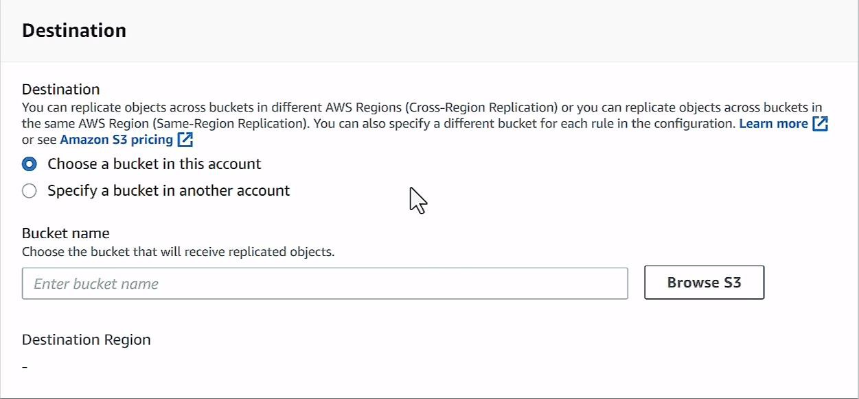
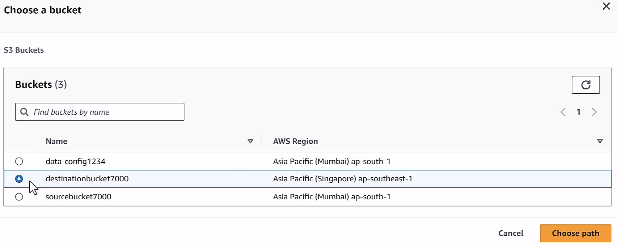
16.After this you need an IAM role.
17.But you to create this IAM role because you don’t have any.
18.But if you will see carefully, it has an option to create a new role itself. Select that option and move forward.
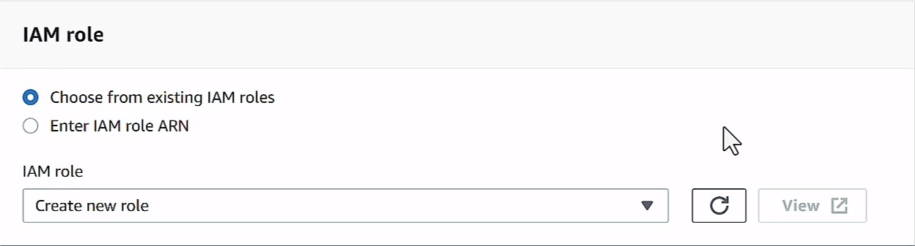

19.After that click on save and save your replication settings.
20.After that you will see that it will take some time to get your files into your destination but if you will wait for time they will there.

