Basic-DNS-Management-with-Route-53-Simple-Routing

Step 1: Creating a record set for a simple routing policy
- Open Route 53 console
- In the dashboard, click on Hosted zones and create a hosted zone as shown below
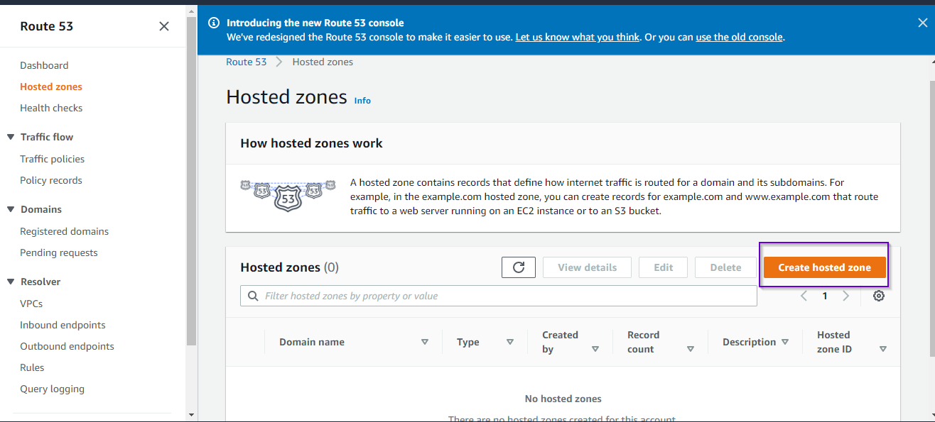
- Enter the domain name for the hosted zone and create it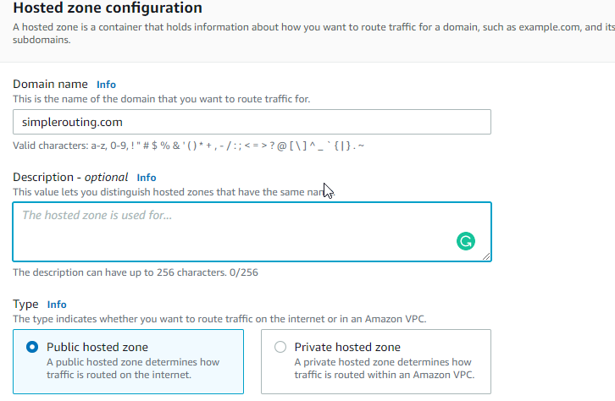
- Once you create it, navigate to the page with hosted zones where you can create a record
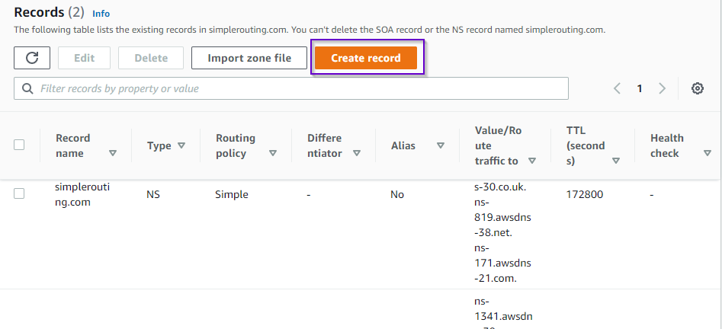

5. The previous step will take you to the page of routing policies. Select Simple routing and then select Next.
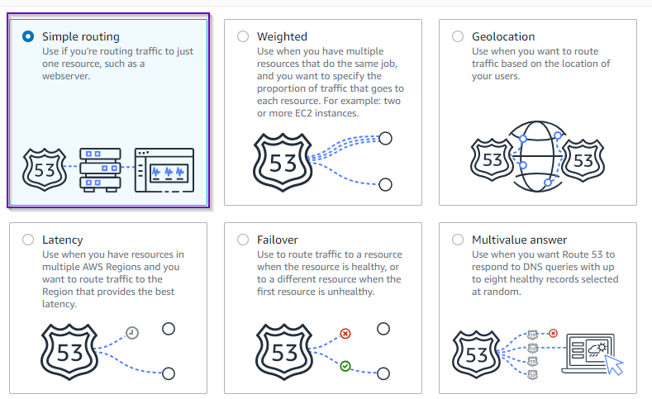
6. Now, it will ask you to Define simple record. Provide the necessary information as shown below.
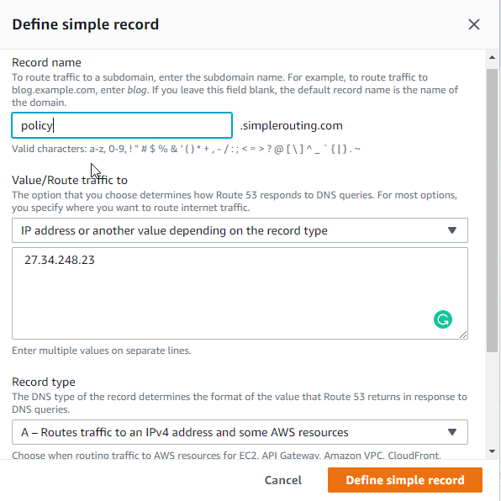

7. After this, hit on the Create records button and you will see all these details.
You can go ahead and test the record or query the log in Hosted zone details.
