S3-to-DynamoDB-via-Lambda

- Now navigate to DynamoDB. There you need to create a table.

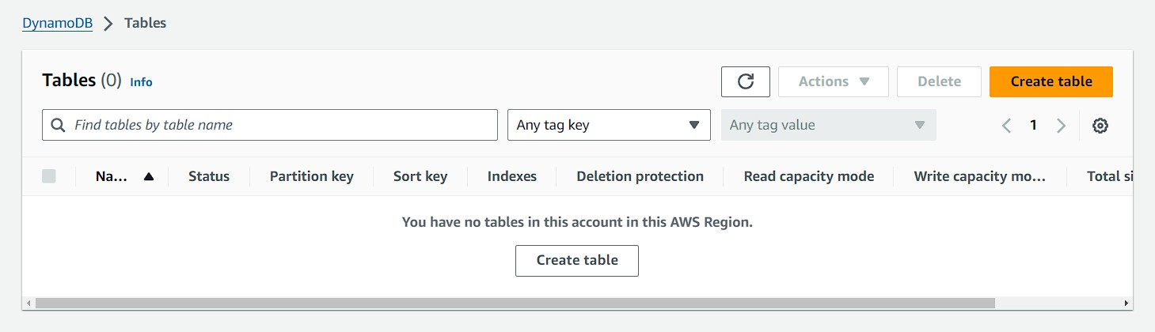
- Name this table. Then give the partition key. After that give the sort key. And then just create your table
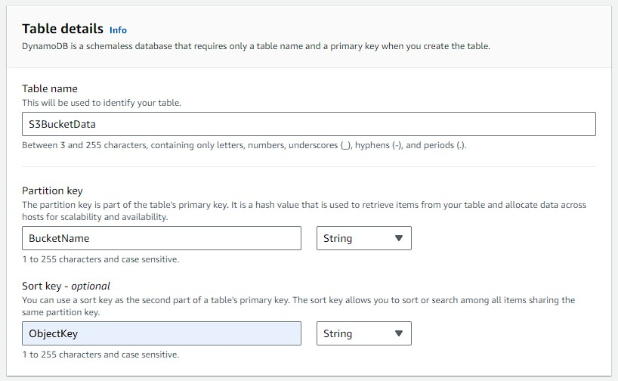

- After that come back to AWS Lambda and there create a function or choose any previous function if you have.
- There you need to change the code to this.

import json import boto3
def lambda_handler(event, context):
bucket_name = event['Records'][0]['s3']['bucket']['name']
object_key = event['Records'][0]['s3']['object']['key']
object_size = event['Records'][0]['s3']['object']['size']
print(bucket_name) print(object_key) print(object_size)
dynamodb = boto3.client('dynamodb', region_name='ap-south-1') params = {
'Item': {
'BucketName': {'S': bucket_name}, 'ObjectKey': {'S': object_key},
'ObjectSize': {'N': str(object_size)}
},
'TableName': 'S3BucketData'
}
response = dynamodb.put_item(**params) return {
'statusCode': 200,
'body': json.dumps('Item added to DynamoDB table')
}

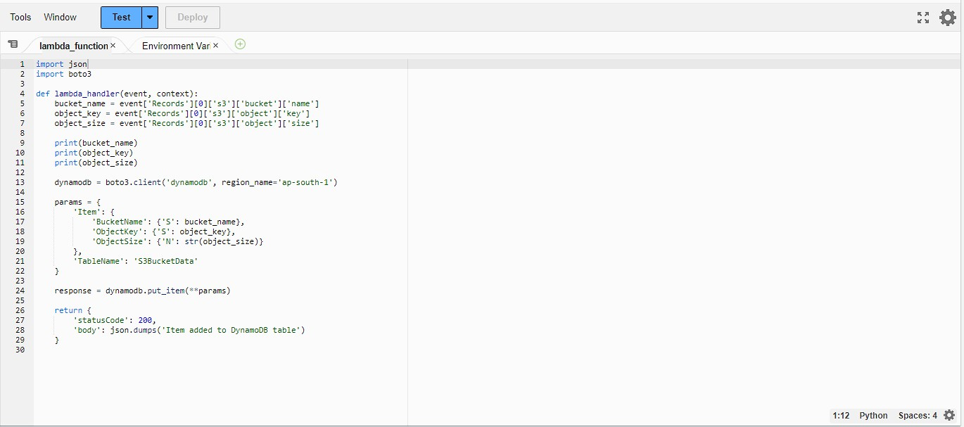

- Now you need to go to IAM roles and check that you should have these policies attached to your Role.
- This role should also be attached with your Lambda function.

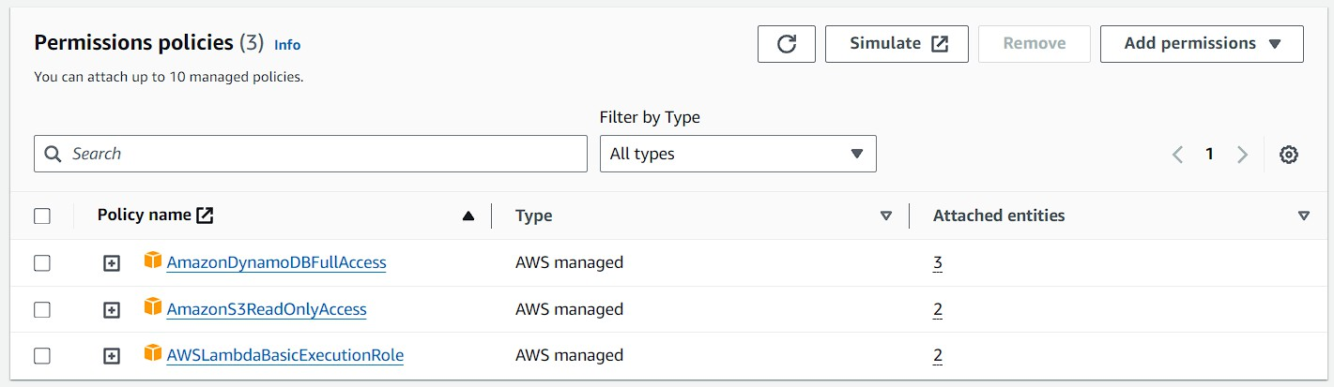
7.After that navigate to S3 and open any bucket of your choice and open its properties then scroll down to Event Notifications.
8.Then in there you need to give it a name.
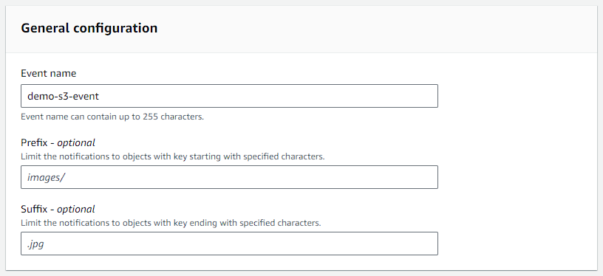

9.Then in event types just select PUT and POST. After that scroll down to the bottom.

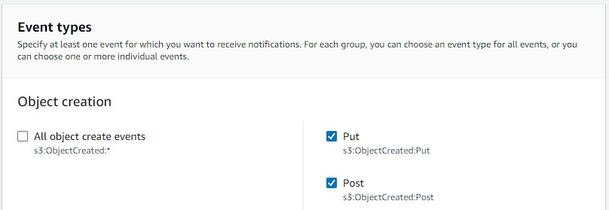
10.Now choose your destination as Lambda Function. Then you need to specify the Lambda function.
11.For that you just need to choose your Lambda function. Then click on Save changes.

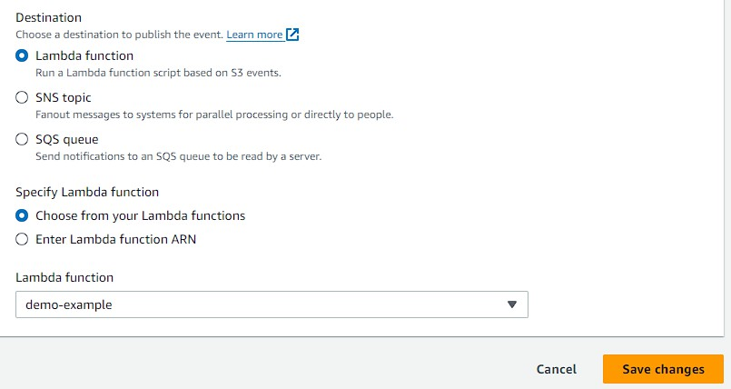

12.Then you need to upload something in your S3 bucket.
13.Once you are done then go to DynamoDB open your table and click on Explore table items.
14.After that click on Run.
15.You will see that you have an item that DynamoDB has returned.
16.You have the bucket name, the object key and the object size.

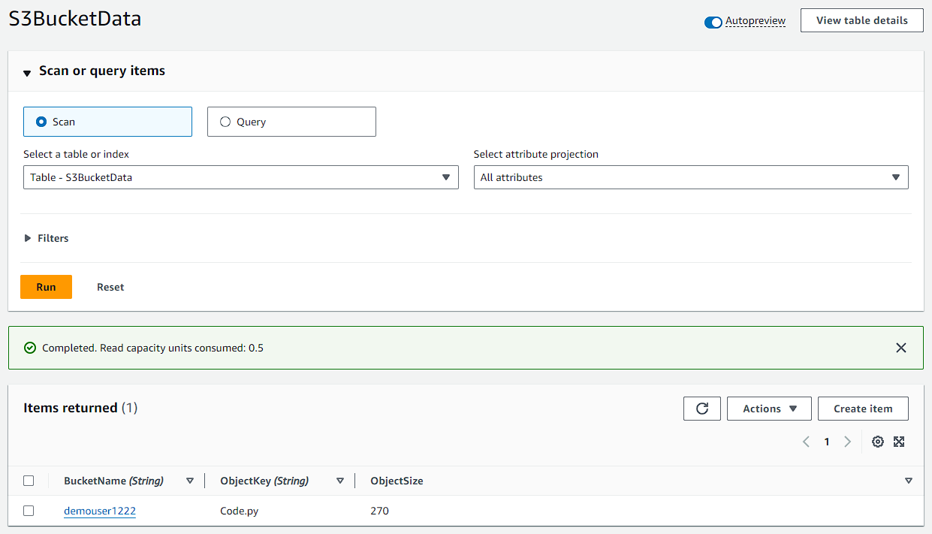

17.You are now consuming events from S3 via AWS Lambda and then taking the data within that event, those events that are being streamed onto the Lambda function and writing it onto DynamoDB

