**FACE MASK DETECTOR**

**TEAM: SPIRIT**

**BACHELOR OF TECHONOLOGY**

**IN**

**COMPUTER SCIENCE AND ENGINEERING**

At



**SHARDA UNIVERSITY**

**Knowledge Park III, Greater Noida, Uttar Pradesh 201310**

**Table of Contents**

|  |  |
| --- | --- |
|  | |
|  | |
| Abstract | |
|  | |
|  | |
|  | |
| **1.** | **INTRODUCTION** | |
|  | * 1. Problem Definition   2. Project Overview/Specifications   3. Hardware Specification   4. Software Specification | |
|  |  | |
| **2.** | **LITERATURE SURVEY** | |
|  | 2.1 Existing System  2.2 Proposed System  2.3 Feasibility Study* (page-4) | |
|  |  | |
| **3.** | **SYSTEM ANALYSIS & DESIGN** | |
|  | 3.1 Requirement Specification* (page-2)  3.2 Flowcharts / DFDs / ERDs  3.3 Design and Test Steps / Criteria  3.3 Algorithms and Pseudo Code  3.3.1  3.3.2  3.4 Testing Process if any  … | |
|  |  | |
| **4.** | **RESULTS / OUTPUTS** | |
| **5.** | **CONCLUSIONS / RECOMMENDATIONS** | |
| **6.** | **REFERENCES** | |

**ABSTRACT**

Face mask detection is emerging as a new problem statement because of Covid-19

So are team will be working on different datasets to train our face mask detection application in a very efficient way.

Our application will be able to detect face masks with an accuracy of more than 90%.

It can be used in surveillance cameras in many public places to detect face masks.

There are only a few research studies about face mask detection based on image analysis. Therefore, we bring a high-accuracy and efficient face mask detector. This is a one-stage detector, which consists of a feature pyramid network to fuse high-level semantic information with multiple feature maps, and a novel context attention module to focus on detecting face masks. We will also use cross-class object removal algorithm to reject predictions with low confidences and the high intersection of union. We will be using OpenCV and Keras / TenserFlow for detecting faces and face mask by using CNN algorithm.

**1. INTRODUCTION**

**1.1 Problem Definition**

* As we all know Corona virus disease 2019 has affected the world seriously. One major protection method for people is to wear face masks in public areas. Furthermore, many public service providers require customers to use the service only if they wear masks correctly. Therefore, we are proposing this project which will detect the face mask with a high-accuracy and efficiency using ML algorithms. This will help general public all around the world to keep themselves safe and help them to take care of their health. Making this world a much safer place.
* Many countries have been affected adversely due lack of proper implementations of the Covid-19 lockdown and unlock rules.
* There are rules that one should always wear protective gears such face masks, hand gloves, etc., but people often don’t abide with rules which is the main reason behind the spread of corona virus disease.
* It becomes difficult for law keepers to keep an on each and every individual in public areas, but it is far easier and faster for computers to do so within fraction of second.

**1.2 Project Overview**

* To train object detection models capable of identifying the location of masked faces in an image

* To detect the location of unmasked faces in the image.

* It should be robust to noise and provide as little room as possible to accommodate false positives for masks due to the potentially dire consequences that they would lead to.

* Ideally, it should be fast enough to work well for real-world applications.

**RESULTS**

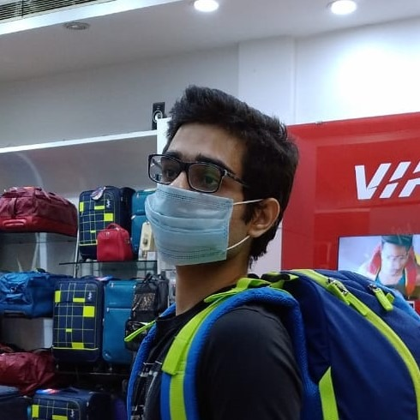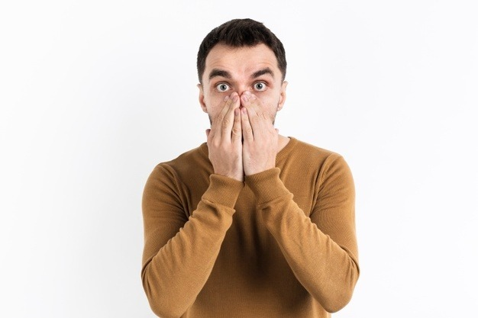

Figure 1 Raw picture

Figure 3 Input a raw picture

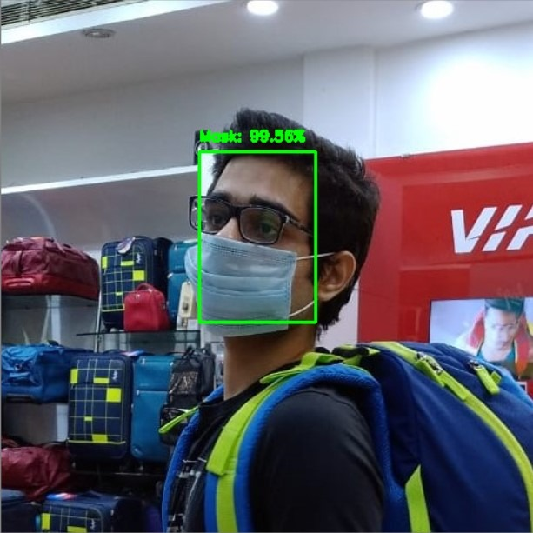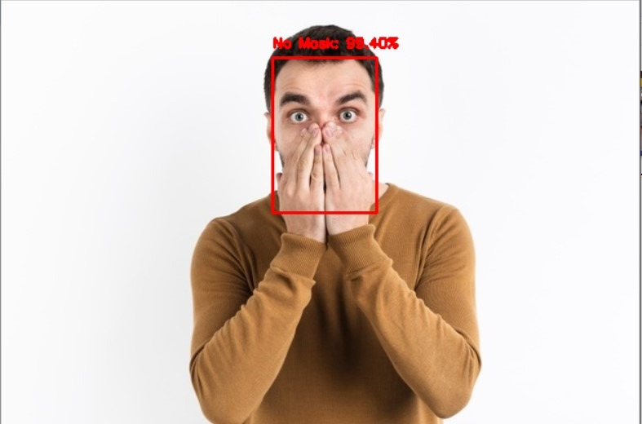

Figure 2 Detection after processed

Figure 4 Detection after processed

**1.3 Hardware Specification**

* Laptops with camera
* Desktop with webcam
* Camera with scanning functionality

**1.4 Software Specification**

* Operating system Windows 7 or above

**2. LITERATURE SURVEY:**

|  |  |  |  |  |  |  |  |
| --- | --- | --- | --- | --- | --- | --- | --- |
| **S.No.** | **Title** | **Author** | **Algorithm / Methodology** | **Dataset** | **Result** | **Finding Achievement** | **Drawback** |
| 1. | Face Mask Detector with OpenCV,Keras/TensorFlow,and Deep Learning | Adrian Rosebrock  (2020) | Computer Vision approach involving:  OpenCV Algo  Keras | PyImageSearch | With mask=99%    Without mask=99With % | This approach used helped in achieving a high accuracy rate. | Limited data for training detector software. |
| 2. | Face Mask Detector using Deep Learning(YOLOv3) | Alexandra  Lorenzo | Machine Learning | Kaggle | With mask=95% | Use of YOLO makes it a lot faster to detect. | With faster detection comes low accuracy. |
| 3. | Detecting Masked Faces in the Wild with LLE-CNNs | Shiming Ge et al  (2020) | ocally linear embedding (LLE) ,  Machine Learning | Masked Faces(MAFA), Magnetotelluric  (MT). | 76.4% with MAFA,  60.8% with MT | The ‘real wild’ scenarios are much more challenging than expected for con-  training faces captured at unexpected resolution, illumination and occlusion | MAFA is  very challenging for existing face detectors |
| 4. | Retina facemask: a face mask detector | Mingjie Jiang at el(2020) | Feature Pyramid Network(FPN),  Single Shot MultiBox Detector (SSD) | Wider Face, Masked Faces (MAFA) | RetinaFaceMask+MobileNet; Face=95.6% | face and mask detection precision respectively, and 11.0% and 5.9% | ________ |
| 5. | Face Detection and Segmentation Based on Improved Mask R-CNN | Kaihan Lin, Huimin Zhao  (2020) | R-CNN,  Fast R-CNN,  Faster R-CNN | COCO challenges,  Cityscapes dataset, FDDB,  ChokePoint | G-Mask method achieved 95.97% average precision (AP) | G-Mask method achieves promising performance. | The extracted face features have background noise. |
| 6. | Identifying Facemask-wearing Condition Using Image SuperResolution with Classification Network to Prevent COVID-19 | BOSHENG QIN, DONGXIAO LI(2020) | SRCNet, CNN | Medical Masks Dataset in the Kaggle | Mask : 98.57%  Net : 97.26 | SRCNet achieved 98.70% accuracy | These findings are achieved bby using contained test data cannot be said same for live data. |

**3. SYSTEM ANALYSIS & DESIGN**

**3.1 Requirement Specification**

* Software used Open CV.
* Language used Python

**3.2 Flowchart**

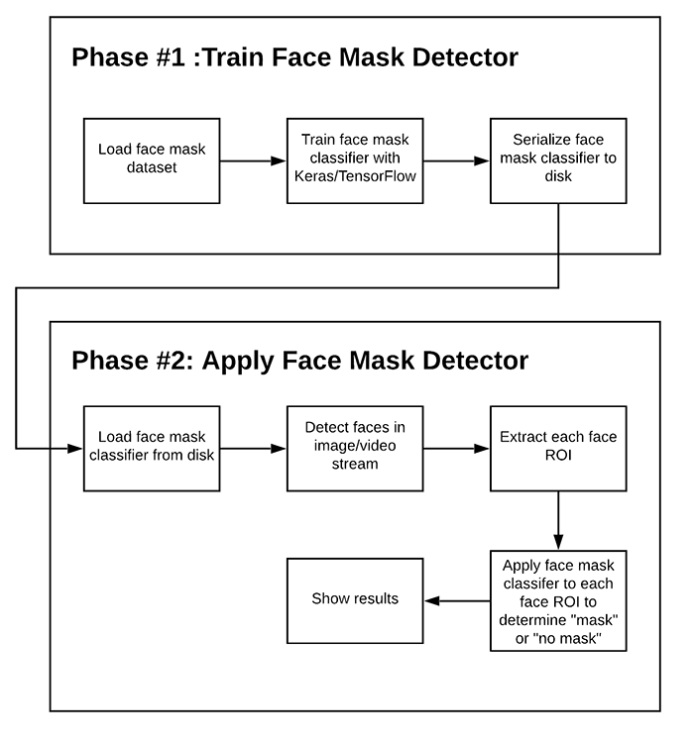

YES(Green)/Accuracy percentage(%)

NO(Red)/Accuracy percentage(%)

No Mask

Mask

**4. RESULTS**

As we processed the raw images into the face mask detector system it responded its best accuracy.



Figure 1



Figure 2

As the result of figure 1 we receives No mask Detect in the system with accuracy 98.4%.

**5. CONCLUSION**

Finally with the help of Face mask detector system we come to the conclusion that the system is performing its best to provide more precise accuracy. With the help of this system any of us can detect that the person is wearing a mask or not in this pandemic which will help us to stay safe from the corona virus spread.

**6. REFERENCES**

1.Face Mask Detector using Deep Learning(YOLOv3) - Alexandra Lorenzo

2. Detecting Masked Faces in the Wild with LLE-CNNs - Shiming Ge et al(2020)

3. Retina facemask: a face mask detector - Mingjie Jiang et al(2020)

4. Face Detection and Segmentation Based on Improved Mask R-CNN – Kaihan Lin, Huimin Zhao(2020)

5. Face Mask Detector with OpenCV,Keras/TensorFlow,and Deep Learning – Adrian Rosebrock(2020)