Cart Validation_Cart PageADIDAS ORIGINAL2.png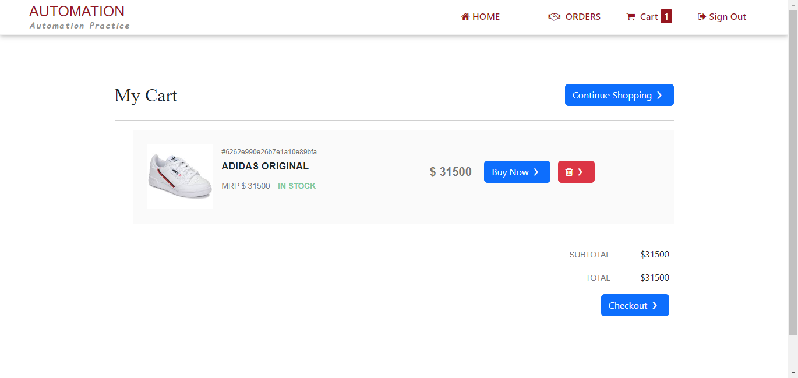

Cart Validation_Cart PageZARA COAT 31.png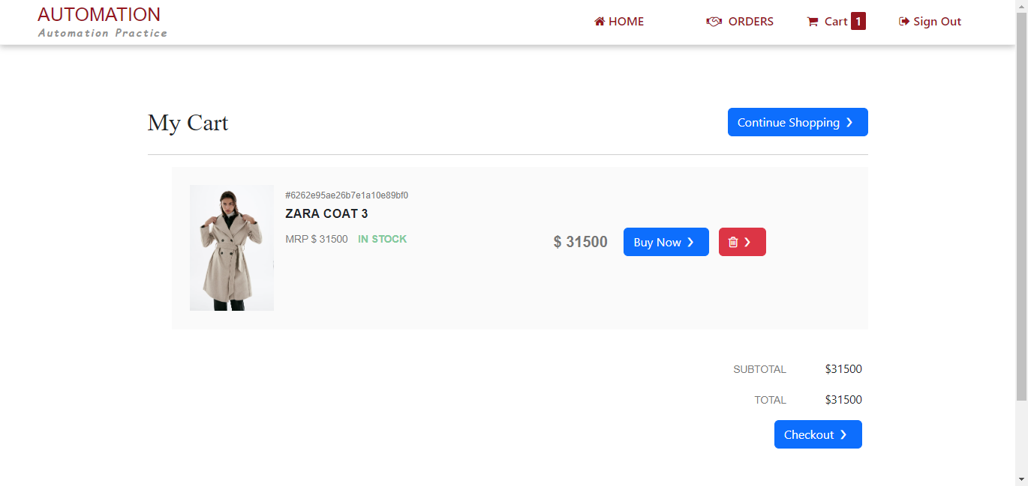

Cart Validation_Product catalogue PageADIDAS ORIGINAL2.png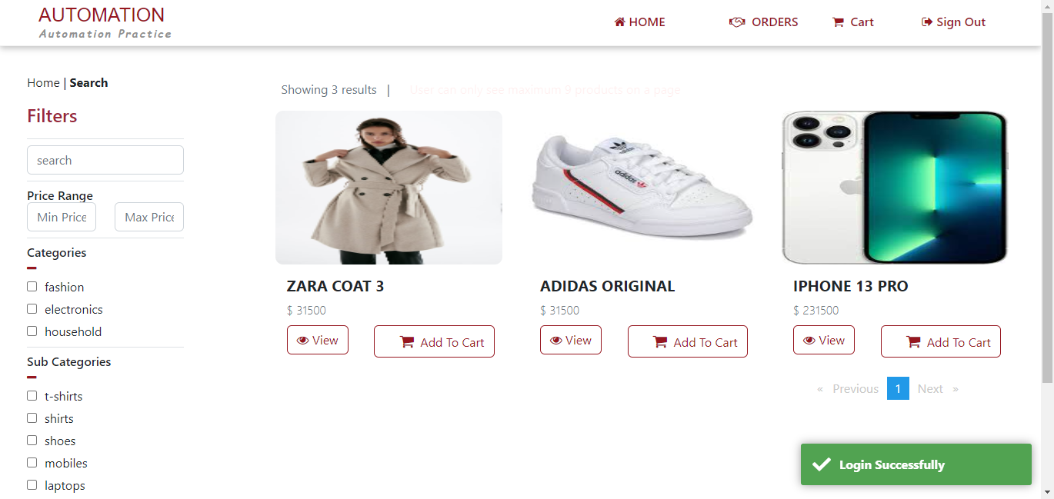

Cart Validation_Product catalogue PageZARA COAT 31.png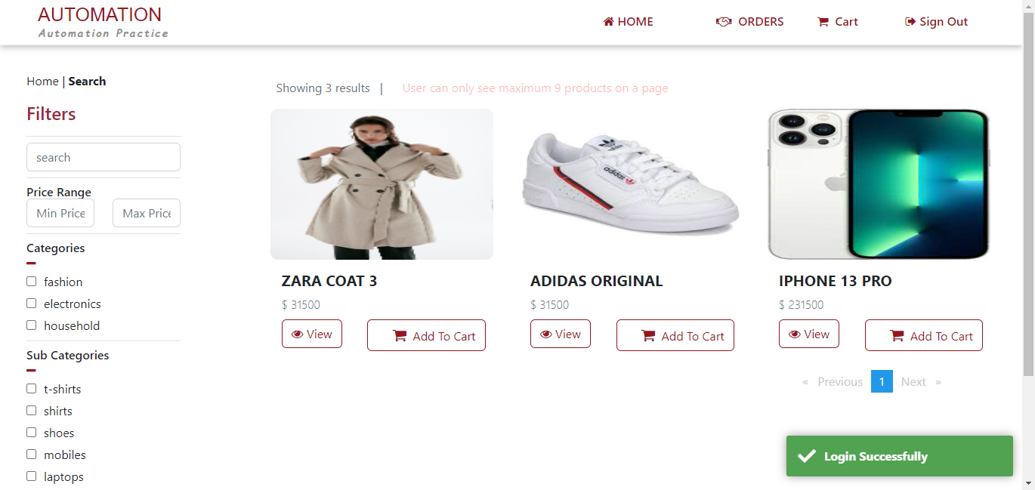

getErrorMesg1.png

Submit Order_Cart PageADIDAS ORIGINAL4.png

Submit Order_Cart PageZARA COAT 33.png

Submit Order_Checkout pageADIDAS ORIGINAL2.png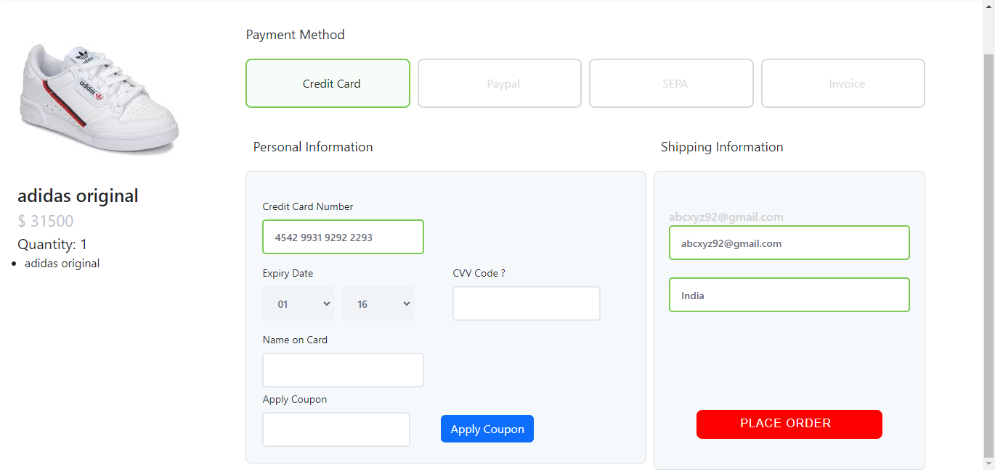

Submit Order_Checkout pageZARA COAT 31.png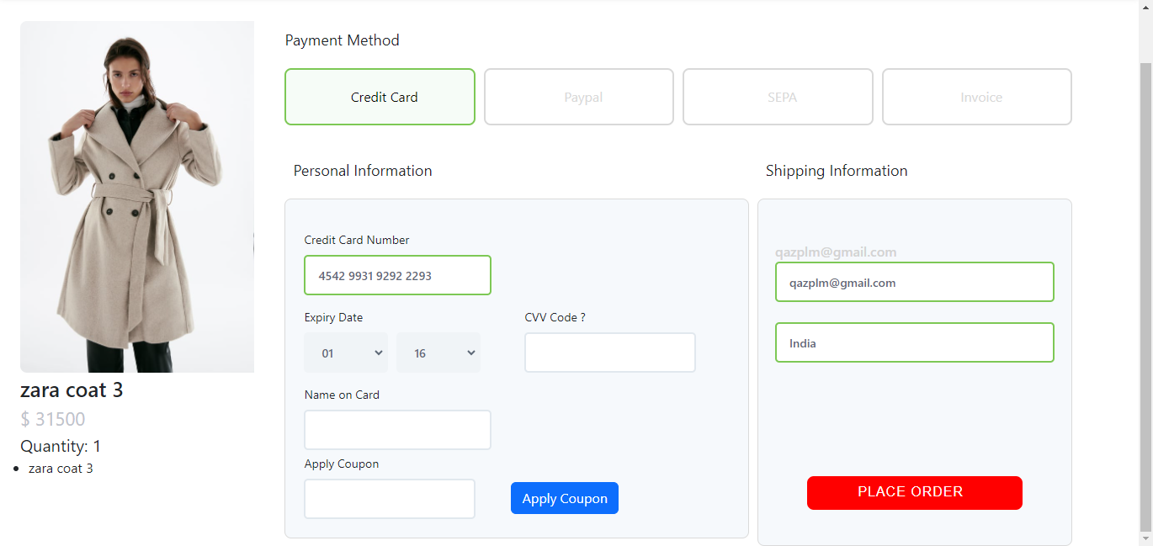

Submit Order_Confirmation PageADIDAS ORIGINAL2.png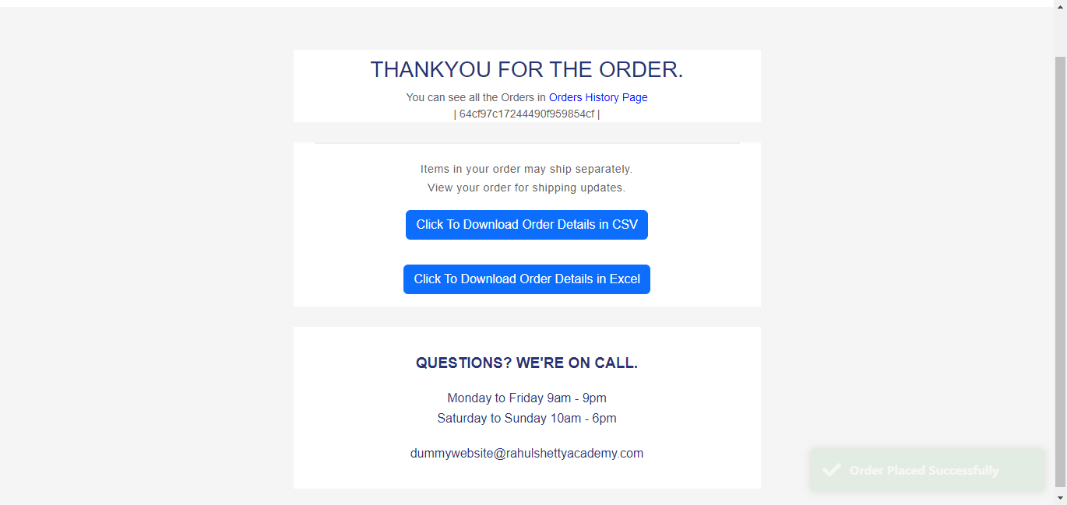

Submit Order_Confirmation PageZARA COAT 31.png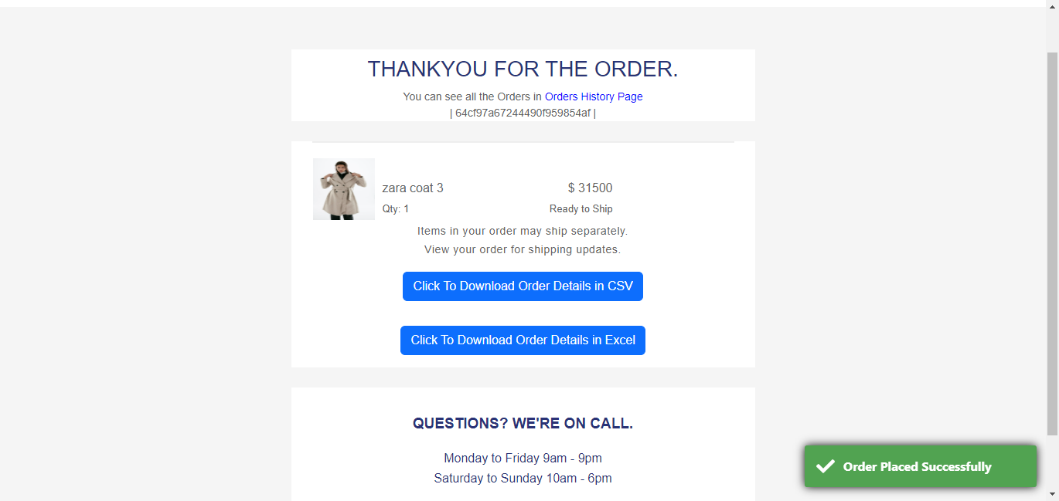

Submit Order_Product catalogue PageADIDAS ORIGINAL4.png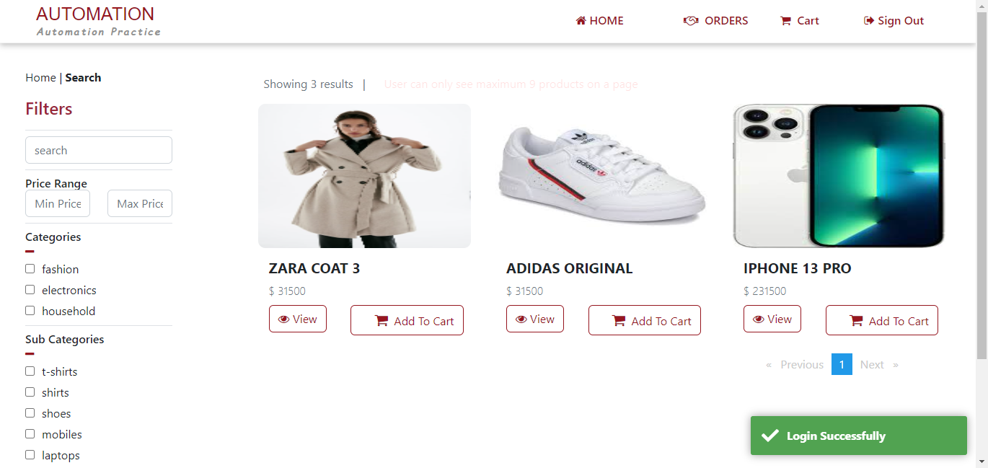

Submit Order_Product catalogue PageZARA COAT 33.png