**EXPERIMENT - 1**

**AIM:**

Generation & detection of Amplitude modulation using MATLAB

**THEORY:**

Modulation is defined as process in which changing the characteristics usually amplitude, frequency and phase of high frequency wave (Carrier wave) by using instantaneous values of the low frequency signal (modulating signal).

Amplitude modulation (AM) is defined as a process in which the amplitude of the carrier wave c(t) is varied about a mean value, linearly with the base band signal m(t). An AM wave may thus be described, in its most general form, as a function of time as follows. S(t)=A [1+Kam(t)] Cos (2πfct) The amplitude of Kam(t) is always less than unity, that is |Kam(t)| 1 for any t, the carrier wave becomes over modulated, resulting in carrier phase reversals. whenever the factor 1+Kam(t) crosses zero. The absolute maximum value of Kam(t) multiplied by 100 is referred to as the percentage modulation.

The following two modulators generate AM wave.

* Square law modulator
* Switching modulator

**BLOCK DIAGRAM:**

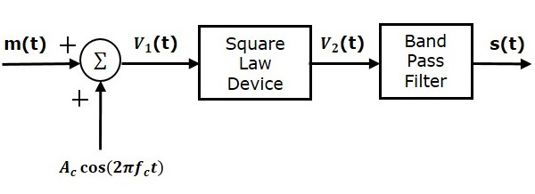SQUARE LAW MODULATOR

SWITCHING MODULATOR

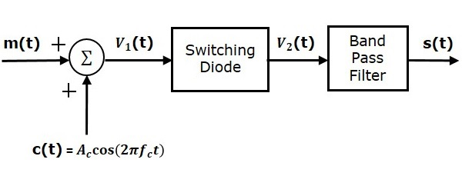

DEMODULATOR

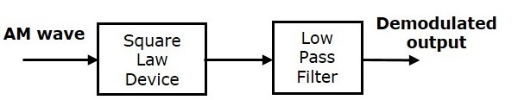

**MATLAB CODE:**

fc = 1000; %carrier frequency

fm = 20; %message signal frequency

fs = 8000; %sampling frequency

Am = 5; %Amplitude of message signal

Ac = 10; %Amplitude of carrier signal

T = 1/fs; %Time period

t = [0:T:0.1]; %Time range used in plotting signals

m = Am/Ac; %modulation index given as the ratio of message signal amplitude with carrier signal amplitude

%Carrier Signal

Sc = Ac*cos(2*pi*fc*t);

subplot(4,1,1); %Representation of plot at 1st row , 1st column out of 4 rows

plot(t,Sc); %Representing Carrier signal (Sc) wrt time at 1st row , 1st column

title('Carrier Signal')

%Message Signal

Sm = Am*cos(2*pi*fm*t);

subplot(4,1,2); %Representation of plot at 2nd row , 1st column out of 4 rows

plot(t,Sm); %Representing message signal (Sm) wrt time at 2nd row , 1st column

title('Message Signal')

%amplitude modulation

%AM = ammod(Sm,fc,fs);

AM = Ac*(1+(m*cos(2*pi*fm*t).*cos(2*pi*fc*t)));

%AM = Ac*cos(2*pi*fc*t)+(Ac*m*Sm.*cos(2*pi*fc*t));

subplot(4,1,3); %Representation of plot at 3rd row , 1st column out of 4 rows

plot(t,AM); %Representing Amplitude Modulation signal (AM) wrt time at 3rd row , 1st column

title('Amplitude Modulation Signal')

%amplitude demodulation

DAM = (1+Sm).*cos(2*pi*fc*t).*cos(2*pi*fc*t);

subplot(4,1,4); %Representation of plot at 4th row , 1st column out of 4 rows

plot(t,DAM); %Representing Amplitude Demodulation signal (DAM) wrt time at 4th row , 1st column

title('Demodulated Signal')

**WAVEFORM OBTAINED:**

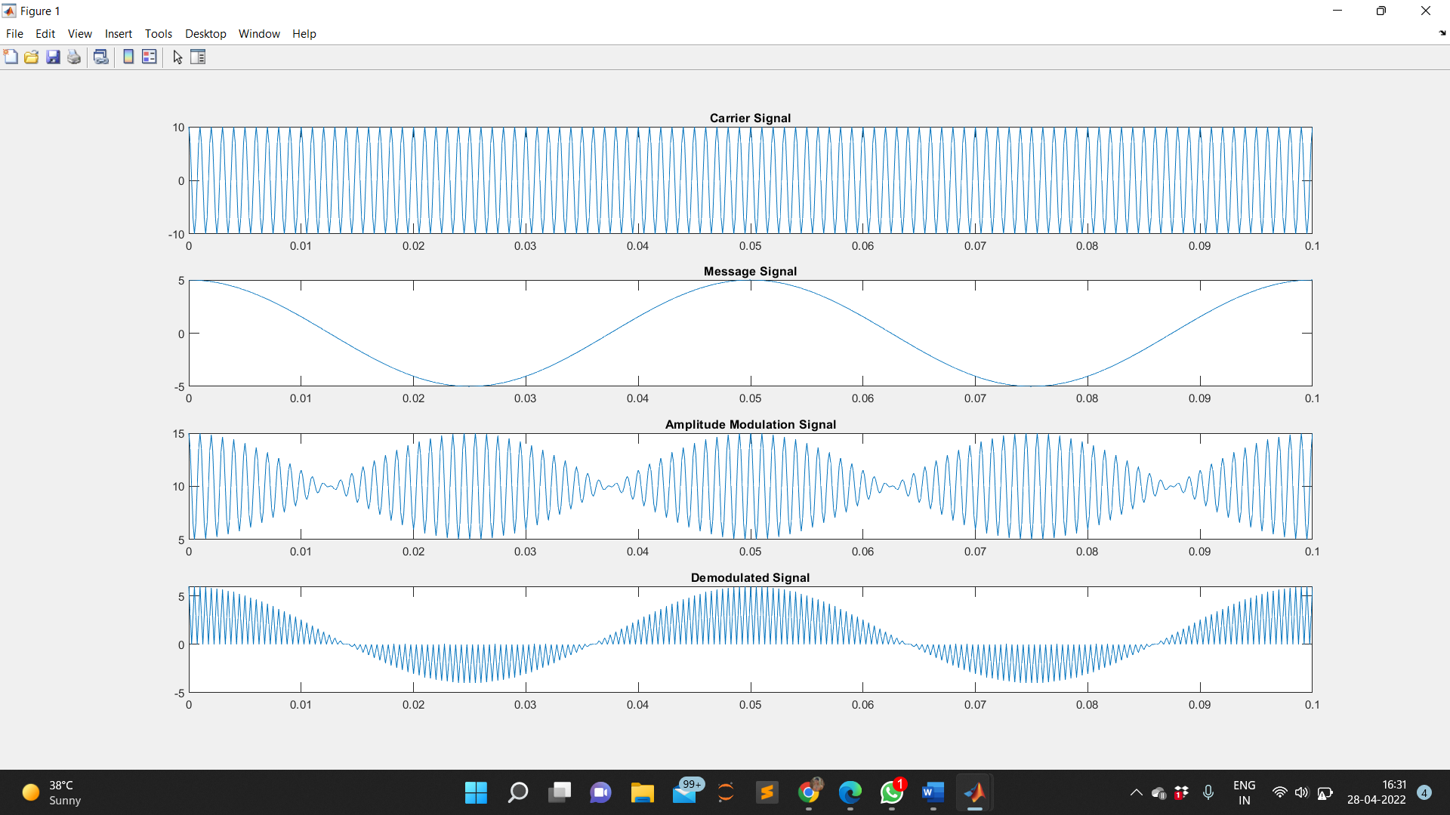

**RESULT:**

The output waveforms of Amplitude modulation and de-modulation are observed and plotted.

**APPLICATIONS:**

AM was the earliest modulation method used to transmit voice by radio. It remains in use today in many forms of communication; for example it is used in portable two way radios, VHF aircraft radio, Citizen's Band Radio and in computer modems. "AM" is often used to refer to medium wave AM radio broadcasting.