**EXPERIMENT - 2**

**AIM:**

Generation & detection of Frequency modulation using MATLAB

**THEORY:**

Modulation is defined as process in which changing the characteristics usually amplitude, frequency and phase of high frequency wave (Carrier wave) by using instantaneous values of the low frequency signal (modulating signal).

FM Modulation is a non-linear modulation technique. In FM the frequency of carrier is varied in accordance with amplitude of modulating signal (AF signal). But amplitude is maintained constant. Since the variation in phase angular term it is comes under angle modulation scheme, the most important feature of FM modulation is that it can be provide better discrimination against noise and interference than AM. The disadvantage of FM is it requires more transmission bandwidth than AM and we transmit the FM signals to longer distances.

The quantity Kf represents frequency sensitivity of modulator. Hence Kf * Am represents the total deviation f. The ratio of max frequency deviation to modulating frequency defines as modulation index, which is given by

Modulation index = (Max frequency deviation / Modulating frequency)

If Modulation index is less than one then the modulated wave is called Narrow Band FM signal. If Modulation index is greater than one then the modulated wave is called Wide Band FM signal.

**BLOCK DIAGRAM:**

MODULATOR

CARRIER SIGNAL GENERATOR

MODULATING SIGNAL

CRO

FREQUENCY MODULATOR

DEMODULATOR

CRO

DEMODULATOR

FM INPUT

**MATLAB CODE:**

fc = 500; %carrier frequency

fm = 30; %message signal frequency

fs = 8000; %sampling frequency

Am = 1;

Ac = 1;

t = [0:1/fs:0.1]'; %time range for plotting signals

x = sin(2*pi*fm*t); %Modulating signal assuming frequency as 10 since message frequency is not given

fDev = 50; %frequency deviation

y = fmmod(x,fc,fs,fDev); %frequency modulation function

z = fmdemod(y,fc,fs,fDev); %frequency demodulation function

subplot(4,1,1); %Representation of plot at 1st row , 1st column out of 4 rows

plot(t,x); %Representing Modulating signal (x) wrt time at 1st row , 1st column

xlabel('Time(s)');

ylabel('Amplitude');

title('Message Signal')

subplot(4,1,2); %Representation of plot at 2nd row , 1st column out of 4 rows

plot(t,sin(2*pi*fc*t)); %Representing Carrier signal wrt time at 2nd row , 1st column

xlabel('Time(s)');

ylabel('Amplitude');

title('Carrier Signal');

subplot(4,1,3); %Representation of plot at 3rd row , 1st column out of 4 rows

plot(t,y); %Representing Frequency Modulation (y) wrt time at 3rd row , 1st column

xlabel('Time(s)');

ylabel('Amplitude');

title('Frequency Modulated Signal');

subplot(4,1,4); %Representation of plot at 4th row , 1st column out of 4 rows

plot(t,z); %Representing Frequency Demodulation (z) wrt time at 4th row , 1st column

xlabel('Time(s)');

ylabel('Amplitude');

title('Demodulated Signal')

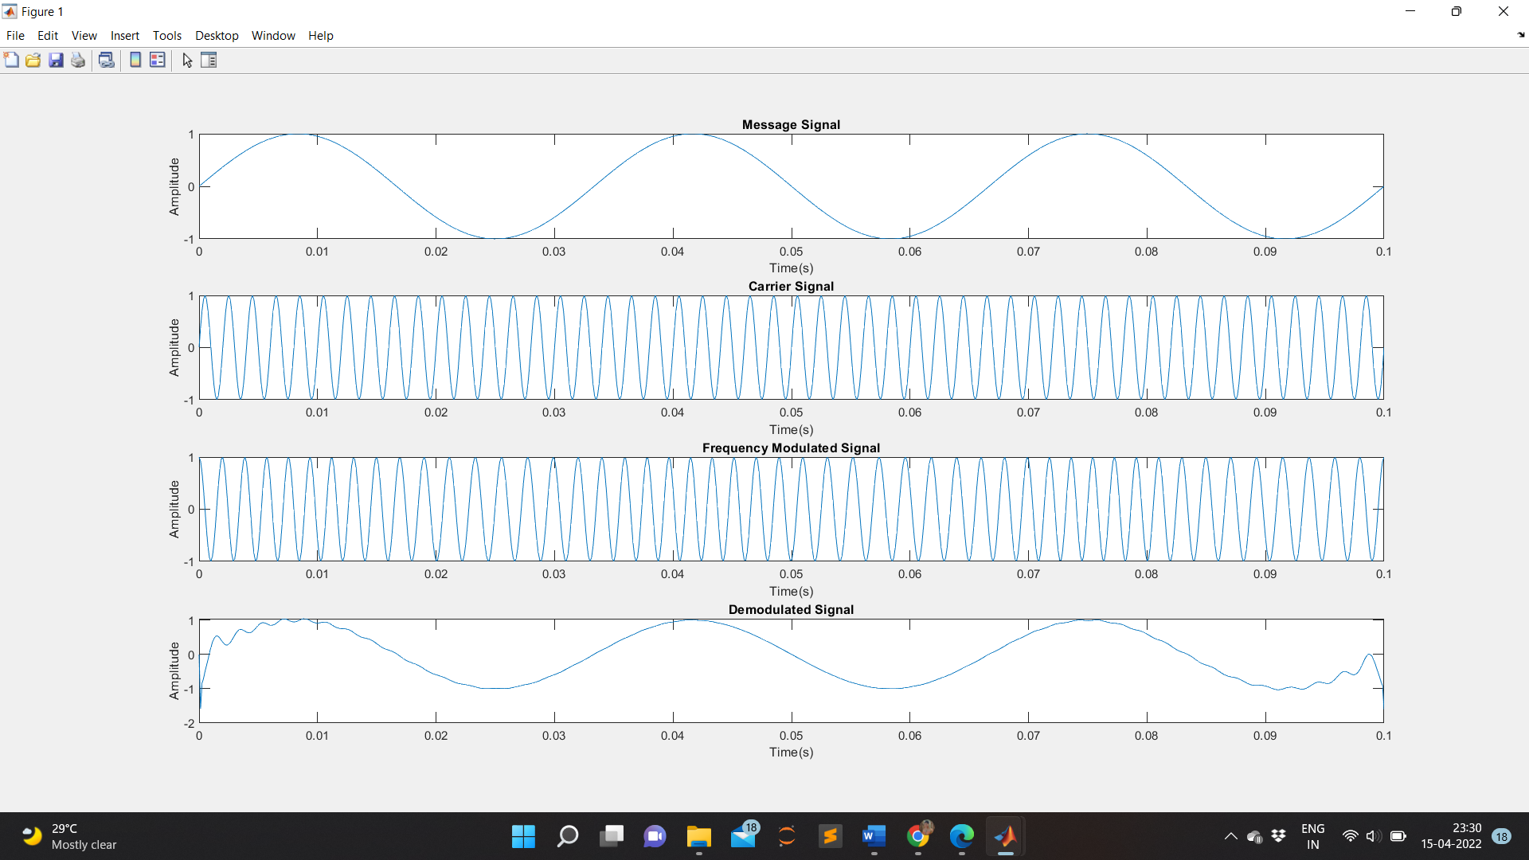**WAVEFORM OBTAINED:**

**RESULT:**

The output waveforms of Frequency modulation and de-modulation are observed and plotted.

**APPLICATIONS:**

Frequency modulation is widely used for FM radio broadcasting. It is also used in telemetry, radar, seismic prospecting, and monitoring newborns for seizures 31 via EEG, two-way radio systems, music synthesis, magnetic tape-recording systems and some video-transmission systems.