**EXPERIMENT - 3**

**AIM:**

Generation of SSBSC signal using MATLAB

**THEORY:**

AM & DSB-SC both modulation techniques require bandwidth twice of the modulating signal bandwidth. Since two side bands having the same information. It is possible to recover the base band signal from any one of the side band, so only one side band is enough to give information without any loss of course the carrier is suppressed. Such transmission system is called single side band transmission system. SSB requires transmission bandwidth is equal to modulating signal bandwidth.

We can generate SSBSC wave using the following two methods.

* Frequency discrimination method
* Phase discrimination method

The reduced bandwidth also improves the SNR ratio and allows more no of channels in a given frequency. These advantage of SSB results in wide spread of SSB for aircrafts, transonic radio telephones, and mature radio communication systems.

**BLOCK DIAGRAM:**

FREQUENCY DISCRIMINATION METHOD

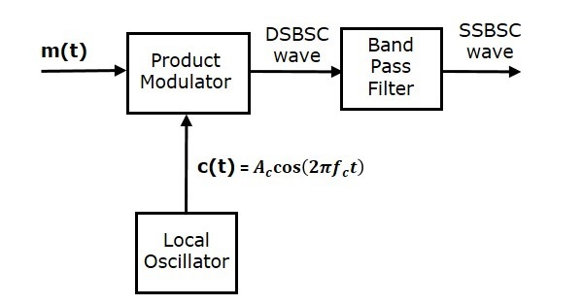

PHASE DISCRIMINATION METHOD

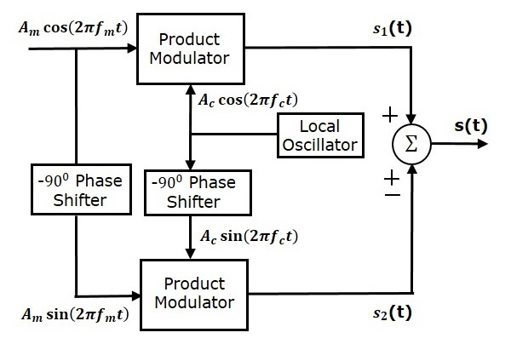

DEMODULATION

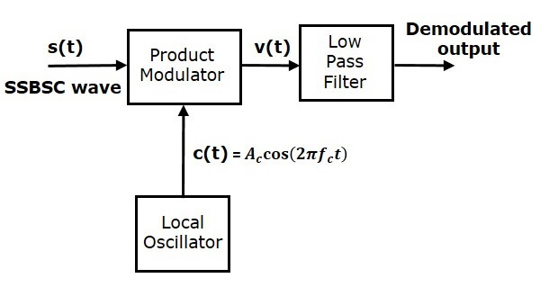

**MATLAB CODE:**

fc = 50; %carrier frequency

fm = 20; %message signal frequency

fs = 8000; %sampling frequency

Am = 1; %Amplitude of message signal

Ac = 1; %Amplitude of carrier signal

T = 1/fs; %Time period

t = [0:T/999:0.5]; %Time range used in plotting signals

m = Am/Ac; %modulation index given as the ratio of message signal amplitude with carrier signal amplitude

%Message Signal

Sm = Am*cos(2*pi*fm*t);

subplot(6,1,1)

plot(t, Sm, 'r');

grid();

title('Message signal');

%Carrier Signal

Sc = Ac*cos(2*pi*fc*t);

subplot(6,1,2)

plot(t, Sc, 'g');

grid();

title('Carrier signal');

%SSBSC Signal with upper sideband

ssb_us = ((Am*Ac).*cos(2*pi*(fc+fm).*t));

subplot(6,1,3)

plot(t, ssb_us, 'k');

grid();

title('SSBSC Signal with upper sideband');

%SSBSC Signal with lower sideband

ssb_ls = ((Am*Ac).*cos(2*pi*(fc-fm).*t));

subplot(6,1,4)

plot(t, ssb_ls, 'm');

grid();

title('SSBSC Signal with lower sideband');

%SSBSC demodulating Signal

ssb_dm = (Am*Ac*Ac).*(cos(2*pi*fm*t)); %Demodulating signal for both (upper sideband as well as lower sideband) is same

subplot(6,1,5)

plot(t, ssb_dm, 'b');

grid();

title('SSBSC demodulating Signal');

%Comparison of original and demodulated signal

subplot(6,1,6)

plot(t,Sm,'r',t,ssb_dm,'b--');

grid();

title('Comparison of message signal and demodulated signal');

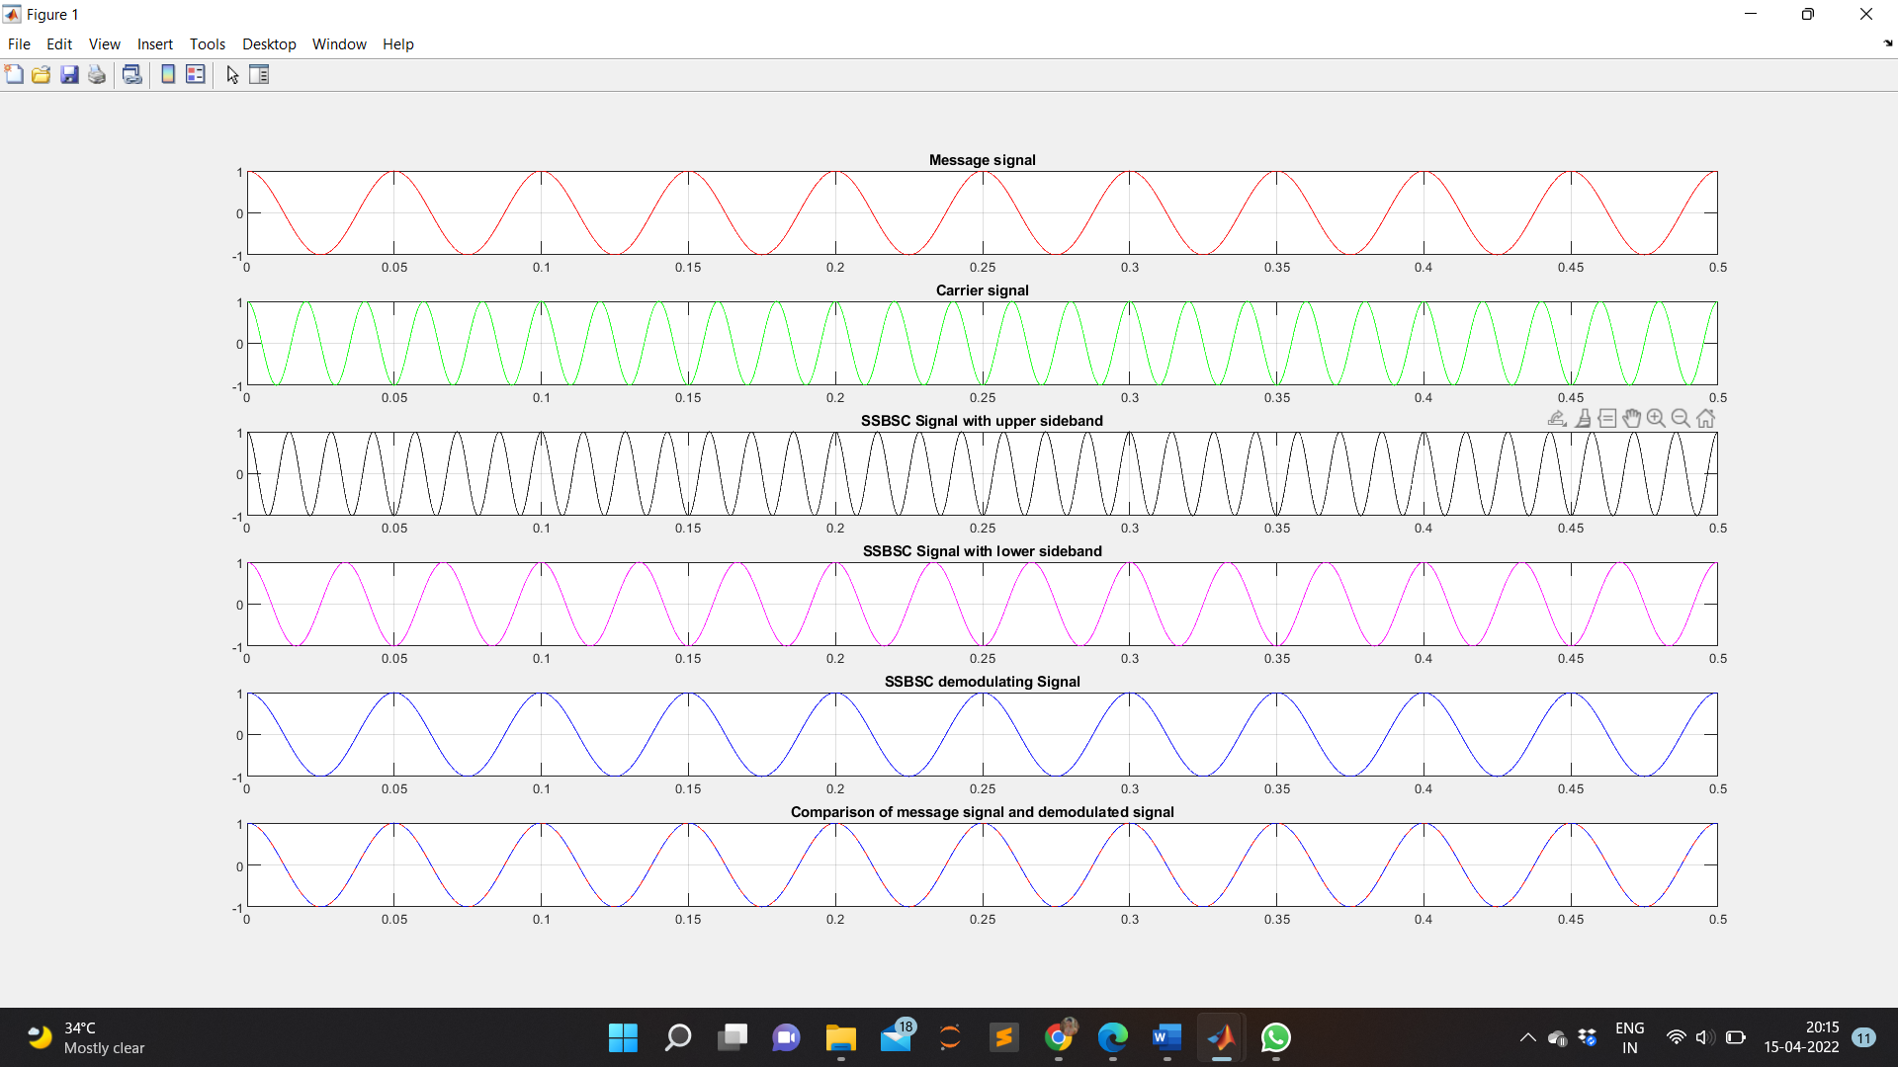**WAVEFORM OBTAINED:**

**RESULT:**

The output waveforms of SSB modulation and de-modulation are observed and plotted.

**APPLICATIONS:**

In radio communications, single-sideband modulation (SSB) or singlesideband suppressed-carrier modulation (SSB-SC) is a refinement of amplitude modulation which uses transmitter power and bandwidth more efficiently.