**EXPERIMENT - 4**

**AIM:**

Generation of DSBSC signal using MATLAB

**THEORY:**

The transmission of a signal, which contains a carrier along with two sidebands can be termed as Double Sideband Full Carrier system or simply DSBFC. If this carrier is suppressed and the saved power is distributed to the two sidebands, then such a process is called as Double Sideband Suppressed Carrier system or simply DSBSC.

Balance modulator is used for generation of double side band suppress carrier signal. The output of balanced modulator is equal to the product of applied input signals. In order to generate this it uses the nonlinear characteristics of semi conductor device. Since the carrier does not convey any information, transmitting the carrier along with side band is only wasting of transmission power; therefore carrier is suppressed before transmission. By doing suppression 67% of transmission power can be saved. The method of transmission of modulated wave without carrier is DSBSC signal. Balance modulator is also used in generation of SSB signals. The modulated signal undergoes a phase reversal whenever the base band signal crosses zero. Unlike AM, The envelope of DSBSC id different from base band signal. The ring modulator is another circuit for generating the DSBSC signal.

The following two modulators generate DSBSC wave.

* Balanced modulator
* Ring modulator

**BLOCK DIAGRAM:**

BALANCED MODULATOR

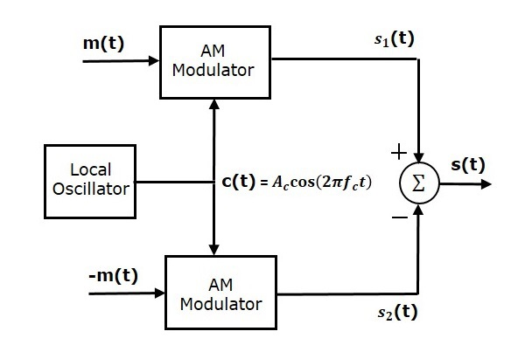

RING MODULATOR

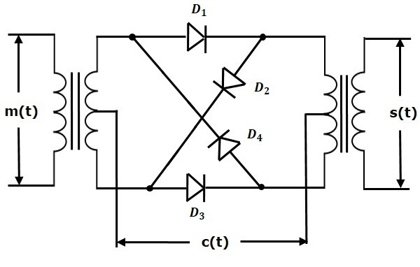

DEMODULATION

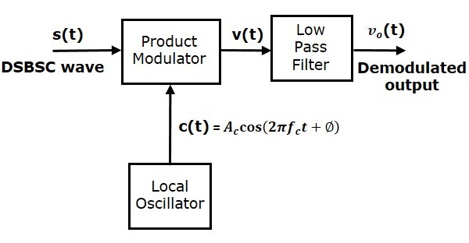

**MATLAB CODE:**

fc =50000; %carrier frequency

fm = 2000; %message signal frequency

fs = 800000; %sampling frequency

Am = 1; %Amplitude of message signal

Ac = 1; %Amplitude of carrier signal

T = 1/fs; %Time period

t = [0:T/999:0.001]; %Time range used in plotting signals

m = Am/Ac; %modulation index given as the ratio of message signal amplitude with carrier signal amplitude

%Message Signal

Sm = Am*cos(2*pi*fm*t);

subplot(5,1,1)

plot(t, Sm, 'r');

grid();

title('Message signal');

%Carrier Signal

Sc = Ac*cos(2*pi*fc*t);

subplot(5,1,2)

plot(t, Sc, 'g');

grid();

title('Carrier signal');

%DSBSC Signal

dssb = ((Am*Ac).*(cos(2*pi*fc.*t)).*(cos(2*pi*fm*t)));

subplot(5,1,3)

plot(t, dssb, 'm');

grid();

title('DSBSC Signal');

%DSBSC demodulating Signal

dssb_dm = ((Am*Ac*Ac)).*(cos(2*pi*fm*t));

subplot(5,1,4)

plot(t, dssb_dm, 'b');

grid();

title('SSBSC demodulating Signal');

%Comparison of original and demodulated signal

subplot(5,1,5)

plot(t,Sm,'r',t,dssb_dm,'b--');

grid();

title('Comparison of message signal and demodulated signal');

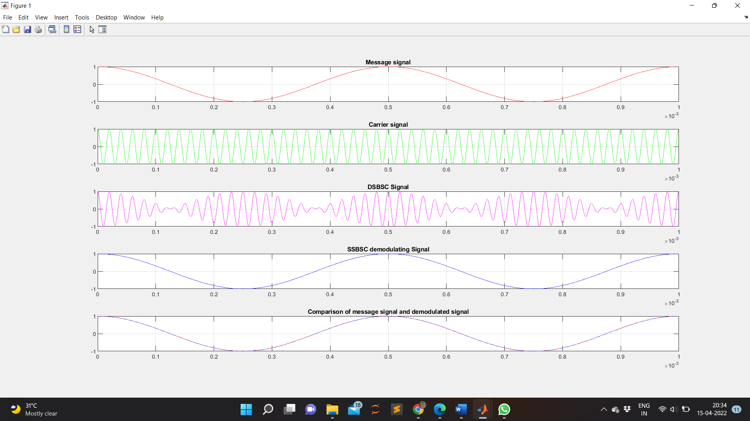**WAVEFORM OBTAINED:**

**RESULT:**

The output waveforms of DSBSC modulation and de-modulation are observed and plotted.

**APPLICATIONS:**

DSB-SC transmission is a special case of double-sideband reduced carrier transmission. It is used for radio data systems.