**EXPERIMENT - 5**

**AIM:**

Generation and detection of Pulse Amplitude Modulation using MATLAB

**THEORY:**

Pulse modulation is used to transmit analog information. In this system continuous wave forms are sampled at regular intervals. Information regarding the signal is transmitted only at the sampling times together with syncing signals.

At the receiving end, the original waveforms may be reconstituted from the information regarding the samples.

The pulse amplitude modulation is the simplest form of the pulse modulation. PAM is a pulse modulation system is which the signal is sampled at regular intervals, and each sample is made proportional to the amplitude of the signal at the instant of sampling. The pulses are then sent by either wire or cables are used to modulated carrier.

The two types of PAM are i) Double polarity PAM, and ii) the single polarity PAM, in which a fixed dc level is added to the signal to ensure that the pulses are always positive. Instantaneous PAM sampling occurs if the pulses used in the modulator are infinitely short.

Natural PAM sampling occurs when finite-width pulses are used in the modulator, but the tops of the pulses are forced to follow the modulating waveform.

Flat-topped sampling is a system quite often used because of the ease of generating the modulated wave.

PAM signals are very rarely used for transmission purposes directly. The reason for this lies in the fact that the modulating information is contained in the amplitude factor of the pulses, which can be easily distorted during transmission by noise, crosstalk, other forms of distortion. They are used frequently as an intermediate step in other pulsemodulating methods, especially where timedivision multiplexing is used.

The demodulation of the PAM is quite a simple process. PAM is fed to the integrating Rx circuit (LPF), from which the demodulating signal emerges whose amplitude at any instant is proportional to the PAM at that instant. This signal is given to an inverting amplifier to amplify Its level so that demodulated output is having almost equal amplitude with the modulating signal, but it is having same phase difference.

**BLOCK DIAGRAM:**

MODULATOR

PAM MODULATOR

A.F. Signal P.A.M. Signal

Clock

DEMODULATOR

P.A.M. Signal Demodulated Signal

L.P.F.

AMPLIFIER

**MATLAB CODE:**

fc= 100; %carrier frequency

fm= fc/10; %message signal frequency

fs= 100*fc; %sampling frequency

t=0:1/fs:1; %Time range used in plotting signals

%Message Signal

Sm = cos(2*pi*fm*t);

subplot(4,1,1);

plot(t,Sm);

title('Message Signal');

xlabel('Time Period');

ylabel('Amplitude');

%Carrier Signal

Sc= 0.5*square(2*pi*fc*t)+0.5;

subplot(4,1,2);

plot(t,Sc);

title('Carrier Signal')

xlabel('Time Period');

ylabel('Amplitude');

ylim([-1 1]);

%Pulse Amplitude Modulation Signal

PAM = Sm.*Sc;

subplot(4,1,3);

plot(t,PAM);

title('PAM Modulated signal')

xlabel('Time Period');

ylabel('Amplitude');

%Demodulation

filter = fir1(100,fm/fs,'high');

DPAM = conv(filter,Sm);

t1 = 0:1/(length(DPAM)-1):1;

subplot(4,1,4);

plot(t1,DPAM);

title('PAM Demodulated signal')

xlabel('Time Period');

ylabel('Amplitude');

**WAVEFORM OBTAINED:**

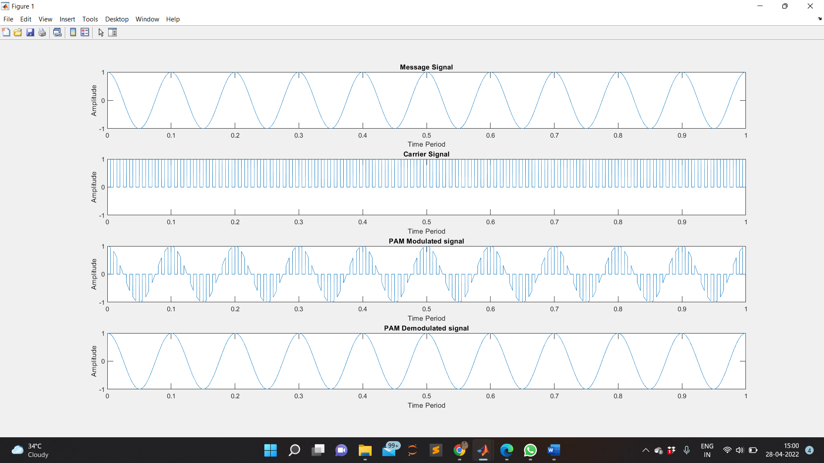

**RESULT:**

The pulse amplitude modulation and demodulation is studied, verified and the output waveforms are plotted.

**APPLICATIONS:**

Some versions of the Ethernet communication standard are an example of PAM usage. The concept is also used for the study of photosynthesis using a specialized instrument that involves a spectrofluorometric measurement of the kinetics of fluorescence rise and decay in the light-harvesting antenna of thylakoid membranes, thus querying various aspects of the state of the photosystems under different environmental conditions.