**EXPERIMENT - 6**

**AIM:**

Study the Pulse Width Modulation (PWM) and Demodulation Techniques

**THEORY:**

PWM is also called as pulse duration modulation or pulse length modulation. In PWM, the width of the pulse is varied in proportional to the amplitude of the analog input signal. Three types of PWM signals are available. Leading edge, trail edge and central edge. In leading edge PWM, the leading edge is fixed and trail edge is modulated where as in trailing edge PWM, the trailing edge is fixed and leading edge is modulated. In PWM with centered, the middle of the pulse is fixed and both edges are modulated according to the amplitude of modulating signal. PWM has disadvantage that it is varying the pulse with width and therefore varying power is not constant. So the transmitter and receiver must be able to handle maximum pulse width, but PWM works even though synchronization is not exist between the Tx and Rx pulse trails, where PPM does not. Applying trigger pulses at sampling rate to control the starting time of the pulse can generate PWM and end of the pulse depends on the amplitude of the modulating signals. The pulse width will be maximum at positive peak and minimum width at negative peak.

**BLOCK DIAGRAM:**

MODULATOR

PWM MODULATOR

A.F. Signal P.W.M. Signal

Clock

DEMODULATOR

P.W.M. Signal Demodulated Signal

L.P.F.

AMPLIFIER

**MATLAB CODE:**

fc=1000; %carrier frequency

fs=10000; %sampling frequency

f1=200;

t=0:1/fs:((5/f1)-(1/fs)); %Time range used in plotting signals

%Message Signal

Sm =0.4*cos(2*pi*f1*t)+0.5;

subplot(3,1,1);

plot(t,Sm);

title('Message signal');

xlabel('Time Period');

ylabel('Amplitude');

%modulation

PWM = modulate(Sm,fc,fs,'pwm');

subplot(3,1,2);

plot(PWM);

axis([0 300 -0.2 1.2]);

title('Pulse Width Modulation');

xlabel('Time Period');

ylabel('Amplitude');

%demodulation

DPWM = demod(PWM,fc,fs,'pwm');

subplot(3,1,3);

plot(t,DPWM);

title('Demodulated Signal');

xlabel('Time Period');

ylabel('Amplitude');

**WAVEFORM OBTAINED:**

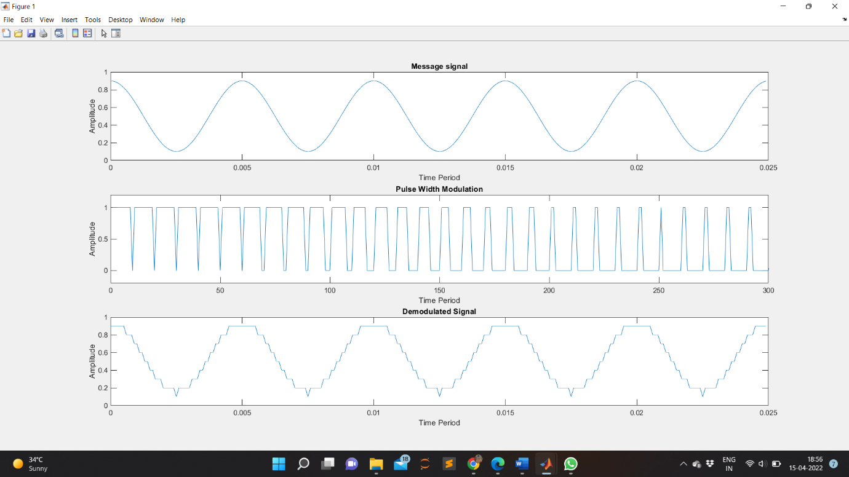

**RESULT:**

The pulse width modulation and demodulation is studied, verified and the out put waveforms are plotted.

**APPLICATIONS:**

This modulation technique used to encode a message into a pulsing signal. Although this modulation technique can be used to encode information for transmission, its main use is to allow the control of the power supplied to electrical devices, especially to inertial loads such as motors. In addition, PWM is one of the two principal algorithms used in photovoltaic solar battery chargers,the other being maximum power point tracking.