**Shardul Nazirkar (email - shardul.17u024@viit.ac.in) (No. - 9970661585)**

**Harsh Shinde (email - harsh.17u008@viit.ac.in) (No. - 9850889719)**

**Title** – Detection of vehicle logos, model name, number plate and stickers on cars. Also detection of scratched and dents on cars.

**Introduction –** This document presents a detailed description of the project related to data science and machine learning application to detect various logos, stickers on cars. This system will also be used to identify scratches and dents on cars.

**Technology Used –** For Image recognition, processing and AI/ML models: openCV, TensorFlow, Keras, Scikit-Learn in Python programming language.

Front-End – Web-based made using Stream-Lit Engine.

Database – MySQL.

**Hardware Requirements –** Cameras (qty. 4)

For starters we believe in using simple usb cameras like ‘PlayStation Eye’, which are widely popular among computer vision applications. But acquiring these cameras has become difficult these days, so as an alternative we suggest Logitech c270 for starters.

**PlayStation Eye – Cost Rs. 1500 for one**

**Logitech c270 – Cost Rs. 3000 for one**

On successful implementation and as and when need arises we can think of industry-grade cameras.

To develop and train AI/ML datasets and models, a pc with minimum requirements like 8gb ram, 3.5ghz processor, high speed hard drive and a good internet connection is required(which we already have).

On successful implementation of our project, we can embed it onto mini-computational modules like Raspberry Pi or NVidia Jetson.

**Software Requirements –** Necessary python coding environments for developing (like Anaconda distribution).

Large Datasets containing images related to cars from all angles, required for training machine learning models.

**ARCHITECTURE**

**Overview of a Typical ML project workflow**

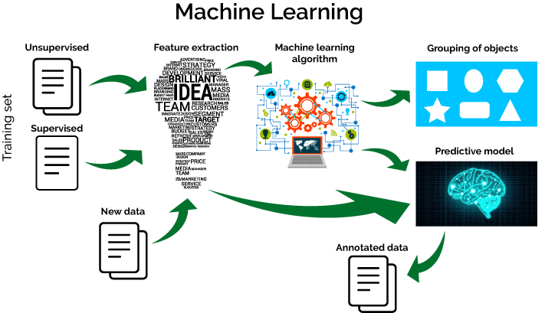

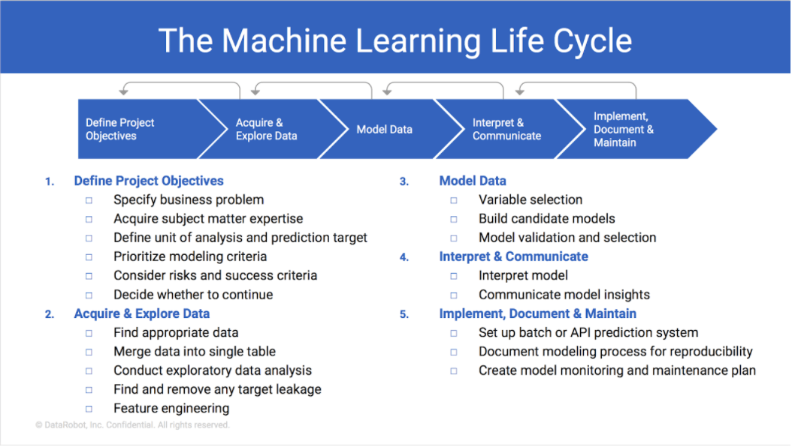**Stages of AI/ML System**

**Steps for Development:**

1. Gather large datasets for model training purposes.
2. Label Data according to our needs.
3. Processing data using image enhancement techniques.(eg. remove noise, correct contrast, remove background etc.)
4. Train different object detection models for each of stickers, number plates, scratches and dents using openCV, TensorFlow etc.
5. Test our model using testing data and edit and tune it for best accuracy and results.
6. Testing different models and comparing accuracy results. Finally selecting the best model.
7. Developing Front-End of the product in Stream-Lit engine and final procedures for product deployment.

**Steps during implementation:**

1. Cameras will capture and provide real-time live feed of the car from 4 different angles/views.
2. System will detect the car from these images and the unnecessary backgrounds and objects will be removed.
3. The models trained in AI/ML will detect logos, stickers, number plate, scratches and dents on the car images.
4. Required output will be sent to the user with details about the logos, stickers, number plate, scratches and dents.

**BLOCK DIAGRAM FOR STEPS**

Integrate our model with a web-based front-end and deploy an end to end product.

Handle inconsistencies and missing data

Evaluate the accuracy of our trained models, tune parameters and repeat.

Train multiple models with above data to identify scratches, dents, stickers.

Transform images into compatible format (removing noise, cropping, background etc.)

Acquire raw data and images of cars with stickers, scratches, dents etc.

MODEL EVALUATION

DEPLOYMENT

MODEL TRAINING

DATA TRANSFORMATION

DATA ACQUISITION

DATA PRE-PROCESSING