PUNE INSTITUTE OF COMPUTER TECHNOLOGY,
DHANKAWADI PUNE-43.

A Mini-Project Report
On
RMI Stocks
SUBMITTED BY

Ms. Amulya Chetlapalli- 4106
Ms. Archisha Shrivastava - 4110
Mr. Shardul Dabhane - 4117

CLASS: BE-1
UNDER THE GUIDANCE OF
DR. S.N.Girme

COMPUTER ENGINEERING DEPARTMENT
Academic Year: 2018-19

Table of Contents
1. Introduction
2. Concepts
3. Execution
4. Conclusion

1.Introduction

The stock market could be said to be one of the major applications of distributed systems. Each user can get to know the current situation of the stock market within the palm of his hand, due to various applications created for this purpose. Each user wishes to see notifications only about the stocks he’s interested in. The concept of RMI can be used to carry out this application. This project is a simplistic attempt at creating a simple notification system.
` The main purpose of this project is to design and implement a distributed computing system. The objectives of the project are to provide significant price/performance improvement, to inherently incorporate the concept of callback technology and to provide the choice of selecting a particular service in a set of available services so that the clients (Users) can make well-informed decision(s) on which service to choose. We will be using the concept of publisher and subscriber for this mini project. The project aims at implementing a stock notification system in which users are registered to the system and each user can subscribe to a unique stock. Whenever there is any fluctuation in the price of that stock symbol, the user will be notified of the change.

Keywords: Remote Method Invocation, Callback

2.Concepts

2.1.Java RMI

Java Remote Method Invocation (RMI) allows you to write distributed objects using Java. This paper describes the benefits of RMI, and how you can connect it to existing and legacy systems as well as to components written in Java.
RMI provides a simple and direct model for distributed computation with Java objects. These objects can be new Java objects, or can be simple Java wrappers around an existing API. Java embraces the "Write Once, Run Anywhere model. RMI extends the Java model to be run everywhere."
Because RMI is centered around Java, it brings the power of Java safety and portability to distributed computing. You can move behavior, such as agents and business logic, to the part of your network where it makes the most sense. When you expand your use of Java in your systems, RMI allows you to take all the advantages with you.
RMI connects to existing and legacy systems using the standard Java native method interface JNI. RMI can also connect to existing relational database using the standard JDBC?? package. The RMI/JNI and RMI/JDBC combinations let you use RMI to communicate today with existing servers in non-Java languages, and to expand your use of Java to those servers when it makes sense for you to do so. RMI lets you take full advantage of Java when you do expand your use.

The primary advantages of RMI are:
- Object Oriented: RMI can pass full objects as arguments and return values, not just predefined data types. This means that you can pass complex types, such as a standard Java hashtable object, as a single argument. In existing RPC systems you would have to have the client decompose such an object into primitive data types, ship those data types, and the recreate a hashtable on the server. RMI lets you ship objects directly across the wire with no extra client code.
- Mobile Behavior: RMI can move behavior (class implementations) from client to server and server to client. For example, you can define an interface for examining employee expense reports to see whether they conform to current company policy. When an expense report is created, an object that implements that interface can be fetched by the client from the server. When the policies change, the server will start returning a different implementation of that interface that uses the new policies. The constraints will therefore be checked on the client side-providing faster feedback to the user and less load on the server-without installing any new software on user's system. This gives you maximal flexibility, since changing policies requires you to write only one new Java class and install it once on the server host.
- Design Patterns: Passing objects lets you use the full power of object oriented technology in distributed computing, such as two- and three-tier systems. When you can pass behavior, you can use object oriented design patterns in your solutions. All object oriented design patterns rely upon different behaviors for their power; without passing complete objects-both implementations and type-the benefits provided by the design patterns movement are lost.
- Safe and Secure: RMI uses built-in Java security mechanisms that allow your system to be safe when users downloading implementations. RMI uses the security manager defined to protect systems from hostile applets to protect your systems and network from potentially hostile downloaded code. In severe cases, a server can refuse to download any implementations at all.
- Easy to Write/Easy to Use: RMI makes it simple to write remote Java servers and Java clients that access those servers. A remote interface is an actual Java interface. A server has roughly three lines of code to declare itself a server, and otherwise is like any other Java object. This simplicity makes it easy to write servers for full-scale distributed object systems quickly, and to rapidly bring up prototypes and early versions of software for testing and evaluation. And because RMI programs are easy to write they are also easy to maintain.
- Connects to Existing/Legacy Systems: RMI interacts with existing systems through Java's native method interface JNI. Using RMI and JNI you can write your client in Java and use your existing server implementation. When you use RMI/JNI to connect to existing servers you can rewrite any parts of you server in Java when you choose to, and get the full benefits of Java in the new code. Similarly, RMI interacts with existing relational databases using JDBC without modifying existing non-Java source that uses the databases.
- Write Once, Run Anywhere: RMI is part of Java's "Write Once, Run Anywhere" approach. Any RMI based system is 100% portable to any Java Virtual Machine *, as is an RMI/JDBC system. If you use RMI/JNI to interact with an existing system, the code written using JNI will compile and run with any Java virtual machine.
- Distributed Garbage Collection: RMI uses its distributed garbage collection feature to collect remote server objects that are no longer referenced by any clients in the network. Analogous to garbage collection inside a Java Virtual Machine, distributed garbage collection lets you define server objects as needed, knowing that they will be removed when they no longer need to be accessible by clients.
- Parallel Computing: RMI is multi-threaded, allowing your servers to exploit Java threads for better concurrent processing of client requests.
- The Java Distributed Computing Solution: RMI is part of the core Java platform starting with JDK?? 1.1, so it exists on every 1.1 Java Virtual Machine. All RMI systems talk the same public protocol, so all Java systems can talk to each other directly, without any protocol translation overhead.

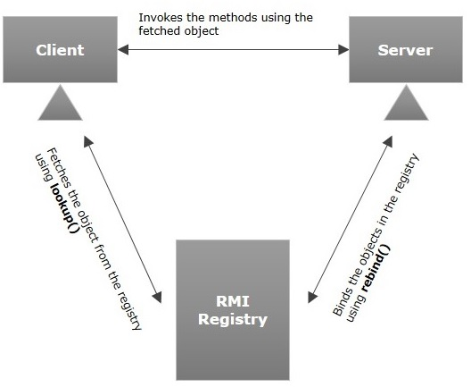

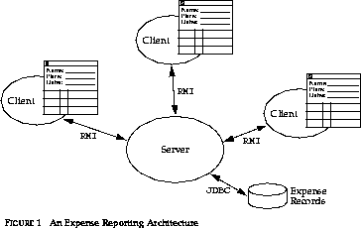

2.2.Java RMI Callback

One major benefit of RMI is that almost any kind of object can be passed as a parameter or return value of a remote method. The recipient of the object will not know ahead of time the class of the actual object it will receive. If the object is of a class that implements Remote (java.rmi.Remote), then in fact the returned object will be a proxy object that implements at least the declared interface. If the object is not remote, it must be serializable, and then a copy of it will be transmitted across the Net. The prime example of this is a String. It makes no sense to write an RMI proxy object for String. Once you have a String, you can copy it locally but never change it. So Strings, like most other core classes, can be copied across the RMI connection just as easily as they are copied locally. But Remote objects will cause an RMI proxy to be delivered. So what is stopping the caller from passing an RMI object that is also itself a proxy? Nothing at all, and this is the basis of the powerful RMI callback mechanism.
An RMI callback occurs when the client of one service passes an object that is the proxy for another service. The recipient can then call methods in the object it received, and be calling back (hence the name) to where it came from.
Implementing callbacks, however, is not without challenges -- particularly in a distributed-object environment like RMI. Callbacks are implemented in RMI by setting the client itself as an exportable remote object (that is, make it implement some remote interface), then registering a reference of this with the remote-server object. This way, the server can asynchronously invoke the remote methods of any connected client in the same way the client can asynchronously invoke the methods implemented within the remote-server objects.
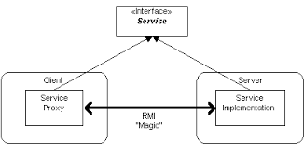

3.Execution

The execution of this project consists of 2 parts. One part acts as the publisher and the other part as the subscriber.

3.1.Publisher
The publisher will have the user setting up the rmiregistry and waiting for invocations from the client. The server will consist of stocks and the users. All the notifications regarding the subscribing and unsubscribing will be seen here.

3.1.1.Notifiable
Notifiable is an interface with two methods:
The method notify (String stockSym, double price) is called by the server and informs the callback client that a change in the stock price has occurred.
The method exit() is also called by the server and tells the callback client that it should cease listening for this client. The user has exited the system.
This interface will be implemented on the client side.The implementation will be done by an object that extends the UnicastRemoteObject. The interface will be available on the client and the server.
The remote stock service will be carried out by the stock rmi service. There are three types of clients of this service.
One client will be calling stockUpdate() to report on new prices for various stocks.
A second client will be calling subscribe() and unsubscribe() to register interest in or remove interest from a particular stock. This client will also deRegisterCallBack() when it terminates.
A third type of client will be calling the registerCallBack() method so that it may receive call backs from the service when stock prices change.
Two two last clients are associated with a single human user. So, for example, a user might use a call to subscribe to register interest in a particular stock. At that point, the stock service will begin to make calls back to the client when that stock price changes.

3.2.Subscriber

3.2.1. StockRMIClientSubscription
The StockRMIClientSubscription class interacts with the user to subscribe and unsubscribe to specific stock. After subscribing, the client will begin to receive updates to that stock price. After unsubscribing, the client are no longer informed of updates to that stock.

3.2.2. StockRMIClientPriceUpdate
This class interacts with users to obtain stock update and pass it to the server. This class represents an external source of events. The price if updated, is passed on to the server.

3.2.3. StockPriceCallBack
The StockPriceCallBack class is meant to provide callable methods to the server side and would normally run on the dealer's computer.

Output:-

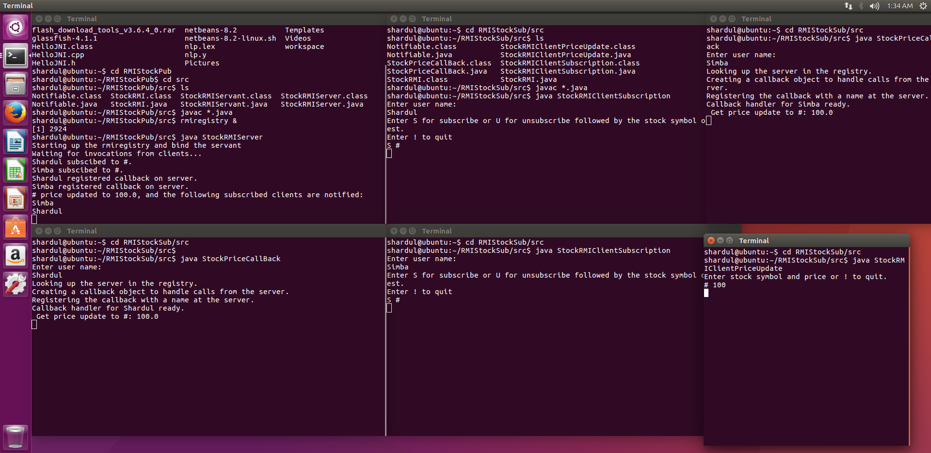
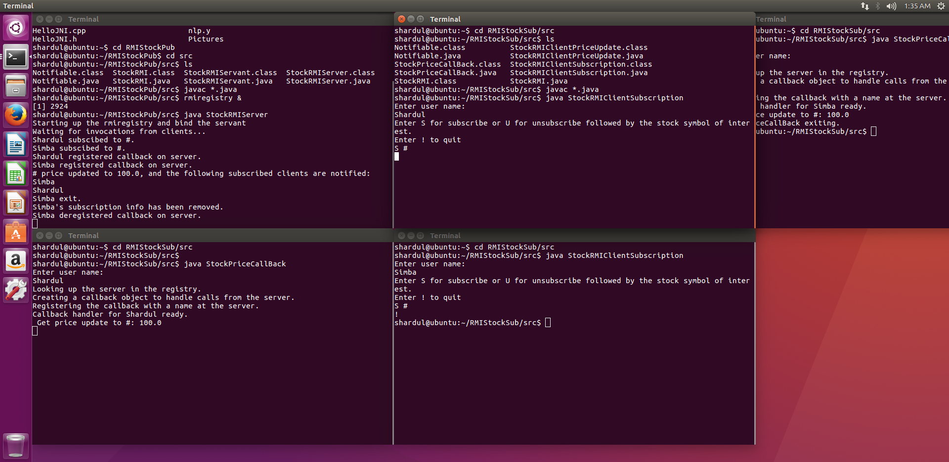

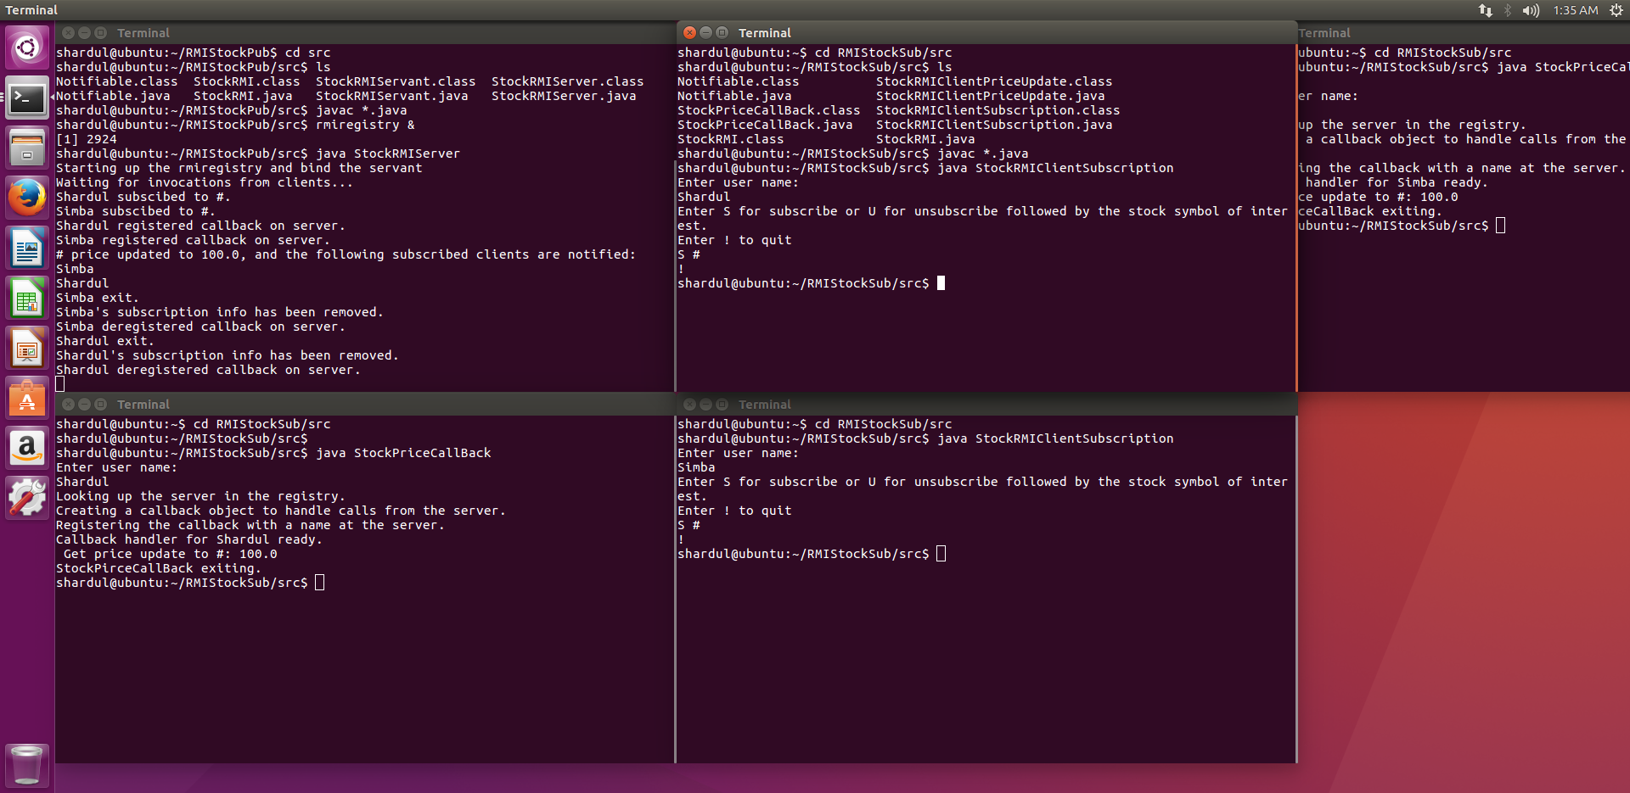
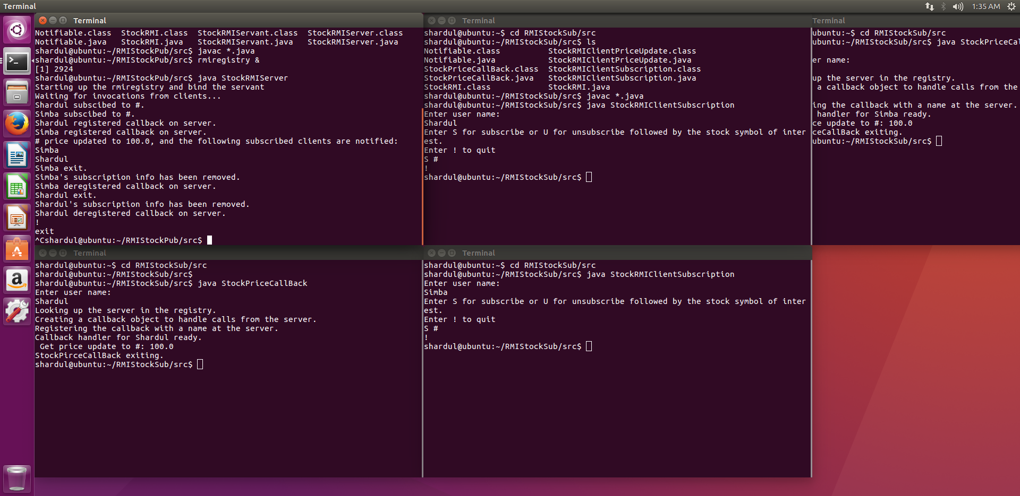

Conclusion:-

From this project, we learnt how to implement a basic Java RMI system using callbacks.
We learnt how to make a simple prototype of a real life application in distributed systems. This project can be further implemented with a better GUI and many more systems to make it a proper distributed systems application.
A distributed systems application which could be implemented as a real life application was attempted by our group.

