
.
Project Title: InstaCharito
Team Members:
Mohd khaja shareef
Muhammed omaar
Gottipati Rohith
Shaik Ismail Ahmed

Abstract:
InstaCharito app is a non-profit social enterprise, empowering mobile users to connect and securely donate to charities and causes of their choices. InstaCharito is a unique giving platform that allows charities, cause, and appeals to connect to a new world of mobile and digital giving. If you are a charitable cause or a charitable giver, InstaCharito is a simple, fast and secure way to join the future of giving. This app is dedicated to make the future of giving digital.
For this app, we need to have the data of all charitable causes info and a way to transfer money into their account. We should identify the real needy organizations or individuals. The Project is developed by Java Programming Language by using Integrated Development Environment. We use the Android software development kit which has various of custom tools that help us develop mobile applications on Android platform
Purpose of this Project: Instacharito is a mobile app for charity..
The main aim is to make the donations from persons to reach the charity organizations easily by mobile app. To give the details of some
orphanages, oldage homes, other welfare societies and also any emergency needs and relief funds. Through this app we want help the donor to make charity easy and efficient and also free publicity for charity organizations
Scope of this Project:
We can create a common platform for donors and charitable organizations with the help of mobile app Through this the details of the organizations can be reached among the people all over easily and effectively.

The InstaCharito mobile app is a smart, social and simple app which is user friendly and unique where we can even post individual causes.we are giving access to the users to either give donation or to publish their cause or details about their organizations which will be posted after being verified by us personally. This app even includes animal welfare organizations and also national relief funds apart from charity organizations in the city.

Screenshots:
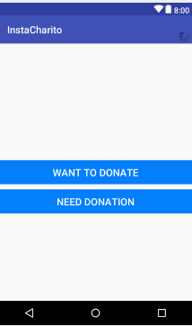

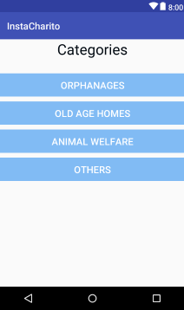
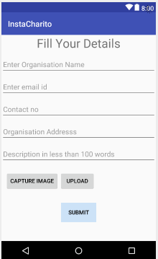

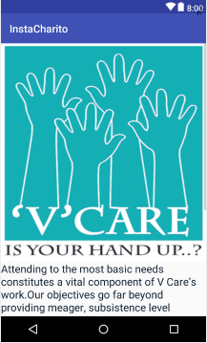

EXISTING SYSTEM:

The existing system is a manual process where a person representing the charity organization goes to every person’s in search of charity. The information about the organization can only be Shared by the volunteers of that organization. To make the people aware of these organizations and their activities is the most important thing in this system. The existing system is slow and not much effective.

PROPOSED SYSTEM:

The development of this new system objective is to provide the solution to the problems of existing system. By using this new system, we can fully automate the entire process of the current system. The new system would like to make a mobile application so that the information is spread across people with minimum effort. To track the activities and needs of the organizations is done regularly. Being a mobile app the information can be processed all over the world easily. This system also providing the features where you can donate directly from the app and also post any emergency or personal helps which can be viewed from all over the world. In this new system, people can post their individual cause or we can also get charity for emergency relief. In this new system people can contact us through information available in contact us if they want to post any of their personal cause. We Examine about the cause and if we feel it is an TrustWorthy Cause then we would surely post about that specific cause.

Hardware Requirements:
- Smart Phone
- Storage 50MB
- RAM 512MB

Software Requirements:
- ANDROID OS (4+)
- Java SDK
- Android Studio.

Limitations of the system:.
  - Trust issue about the articles presented in the app.
  - Equal distribution of donations among all orginazations.
  - No storage of money for emergency needs.
  - Less awareness of these type of app.

