**Dissertation Study carried out**

**On**

**Characterization of the Heavy Minerals and Separation of Rutile & Sillimanite Heavy Minerals from sample from Chavara Mineral Sand Deposit, Kerala.**

**ACKNOWLEDGEMENT**

We would earnestly like to place here in record our gratitude to all those who have helped us to compete this dissertation work throughout the course of work and at different stages.

We heartily thank **Mr. SABU JOSEPH**, Sr. Manager, IREL India Limited , Research Centre, Kollam for his cooperation in completion of this report.

We are indebted to **Mr. SABU JOSEPH and Mr. K.JAYAPRAKASH NAIR** , for giving us an opportunity to do this work, for which we extend our sincere thanks for their encouragement, valuable suggestions, useful guidance, support and generosity in successful completion of this M.Sc dissertation work.

We gratefully thank **Mr. VINEETH** for his constant help and guidance in the work.

We are thankful to all the faculty members and staffs of **IREL Research centre ,KOLLAM** .

Sincerely,

Adarsh.K

Athul.R

Harikrishnan . J

Nithin.K.V

Sreenath .P

Sooraj.S.S

CONTENTS

**1** .**CHAPTER 1. INTRODUCTION**

1.1INTRODUCTION……………………………………………………..… 07

1.2. FORMATION OF BEACH SAND MINERALS………………………..08

1.3. IREL(INDIA) LIMITED…………………………………………….…..08

1.4. IRE RESEARCH CENTRE, KOLLAM, KERALA………………….....09

1.5. HISTORY…………………………………………………….………….09

1.6. IREL AND ITS OPERATIONS…………………………………………10

**2. CHAPTER 2: SCOPE OF PROJECT WORK**

2.1. MODE OF OCCURENCE………………………….……………………12

2.2. BEACH PLACER RESERVES AND RESOURCES OF KERALA…….12

2.3. CHAVARA MAJOR DEPOSITS…………..…………………………….14

2.4. MINE PLANNING……………………………………………………….15

2.5 DESCRIPTION OF MINERALS………………………………………….15

*2.5.1. ILMENITE*

*2.5.2. RUTILE*

*2.5.3. ZIRCON*

*2.5.4. MONAZITE*

*2.5.5. SILLIMANITE*

*2.5.6. GARNET*

*2.5.7. QUARTZ*

**3. CHAPTER 3: SAMPLE COLLECTION**

3.1. LOCATION……………………………………………………………….24

3.2. COLLECTION AND PREPARATION……………………………………25

**4. CHAPTER 4: CHARACTERIZATION OF BEACH SAND MINERALS**

4.1.SIZE ANALYSIS…………………………………………………………..27

4.2 DETERMINATION OF SHELL CONTENT IN THE SAMPLE………….31

4.3 HEAVY MEDIA SEPERATION……………………………………………….…..32

4.4 DETERMINATION OF MAGNETIC MINERALS FROM HEAVY MINERALS..35

4.5 MICROSCOPIC ANALYSIS OF FEED SAMPLE……………………………….37

**5. CHAPTER 5: SEPERATION OF BEACH SAND MINERALS IN BULK QUANTITY**

5.1 SEPERATION OF COMMERCIAL GRADE RUTILE AND SILLIMANITE…45

5.2. GRAVITY SEPARATION……………………………………………………...48

5.3. ELECTROSTATIC SEPARATION…………………………………………….54

5.4. MAGNETIC SEPARATION ……………………………………………….......60

5.5 FROTH FLOATATION…………………………………………………………..70

5.6 MINERALOGICAL ANALYSIS…………………………………………………72

**6. RESULT**

**7. CONCLUSION**

**INTRODUCTION**

India has large reserves of beach sand minerals such as Ilmenite, Rutile, Zircon, Monazite, Sillimanite and Garnet; first four being categorized as prescribed substance for use in production of Atomic Energy and related research and Development activities. These reserves are mostly located in coastal stretches of peninsular India with exception of few inland placer deposits. According to the Beach sand and Off shore investigation Groups in Atomic Mineral Directorate for exploration and researches who has so far surveyed 2088 km against the target of 6000 km of coastal tract, the Ilmenite reserves is estimated as high as 348 million tons (highest I the world), along with 18 million tons of rutile, 21 million tons of zircon, 8 million tons of monazite, 107 million tons of garnet and 130 million tons of sillimanite. These recourses occur as beach washing deposits between the high and low tide lines along the beach and also as inland extension of placer sands.

India has vast coast line of about 6000 km associated with large deposit of beach sand minerals with the exceptions of few island deposits in riverine placers of BIHAR and Teri sands of Tamil Nadu. Atomic Minerals Directorate for exploitation and Research under Department of Atomic Energy is constantly engaged in exploration of beach sand minerals and investigated about 2100 km of coastal length proving in the process a larger reserve of 348 million tons of Ilmenite representing 35% of the world reserve.

Referring to the west coast part of the country, in Maharashtra state occurrences have been identified along Ratnagiri coast which are predominantly mono-mineral in nature with Ilmenite constituting about 3 million tons. As we go down south along the 600 km long coastal line in Kerala about 10 locations are surveyed proven resources of 5MT, of this the stretch between the Neendakara to south and Kayamkulam to north at an average coastal width 225 meter and its eastern extension covering an area of 75 sq. km have one of the richest Ilmenite deposits containing 62 MT. Further going down in Tamilnadu, the 60 km in east coast surveyed so far has yielded 87 MT of Ilmenite reserves with 77 MT reporting from seven inland Teri deposited-Kudiraimozhi (23MT), Sattanakulam-Vijayapuram (14MT) and Navaladi-Kuttapanai-Perithalai (23.5MT) being the notable ones.

In Andhra Pradesh, 663 km out of 970 km coastal length surveyed have brought to light 29 occurrences with a yield of 73MT of Ilmenite reserve. Notably among these are 4 Bharanaperudu (9MT), Kalinagapattanam (10MT), Bhimilipatanam (3MT), and Kakinada (33MT).

**1.2 FORMATION OF BEACH SAND MINERALS AND DEPOSITS**

In the state Odisha, exploration of 128 km out of 700 km coastal line has brought to light 11 deposits with reserve of 38 MT of Ilmenite of which the predominant and attractive deposit is in the 22 km stretch between Gopalpur and Chatrapur with eliminate reserve of over 20MT. IN addition to beach placer deposit, inland alluvial deposits occur in Purulia district of West Bengal (2.08MT) and Ranchi in Jharkhand (0.74MT).

In India the heavy minerals are found in the placer deposits formed along the coastal structure. The origin of the deposits belongs to the parent rock type available in the Eastern Ghats and the Western Ghats mountain ranges which contain these minerals in very low concentration to call for profitable extraction. The main sources are Khondalites, Charnockites, Gneiss, Granites, Laterites and sand stones etc., when the source rocks are subjected to weathering processes the minerals are liberated from it and transported downward by running water and rivers. The tropical climate with heavy rainfall assists in weathering process. The liberated minerals transported downward are deposited in the seashore in a sorted condition.

The actual sorting and concentration take place due to action of two important agents-actions of waves and surfs and the action of wind. Ocean waves and surfs play predominant roles in the concentration of heavy minerals. Breaking wave takes all the foreshore minerals in the beach but the backwash carries only the lighter sand particles thus leaving the in-situ deposit rich in heavy minerals.

**1.3 IREL (INDIA) LIMITED**

IREL (India) Limited was incorporated in the year 1950 under the companies Act 1993. A Government of India undertaking under the administrative control of department of Atomic Energy (DAE) is engaged in the mining and processing of beach sands in the coastal areas of Kerala (Chavara) ,Tamil Nadu (Manavalakurichy) and Orissa (Chatrapur). The Chavara plant is based on the Mineral deposit of 23 km long stretch of land in the belt of Neendakara and Kayamkulam which is well known as the richest and single largest Ilmenite deposit in the country. The IREL Manavalakurichy plant, situated 25 km North of Kanyakumari, exploits minerals from 8 km stretch between Kadiapatanam and Colachal in the Midlam area. The Rare Earth Plant of IREL at Aluva, produce rare earth salts only. The company produces more than 0.4 million tons of Ilmenite in addition to the associated heavy minerals like Rutile, Zircon, Monazite and Garnet. The Corporate office of the company is located in Mumbai.

Apart from the domestic demands, IREL supplies to the international markets viz. USA, UK, France, Germany, Norway, Japan, Korea, and China etc., The Company has been a significant earner of foreign exchange to the nation. Since its inception, IREL has built a corporate image in the world market as a reliable supplier of beach sand minerals, rare earth compounds and associated products. The company has three main well-equipped laboratories to take care of the various Researches and Development needs.

**1.4. IRE RESEARCH CENTRE, KOLLAM, KERALA**

Company’s Corporate Research Centre is located at Kollam, Kerala. The Centre is set up to facilitate basic sand scientific research for expanding knowledge base in the field of beach sand related value-added products. The laboratory is equipped with whole range of ore beneficiation and separation facilities. The centre had undertaken many investigative and flow sheet development studies, catering the needs of internal and external customers.

**1.5. HISTORY**

The presence of two prominent beach sand minerals namely Ilmenite and monazite along the west coast of India was reported for the first-time way back in 19th century by captain Blair and Kid, chief surveyor of east India company. Herr Schaumburg in 1909 discovered monazite deposit of Travancore by tracing back its presence attached to coir exported from south India. London cosmopolitan company started operation from 1910 for recovery of monazite to produce Thorium compounds for gas mantle application. Subsequently the co-mineral like Ilmenite from India left in the year 1992. Although export of monazite was banned soon after independence of India. The beach sand industry in India continued by private companies mainly 3 for Ilmenite. It was in 1965 the beach sand mineral industry dealing with four atomic minerals namely Ilmenite, Rutile, Zircon and Monazite was taken over by two public sector undertakings one (Indian Rare Earths Limited) under Central Government and the other (Kerala Minerals and Metals Limited) under Government of Kerala.

**1.6 IREL AND ITS OPERATION**

IREL was incorporated as a private Company jointly owned by GOI and Govt. of Travancore & Cochin way back in 1950. Its production activity commenced with sitting up and operation of a Rare Earth Plant at Alwaye, Cochin in 1952 to produce rare earths and thorium products. In 1965 IRE took over the private operators engaged in mining and separation of beach sand minerals in Kerala and Tamil Nadu and emerged as full-fledged Central Government Public Sector Undertaking (PSU). Today IREL operates 3 Mineral Divisions one each at Kerala (Chavara Mineral Division), Tamil Nadu (Manavalakurichi Mineral Division) and Orissa (Orissa Sands Complex) besides the original chemical plant at Alwaye mentioned earlier and now known as Rare Earths Division (RED).

The product range of the three Mineral Divisions of the Company is as follows:

• Ilmenite (50 to 60% TiO2) – 4,33,000 T

• Rutile (94% TiO2) – 19,000 T

• Zircon (64-65% ZrO2) – 27,000 T

• Sillimanite – 15,000 T

• Garnet – 22,000 T

• Monazite – 3,000 T

Against production figures mentioned above, name plate capacities of the three Mineral Divisions are 1.54 LTPA (Chavara, 60% grade Ilmenite), 0.9 LTPA (MK, 55% grade) and 2.2 LTPA (OSCOM, 50% grade) indicating overall capacity utilization of 93%. Among the three Mineral Divisions of IREL, OSCOM is the youngest and largest commissioned in 1985. This unit having mining lease of about 2900 hectares enjoys huge scope of expanding the activity and running it for many years although the deposit is relativelyless rich with respect to heavymineral concentration (approx.20%) in comparison to beach washings of Kerala and Tamil Nadu.

**SCOPE OF PROJECT WORK DONE**

Major scope of the project work done was to get a detailed understanding on the commercial value of heavy mineral deposits and the most appropriate and economically feasible methods for their separation . In order to analyse their economic importance it is essential to know about the major deposits and their mode of occurrence, they are the following ;

**2.1. MODE OF OCCURRENCE**

The occurrence of beach sand deposit is usually in the form of dunes along the shorelines of the sea. The deposits in the vicinity of the seashore are coarsegrained having the highest degree of concentration and are known as Frontal Dune Deposits. Some of the finer heavy minerals are blown away from the frontal dunes and moved towards the intermediate leeward side until it is obstructed. When these minerals are deposited in the form of dunes in the sea side of the deposits they are called Rear Dune Deposits. The concentration of heavy minerals, grain size and the minerals composition in the dune deposits vary across the width of the deposits due to the variation of ground water table in the locality.

**2.2BEACH PLACER RESERVES AND RESOURCES OF KERALA**   
The present strand deposits of Kerala are characterised by higher concentration of heavy minerals -up to 90% as in the case of Chavara barrier beach. The Chavara barrier beach is divided into 8 blocks, apportioned alternatively between KMML and IREL, engaged in the mining and processing operations. The continuity of viable mineralization inland invited exploration inputs in two phases as Chavara Eastern Extension (EE), phase I and phase II. The phase I program is limited to the distance of about 1km from the backwaters of the Chavara barrier beach. The phase II programme extends further east up to 6km or to the end of sand stretch. Together these have been designated as the Chavara major deposit.In addition to the aforementioned Chavara deposit, a number of heavy mineral placer deposits/occurrences have been identified. These can be categorized in to the following three types:

3.2.1. Deposits in the northern contiguity of Chavara, namely

i.Kayamkulam bar - Arattupuzha (KA) and its eastern extension - NTPC plant and dredging sites.ii.Arattupuzha - Thrikkunnapuzha (AT)

iii.Thrikkunnapuzha - Thottapally (TT)3.2.2. Minor deposits/occurrences of the southern Kerala

i.Kannimelssery - Neendakara (KN)

ii.Malappuram - Odetti (MO)iii.Anjengo - Vettur (AV)

iv.Veli - Kahakuttam (VK)v.Vizhinjam - Kovalam - Pachallur (VP)

3.2.3. Minor deposits/occurrences of the northern Kerala

i.Valarpattanam - Azhikodeii.Chavakkad - Ponnani (CP)

iii.Azhikode - Chavakkad (AC)The mineral deposits are classified on the basis of geological and geomorphological setting, geometry and geography, latitude, altitude, mode and means of transportation, deposits, size and shape, grain -size, mineralogy, major and the minor constituents of the individual minerals and other related factors. Obviously, any simple classification to encompass all these factors is rather impossible. An attempt is made here to categorize Kerala placer deposits, mainly based on the constituent mineralogy, in to two distinct provinces.

i.Ilmenite-Sillimanite province: major Chavara deposits and its northern contiguities and deposits/occurrences to south of Chavara in southern Keralaii.Pyribole-Ilmenite province: deposits/occurrences of northern Kerala mentioned above.

**2.3 CHAVARA MAJOR DEPOSITS**

This is rated as the one of the best of its kind in the world owing to its unique mineralogical assemblage, vast reversed and altered/leucoxenised chemical characters of ilmenite with 60% 𝑇𝑖𝑂2.3.6.1. Neendakara - Kayamkulam, NK (Chavara barrier beach) deposit

(N.0808°56’36" − 09°08’24”𝑙𝑎𝑡, 𝐸. 76°27’56” − 76°32’34”𝑙𝑜𝑛𝑔. )

Neendakara - Kayamkulam placer deposit in the Kollam district, commonly known as Chavara deposit, covers a total coastal length of 22.54 km (Prabhakar Rao, 1973). The deposit is located along a barrier beach with an average width of about 200 m between the two tidal channels, at Neendakara in the south and Kayamkulam in the north.The total area of the barrier beach deposit is 4.20 sq km, with the average Total Heavy Mineral (THM) content of 49.08% (18.49 million tonnes of THM), of which ilmenites accounts for 34.97% (13.15 million tonnes) followed by sillimanite 6.48% (2.44 million tonnes). The deposit is having a maximum thickness of 7.62 m, but the grade gradually depletes with depth. The richest sands are seen from the surface to a depth of 1.52 m, where in the grades of THM record 73 to 91%. Ilmenite occurs in the grain size of 177 microns, rutile 125 microns and zircon and monazite 105 microns.

**2.4 MINE PLANNING**Mine planning activities cover two important aspects in the total mining operations. The first aspect deals with the prospecting, exploration and deposit evaluation. The selection of equipment, sequence of extraction of minerals in short term period is determined from the data obtained during preliminary investigations. The second aspect cover a wide number of current mining activities such as providing support facilities to the operating personals, guiding the operating personal by providing information related to the production activities, rehabilitation of the mined out area by systematic planning etc. laying of road power lines ahead of the dredge movement is also an important planning function.Dredge mining of the beach sand deposit is based upon a number of data such as production target data, such as dredging area, height of deposit, drudging depth desired, grades of minerals available in the area behaviour of the ground water table etc. the focus of the planners is always to utilize the maximum land available and guide the dredging personal to minimize the losses that may arise due to encroachment of the tailings in the virgin area and also between successive runs that the drudge takes in the deposit. Different unit operations are employed to separatethe heavy minerals by exploiting the differences in their physical properties like specific gravity, electrical conductivity, and magnetic susceptibility etc. sometime combination of techniques has to be employed to obtain the final product.The most common processes are magnetic separation with the help of different magnetic separators; electrostatic separation with the help of high-tension roll separators, electrostatics plate separators etc. and froth floatation is also employed in the separation of Heavy Minerals.

**2.5 DESCRIPTION OF MINERALS**The different minerals in beach sands are follows:

2.5.1 ILMENITE

This is Iron Titanium oxide (FeTiO3). It is black and opaque. Ilmenite occurs as accessory constituent in the more basic igneous rocks. Many important deposits of Ilmenite are of detritus character, chiefly beach sand. It is mainly used for the production of TiO2 pigment for paint industry. The chief producer of Ilmenite is U.S.A, Canada, India, Norway, South Africa, Australia and Malaysia.Uses: - Ilmenite is used for the manufacture of synthetic Rutile, Titanium metal, Ferro Titanium alloys and TiO2 pigments which find wide use in printing inks, paper industry, textile, plastic, rubber, leather industry and production of synthetic gems.

2.5.2. RUTILE

This mainly consists of TiO2 (96.4%). It is an important constituent of beach sand resulting from denudation of Rutile bearing rocks as in Australia, Florida and India.Uses: - The Rutile is used in ceramic mixture to improve acid resistance, opacity, to impart cream colour to pottery bodies and glasses, manufacture of electric insulators and welding electrodes. Also used for the production of Titanium Dioxide and Titanium Tetrachloride.

2.5.3. ZIRCONZirconium does not occur freely in nature but exist as a number of complex silicates, most of which are rare. The simple silicates (ZrSiO4) is of wide spread occurrence as the mineral Zircon and this mineral is the source of the metal and its compounds used in industry. Concentration of Zircon, associated with Ilmenite, Rutile, Monazite etc. occur as beach sand in Australia, India, Florida, Brazil etc.Uses: - In ceramics, foundries and refractory, also in the manufacture of Zirconium chemicals, metal alloys. Zirconium oxide is used in structural chemicals, electrical and electronics, oxygen sensors, fuel cells, MHD electrodes, thermal barriers, artificial gems and many novelty items. Zircon flour is used in the foundries for high temperature casting.2.5.4. MONAZITEMonazite is the phosphate of the rare earth elements (Ce, La, Yt) PO4present in the right proportion to form Thorium Silicate. The mineral occurs as a constituent of the seashore sands or Monazite sands in Kerala, Tamil Nadu, in the south states of Bahia, Brazil and at various parts of the coast of the states of Espirito Santo and Rio De Janeiro. Monazite sands usually consist of monazite naturally concentrated with other heavy minerals like Garnet, Magnetite, Rutile, Ilmenite, and zircon. Electromagnetic separator effect separation. Monazite is the heaviest beach sand mineral. The manufacture of the Thorium from separated monazite is a complicated and purely chemical operation.Uses: - Monazite is used for the manufacture of rare earth chlorides, rare earth fluorides, rare earth oxides, cerium oxide, cerium hydrate, didymium compounds, samarium oxides, trisodium phosphate, thorium nitrate and thorium oxide. Rare earth chlorides are widely used in the production of catalyst for cracking petroleum, in the manufacture of metallic soaps which finds used as driers in paints, for the removal of the organic impurities and in the decolourisations of paper mill effluents. Cerium oxide finds applications in solid state devices, ultraviolet absorption glasses, radiation productive glasses, polishing of television to face planets etc. samarium oxide is used in the manufacture of samarium metal alloys, which finds use in samarium- cobalt permanent magnets with high coercive force and high magnetic energy. Gadolinium oxide is used in nuclear reactor as neutron absorbers. Yttrium tubes are used in the manufacture of the colour television tubes and fluorescent lights. Trisodium phosphate is used as descaling and degreasing agent in boilers, as fillers in the manufacture of detergent powders, to improve clarification of sugar juices and decreases the quantity of molasses.

2.5.5. SILLIMANITEThis is Aluminium silicate (Al2SiO3). Indian Sillimanite contains 58-60% Al2O3.

Uses: - It is mainly used in the manufacture of high temperature refractories and ceramic industries.

2.5.6. GARNETThese are Trisilicate of Alumina, Magnesia, and Ferrous oxide.

Uses: - The common garnet is used in as an abrasive in the form of complex calcium –aluminium-iron-silicate. Also used as grinding wheels for polishing glass/TV tubes, as sand blasting media and in water filtration.

2.5.7. QUARTZ

It mainly contains SiO2. Rock crystal is the purest and most transparent form of quartz. Other forms of quartz are amethyst, rosy quartz, cairngorm, smoky quartz, Morison, milky quartz etc.Uses: - Quartz sands, sandstone and quartzite are used in the building Trade, moulding and glass making. It is used as an abrasive as in source in soaps, sand paper, tooth paste, in the manufacture of pottery, silica breaks, fused silica wires, as a flux, as lining of tube mills and as filer. An important new use of quartz depending on its piezo-electric properties is in quartz crystal using to control the frequency of radio circuits.

The Wentworth Scale is a scale for classifying and describing sediments by grain size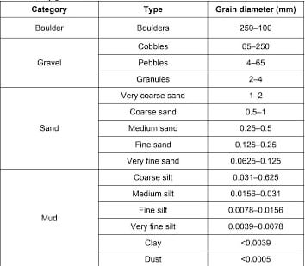

**PROPERTIES OF BEACH SANDS**

1. **PHYSICAL PROPERTIES**
2. **OPTICAL PROPERTIES**

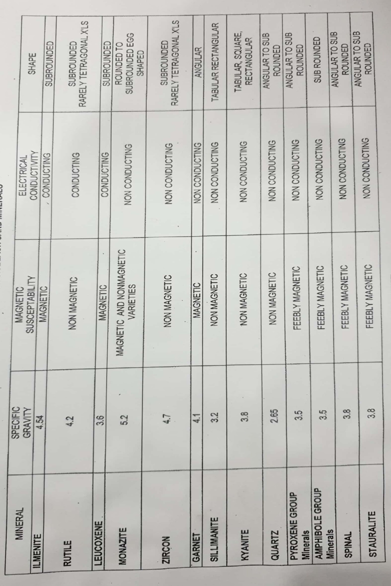

**TABLE:** Physical properties of RE Minerals



**TABLE**: Optical properties of RE Minerals

**SAMPLE COLLECTION**

**3.1 LOCATION**

Sample for the analysis was collected from karithura mining are near the main gate of IREL Ltd (India). It is located at 8° 58' 12" N and 76° 31' 12" E .The place is an active mine site. The main locality covers a total length of 22 km and width of about 8 km in the northern side and 6 km in the southern side. These deposit is estimated to contain 127 million tones of heavy minerals with ilmenite content of 80 millon tones from the total reserve of raw sand of the order of 1400 million tones. In the northern portion beyond kayamkulam pozhi extending upto Thottappally in Alappuzha district the total reserve of heavy minerals is estimated to the order of 17 million tones with ilmenite content of 9 million tones from the raw sand of 242 million tones.

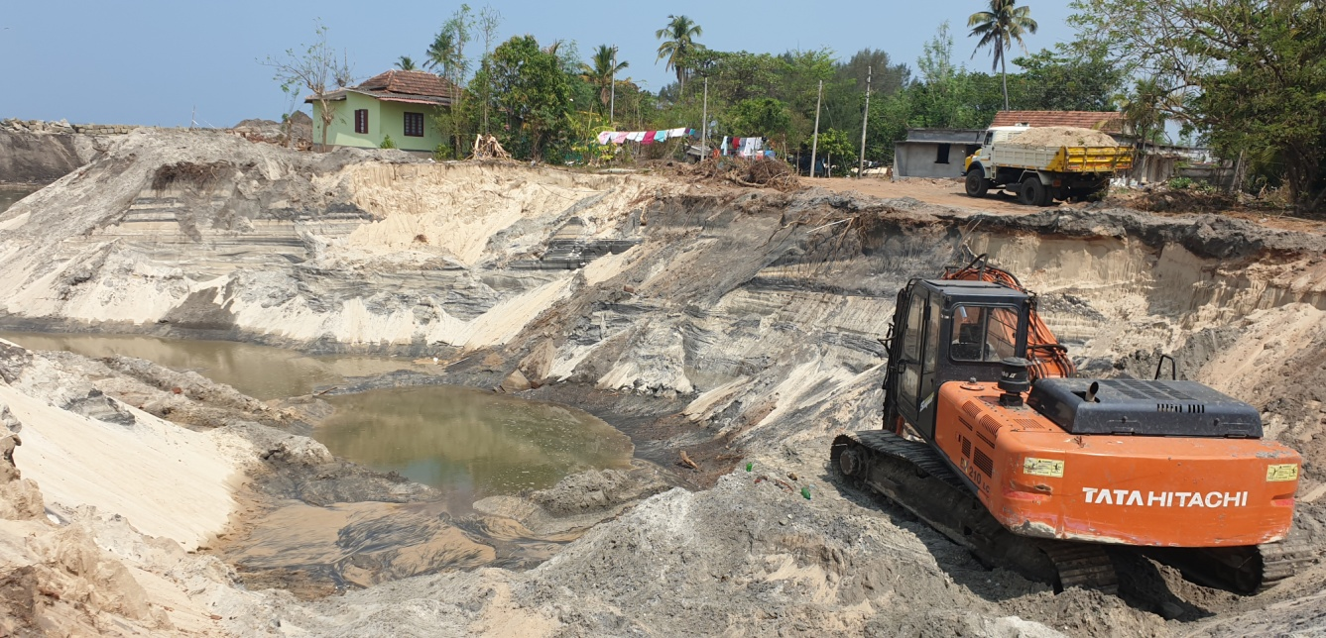

Fig : karithura mining area , Chavara

Chavara barrier beach with a width of 225 m is divided into 8 blocks numbered from i to vii for separating ilmenite for the manufacture of Tio2. The blocks are apportioned between Kerala Minerals And Metals Ltd(KMML) and IREL (India) Limited (IRE), A Government of India Enterprise under the Department of Atomic Energy.

**3.2 COLLECTION AND PREPARATION**

Since the area does not contains any harmfull toxic substance the sample was collected by showel as well as with bare hand. It was stored in a sack. As the further processes involves several steps such as washing and shell wash there exists a chance for the lose of a considerable amount of sample, so in order to meet all the requirement sufficient amount of sample was collected. The weight of the sample was approximately 20 kg. The sample collected was stored in a sack and transported to IRE Research Centre at Madakkal village, Kollam.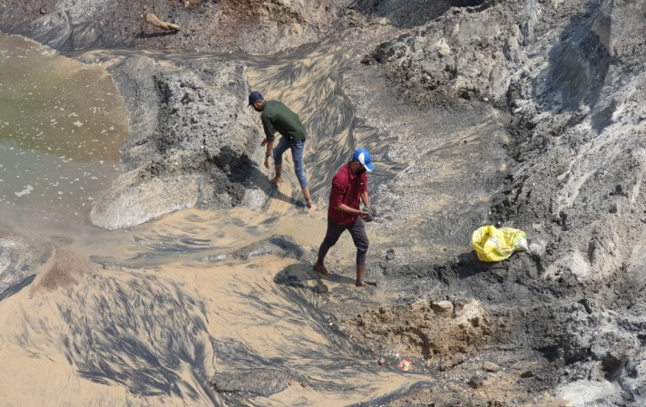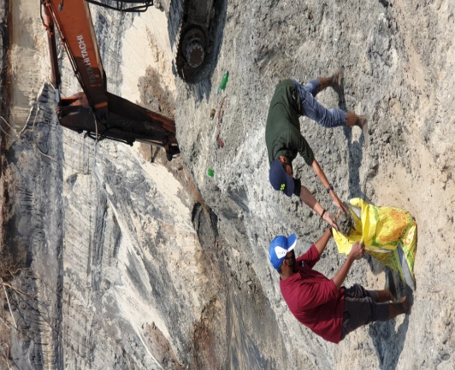

Fig :- sample collection

The bulk quantity of sample collected was washed in order to get rid of impurities and large shells. After washing the sample is stored in large trays and heated(as in picture below), so that it should become dry and suitable for further process.

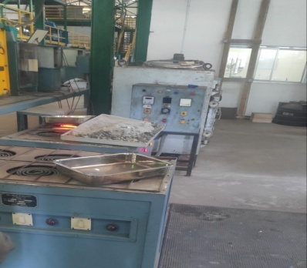

**Characterization of beach sand minerals.**

* 1. **SIZE ANALYSIS**

Particle size is an important physical property of minerals for understanding its  
origin as well as for classifying them in separation processes. Size analysis of the  
various products of a concentrator constitutes a fundamental part of laboratory  
testing procedure. The main purpose of size analysis is to determine the quality of  
grinding and in establishing the degree of liberation of the valuable minerals from  
the gangue at various particle sizes. In the separation plants, size analysis of the  
products is used to determine the size range at which any losses are occurring in  
the plant, so that they may be controlled. Particles size analysis has many  
applications in sedimentary rock classification, textural classification in petrology,  
provenance study etc. In the test sieving method standard test sieves are used to  
separate minerals into different size ranges. The aperture openings of these sieves  
are standardized as per standards like ASTM, BIS, ISS, and ISI etc. as shown  
below in the table. The sieve no e.g. ASTM 40 etc. is fixed based on the number of  
linear wires in an inch with standard thickness of sieve wire for each sieve no. The  
aperture openings are now mostly considered rather than the number.

**INSTRUMENT**: -Sieving-Shaking Machine

**AIM:** -Analysing sizes of the grain samples and interpreting the data

**APPARATUS**: -

1. Analytical Weighing Balance  
2. Test Sieves, mesh no: 40(420 micron), 50(297 micron), 70(210 micron), 100(149  
micron), 140(105 micron), 200(74 micron)  
3. Brush: A soft brush for brushing the underside of the sieves.  
Sample taken for sieving is 84.423g

**PROCEDURE:**

Take less than 100gm of moisture free sample by riffle sampling and weigh to 3  
decimals in an analytical weighing balance. The sieves are arranged with coarser sieves  
on top to the finer sieves to bottom and with the bottommost pan.  
Add samples to the topmost sieve, close with lid, keep the set on the sieve shaker  
and set time for 10min and amplitude 1.5mm and switch on the sieve shaker. after 10min  
the sieve shaker will stop. Take out the sieve set from the shaker. Remove and collect  
separately the samples in each sieve completely by careful brushing. Weigh each size  
fraction thus collected in an analytical weighing balance. Calculate the total weight,  
determine the loss weight to confirm less than 0.1%. calculate the weight percentage in  
each sieve, cumulative percentage of passing, cumulative percentage of retaining.  
The end point of the sieving process has been reached is considered when the  
quantity passing through the sieve or through any one sieve of a nest, in 1 min is less  
than 0.1 percent of the mass of the charge.  
In order to ensure that the sieving is complete (i.e. endpoint is achieved), the  
collected fractions are again placed in the same sieves from which it is collected and  
the full nest is further sieved for 1 minute at amplitude 1.5mm. The size fractions are  
again collected and weighed. If the difference in percentage between the initial and  
second sieving is less than 0.1% for at least one sieve, it is concluded that sieving is  
complete.  
**Note:**I. Shaking periods of less than 15 min may be acceptable. This would need to be  
established for particular material under particular sieving conditions using the  
procedure described above.  
ii. Care should be taken to ensure that any fine sieves are not damaged during  
brushing.

**Observation and Calculation**

Weight before size analysis = 96.332 g

Sieving Test:- 1

Amplitude = 1amp

Time = 10 min

Interval = 15 sec

|  |  |  |  |
| --- | --- | --- | --- |
| **SIEVE MESH NUMBER (ASTM)** | **m** | **WEIGHT OF SAMPLES IN SIEVE** | **WEIGHT PERCENTAGE** |
| **+50#** | **300** | **20.089 g** | **20.88 %** |
| **-50#+70#** | **212** | **20.951 g** | **21.78 %** |
| **-70#+120#** | **125** | **45.262 g** | **47.04 %** |
| **-120#+140#** | **106** | **5.936 g** | **6.17 %** |
| **-140#+200#** | **75** | **3.681 g** | **3.83 %** |
| **-200#** |  | **0.304 g** | **0.32 %** |
| **Total** |  | **96.233** | **100.00%** |

SIEVING TEST**: - 2** (For determination of End Point of sieving)

Amplitude – 1.5 amp

TIME – 1 min.

Interval – 15 sec

|  |  |  |  |  |  |
| --- | --- | --- | --- | --- | --- |
|  |  |  | |  |  |
| **Mesh** | **m** | **Wt. (gm)** | **Wt. %** | **Cumulative passing %** | **Cumulative retaining %** |
| +50# | 300 | 20.034 | 20.82 | 79.18 | 20.82 |
| -50+70# | 212 | 20.900 | 21.72 | 57.46 | 42.54 |
| -70#+120# | 125 | 45.313 | 47.10 | 10.36 | 89.64 |
| -120#+140# | 106 | 5.965 | 6.20 | 4.16 | 95.84 |
| -140#+200# | 75 | 3.699 | 3.84 | 0.32 | 99.68 |
| -200 |  | 0.305 | 0.32 |  |  |
| **Total** |  | **96.216** | **100** |  |  |
|  |  |  |  |  |  |

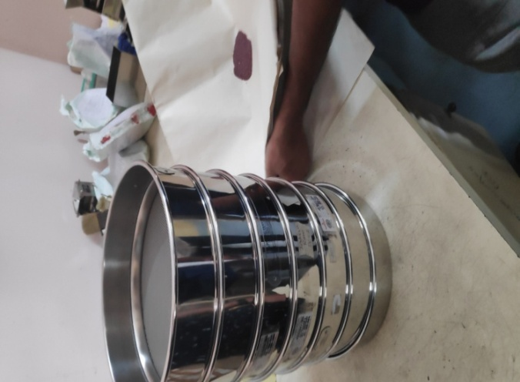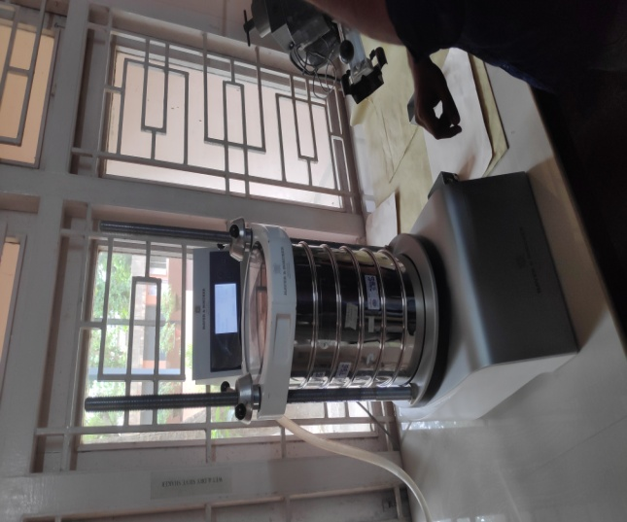

a : Test Seives b : Sieving Shaking Machin

4.2 DETERMINATION OF SHELL CONTENT IN THE SAMPLE

**AIM: -**

**To determine the shell content in the sand sample**

**APPARATUS: -**

1. Analytical Weighing Balance. For weighing fine aggregates, a balance having a capacity of about 100 g, sensitive to at least 0·001g.

2. Hot Air Oven: For drying of mineral sand sample. Temperature range required 80°C to 100°C (+10°C)

3. Containers/Glass beakers: suitable for drying the aggregate samples and containers suitable for holding the acid.

4. Whatman no. 4 or equivalent filter paper- 185 mm diameter circular.

5. Stirring rod.

**CHEMICALS USED**

1. Dil. HCl- 1:1. Commercial / Laboratory reagent grade.

**WORKING PRINCIPLE**

When a sample containing shell, which is essentially CaCO3 or MgCO3is treated with Dil. HCl, 𝐶𝑎𝐶𝑙2 or MgCl4& CO2 is formed. The un-dissolved mineral residue is washed and percent of shells determined based on loss of weight.

**EXPERIMENT**

A sample weigh less than 50g was taken in glass beaker and poured sufficient amount of dil. HCl(80% of water and 20%con.HCl) to it. Stir the contents with glass rod till CO2 effervescence stop and then dilute the liquid with water and decant minimum solution without loss of sample. After that Filtered the contents through a Whatman No.4 Filter paper and wash the residue thoroughly with water. For removing the water content, the filter paper with the contents along with the funnel is placed in a hot air oven. When it is completely dry take out from oven and cool. Weigh the residue and place the residue back in the oven to ensure complete removal of moisture. Take the residue from the oven, cool& weigh and percentages are calculated.

**OBSERVATION AND CALCULATION**

**Initial weight of the sample = 49.890 g**

**Weight after shell wash = 47.986 g**

**Loss of weight in grams = 1.904 g**

**Weight percentage of the mineral content**

=(weight of the mineral residue fraction /weight of the sample taken for shell wash )*100

=(47.986/49.890)*100

=96.18%

**Weight percentage of shell = 100– mineral content %**

= 100 – 96.18

= 3.82%

**RESULT**

**The total percentage of shell content in the sample taken is 3.8 %**

**4.3. HEAVY MEDIA SEPARATION**

**AIM**: - Determination of Heavy Mineral content in Beach sand sample.

**APPARATUS: -**

1. Analytical Weighing Balance. For weighing fine aggregates, a balance having a capacity of about 100 g, sensitive to at least 0·001 g.

2. Conical shaped Separating funnel: Capacity 250ml with rubber hose at bottom and pinch cock stopper clip.

3. Hot Air Oven: For drying of Heavy and light fractions after washing with acetone or ethyl alcohol. Temperature range required 80°C to 100°C (+5°C)

4. Containers/Glass beakers: suitable for drying the aggregate samples and containers suitable for holding the heavy liquid and washings after the sink-float separation.

5. Whatman no. 4 or equivalent filter paper- 185 mm dia circular.

6. Stirring rod.

**CHEMICALS/ REAGENTS**

1) Heavy Liquid**-** Bromoform (Specification: Density 2850kg/m2. (Specific gravity 2.85- for separation of minerals) or Tetrabromoethane (Specification: Density 2960kg/m2 (Specific gravity 2.93)

2) Ethyl Alcohol or Acetone – Commercial/Laboratory grade or suitable to wash and remove the heavy liquid from sand.

NOTE: -The heavy minerals comprises those minerals with a density greater than 2850kg/m2 (Specific Gravity 2.8) and light minerals comprises those minerals with a density of less than 2850kg/m2 (Specific Gravity 2.8).

**WORKING PRINCIPLE**

Separation of minerals in heavy liquids is based on differences in density between associatedminerals. A suitable heavy liquid is chosen with a density such that the desired mineral or minerals sink in the liquid while the unwanted lighter density minerals float.

**EXPERIMENT**

For the heavy mineral identification samples weigh about 47.986 g and was taken for the bromoform test. First take 200ml of bromoform in a funnel and Slowly pour the test portion into the heavy liquid in the funnel. Stir the mixture continuously with the stirring rod, when the test portion is being poured into the funnel and after pouring the sample. Rinse the stirring rod and the walls of the funnel with the heavy liquid. Once a clear separation is obtained between sink and float, Drain the heavy mineral (sink) plus the heavy liquid in to a Whatman no. 4 filter paper placed in a funnel with beaker for collection of drained heavy liquid and sink. While draining the sink fraction the pinchcock should be carefully released so that only the settled heavy minerals are released to the collecting funnel leaving behind the floating fraction and minimum 20 ml of the heavy liquid. Add further heavy liquid to separating funnel to top up to original level, stir rinse, allow the mixture to stand for clear separation of sink & float is obtained. Again, drain the sink to filter paper. Repeat the above process until no sink fraction remains. Remove the funnel with sink fraction collected in the filter paper. Remove the funnel with sink fraction collected in the filter paper. Drain the remaining heavy liquid present in the separating funnel along with float fraction into a separate filter paper. Wash the sink and float fractions using Ethyl Alcohol or Acetone till entire heavy liquid is washed down. Transfer the washed fractions to Hot Air Oven set at about 80°C for drying.

**CALCULATION**

**Weight of the sample before HM = 47.986g**

**Weight of sample after HM =27.514 g**

**Weight of light minerals = 20.472 g**

**Total mineral content = Heavy mineral content % + Light mineral content %**

**Heavy minerals percentage=(**𝒘𝒆𝒊𝒈𝒉𝒕 𝒐𝒇 𝒕𝒉𝒆 𝒉𝒆𝒂𝒗𝒚 𝒎𝒊𝒏𝒆𝒓𝒂𝒍𝒔 /𝒕𝒐𝒕𝒂𝒍 𝒘𝒆𝒊𝒈𝒉𝒕 𝒐𝒇 𝒕𝒉𝒆 𝒔𝒂𝒎𝒑𝒍𝒆)*100

**= (27.514/47.986)*96.18**

= 55.14%

**Light minerals percentage = 100-HM %**

**=**96.18-55.14

=41.04%

**RESULT: -**

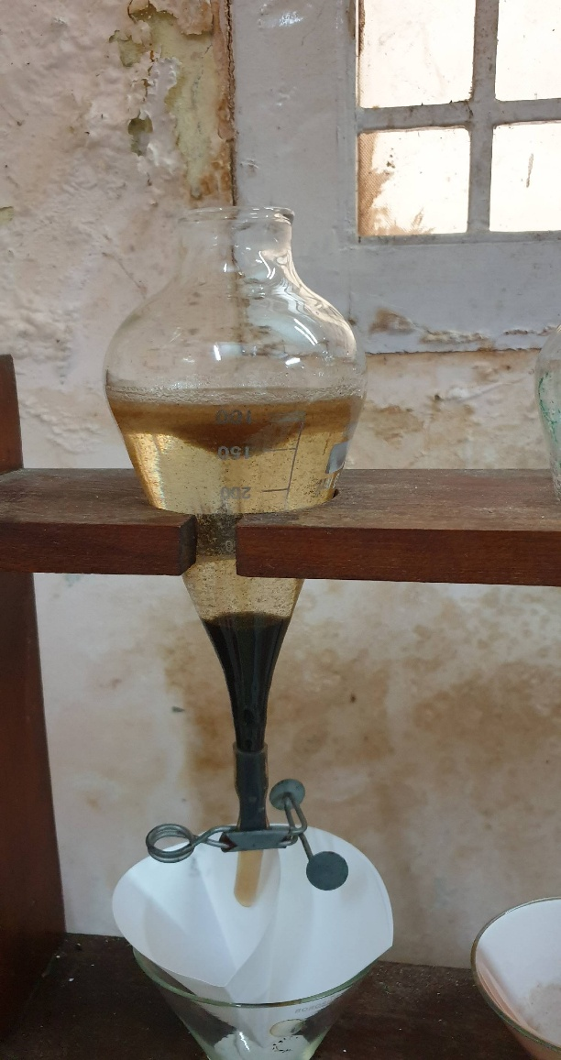**The percentage of heavy minerals in the sample is 55.14%**

**Fig ;** Heavy media separation usingHeavy Liquid**-** Bromoform

**4.4. DETERMINATION OF MAGNETIC MINERALS FROM THE HEAVY MINERALS**

**AIM: - Determination of Magnetic Minerals**

**EQUIPMENTS/APPARATUS:**

1. a) Analytical Weighing Balance. For weighing fine aggregates, a balance having a capacity of about 100 g, sensitive to at least 0·001 g.
2. b) Laboratory Magnetic Separator or G Frantz Lab Magnetic Separator is suitable for Ilmenite separation.

**PRINCIPLE:**

When a sample containing mixture of magnetic and non-magnetic minerals are brought near to a hand magnet, the magnetic particles are attracted and held on to the magnet. The non-magnetic minerals are left unattached and are removed.

**PROCEDURE**

Switch on the magnetic separator and set the low field control and range switch to high. Turn the voltage potentiometer to maximum and turn the current potentiometer to .8 amps to magnetize the separator to required intensity for separation of 100% ilmenite to magnetic fraction. Introduce the sample, once the sample is complete, remove the non magnetic fraction and repass to the machine. Demagnetize the machine and run the chute vibration to remove any magnetic minerals attached and collect the magnetic fraction as “mag 1”, and non magnetic fraction is passed again under the condition of 1.4 amps ,once the sample is complete ,demagnetize ,then the resultant magnetic fraction obtained is “mag 2”. The remaining portion in “non mag”.

**CALCULATION**

**Weight % of Heavy Mineral after HM Seperation = 55.14%**

Weight of mag 1 = 10.090 g

Weight of mag 2 = 0.294 g

Weight of non mag = 3.468 g

Total weight = 13.852 g

Weight % of mag 1 = (weight of mag1 /total weight) * 55.14

= 40.16 %

Weight % of mag 2 = ( weight of mag 2 /total weight) * 55.14

= 1.17 %

Weight % of non mag = ( weight of non mag /total weight )* 55.14

= 13.81 %

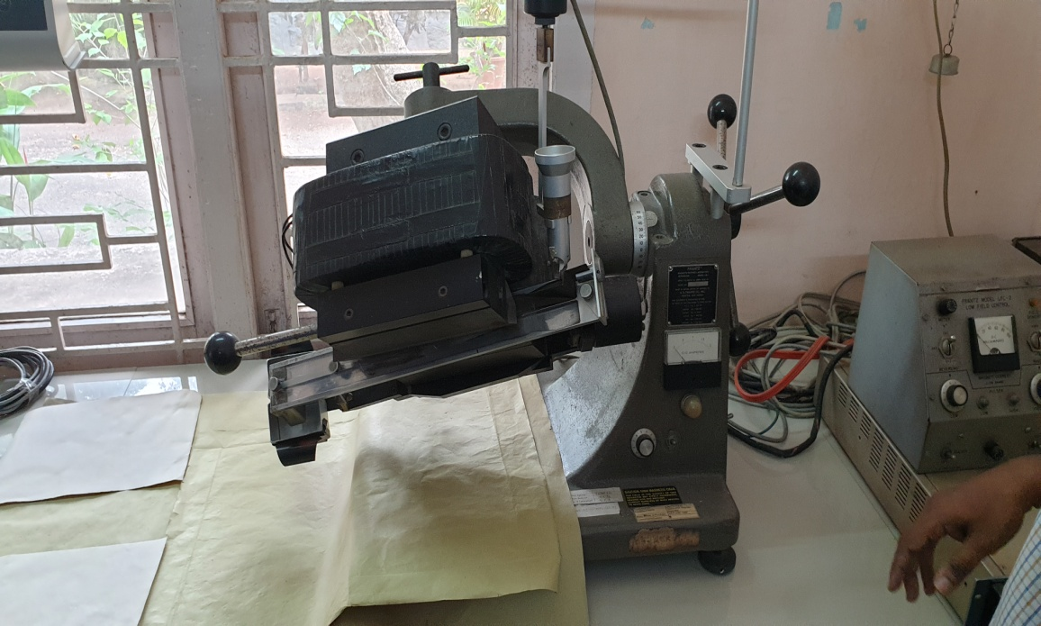

## Fig : Laboratory Magnetic Separator or G Frantz Lab Magnetic Separator

**4.5 MICROSCOPIC ANALYSIS OF FEED SAMPLE**

**INSTRUMENT:** - Optical Microscope

**AIM: -**To conduct grain counting analysis.

The **optical microscope**, often referred to as the "**light microscope**", is a type of microscope which uses visible light and a system of lenses to magnify images of small samples. Optical microscopes are the oldest design of microscope and were possibly invented in their present compound form in the 17th century. Basic optical microscopes can be very simple, although there are many complex designs which aim to improve resolution and sample contrast.

The image from an optical microscope can be captured by normal light-sensitive cameras to generate a micrograph. Originally images were captured by photographic film but modern developments in CMOS and charge-coupled device (CCD) cameras allow the capture of digital images. Purely digital microscopes are now available which use a CCD camera to examine a sample, showing the resulting image directly on a computer screen without the need for eyepieces.

Alternatives to optical microscopy which do not use visible light include scanning electron microscopy and transmission electron microscopy.

**PARTS AND FUNCTION: -**

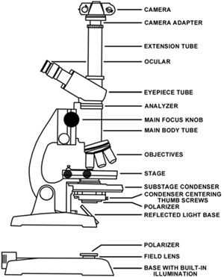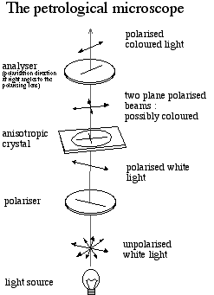

* **Light source-** provides light into the microscope for viewing. Usually an electric bulb or a two sided (plane & concave) mirror.
* **Polarizing unit 1 –** This converts normal light into plane polarized light & is situated below the microscope.
* **Condenser System –** This removes the effects of interference of light by changing the phase of light.
* **Diaphragm Lever –** This lever is used to control the intensity of light.
* **Microscopic Stage –** This is a graduated, rotatable disk on which the thin sections are mounted for viewing purposes.
* **Objective –** This contains several objective lenses of different magnifying power that can be selected.
* **Slot –** the slot is used to insert accessory plates for different viewing purposes.
* **Analyzer (polarizing unit 2) –** This is also a light polarizing unit. However, the plane of polarization is perpendicular to that of the polarizing unit that is situated below the microscope stage. This can be set in either “in” or “out”.
* **Bertrand lens: -**This is a special lens system that is used to be observe interference figures. This too can be set in either “in or “out” position, the view seen from the eyepiece is smaller.
* **Eyepiece-**This the lens through which is the observer views the thin section. It has a circular view with center cross-hairs to help viewing.

The petrological microscope can be set up in two arrangements depending on viewing purposes and optical properties of the minerals. They are,

1. PPL arrangement (Plane Polarized Light)-analyzer is out, Bertrand lens out.
2. CPL arrangement (Cross Polarized Light)-Analyzer is in Bertrand lens is out

|  |  |  |  |  |  |  |  |  |  |
| --- | --- | --- | --- | --- | --- | --- | --- | --- | --- |
| GARNET | TRANSPARENT | ANGULAR | NONE | COLOURLESS  LIGHT GREEN , RED | CRACKS,  INCLUSIONS  CONCOIDAL SURFACE | HEDIUM  G>Si | ISOTROPIC |  |  |

**EXPERIMENT:-**

* FEED PREPARATION

The preparation of the feed sample for testing under microscope is done by the cone sampling method.

### *Coning and quartering*

Coning and quartering is a method used by analytical scientists to reduce the sample size of a powder without creating a systematic bias. The technique involves pouring the sample so that it takes on a conical shape, and then flattening it out into a cake. The cake is then divided into quarters; the two quarters which sit opposite one another are discarded, while the other two are combined and constitute the reduced sample. The same process is continued until an appropriate sample size remains. Analyses are made with respect to the sample left behind.

* *Preparation of slide*

For preparation of the slide we need, one glass slide, clove oil, 1needle, and optic cover glass22m. We have taken required amount of clove oil on the slide and spread it with the help of the needle. Then poured the small amount of sample on that oil and spread it by the needle. Due to the oil the sample is clotted on the slide with the help of the small fiber cover glass. We covered the sample. In this way the slide is prepared. By putting the slide under the microscope we have identified the minerals like Magnetite, Ilmenite, monazite, leucoxene, garnet zircon...etc. based on the optical properties of those minerals.

The next step after the mineral identification is the grain count.

MODAL GRAIN COUNTING ANALYSIS

In this process we have counted the number of each type of grains of different minerals present in the total slide. For this the mineral grains touching the horizontal or vertical cross line in the field of vision of microscope is counted in a traverse. After completing one traverse subsequent traverses are taken at equal distance on the microscope stage. The entire slide is covered in this way and the total count of each mineral is determined.

**OBSERVATIONS:-**

The obtained Magnetic and Non magnetic fractions ( in % ) through Frantz Lab Magnetic Barrier Separator was analysed as per procedure given above. The counts received for each fraction and the calculations aregiven below.–

* M-1 = 40.16 %
* M-2 = 1.17 %
* NM = 13.81 %
* Total Heavy Mineral Percentage = 55.14 %

M-1 and NM fractions sieved in 80 Mesh (180 Microns) for better accuracy.

M-1 +80#(+180 Mic)=10.78%

M-1 -80#(-180 Mic)=29.38%

NM +80#(+180 Mic)=6.01%

NM -80#(-180 Mic)=7.80%

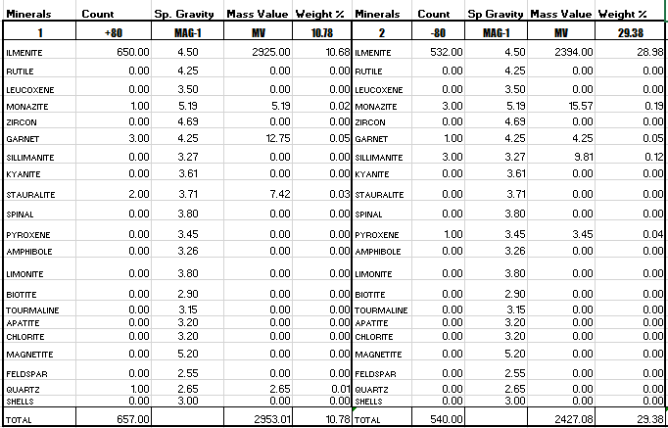

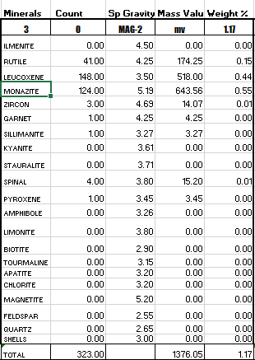

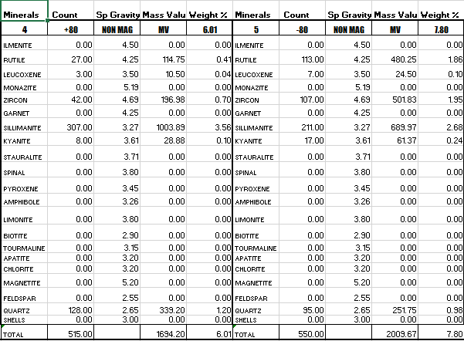

**CONCLUSION**

Thus, the consolidated mineralogical analysis of feed sample tested through Heavy Media Separation, Magnetic Separation and Microscopic Analysis is given below.

|  |  |  |
| --- | --- | --- |
| ***No.*** | ***Minerals*** | ***Total Weight (%)*** |
| 1 | Ilmenite | 39.7 |
| 2 | Rutile | 2.4 |
| 3 | Leucoxene | 0.6 |
| 4 | Monazite | 0.8 |
| 5 | Zircon | 2.7 |
| 6 | Garnet | 0.1 |
| 7 | Sillimanite | 6.4 |
| 8 | Kyanite | 0.3 |
| 9 | Shells | 3.8 |
| 10 | Lights | 43.2 |
| TOTAL | | 100.0 |

**SEPARATION OF BEACH SAND M INERALS.**

**5.1 SEPERATION OF COMMERCIAL GRADE RUTILE AND SILLIMANITE RUTILE;** This mainly consist of TiO2 (96.4%). It is an important constituent of beach sand resulting from denudation of Rutile bearing rocks as in Australia, Florida and India.Uses: - The Rutile is used in ceramic mixture to improve acid resistance, opacity, to impart cream colour to pottery bodies and glasses, manufacture of electric insulators and welding electrodes. Also used for the production of Titanium Dioxide and Titanium Tetrachloride HIGH TENSION ROLL SEPERATORPRINCIPLE: - conductivity of minerals. High tension separator is used for the separation of materials of different surface conductivities **AIM: -** Separation of Rutile from beach sand minerals. **PROCEDURE**:Dry samples are required and should be preheated to around 100 to 120°C. Samples may be preheated over a hot plate, gas burner or oven. This sample is put into the feed lip. When the particles exit the feed lip they are quickly charged by the corona field. Conductor mineral quickly discharge and are attracted toward the plate electrode with the assistance of the centrifugal force generated by the rotational speed of the separation roll. The plate electrode assists conductor mineral to follow trajectories across the conductor splitter and report to the conductor product chute. Non-conductors, still held onto the roller by the residual charge, are dislodged by the brush behind the non-conductor splitter. These non-conductors then travel directly to the non-conductor product chute. There are several additional factors that influence separation. These include temperature of the feed material, feed size and feed rate, speed of the separation roller, voltage applied to the corona and plate electrodes, relationship between the corona and electrodes to the separation roller and polarity of the power supply to the corona and electrodes.

**SILLIMANITE**

This is Aluminium silicate (Al2SiO3). Indian Sillimanite contains 58-60% Al2O3.

**Uses: -** It is mainly used in the manufacture of high temperature refractories and ceramic industries.

**Froth Flotation**

* Froth flotation is a process for selectively separating hydrophobic materials from hydrophilic. This is used in mineral processing.
* It has been described as "the single most important operation used for the recovery and upgrading of sulfide ores.
* The development of froth flotation has improved the recovery of valuable minerals, such as copper and lead-bearing minerals

**Procedure**

Take 500 ml of water and mix it with separated samples and add 6 ml of sodium silicate solution.

Take 5 minute break, allow unwanted minerals to settle down.

For froth flotation, an aqueous slurry the ground ore is treated with the frothing agent.

Here we use Olic acid as frothing agent.

The particles are brought to the water surface by air bubbles. About 300 g/tonne of ore is required for efficient separation.

Aqueous solutions with pH=7–11 are normally used in the process. This slurry (more properly called the *pulp*) of hydrophobic particles and hydrophilic particles is then introduced to tanks known as *flotation cells* that are aerated to produce bubbles. The hydrophobic particles attach to the air bubbles, which rise to the surface, forming a froth. The froth is removed from the cell, producing a concentrate ("con") of the target mineral.

Here the targeted mineral is Sillimanite .

The minerals that do not float into the froth are referred to as the *flotation tailings* or *flotation tails*.

## SEPARATION OF BEACH SAND MINERALS IN BULKQUANTITY

### INTRODUCTION

Beach sand contain valuable and non-valuable minerals. Valuable minerals include Ilmenite, Rutile, Zircon, Monazite, Sillimanite, Garnet and Leucoxene and nonvaluable minerals include Quartz, and minor content of Staurolite, Spinal, Pyroxenes, Amphiboles etc.Separation techniques based on the physical characteristics of minerals such as size, specific gravity, magnetic, electrical and surface tension. Processing equipment’s functioning based on these principles are developed and utilized in the production plants.

#### 1.Gravity Separators

#### 2. Electrostatic Separators

#### 3.Magnetic Separators

**4.Froth Flotation**

Combination of these equipment’s are used for achieving the desired purity and recovery of valuable minerals.

### 5.2GRAVITY SEPARATION

#### PRINCIPLE: -

Gravity Concentration may be defined as the separation of two or more minerals, usually of different specific gravity, by their relative movement in response to the force of gravity and one or more other forces, one of which is generally the resistance to motion by a viscous fluid such as water.

Factors which are important in determining the relative movement include the weight, size, shape, and density of the particle, not only in absolute terms, but relative to all other particles. If, in a hypothetical two mineral separations, any one of these factors is significantly different, but all others are the same, separation is relatively easy. In nearly every case, however, there will be a range of particle weight, size and shape: the ease or difficulty of separation of one species from another will depend on the relative differences in these factors, and whether such differences assist or oppose separation.

**SPIRAL SEPERATOR**

The term spiral separator can refer to either a device for separating slurry components by density (*wet spiral separators*), or for a device for sorting particles by shape (*dry spiral separators*).

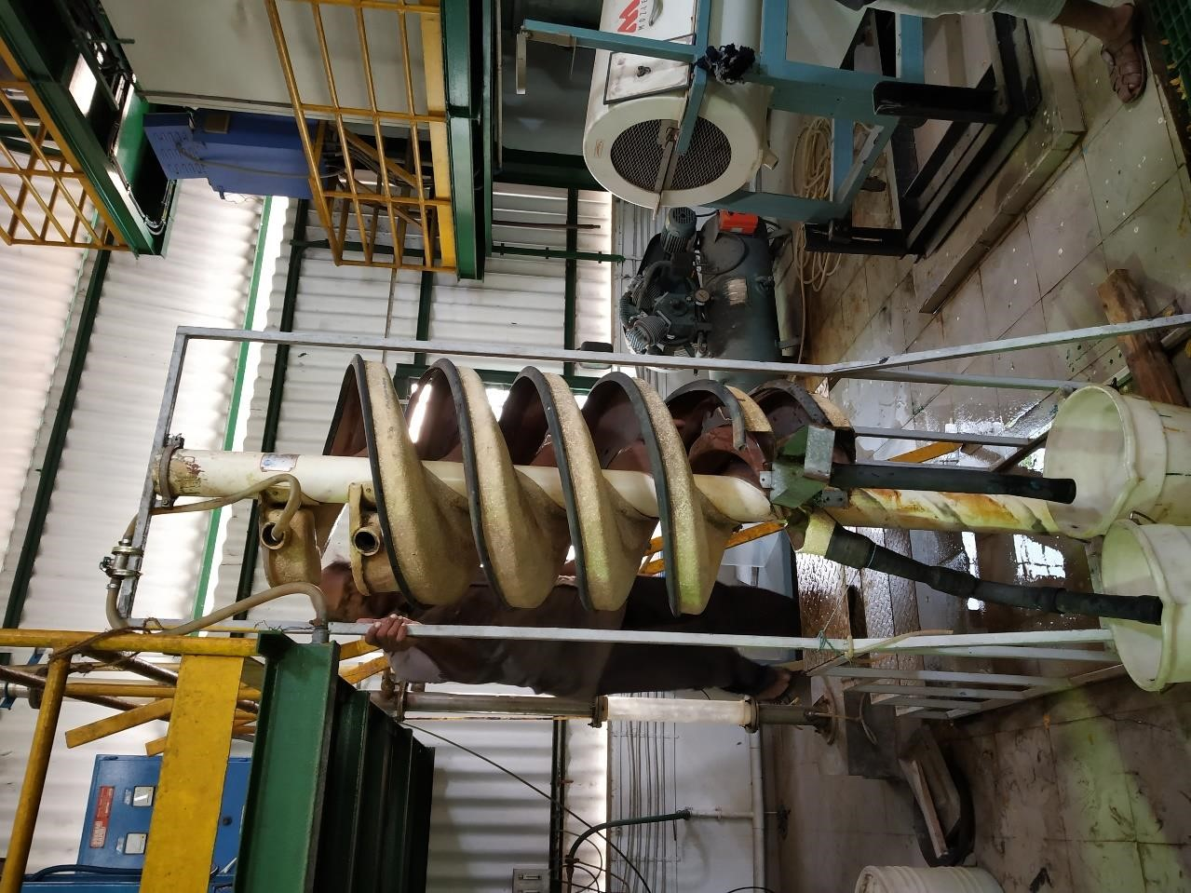

**INSTRUMENT**: -MG6.3 wet Spiral Separator

#### PRINCIPLE: -

Spiral separators of the wet type, also called spiral concentrators, are devices to separate solid components in a slurry, based upon a combination of the solid particle density as well as the particle's hydrodynamic properties (e.g. drag). The device consists of a tower, around which is wound a sluice, from which slots or channels are placed in the base of the sluice to extract solid particles that have come out of suspension. As larger and heavier particles sink to the bottom of the sluice faster and experience more drag from the bottom, they travel slower, and so move towards the centre of the spiral. Conversely, light particles stay towards the outside of the spiral, with the water, and quickly reach the bottom. At the bottom, a "cut" is made with a set of adjustable bars, channels, or slots, separating the low- and high-density parts. Many things can be done to improve the separation efficiency, including:

* changing the rate of material feed
* changing the grain size of the material
* changing the slurry mass percentage
* adjusting the cutter bar positions
* running the output of one spiral separator (often, a third, intermediate, cut) through a second.
* adding wash water inlets along the length of the spiral, to aid in separating light minerals
* adding multiple outlets along the length, to improve the ability of the spiral to remove heavy contaminants
* adding ridges on the sluice at an angle to the direction of flow

NOTE:

* Finer size particles tend to flow into concentrates which may also include the light finer particles.
* Coarser size particles tend to flow in to the tails which may also include the heavy coarser particles.

**MG 6.3 SPIRAL SEPARATOR-DESIGN DATA**

Head feed(per start)

|  |  |
| --- | --- |
| Capacity :upto 4 t/h per start (tyoically 2.0 to 3.0 t/h/start)   |  | | --- | |  | |
| Pulp density: 25 to 60% solids(typically 25 to 40%) |
| Size range :0.02 to 2.0 mm (0.04 to 0.7 for optimal separation ) |
| Pulp volume:up to 8 m3 /h per start slurry volume(typically 4 to 6 m3/h/start) |

**PARTS OF SPIRAL** ➢**The Trough:**

This is an elliptical structure that goes through the length of the spiral. The material of construction is mainly fibre glass coated with Polyurethane. However mild steel or alloy steel can also be found in some models

➢**Feed Box:** Head feed to the spiral fist enters the feed box. The feed box reduces the velocity of the incoming slurry and establishes the correct pattern of flow. It further helps slurry to enter as a homogeneous mixture. The feed box is mainly made of polyurethane material.

* **Centre Column:**

The centre column of the spiral acts as a support for the helical trough. It helps to maintain verticality of the spiral. In some spirals it also duals as a super concentrate collector.

* **Repuler:**

The centre column of the spiral acts as a support for the helical trough. It helps to maintain verticality of the spiral. In some spirals it also duals as a super concentrate collector.

* **Diverters:**

Just above the splitters, diverters are kept which normally extends from the spiral centre to outwards. These help in freeing the interlocked gangue materials from the concentrate.

* **Swirl Chamber:**

Just before the feed goes to the distributor it passes through the swirl chamber. This swirl chamber has curved vanes. These curved vanes help to distribute the pressure radially thereby minimizing the impact on top cover of distributor and guide homogeneous slurry to distributor outlet.

##### ➢Distributer

The distributor distributes the feed to all spirals equally. These are classified into two, Pressure distributor & Gravity distributor.

##### ➢Splitter

They can be classified into product & auxiliary splitters. Product splitters are located at the base of spiral trough and Auxiliary splitters are located at 2nd,4th& 6th in MDL spirals & 2nd,3rd &4th in Humphrey’s spiral. These splitters are used for tapping concentrate, middling & tails from spiral trough

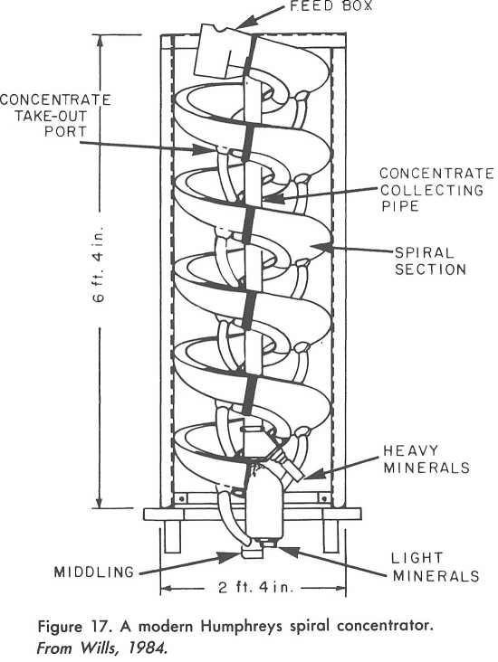

**Fig 5.2; Wet Spiral Separator**

**PROCEDURE**

Around 29.626kg sample is feeded to spiral separator along with water.At the bottom,by adjusting the cutter,separate the heavier and lighter parts of slurry.Heavier particle is collected as “**concentrate**” and lighter particles is collected as “**tailings”** .and they separately dried and measure the weight of concentrate and tailings.

**CALCULATION:**

**Weight of the feed=29626g**

**Weight of the concentrate=12637g**

**Weight of the tailings=14186g**

### 5.3. ELECTROSTATIC SEPARATION

#### HIGH TENSION ROLL SEPARATOR(400dia.)

**PRINCIPLE**: - conductivity of minerals

High tension separator is used for the separation of materials of different surface conductivities. If one or more of the materials in a granular mixture can receive a surface charge on or before entering an electrostatic field, the grains of the material will be repelled from one of the electrodes and attracted towards the other, depending upon the sign of the charge on the grain. The fine wire in electrode assembly of HTRS develops discharge field, whereas electrode gives non-discharge static field. the separation is achieved by a combination of three predominant forces, centrifugal force, electrostatic force and the secondary electrical field between the rolling drum and the electrode.

|  |  |
| --- | --- |
| **MINERAL** | **ELECTRICAL CONDUCTIVITY** |
| ILMENITE | CONDUCTING |
| RUTILE | CONDUCTING |
| LEUCOXENE | CONDUCTING |
| MONAZITE | NON-CONDUCTING |
| ZIRCON | NON-CONDUCTING |
| GARNET | NON-CONDUCTING |
| SILLIMANITE | NON-CONDUCTING |
| KYANITE | NON-CONDUCTING |
| QUARTZ | NON-CONDUCTING |

Table 5.1 Electrical conductivity of minerals

#### PARTS OF HIGH-TENSION ROLL SEPARATOR

##### ➢Voltage controller

The voltage to the electrodes is controlled by the multi-turn potentiometer on the control panel and the voltage is displayed on the meter. The input voltage is typically set at 26KV.

##### ➢Splitters

The splitters separate the samples to different chute, the splitters movement extends from a position behind the roller and just in front of the brush. Splitters allows the cleanest non-conductors to be generated, to a position out in front of the roller where a very clean conductor product can be taken.

##### ➢Feed Rate Controller

Feed rate is adjusted by varying the rotational speed of the feeder roll via the variable speed drive (VSD). The feeder roll speed is displayed in rpm. Feed rate affects the performance of the separator due to inter particle hindrance, which increases as feed rate is increased.

##### ➢Corona Wire Electrode

Corona wire positioned with a 60mm gap at the top dead centre of the roll with an applied voltage of 26KV.

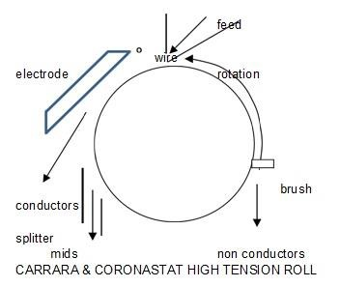

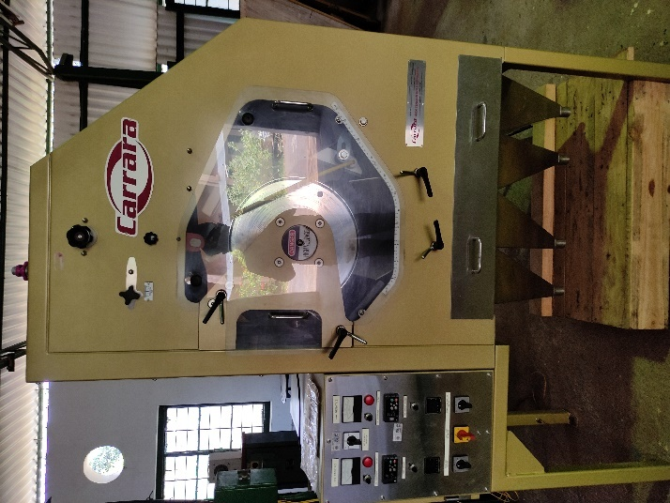

**HTRS(400dia.)-DESIGN DATA**

|  |  |
| --- | --- |
| Capacity : up to 450kg/h | Separator dimension(mm) :1400wide*900deep*2000high |
| moisture content :dry,free-flowing | Separator weight :420 |
| size range :40 to 800microns | Power consumption :08 |
| Feed temperature :up to 1200c |  |

**AIM: -** Separation of Ilmenite from beach sand minerals

**PROCEDURE**:

Dry samples are required and should be pre heated to around 100 to 120°C. Samples may be preheated over a hot plate, gas burner or oven. This sample is put into the feed lip. When the particles exit the feed lip they are quickly charged by the corona field. Conductor mineral quickly discharge and are attracted toward the plate electrode with the assistance of the centrifugal force generated by the rotational speed of the separation roll. The plate electrode assists conductor mineral to follow trajectories across the conductor splitter and report to the ṁṁṁconductor product chute.

Non-conductors, still held onto the roller by the residual charge, are dislodged by the brush behind the non-conductor splitter. These non-conductors then travel directly to the non-conductor product chute.

There are several additional factors that influence separation. These include temperature of the feed material, feed size and feed rate, speed of the separation roller, voltage applied to the corona and plate electrodes, relationship between the corona and electrodes to the separation roller and polarity of the power supply to the corona and electrodes.

#### EXPERIMENT

-Sample weigh about 12.63Kg was taken for the experiment. Sample heated up to 120ºC and this sample passed to the feed lip. The sample is subjected to pass through the HTRS samples will be obtained in four fractions as pure conducting(C), middling one (M1), middling two(M2) and non-conducting(NC). The experiment was carried out two times by refeeding the M1&M2 portions together until the non-conducting fraction becomes pure.

#### OBSERVATION AND CALCULATION

**HTRS - 1**

Quantity of sample taken = 12.63Kg

Temparature=1200c

Voltage=25KW

RPM=110

|  |  |  |
| --- | --- | --- |
|  | WEIGHT | WEIGHT% |
| CONDUCTING | 6620g | 53.27% |
| MIDDLING(M1+M2) | 2559g | 20.59% |
| NON CONDUCTING | 3248g | 26.14% |

-Non-conducting fraction which is heated to1000c is again passed to HTS for accurate separation between conducting and non-conducting fractions. A small portion of nonconducting samples were taken for heavy media separation at the end of experiment to analyse the nonconducting heavy mineral(mainly sillimanite) percentage in the nonconducting portion.

Flowchart of Experiment HTRS-2

Feed-NC from HTRS-1

RPM-180

TEMP-1000C

ROLL SPEED=150rpm

TEMP= 1000C

VOLTAGE=25kw

CONDUCTING

**OBSERVATION AND CALCULATION**

**HTRS-2**

|  |  |
| --- | --- |
|  | WEIGHT |
| CONDUCTING | 1763g |
| MIDDLING(M1+M2) | 500g |
| NON CONDUCTING | 687g |

**HEAVY MEDIA SEPARATION**

Weight before HM =24.396g Weight % of heavy media=56.44%

Weight after HM =13.770g Weight % of lites=43.56%

5.4 MAGNETIC SEPARATION OF BEACH SAND MINERALS

Magnetic separat**ion** is the process of separating components of mixtures by using magnets to attract magnetic materials. The process that is used for magnetic separation detaches non-magnetic material with those that are magnetic. This technique is useful for not all, but few minerals such as Ferromagnetism/ferromagnetic (materials strongly affected by magnetic fields) and Paramagnetic (materials that are less affected) but the effect is A large diversity of mechanical means are used to separate magnetic materials.During magnetic separation, magnetsare situated inside two separator drums which bear liquids. Due to the magnets, magnetic particles are being drifted by the movement of the drums.

PRINCIPLE OF MAGNETIC SEPARATION: -

The principle of operation of magnetic separation devices is the interaction between magnetic forces and competing gravitational, hydrodynamic, and interparticle forces within the magnetic separator.

➢Ferromagnetic- Certain metallic materials possess a permanent magnetic  
moment in the absence of an external field, and manifest very large andpermanent magnetizations. These are the characteristics of ferromagnetism E.g.  
- magnetite, Ilmenite

➢Paramagnetic- Para magnetism is a form of magnetism whereby certain  
materials are attracted by an externally applied magnetic field and form internal  
induced magnetic fields in the direction of the applied magnetic field. In contrast  
with this behaviour, diamagnetic materials are repelled by magnetic fields and  
form induced magnetic fields in the direction opposite to that of the applied  
magnetic field. Paramagnetic materials include most chemical elements and  
some compounds; they have a relative magnetic permeability greater than or  
equal to 1 (i.e., a positive magnetic susceptibility) and hence are attracted to  
magnetic fields. The magnetic moment induced by the applied field is linear in  
the field strength and rather weak. Paramagnetic materials include magnesium,  
molybdenum, lithium, and tantalum.

➢Diamagnetic- Diamagnetism is a very weak form of magnetism that is not  
permanent and persists only while an external field is being applied. It is induced  
by a change in the orbital motion of electrons due to an applied magnetic field.  
The magnitude of the induced magnetic moment is extremely small, and in a  
direction opposite to that of the applied field. Diamagnetic materials are  
attracted toward regions where the field is weak. E.g. Bismuth, quartz

➢Nonmagnetic- The minerals having no magnetic properties - they are said to be  
non-magnetic. In these materials, the magnetic fields of the individual atoms are  
randomly aligned. E.g. Serpentine

RARE EARTH DRUM MAGNETIC SEPARATOR

Rare earth drum separator is used to separate the minerals on the basis of their difference in magnetic susceptibility properties. The magnet used in this equipment is permanent type made of Nd-Fe-B. Magnetic intensity on the surface of the drum is 6000 gausses. A unique 5 pole magnetic element is employed in the Reading Rare Earth Drum (RED) to generate a field intensity in excess of 0.7 Tesla on the drum skin. The magnetic element design affords the maximum field gradient and the 5 poles enables additional cleaning of the magnetic stream. This gives a very selective separation at high throughputs compared to alternative magnetic separators.

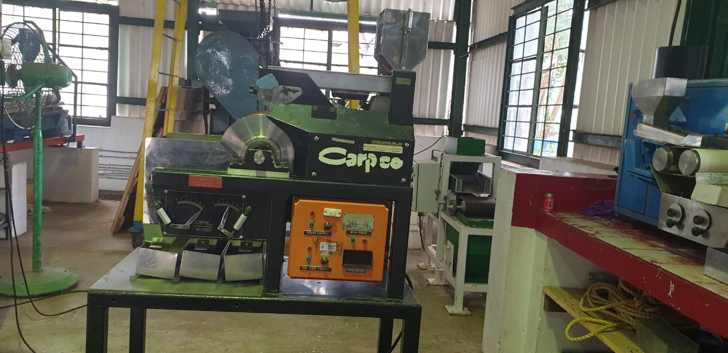

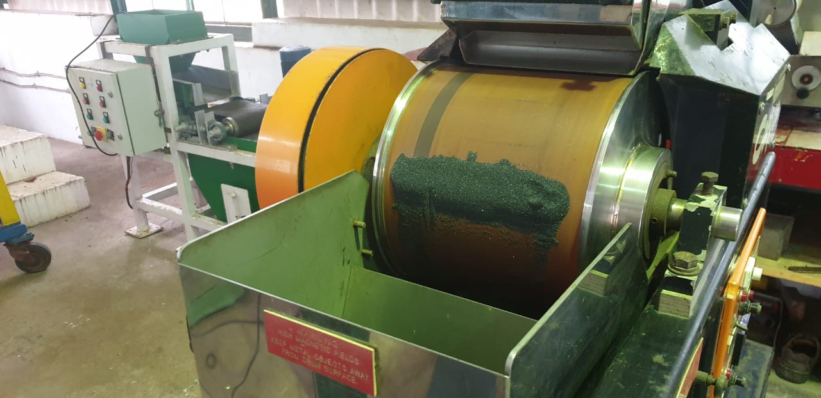

**PARTS: -**

Major parts of this instrument are as follows:

* Hopper.
* Feeder.
* Earth drum magnetic roller.
* Separation splitter.
* Controller (power source, feeder controller, roll controller.).

**WORKING PRINCIPLE**

As material is introduced to the drum surface, a magnetic field attracts ferrous material to the rotating outer drum. This action continually conveys the captured ferrous material out of the product flow to the ferrous discharge area creating a self-cleaning action.Common uses for magnetic drum separators include magnetite recovery in heavy media mining circuits, tramp metal extraction, and product purification.Permanent magnetic drum is designed and manufactured in such a manner that only half of its side is magnetized. An empty stainless steel 304 shell which surrounds the magnet rotates freely. The magnet is stationary. Magnetic particles which get attracted are collected separately as shown. Magnetic drums up to 600mm diameter and 1500mm length are available.

**PARAMETER: -**

In this instrument, there are three parameters such as  
• Feed rate  
• Roll speed drum  
• Magnetic intensity - fixed 6000 G

**Features**

* Suitable for high capacity, heavy duty applications.
* Fully controllable 200mm wide vibratory feeder.
* R.E. Drum with variable frequency geared-motor drive.
* Removable stainless steel free draining product discharge chute.
* Adjustable position,- product splitters.
* Adjustable arc position of magnetic element.
* Easily relocatable / transportable.
* Separator supplied with integral control panel and machine isolator .
* Readily removable safety guarding for cleaning purposes.

**Applications**

* Removal of magnetics from most granular, free flowing feedstocks.
* Production of very pure magnetic concentrates.
* Production of ilmenite, chromite, hematite concentrates.
* Cleaning of garnet and staurolite concentrates.
* Removal of magnetic contaminants from gem stone concentrates.
* Iron-ore fines.

PROCEDURE**: -**

The mixture sample of beach sand is put to feed HOPPER, through which samples  
falls on the vibrator plate called FEEDER which vibrate the samples and in a particularwidth the mixture of sample falls on the Rare Earth Drum Magnetic Roller due tovibration. This Drum roller has two region i.e. Magnetic section and Non-Magneticsection, First the minerals falls on the magnetic region of drum roller and the magneticminerals stick on the Drum roller and nonmagnetic minerals are separated and thrownaway from the drum due to centrifugal force of rotating drum. The stuck magneticminerals goes to the non-mag region of drum roller at which the magnetic minerals losetheir magnetic properties and get detached from the drum and collected as magneticfraction. The whole process is controlled by controller zone which consist FEEDERCONTROLLER, ROLL CONTROLLER and POWER SOURCE. The feeder controllerused for the rate of vibration of feed plate results the increasing or decreasing of speedof minerals falling on drum roller, and the roll controller used for increase or decreasethe rate of rolling of drum roller.

**EXPERIMENT**

The conducting and middling fractions obtained from the High-tension roll  
separator mixed together and taken as the sample for magnetic separation. This sample was fed to the hopper and falls on the drum roller and finally the minerals are separated from each other and stored at their respective trays according to their magnetic susceptibilities.The magnetic minerals which are separated out and stored at inner most trays may be Ilmenite and the nonmagnetic minerals are separated and stored at outer most tray. The middling stored at mid tray may be Garnet which has less magnetic intensity than Ilmenite.

**FLOWCHART OF MAGNETIC SEPERATION PROCESS**

PARAMETERS:

Roll Speed: 80 RPM

Magnetic Intensity: 6000 gauss

MAGNETIC

MIDLINGS

NON MAGNETIC

**OBSERVATIONS AND CALCULATIONS**

|  |  |  |
| --- | --- | --- |
|  | **WEIGHT IN kg** | **WEIGHT PERCENTAGE** |
| **MAGNETIC** | **4.393 kg** | **68.17 %** |
| **MIDLINGS** | **1.363 kg** | **21.15 %** |
| **NON MAGNETIC** | **0.688 kg** | **10.68 %** |
| **TOTAL** | **6.4440 kg** | 100 % |

**RESULT: -** The total magnetic minerals weight percentage = 68.17%

2. INDUCED ROLL MAGNETIC SEPERATOR

The Induced Roll Separator is used for the continuous extraction of small paramagnetic particles from material to produce mineral purification for a wide range of mineral and ceramic processing industries.THE INDUCED ROLL SEPARATOR (IRS) Induced Roll Separators are a versatile magnetic separator in which a powerful electro-magnet uses an iron circuit to induce a magnetic field in a rotating separation roll, set between fixed and adjustable magnetic poles.

**WORKING**

The material being treated is fed from a hopper or vibratory feeder at a controlled rate onto a high intensity magnetic roll. The paramagnetic material attaches itself onto the roll face or is deflected towards the roll. Non - magnetic material is thrown off the face at a normal trajectory. Magnetic material is discharged off the roll face at a point of lower magnetic intensity aided by a brush.

INDUCED ROLL SEPARATORS

A splitter plate is interposed between the two product streams. The machine can also be set up to give a middling stream by the addition of a second splitter plate. Two rolls can be mounted in series on the same unit to give a double pass machine for improved efficiency and process performance.

This type of separator has great flexibility for the process engineer, the magnetic field strength is variable due to the adjustable electromagnetic coil, the roll speed is adjustable and the roll/pole gap can be adjusted to accommodate different feed size ranges. It can also process hot mineral feeds (up to 80-100 C) without compromising separation efficiency, unlike its permanent magnetic equivalent. The roll also tends to generate very little static charge on the surface which means that there is minimal carryover of fine particles into the magnetics fraction – giving good grades and recoveries of valuable mineral from finer particle size distributions. Typical capacities for a metre wide unit vary based on mineral type, density and particle size distribution and are ideally determined by laboratory test trials:

Silica Sand: 3-5 tph per metre roll width

Ilmenite: 4-6 tph

Garnet Sand: 3-6 tph

Feldspar: 3-5 tp

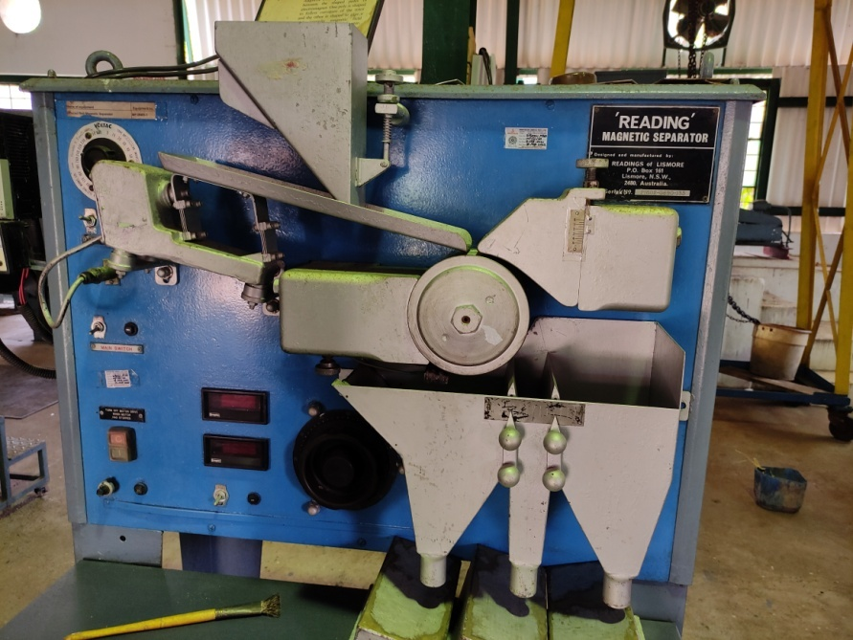

**PARAMETERS**

1. Magnetic Intensity
2. Roll speed

**Flowchart of Induced Roll Magnetic Seperator**

PARAMETERS

Roll Speed : 80 RPM

Magnetic Intensity: 14000 gauss

MAGNETIC

MIDLINGS

NON MAGNETIC

MAGNETIC

MAGNETIC

NON MAGNETIC

MIDLINGS

**OBSERVATION AND CALCULATION**

|  |  |  |
| --- | --- | --- |
|  | **Weight in kg** | **Weight percentage** |
| **NON MAGNETIC** | **0.194 kg** | **28.61 %** |
| **MIDLINGS** | **0.404 kg** | **59.59 %** |
| **MAGNETIC** | **0.080 kg** | **11.80 %** |
| **TOTAL** | **0.678 kg** | **100 %** |

**RESULT**

Total Magnetic mineral weight percentage = 59.59%

Total Non-Magnetic mineral weight percentage = 28.61 %

**5.5 FROTH FLOATATION**

AIM : For the separation of hydrophilic minerals such as sillimanite.

PROCEDURE :

Machine used for the froth flotation process is the DENVER D12 flotation machine . Add 500 ml of water to the container and add the sample the add approximately 6ml of 10% sodium silicate solution ,which serves as a depressant to settle the unwanted minerals. Then set five minutes on the timer . After the required time add oleic acid which is used as a froth producing agent , then check the pH of the mixture, again wait three to four minutes for conditioning. Then add around 2ml of soda ash and check the Ph ,it should be around 9. Then the froth is being separated out and weighed it should be hydrophilic minerals such as sillimanite, and the tailings are weighed ,it may be impurities such as quartz.

**OBSERVATION AND CALCULATION**

**Weight of sample taken for froth flotation : 500 g**

|  |  |  |
| --- | --- | --- |
|  | Weight in grams | Weight percentage |
| Weight of float | 220 g | 44% |
| Weight of tailings | 269 g | 53.8% |
|  |  |  |

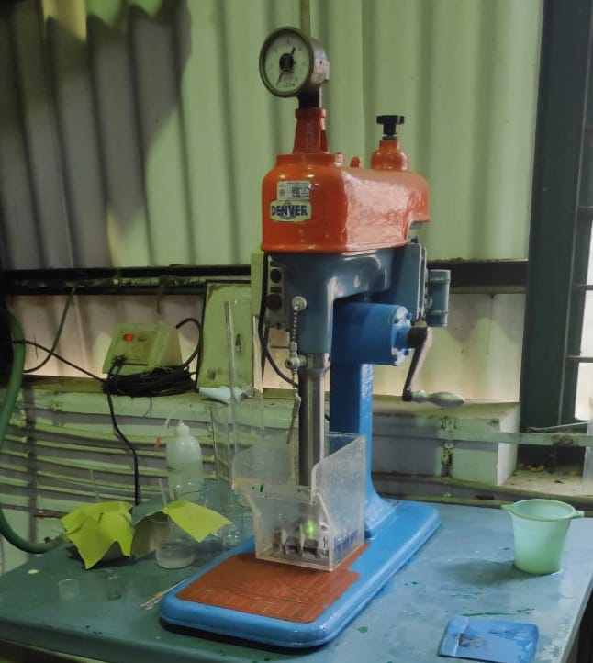

Denver D12 Froth Flotation Machine

**5.6.MINERALOGICAL ANALYSIS -**

**AIM**: To determine the content of individual minerals in the beach sand mineral sample

**INSTRUMENT** : - Optical Polarising Microscope

The optical polarising microscope, often referred to as the "light microscope", is  
a type of microscope which uses visible light and a system of lenses to magnify images  
of small samples. Optical polarising microscopes are the oldest design of microscope  
and were possibly invented in their present compound form in the 17th century. Basic  
optical microscopes can be very simple, although there are many complex designs  
which aim to improve resolution and sample contrast.  
The image from an optical polarising microscope can be captured by normal  
light-sensitive cameras to generate a micrograph. Originally images were captured by  
photographic film but modern developments in CMOS and charge-coupled device  
(CCD) cameras allow the capture of digital images. Purely digital microscopes are now  
available which use a CCD camera to examine a sample, showing the resulting image  
directly on a computer screen without the need for eyepieces.  
Alternatives to optical microscopy which do not use visible light include  
scanning electron microscopy and transmission electron microscopy.  
**PARTS AND FUNCTION**Fig 4.4; Petrological Microscope  
26  
➢ **Light source**- provides light into the microscope for viewing. Usually an electric  
bulb or a two-sided (plane & concave) mirror.  
➢ **Polarizing unit 1** – This converts normal light into plane polarized light & is  
situated below the microscope.  
➢ **Condenser System** – This removes the effects of interference of light by  
changing the phase of light.  
➢ **Diaphragm Lever** – This lever is used to control the intensity of light.  
➢ **Microscopic Stage** – This is a graduated, rotatable disk on which the thin  
sections are mounted for viewing purposes.  
➢ **Objective** – This contains several objective lenses of different magnifying  
power that can be selected.  
➢ **Slot** – the slot is used to insert accessory plates for different viewing purposes.  
➢ **Analyzer** (polarizing unit 2) – This is also a light polarizing unit. However, the  
plane of polarization is perpendicular to that of the polarizing unit that is situated  
below the microscope stage. This can be set in either “in” or “out”.  
➢ **Bertrand lens**: -This is a special lens system that is used to be observe  
interference figures. This too can be set in either “in or “out” position, the view  
seen from the eyepiece is smaller.  
➢ **Eyepiece**-This the lens through which is the observer views the thin section. It  
has a circular view with centre cross-hairs to help viewing.  
The petrological microscope can be set up in two arrangements depending on viewing  
purposes and optical properties of the minerals. They are,  
• PPL arrangement (Plane Polarized Light)-Analyzer is out, Bertrand lens out.  
• CPL arrangement (Cross Polarized Light)-Analyzer is in Bertrand lens is out.  
27  
Table 4.5 optical properties of RE Minerals  
28  
Table 4.6 RE minerals under open and closed Nicols  
29  
**EXPERIMENT: -** Microscopic Analysis  
**FEED PREPARATION**The preparation of the feed sample for testing under microscope is done by the cone  
sampling method.  
**Coning and Quartering: -**Coning and quartering is a method used by analytical scientists to reduce the  
sample size of a powder without creating a systematic bias. The technique involves  
pouring the sample so that it takes on a conical shape, and then flattening it out into a  
cake. The cake is then divided into quarters; the two quarters which sit opposite one  
another are discarded, while the other two are combined and constitute the reduced  
sample. The same process is continued until an appropriate sample size remains.  
Analyses are made with respect to the sample left behind.  
**Preparation of slide: -**For preparation of the slide, one glass slide, clove oil, 1needle, and optic cover  
glass22m is needed. Then take required amount of clove oil on the slide and spread it  
with the help of the needle. Then poured the small amount of sample on that oil and  
spread it by the needle. Due to the oil the sample is clotted on the slide, with the help of  
the small fibre cover glass sample is covered. In this way the slide is prepared. By  
putting the slide under the microscope, we have identified the minerals like Magnetite,  
Ilmenite, monazite, leucoxene, garnet zircon...etc. based on the optical properties of  
those minerals.  
The next step after the mineral identification is the grain count.  
**MODEL GRAIN COUNTING ANALYSIS**In this process the total number of each type of grains of different minerals  
present in the total slide is counted. For this the mineral grains touching the horizontal  
or vertical cross line in the field of vision of microscope is counted in a traverse. After  
completing one traverse subsequent traverse are taken at equal distance on the  
microscope stage. The entire slide is covered in this way and the total count of each  
mineral is determined.  
**OBSERVATION AND CALCULATION**The samples obtained from the previous test (high tension roll separator test and  
rare earth drum magnetic separator test) is taken for the grain counting analysis and the  
percentage of ilmenites and non-ilmenites was analysed.

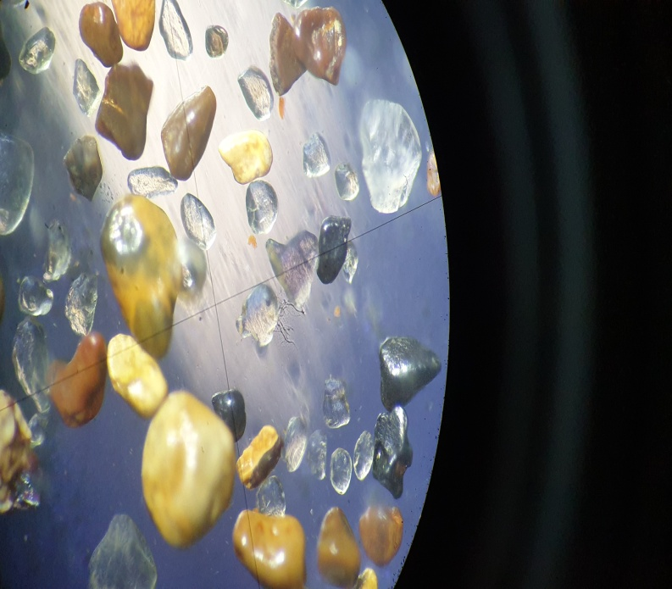

RUTILE

**MINERALOGICAL ANALYSIS OF END PRODUCT**

Thus, the consolidated mineralogical analysis of Rutile and Sillimanite samples tested through Magnetic Separation and Microscopic Analysis is given below.

|  |  |  |
| --- | --- | --- |
| ***No.*** | ***Minerals*** | ***Total Weight (%)*** |
| 1 | Ilmenite | 11.3 |
| 2 | Rutile | 87.4 |
| 5 | Zircon | 1.2 |
| 10 | Lights | 0.1 |
| TOTAL | | 100.0 |

Table : Mineralogical anlysis of rutile Sample

|  |  |  |
| --- | --- | --- |
| ***No.*** | ***Minerals*** | ***Total Weight (%)*** |
| 1 | Rutile | 0.5 |
| 2 | Monazite | 0.3 |
| 3 | Zircon | 1.0 |
| 4 | Sillimanite | 90.6 |
| 5 | Kyanite | 0.2 |
| 6 | Other Heavy Mineral | 0.2 |
| 7 | Lights | 1.7 |
| 8 | shells | 5.5 |
| TOTAL |  | 100.0 |

**Table No Mineralogical analysis of sillimanite Sample**

**RESULT**

|  |  |
| --- | --- |
| Shell content | 3.82% |
| Heavy mineral content | 55.14% |
| Magnetic mineral content | M1 = 40.16%  M2 = 1.17%  M3 = 13.87% |
| Spiral separation | Heavy Mineral = 42.65%  Light mineral = 47.88% |
| HTRS | Conducting = 53.27%  Non Conducting = 26.14%  Middling= 20.59% |
| Magnetic Separation | Magnetic = 68.17 %  Non Magnetic = 10.68 %  Middling = 21.15 % |
| Froth Flotation | Weight % of Float = 44% |
|  |  |

**Conclusion**

The Beach Sand Mineral Deposit in Chavara, Kollam Distict, Kerala is a rich source of valuable minerals such as Ilmenite, Rutile………

IREL(India)Ltd a Public Sector undertaking under Department of Atomic Energy, Government of India is engaged in the mining and separation of the beach sand minerals to produce commercial grade Ilmenite,Rutile The dissertation was about the

1. Study of the mineralogical properties (Characterization) of Chavara beach sand heavy minerals and
2. Study separation of Rutile and Sillimanite heavy minerals from Chavara beach placers.

The dissertation work was carried out at IREL Research Centre, Kollam.

The sample was collected from IREL(India)Ltd, Chavara mine site Karithura, near IREL main gate, Chavara,Kollam district.

The sample collected was reduced using Riffle type divider and testing and analysis were conducted as per the objective of the present study.

1. **CHARACTERIZATION OF THE SAMPLE**
2. **Size Distribution of Sample**

The majority of sample mineral size is between the range of 70 and 120 microns.

1. **Shell Content in the Sample**

The total percentage of Shell content in the taken sample is 3.82%.

1. **Heavy Mineral Content the Sample**

The total percentage of Heavy minerals in the collected sample is 55.14%.

1. **Magnetic Mineral Content in the Sample**

In the 55.14% Heavy Mineral the weight percentage of Magnetic minerals is 40.16% and that of non- magnetic minerals is 13.8% and the magnetic fraction is Leucoxene and ilmenite .

1. **MINERAL SEPARATION**
2. **Spiral Separation**

Using spiral separator,bulk sample separated into heavy minerals and light minerals.Heavy minerals in the sample is 47.05% and light minerals is52.82%.

1. **Electrostatic separation**

Using High Tension Roll Separator(HTRS),

1. Weight percentage of conducting,middlings and non conducting minerals fraction is 53.27%, 20.59% and 26.14% respectively. So from the results it can be concluded that majority of the conducting fraction is Rutile,Ilmenite and leucoxene, for further confirmation magnetic separation is evaluated.
2. Weight percentage of non conducting fraction in secondly done HTRS is 21.15% and the non conducting fraction is sillimanite.

**iii. Magnetic Separation**

Using Rare Earth Drum Magnetic Separator (REDMS),

* 1. The weight percentage of magnetic mineral is 68.17%, and it is assumed to be leucoxene and Ilmenite.
  2. The weight percentage of non magnetic mineral is 28.61% and the mineral is assumed to be Rutile.
  3. So Rutile percentage is found to be 28.61% of the conducting fraction

**iv. Froth flotation**

Using Denver D12 Flotation machine,

1. Weight percentage of float is 32.02%
2. Weight percentage of tail is 39.15%
3. Sillimanite weight percentage is found to be 32.02%

The dissertation work carried out could characterize the Heavy Mineral deposit and carryout out Separation of Rutile and Sillimanite Heavy Minerals from a sample from Chavara Mineral Sand Deposit.