**BAGADIONG**

**2-ECE-B**

**EXPERIMENT 9: DATA WRANGLING WITH PANDAS**

**Problem 1:**

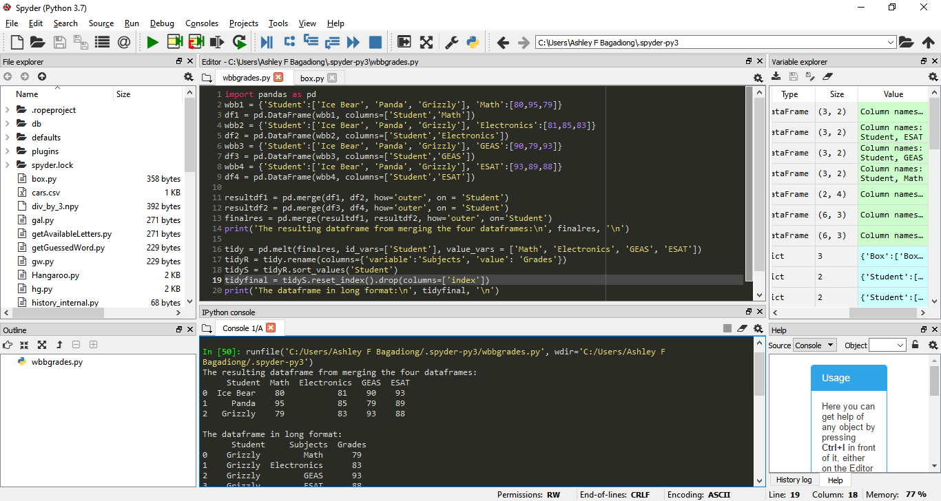

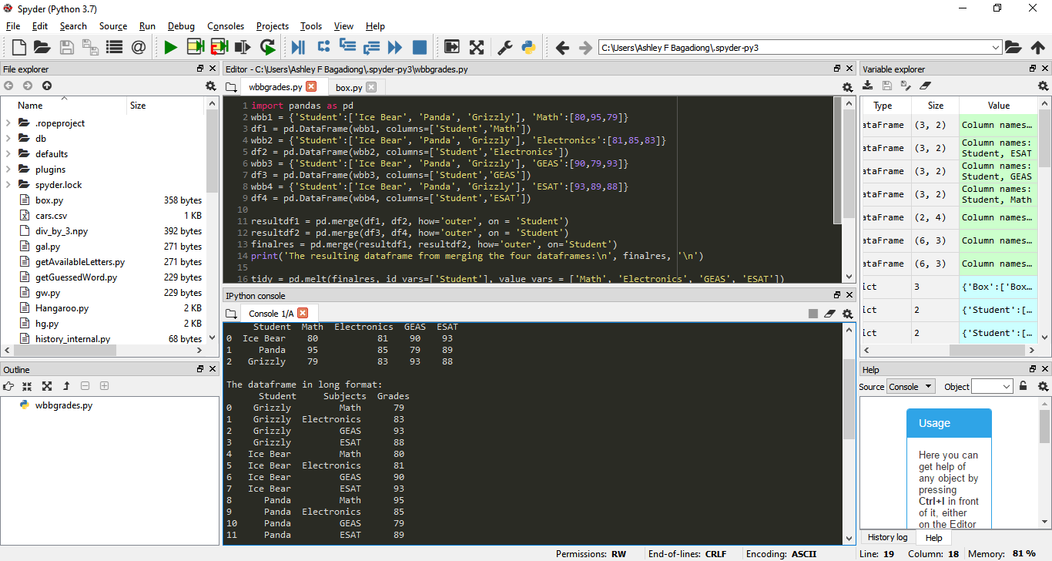

**Problem 2:**

