**Bagadiong**

**2-ECE-B**

**Experiment 8: Pandas**

**Problem 1:**

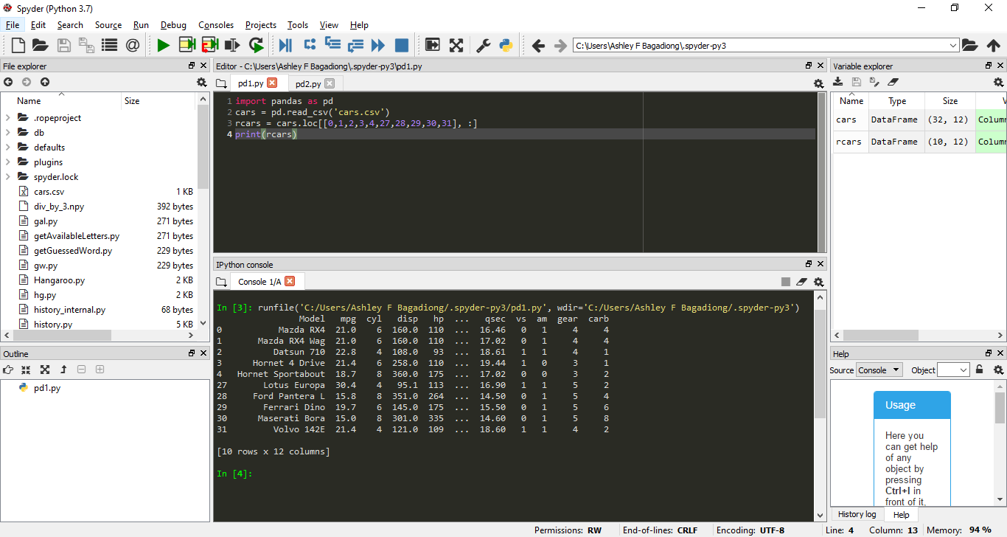

**Problem 2:**

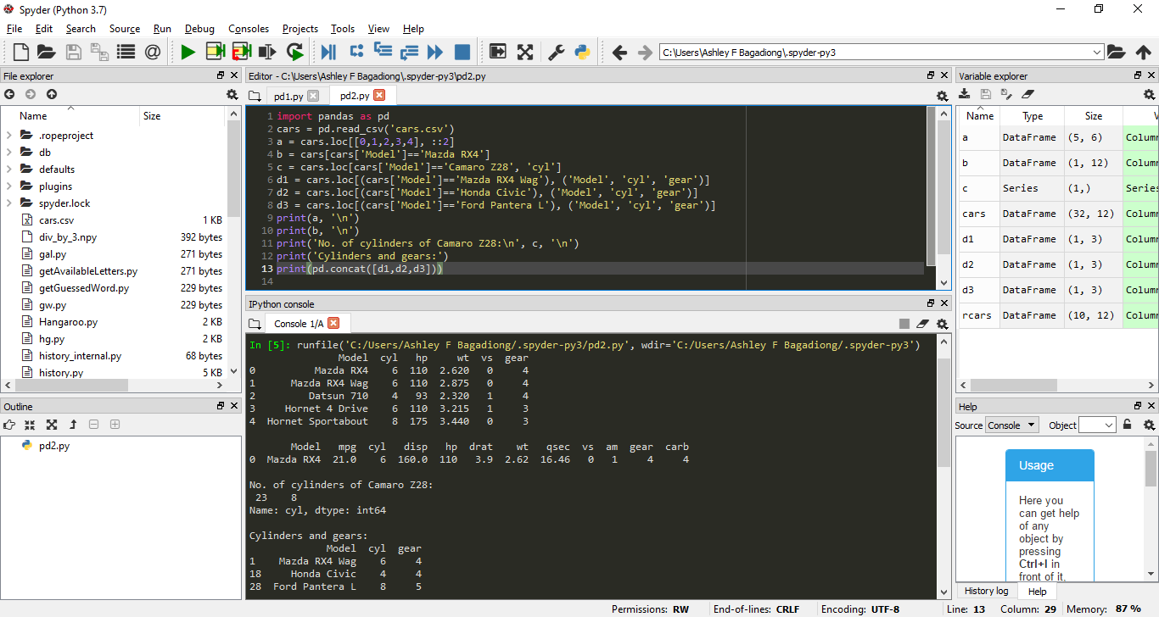

c) How many cylinders (‘cyl’) does the car model ‘Camaro Z28’ have?

* The car model Camaro Z28 has 8 cylinders.

d) Determine how many cylinders (‘cyl’) and what gear type (‘gear’) do the car models ‘Mazda RX4 Wag’, ‘Ford Pantera L’, and ‘Honda Civic’ have.

* Mazda RX4 Wag: cylinders – 6; gear – 4
* Ford Pantera L: cylinders – 8; gear – 5
* Honda Civic: cylinders – 4; gear – 4