**Bagadiong, Sharee Mae F.**

**2-ECE-B**

Problem 1:

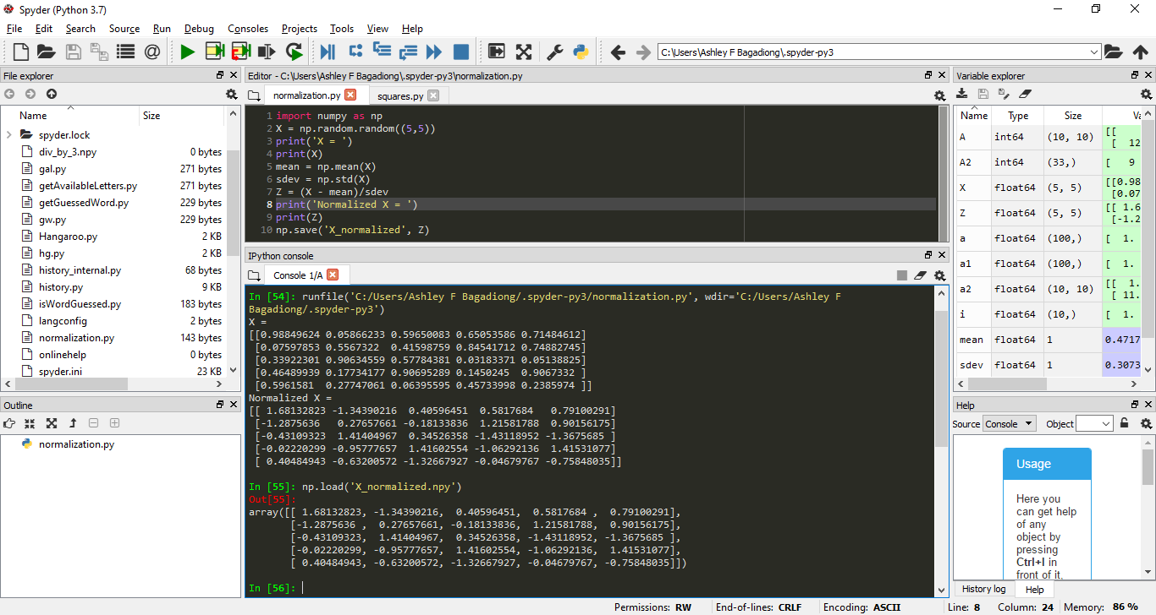

Problem 2:

