A Case Study of Short Circuit Indicator Project

Shamshadh Unissa,

Shareen Khan

Dept of CSE

Institute of Aeronautical Engineering

Hyderabad, India

[20951A05H1@iare.ac.in](mailto:20951A05H1@iare.ac.inm) , [20951A05H3@iare.ac.in](mailto:20951A05H3@iare.ac.in)

Dr. B J D Kalyani

Associate Professor &

Deputy Head

Institute of Aeronautical Engineering

Hyderabad, India

bjd.kalyani@iare.ac.in

Moulana Mohammed

Associate Professor, Dept. of CSE

Koneru Lakshmaiah University,

Guntur, India

0000-0001-5039-8836

moulanaphd@gmail.com

***Abstract:***

As the world becomes increasingly connected, digitalization is a key differentiator that will enable. By using IoT smart devices which generate huge volumes of digitalized data, which promises lower costs, improved production quality, enhance flexibility, increase efficiency, shorter response time as per market demands, and opens new innovative opportunities. IoT is Internet of things which interconnect the computing devices through the internet which encompassed both sending and receiving. When such concept is added in house application it aptly incorporated to make smarter and automated.

Short circuit condition is a condition in which the input terminals of a power supply get in electrical contact with each other causing huge current flow. This leads to very large heat generation which can damage the system and pose a threat to people nearby it. Thus, short circuit conditions are necessary to be detected and be attended immediately.

***Introduction:***

Short circuit condition is a condition in which the input terminals of a power supply get in electrical contact with each other causing huge current flow. This leads to very large heat generation which can damage the system and also pose a threat to people nearby it. Thus, short circuit conditions are necessary to be detected and be attended immediately.

A short circuit is an abnormal connection between two nodes of an electric circuit intended to be at different voltages. This results in an [electric](https://en.wikipedia.org/wiki/Electric_current) current limited only by the Thevenin [equivalent t resistance](https://en.wikipedia.org/wiki/Th%C3%A9venin%27s_theorem)  of the rest of the network which can cause circuit damage, [overheating,](https://en.wikipedia.org/wiki/Overheating_(electricity))  [fir e](https://en.wikipedia.org/wiki/Fire) or  [explosion.](https://en.wikipedia.org/wiki/Explosion)  Although usually the result of a fault, there are cases where short circuits are caused intentionally, for example, for the purpose of voltage-sensing [crowbar circuit protectors .](https://en.wikipedia.org/wiki/Crowbar_(circuit))

Short Circuit Indicator Project does the task of detecting the short circuit in a circuit in which it is connected automatically. With the help of a regulator and a pair of transistors we lit up an indicator LED that glows only when there is a short circuit event occurring.

In this way one can easily understand the short circuit condition and take appropriate measures of cutting off the power supply and removing the short circuit. We have demonstrated the short circuit in our circuit board using a wire piece which has very low, close to zero value of resistance thus creating a short circuit at the source connector.

***Background and Related Work:***

**What is IoT?**

Internet of Things is an interconnected and interrelated system of computing device, which has ability to transfer the data over the network by using internet. It describes a corporeal objects or things that are fixed with sensors software and other technologies for the purpose of connecting and transferring a data with the other devices with less human interference. The exchange of data can be done by using internet. In recent years, Internet of things has one of the important technologies in 21stcentury.By using the IoT our daily life become so easy. By using smart IoT devices we can connect our daily appliances – kitchen equipment, cars, baby monitors, through the internet, and communication is also possible between person, devices etc. Using IoT devices, low-cost computing, the cloud, big data, analytics, and mobile technologies, physical things can share and collect data with less human effort. In this fast-growing world, digital working system can control, record, and adjust each interaction between connected devices. The physical world meets the digital world—and they work efficiently.

**In** [**main**](https://en.wikipedia.org/wiki/Mains_electricity) **circuits,** short circuits may occur between two [phases ,](https://en.wikipedia.org/wiki/Polyphase_system) between a phase and [neutral](https://en.wikipedia.org/wiki/Ground_and_neutral)  or between a phase and [earth](https://en.wikipedia.org/wiki/Ground_and_neutral) ( ground ). Such short circuits are likely to result in a very high current and therefore quickly trigger an overcurrent protection device. However, it is possible for short circuits to arise between neutral and earth conductors, and between two conductors of the same phase. Such short circuits can be dangerous, particularly as they may not immediately result in a large current and are therefore less likely to be detected.

Possible effects include unexpected energisation of a circuit presumed to be isolated. To help reduce the negative effects of short circuits, power distribution transformers are deliberately designed to have a certain amount of [leakage reactance .](https://en.wikipedia.org/wiki/Leakage_inductance) The leakage reactance ( usually about 5 to 10 % of the full load impedance) helps limit both the magnitude and rate of rise of the fault current.

The approach based on a system of indicators of short-circuit currents levels aimed to increase the information content of a power system design and management as well as check the switching equipment compliance with the existing short-circuit currents and their perspective values on each object of a power system.

***Designing of Short Circuit Indicator Project:***





***Hardware Design:***

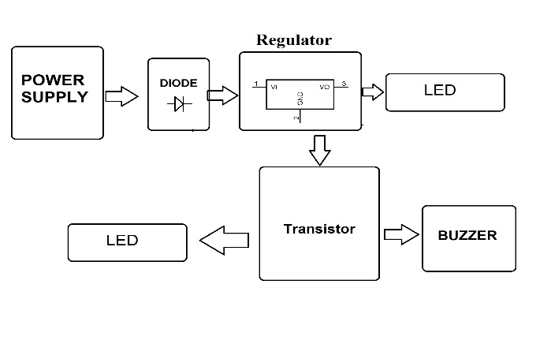

Hardware Specifications

* Buzzer
* Resistors
* Resistors
* Capacitors
* Transistors
* Cables and Connectors
* Diodes
* PCB and Breadboards
* LED
* Transformer/Adapter
* Push Buttons
* Switch

***Implementation of Project:***

Utility: Use of calculated values of short-circuits currents levels on substations-indicators allows to create requirements to newly implemented power switches on the breaking capacity based on the average and maximum levels of short-circuits currents for the considered load node.

The indicators system presented in this paper allows a degree of information clarity including at the expense of a possibility of an assessment of dynamics of short- circuits currents levels change that in turn will allow to increase efficiency of decision-making at operation and development planning of electrical power systems.

Perspective development of an electrical grid complex along with power generating capacities development have significant effect on levels of short-circuit currents due to change of the current circuit and regime situation. It is confirmed by calculations of short-circuit currents for the considered regional power system on stages of 2015-2020. Dynamics of average short-circuit current.

The statement about the constant growth of short-circuits currents also confirms the analysis of short-circuits currents level change on indicators as they precisely characterize the nature of short-circuit currents change in each energy area because of high sensitivity to the changes of an electric network configuration or installed capacity of power plants.

***Testing of Short Circuit Indicator Project:***

**Economic Sustainability:** Analysing short-circuits current level changes on substations-indicators of electric networks areas in a large regional power system, it is possible to conclude that the short-circuits current level increases within the considered period from 2015 to 2020. Increasing short-circuit current levels results in the necessity to consider the questions of the power equipment replacement planning, calculation of settings of protective relays and automatic equipment, revision of the principles of electric networks construction.

Represents time dependencies of installed capacity in the Central and Industrial districts of electric networks and of the maximum short-circuit current on substations-indicators. Apparently from the schedule for Industrial district of electric networks indicators are sensitive both to electrical grid implementations and to implementations of new generators.

A similar situation is in the Central district of electric networks. Indicators rather clearly display the changes of short-circuit current level caused by implementation of new substation of 220 kV and of the new generating equipment. Thus, indicators are rather demonstrative characteristics of short-circuit current level in the energy area.

***Advantages:***

The system is flexible in nature

Increase in Home security

Remotely control all appliances

Energy efficient system

***Conclusion:***

The smart home automation using Internet of Things has been experimentally proven to work satisfactorily by connecting home appliances to it and the appliances were successfully controlled remotely through internet and application. The new innovative system not only analysed the sensor data, but also controlled the various applications & also operates process according to the requirement short circuit condition is necessary to be detected and be attended immediately. Short Circuit Indicator Project does the task of detecting the short circuit in a circuit in which it is connected automatically. We have demonstrated the short circuit in our circuit board using a wire piece which has very low, close to zero value of resistance thus creating a short circuit at the source connector.

***Acknowledgement:***

The authors would like to thank Institute of Aeronautical Engineering ,professor Dr. B J D Kalyani and

Dr. R.M. Noorullah for their honest efforts and selfless time. Their insightful advice and criticism helped me finish my job.

***References:***

1.https://www.electroschematics.com/short-circuit-indicator/

2.https://www.academia.edu/43455263/Arduino_based_Short_Circuit_Protection_System_using_various_sensors

3.https://www.questjournals.org/jecer/papers/vol8-issue10/08100104.pdf

4.https://www.thespruce.com/what-causes-short-circuits-4118973

5.https://www.exploratorium.edu/snacks/short-circuit

6.https://patents.google.com/patent/DE3117204A1/en

7.https://youtu.be/FnU3rLk5V9o

8.https://dmohankumar.wordpress.com/2015/08/12/short-circuit-indicator-for-bread-board-design-note-38/