Tampilan Awal
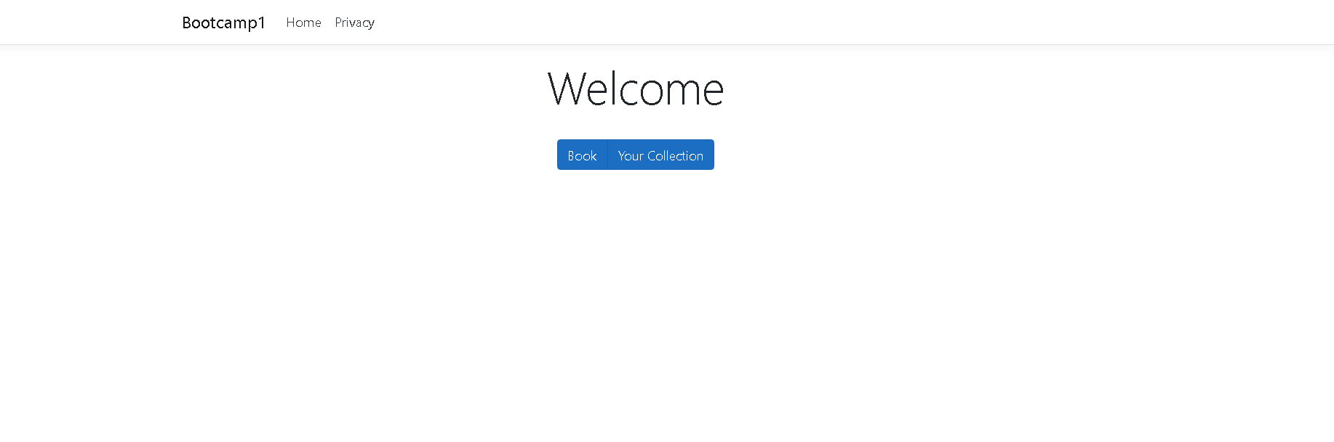

Tampilan Book
