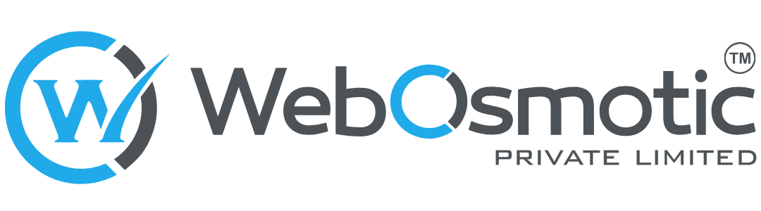

[Workscope & Budget Proposal]
Subtext [optional]

Presented to
[Client's Name]
Presented By
[Client's Name]

Table of Contents

WebOsmotic Private Limited
Bangalore, India | USA
[Today]
This proposal is valid for 30 days from the date of issue.

1. Overview 3
2. User Roles and Features 3
3. Features Breakdown 3
Parent Mobile App (iOS and Android) 4
Parent Web 6
School Dashboard (Web) 6
ZENi5 Operations Console (Web) 6
Backend Platform 7
4. Flow Plan: Step-by-Step Workflow 8
Flow A: Parent Journey 8
Flow B: Paying With the Card 9
Flow C: Schools 10
Flow D: Operations Behind the Platform 11
5. Milestones 12
Milestone 1: Discovery and Architecture 12
Milestone 2: Foundation, Onboarding, and Schools 13
Milestone 3: Card and Pocket Money 13
Milestone 4: Insurance, Investments, and Benefits 14
Milestone 5: QA, Pilot, and Launch 14
6. Milestone and Payment 15
7. Technology Stack 15
8. Deliverables 16
9. Out of Scope 16
10. Future Scope 17
11. Client Responsibilities 18
12. General Notes 18
Assumptions Made for This Scope 18

1. Overview
ZENi5 is a school-fee-linked financial platform for Indian school families. One annual subscription bundles an education insurance policy with parent income protection, a prepaid card for the child with parental spending controls and real-time alerts, guided commission-only investments for the child's education, and student discounts and benefits. Schools bring families in through a partner registry, and the ZENi5 operations team runs the platform from an internal console.
This document is the work scope for the MVP release: a live, regulated product, not a prototype. It covers school onboarding with bulk parent upload, parent onboarding with consent and KYC, a single subscription plan paid annually, the prepaid card with pocket money and controls, transactions and statements, education insurance, the SIP Education Fund, discounts and partner benefits, the parent web, the school dashboard, and the operations console. It is built for money movement on a sponsor bank's card programme, with data held in AWS Mumbai, encryption in transit and at rest, PCI DSS readiness, and the consent and data-rights obligations of the DPDP Act. The scope is based on the ZENi5 Product Requirements Document (v1.0) and the ZENi5 MVP Basic User Flow (draft v1.0). Later releases are listed in Section 10.

2. User Roles and Features
Four roles are live in this release. The student has a card but no app; the student profile and its permissions are built now so that a student app can follow without rework.
Role | Who they are | What they can do in this release
Parent | The account holder, identified by mobile number | Join by school invitation or directly, give consent and complete KYC for themselves and the child, pay the annual subscription, request the virtual and physical card, set spending controls, send one-time and recurring pocket money, view transactions and statements, hold the education insurance policy, activate the SIP Education Fund, and use discounts and partner benefits
Student | The child, in the age band set by school class | Spend with the card within the parent's limits and use discounts through the parent's app
School administrator | Finance head, principal, or admin officer at a partner school | Activate the school account, download the parent upload template, upload and correct the parent list, track adoption by family status, resend invitations. Never sees balances or spending
ZENi5 operations | The ZENi5 team running the platform | Create schools and codes, run uploads on a school's behalf, review failed verification, handle card and transaction queries, manage offers, reconcile money daily, control which sections are unlocked for which families

3. Features Breakdown

Parent Mobile App (iOS and Android)
- Onboarding by invitation or direct signup
  - Claim link opens the app or the web, one-time password to the school-supplied number, pre-filled school and child details to confirm or correct, corrections flagged back to the school
  - Direct signup with mobile number and one-time password, parent details, child profile, optional school code entered now or later
  - PIN or biometric credential for the app, used again to confirm money movements
- Consent and verification
  - Consent to data protection, identity-data use, and platform terms, each stored with the time and the version of the text shown
  - Parent KYC with PAN and Aadhaar-based electronic verification, auto-verified where the central registry matches and otherwise reviewed within 24 hours, with the identity number masked on screen and never stored readable
  - Child verification by identity document, or birth certificate together with the parent's verified identity, completed later where needed
  - Leave and return at any step, plain-language reasons and retry on failure, verification progress bar
- Subscription
  - Child profile with name, class, school, and date of birth; several children under one account, each as a separate student profile
  - School linked from the partner registry by invitation or school code, or added later; a family without a partner school subscribes directly
  - One subscription plan in this release, paid annually by UPI or net banking, with a renewal reminder before expiry; the plan structure is built so that further plans can be added later
- Dashboard
  - Child selector for families with more than one child, school badge, verification progress
  - Tiles for card, pocket money, transactions, insurance, investments, discounts, and benefits, each active or locked as the entitlement rules decide
  - Locked tiles for the future features listed in Section 10, such as Gold Savings, the Education Fund, financial education, savings goals, scholarships, and referrals: each shows a short preview and a notify-me action, and opens by a server-side switch when the feature ships, without an app release
- Card
  - Request the card per child with delivery address, virtual card issued immediately, card details shown behind a second authentication
  - Physical card dispatch tracking and activation on receipt
  - Lock and unlock in one tap, daily and monthly spending limits, merchant category restrictions, report lost or stolen with replacement request
- Pocket money
  - Fund from UPI, net banking, or a saved bank instrument, with a second factor on larger amounts
  - One-time transfer, or a weekly or monthly allowance with start date and amount, paused or cancelled at any time
  - Confirmation with the app credential, notification on both sides, automatic reversal of failed transfers with a reason
- Transactions and alerts
  - Push alert on every card transaction, low balance, and renewal
  - Full history per child with filters by child, date range, and category, a spending summary by category, a detail view with reference number and a raise a query action
  - Monthly statement download
- Education insurance
  - Policy issued with the subscription, with the cover and parent income protection included in the plan
  - Policy view, coverage details, PDF download, renewal reminder
- SIP Education Fund
  - Interactive returns calculator over 5 to 18 years, illustrative only
  - Fund selection, amount, commission disclosure, e-mandate setup with bank account link, confirmation with the first deduction date, portfolio view
  - Where a partner is not yet live, the section shows a preview and records interest until it is switched on
- Discounts and benefits
  - Offer catalogue filtered by the child's age band and linked school, showing partner, benefit, validity, and redemption method
  - Redemption by in-app code or QR, or a handoff to the partner, recorded either way for partner reporting
  - ekincare health services by age band, one-time opt-in, secure single sign-on with minimum data, enrolment and usage status back on the dashboard
- Notifications and support
  - Push notifications for transfers, card transactions, low balance, verification outcomes, SIP reminders, and renewals
  - Support entry point in the app

Parent Web
- Onboarding in the browser
  - The claim link and direct signup journeys above, for parents who start on the web before installing the app, handing over to the app for verification where the camera is needed
- Account view
  - Card balance, transactions, insurance policy view and download, investments, benefits

School Dashboard (Web)
- Account activation
  - Invitation by email and SMS with a one-time activation link, mobile one-time password, password, acceptance of school terms and data processing terms
- Parent upload
  - Fixed-format Excel template with locked headers for student, class, section, date of birth, parent name, mobile, email, and relationship
  - Background processing of files with thousands of rows, per-row result of accepted, duplicate, merged, or rejected, downloadable result file with a reason per row
  - Confirmation step before any family record is created
- Adoption tracking
  - Live counts by family status, resend to one parent or in bulk to all who have not claimed
  - No balances, transactions, or spending, ever

ZENi5 Operations Console (Web)
- School management
  - Create school records with address, contact person, student count, commercial terms, and a generated school code; run uploads on a school's behalf
- Verification queue
  - Every pending or failed verification with the partner's error code, approve or request a re-do, service-level timer
- Support and money operations
  - Family lookup by mobile number with the full status history, card and transaction queries raised by parents, refunds and reversals with an audit trail
  - Daily reconciliation view of the ZENi5 ledger against the card partner's settlement file and the payment aggregator, with break detection
- Catalogue and entitlements
  - Offers and partner benefits with validity and age band, plan and price settings, notification templates
  - Section unlock per family or pilot group without an app release
- Fraud alerts
  - Rule-based velocity and anomaly alerts for review, with block and release actions

Backend Platform
- Identity, consent, and family records
  - Mobile number as the identity key, sessions and device binding, consent records, the one family one record merge rule, a family status that drives the school counts, the operations queue, and the parent progress bar
- School registry and bulk upload
  - School codes, queued upload processing and validation, invitation dispatch by SMS and WhatsApp with throttling and delivery status
- Subscription and entitlements
  - One plan with annual payment through the aggregator and idempotent webhooks, an entitlement service returning each section's state per family and built to carry further plans later, server-side unlock for pilot groups
- Card and wallet ledger
  - Card partner integration for customer onboarding, card issuance, physical card ordering and shipping, loads from the pool wallet, card status, PIN, and encrypted card data; spending limits and merchant categories set through the partner and enforced in its card system; transaction notifications feeding alerts; a double-entry ledger of every movement; daily reconciliation against the partner settlement file, where the partner's list is a confirmation and never the source of truth
- Pocket money and transactions
  - Transfer processing, recurring schedules that place loads through the card partner, automatic reversal, transaction history, category summary, statement generation from the ZENi5 ledger
- Insurance and investments
  - Policy issuance and document storage through the insurer; investor onboarding with KYC reuse, SIP registration, e-mandate, order status, and holdings through BSE StAR MF; preview and interest capture for every locked tile
- Benefits and partners
  - Offer catalogue, redemption records, partner reporting, ekincare single sign-on and status callback
- Notifications, audit, and monitoring
  - Push, SMS, WhatsApp, and email delivery; an append-only audit log of every sensitive action; rules-based fraud monitoring; operational alerting on verification, payment, and reconciliation failures

4. Flow Plan: Step-by-Step Workflow

Flow A: Parent Journey
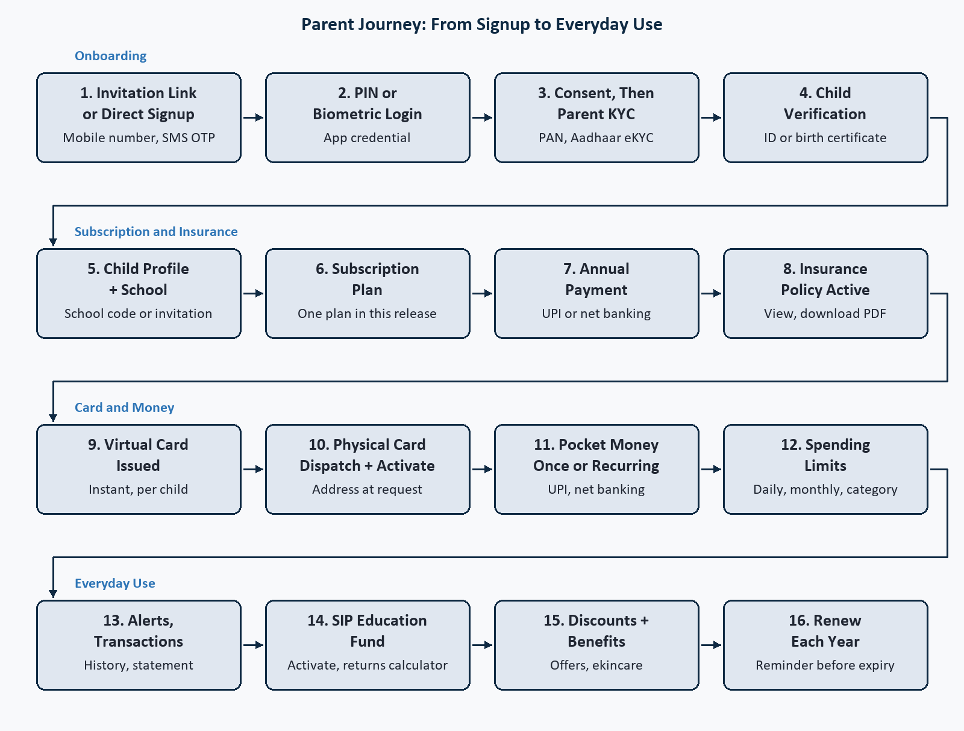
Parent journey from signup to everyday use
A parent arrives through a school invitation or signs up directly, verifies the mobile number, sets a PIN or biometric credential, gives consent, and completes KYC for themselves and the child. The parent pays the annual subscription, and the insurance policy is active from that moment. The virtual card is issued at once, the physical card follows to the address given, and pocket money moves as a one-time transfer or a weekly or monthly allowance within the limits the parent sets. From then on the parent lives in the dashboard: alerts and transactions, the SIP Education Fund with its returns calculator, discounts and partner benefits, and a renewal each year. Future features appear as locked tiles with a notify-me action, so that interest is recorded before they ship.

Flow B: Paying With the Card
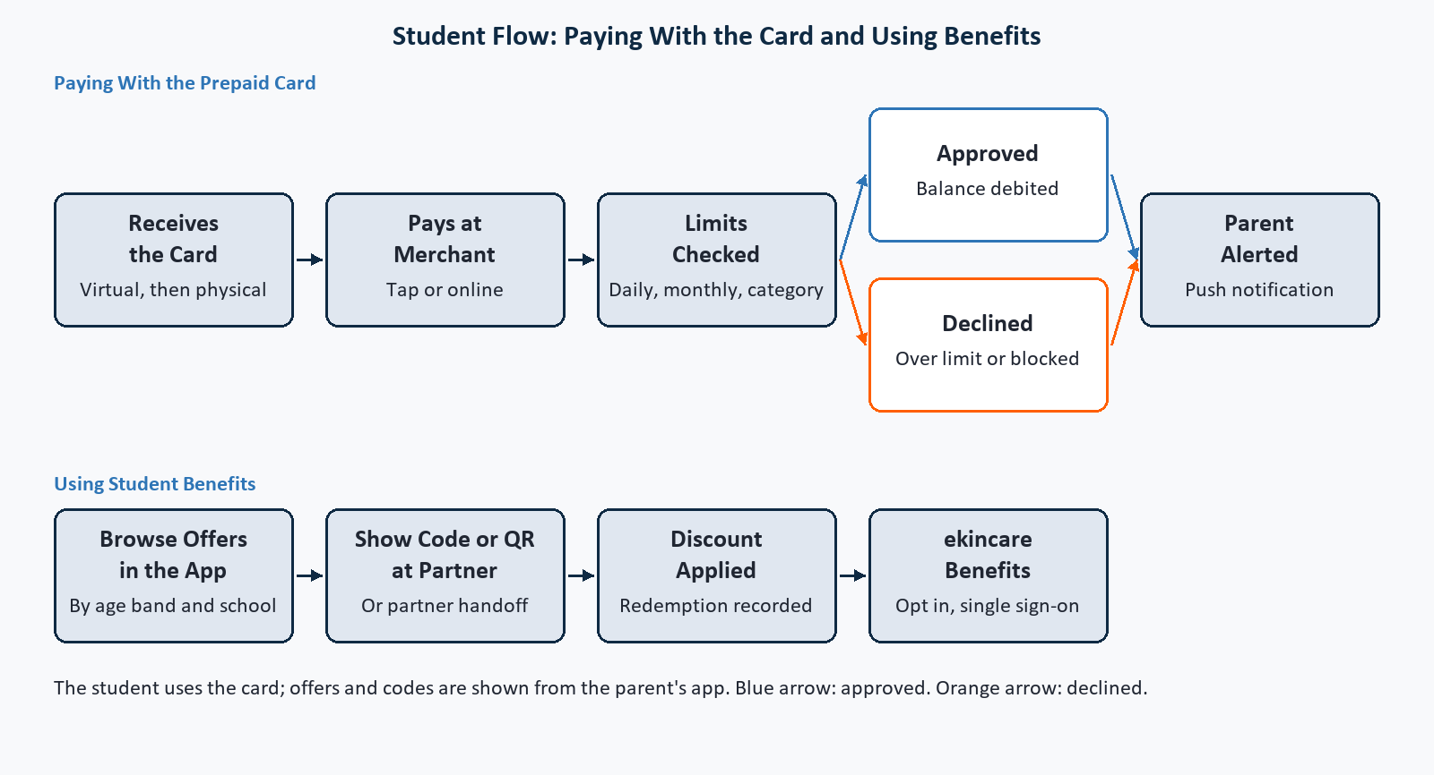
Student card payment with approve and decline paths, and benefits redemption
Every card payment is checked against the daily and monthly limits and the merchant category restrictions the parent has set, which ZENi5 pushes to the card partner and the partner enforces at authorisation. The parent is alerted either way. Approved payments are recorded in the wallet ledger; declined ones tell the parent why. Discounts are redeemed by an in-app code or QR, or by a handoff to the partner, and ekincare benefits open through a single sign-on. The student has no app in this release, so offers and codes are shown from the parent's app.

Flow C: Schools
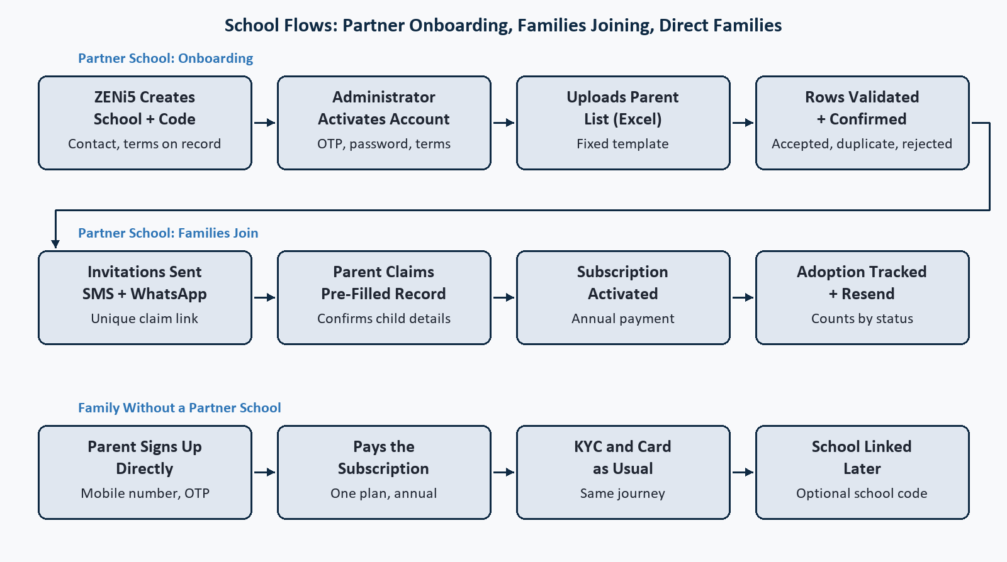
School flows: partner onboarding, families joining, manual path
A partner school is created by ZENi5 operations with its fee and terms on record, receives a school code, and its administrator activates the account and uploads the parent list. Every row is validated before anything is created; confirmed families receive a claim link by SMS and WhatsApp, and the administrator watches adoption by status and resends where needed. A parent whose school is not a partner subscribes directly, follows the same KYC and card journey, and can link a school by code later. The rule that must not be missed: one family, one record. A school upload that matches a directly registered parent attaches the school link and never creates a second family.

Flow D: Operations Behind the Platform
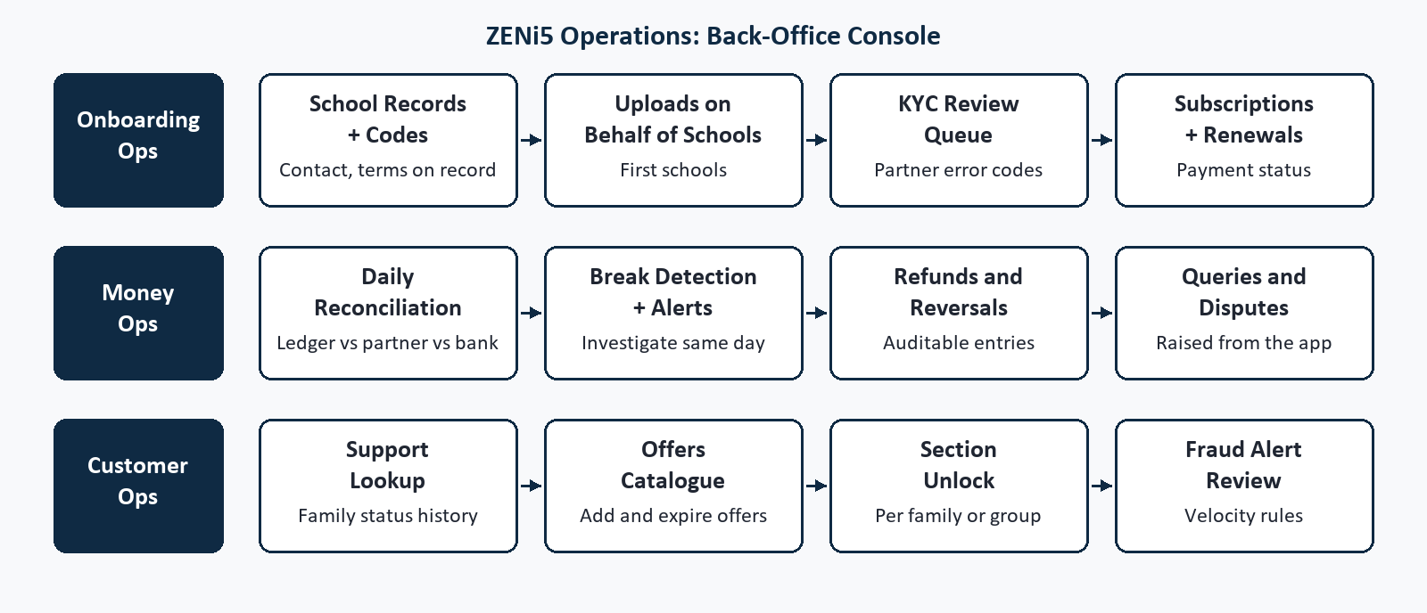
The ZENi5 operations console lanes
The operations console is where the platform is kept honest: failed verifications are reviewed with the partner's error code, subscriptions and renewals are tracked, schools and offers are maintained, queries and refunds are handled with an audit trail, sections are unlocked per family or pilot group, and every day the ZENi5 ledger is reconciled against the card partner and the payment aggregator so that a break is found the same day.

5. Milestones

Assumed project commencement date: to be confirmed upon client sign-off.

Milestone 1: Discovery and Architecture

Tentative Duration: 3 weeks from commencement
- Discovery and Setup
  - Partner-integration contracts and sandbox credentials: card partner, insurer, BSE StAR MF, payment aggregator, WhatsApp provider, SMS gateway, ekincare
  - Compliance and licensing decisions: card issuance route, sponsor bank approval of a minor's card on the parent's KYC, insurance distribution route, mutual fund distribution route
  - Security and data-localisation model
  - Decisions register covering the open product decisions and the assumptions in Section 12
  - Feature-level backlog and firm estimate for Milestones 2 to 5
- Design
  - Screen flows and visual design for onboarding, subscription, dashboard, card, pocket money, insurance, SIP, benefits, locked tiles, school dashboard, and the operations console
- Backend
  - Architecture and data model, environments and infrastructure as code, partner sandbox connectivity

Milestone 2: Foundation, Onboarding, and Schools

Tentative Duration: 6 to 7 weeks from Milestone 1 Completion
- Frontend
  - Parent app: claim link and direct signup, credential, consent, parent and child verification, child profile, subscription payment, dashboard shell
  - Parent web onboarding
  - School dashboard: activation, template, upload, results, adoption counts, resend
  - Operations console: schools and codes, uploads on behalf, verification queue, family lookup
- Backend
  - Identity and consent, KYC integration, family status model, school registry and merge rule
  - Bulk upload engine, invitation dispatcher with SMS and WhatsApp
  - Subscription plan and payment, entitlement service, notifications, audit log, ledger skeleton

Milestone 3: Card and Pocket Money

Tentative Duration: 6 to 8 weeks from Milestone 2 Completion
- Frontend
  - Card request with address, virtual card, card details behind second authentication, physical card tracking and activation
  - Lock and unlock, daily and monthly limits, merchant category restrictions, report lost
  - Pocket money one-time and recurring, transactions with filters, category summary, detail with raise a query, monthly statement
  - Operations console: card and transaction queries, refunds and reversals, reconciliation view, fraud alerts
- Backend
  - Card partner integration: onboarding, issuance, physical card, loads, status, PIN, encrypted card data, limits and merchant categories, transaction notifications
  - Double-entry wallet ledger, pocket money scheduler, automatic reversal
  - Statement generation, daily reconciliation, rules-based fraud monitoring

Milestone 4: Insurance, Investments, and Benefits

Tentative Duration: 5 to 6 weeks from Milestone 3 Completion
- Frontend
  - Insurance policy view, coverage details, and download
  - SIP activation, mandate setup, commission disclosure, portfolio view, returns calculator
  - Discounts catalogue and redemption, ekincare benefits with single sign-on and status
  - Locked tiles for future features with preview and notify me; preview and interest capture for any section whose partner is not yet live; operations console offers and section unlock
- Backend
  - Insurer integration and policy documents
  - BSE StAR MF integration: investor onboarding, SIP registration, e-mandate, order status, holdings
  - Offer catalogue, redemption records, partner reporting, ekincare callback
  - Interest capture, pilot-group unlock

Milestone 5: QA, Pilot, and Launch

Tentative Duration: 3 to 4 weeks from Milestone 4 Completion
- QA and Testing
  - Upload files with duplicate, merged, and rejected rows; invitation delivery failures and resend
  - Verification failure and retry, child verification completed later, leave and return mid-flow
  - Card decline on limit and category, failed transfer reversal, reconciliation break detection, SIP mandate failure
  - Section unlock for a pilot group without an app release, load test at school-fee-season peak, security review
- Deployment
  - Production environment in AWS Mumbai, App Store and Play Store submission, pilot cohort switch-on, launch support
Total estimated duration: 23 to 28 weeks. Indicative timeline, with final dates confirmed after Milestone 1 discovery. Milestones 2 to 4 overlap where partner sandboxes are ready, which shortens the calendar.

6. Milestone and Payment
Milestone | Description | Timeline
Milestone 1 | Discovery and Architecture | 3 weeks from commencement
Milestone 2 | Foundation, Onboarding, and Schools | 6 to 7 weeks from Milestone 1 completion
Milestone 3 | Card and Pocket Money | 6 to 8 weeks from Milestone 2 completion
Milestone 4 | Insurance, Investments, and Benefits | 5 to 6 weeks from Milestone 3 completion
Milestone 5 | QA, Pilot, and Launch | 3 to 4 weeks from Milestone 4 completion
Total |  | 23 to 28 weeks

Basis of the timeline: indicative, with final dates confirmed after Milestone 1 discovery. Milestones 2 to 4 overlap where partner sandboxes are ready, which shortens the calendar. Each regulated capability goes live when its partner is live, so a late partner delays that lane rather than the whole release.
Hourly rate and milestone costs: provided in the commercial proposal that accompanies this document.
Payment note: for each milestone, we request a 25 percent advance payment before we begin the work. The remaining 75 percent is paid once the milestone deliverables are submitted. Source code is shared on completion of the final milestone payment.
Third-party charges (card programme, KYC, SMS, WhatsApp, cloud, and partner fees) are billed to ZENi5 directly. A change in scope changes the estimate.

7. Technology Stack
- Mobile: React Native (iOS and Android)
- Web: React.js with Next.js (parent web, school dashboard, operations console)
- Backend: NestJS (Node.js) with REST APIs and WebSocket
- Database: AWS RDS (PostgreSQL) for the system of record and the double-entry ledger; Redis for sessions, one-time passwords, and caching
- Storage: AWS S3 (ap-south-1, Mumbai) for KYC documents, statements, and policy documents
- Card programme and KYC: iServeU on a sponsor bank's prepaid licence, as named by ZENi5
- Payments: UPI and net banking through a payment aggregator (Razorpay or PayU), with e-mandates for SIP
- Insurance and investments: the IRDAI-registered insurer's API; BSE StAR MF or MFU for SIP
- Messaging: SMS gateway with registered templates, WhatsApp Business API, Firebase and Apple push, Amazon SES
- Infrastructure: AWS Mumbai region, ECS or EC2, SQS, CloudFront, WAF, Terraform, GitHub Actions

8. Deliverables
- Parent mobile app published to the App Store and Google Play
- Parent web, school dashboard, and operations console deployed
- NestJS backend with REST APIs, WebSocket, the double-entry ledger, and daily reconciliation
- Integrations configured in sandbox and production: card partner, insurer, BSE StAR MF, payment aggregator, SMS, WhatsApp, push, email, ekincare
- AWS infrastructure in Mumbai with monitoring, alerting, and backups, defined as code
- Screen flows and visual designs for every surface
- Infrastructure, integration, and operations documentation
- Security review report and PCI scope note
- Admin credentials, source code, and handover pack

9. Out of Scope
- Compliance certification and audit (PCI DSS, ISO, SOC 2, and equivalents). We build to readiness and supply the evidence; certification sits with the client's auditor, with our support available separately
- Licences, registrations, and regulatory approvals: prepaid instrument authorisation or sponsor bank arrangement, IRDAI registration, AMFI registration. We build to readiness and integrate with the licensed partner
- Partner commercial agreements with the card partner, sponsor bank, insurer, fund houses, ekincare, discount partners, and the escrow bank
- All platform, hosting, infrastructure, and third-party charges, including card, KYC, SMS, WhatsApp, and cloud usage, billed to the client directly
- Purchase or creation of domains, cloud accounts, developer accounts, and third-party subscriptions. We guide the setup
- Authoring of legal documents: terms, privacy notice, consent texts, school data processing agreement. Counsel owns these; we supply the system behaviour they describe
- Insurance underwriting, investment advice, deposit taking, and lending. ZENi5 distributes through licensed partners
- Production of financial education, marketing, or offer content
- Anything not explicitly described in this document, and everything listed under Future Scope

10. Future Scope
Each parent-facing item below appears in the app from day one as a locked tile with a short preview and a notify-me action, so that demand is captured before the feature ships; the tile opens by a server-side switch when it does.
- Fee-linked subscription plans: further plans priced to the school's fee (Starter, Growth, Elite), with plan assignment from the fee on record, fee receipt verification for non-partner schools, and cover, benefits, and support tiers by plan
- Gold Savings: digital gold buy, sell, and vault through SafeGold or MMTC-PAMP
- 18-Year Education Fund: a long-horizon fund product alongside the SIP
- In-app insurance claims: claim initiation with document upload
- School reporting beyond adoption: school-wide usage statistics and report export for administrators, and any hospital partner reporting
- Financial education content: paid content and its payment gateway
- Financial literacy badges and streaks: an engagement layer for students
- Weekly spend digest: a summary email to parents
- Merchant-level block and allow: block a specific merchant, allow the school canteen
- Smart low-balance prediction: a model-based alert before the balance runs out
- Machine-learning fraud detection: anomaly models on top of the rules engine, once live transaction history exists
- Student app: a limited-access app for the student with its own login
- AI spend insights and budget coaching: personalised guidance on spending patterns
- Parent and student shared savings goals: joint goals with progress tracking
- Referral programme: parent invites earn a free month
- School leaderboard: financial literacy adoption across schools
- Scholarship discovery and application: in-app search and apply
- Tax benefit tracking: Section 80C deduction reports
- International student card: a card programme for study abroad
Items in Future Scope are not planned, not estimated, and not covered by the current scope or cost. A separate scope will be required and agreed before any of them is implemented.

11. Client Responsibilities
- Partner and account access: the card partner and its sponsor bank, the insurer, BSE StAR MF or MFU, the payment aggregator, SMS gateway with registered templates, WhatsApp Business API provider, ekincare, AWS, and Apple and Google developer accounts. Where an account does not exist yet, we will guide you through the setup
- Brand assets and content: logo and brand guidelines, consent texts and terms from counsel, offer catalogue content, and the preview copy for sections not yet live
- A named product owner with authority to decide, and timely answers on the open product decisions and the assumptions in Section 12
- Counsel and compliance sign-off on the card issuance route, the minor's card on the parent's KYC, insurance and mutual fund distribution, and data protection obligations
- Operating the platform after launch: school onboarding and uploads on schools' behalf, verification and receipt review, daily reconciliation, and support

12. General Notes
- Third-party usage charges are incurred on ZENi5's own accounts throughout development, testing, and after launch: card programme fees, KYC verifications, SMS and WhatsApp messages, payment aggregator fees, and AWS usage. We recommend budget alerts on each account from the start of Milestone 2.
- Testing against partner sandboxes and, where a partner has none, against production in small amounts, will be agreed in a testing plan shared before Milestone 3 so that both sides are aligned on how cards, loads, and mandates are exercised.
- The timeline in Section 6 is indicative. Discovery in Milestone 1 converts it into a firm plan and a feature-level estimate; a change in scope after that is handled as a change request.
- Post-handover support, enhancements, and change requests are handled on a time-and-materials basis.
- Future enhancements beyond this release, listed in Section 10, are separately scoped and agreed.

Assumptions Made for This Scope
- Education insurance is in this release: policy issuance at activation, view, and download through one insurer's API. Claims are a later release.
- One subscription plan in this release, as agreed: a single annual plan paid at onboarding, with one entitlement set. Further plans priced to the school's fee follow in a later release, and the plan structure is built to take them.
- The card is live at onboarding, with any age condition applied as an entitlement rule per child rather than a build decision.
- One parent account holds several student profiles.
- The school dashboard is built in this release, and ZENi5 operations may run uploads on schools' behalf for the first schools using the same screens.
- The card partner covers cardholder KYC with Aadhaar-based verification inside the card programme, and the parent's identity checks through its identity APIs, unless the sponsor bank requires a separate provider.
- Two-tier wallet: the parent's balance sits in the ZENi5 ledger and each child's card is loaded from a ZENi5 pool wallet at the card partner. Scheduled allowances run through the partner's batch load without the customer's one-time password each time.
- Several cards per parent: the card partner allows one parent's mobile number to hold a card for each child.
- SIP is distributed under ZENi5's mutual fund distributor registration through BSE StAR MF with one set of funds, with commission disclosure and no investment advice.
- Financial education content is not in this release.
- English only in this release.
- Design is included and no existing designs are provided.
- Partner sandboxes are available by the start of Milestone 2. A late sandbox delays the lane that depends on it, not the whole release.
- ZENi5 supplies content: consent texts, terms, offer catalogue entries, and preview copy, before the milestone that needs them.
- Alerts are push notifications, with SMS and WhatsApp used for invitations and one-time passwords.
- Upload volumes are files of up to several thousand rows and about a hundred schools in the first year.
- The physical card is included in the plan and priced into the subscription rather than charged as an add-on, with card printing and delivery handled by the card partner.
- Fraud monitoring at launch is rules-based; machine-learning models follow once live transaction history exists.

