**Project 1**

**CSE 402 - Biometrics and Pattern Recognition**

**Instructor: Dr. Arun Ross**

**Due Date: October 7, 2022 (11:00 pm)**

**Total Points: 100**

**Note:**

**1. You are permitted to discuss the following questions with others in the class. However, you *must* write up your *own* solutions to these questions. Any indication to the contrary will be considered an act of academic dishonesty. Copying from *any source* constitutes academic dishonesty.**

**2. A neatly typed report is expected (alternately, you can neatly handwrite the report and then scan it). The report, in PDF format, must be uploaded in D2L by October 7, 11:00 pm. Late submissions will not be graded. In your submission, please include the names of individuals you discussed this homework with and the list of external resources (e.g., websites, other books, articles, etc.) that you used to complete the assignment (if any).**

**3. When solving equations or reducing expressions you must explicitly show every step in your computation and/or include the code that was used to perform the computation. Missing steps or code will lead to a deduction of points.**

**4. Code developed as part of this assignment must be (a) included as an appendix to your report or inline with your solution (in the report), and (b) archived in a single zip file and uploaded in D2L. Including the code without the outputs or including the outputs without the code will result in deduction of points.**

**5. Please submit the report (PDF) and the code (Zip file) as two separate files in D2L.**

1. [10 points] Consider an experiment involving the face images from *N* different individuals. Assume that each individual, *Pi*, provides *mi*face images, *i* = 1, 2 . . .*N*. *Derive* expressions for the number of genuine scores and number of impostor scores that will be generated by a *symmetric* face matcher.

Pi : individuals mi : face images

Genuine(symmetric matcher):

* For every Pi there are any number of face images(m).
  + P1 -> m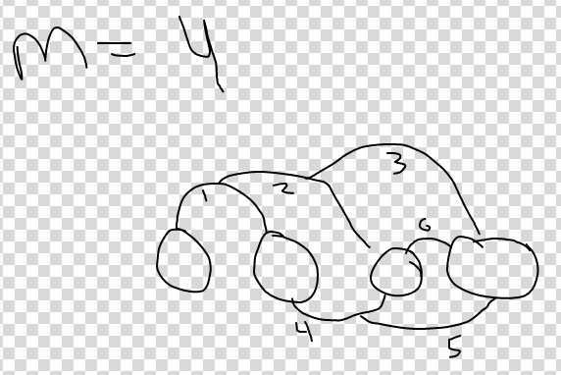
  + P2 -> m
  + Pn -> m
* binomial(m, 2) Choose 2: 2 images can match.
* binomial(a, b) = (a!)/(b! (a - b)!)
* Example:
  + (4!)/(2! (4 - 2)!)
* Since there are N -people. There can be binomial(m, 2) per person.
* The final equation is N binomial(m, 2).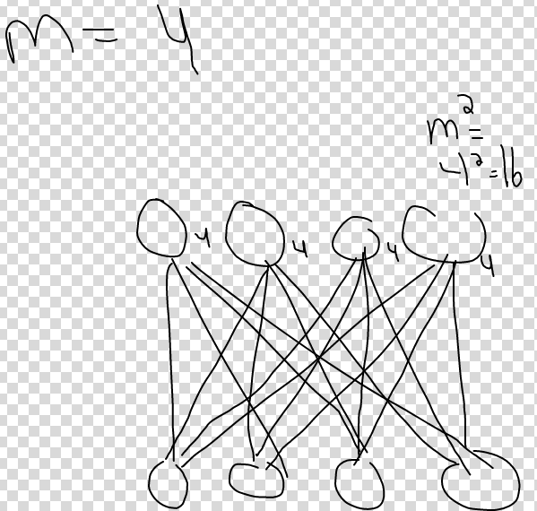

Imposter (symmetric matcher):

* For every Pi there are any number of face images(m).
  + P1 -> m
  + P2 -> m
  + Pn -> m
* To get an imposter, compare two different identities.
* Therefore, all comparison between two individuals is m2.
* Every identity can be paired. 
* For each pairing, there are 2possibilities.
* The final equation is m^2 binomial(N, 2).

2. [15 points] Let *B*1, *B*2 and *B*3 denote 3 different fingerprint matchers that are used to generate genuine and impostor match scores on a fixed set of fingerprint images. The mean (*µ*) and variance (*σ*2) of the genuine and impostor score distributions resulting from the 3 different matchers are tabulated below.

| **Matcher** | **Genuine** | | **Impostor** | |
| --- | --- | --- | --- | --- |
|  | *µ* | *σ*2 | *µ* | *σ*2 |
| *B*1 | 10 | 25 | 60 | 25 |
| *B*2 | 60 | 5 | 75 | 3 |
| *B*3 | 40 | 15 | 70 | 25 |

Based on the score statistics, determine which one of the three matchers has performed well and which one has performed the worst. Provide adequate numerical justification.

d-prime value is the statistical measure which grades the ability of a system to distinguish between biometric samples or individuals.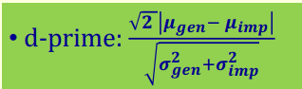

A higher d-prime means the matcher is more capable

of distinguishing between 2 examples.

B1 = (sqrt(2) abs(10 - 60))/sqrt(25 + 25) = 10 B1 performed the best.

B2 =  (sqrt(2) abs(60 - 75))/sqrt(5 + 3)  = 7.5

B3 = (sqrt(2) abs(40 - 70))/sqrt(15 + 25)= 6.708 B3 performed the worst.

3. [15 points] Consider a biometric matcher that generates similarity scores in the range [0, 1]. Its genuine and impostor score distributions are as follows: *p*(s|genuine) = 3s2and *p*(s|impostor) = 2 − 2s. Suppose the following decision rule is employed: *s* is classified as a genuine score if *s* ≥ *η*; else it is classified as an impostor score. Here, *η* ∈ [0, 1].

• Plot the genuine and impostor distributions in a single graph.

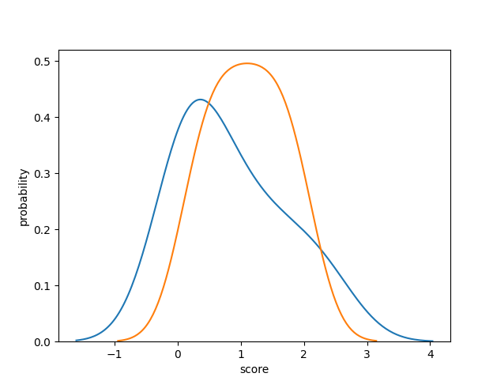

• If *η* = 0.2, what is the FMR (i.e., FAR) and FNMR (i.e., FRR) of the biometric matcher?

FMR = integral_0.2^1 3 s^2 ds = 0.992 FNMR = integral_0^0.2 3 s^2 ds = 0.008

• If *η* = 0.8, what is the FMR (i.e., FAR) and FNMR (i.e., FRR) of the biometric matcher?

FMR = integral_0.8^1 3 s^2 ds = 0.488 FNMR = integral_0^0.8 3 s^2 ds = 0.512

• Write a program to compute the DET curve based on these two distributions. Plot the DET curve.

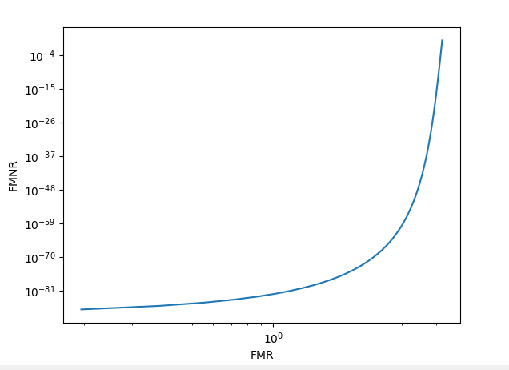

4. This exercise involves generating match score distributions and DET curves for two different modalities/matchers - fingerprint and hand. The fingerprint scores are *similarity-based*, while the hand scores are *distance-based*. The set of scores can be accessed here.

(a) [5 points] Compute and report the mean and variance of the (a) genuine scores and (b) impostor scores for each matcher.

Finger-genuine mean is: 306.58222222222224

Finger-genuine variance is: 40825.04323950619

Finger-impostor mean is: 7.971111111111111

Finger-impostor variance is: 90.80583209876544

Hand-genuine mean is: 50.644444444444446

Hand-genuine variance is: 1516.273580246914

Hand-impostor mean is: 144.43555555555557

Hand-impostor variance is: 6925.659180246915

(b) [10 points] Compute and report the d-prime value for each matcher.

Finger matcher d-prime is: 0.010344112462996205

Hand matcher d-prime is: 0.018708925418523897

(c) [10 points] For each matcher, plot the histogram of genuine and impostor scores in the same graph. So there will be two graphs - one for the fingerprint matcher and the other for the hand matcher.

Fingerprint Matcher Hand Matcher

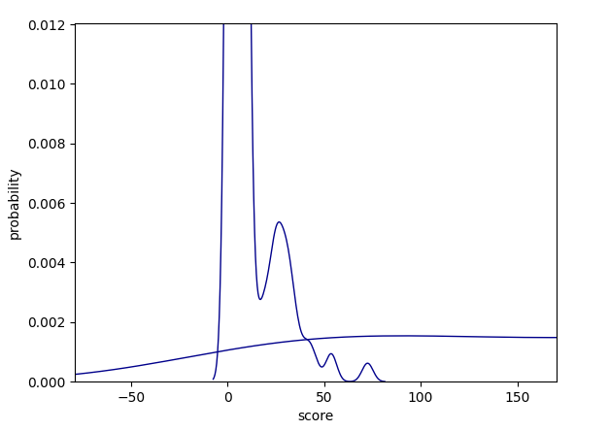 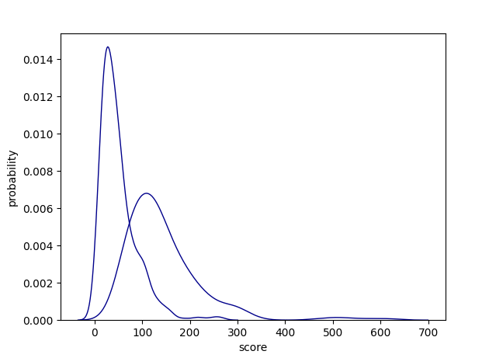

(d) [10 points] Write a program that inputs a threshold value, *η*, for each matcher and outputs the False Match Rate (FMR) and False Non-match Rate (FNMR) at that threshold. Use this program to compute the FMR and FNMR for the following scenarios:

i. Fingerprint Matcher: *η* = 500

ii. Hand Matcher: *η* = 300

The FMR is for finger is: 0.0

The FMR is for hand is: 0.035555555555555556

The FNMR is for finger is: 0.8022222222222222

The FNMR is for hand is: 1.0

(e) [15 points] Based on the program designed in (4d), write another program that inputs a set of genuine scores and impostor scores and plots the Detection Error Tradeoff (DET) Curve. Use this program to plot the DET curve for both the matchers and report the Equal Error Rate (EER).

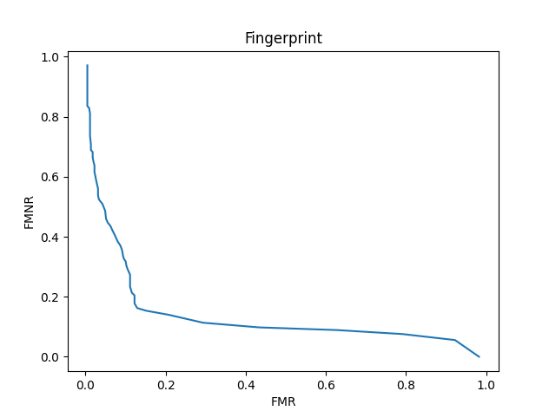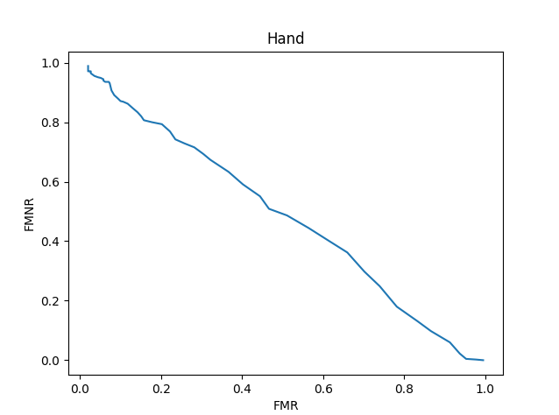

(f) [5 points] For each of the two matchers determine what the FNMR is at

(a) FMR = 10%;

(b) FMR = 5%;

(c) FMR = 1%.

You can determine these values from the DET curve.

(g) [5 points] Which matcher, in your opinion, has performed well? **Justify your answer.**

The hand matcher has a slightly higher d-prime value. Therefore it has a better capability of distinguishing two samples.