

GaariYaari
LAB MID REPORT
Web Technologies
Instructor: Amir Parre

Student Names: |  | Sharia Noor  Sufwan Amir
Registration No: |  | FA23-BDS-036 FA23-BDS-063
Department: |  | Data Science

COMSATS UNIVERSITY ISLAMABAD

Contents
Abstract 3
1. Introduction 3
2. Project Objectives 4
3. Tools and Technologies Used 4
4. System Overview 5
• Home Page: 5
• Find Ride Page: 5
• Offer Ride Page: 5
• About Page: 5
• Contact Page: 5
• Login and Signup Pages: 5
5. User Interface Design 5
5.1 Navbar 5
5.2 Hero Section 6
5.3 Buttons 6
6. Page-by-Page Description 6
6.1 Home Page 6
6.2 Find Ride Page 6
6.3 Offer Ride Page 7
6.4 Login and Signup Pages 7
6.5 Contact Page 7
6.6 About Page 8
7. CSS Styling and Design Features 8
8. Responsiveness and Accessibility 9
9. Testing and Validation 9
10. Future Enhancements 10
11. Conclusion 10
12. References 10
13. Appendix 11

Abstract
Transportation has become a significant concern in today’s urban lifestyle due to increasing fuel costs, traffic congestion, and environmental pollution. Carpooling offers an efficient and eco-friendly alternative, helping individuals save time, money, and reduce their carbon footprint.
This project, “GaariYaari – Your Smart Ride Partner”, is a web-based ride-sharing platform that enables users to either find a ride or offer one conveniently. Developed using HTML5, CSS3, and JavaScript, the website provides an intuitive interface and responsive design suitable for all devices.
The project focuses on simplicity, usability, and aesthetics through a clean pastel-blue theme. It includes essential pages such as Home, Find Ride, Offer Ride, About, Contact, Login, and Signup, forming a complete system for ride-sharing interaction.
GaariYaari demonstrates the potential of front-end technologies in developing socially impactful and scalable digital solutions. Future enhancements can integrate real-time data, authentication, and payment systems to transform it into a fully functional web application.

1. Introduction
In today’s fast-moving world, urban transportation has become a critical challenge due to traffic congestion, limited parking space, and the rising cost of fuel. People often commute in similar directions, yet travel separately, leading to inefficiency and increased pollution.
To address these issues, GaariYaari is introduced as a web-based carpooling platform that connects people traveling along the same route. The name “GaariYaari” symbolizes friendship through rides — combining convenience with sustainability.
The main purpose of this project is to develop a responsive and visually appealing website where users can easily find or offer rides. It aims to reduce travel costs, promote social interaction, and encourage environment-friendly commuting.

2. Project Objectives
The main objectives of GaariYaari are as follows:
- To create a simple and efficient ride-sharing web platform.
- To allow users to find available rides easily based on location, date, and seat availability.
- To enable car owners to offer rides and post their travel details.
- To provide user authentication features through login and signup pages.
- To ensure a modern and consistent interface with pastel blue gradients.
- To make the design responsive across different screen sizes for accessibility on both desktop and mobile devices.
- To promote eco-friendly travel by encouraging shared rides.

3. Tools and Technologies Used
Technology |  |  | Purpose
HTML5 |  |  | Structure and layout of web pages
CSS3 |  |  | Styling and responsiveness
Google Fonts (Poppins) |  |  | Font consistency and modern typography
Favicon |  |  | Branding and tab icon
Google Maps Embed |  |  | Displaying location on Contact page
Visual Studio Code |  |  | Development environment
Browser Developer Tools |  |  | Debugging and testing
Images and Icons |  |  | Branding and visual appeal

4. System Overview
The GaariYaari web project consists of multiple interlinked pages forming a complete user journey:
- Home Page: Acts as the main landing page introducing GaariYaari’s concept and navigation options.
- Find Ride Page: Allows users to search for rides based on input parameters.
- Offer Ride Page: Enables users to share their travel route and offer available seats.
- About Page: Provides detailed background information about the platform and its purpose.
- Contact Page: Offers a communication channel with the GaariYaari team via a contact form.
- Login and Signup Pages: Handle user registration and authentication.
All pages are connected through a consistent navigation bar and footer, ensuring uniformity and easy navigation.

5. User Interface Design
The website follows a clean, pastel-blue color palette representing calmness, trust, and technology.The Poppins font family gives a modern and sleek look.
The design emphasizes simplicity, readability, and user focus.

5.1 Navbar
- Present on every page.
- Contains links to Home, Find Ride, Offer Ride, About, Contact, and Login.
- Uses a gradient underline and hover effect for interactivity.
- Logo image (“GaariYaari_navbar.png”) is placed on the left for brand identity.

5.2 Hero Section
- Features a large banner with a blue gradient background.
- Includes welcoming headings such as “Find Rides with GaariYaari” or “Share Your Journey with GaariYaari”.
- Contains short introductory text that quickly tells users what the page offers.

5.3 Buttons
- Rounded and colorful with gradient backgrounds (#00b4db to #0083b0).
- Two main types:
  - Offer Ride button (blue gradient)
  - Find Ride button (outlined style)
- Hover animations enhance the interactive experience.

6. Page-by-Page Description

6.1 Home Page
The homepage introduces users to GaariYaari’s concept of smart, shared travel.
It has a navigation bar, hero banner, short introduction text, and call-to-action buttons that lead to
“Find Ride” and “Offer Ride” pages.
The design ensures that the purpose of the platform is clear from the first glance.

6.2 Find Ride Page
This page allows users to search for available rides.
It contains a form with the following fields:
- Pickup Location
- Destination
- Date
- Number of Seats Needed
The “Search Ride” button allows users to submit the form.
Below the form, a section displays “Available Rides.” Currently, it shows a placeholder text “No rides found yet” — which can later be connected to a backend or database system.
The layout is centered, clean, and easy to navigate.

6.3 Offer Ride Page
The Offer Ride page enables car owners to post their travel details.
The form includes fields for:
- Pickup Location
- Drop Location
- Date & Time (datetime-local input)
- Available Seats
- Cost per Seat
The “Post Ride” button submits the details.
This page promotes community sharing by encouraging drivers to help others commute conveniently.

6.4 Login and Signup Pages
The Login Page provides fields for email and password, with a link to create an account.
The Signup Page includes inputs for full name, email, and password.
Both pages are styled with white card boxes, rounded corners, and centered layouts maintaining a minimalist design.
These pages ensure that user access is secured and personalized.

6.5 Contact Page
The Contact page allows users to reach out for queries or support.
It includes:
- Name and Email input fields
- Message box
- “Send Message” button
It also embeds a Google Map showing Islamabad, Pakistan, to indicate location or service area.
The section is enhanced with a light background and rounded form boxes for an elegant look.

6.6 About Page
This page explains the platform’s purpose, mission, and benefits of ride-sharing.
It discusses how GaariYaari encourages carpooling, reduces travel costs, and helps the environment.
Headings and paragraphs are styled with vibrant blue tones for emphasis and readability.

7. CSS Styling and Design Features
The style.css file plays a crucial role in maintaining the website’s modern and responsive layout.
Key design decisions include:
- Consistent Typography:
All pages use the Poppins font family for a cohesive look.
- Color Scheme:
Blue gradients (#00b4db → #0083b0) for headers and buttons.
Light backgrounds (#f9fafb and #f0f9ff) ensure readability.
- Responsive Layouts:
Grid and flexbox are used for responsive design and alignment.
The navbar and forms adjust well to different screen sizes.
- Hover & Transition Effects:
Links and buttons smoothly change color or opacity when hovered, creating a professional and interactive feel.
- Form Styling:
Inputs and buttons are rounded, with subtle shadows for depth.
The focus effect highlights active input fields with soft blue glows.
- Footer Design:
Uses a gradient background and white text to contrast with the rest of the site.
Links for privacy policy, terms, and help are included for professionalism.

8. Responsiveness and Accessibility
GaariYaari was designed to be responsive across devices.
The use of flexible units, media-friendly layouts, and minimal fixed widths ensures compatibility with:
- Desktops
- Tablets
- Mobile phones
Accessibility has also been considered by using:
- Proper labels for form inputs.
- Descriptive alt text for all images.
- Readable color contrast ratios.
These design decisions make the platform inclusive and user-friendly for everyone.

9. Testing and Validation
To ensure proper functioning, each page was tested using different browsers (Chrome, Edge, Firefox).
The HTML and CSS were validated through W3C Validator to remove syntax errors and maintain clean code standards.
Testing scenarios included:
- Navigation between all pages.
- Form field alignment and responsiveness.
- Font consistency and layout scaling on mobile view.
All tests confirmed that the website performs smoothly and displays consistently.

10. Future Enhancements
In the future, GaariYaari can be extended into a full-fledged web application using backend technologies such as:
- PHP or Node.js for server-side logic.
- MySQL or Firebase for storing rides, user data, and feedback.
- Geolocation API for auto-detecting user pickup locations.
- Live Chat or Notifications for user interaction.
- Payment Integration for seat booking.
These features would transform GaariYaari from a static website into a dynamic ride-sharing platform with real-time functionality.

11. Conclusion
GaariYaari successfully demonstrates a modern, responsive, and cleanly designed web platform aimed at simplifying ride-sharing and promoting sustainable travel.
The project showcases the effective use of HTML and CSS to create a visually appealing, structured, and interactive web interface.
This project not only fulfills the academic requirement but also lays a solid foundation for future enhancements into a real-world carpooling solution.
GaariYaari stands as an example of how technology and design can come together to create meaningful, socially beneficial digital solutions that make transportation smarter, greener, and more connected.

12. References
- Mozilla Developer Network (MDN). (2024). HTML: HyperText Markup Language. Retrieved from https://developer.mozilla.org/en-US/docs/Web/HTML
- Mozilla Developer Network (MDN). (2024). CSS: Cascading Style Sheets. Retrieved from https://developer.mozilla.org/en-US/docs/Web/CSS
- W3Schools. (2024). HTML and CSS Tutorial. Retrieved from https://www.w3schools.com/
- Google Fonts. (2024). Poppins Font Family. Retrieved from https://fonts.google.com/specimen/Poppins
- Google Maps Platform. (2024). Embed API Overview. Retrieved from https://developers.google.com/maps/documentation/embed/overview
- World Economic Forum. (2023). The Future of Shared Mobility. Retrieved from https://www.weforum.org/agenda/

13. Appendix
Appendix A: Website Screenshots

- Figure A1: Home Page of GaariYaari
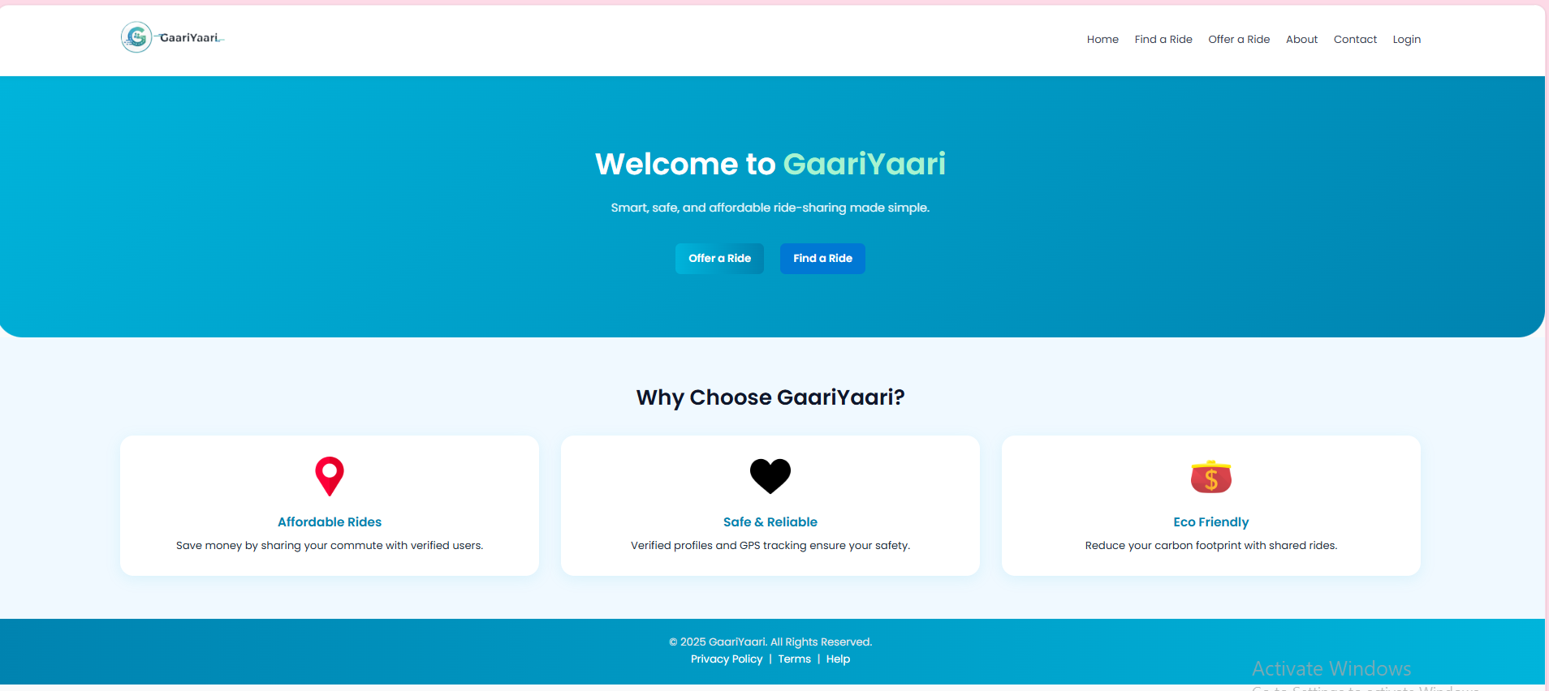

- Figure A2: Offer Ride Page
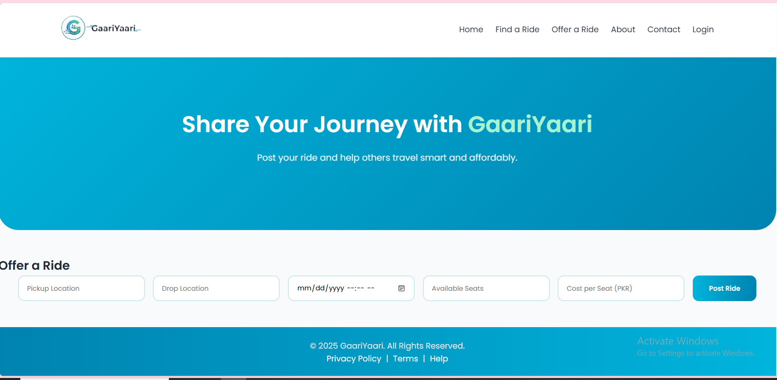
- Figure A3: Find Ride Page
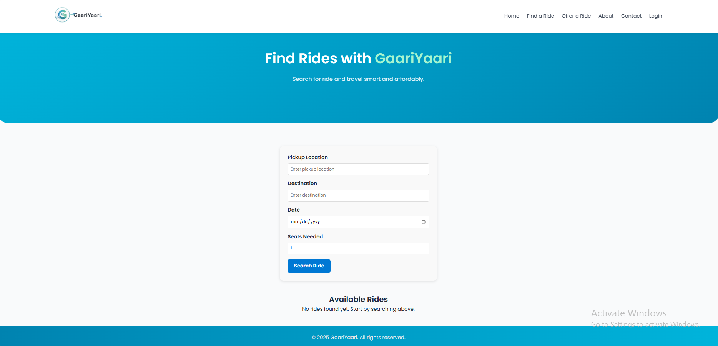

- Figure A4: Login and Signup Pages
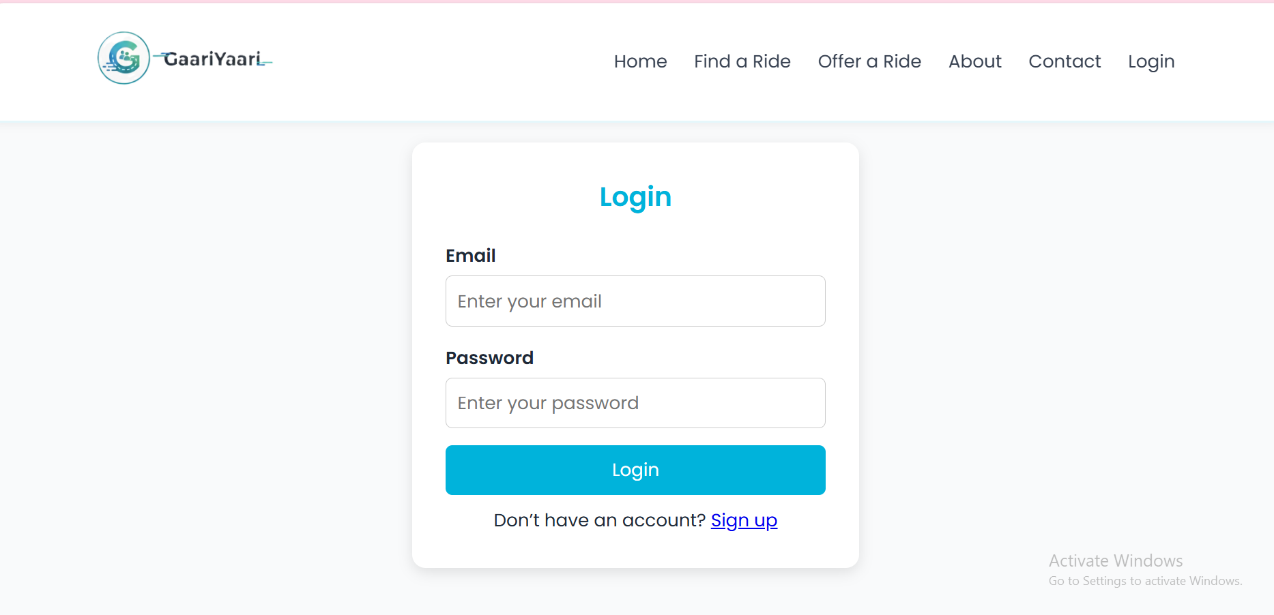 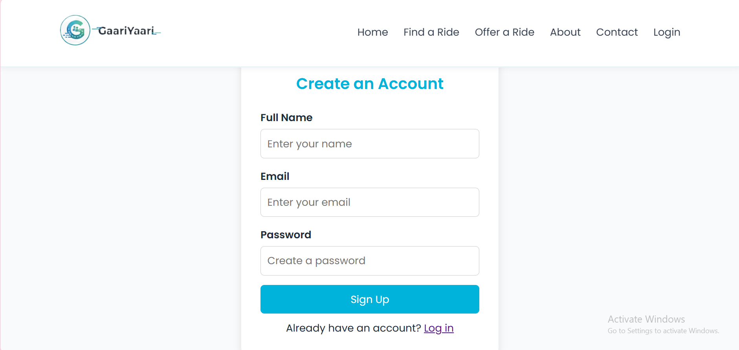

- Figure A5: Contact Page and Map Integration
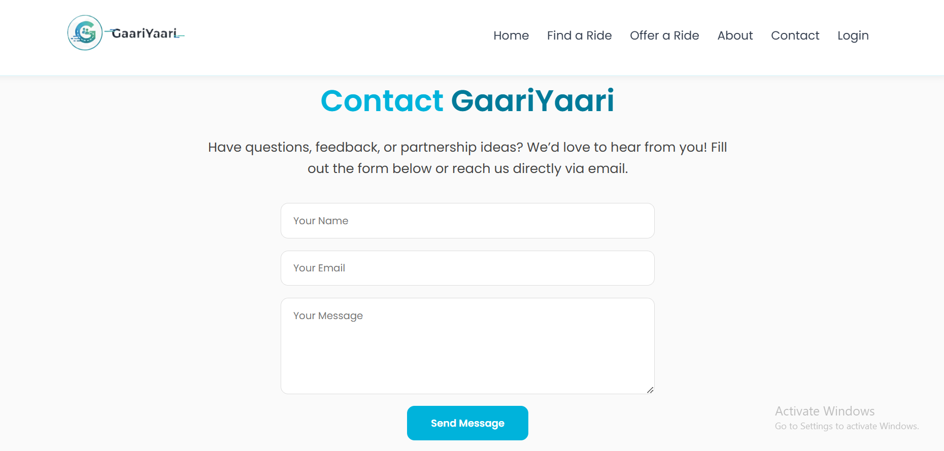 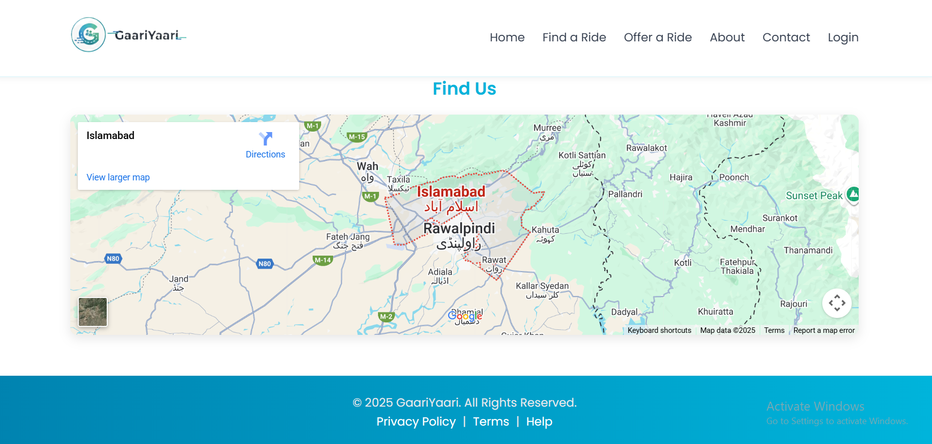

Figure A6: About Us
