TicTacToe implementation using Deep Q-Learning
Implementation Understanding:
The implementation of TicTacToe using Deep Q-Learning consists of several main components: the QModel, Agent, TicTacToe environment, and the main training script. The QModel is a neural network built with PyTorch that estimates the Q-values $Q(s,a)$for the nine possible actions in TicTacToe. The game state is encoded as a 3×10 tensor, representing the nine board cells and the current player’s turn, and each value is embedded using a PyTorch embedding layer before being passed through fully connected layers to output Q-values for each action. The Agent class manages action selection using an epsilon-greedy policy, meaning the agent sometimes explores random moves and otherwise chooses the move with the highest predicted Q-value. It also performs the Q-learning update using the Bellman equation and optimizes the neural network parameters using the Adam optimizer and smooth L1 loss. The TicTacToe class acts as the environment that manages the board state, validates moves, determines wins or draws, assigns rewards, and stores transitions (s, a, s’, r) for training. The main program repeatedly simulates batches of games between two agents, collects experience transitions, trains the neural networks, and saves the trained models to a checkpoint folder.
Training
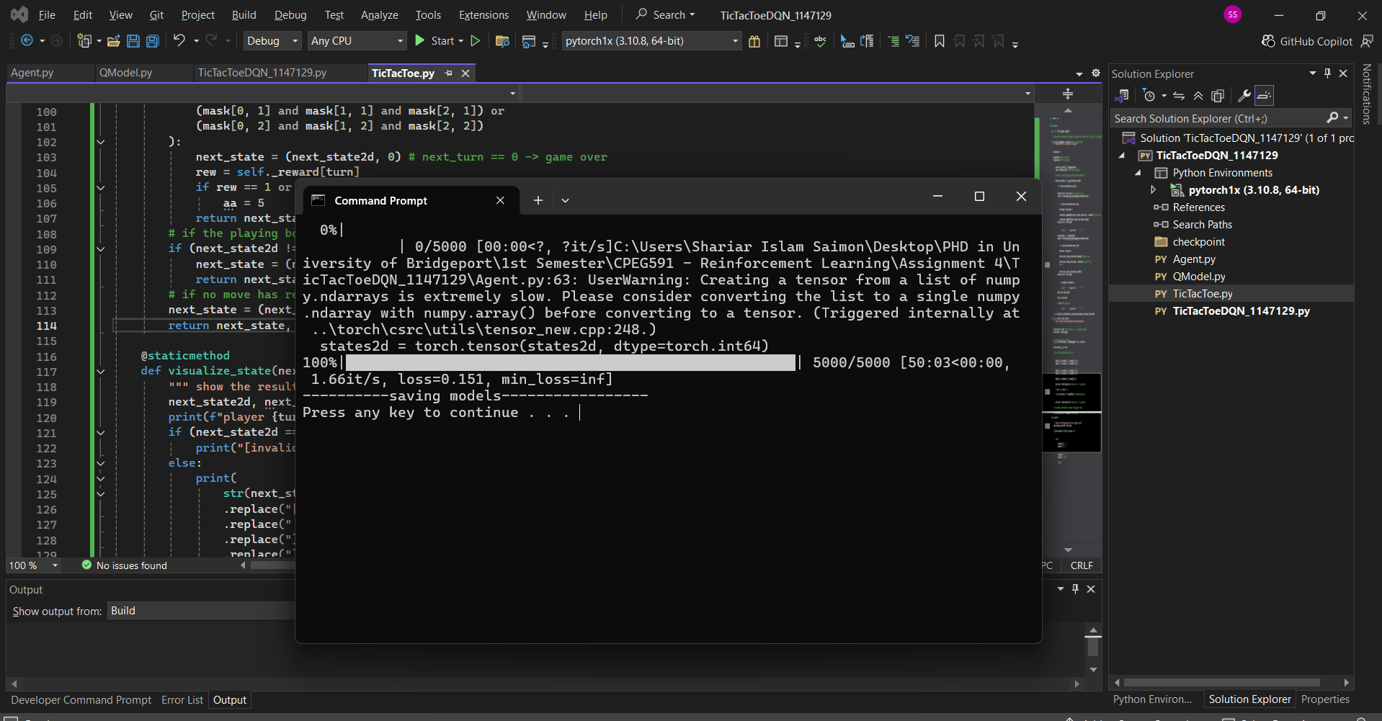
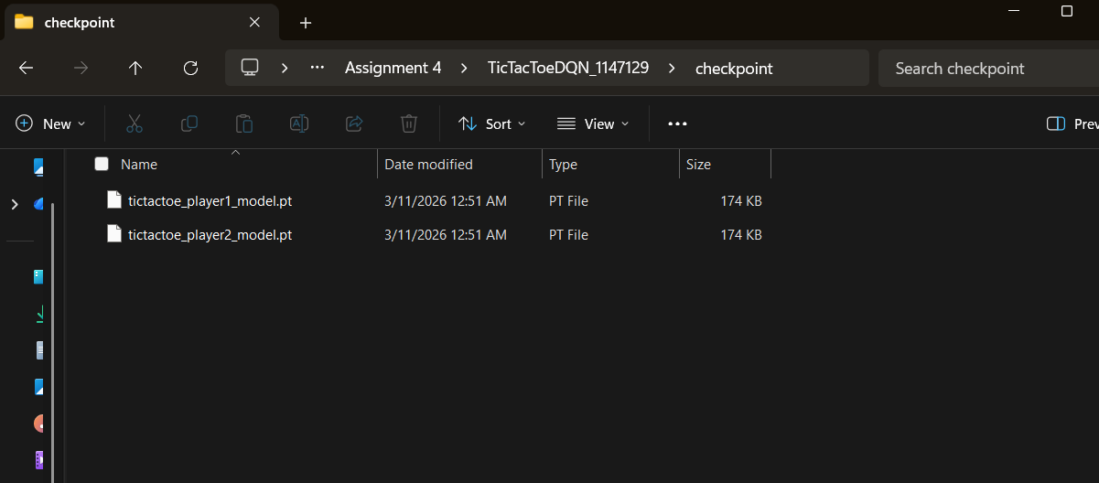
Game Play (Output for test data)
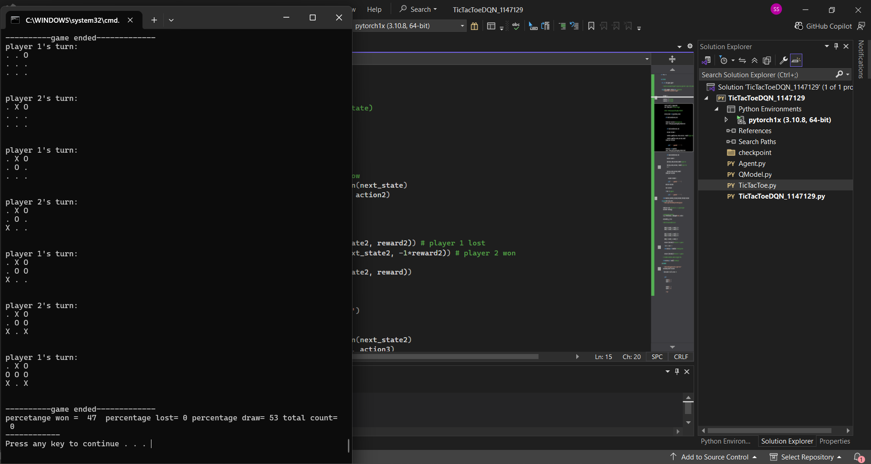
There is a mistake here: player2.qmodel.load_state_dict(checkpoint_data1['state_dict']) correction: player2.qmodel.load_state_dict(checkpoint_data2['state_dict'])

Game Play
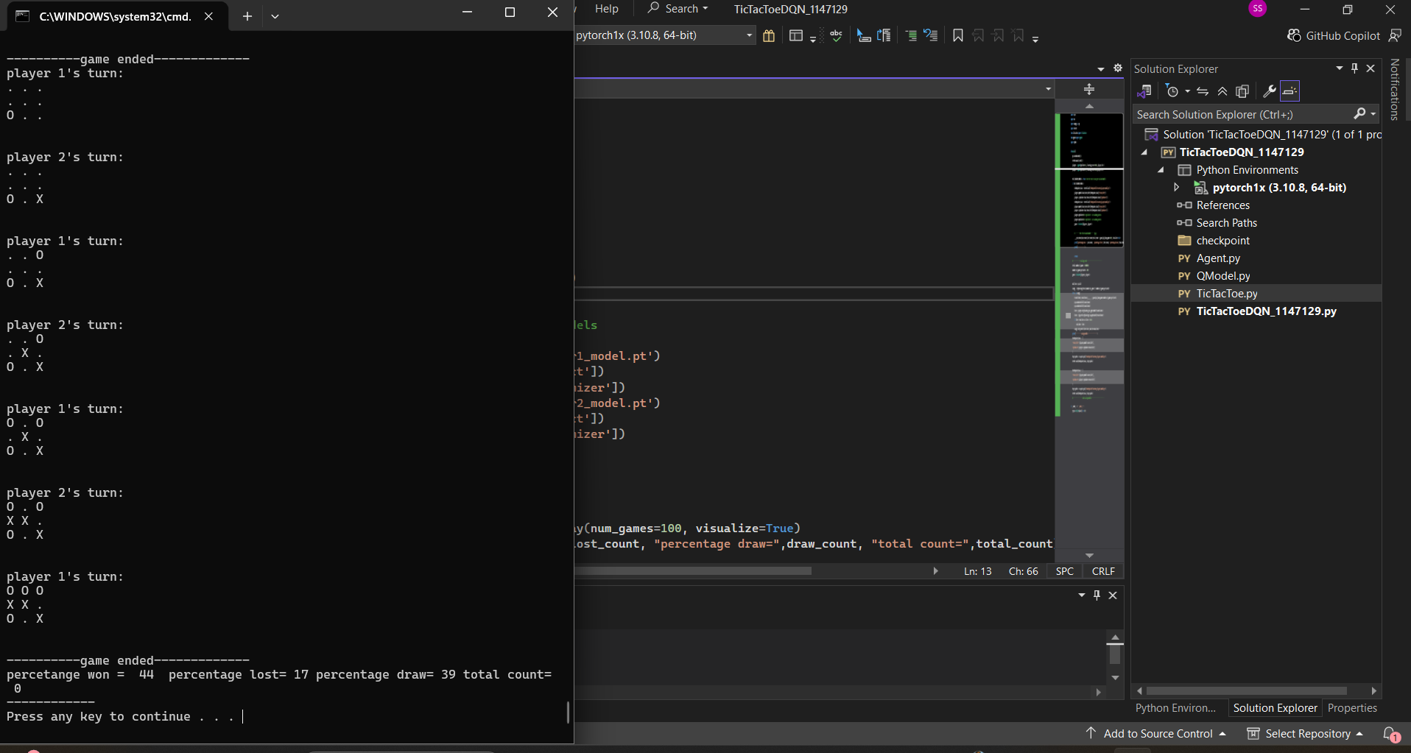
Enhancement:
To implement the enhancement, the code was modified to identify and learn from the situations where player 1 loses the game. First, the TicTacToe.play() function was updated to optionally store losing transitions by adding a new parameter store_losing_cases. When player 1 loses (i.e., when reward2 == -1), the transition (state, action, next_state, reward) is saved in a list called losing_cases_player1. The function was also modified to return this list along with the other outputs so it can be accessed in the main program. In the main script, a new function called fine_tune_on_losing_cases() was added, which takes these stored losing transitions and performs additional Q-learning updates on the trained model. After loading the trained models and running several test games to collect losing cases, this fine-tuning function is executed to retrain the model specifically on the mistakes that led to losses. Finally, the updated model is saved and tested again to verify that the number of losses decreases when playing against the other agent. This enhancement allows the agent to learn from its mistakes and improve its strategy by focusing on previously losing scenarios.
Conclusion:
This Problem demonstrates how Deep Reinforcement Learning can be applied to a simple game environment such as TicTacToe. Two agents are trained through self-play, where each agent learns optimal strategies by interacting with the environment and improving its Q-value estimates over many simulated games. Rewards are assigned based on the outcome of the game, allowing the neural networks to gradually learn which moves lead to winning or losing outcomes. The epsilon-greedy strategy ensures a balance between exploration and exploitation during training. After sufficient training, the agents learn strong TicTacToe strategies, typically resulting in mostly draws when both play optimally. As an enhancement, losing scenarios can be stored and used to fine-tune the model, allowing the agent to correct mistakes and further improve its decision-making ability. This approach illustrates the core principles of Deep Q-Learning, including state representation, policy learning, reward feedback, and neural network optimization in reinforcement learning environments.

