CPEG591-2026SP- Reinforcement Learning, Assignment #5

CPEG 591 – Assignment #5

Submitted by:
Shariar Islam Saimon
(Student ID: 1147129)



Department of Electrical/Computer Engineering
University of Bridgeport
Bridgeport, CT-06604
USA

Problem 1:
Q-Learning using Image Frames to Learn a Game Policy
Implementation Understanding:
This assignment implements a Deep Q-Learning (DQN) agent that learns to play a simple catch game using image frames as the state input. The game is first built using pygame, where a ball falls from one of five positions and the catcher moves left, right, or stays. The environment version (CatchGameEnv.py) allows the agent to interact using actions instead of keyboard input and returns the game state as image frames. These frames are resized to 100×100 grayscale images and fed into a Convolutional Neural Network (DQNetwork), which outputs Q-values for the three possible actions. The agent learns by storing experiences (state, action, reward, next_state) in memory and updating the network using the Q-learning equation with mini-batch training.
Output
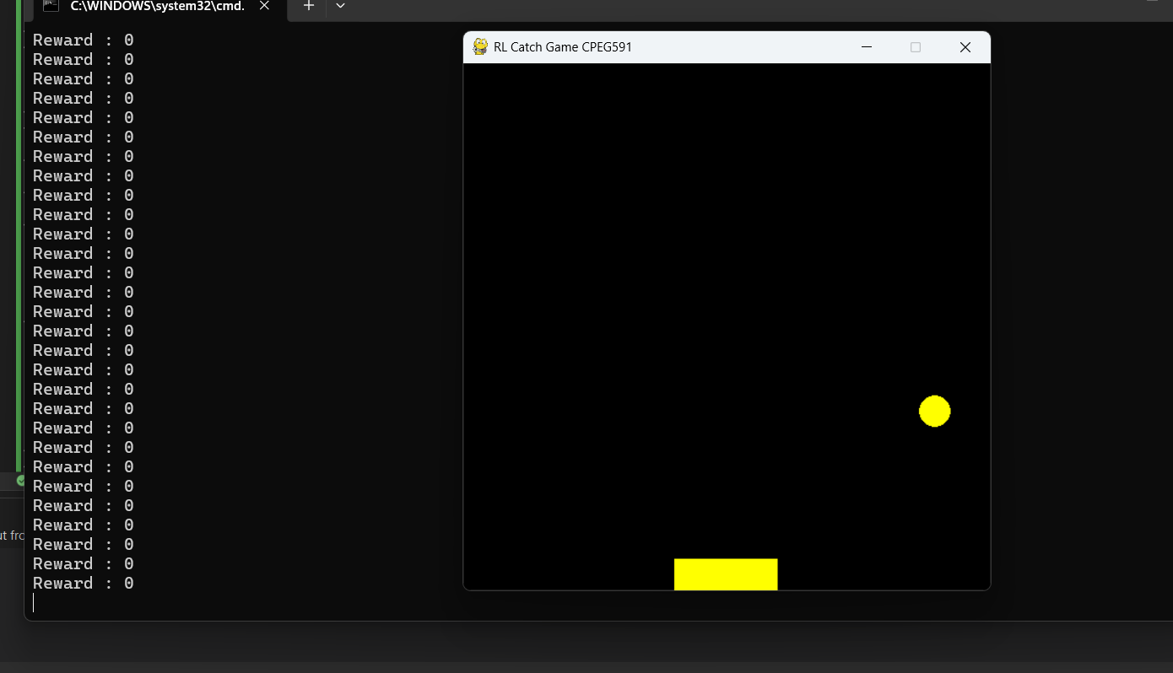

Reward -1 when loosing
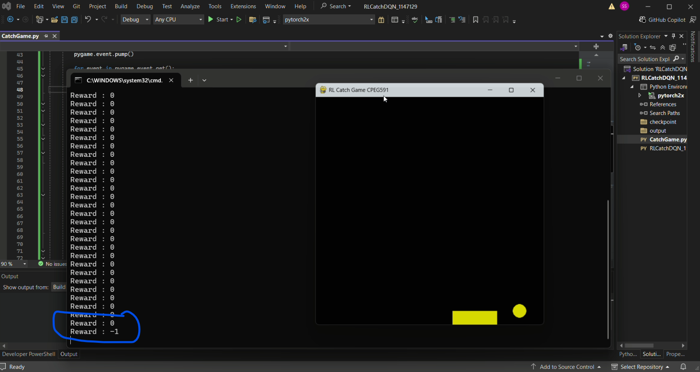

Reward 1 when winning
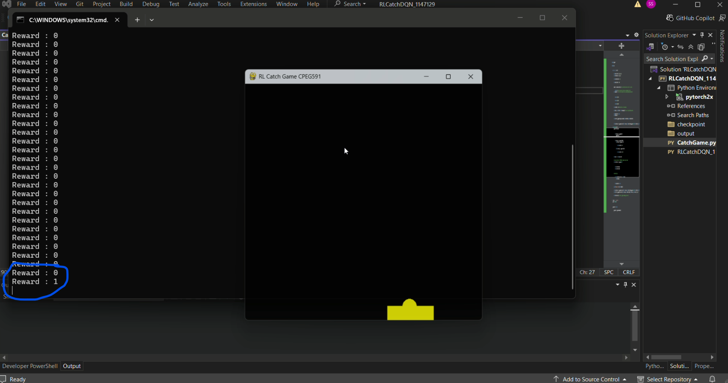

For 100 games win counts
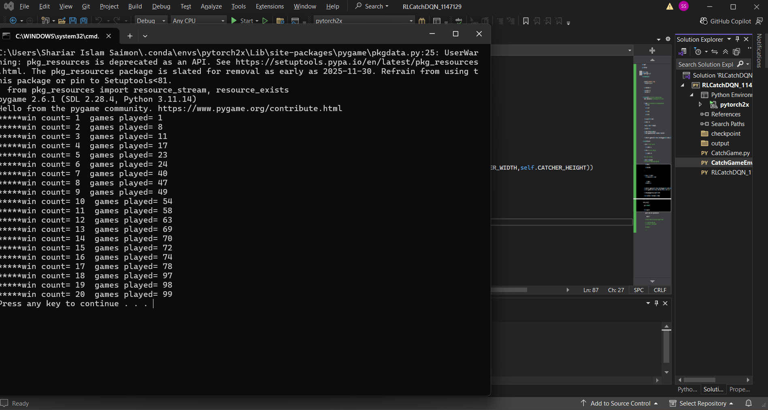

Training:
Image as a state and passed to the deep network with size 1*100*100
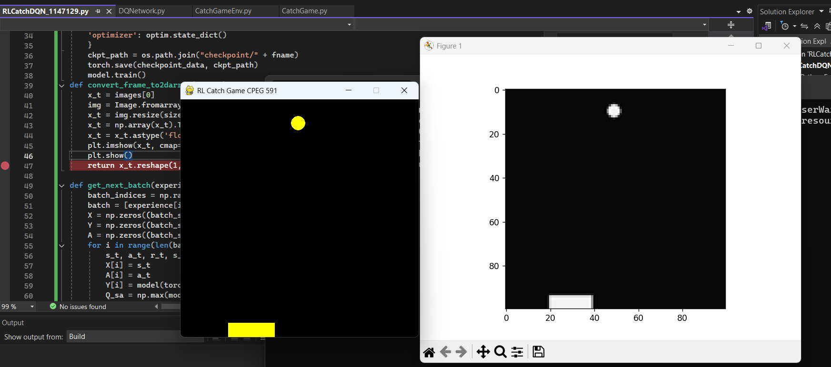

Saving the model (5000 epoch for training)
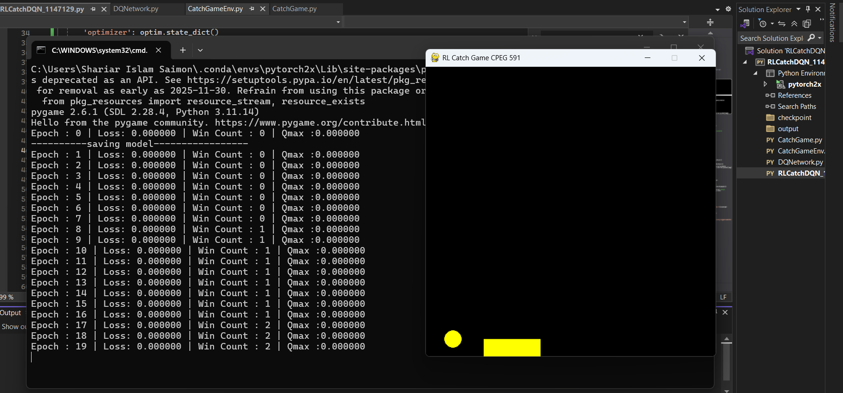

Training after 6257
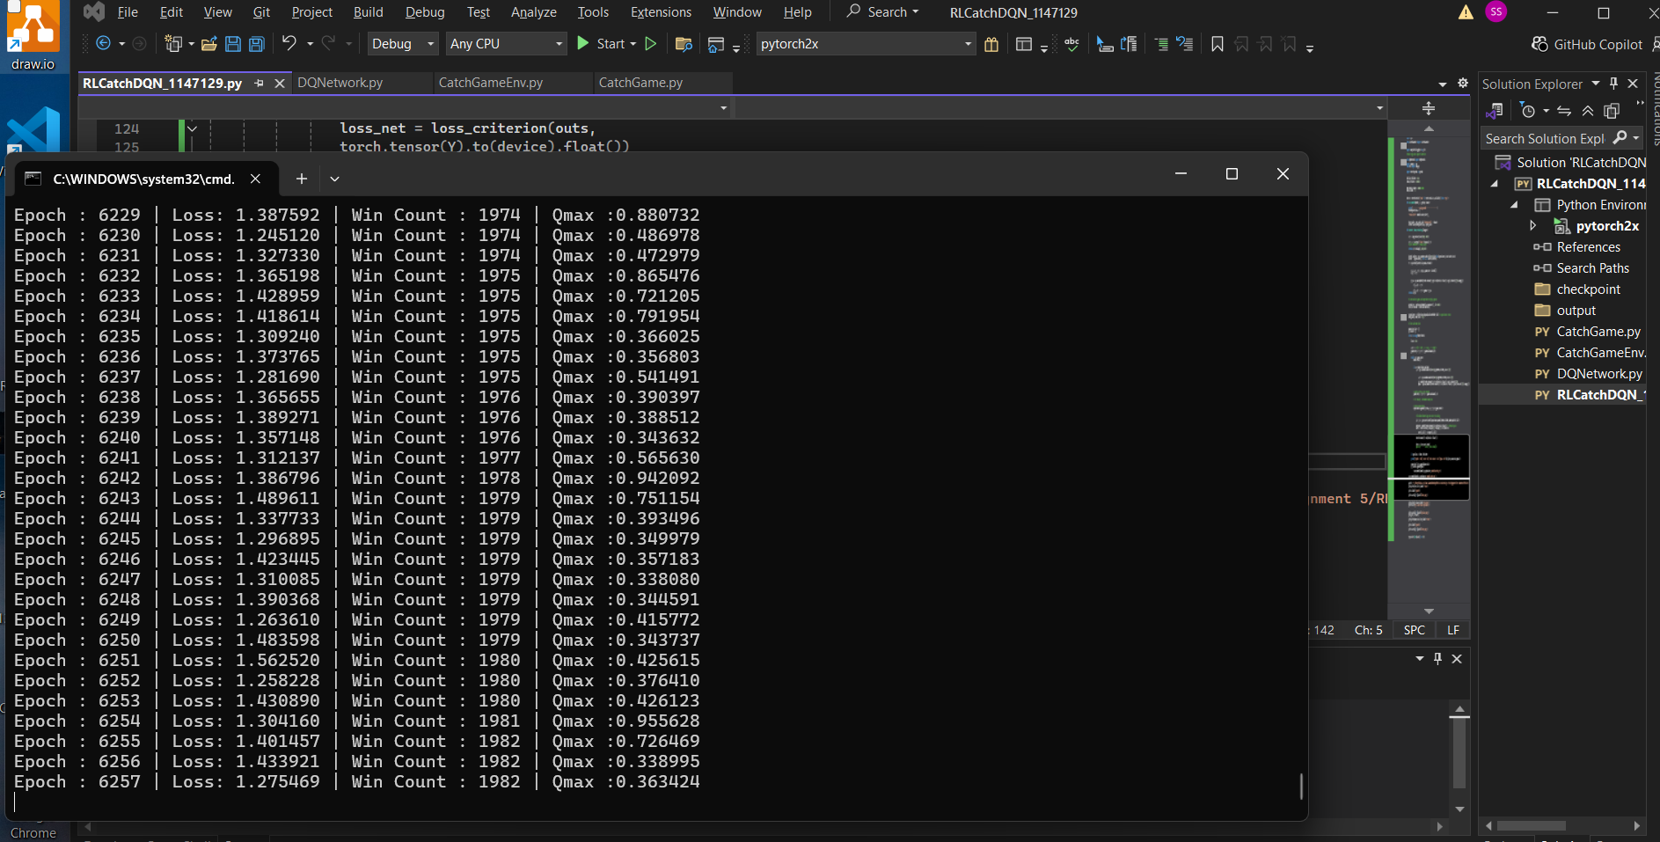
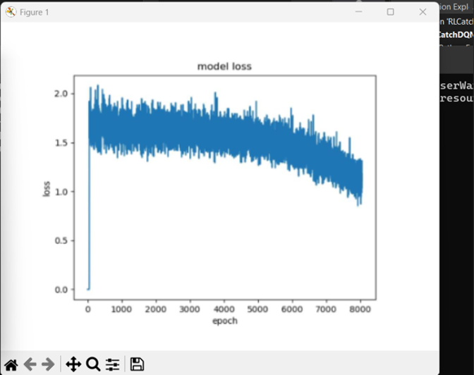
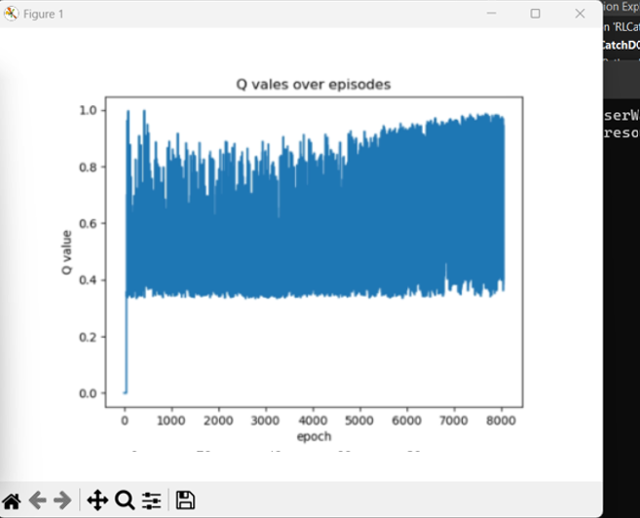
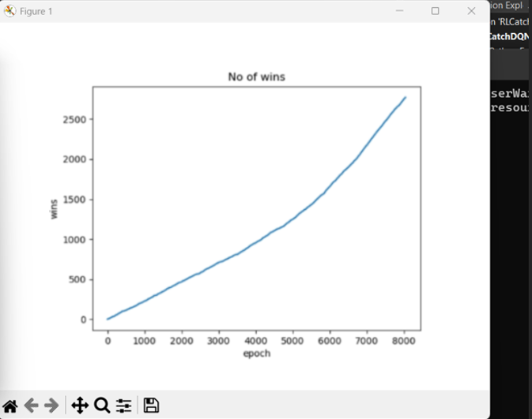

Testing
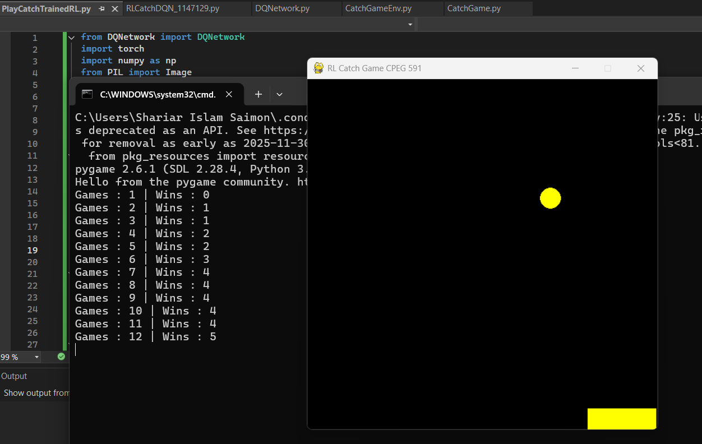

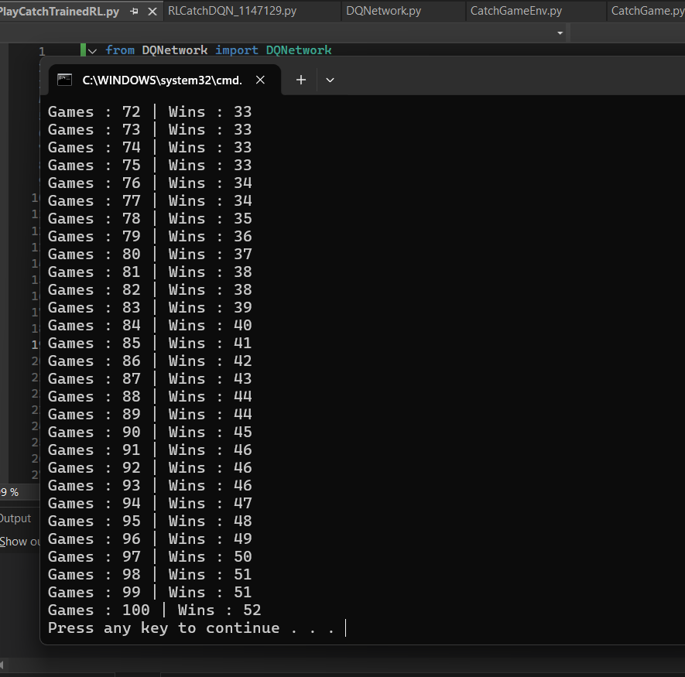

Discussion
During training (RLCatchDQN_main.py), the agent uses an epsilon-greedy strategy, where it initially explores by taking random actions and gradually shifts toward choosing actions with the highest predicted Q-values. Experience replay improves learning stability by sampling random batches instead of sequential data. Over time, the model learns the optimal policy to align the catcher with the falling ball, increasing the win rate from about 20% (random) to near 70% after sufficient training. Finally, the trained model is loaded and used to automatically play the game, demonstrating how reinforcement learning can learn effective behavior directly from visual inputs.

